PROJECT DESIGN PHASE

  - Problem–Solution Fit
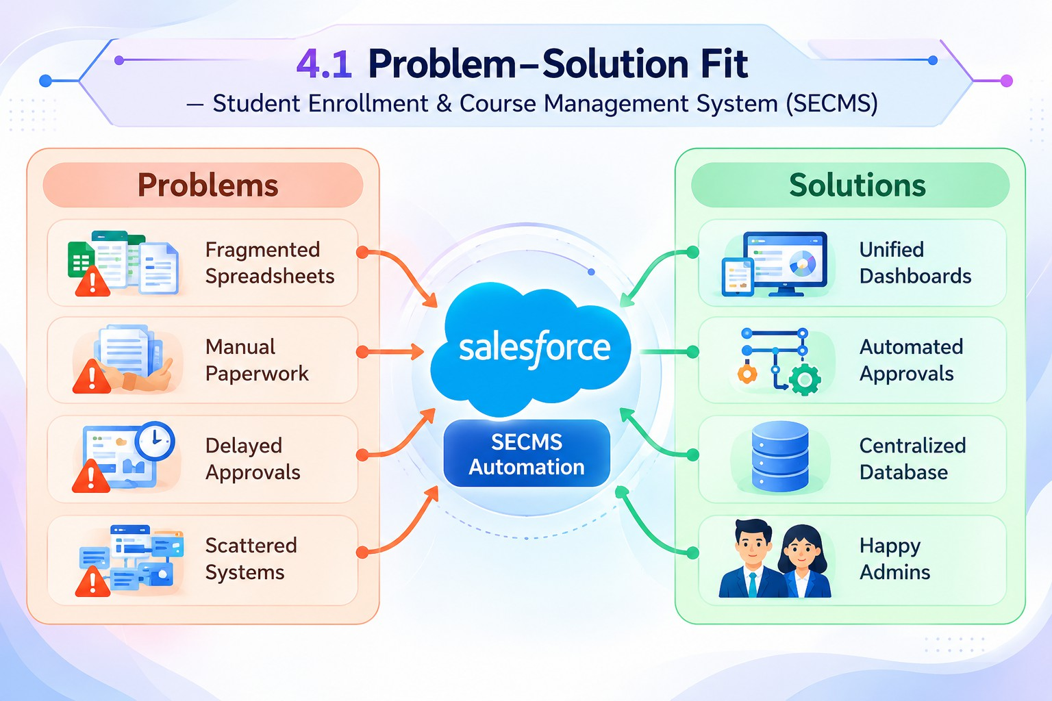
SECMS directly addresses fragmented enrollment workflows by aligning user behavior, constraints, and automation using Salesforce-native capabilities.

  - Proposed Solution
Functional Requirements
Parameter | Description
Problem | Manual enrollment handling
Solution | Salesforce-based SECMS
Novelty | End-to-end automation
Social Impact | Improved student experience
Revenue Model | Institutional deployment
Scalability | Multi-department support

  - Solution Architecture
The architecture integrates Salesforce objects, automation flows, approval processes, dashboards, and security layers.
