Project Development Phase:
Project Flow:
Milestone 1 | : Salesforce Developer Account Creation
Milestone 2 | : Custom Object Creation (Student, Course, Enrollment, Instructor)
Milestone 3 | : Tabs Creation
Milestone 4 | : Lightning App Creation
Milestone 5 | : Fields Creation
Milestone 6 | : Create Relationships
Milestone 7 | : Page Layout Customization
Milestone 8 | : Validation Rules
Milestone 9 | : Flows (Automation)
Milestone 10 | : Approval Process
Milestone 11 | : Reports
Milestone 12 | : Dashboards
Milestone 13 | : Security Setup
Milestone 14 | : Conclusion
What you'll learn
- Real-time Salesforce project implementation
- Designing custom objects and relationships
- Creating page layouts & record types
- Writing validation rules
- Building automation with flows
- Creating approval workflows
- Developing reports & dashboards
- Setting up security with profiles, permission sets, and sharing
- End-to-end application testing

Milestone 1-Salesforce:
Introduction:
Are you new to Salesforce? Not sure exactly what it is, or how to use it? Don’t know where you should start on your learning journey? If you’ve answered yes to any of these questions, then you’re in the right place. This module is for you.
Welcome to Salesforce! Salesforce is game-changing technology, with a host of productivity-boosting features, that will help you sell smarter and faster. As you work toward your badge for this module, we’ll take you through these features and answer the question, “What is Salesforce, anyway?”.

What Is Salesforce?
Salesforce is your customer success platform, designed to help you sell, service, market, analyze, and connect with your customers.
Salesforce has everything you need to run your business from anywhere. Using standard products and features, you can manage relationships with prospects and customers, collaborate and engage with employees and partners, and store your data securely in the cloud. So what does that really mean? Well, before Salesforce, your contacts, emails, follow-up tasks, and prospective deals might have been organized something like this: https://youtu.be/r9EX3lGde5k

Activity 1: Creating Developer Account:
Creating a developer org in salesforce.
Go to https://developer.salesforce.com/signup On the sign-up form, enter the following details:
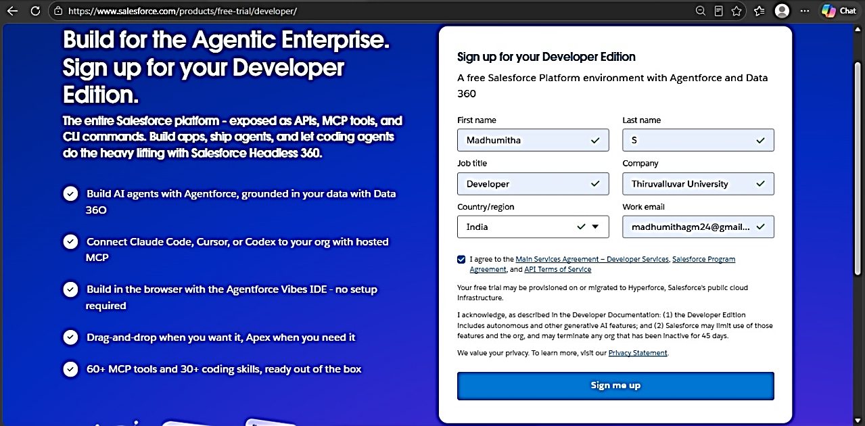

First name & Last name Email
Role: Developer Company: College Name County: India
Postal Code: pin code
Username: should be a combination of your name and company
This need not be an actual email id, you can give anything in the format: username@organization.com
Click on sign me up after filling these

Activity 2: Account Activation:
- Go to the inbox of the email that you used while signing up. Click on the verify account to activate your account. The email may take 5-10mins.
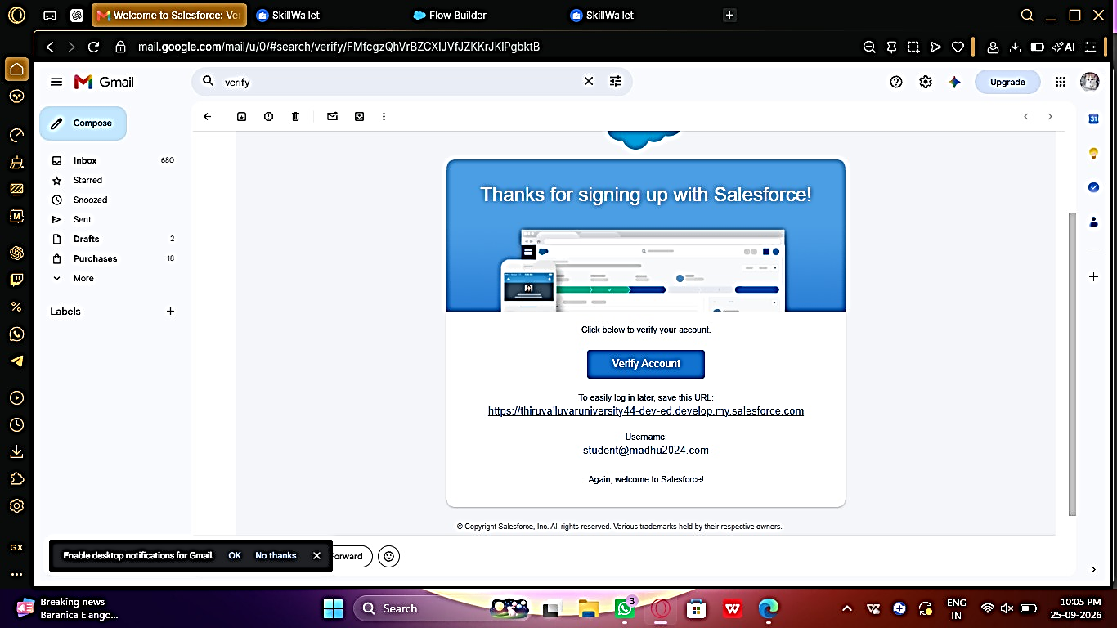
- Click on Verify Account
- Give a password and answer a security question and click on change password.
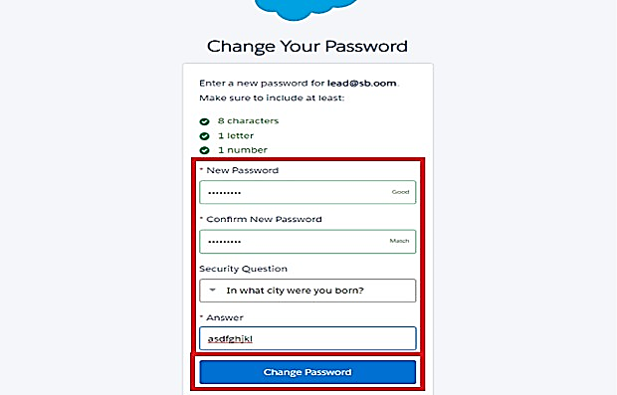

- Then you will redirect to your salesforce setup page.
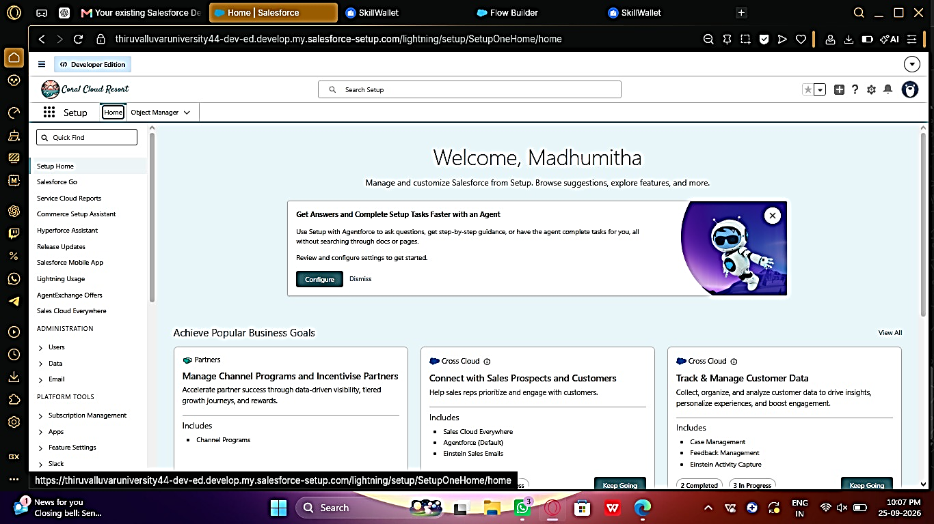

Milestone 2 – Objects:

Activity 1: Creating Student Object:
The purpose of creating the student custom object is to store and manage information about students such as their personal details, contact information, and enrollment status.
To create the student object:
Go to the Setup page. Click on Object Manager.
Click on Create → Custom Object.
Enter the details as below:
- Label: Student
- Plural Label: Students
- Object Name: Student
- Record Name: Student Name
- Data Type: Text
- Under Optional Features, select:
- Allow Reports
- Allow Activities (optional but recommended)
- Track Field History (optional, if you want)
- Under Search Status, select:
- Allow Search
- Click Save.
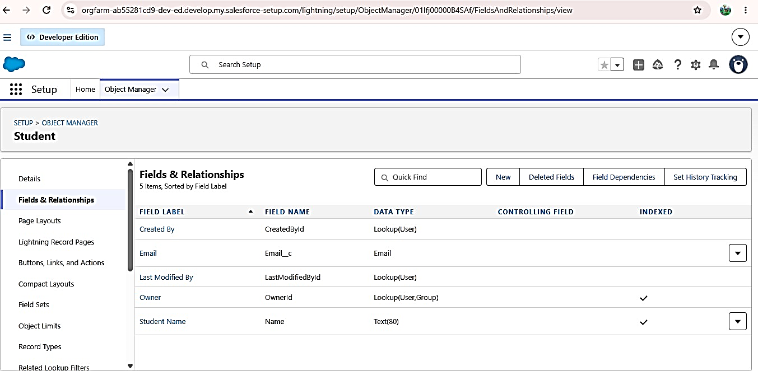
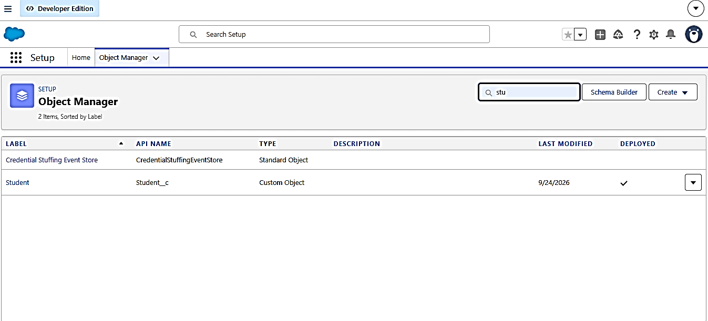

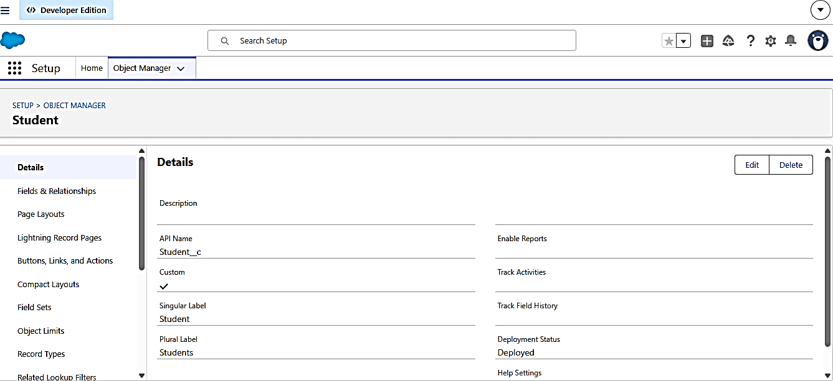

In the same way Create Courses, Instructors, and Enrolments objects

Milestone 3 - Fields:

Table 1: Student Object Fields:
Field Label | Data Type
Student Name | Text (Standard)
Email | Email
Phone | Phone
Date of Birth | Date
Student Status | Picklist
Address | Text Area

Table 2: Course Object Fields:
Field Label | Data Type
Course Name | Text (Standard)
Category | Picklist
Duration | Number/Text
Course Fee | Currency
Description | Text Area

Table 3: Instructor Object Fields
Field Label | Data Type
Instructor Name | Text (Standard)
Instructor Code | Text
Expertise | Picklist
Phone | Phone
Email | Email

Table 4: Enrollment Object Fields:
Field Label | Data Type
Student | Lookup (Student)
Course | Lookup (Course)
Instructor | Lookup (Instructor)
Enrollment Date | Date
Enrollment Status | Picklist
Fees Paid | Checkbox
Total Amount | Currency
Comment s | Text Area

Milestone 4 – Create Relationships:

Activity 1: Create Lookup from Enrollment to Student:
Go to Setup → click Object Manager.
- Type Enrollment in Quick Find → click Enrollment c object.
- Click Fields & Relationships → click New.
- Select Lookup Relationship → click Next.
- For Related To, select Student c → click Next.
- Enter Field Label: Student (API Name: Student c).
- Click Next through Field-Level Security and Layout options (ensure it’s visible and added to layout).
- Click Save.

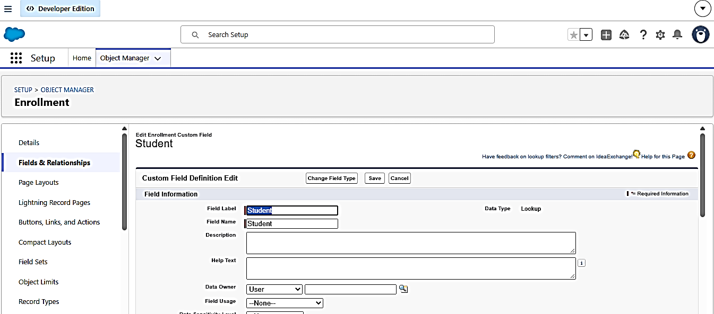

Activity 2: Create Lookup from Enrollment to Course
Purpose:
To link each Enrollment to a Course.
Steps:
- Go to Setup → Object Manager → Enrollment c.
- Click Fields & Relationships → New.
- Select Lookup Relationship → Next.
- Related To: select Course c → click Next.
- Field Label: Course (API Name: Course c).
- Click Next (set visibility and layout) → Save.
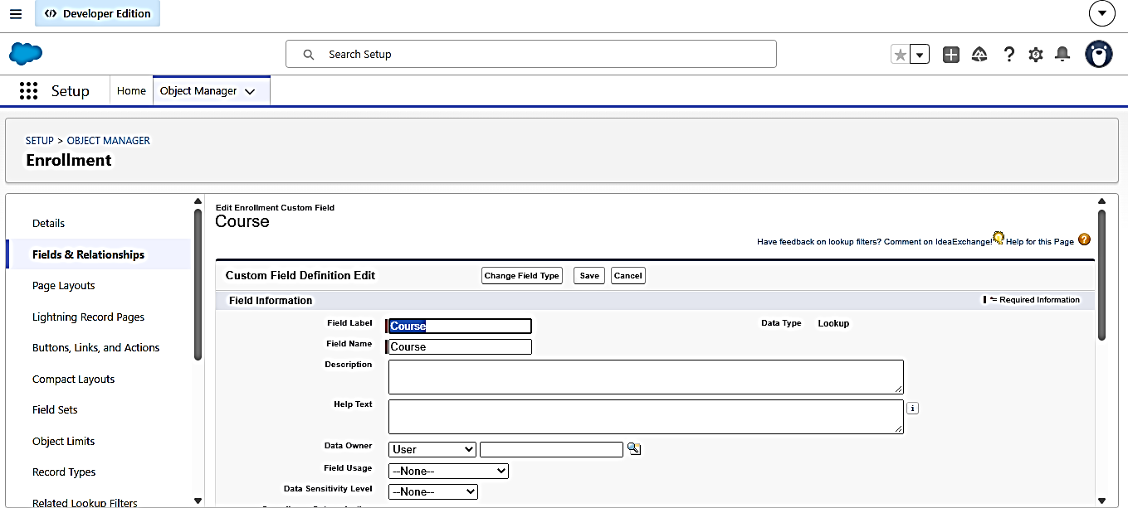

Activity 3: Create Lookup from Enrollment to Instructor:
Purpose:
To store which Instructor is assigned to a particular Enrollment.
Steps:
- Go to Setup → Object Manager → Enrollment c.
- Click Fields & Relationships → New.
- Choose Lookup Relationship → Next.
- Related To: select Instructor c → Next.
- Field Label: Instructor (API Name: Instructor c).
- Complete Field-Level Security and Page Layout options → Save.

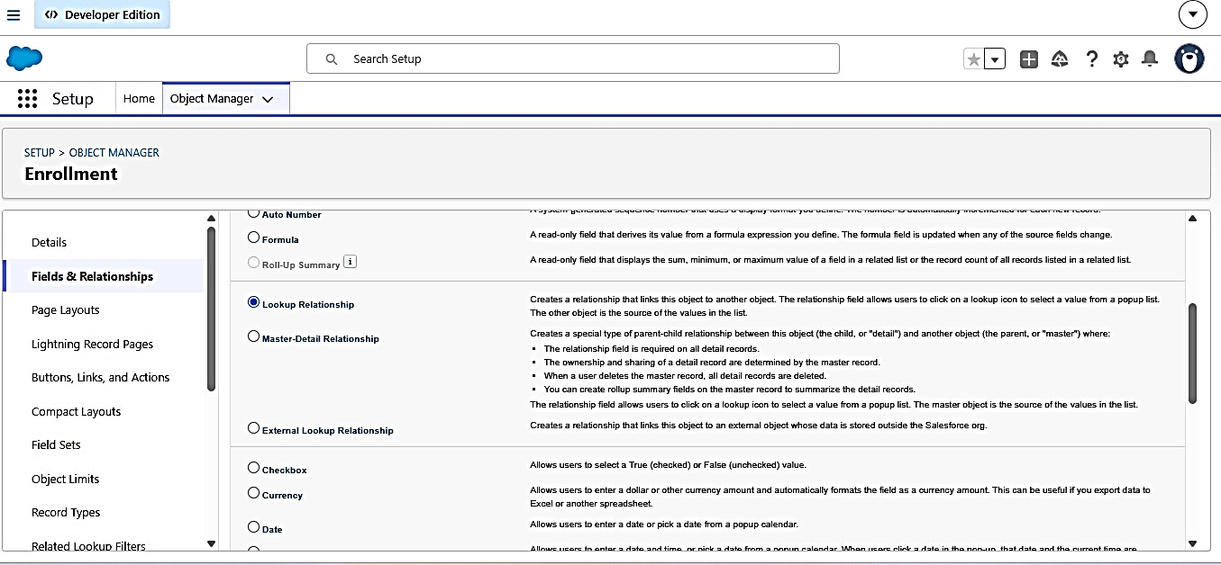

Milestone 5 – Validation Rules:

Activity 1: Student Email Domain Validation
Purpose:
To ensure students use only allowed institutional email addresses. Steps:
Go to Setup → Object Manager → Student c. Click Validation Rules → New.
Rule Name: Student Email Domain Validation. Error Condition Formula: (example for @student.edu)
- NOT (CONTAINS (Email c, "@student.edu"))

Error Message: Email must be a valid student institutional email. Error Location: Field → Email c.
Click Save.

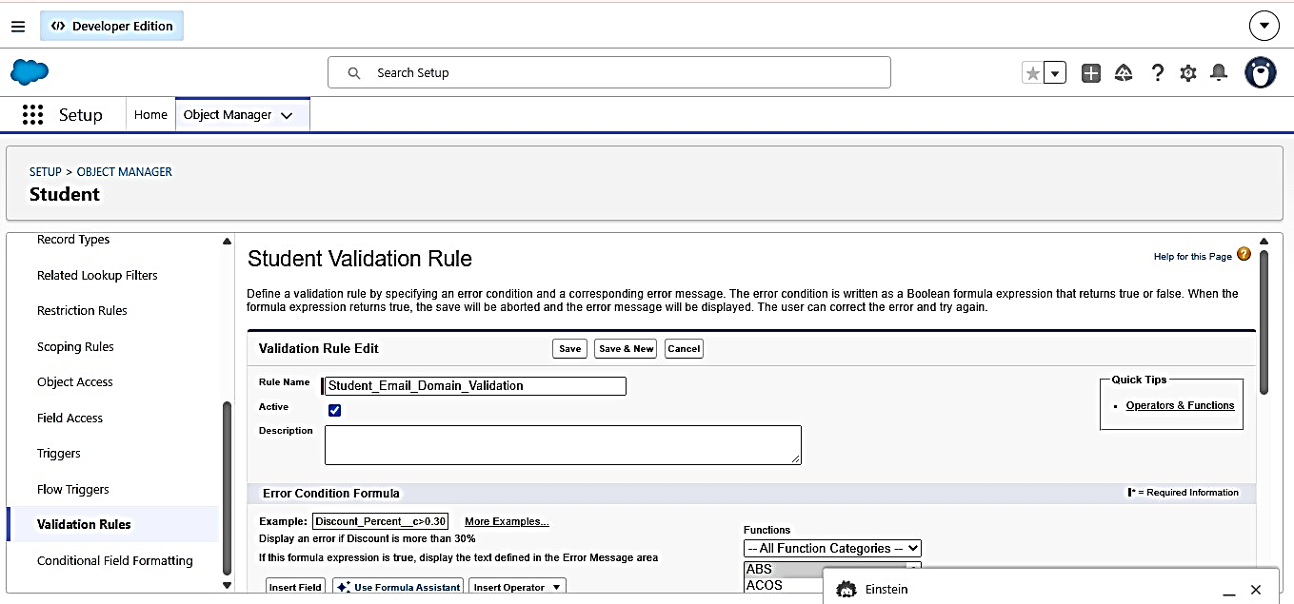
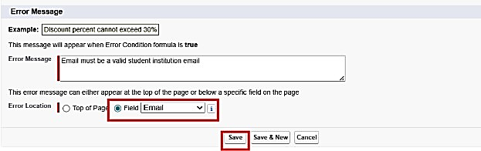

Activity 2: Fees Must Be Paid Before Approval
Purpose:
Prevent Enrollment from being approved until fees are paid. Steps:
- Go to Setup → Object Manager → Enrollment c.
- Click Validation Rules → New.
- Rule Name: Fees_Must_Be_Paid_Before_Approval.
- Error Condition Formula:
AND (
ISPICKVAL (Enrollment_Status c, "Approved"),
Fees Paid c = FALSE)
- Error Message: Fees must be paid before approving an enrollment.
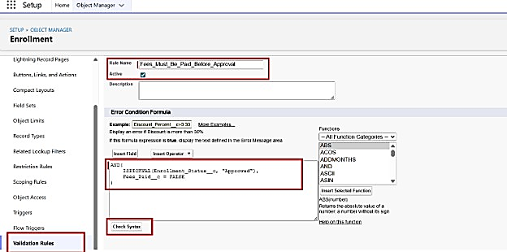
- Error Location: Top of Page (or field as needed). Click Save.

Milestone 6 – Approval Process

Activity 1: Create Approval Process for Enrollment Requests
Purpose:
Route Enrollment requests to the Training Manager for approval or rejection.
Steps:
- Go to Setup → Approval Processes → select Enrollment c.
- Click Create New Approval Process → Use Standard Setup.
- Process Name: Approval Enrollment Request.
- Entry Criteria: Enrollment_Status c = "Requested".
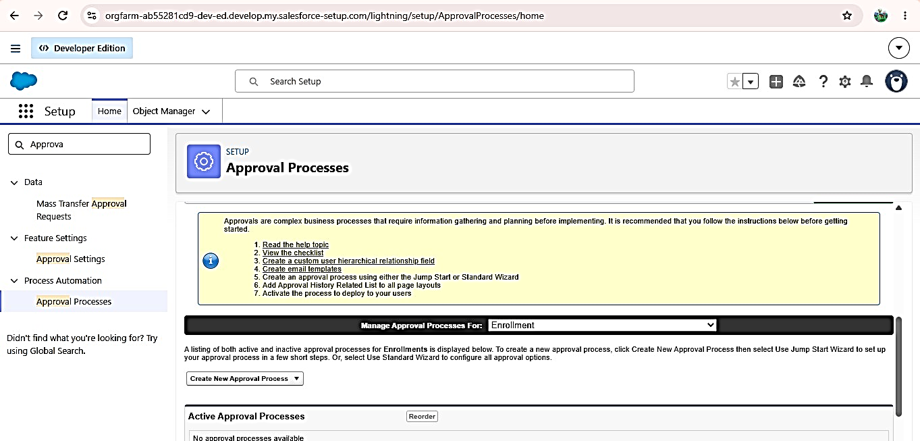
- Save and configure steps.
- Add Approval Step:
- Approver: specific Training Manager user.
- Under Final Approval Actions:
- Add Field Update to set Enrollment_Status c = "Approved".
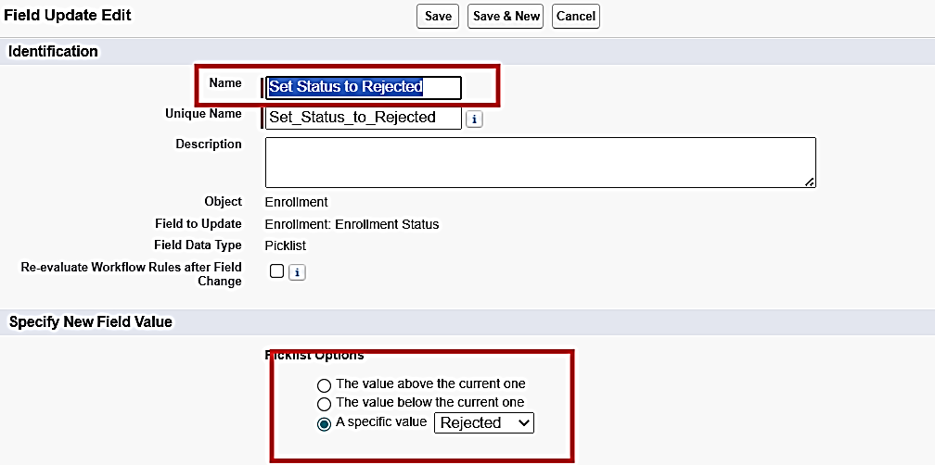
- Under Final Rejection Actions:
- Add Field Update to set Enrollment_Status c = "Rejected".

- Add Email Alert to send rejection email to student.
- Activate the approval process.

Milestone 7- Tabs

Activity 1: Creating a Tab for the Student Object:
Go to Setup.
- In the Quick Find box, type Tabs.
- Under Custom Object Tabs, click New.
- Select Student from the object list.
- Choose a tab style (icon).
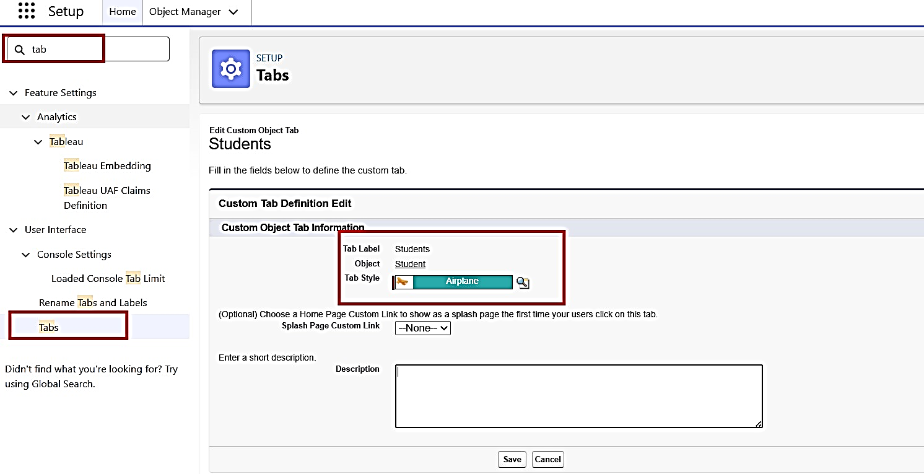
- Click Next, assign it to all profiles, and then click Save.

Activity 2: Creating Remaining Tabs
Now create the Tabs for the remaining Objects, they are “Courses, Instructors, Enrollment”.
Follow the same steps as mentioned in Activity -

Milestone 8 - The Lightning App

Activity 1: Creating the Lightning Application for the Project
Navigate to Setup.
Enter App Manager in the Quick Find search box. Click New Lightning App.
Provide the app details:
App Name: Student Enrollment & Course Management Developer Name auto-fills
Description: Optional, but can describe the purpose of the app Click Next and choose the following settings:
App Branding (optional): Add logo or select color theme Navigation Style: Choose Standard Navigation
Click Next and assign the app to specific profiles (e.g., Admin, Enrollment Officer, Instructor).
Click Next to select the items (tabs) to be included in the app. Add:
- Student
- Course
- Instructor
- Enrollment
- Reports
- Dashboards
- Home
- Tasks
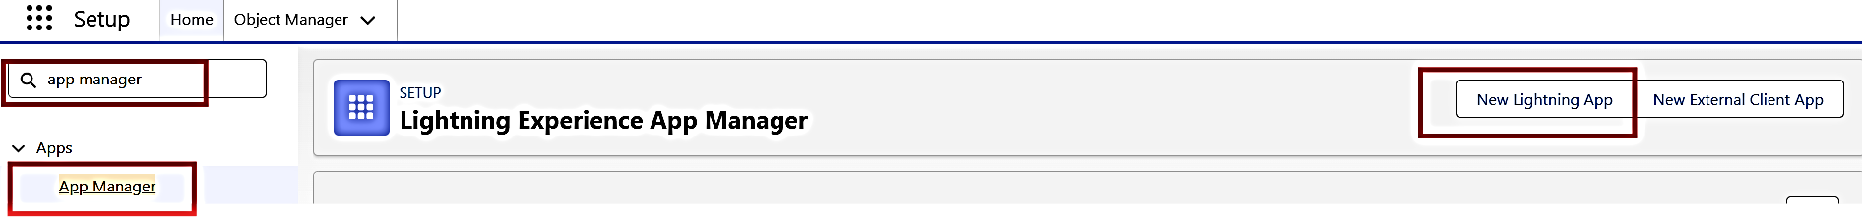
Click Next and review the app settings. Finally, click Save & Finish.

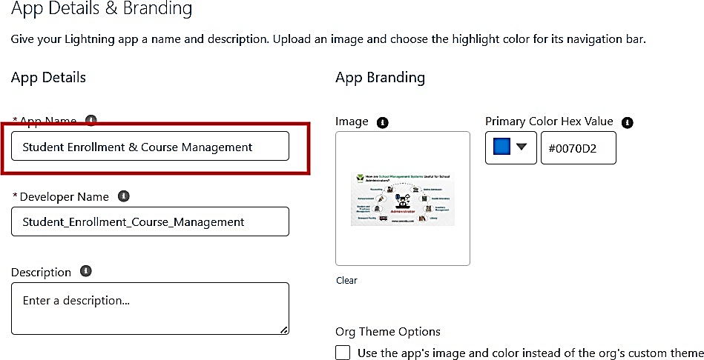

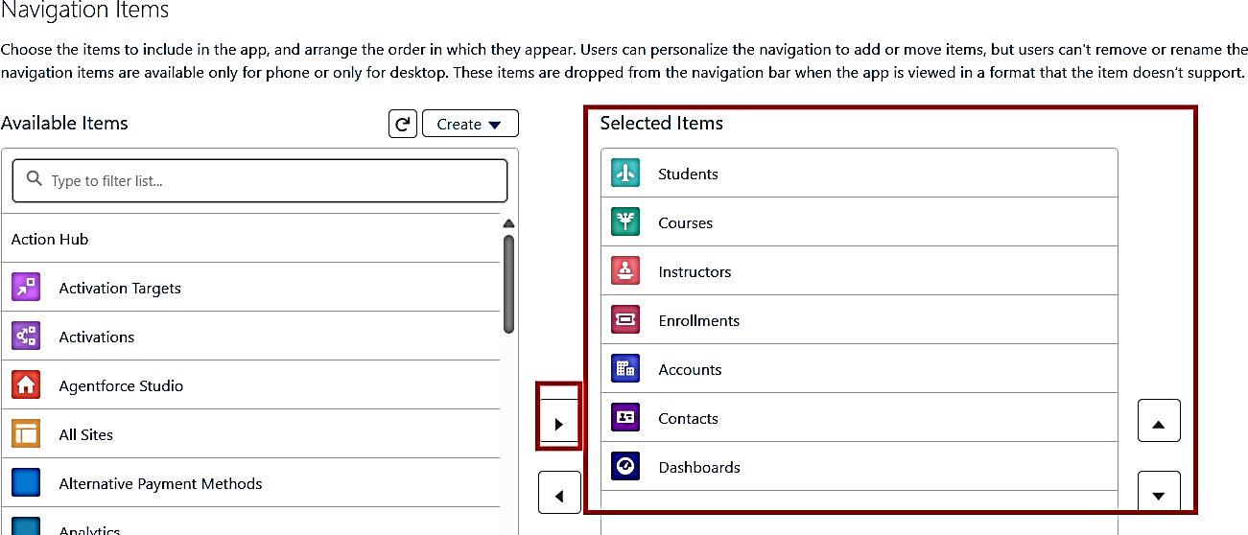

Milestone 9 – Page Layouts and Record:

Activity 1: Create Record Types for Enrollment:
Purpose:
To separate New Enrollment vs Re-Enrollment processes. Steps:
- Go to Setup → Object Manager → Enrollment c.
- Click Record Types → New.
- For the first record type:
- Existing Record Type: Master
- Record Type Label: New Enrollment
- Enable for required profiles (Admin, Enrollment Officer).
- Select the default Page Layout → Save & New.
- For the second record type:
- Record Type Label: Re-Enrollment
- Enable for the same profiles.
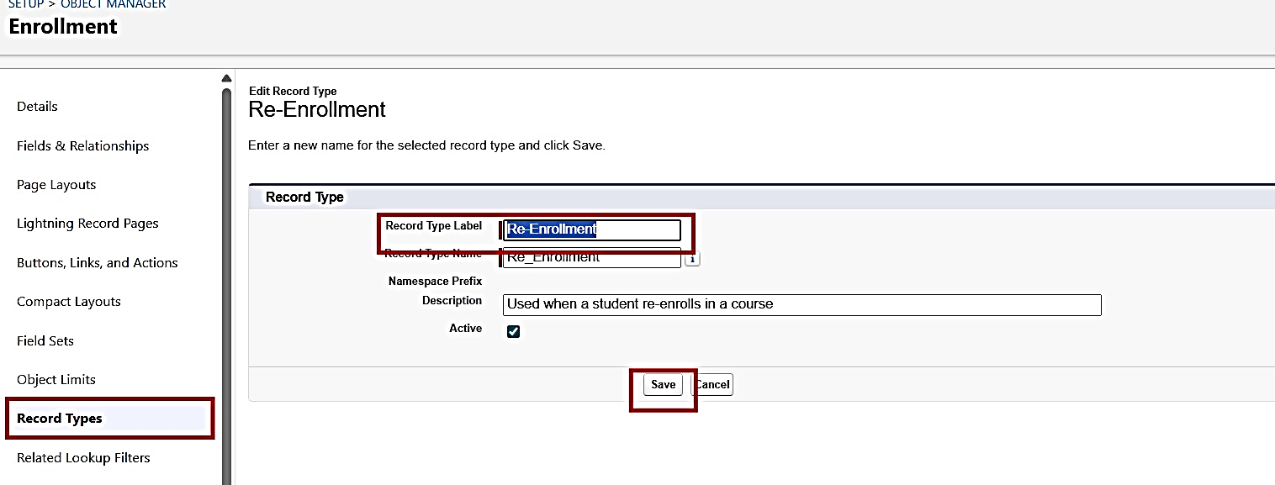
- Select the default Page Layout → Save.
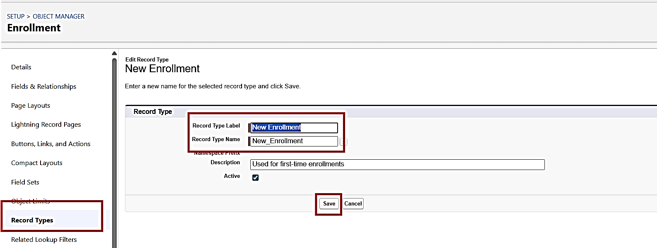

Activity 2: Separate Page Layout Creators for Each Enrollment Record Type
Purpose:
To show different fields for New Enrollment vs Re-Enrollment. Steps:
- Enrollment c object → click Page Layouts.
- Click New to create a layout for New Enrollment:
- Clone from existing Enrollment Layout → name it New Enrollment Layout → Save.
- Keep fields relevant for first-time enrollment: Student, Course, Instructor, Enrollment Date, Status, Fees, etc.
- Remove unnecessary re-enrollment fields if any.
- Click Save.
- Again, click New to create Re-Enrollment Layout:
- Clone existing layout → name it Re-Enrollment Layout → Save.
- Include fields like previous Enrollment reference (if any), Re-Enrollment Reason, Status, Fees, et
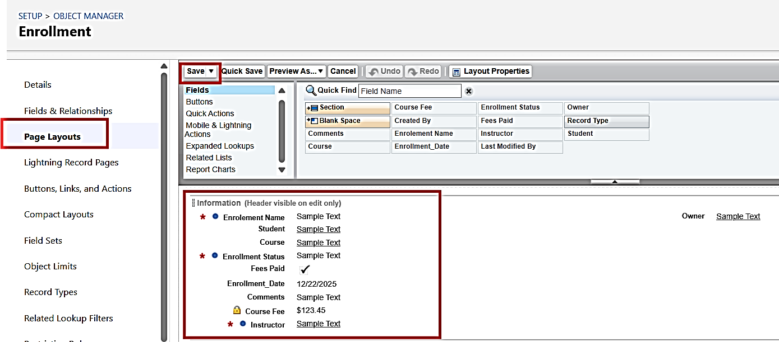
- Click Save
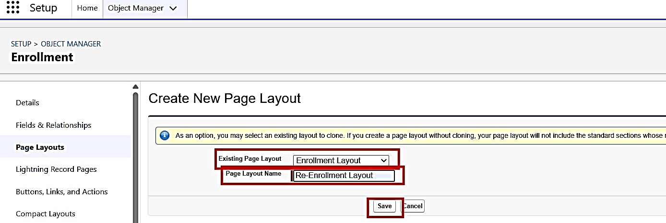

- Click Page Layout Assignment → Edit Assignment.
- For each profile and record type:
- New Enrollment → use New Enrollment Layout.
- Re-Enrollment → use Re-Enrollment Layout. Click Save.

Activity 3: Enrollment R Add Elated Lists to Parent Objects:
Purpose:
To see all Enrollments from Student, Course, and Instructor records.
- Student → Enrollment Related List
Go to Setup → Object Manager → Student c.
Click Page Layouts → open the main layout.
In the palette, select Related Lists.
Drag Enrollments related list onto the layout. Customize columns if needed → Save.
- Course → Enrollment Related List
Go to Object Manager → Course c → Page Layouts. Open layout → add Enrollments related list.
Save.
- Instructor → Enrollment Related List
Go to Object Manager → Instructor c → Page Layouts. Open layout → add Enrollments related list.
- Save.

Milestone 10 – Automation with Flow

Activity 1: Auto-Populate Enrollment Date (Record-Triggered Flow)
Purpose:
Set Enrollment Date c to today when Enrollment is created. Steps:
- Go to Setup → Flows → New Flow.
- Select Record-Triggered Flow → Create.
- Object: Enrollment c.
- Trigger: A record is created.
- Optimize for Actions and Related Records → Done.
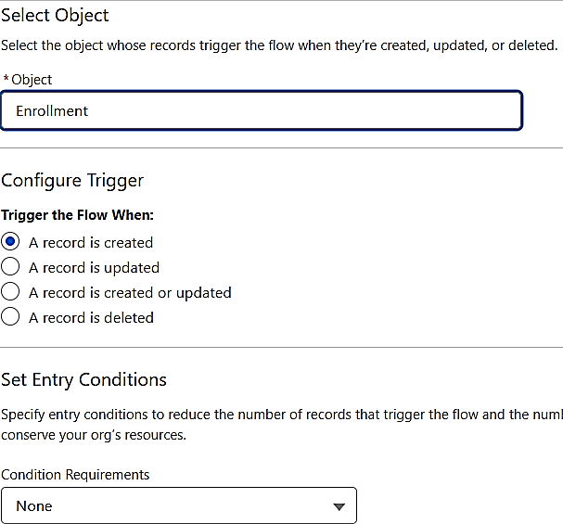

- Add Update Records element:
- Label: Set Enrollment Date.
- Use a record that triggered the flow.
- Field: Enrollment Date c → Value: $ Flow Current Date.
- Save as Set Enrollment Date → Activate.

Activity 2: Send Email When Enrollment Approved
Purpose:
When Enrollment_Status c = Approved, send email, alert admin, and set Student to Active.
Steps (high level for document):

- Create Email Template and Email Alert for student notification.
- Go to Flows → New → Record-Triggered Flow.
- Object: Enrollment c, Trigger on update.
- Condition: Enrollment_Status c Equals "Approved"
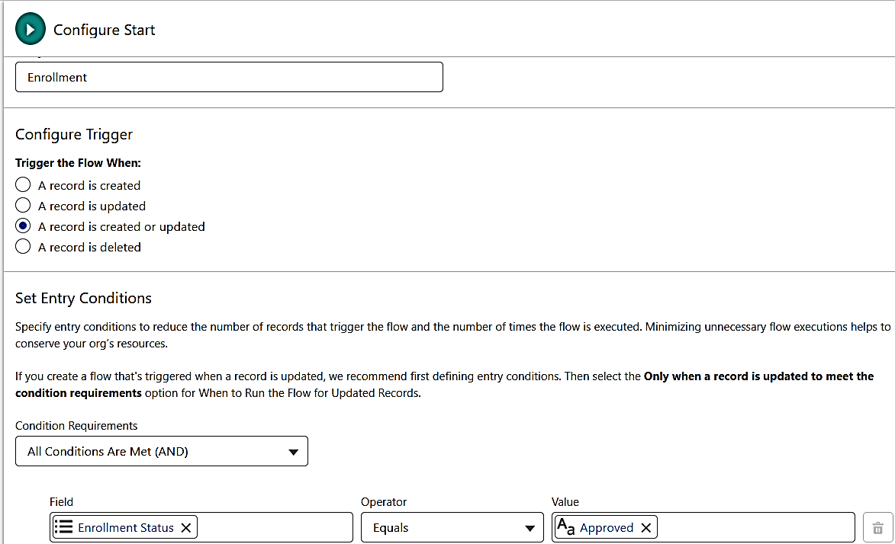

- Add Get Records to fetch related Student c.
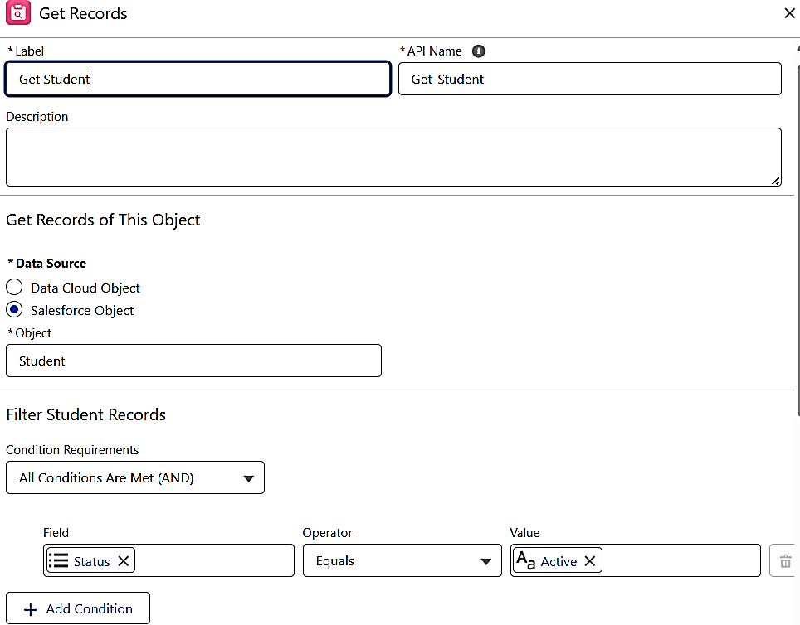

- Add Action (Email Alert) to send email to student.
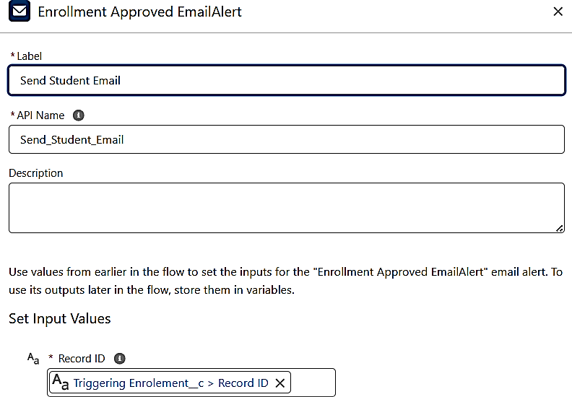
- Add Action to notify Admin if needed.
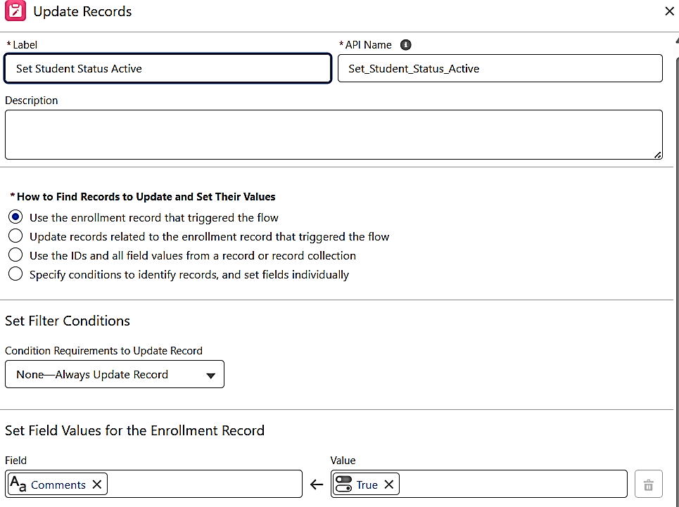
- Add Update Records to set Student c_________ Status c = "Active".

- Save as Enrollment Approved Action → Activate.

Activity 3: Auto-Assign Instructor Based on Course Category
Purpose:
Assign Instructor automatically based on Course category. Rules:
Technical → Instructor A Language → Instructor B Non-Technical → Instructor C
Steps:
- Prepare Instructor c records with codes (e.g., INSTR_A, INSTR_B, INSTR_C).
- Create Record-Triggered Flow on Enrollment c (created/updated).
- Add Get Records to fetch related Course c.
- Add Decision element on Course r. Category c:
- Technical / Language / Non-Technical outcomes.
- For each outcome:
- Get Instructor record (A/B/C) based on code or name.
- Update Records: set Instructor c = Get Instructor X. Id.
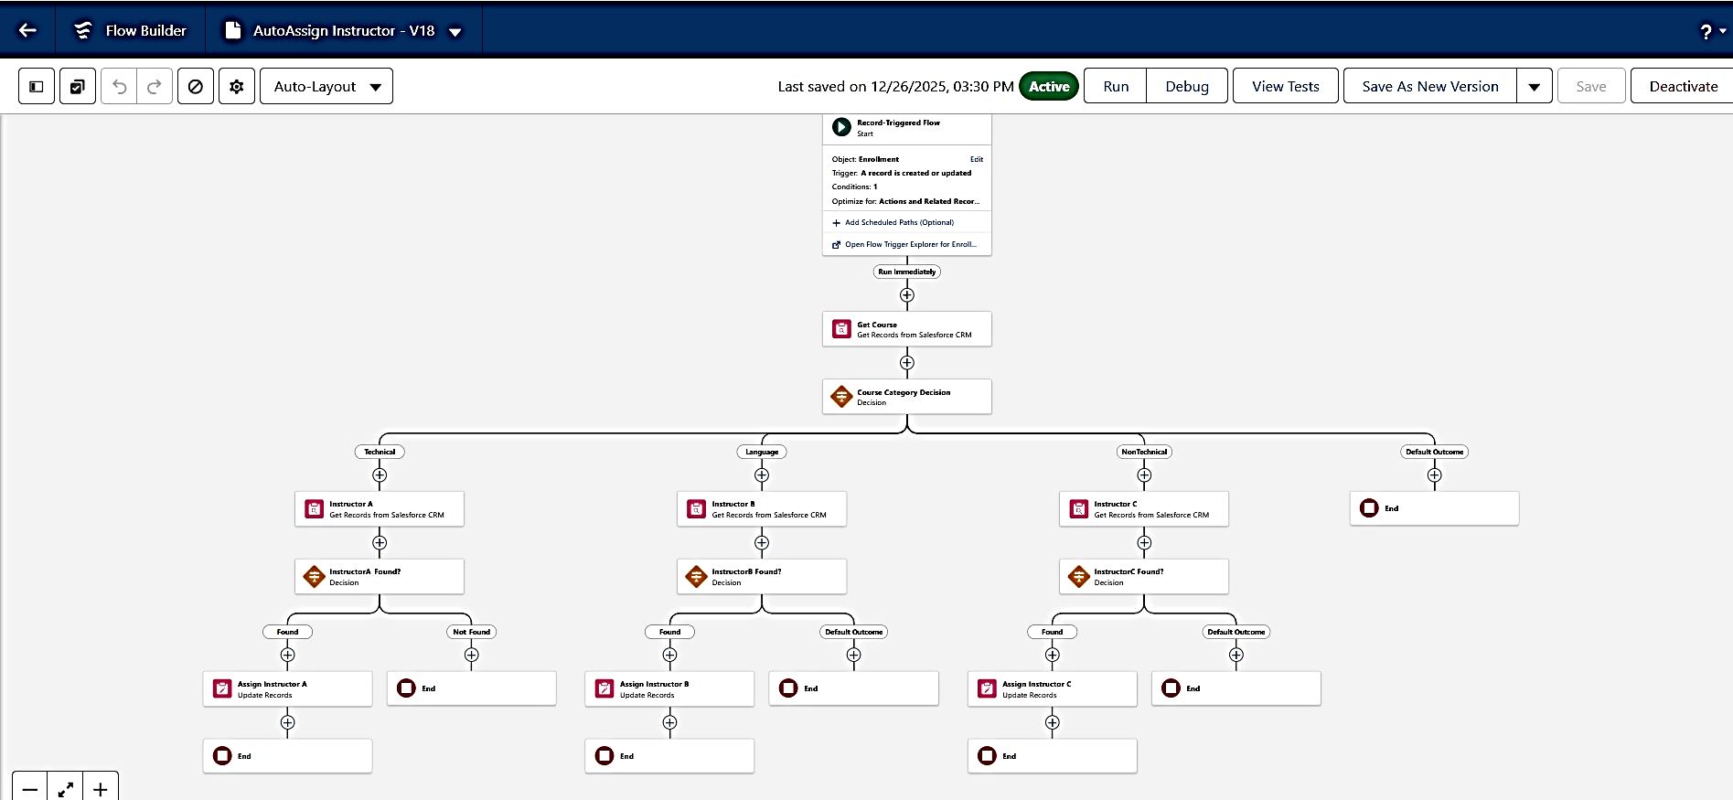
- Save as Auto Assign Instructor → Activate.

Activity 4: Auto-Create Task for Follow-Up
Purpose:
When Enrollment is “Requested”, create a follow-up task for Admin. Steps:
- Create Record-Triggered Flow on Enrollment c.
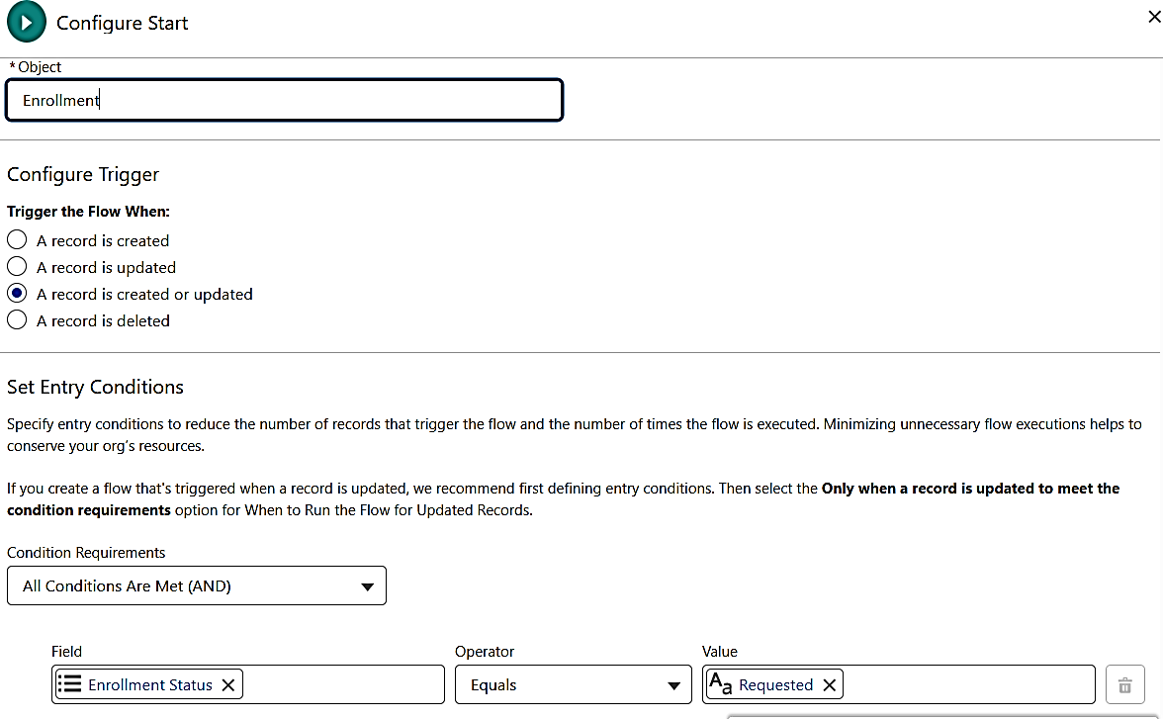
- Trigger: Record created or updated; condition Enrollment_Status c"Requested".

- Add Get Records to fetch Admin user (by Username / Profile).
- Add Formula (Date): TODAY () + 2 for due date.
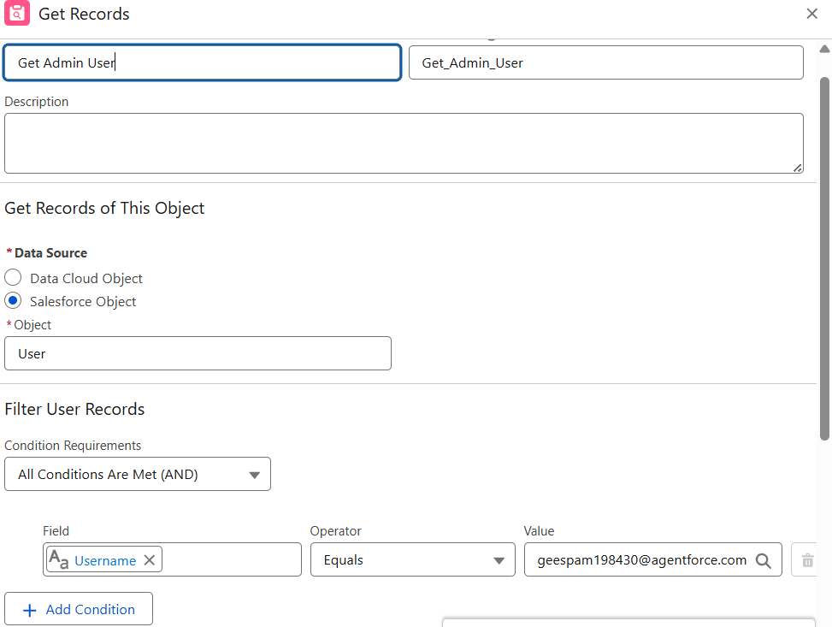

- Add Create Records for Task:
- Subject: Follow up on enrollment request.
- Owner Id: Admin user Id.
- What Id: Enrollment Id.
- ActivityDate: formula Today + 2.
- Save as Create Follow up Task → Activate.

Milestone 11 – Reports:

Activity 1: Create “Students by Status” Report
- Go to Reports → New Report.
- Report Type: Students.
- Group rows by Status c.
- Add columns as needed (Name, Email, Phone).
- Save as Students by Status.

Activity 2: Create “Enrollments by Course” Report
- New Report → Report Type: Enrollments.
- Group rows by Course r. Name.
- Show Record Count per course.
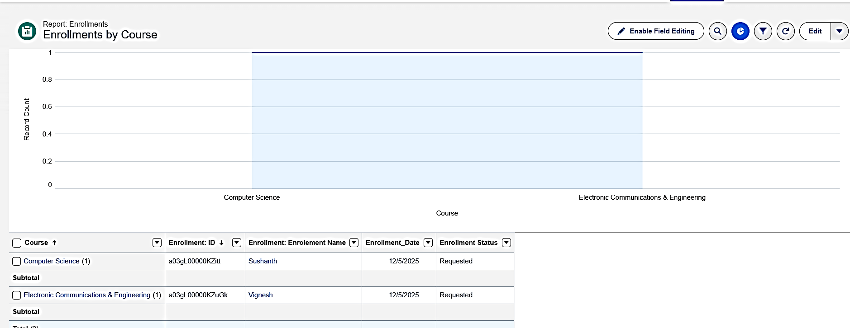
- Save as Enrollments by Course

Activity 3: Create “Pending Enrollment Approvals” Report
  - New Report → Enrollments report type.
  - Filter: Enrollment_Status c = "Requested".
  - Add columns (Student, Course, Owner, Created Date).
  - Save as Pending Enrollment Approvals.
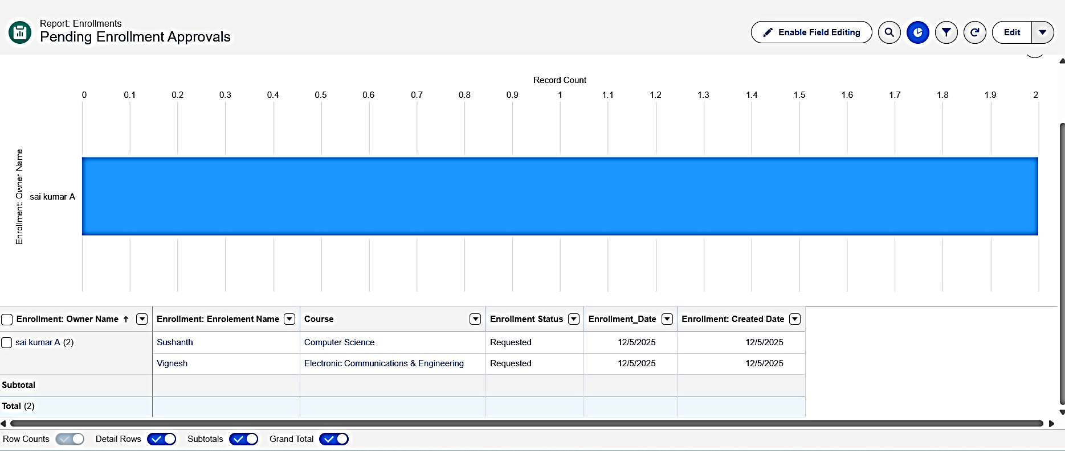

Activity 4: Create “Revenue Report (Fees Paid)” Report
- New Report → Enrollments report type.
- Filter: Fees_Paid c = TRUE.
- Group by Course r.Name.
- Summarize Course_Fee c or similar fee field.
- Save as Revenue Report – Fees Paid.

Milestone 12 – Dashboards:

Activity 1: Create “Student Management Dashboard”
Steps:

- Go to Dashboards → New Dashboard.
- Name: Student Management Dashboard.
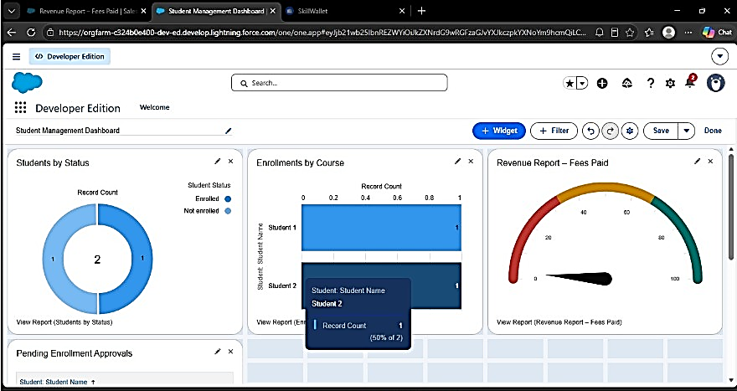
- Select folder → Create.
- Select the new Dashboard folder and Save
Add components:
  - Donut Chart → using Students by Status report.
  - Bar Chart → using Enrollments by Course report.
  - Gauge → using Revenue Report – Fees Paid (sum of revenue field).
  - Table → using Pending Enrollment Approvals report.
- Arrange components on canvas.
Click Save → Done.

Milestone 13 – Security Setup

Activity 1: Configure Profiles):
- Go to Setup → Profiles → New (or CloneProfiles Required:
- Admin – Full access.
- Enrollment Officer – Create/Update Enrollments.
- Instructor – Read-only access to assigned Enrollments.
- Steps (example for Enrollment Officer fName: Enrollment Officer.
- In Object Settings:
- Enrollment c: Read, Create, Edit.
- Student c / Course c: Read (and Edit if required).
- Save.
Repeat similarly for Instructor profile with Read-Only on Enrollments.
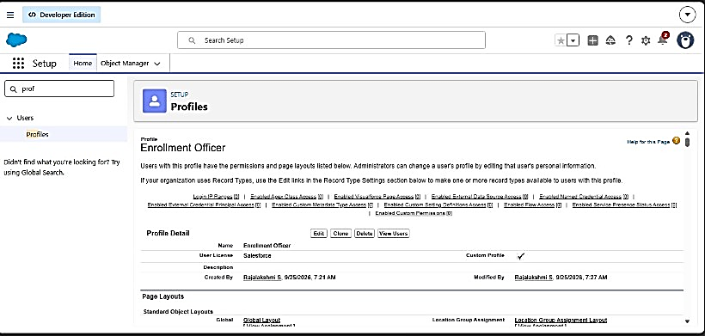
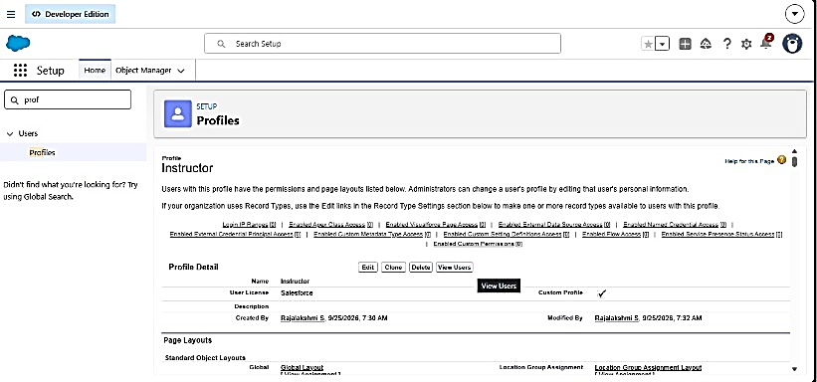

Activity 2: Create Permission Sets
- Go to Setup → Permission Sets → New.
- Create Custom Object Access (additional access to project objects if needed).
- Create Dashboard Editor (Create/Customize Reports & Dashboards permissions).
- Assign to relevant users.

Activity 3: Configure Sharing & OWD
Steps:
- Go to Setup → Sharing Settings.
- Set Organization-Wide Defaults:
- Students (Student__c): Public Read/Write.
- Courses (Course__c): Public Read/Write.
- Enrollments (Enrollment__c): Private.
- Save.
For Instructor access to assigned Enrollments, optionally:
- Add a User lookup on Enrollment (Instructor User).
Use a simple Record-Triggered Flow to set Owner Id = Instructor User so they can see only their own records

