Student Enrollment & Course Management System (SECMS)

USER STORY:

The Student Enrollment & Course Management System is a comprehensive Salesforce application designed to streamline and automate the academic enrollment operations of an educational institute. This system enables administrators, enrollment officers, and instructors to efficiently manage student records, course offerings, enrollments, instructor assignments, approval processes, payments, and reporting—all within a unified Salesforce environment.

INTRODUCTION

Project Overview:
This project aims to centralize all student, course, and enrollment-related data within a single Salesforce application to ensure easy data access, structured workflows, and accurate reporting. The system allows Enrollment Officers to manage student admissions, course registrations, and communication effectively, while instructors and administrators gain full transparency into course allocations and academic progress. The solution also enables automated instructor assignment, task creation, validation checks, and multi-level approval processes for enrollment management.
PS | I am (Customer) | I’m trying to | But | Because | Which makes me feel
PS-1 | Enrollment Officer | manage student enrollments efficiently | enrollment data is scattered | systems are manual and unintegrated | frustrated and  error-prone
PS-2 | Administrator | track enrollments and revenue | reporting is delayed | data is not centralized | uncertain in decision-ma king
With Salesforce Flows, Approval Processes, Validation Rules, Reports, and Dashboards, the organization can ensure that all enrollment operations—from admission to course completion—are handled systematically and with continuous monitoring of key performance indicators such as enrollment volume, revenue, student status distribution, and pending approvals.

Purpose:

The primary purpose of SECMS is to replace manual and fragmented enrollment processes with a scalable, automated, and secure Salesforce solution that ensures:
Accurate student data management Structured enrollment workflows Automated approvals and validations Transparent reporting and monitoring

IDEATION PHASE

Problem Statement (Customer Problem Statement Template)
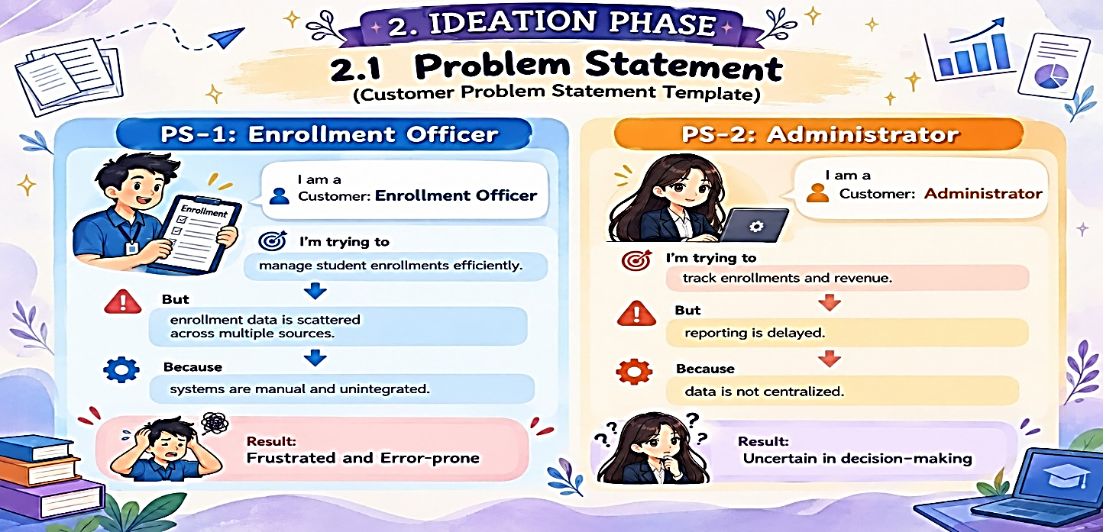

  - Empathy Map Canvas
User Persona: Enrollment Officer
- Think & Feel: Concerned about double bookings and revenue loss
- Hear: Complaints from students and management
- See: Multiple spreadsheets and emails
- Say & Do: Rechecks data, follows up manually
- Pain: Duplicate entries, approval bottlenecks
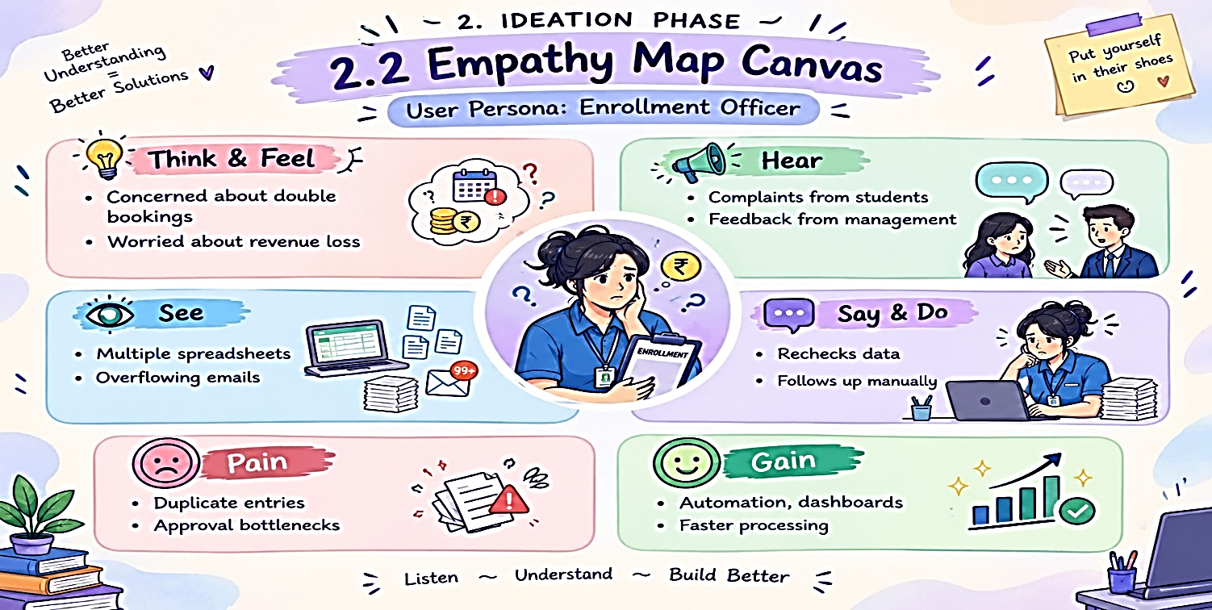
- Gain: Automation, dashboards, faster processing
  - Brainstorming & Idea Prioritization
Step 1 – Brainstormed Ideas
- Spreadsheet automation
- Standalone enrollment portal
- ERP integration
- Salesforce-based enrollment system
Step 2 – Grouping
- Manual solutions
- Semi-automated solutions
- Fully automated cloud solutions
Step 3 – Prioritization
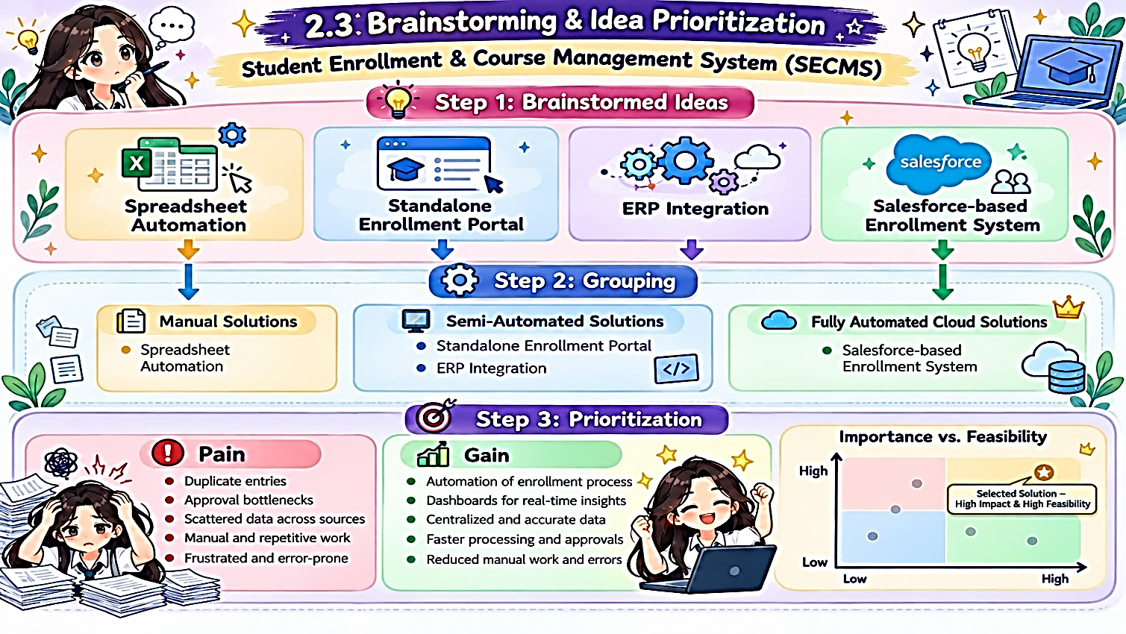
Salesforce-based SECMS was selected due to high feasibility and high impact

