DEEVUH — Entity Relationship Diagram & Schema Specification V3
This document defines the MVP database schema, entity relationships, and core data structures for the Deevuh fashion e-commerce platform.

1. Entity Relationship Diagram (ERD)
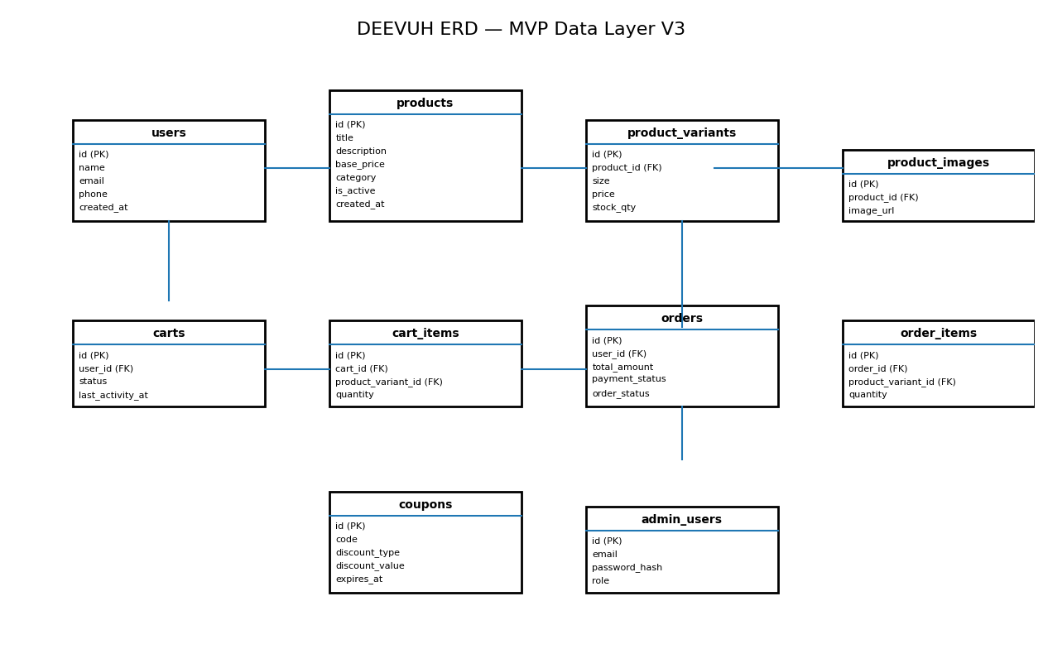

2. Core Database Philosophy
- Lean relational schema optimized for MVP launch
- Supports future scaling without unnecessary complexity
- Normalized structure for maintainability
- Transactional consistency for orders and payments
- Simple operational workflows for admin management

3. Schema Specification

users
Field | Type / Description
id | UUID / PK
name | VARCHAR
email | VARCHAR UNIQUE
phone | VARCHAR
created_at | TIMESTAMP

products
Field | Type / Description
id | UUID / PK
title | VARCHAR
description | TEXT
base_price | DECIMAL
category | VARCHAR
is_active | BOOLEAN
created_at | TIMESTAMP

product_variants
Field | Type / Description
id | UUID / PK
product_id | FK → products.id
size | VARCHAR
price | DECIMAL
stock_qty | INTEGER

product_images
Field | Type / Description
id | UUID / PK
product_id | FK → products.id
image_url | TEXT

carts
Field | Type / Description
id | UUID / PK
user_id | FK → users.id
status | ENUM(active, abandoned, converted)
last_activity_at | TIMESTAMP

cart_items
Field | Type / Description
id | UUID / PK
cart_id | FK → carts.id
product_variant_id | FK → product_variants.id
quantity | INTEGER

orders
Field | Type / Description
id | UUID / PK
user_id | FK → users.id
total_amount | DECIMAL
payment_status | ENUM
order_status | ENUM
created_at | TIMESTAMP

order_items
Field | Type / Description
id | UUID / PK
order_id | FK → orders.id
product_variant_id | FK → product_variants.id
quantity | INTEGER

coupons
Field | Type / Description
id | UUID / PK
code | VARCHAR UNIQUE
discount_type | ENUM
discount_value | DECIMAL
expires_at | TIMESTAMP

admin_users
Field | Type / Description
id | UUID / PK
email | VARCHAR UNIQUE
password_hash | TEXT
role | VARCHAR

4. Relationship Definitions
- One user can have multiple carts
- One cart can contain multiple cart items
- One product can have multiple variants
- One product can have multiple images
- One order can contain multiple order items
- One user can place multiple orders
- Cart items and order items reference product variants
- Coupons can be applied during checkout

5. MVP Optimization Decisions
- No microservice-specific schema separation
- No event-store architecture
- No advanced analytics tables initially
- No Redis-dependent schema logic
- Minimal joins for admin dashboard efficiency

6. Future Expansion Readiness
- Wishlist tables
- Reviews and ratings
- Inventory logs
- Marketing automation
- Loyalty systems
- Advanced analytics events
- Multi-address support
- Shipment tracking

7. Final Technical Direction
The data layer is intentionally designed to remain simple, maintainable, and operationally efficient for the early-stage launch of the Deevuh platform. The schema supports the current business requirements while preserving a clean upgrade path for future scaling.

