DEEVUH — State Machine & Edge-Case Lifecycle Specification V3
This document defines the operational lifecycle states, state transitions, edge-case handling, and business logic behaviors for the Deevuh e-commerce platform.

1. High-Level State Machine
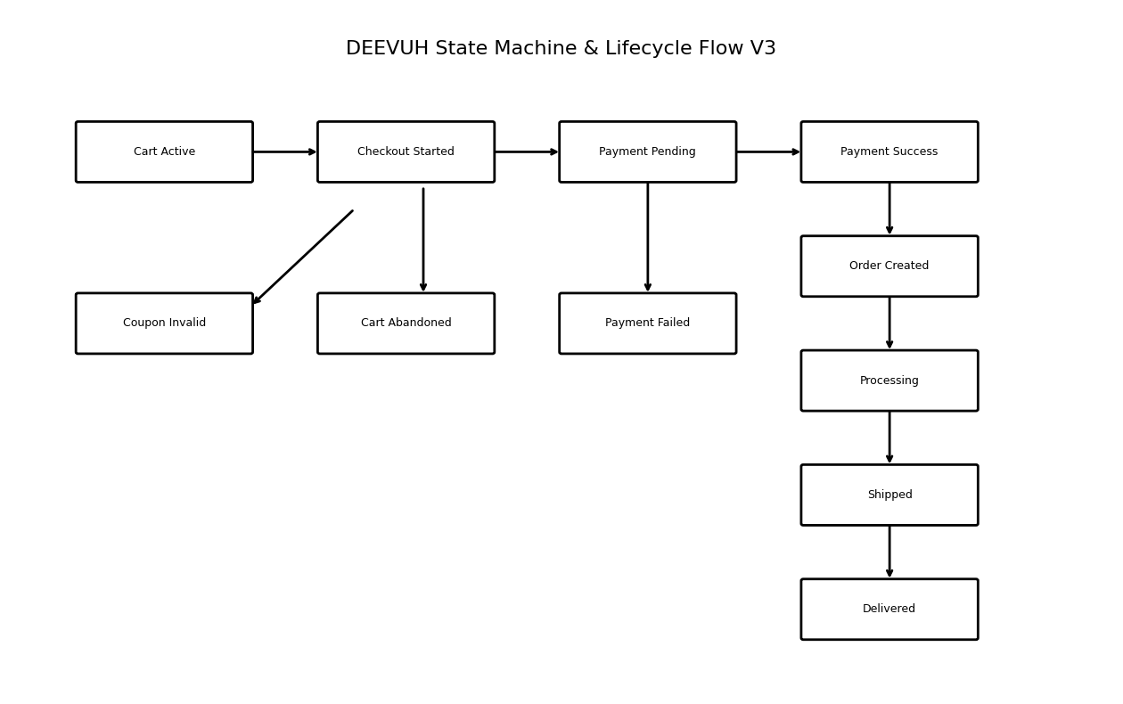

2. Lifecycle Design Philosophy
- Prevent inconsistent order states
- Ensure payment reliability
- Protect against duplicate transactions
- Maintain accurate inventory tracking
- Provide operational visibility for admins
- Gracefully handle failed or interrupted user flows

3. Cart Lifecycle States
State | Description
ACTIVE | User actively interacting with cart
ABANDONED | No checkout completion after inactivity threshold
CONVERTED | Cart successfully converted into order
EXPIRED | Old inactive cart archived/invalidated

4. Checkout Lifecycle States
- Checkout Initiated
- Shipping Details Submitted
- Coupon Validation
- Payment Request Created
- Redirected to PayU
- Awaiting Payment Confirmation

5. Payment State Machine
Payment State | Description
PENDING | Payment initiated but not confirmed
SUCCESS | Payment successfully verified
FAILED | Payment failure
CANCELLED | User cancelled payment
TIMEOUT | Payment session expired

6. Order Lifecycle States
Order State | Description
CREATED | Order successfully generated
PROCESSING | Admin preparing order
SHIPPED | Order dispatched
DELIVERED | Order completed
CANCELLED | Order cancelled
REFUNDED | Payment refunded

7. Edge-Case Handling

Duplicate Payment Webhooks
- Webhook idempotency validation
- Ignore already processed transactions
- Prevent duplicate orders

Payment Success But Order Creation Failure
- Retry order creation
- Log incident
- Admin visibility for manual intervention

Coupon Misuse
- Validate expiry
- Validate usage limits
- Validate minimum purchase amount

Inventory Race Conditions
- Validate stock during checkout
- Re-check stock before order creation

Session Expiry During Checkout
- Persist cart state
- Allow checkout resume

Abandoned Cart Detection
- Track last activity timestamp
- Mark inactive carts automatically

8. Failure Recovery Strategy
- Graceful API error handling
- Retry-safe payment verification
- Admin visibility into failed flows
- Logging for operational debugging
- Webhook retry support

9. State Transition Rules
- Orders cannot move to DELIVERED before SHIPPED
- Payments must be SUCCESS before order confirmation
- Coupons cannot apply after checkout completion
- Cancelled orders cannot transition to PROCESSING
- Abandoned carts cannot directly become DELIVERED

10. Final Operational Philosophy
The lifecycle and state machine architecture prioritizes operational reliability, payment consistency, and clean admin workflows while remaining lightweight enough for an MVP-stage fashion e-commerce platform.

