DEEVUH — System Architecture V3
This document outlines the technical architecture for the Deevuh fashion e-commerce platform. The system is designed as a lean MVP-focused architecture optimized for reliability, low operational cost, maintainability, and future scalability.

1. High-Level Architecture
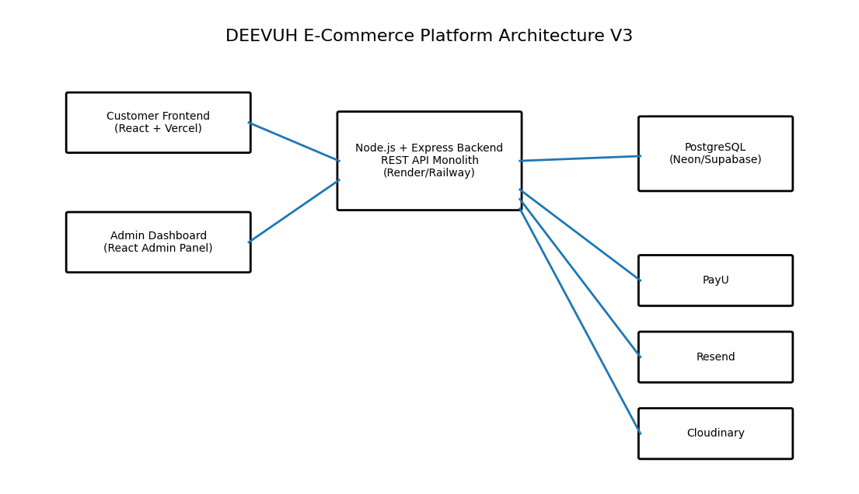

2. Core Architecture Components

Frontend Layer
- React.js-based customer storefront
- Responsive mobile-first UI
- Hosted on Vercel
- SEO-friendly routing
- Optimized image rendering

Admin Dashboard
- React-based admin interface
- Product management
- Order management
- Revenue tracking
- Abandoned cart monitoring

Backend Layer
- Node.js + Express.js monolith
- REST API architecture
- Authentication & authorization
- Payment processing
- Coupon and promo logic
- Cart and order management

Database Layer
- PostgreSQL database
- Hosted on Neon or Supabase
- Transactional consistency
- Relational schema for e-commerce workflows

External Services
- PayU for payment processing
- Resend for transactional emails
- Cloudinary for product image hosting

3. Request Flow
- Customer opens frontend application
- Frontend communicates with backend APIs
- Backend validates requests and business logic
- Backend reads/writes data from PostgreSQL
- Backend communicates with external services when required
- Response returned to frontend
- Frontend updates UI dynamically

4. Hosting Strategy
Component | Hosting/Provider
Frontend Hosting | Vercel
Backend Hosting | Render or Railway
Database Hosting | Neon or Supabase
Image Hosting | Cloudinary
Future Migration Path | DigitalOcean

5. Architecture Philosophy
The architecture intentionally avoids premature complexity such as microservices, Kubernetes, distributed systems, or advanced infrastructure layers. The focus is on shipping a stable, maintainable, and conversion-focused e-commerce platform suitable for an early-stage fashion brand.

6. Future Scalability
- Migration to DigitalOcean infrastructure
- Redis caching layer if traffic increases
- CDN integration
- Advanced analytics
- Search optimization
- Inventory management improvements

