**Under The Guidance Of :**

Mr. Brijendra Pal Singh

November , 2023



**Submitted By :**

Riddhima Rai – 12308762

Deewakar Kumar - 12307482

CSE326

**Online Learning Management System**

**PROJECT REPORT**

**Name :** Riddhima Rai **Name :** Deewakar Kumar

**Registration no :** 12308762 **Registration no:** 12307482

**Roll no:** 19 **Roll no:** 20

**Section :** K23EP **Section :** K23EP

**Creation –** Created with the help of :

* HTML
* CSS
* JAVASCRIPT

**Online Learning Management System [LMS]** - A Learning Management System (LMS) is a software application or platform designed to facilitate the administration, documentation, tracking, reporting, and delivery of educational courses, training programs, or learning and development initiatives. LMSs are used in various settings, such as schools, universities, businesses, and other organizations, to manage and optimize the learning process.

**Website Name – “ COGNITION ”**

**GROUP MEMBERS**

**CREATION**

**TOPIC**

**ASSESSMENT**

**INDEX**

**Table Of Content**

1 **Introduction**…………………………………………………………………………………………………………………………………………….4

2 **Technologies used**……………………………………………………………………………………………………………………………………5

3 **Objective**…………………………………………………………………………………………………………………………………………………6

4 **Features of Project**………………………………………………………………………………………………………………………………….7

5 **Flow of project**………………………………………………………………………………………………………………………………………..8

6 **Screen Shots**……………………………………………………………………………………………………………………………………………9

7 **Conclusion Of Project**…………………………………………………………………………………………………………………………….14

8 **References**……………………………………………………………………………………………………………………………………………..15

**INTRODUCTION**

**Welcome To Cognition**: Elevate Your Learning Experience

Unlock a world of knowledge and elevate your learning journey with Cognition – your gateway to seamless, effective, and personalized online education. At Cognition, we believe in the power of education to transform lives, and we've designed a cutting-edge learning management system to make that transformation accessible to you.

**Why Cognition?**

1. **Intelligent Learning Design**:

Immerse yourself in a learning experience crafted with intelligence. Cognition utilizes advanced algorithms to tailor courses to your unique learning style, ensuring maximum comprehension and retention.

1. **Anywhere, Anytime Access:**

Learning knows no boundaries. With Cognition, access your courses and materials from the comfort of your home, during your commute, or anywhere your journey takes you. Our platform is designed for flexibility to accommodate your busy lifestyle.

1. **Engaging Multimedia Content**:

Say goodbye to mundane lectures. Cognition brings learning to life with interactive multimedia content, engaging videos, and dynamic assessments, making each lesson a captivating experience.

1. **Collaborative Learning Communities :**

Connect with like-minded learners, share insights, and collaborate on projects within our vibrant online community. Cognition fosters an environment where knowledge is not just acquired but shared.

1. **Progress Tracking Analytics :**

Stay on top of your achievements and goals with our intuitive progress-tracking tools. Cognition provides detailed analytics, empowering you to monitor your growth and make informed decisions about your learning journey.

Join us at Cognition and embark on a learning adventure where knowledge meets innovation. Your education is not just a destination; it's a continuous journey of discovery, and we're here to guide you every step of the way.

Start your educational odyssey with Cognition today.

**TECHNOLOGIES USED**

The main tool we used :

* HTML
* CSS
* JAVASCRIPT

**HTML : [Hyper Text Markup Language]**

HTML, or Hypertext Markup Language, is the foundational language of the World Wide Web. It serves as the backbone for creating the structural framework of a webpage. HTML uses a markup system, utilizing tags to define various elements on a web page such as headings, paragraphs, images, links, and more. Each HTML tag encapsulates content, providing browsers with instructions on how to display and organize information.

**CSS : [Cascading Style Sheet]**

While HTML defines the structure of a webpage, CSS (Cascading Style Sheets) takes centre stage in the realm of styling and design. CSS allows developers to control the visual presentation of HTML elements, ensuring a consistent and visually appealing user experience. CSS achieves this through a style rule mechanism. Selectors identify HTML elements, and declarations within the rule specify how those elements should be styled. Properties like colour, font size, margin, padding, and more are used to define the appearance.

**JAVASCRIPT:**

JavaScript, as a crucial part of web development, complements HTML and CSS by adding interactivity, functionality, and dynamism to websites. It enables me to create engaging user experiences and perform various tasks on the client-side.

**OBJECTIVE**

**Objective Of Cognition Learning Management System**

*Empowering Learners, Transforming Education*

At Cognition, our primary objective is to revolutionize the learning experience by providing a dynamic, intelligent, and user-centric platform. Our goals are centered around:

**1. Personalized Learning** :

Tailoring education to individual needs. Cognition strives to understand and adapt to each learner's unique style, pace, and preferences, fostering a personalized learning journey.

**2. Accessibility & Flexibility :**

Breaking down barriers to education. Cognition aims to make learning accessible anytime, anywhere, ensuring flexibility for learners with diverse schedules and commitments.

**3. Engaging Content And Interactivity :**

Transforming information into inspiration. Cognition is committed to delivering engaging multimedia content and interactive assessments, creating an immersive learning environment.

**4. Collaborative Learning Communities :**

Building connections for shared success. Cognition fosters collaborative learning communities, where learners can connect, collaborate, and share knowledge, enhancing the overall educational experience.

**5. Data-Driven Insights:**

Empowering learners and educators with actionable data. Cognition provides robust analytics and progress-tracking tools, offering insights into individual and collective learning achievements.

**6. Continuous Innovation :**

Staying ahead of the educational curve. Cognition is dedicated to continuous improvement, incorporating the latest advancements in learning technology to ensure a cutting-edge platform.

**7. Global Impact :**

Making a difference in education worldwide. Cognition aspires to contribute to the global landscape of education, bridging gaps and fostering a culture of lifelong learning.

With these objectives, Cognition aims to be more than just an LMS; it strives to be a catalyst for positive change in the way we learn, share knowledge, and grow together. Join us on this transformative journey toward a brighter future in education.

1. **User Management**

**User Registration:** Allows users (students, instructors, administrators) to create accounts.

**User Authentication:** Ensures secure access to the system with usernames and passwords.

1. **Course Management**

**Course Creation:** Enables instructors to create and organize courses, modules, and lessons.

**Content Upload:** Allows the uploading of various types of content, such as documents, videos, quizzes, and presentations.

**Course Catalog:** Provides a centralized location for users to browse and enroll in available courses.

1. **Communications & Collaborations**

**Discussion Forums:** Facilitates online discussions among students and instructors.

**Messaging Systems:** Allows direct communication between users.

**Announcements:** Enables administrators and instructors to broadcast important information to users.

1. **Assessment & Evaluation**

**Quizzes and Exams:** Supports the creation and administration of assessments.

**Grading:** Automates the grading process and provides feedback to learners.

**Progress Tracking:** Allows learners to track their progress and completion status.

1. **Reporting & Analytics**

**User Progress Reports:** Generates reports on individual and overall course progress.

**Assessment Analytics:** Provides insights into quiz and exam performance.

**Attendance Tracking:** Monitors user attendance and participation.

1. **Update & Support**

**Regular Updates:** Ensures the LMS stays current with technology and security standards.

**Technical Support:** Provides assistance to users in case of issues or inquiries.

**FEATURES OF PROJECT**

**Riddhima Rai**

* Login Page
* Registration Page
* Booking Demo Class Page
* Home Page
* About Page

**Deewakar Kumar**

* Student Page
* Contact Us Page
* Footer Section
* Navbar
* Course Page

**FLOW OF PROJECT**

**Screen Shots of Project**

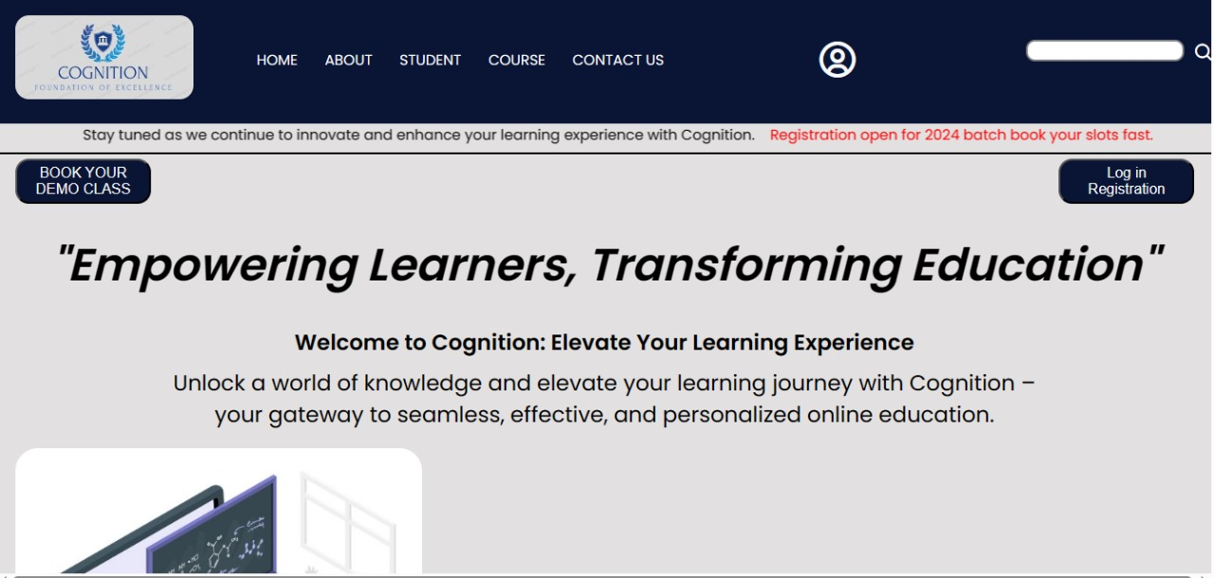

**HOME PAGE**

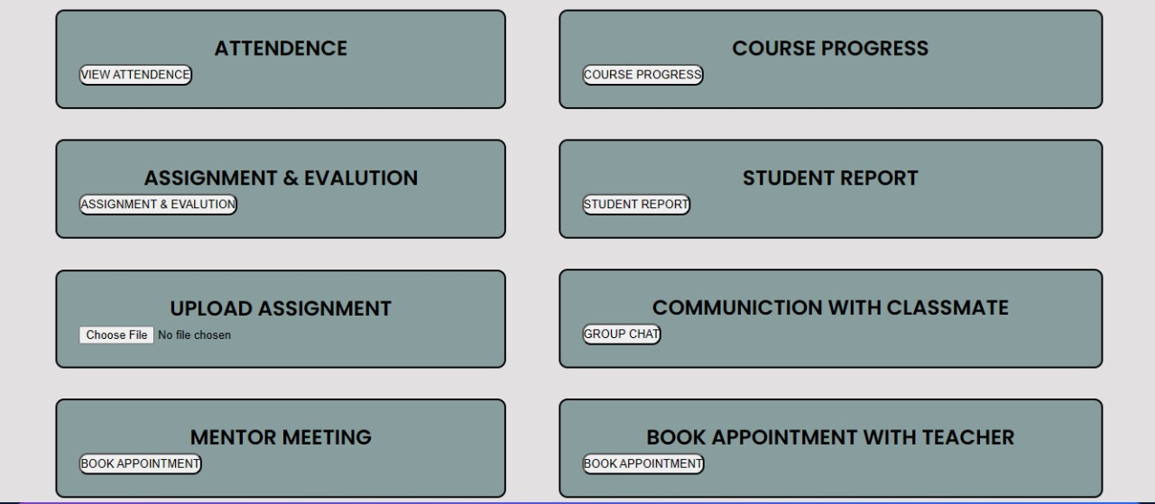

**STUDENT PORTAL PAGE**

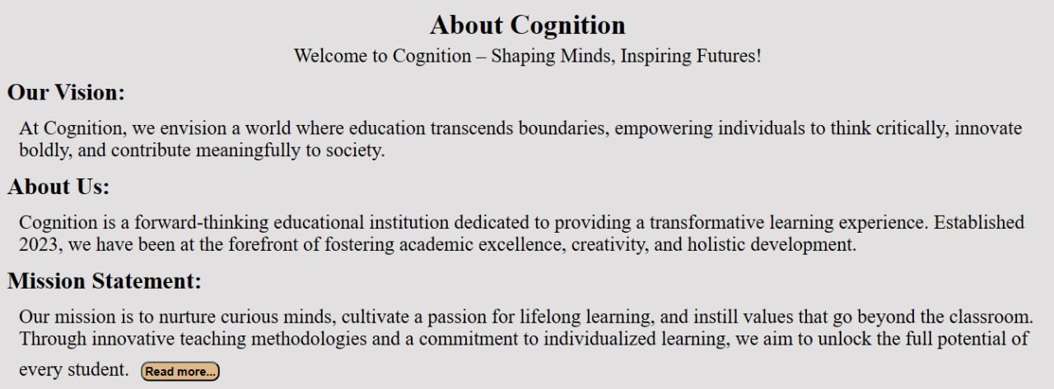

**ABOUT PAGE**

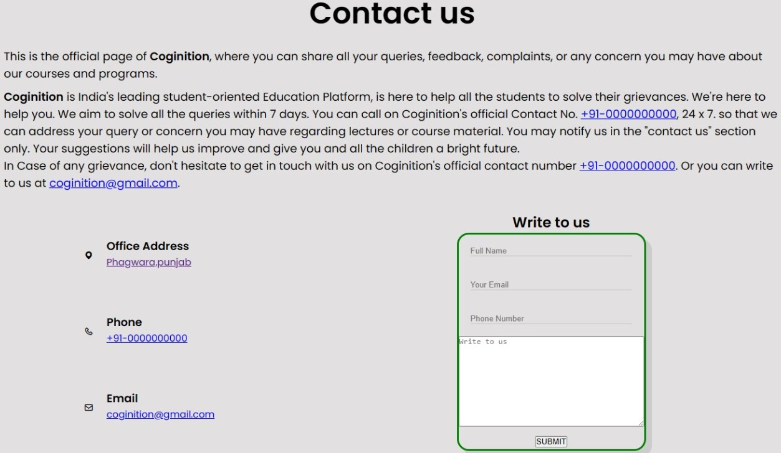

**CONTACT PAGE**

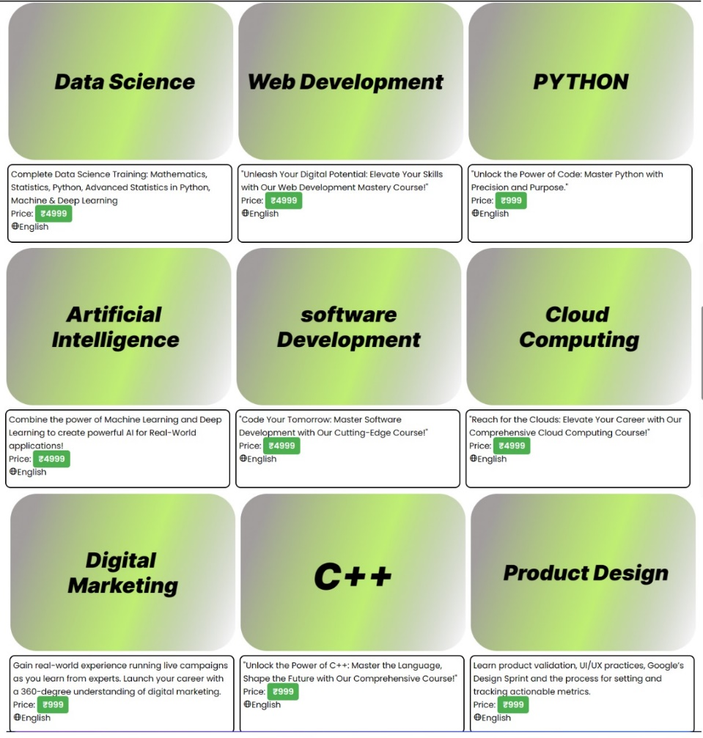

**COURSE PAGE**

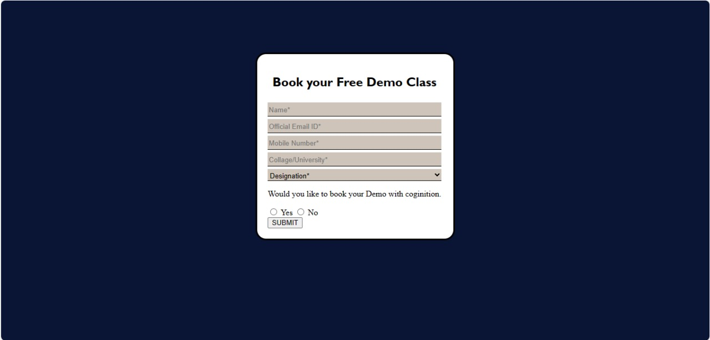

**BOOKING DEMO CLASS PAGE**

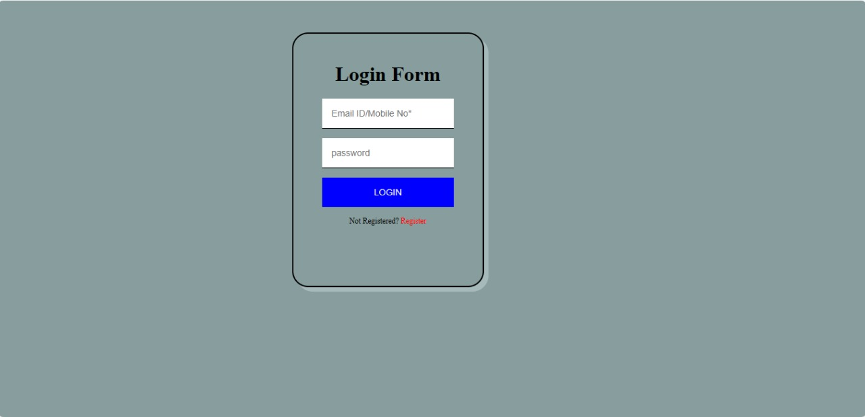

**LOGIN PAGE**

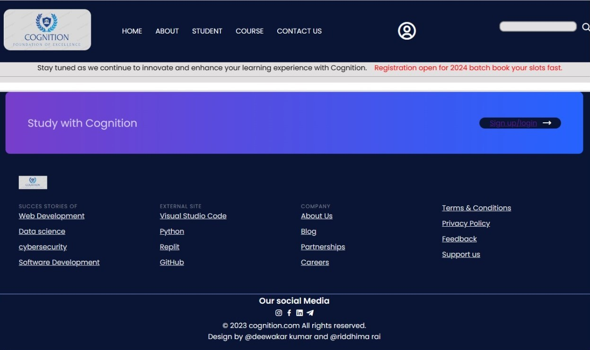

**NAVBAR & FOOTER SECTION**

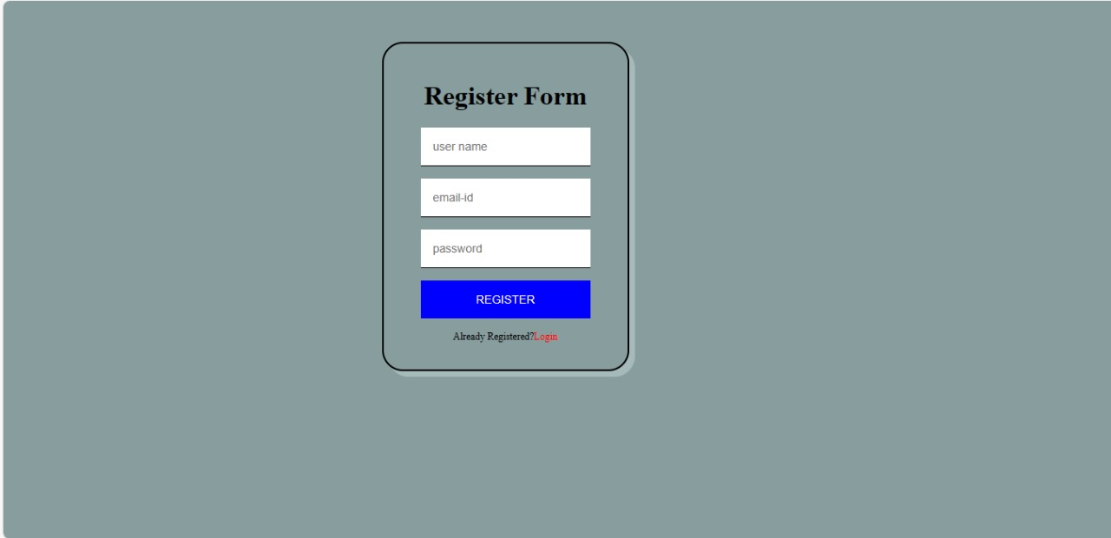

**REGISTRATION PAGE**

**CONCLUSION OF PROJECT**

As we look ahead, the Cognition team remains committed to innovation, personalization, and the pursuit of excellence in online education. We are continually exploring new ways to enhance your learning experience, introducing features that empower you to thrive in your educational endeavors.

In closing, thank you for choosing Cognition as your learning partner. Whether you're a seasoned professional, a student, or someone simply curious to explore new horizons, your presence has enriched our community. Together, we've embraced the ethos that learning is a lifelong journey, and we're honored to have been part of yours.

**Happy Learning!**

**Cognition**

**REFERENCE OF PROJECT**

* <https://www.w3schools.com/>
* <https://boxicons.com/>
* <https://github.com/>