Q.1) Pizza Monthly Sales (August has the highest number of orders.)
Input
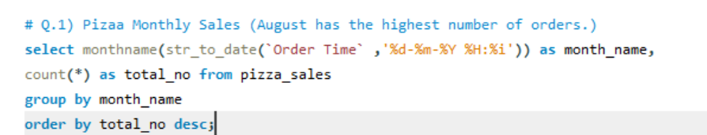
Output
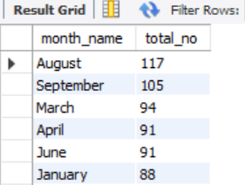
Insights:- August has the highest number of orders
Q.2) Find Popular Pizzas
Input
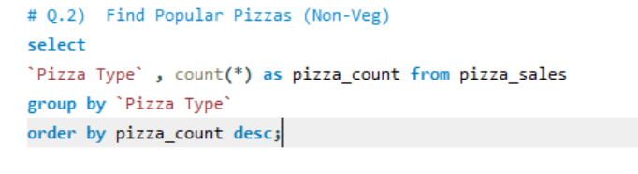
Output
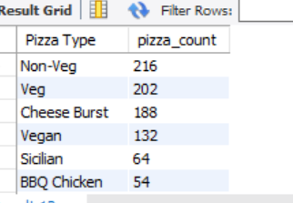
Insight:- Non-veg pizzas dominate the orders preferred.
Q.3) Weekend Vs Weekday Sales
Input
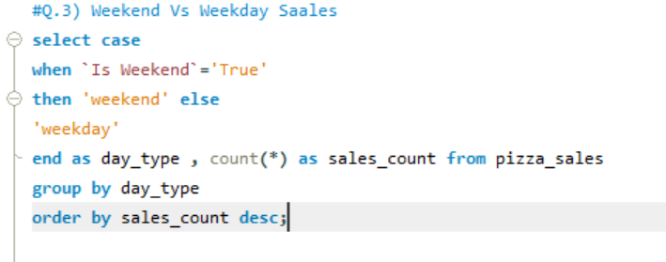
Output
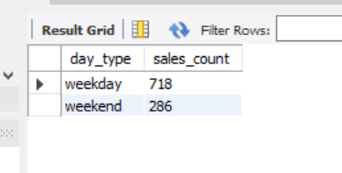
Insight :- Weekend vs Weekdays have nearly 3× more orders than weekends
Q.4) Find Peak Hour Trends in data sate
Input
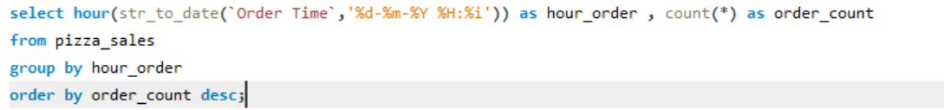
Output
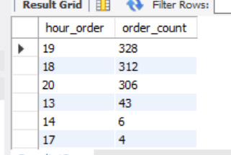
Insight :- Orders spike around 7 PM, indicating dinner rush
Q.5) find Delay Patterns in data set
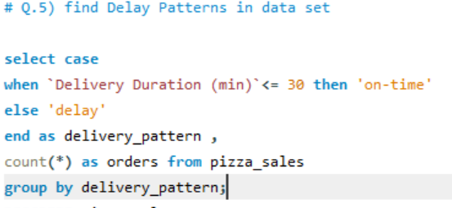
Output
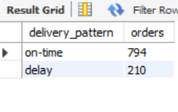
Insight:- Most of Order is on Time .
Q.6) find Topping Preferences
Input
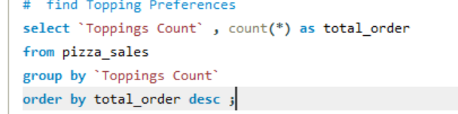
Output
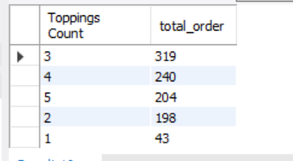
Insight:- Most customers prefer 3 toppings on their pizza
Q.7) Find Best Locations as sales
Input
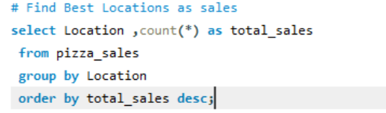
Output
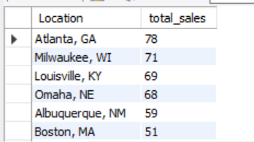
Insight :- Atlanta has the highest orders and good delivery time, indicating efficient service.
Q.8) find the Traffic Impact and peak hours affect
Input
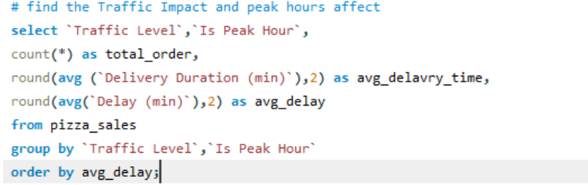
Output
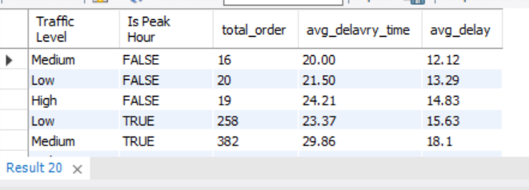
Q.9) find most uses Payment Method
Input
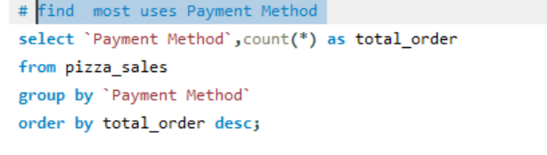
Output
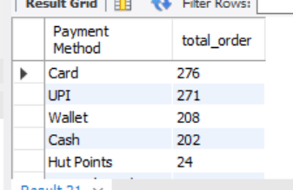
Insight:- Card payments are preferred over cash.
Q.10) most frequently ordered by size
Input
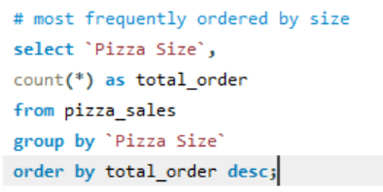
Output
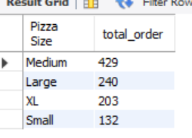
Insight:- Medium pizzas are the most frequently ordered.
Q.11) Delivery Efficiency Orders in high-traffic zones are significantly less efficient.
Input
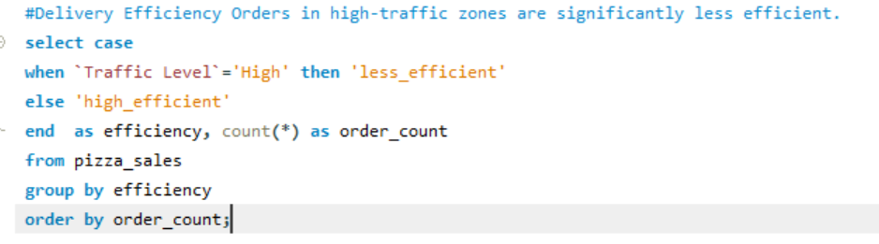
Output
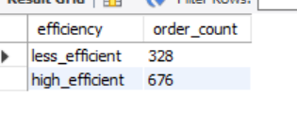
Q.12) Worst Deliveries
Input
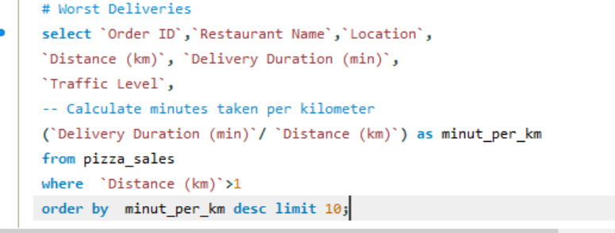
Output
