School Result Analysis
Q.1 Academic Performance Comparison Compared average final grades (G3) of both schools
Input
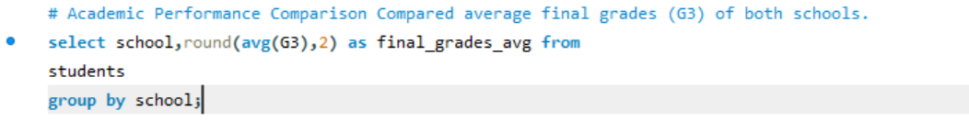
Output
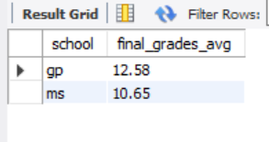
Insight -GP students showed slightly better academic performance.
Q.2) Alcohol Consumption Impact Grouped students by combined alcohol consumption (DALC + WALC) into Low, Medium, High.
Input
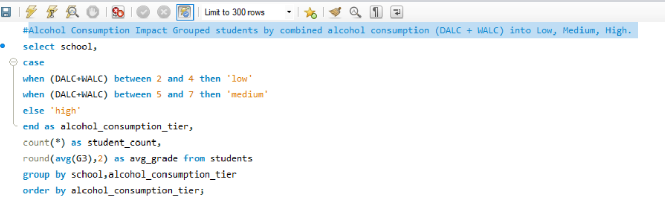
Output
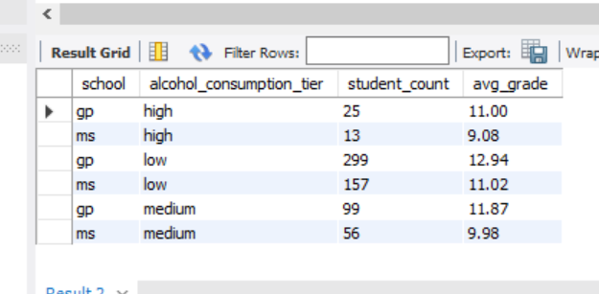
Insight-Higher alcohol consumption was associated with lower grades, especially in MS.
Q.3) study-Time Effectiveness Compared grades across different study time categories.
Input
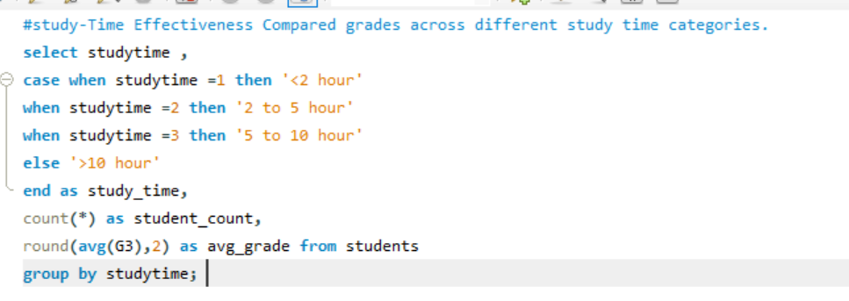
Output
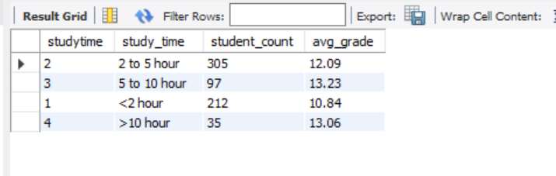
Insight-Higher study time correlated with better grades.
Q.4) Family Support Impact Analyzed the effect of famsup on final grades.
Input
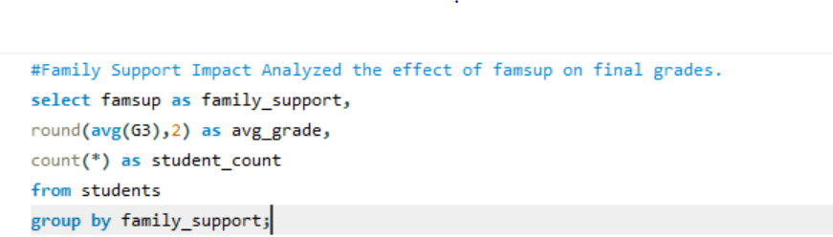
Output
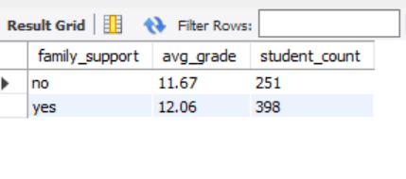
Insight-No major grade difference observed with or without family support.
Q.5) absenteeism Patterns Evaluated average absences and final grades.
Input
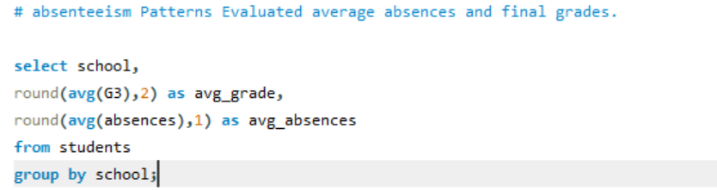
Output
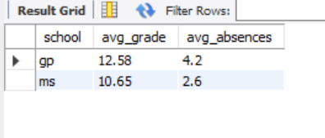
Insight-GP students had more absences but still scored higher on average.
Q.6) Urban vs Rural Performance Compared student performance based on address (Urban vs Rural).
Input
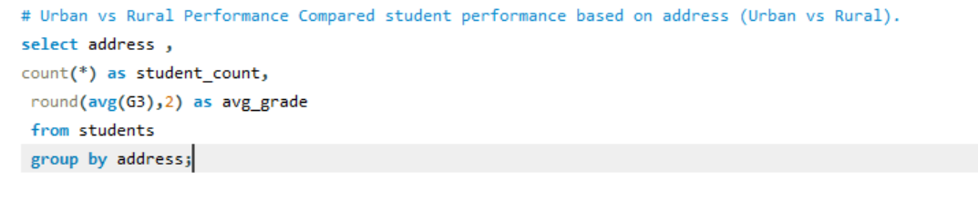
Output
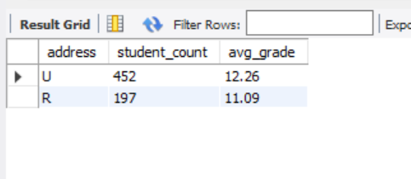
Insight-Minor differences observed; both urban and rural students performed similarly.
Q.7) Extracurricular Activities Impact Compared grades of students with and without activities.
Input
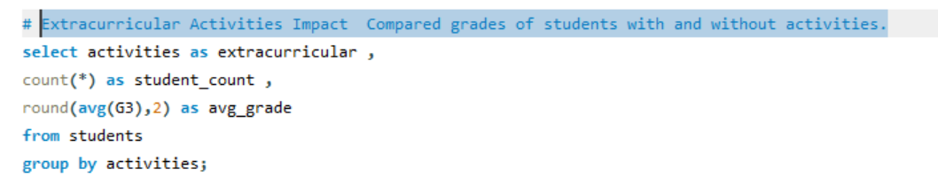
Output
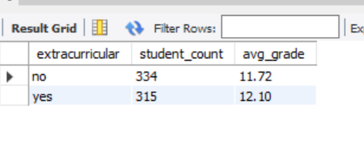
Insight-: Active students generally had better grades.

