Packing Helper Agent

Applied Artificial Intelligence - CS514

Project 1

DEEXITH MYSORE NAGARAJ

**INDEX**

|  |  |  |
| --- | --- | --- |
| ***Sl NO.*** | ***Topics*** | Page |
| 1 | Abstract and Features | 3 |
| 2 | Rules and description | 4 |
| 3 | Usage Manual | 5 |
| 4 | Validations and assumption | 5 |
| 5 | Future Scope | 6 |
| 6 | Sample runs | 7 |
| 7 | Test cases | 9 |

Abstraction:

The packing helper agent is an expert system built in Jess. It is an application of AI which uses rule-based logic system to suggest what things needs to be added to your baggage when you are in a hurry for a business trip or personal excursion. Travel will be the domain of this project.

People tend to forget most important things that they must carry with them when they pack stuffs. People usually tend to forget at least two or more important things. Usually people are in a hurry and these things can happen. When one plans for an excursion suddenly or one’s boss can come to your desk and ask you to travel to affiliate’s place on the next flight, or you might plan for a long weekend excursion, but you were busy with meeting the deadline at work and in all the cases you will tend to pack the necessary stuffs in your backpack.

Now this problem is solved, an AI based packing helper agent will help you to pack all the necessary stuffs you need right before your leaving for the business trip or your personal excursion. Advantage of this system is that, you’re not even required to worry about the weather of the place you are visiting. It takes care of all the conditions like the month you are travelling, place where you are visiting, where you will be staying, what is your purpose of the trip and will help pack stuffs well and you be ready to face all the weather challenges out there.

Features:

* The helper agent takes in the necessary inputs from the user and based on the logical conditions defined, respective rules will be fired.
* For simplicity, also since this is a prototype, only four states are defined, but covers all twelve months.
* Stay place is only defined for staying in “hotel” or “airbnb”, and purpose of the excursion is only personal or business (“B” or “P”).
* Weather report of past three years of all the states are counted for the conclusion of the weather at the given time for a particular state and for the selected month.
* Packing stuffs are suggested based on the gender as well.
* Thus, based on the state, month, gender and where on stays, this agent will help you pack more efficiently and mainly not to miss any of the important things you must need.
* Main advantage of the agent is the based on the weather in a particular state it will suggest you the things you need to add to your backpack.

Rules and description:

Deftemplate:

* user: This template takes the user data. Takes the gender, state the user intends to visit, purpose of the user, whether it is business or personal excursion, stay place is the place where the user plans to stay, for now there are only two main options that are given, hotel or airbnb, also takes the month in which the user plans to travel.

Deffunction:

* checking-in: A simple function just to check whether the user is ready to share his or her details. If the person agrees then the print-banner rule is fired, and the rest of the inputs is read.
* is-type: This function helps the helper agent to validate the response given by the user, does it match with the conditions defined in the rules else the questions are asked again until the user replies correctly.
* ask-user: Function to ask the user with the proper question and read bind the user data.

Defrule:

* request-USERDATA: These are the set of rules which are fired randomly, and this will initiate the system to ask the respective question with the user. Some of these rules include request-purpose, request-stay-place, request-month-of-travel, request-state, ask-question-by-id.
* STATE-MONTH-GENDER-PURPOSE-STAY-PLACE: So, for each state, month, stay place, and purpose, the user selects based on her/his gender a rule will be fired. For each state with respect to the month selected a rule is fired. This has been carefully designed based on a three years survey collected on the average temperature in the state in a month. Thus, the fired rule will suggest what items need to be included into your baggage. It does cover most of the important stuffs one must included if he/she is travelling to that state on a particular month. For example, (defrule CA-JAN-MALE-B-HOTEL, this rule is fired once the user selects state as “CA”, month as “1” for January, selects “male” as the gender, “B” for being the purpose as business, and the stay place or the accommodation is selected as “hotel”, then this rule is fired. This rule has the data as what the weather in California be like in the month of January and also has the record of what one has to carry if it is a business trip. So, it will suggest the user what he must carry in his backpack.

Usage Manual:

As a customer, we always look for a user-friendly interaction with the systems. This helper agent is designed keeping that in mind. This agent asks the user the precise question and will also suggest the user with the available options.

Instructions to run:

* Copy file packingAgent.clp to the bin folder of jess directory
* Open jess and execute the following command.

***jess packingAgent.clp***

Validation and Assumptions:

The system validates the input like state, gender, month of travel, purpose and the accommodation.

* + State of the visit will be asked to the user, since this is a prototype, only four states are covered here. User might have to select any of the state given in the option and as directed packer agent.
  + Month of the travel will be asked, and it must be from 1 till 12, where 1 corresponds to January, 2 to February and so on. If the user types in 13, then the agent knows that there is no month corresponding to 13 and will prompt the user asking the same question again and again until the user gets it right.
  + The gender is assumed to be either male or female, so system accepts value of male or female. This option is provided to the user. If the user fails to type something out of box, then the same question will be asked again until the user gets it right.
  + Purpose of the trip is of more general type and has only two types defined as of now. It can be personal as “P” or business as “B”.
  + Stay-place or the accommodation for now is assumed with only two types as hotel or as airbnb. So, here as well the user must enter either “hotel” or “airbnb”, only then the agent proceeds for further questions.

Future Score:

In future there are a lot of improvements.

* Here only four states are covered and in future we can cover the entire states of USA. Well it isn’t the end, we can further go for covering whole globe.
* This model takes in the weather from past records and tries to interpret the actual weather in a particular state for a particular month. So, we can make use of the weather API and knowing the place a person will travelling we can actually suggest the user more accurately.
* Now let’s see, we are covering the entire state, and we also know that at a given time, there might be that two cities of the same state might have a very different weather. Here also we fail to produce accuracy. So, by using the google maps API and weather API and getting the precision location the user intends to travel more accurate results can be given.
* We can also bring in the machine learning and we can actually train the model to give more accurate and more relevant stuffs to pack.
* This helper system doesn’t mainly cover the age factor, we can bring the facts and rules based in the age and help the user to get more accurate stuffs to pack.
* Once, the above set of things are implemented, we can further move for suggesting not a single user but a group of people who might fall to different categories, namely a very healthy person, person having some medical conditions and so on.
* This agent only covers an abstract view of the purpose as personal or business. This can also be improved to a next state coving a whole bunch of purposes like skiing, trekking, visiting parents, attending a close friend’s wedding and many more. So, the agent can suggest what gift he must carry or what type of shoe he might want to carry for the trekking.

Screen Shot of sample runs:

Figure 1: Sample Run

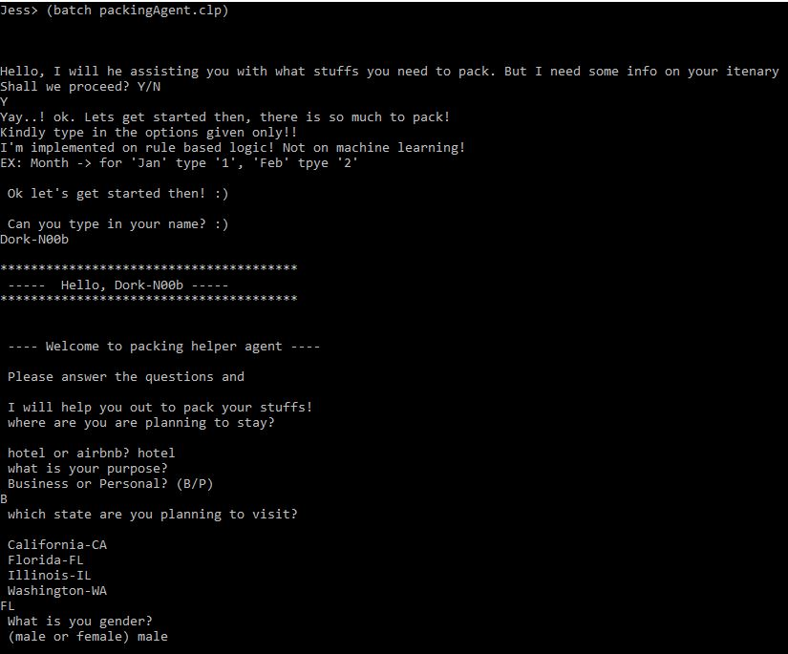

Figure 2: Sample Run continuation

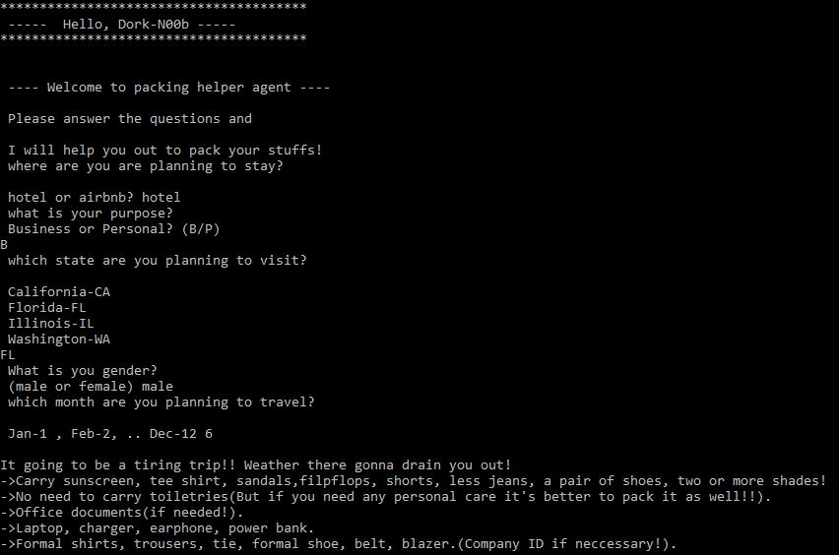

Thus, here the user with name, Dork-N00b selects the options as, show above in the figure, and the respective rule is fired.

Figure 3: Sample Run, where the User does not agree to share the details.

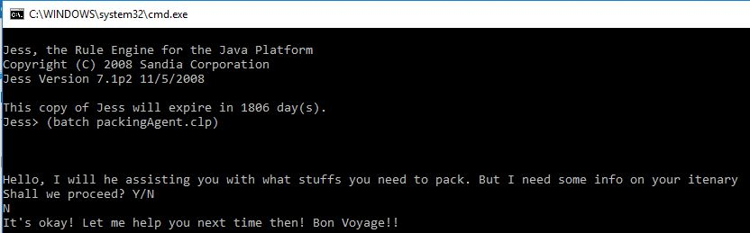

Test Cases:

Test 1:

After typing in “y/Y” first, i.e., agreeing to share your itinerary details.

Name: H4x0r

Purpose: B

State: FL

Gender: male

Month: 1

Test 2:

After typing in “y/Y” first, i.e., agreeing to share your itinerary details.

Name: kannadiga

Purpose: P

State: CA

Gender: male

Month: 6

Test 3:

After typing in “y/Y” first, i.e., agreeing to share your itinerary details.

Name: noobie

Purpose: B

State: IL

Gender: female

Month: 12

Test 4:

Type in “n/N” at the beginning and the program should terminate.