[Portfolio] Site Plan

[Collin Breshears]

WDD 130

Overview

Purpose
[My purpose in creating and having this website is to have a constantly updating resume of my certifications, accomplishments, work experience, and showcase of my projects. It will serve as a landing page for employers, customers, and clients to prove relevance and build trust in my abilities.]

Audience
[My audience will be potential employers, clients, recruiters, and other professional references.]

Branding

Website Logo
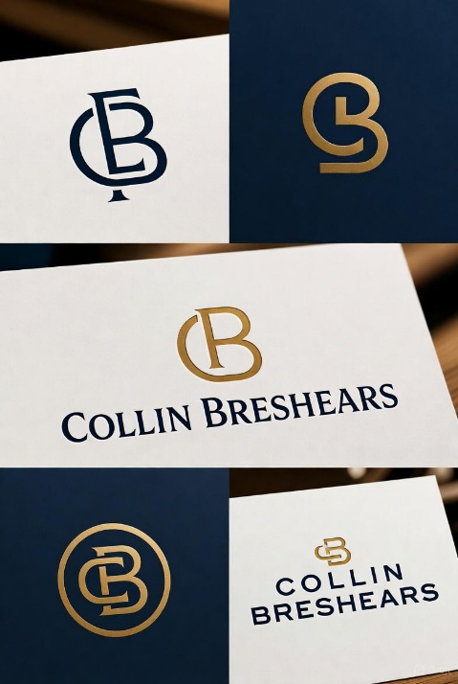

Style Guide

Color Palette
Primary | Secondary | Accent 1 | Accent 2
#111827 | #374151 | #991B1B | #A67C00

Typography

Heading Font: [Orbitron]

Paragraph Font: [Inter]

Navigation
Home About Contact Me

Content

[put all content for the pages here, including written text and images]


LinkedIn- Collin Breshears
Email- Collinbresh@gmail.com
Phone Number- 208-901-9900

Wireframes

Home
