Debre Berhan University

College of Computing

Department of Computer Science

Course: CoSc4181-Selected Topics in computer Science

## **1 Introduction**

Clearance is a status granted to individuals typically students allowing them access to information. The term clearance is also sometimes used in private organizations that have a formal process to check the employee’s information. A clearance by itself is normally not sufficient to gain access the organization must determine the cleared individual has need to know the information.

Clearance is the process of determining and negotiating any permission that are needed to use of someone else’s intellectual property creative project. Part of that process includes: -

* Determining the owner(s) of the intellectual property.
* Contacting the owners and negotiating on agreement.
* Administering written contracts.
* Handling other issues related to the use and licensing of intellectual property.

# 2 Objective

The main objective of this project is to change the manual clearance processing system to web based system.

# 3 Existing System

## 3.1 Overview

* The current system provides manual data control mechanism.
* The manually student clearance system is delay in processing clearance form.
* Lack of centralized source of information.
* Unavailability of some key staff while processing Clearance form.
* Loss of vital documents as the filing system is manual.
* Preparing and getting different reports are time consuming and prone to error.
* The existing system is face to various problems. These problems can be seen from the following perspectives like performance, information, economic, control, efficiency and services given by the existing system to the users.

## 3.2 users/Actors of the system

* Students
* Responsible for
* Apply for clearance
* Manage bank account and profile
* Get notification case.
* Pay or replace for his/her lost material
* View new information
* Send feedback and fill clearance

# 4 Proposed System

## 4.1 Overview

The new system is designed to solve problems affecting the manual system in use. It is design to be used online thereby relieving both the students and the offices workers from much stress as experienced in the manual system.

This system will do the analyzing and storing of information either automatically or interactively. It will make use of online access to Internet. The proposed system will also have some other features like: -

* Login system must be present and secured by password and logout after cover.
* Accuracy in the handling of data.
* Fast rate of operation and excellent response time.
* The system is flexible i.e. it can be accessed at any time.
* Easy way of back up or duplicating data in diskettes in case of data loss.
* Better storage and faster retrieval system.
* Accessibility from anywhere.

#### **4.2 Functional Requirements**

This section points the major functionalities that expected to be included in the proposed system to satisfy the objectives of the project. After discussion, we are going to highlight the modules and to describe the functionalities in detail.

1. **Library System:**

* Students approved by library manager for their case of drop out, withdrawal, ID replacement, end of academic year, if they are free from any lost or unreturned material from library. When students lost books or the material from library, they responsible to pay two times the price of the book and in addition 80 birr for administrative costs.

1. **Student business affair or proctor:**

* Students would be approved by proctor for their case of drop out, withdrawal, ID replacement, end of academic year, if they are free from any lost or unreturned material from dormitory service.
* When students lost materials that received from proctor, they responsible to pay the current original price of the lost materials or replacing the original materials.

1. **Student conduct Administration:**

* Students will be cleared by Student Conduct Administrator, when they are free from any misconduct in the university.
* When students made misconduct, they couldn’t get clearance paper unless get decision for their case.

1. **Departmental Dues:**

* Students will be cleared by department, when they are free from any lost, damage materials from the office
* After properly completing getting them cleared by the appropriate offices, the registrar must submit one clearance slip to the department.

1. **Registrar:**

* Students verified by registrar, if they are cleared from library, proctor, department, Student conduct administration for their case of Drop out, Withdrawal, ID Replacement, End of academic year.
* Students checked by registrar, if they filled cost sharing unless they can’t get Temporary degree upon graduation.
* After properly completing getting them cleared by the appropriate offices copy each to: registrar, department head, and applicant.

1. **Payment or replacement processing:**

* When students lost materials from dormitory, library, department; they are responsible to pay the current original price of the lost materials or original replacement.
* Students get notification case from that office that not being approved.

1. **User Management:**

* The administrator creates the user account, view user account and the users manage and change their password for each user.

## 4.3 Use Case Model

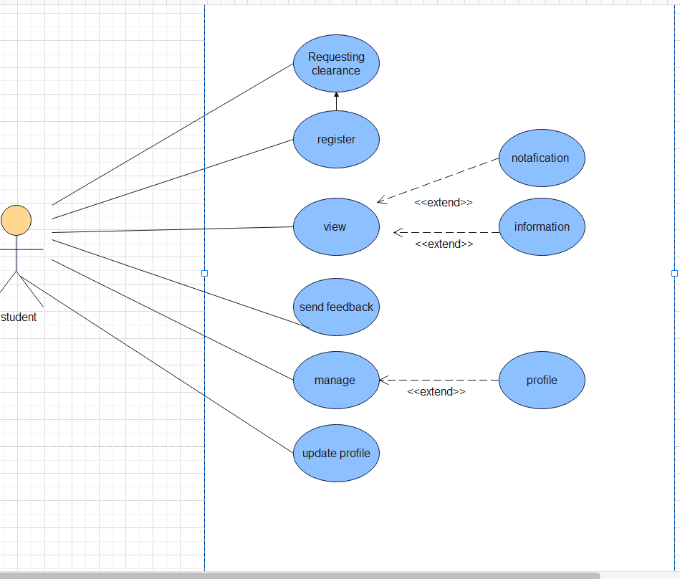

Figure 1:Use Case Diagram

## 4.4 Use Case Descriptions

Table 1: use case description for Send feedback

|  |  |
| --- | --- |
| Use case Id | **UC-1** |
| Use case name | Send feedback |
| Participator Actor | Students |
| Description | User of a system may have some comment and feedback for the system at this time they can sent to the system through web. |
| Pre-condition | To send feedback to the system, user must appear on the web page of the application. |
| Basic course of action | Actor action |
| * + - 1. The user clicks the feedback button from the home of the web.   **3.** The users fill username, email, address and others information.  **6.** Users input the comments and click send. |
| Alternate course of action | A4.1 if the input is invalid, the system returns back to basic flow of event 2. |
| Post conditions | User can successfully send their feedback and comment. |

Table 2: use case description for Request Clearance

|  |  |  |  |
| --- | --- | --- | --- |
| Use case id UC-2 | Use case name | Request | |
| Actor(s) | Student | |
| Pre-condition | The actor cannot Request the information. | |
| Post-condition | The Actors will be Request. | |
| Description | The actor wants to request what they want. | |
| Typical course of action: | Actor Action | System Response |
| Step1: The actor wants to request.  Step3: The user selects the request option. | Step2: The system displays the request option. Step4: The system processes the selections action.  Step5: The system sends information’s to the other page. Step6: The use case ends. |
| Alternative course of action | If the input information invalid or empty Step4.1: The system indicates the user information invalid. Step4.2 The use case continues Step2 of the basic course of action. | |

Table 3: use case description for registration of the user

|  |  |  |  |
| --- | --- | --- | --- |
| Use case id UC-3 | Use case name | Registration | |
| Actors | Students | |
| Pre-condition | The Actors not to register | |
| Post-condition | The users registers to the system | |
| Description | This use case allows users to register in to the system | |
| Typical course of action: | Actor Action | System Response |
| Step1: The user wants to register in to the system.  Step3: The user enters the necessary information in to the form in registration page. | Step2: The system displays registration page Step4: The system validates whether the information submitted is correct or not. Step5: The system register and displays registration confirmation page and leads to home page. Step6: The use case ends |
| Alternative course of action: | Step5: If the actor does not fill the id and password then the system display error message and return to step 2. | |
| Alternative course of action | If the input information invalid or empty Step4.1: The system indicates the user information invalid. Step4.2: The use case continues Step2 of the basic course of action. | |

Table 4: use case description for update profile

|  |  |  |  |
| --- | --- | --- | --- |
| Use case id UC-4 | Use case name | Update profile | |
| Actor(s) | Students | |
| Pre-condition | The Actors cannot be Update profile | |
| Post-condition | The Actors will have update their account information | |
| Description | This use case allows users to update the user account. | |
| Typical course of action: | Actor Action | System Response |
| Step1: The actors can request to update his/her information. The system will display the current customer information to the users. Step3: The user enters the necessary information to update. | Step2: The system displays user account update page. Step4: The system validates information is correct or not. Step5: The system displays confirmation page and save the update information of user. |
| Alternative course of action | If the input information invalid or empty Step4.1: The system indicates the Actors information invalid. Step4.2: The use case continues Step2 of the basic course of action. | |

Table 5: Use case description for View Profile

|  |  |  |  |
| --- | --- | --- | --- |
| Use case id UC-5 | Use case name | View Profile | |
| Actor(s) | Students | |
| Pre-condition | The Actors not seen profile. | |
| Post-condition | The Actors has been viewed his/her profile. | |
| Description | This use case allows users request to view his/her profile. | |
| Typical course of action: | Actor Action | System Response |
| Step1: The actors want to View his/her profile. Step3: The actor selects the view profile option. | Step2: The system displays view option page. Step4: The system process selection.  Step5: The system displays the actor profile.  Step6: The use case ends. |
| Alternative course of action | If the input information invalid or empty Step4.1: The system indicates the user information invalid. Step4.2: The use case continues Step2. | |

## 

## 4.5 Class Diagram

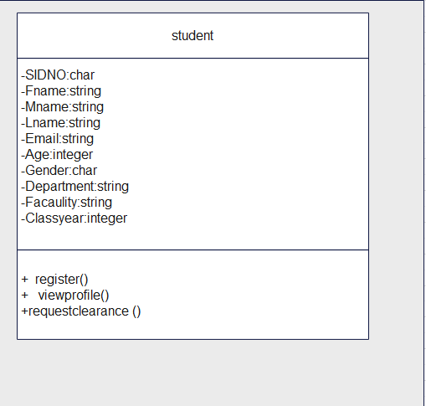

Figure 2:class diagram

4.6 Database Design

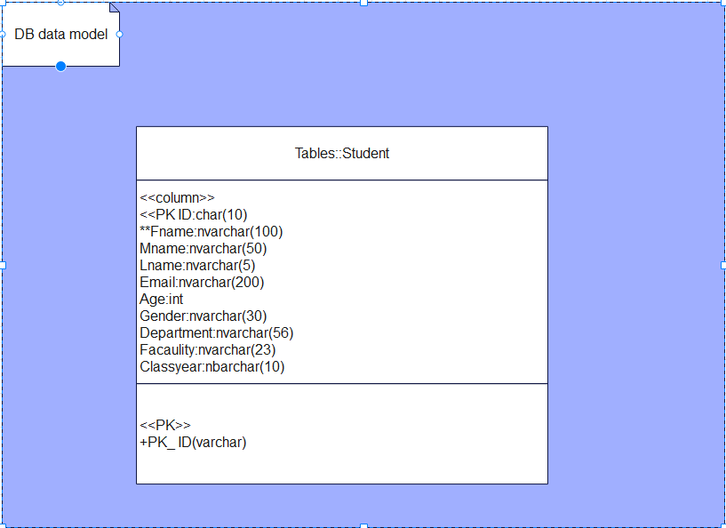

Figure 3: database diagram

## 4.7 User Interface Mock-up

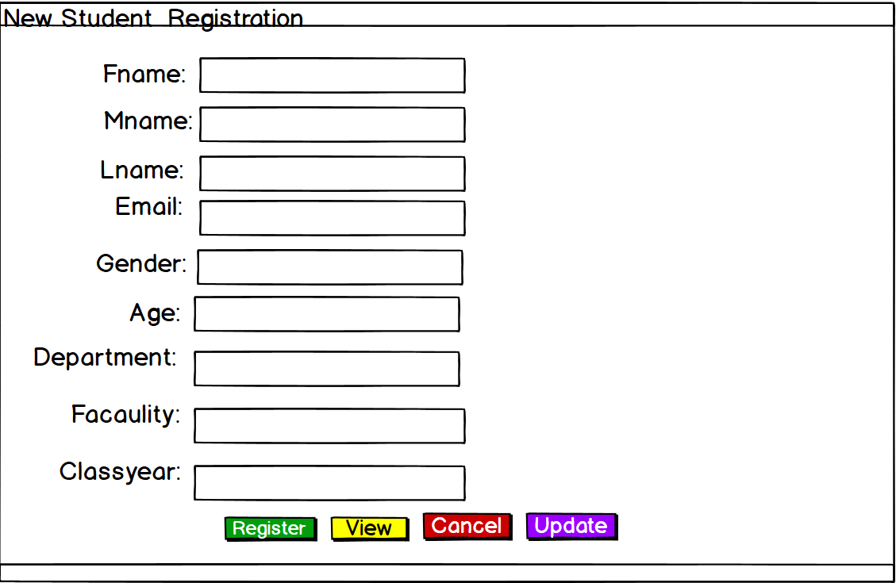

Figure 4:New Student Registration