Untitled

lee7

2023-02-08

#library(readxl)  
projo<-read.csv("PData Review final-3.csv")  
head(projo)

## Gender Gender1 Year.of.study Year.1 Faculty.of.study Faculty.1 Age  
## 1 Male 1 Fourth Year 3 Science 0 19-24 years  
## 2 Male 1 Fourth Year 3 Engineering 1 19-24 years  
## 3 Male 1 Fourth Year 3 Science 0 19-24 years  
## 4 Male 1 Fourth Year 3 Science 0 19-24 years  
## 5 Male 1 Fourth Year 3 Science 0 19-24 years  
## 6 Female 0 Third Year 2 Education 2 19-24 years  
## Age.1 A1 A2 L1 L2 L3 L4 L5 L6 P1 P2 P3 P4 P5 P6 AP1 AP2 AP3  
## 1 1 2 2 5 5 1 2 2 2 5 5 5 2 1 2 1 2 2  
## 2 1 4 4 4 3 3 4 2 3 3 2 5 1 5 3 3 2 2  
## 3 1 1 1 3 3 2 5 5 4 3 4 5 1 5 1 2 2 2  
## 4 1 4 2 2 4 1 4 4 4 3 5 5 3 3 3 1 1 2  
## 5 1 3 4 3 5 5 5 4 1 5 3 4 2 4 4 2 2 1  
## 6 1 4 4 4 5 1 4 5 5 5 4 4 3 2 3 3 2 2

library(tidyverse)

## Warning: package 'tidyverse' was built under R version 4.1.3

## -- Attaching packages --------------------------------------- tidyverse 1.3.1 --

## v ggplot2 3.3.5 v purrr 0.3.4  
## v tibble 3.1.7 v dplyr 1.0.8  
## v tidyr 1.1.3 v stringr 1.4.0  
## v readr 2.1.2 v forcats 0.5.1

## Warning: package 'tibble' was built under R version 4.1.3

## Warning: package 'readr' was built under R version 4.1.3

## Warning: package 'dplyr' was built under R version 4.1.3

## Warning: package 'forcats' was built under R version 4.1.3

## -- Conflicts ------------------------------------------ tidyverse_conflicts() --  
## x dplyr::filter() masks stats::filter()  
## x dplyr::lag() masks stats::lag()

projo %>% ggplot(mapping = aes(x=Gender))+  
 geom_bar(fill="red")

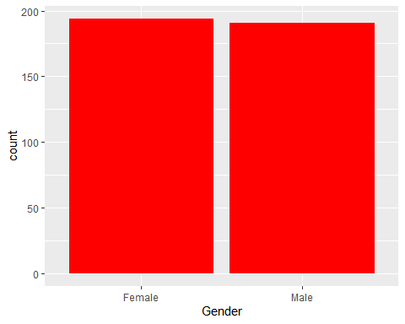

#projo %>% ggplot(mapping = aes(x=`Year of study`))+  
 # geom_bar(fill="red")

projo %>% ggplot(aes(x="",y=Gender,fill=Gender))+  
 geom_bar(stat="identity", width=1) +  
 coord_polar("y", start=0)

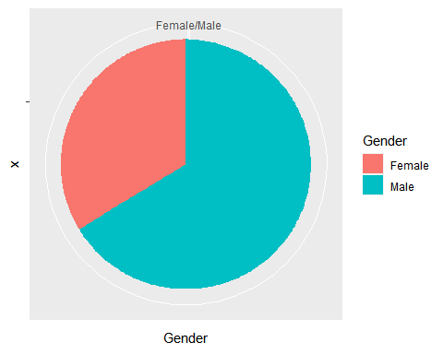

#shapiro.test(projo)

#library(foreign)  
#proje<-read.spss("spss data2.sav")

#library(readxl)  
pro<-read.csv("PR.csv")

shapiro.test(pro$TransL)

##   
## Shapiro-Wilk normality test  
##   
## data: pro$TransL  
## W = 0.98699, p-value = 0.001596

shapiro.test(pro$TransA)

##   
## Shapiro-Wilk normality test  
##   
## data: pro$TransA  
## W = 0.96143, p-value = 1.598e-08

shapiro.test(pro$TransAP)

##   
## Shapiro-Wilk normality test  
##   
## data: pro$TransAP  
## W = 0.93598, p-value = 8.253e-12

shapiro.test(pro$TransS)

##   
## Shapiro-Wilk normality test  
##   
## data: pro$TransS  
## W = 0.98463, p-value = 0.0004117

cor.test(pro$TransA,pro$TransAP)

##   
## Pearson's product-moment correlation  
##   
## data: pro$TransA and pro$TransAP  
## t = 0.52623, df = 383, p-value = 0.599  
## alternative hypothesis: true correlation is not equal to 0  
## 95 percent confidence interval:  
## -0.07326329 0.12648509  
## sample estimates:  
## cor   
## 0.02687921

cor.test(pro$TransL,pro$TransAP)

##   
## Pearson's product-moment correlation  
##   
## data: pro$TransL and pro$TransAP  
## t = 4.3638, df = 383, p-value = 1.646e-05  
## alternative hypothesis: true correlation is not equal to 0  
## 95 percent confidence interval:  
## 0.1203051 0.3108188  
## sample estimates:  
## cor   
## 0.2176339

cor.test(pro$TransS,pro$TransAP)

##   
## Pearson's product-moment correlation  
##   
## data: pro$TransS and pro$TransAP  
## t = 4.4366, df = 383, p-value = 1.196e-05  
## alternative hypothesis: true correlation is not equal to 0  
## 95 percent confidence interval:  
## 0.1238807 0.3140942  
## sample estimates:  
## cor   
## 0.221089

acad<-lm(pro$TransAP~pro$TransL+pro$TransS+pro$TransA)  
summary(acad)

##   
## Call:  
## lm(formula = pro$TransAP ~ pro$TransL + pro$TransS + pro$TransA)  
##   
## Residuals:  
## Min 1Q Median 3Q Max   
## -1.41533 -0.24179 0.04647 0.26157 0.86802   
##   
## Coefficients:  
## Estimate Std. Error t value Pr(>|t|)   
## (Intercept) 1.2277539 0.1978115 6.207 1.41e-09 ***  
## pro$TransL 0.1378668 0.0427790 3.223 0.001379 **   
## pro$TransS 0.1521431 0.0448385 3.393 0.000763 ***  
## pro$TransA 0.0004769 0.0251058 0.019 0.984854   
## ---  
## Signif. codes: 0 '***' 0.001 '**' 0.01 '*' 0.05 '.' 0.1 ' ' 1  
##   
## Residual standard error: 0.442 on 381 degrees of freedom  
## Multiple R-squared: 0.07572, Adjusted R-squared: 0.06844   
## F-statistic: 10.4 on 3 and 381 DF, p-value: 1.355e-06

ks.test(pro$TransA,"pnorm")

## Warning in ks.test(pro$TransA, "pnorm"): ties should not be present for the  
## Kolmogorov-Smirnov test

##   
## One-sample Kolmogorov-Smirnov test  
##   
## data: pro$TransA  
## D = 0.9253, p-value < 2.2e-16  
## alternative hypothesis: two-sided

ks.test(pro$TransL,"pnorm")

## Warning in ks.test(pro$TransL, "pnorm"): ties should not be present for the  
## Kolmogorov-Smirnov test

##   
## One-sample Kolmogorov-Smirnov test  
##   
## data: pro$TransL  
## D = 0.97725, p-value < 2.2e-16  
## alternative hypothesis: two-sided

ks.test(pro$TransS,"pnorm")

## Warning in ks.test(pro$TransS, "pnorm"): ties should not be present for the  
## Kolmogorov-Smirnov test

##   
## One-sample Kolmogorov-Smirnov test  
##   
## data: pro$TransS  
## D = 0.9875, p-value < 2.2e-16  
## alternative hypothesis: two-sided

ks.test(pro$TransAP,"pnorm")

## Warning in ks.test(pro$TransAP, "pnorm"): ties should not be present for the  
## Kolmogorov-Smirnov test

##   
## One-sample Kolmogorov-Smirnov test  
##   
## data: pro$TransAP  
## D = 0.90579, p-value < 2.2e-16  
## alternative hypothesis: two-sided

ks.test(pro$TransL,pro$TransA)

## Warning in ks.test(pro$TransL, pro$TransA): p-value will be approximate in the  
## presence of ties

##   
## Two-sample Kolmogorov-Smirnov test  
##   
## data: pro$TransL and pro$TransA  
## D = 0.24156, p-value = 3.505e-10  
## alternative hypothesis: two-sided

ks.test(pro$TransAP,pro$TransA)

## Warning in ks.test(pro$TransAP, pro$TransA): p-value will be approximate in the  
## presence of ties

##   
## Two-sample Kolmogorov-Smirnov test  
##   
## data: pro$TransAP and pro$TransA  
## D = 0.58961, p-value < 2.2e-16  
## alternative hypothesis: two-sided

ks.test(pro$TransS,pro$TransA)

## Warning in ks.test(pro$TransS, pro$TransA): p-value will be approximate in the  
## presence of ties

##   
## Two-sample Kolmogorov-Smirnov test  
##   
## data: pro$TransS and pro$TransA  
## D = 0.37143, p-value < 2.2e-16  
## alternative hypothesis: two-sided

x=table(projo$Year.of.study)  
label=round(100*x/sum(x),1)  
pie(x,labels=label,main = "Year of Study Pie Chart",col=rainbow(length(x)))  
legend("topright",c("Fifth Year","First Year","Fourth Year","second Year","Third Year"),cex = 0.8,fill = rainbow(length(x)))

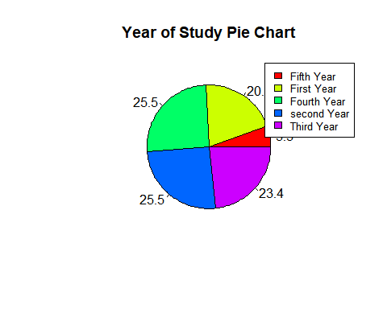

y=table(projo$Faculty.of.study)  
labely=round(100*y/sum(x),1)  
pie(y,labels=labely,main ="Faculty Pie Chart",col=rainbow(length(y)))  
legend("topright",c("Business/Economics","Education","Engineering","Science"),cex = 0.8,fill = rainbow(length(y)))



s=table(projo$Age)  
labelz=round(100*s/sum(x),1)  
pie(s,labels=labelz,main ="Age Pie Chart",col=rainbow(length(s)))  
legend("topright",c("18 and below","19-24 years","25-30 years","31 and above"),cex = 0.8,fill = rainbow(length(s)))

