NightWise Module 1 app shell
  - 9 September 2026 IST | M01 revision 1 | Prepared by Codex for the project owner
Module 1 is complete within its app-shell scope. The Android debug APK builds successfully, its signature is verified and all five browser tests pass. The default is the original blue and navy appearance with teal accents. Mono Light and Mono Dark are available in Settings and the chosen appearance survives a reload. Physical phone behavior and live services remain later validation work.

What I built
- A working NightWise entry screen with the crescent brand, Bengaluru context, journey fields, prepared Manyata Tech Park and Sahakar Nagar starting points, the supplied AEOS destination and an explicit tutorial label.
- A Settings sheet with three appearance choices, immediate theme changes, local preference storage and a usable session fallback when storage is unavailable. All themes share the same screen structure and controls.
- A bundled Higgsfield navy launch background with crisp UI branding, a Skip control and a short dismissal timer. The media was inspected and measured at 4.04 seconds, 720 by 1280 pixels. The app skips motion for reduced-motion preferences and can open without a network video. Android launcher and startup resources use the NightWise crescent and blue background.
- Reusable modal sheets, keyboard focus handling, Android Back handling in code, safe-area spacing and layouts for narrow phones and desktop preview. Location remains optional and no location prompt appears on launch.
- About and privacy explanations and clearly labelled sample screens for later route work. A tutorial can preview the intended journey flow, but these fixtures do not establish live route or activity correctness.

How I approached it
I built real React and TypeScript components from the design references. CSS theme variables control the colors, so blue and monochrome appearances use the same functionality. Capacitor provides the Android container. The launch asset is bundled with the app; the wordmark and controls remain editable UI. Credentials are not needed for this module.
I kept location, live map requests and activity analysis outside the shell's dependency path. The AEOS pin is 13.0628268, 77.5940888. Exact road entrances and origin gates are not verified. Driving is the provisional tutorial mode.

Verification and limits
The production web build passed TypeScript checking and Vite compilation. All five Playwright browser tests passed against the production preview in Microsoft Edge. The final successful run reported 5 passed in 2.0 minutes. Actual app screenshots appear on the next two pages.
- Verified the blue default, tutorial label, available primary action and launch dismissal without Google credentials.
- Verified immediate Mono Light and Mono Dark selection, persistence after reload, return to blue, Escape dismissal and focus returning to the Settings trigger.
- Verified that the location explanation preserves access to prepared starting points and that About explains the tutorial's privacy behavior.
- Verified no horizontal overflow at widths of 320, 360, 390 and 1440 pixels, including the Settings sheet.
- Verified the reduced-motion path and that denied local storage does not prevent the app or appearance switching from working.
The final Android build passed in 5 minutes 7 seconds. The package is nightwise-module-01-debug.apk, version 0.1.0-module1, 5,718,766 bytes. Its signature and package identifier were verified. SHA256 is 1e8655e90d0c2b229945977c1440fb600711d08ae177def039a0ada5881b55e5. The native Back handler, status bar, touch handling and startup have not been checked on the intended physical phone. Live maps, route geometry, location services, activity analysis and billing are outside this module's verified scope.

Errors and fixes
The first browser run found a real focus defect: closing the Settings sheet left its trigger inactive. I saved the opening control and explicitly restored focus during sheet cleanup. The final test now passes.
A rerun timed out during page loading while the development server was also reloading generated build files. I excluded tools, Android output, documents and other generated folders from its watcher and moved final tests to a stable production preview. The observed reload interference was removed; its contribution to every timeout was not independently measured.
The initial npm installation failed inside the peer dependency resolver. A compatible Vite React plugin, pinned Vitest and npm 11.6.2 completed installation. The exact original resolver root cause remains unproven. An empty CSS import also produced a build warning; it was removed.
Word automation stalled during report export and its read-only instance was stopped. The Windows runtime had no bundled LibreOffice. I extracted a verified official renderer privately under .tools and used the packaged document renderer with bundled Python and Poppler. The direct archive assembly reuses extracted files and validates directories once, avoiding repeated disk copying. Future reports use scripts/render-module-report.ps1.

Blue home and appearance settings
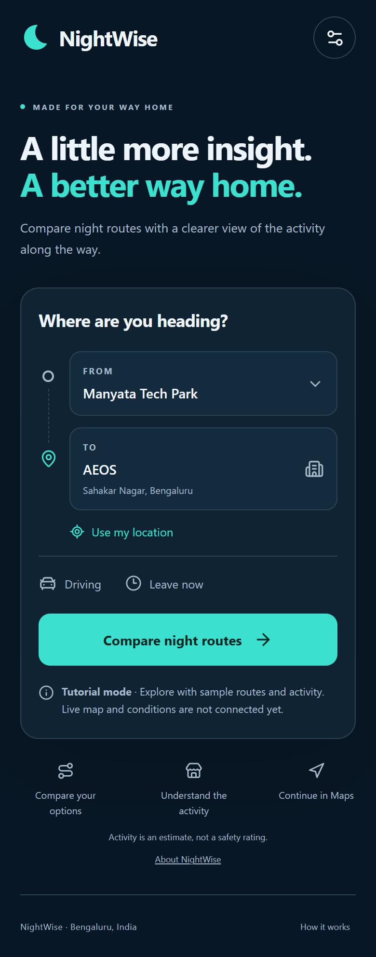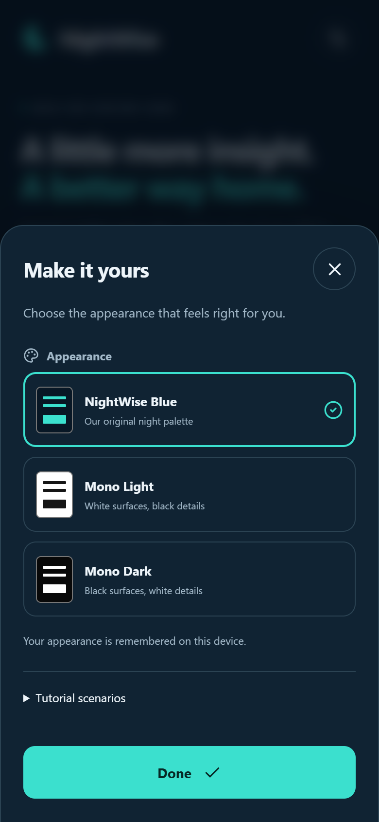
Figures 1 and 2 Actual browser screenshots with sample data. The default blue entry screen and the appearance selector are implemented UI, not generated mockups.

Optional black and white appearances
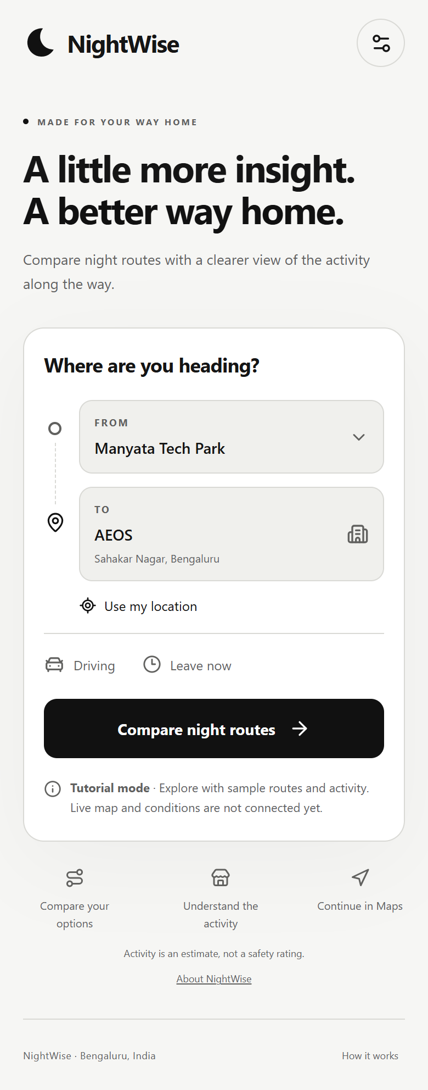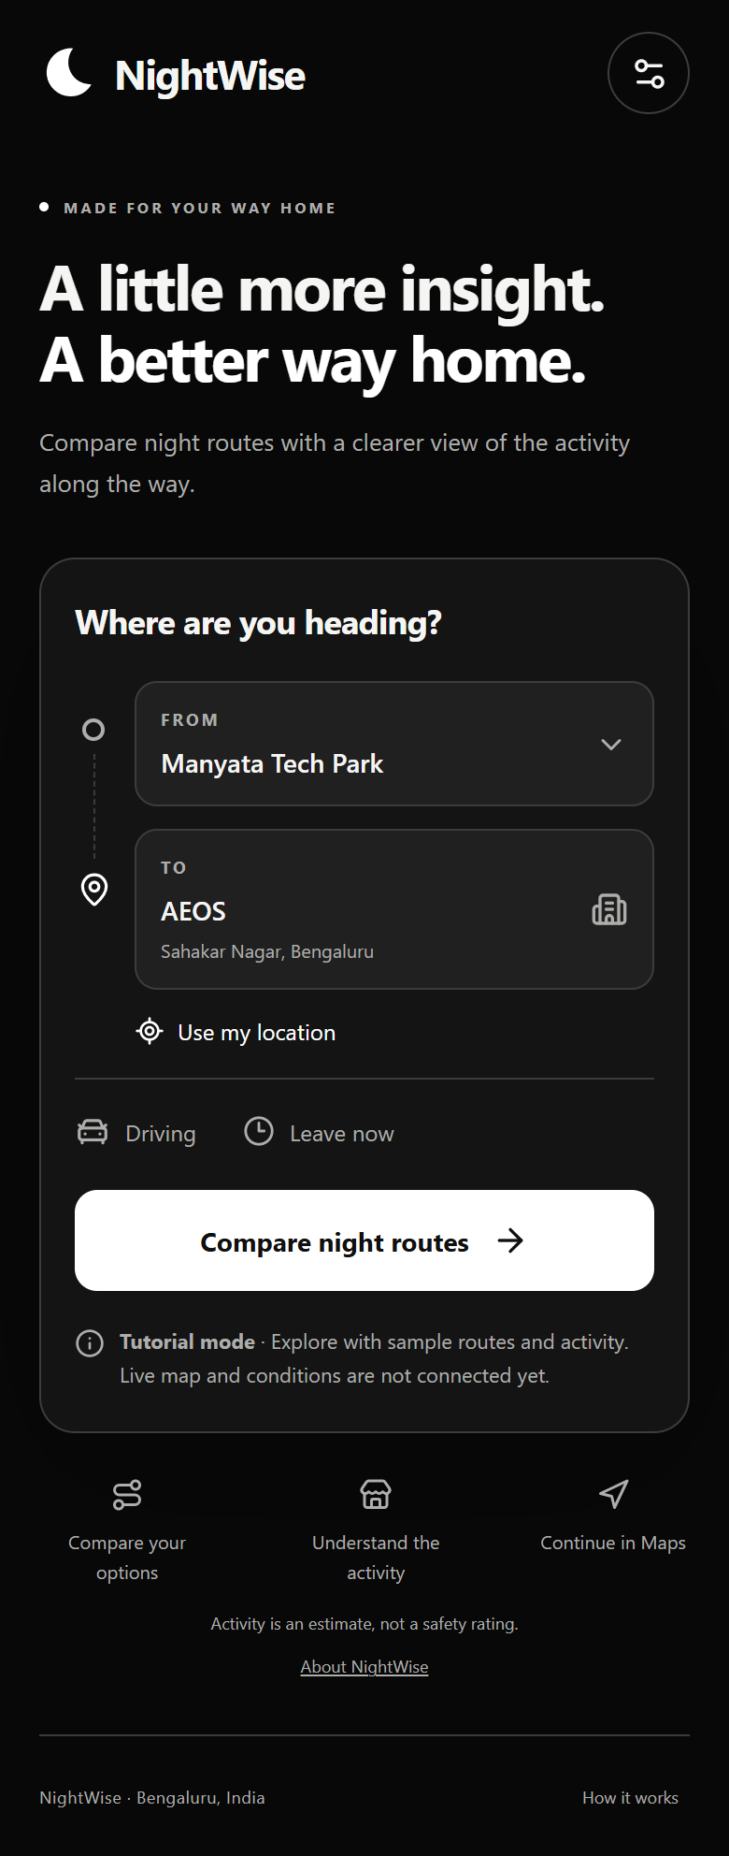
Figures 3 and 4 Actual browser screenshots with sample data. Both monochrome options preserve the blue theme's content and controls.

Files and how to continue
The canonical project root is D:/Aevy TV ( Achina Mayya )/Nightwise. Paths below are relative to that folder. Read AGENTS.md, planning/nightwise-current-status.md and talks/README.md before resuming after context loss.
- src/App.tsx contains the shell and sample flow. src/components.tsx contains the reusable crescent, modal sheet and explicit map placeholder. src/theme.ts and src/styles.css contain appearance storage and the shared visual system.
- src/data/tutorial.ts holds fictional fixtures. src/domain/types.ts holds initial contracts. These files are foundations for later modules, not a completed routing or analysis implementation.
- public/assets/launch/nightwise-launch-navy-concept.mp4 is the bundled launch background. assets/launch/generation-record.json preserves its generation record.
- tests/browser/module1.spec.ts and playwright.config.ts contain the browser checks. talks/screenshots/M01 holds the actual screenshots. package-lock.json records installed dependencies.
- scripts/build-android.ps1, the Android directory and the portable toolchain under .tools support packaging. The toolchain and caches are excluded from source control.

Local review
From the project folder, npm run build creates the production web output. npm run preview -- --port 4173 serves the production preview at http://127.0.0.1:4173. With that preview running, npx playwright test runs the Module 1 checks. npm run dev starts the editing preview at http://127.0.0.1:5173.

Next module and user help
Module 2 will complete journey handling, route-provider boundaries and synchronized route selection. Module 3 will implement and test activity analysis. Google credentials become necessary at Module 4 for live requests. No API keys or billing action is needed to review Module 1.
Before live rehearsal, confirm the exact Manyata gate, Sahakar Nagar starting landmark, AEOS entrance, travel mode and intended Android phone. Do not treat sample route times, distances, counts or map placeholders as observed Bengaluru conditions.

