ADVANCED MICRO DEVICES, INC. (AMD)
FIRST QUARTER 2026 EARNINGS UPDATE
May 16, 2026 | Rating: MAINTAIN OUTPERFORM | Price (May 8): $455.19 | Price Target: RAISE TO $500 (prior: $380)

Q1 2026 EARNINGS SUMMARY | Reported | Estimate | Variance
Q1 2026 RESULTS: BEAT |  |  |  | BEAT
Revenue ($B) | $10.253 | $9.89 | +$0.36 (+3.7%) | ✓
Non-GAAP EPS ($) | $1.37 | $1.28 | +$0.09 (+7.0%) | ✓
Data Center Revenue ($B) | $5.775 | $5.56 | +$0.22 (+3.9%) | ✓
Non-GAAP Gross Margin | 55.0% | 55.0% | In-Line | =
Note: Consensus estimates from Yahoo Finance as of May 2, 2026 (pre-earnings market close).
KEY TAKEAWAYS

- Outstanding Q1 beat on all key metrics: Revenue of $10.25B exceeded consensus by $363M (+3.7%), non-GAAP EPS of $1.37 beat by $0.09 (+7.0%). Data Center revenue reached a record $5.775B (+57% YoY), fueled by accelerating EPYC server CPU share gains and continued Instinct GPU ramp. Free cash flow tripled year-over-year to a record $2.6B, demonstrating exceptional operating leverage.
- Server CPU TAM dramatically revised higher, supporting durable multi-year growth: AMD raised its server CPU TAM forecast to >$120B by 2030 (>35% CAGR), up from ~$60B / 18% CAGR communicated at the November 2025 Financial Analyst Day. Agentic AI is driving CPU-to-GPU ratios higher, creating a structural tailwind for EPYC beyond traditional x86 server share gains. Server CPU revenue is guided to grow >70% YoY in Q2 2026.
- Q2 2026 guidance of $11.2B (+46% YoY, +9% QoQ) sets a new revenue record and signals further acceleration: The Q2 guide at the midpoint implies 46% YoY growth—the highest growth rate since Q4 2024—driven by Data Center segment strength. Gross margin guided to ~56%, +100bps vs. Q1. The Helios/MI450 GPU platform ramp begins in Q3 2026, with significant volume in Q4 2026, positioning 2027 for tens of billions in AI GPU revenue.
- Raising price target to $500 (from $380), maintaining OUTPERFORM: We raise our 12-month price target to $500 (from $380) reflecting higher forward estimates driven by EPYC CPU share acceleration and growing Instinct GPU pipeline. At $455, AMD trades at 79x our updated FY2026E non-GAAP EPS of $5.75 and 59x FY2027E of $7.70, a premium warranted by its structural AI positioning and demonstrated execution. Implied upside +9.8% to our new $500 PT. We maintain OUTPERFORM.

UPDATED FINANCIAL ESTIMATES
 | FY2026E (Old) | FY2026E (New) | Change | FY2027E (New)
Revenue ($B) | $38.5 | $41.0 | +6.5% | $52.0
Revenue Growth (%) | 11% | 19% | +800bps | +27%
Non-GAAP Gross Margin (%) | 54.5% | 55.5% | +100bps | 56.5%
Non-GAAP Operating Margin (%) | 25% | 26% | +100bps | 28%
Non-GAAP EPS ($) | $5.20 | $5.75 | +10.6% | $7.70
GAAP EPS ($) | $3.20 | $3.60 | +12.5% | $4.80
P/E (Non-GAAP, x) | 87.5x | 79.2x |  | 59.1x
Note: "E" = Estimate. Old estimates as of Apr 30, 2026 (pre-Q1 2026 earnings). Based on current price of $455.19 (May 8, 2026).
Source: Broadmark Capital estimates.
SECTION 1: QUARTERLY RESULTS ANALYSIS

Revenue Analysis
Q1 2026 revenue of $10.253B grew 37.8% year-over-year and exceeded both AMD's own guidance midpoint of $9.8B (by ~$453M) and the sell-side consensus of $9.89B (by $363M or +3.7%). Revenue was roughly flat sequentially (-0.5% vs. Q4 2025's $10.3B, which included $390M of one-time China MI308 revenue), reflecting typical seasonal patterns in Client & Gaming and Embedded, offset by continued Data Center growth.
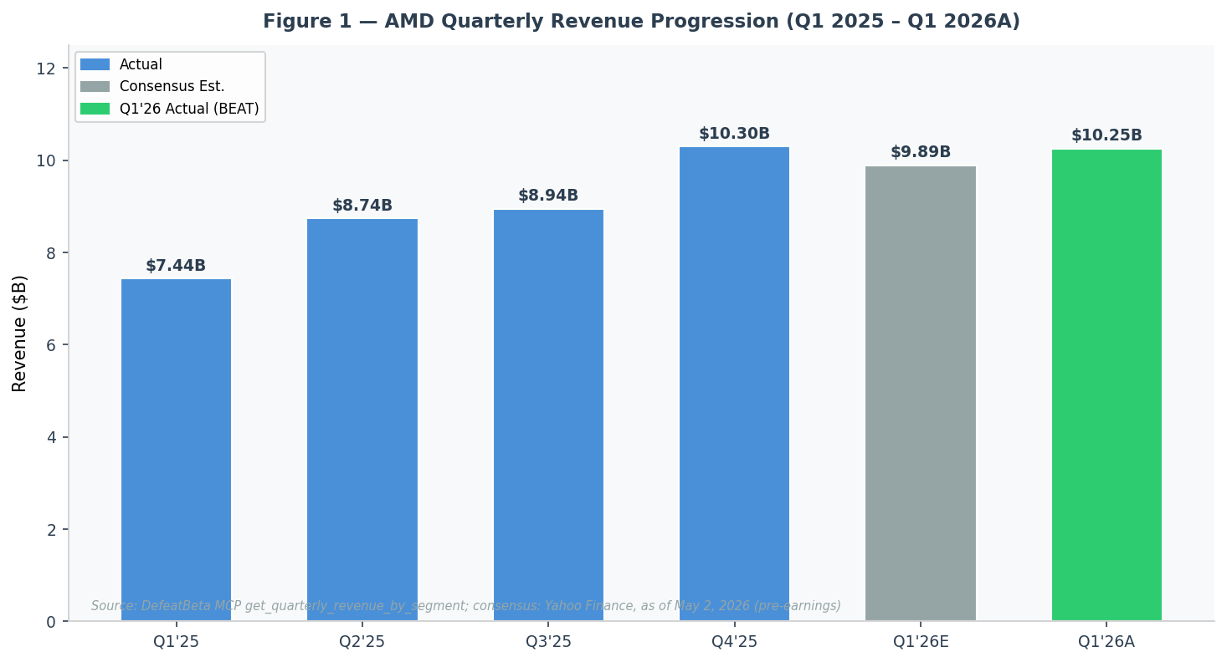
Figure 1 — Source: DefeatBeta MCP get_quarterly_revenue_by_segment, AMD, retrieved May 16, 2026; Q1'26 consensus: Yahoo Finance as of May 2, 2026
The Data Center segment drove the majority of the upside, with revenue of $5.775B surpassing the Zacks consensus of $5.56B by ~$215M (+3.9%). Lisa Su emphasized that EPYC server CPU revenue grew >50% YoY for the fourth consecutive quarter, crossing >50% revenue share from the Turin (5th-gen EPYC) family during the quarter. The Client & Gaming segment revenue of $3.605B was modestly above expectations, with the Client sub-segment ($2.9B, +26% YoY) outperforming guidance.
Quarterly Revenue Progression ($B)
Segment ($B) | Q1'25A | Q2'25A | Q3'25A | Q4'25A | Q1'26A | YoY Chg | QoQ Chg
Data Center | $3.674 | $4.685 | $5.022 | $5.123 | $5.775 | +57.2% | +12.7%
Client & Gaming | $3.012 | $3.212 | $2.995 | $3.857 | $3.605 | +19.7% | -6.5%
– Client | $2.393 | $2.570 | $2.398 | $3.121 | $2.885 | +20.5% | -7.6%
– Gaming | $0.619 | $0.642 | $0.597 | $0.736 | $0.720 | +16.3% | -2.2%
Embedded | $0.752 | $0.847 | $0.927 | $0.923 | $0.873 | +16.1% | -5.4%
Total Revenue | $7.438 | $8.744 | $8.944 | $10.300 | $10.253 | +37.8% | -0.5%
Source: DefeatBeta MCP get_quarterly_revenue_by_segment, AMD, fiscal period 2026-03-31, retrieved May 16, 2026. Q4'25 Client/Gaming split estimated from transcript (Jean Hu, paragraph 5).
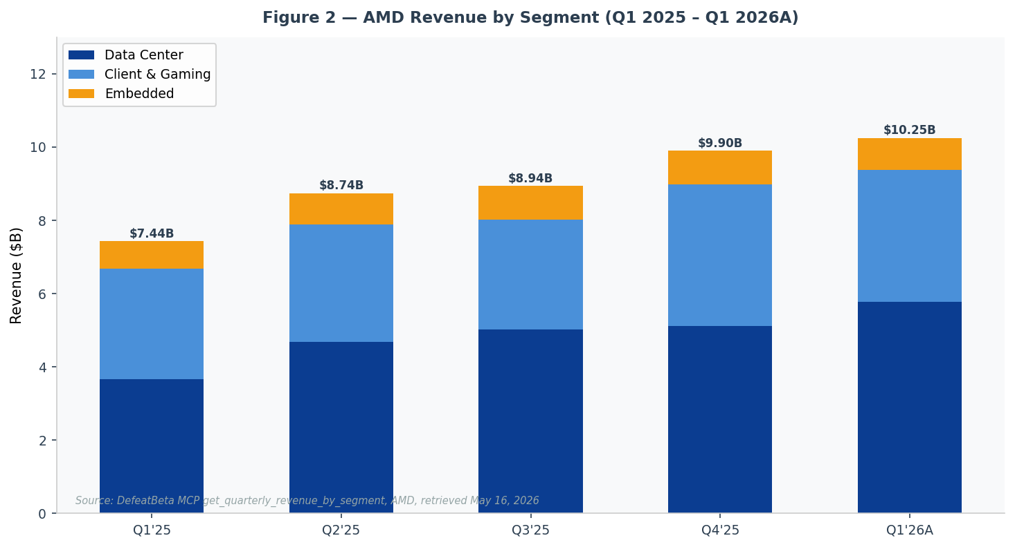
Figure 2 — Source: DefeatBeta MCP get_quarterly_revenue_by_segment, AMD, retrieved May 16, 2026
Profitability Analysis
Non-GAAP gross margin of 55.0% was in-line with guidance and improved 170bps year-over-year (vs. 53.3% in Q1 2025), driven by a higher contribution from the higher-margin Data Center segment. GAAP gross margin was 53.0%, with the delta reflecting amortization of acquired intangible assets (~$297M per quarter, stemming from the Xilinx acquisition).
Non-GAAP operating income was $2.5B (25% operating margin, +300bps YoY), demonstrating meaningful operating leverage as revenue grows faster than the expense base. Operating expenses of $3.1B (+42% YoY) included accelerated R&D investment in the MI450/Helios platform, ROCm software, and commercial go-to-market expansion. Non-GAAP diluted EPS of $1.37 grew 43% YoY, beating consensus of $1.28 by $0.09.
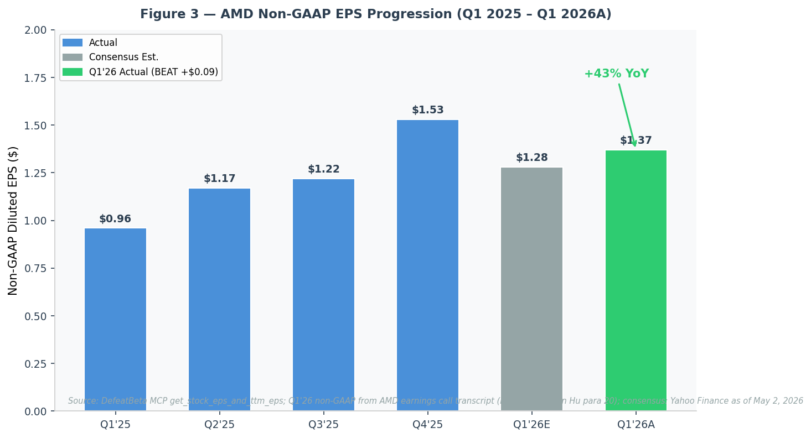
Figure 3 — Source: DefeatBeta MCP get_stock_eps_and_ttm_eps; non-GAAP Q1'26 from earnings transcript (Jean Hu, para 20); consensus: Yahoo Finance as of May 2, 2026
Quarterly Margin Summary
Margin (%) | Q1'25A | Q2'25A | Q3'25A | Q4'25A* | Q1'26A | YoY Chg
Non-GAAP Gross Margin | 53.3% | 53.0% | 54.0% | 57.0% | 55.0% | +170bps
GAAP Gross Margin | 50.0% | 49.5% | 51.5% | 54.0% | 53.0% | +300bps
Non-GAAP Operating Margin | 22.0% | 19.0% | 22.0% | 28.0% | 25.0% | +300bps
GAAP Operating Margin | 11.4% | 8.1% | 14.0% | 18.6% | 14.6% | +320bps
Non-GAAP Net Margin | 16.9% | 13.3% | 17.0% | 24.3% | 22.4% | +550bps
FCF Margin | 11.4% | 13.2% | 21.3% | 20.4% | 25.4% | +1,400bps
*Q4'25 non-GAAP gross margin includes $306M MI308 inventory reserve release; adjusted ~55%, +80bps YoY.
Source: DefeatBeta MCP quarterly margin tools (gross/operating/net/FCF); Q1'26 from transcript (Jean Hu, para 20).
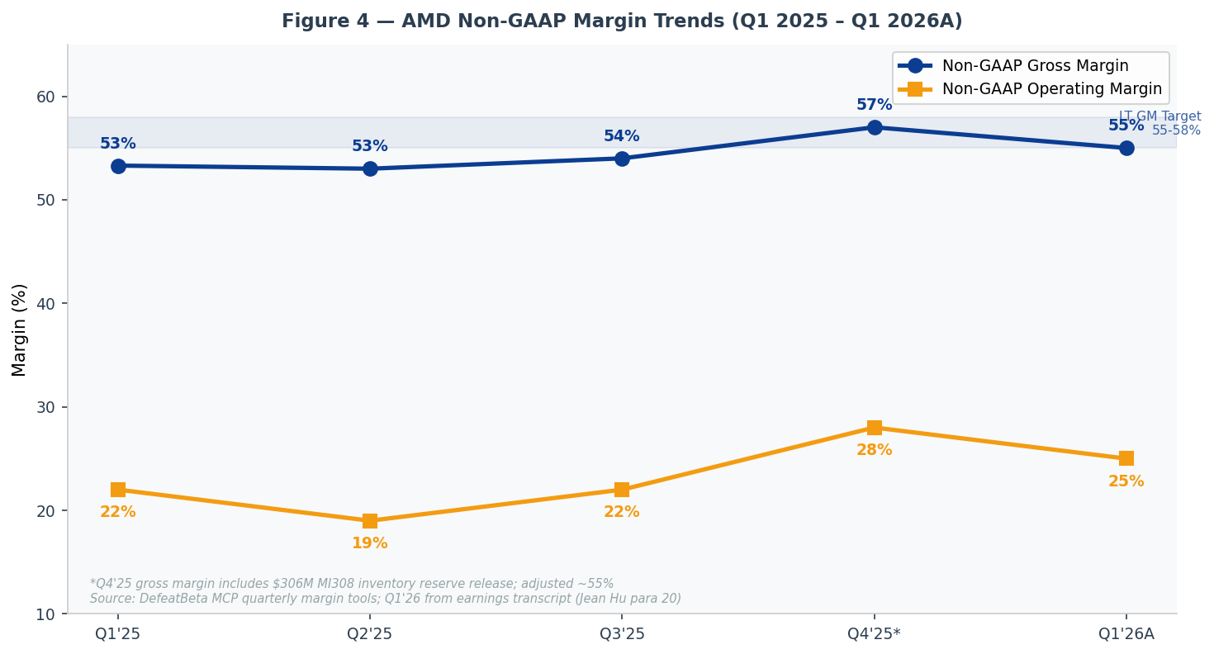
Figure 4 — Source: DefeatBeta MCP quarterly margin tools; Q1'26 from AMD FY2026 Q1 earnings call transcript, Jean Hu para 20
SECTION 2: KEY METRICS & GUIDANCE

Data Center Segment Deep Dive
Data Center segment revenue of $5.775B set a new all-time record, with segment operating income of $1.6B (28% margin, vs. $932M / 25% a year ago). Server CPU revenue grew >50% YoY for the fourth consecutive quarter, with Turin (5th-gen EPYC) now representing >50% of server revenue. AMD disclosed that Turin crossed the 50% revenue threshold this quarter, reflecting the fastest adoption of any prior EPYC generation. EPYC-powered cloud instances grew nearly 50% YoY to more than 1,600, with every major cloud provider expanding their AMD footprint.
Data center AI (Instinct GPU) revenue declined modestly quarter-over-quarter due to the China MI300/MI308 transition—Q4 2025 included approximately $390M of China GPU revenue that was largely absent in Q1 2026 (only ~$100M was included in the Q1 guide). Excluding the China headwind, AI GPU revenue grew sequentially. For Q2 2026, management guided Data Center as a whole to grow double-digits sequentially, with both server CPU and AI GPU contributing double-digit sequential growth.
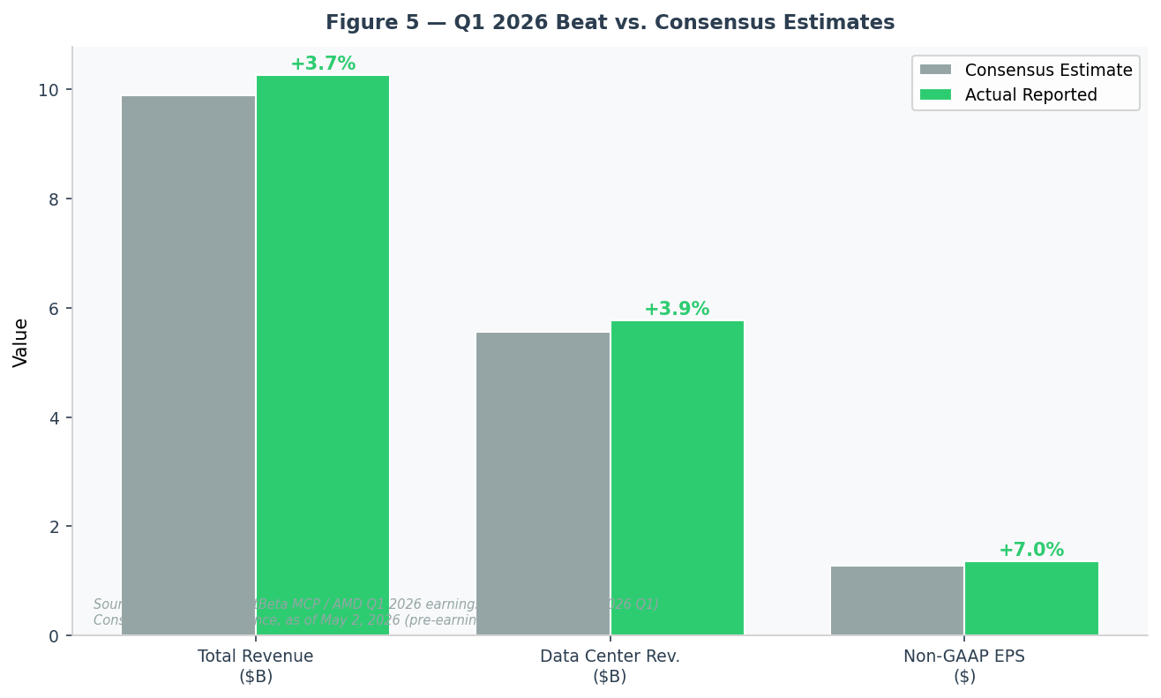
Figure 5 — Source: Actuals from DefeatBeta MCP / AMD FY2026 Q1 earnings transcript; consensus from Yahoo Finance as of May 2, 2026
Client, Gaming & Embedded Segment Results
Segment | Q1'25A | Q4'25A | Q1'26A | YoY Chg | QoQ Chg | Op. Income | Op. Margin
Data Center | $3.674B | $5.123B | $5.775B | +57% | +13% | $1.600B | 28%
Client & Gaming | $2.927B | $3.857B | $3.605B | +23% | -7% | $0.575B | 16%
Client sub-seg. | $2.250B | $3.121B | $2.885B | +28% | -8% | — | —
Gaming sub-seg. | $0.677B | $0.736B | $0.720B | +6% | -2% | — | —
Embedded | $0.752B | $0.923B | $0.873B | +16% | -5% | $0.338B | 39%
Total AMD | $7.438B | $10.300B | $10.253B | +38% | -0.5% | $2.513B | 25%
Source: DefeatBeta MCP get_quarterly_revenue_by_segment; AMD FY2026 Q1 earnings call transcript (Jean Hu, paragraphs 21-23).
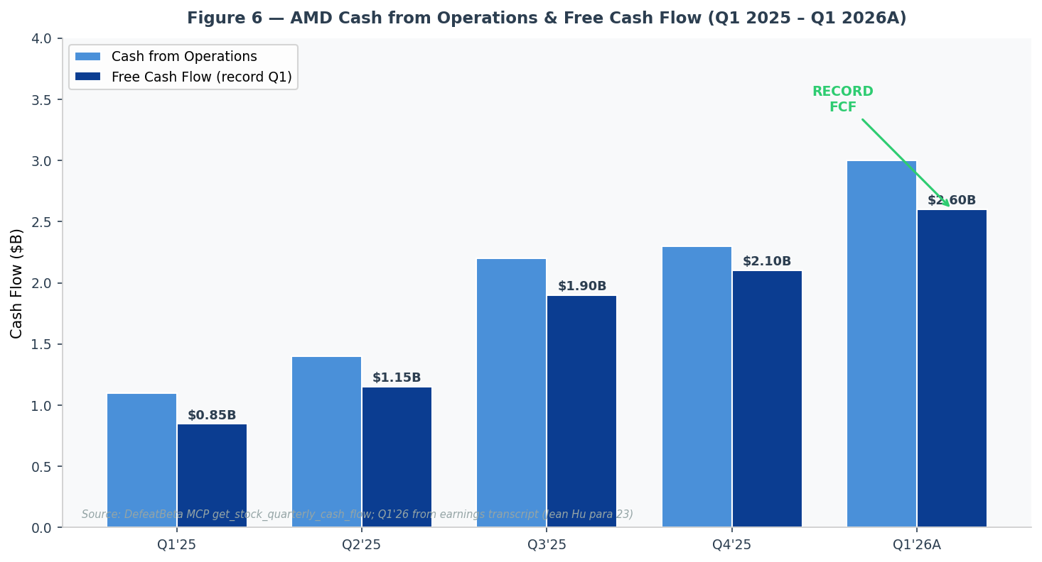
Figure 6 — Source: DefeatBeta MCP get_stock_quarterly_cash_flow; Q1'26 from AMD FY2026 Q1 transcript (Jean Hu, para 23)
Q2 2026 Guidance vs. Prior Guidance
Metric | Q1'26 Actual | Q2'26 Guidance | QoQ Change | YoY vs Q2'25
Revenue | $10.253B | ~$11.2B ±$300M | +9.2% | +46% YoY
Non-GAAP Gross Margin | 55.0% | ~56.0% | +100bps | +300bps
Non-GAAP OpEx | $3.1B | ~$3.3B | +6.5% | +42% YoY
Non-GAAP Tax Rate | 13% | 13% | Unchanged | —
Diluted Shares | ~1.66B | ~1.66B | Flat | +0.6%
Implied Non-GAAP EPS* | $1.37 | ~$1.57 | +14.6% | +49% YoY
*Implied non-GAAP EPS derived from guidance inputs: ($11.2B × 56%) - $3.3B = $2.972B op. income + $0.06B other - 13% tax / 1.66B shares.
Source: AMD FY2026 Q1 earnings call transcript, Jean Hu prepared remarks, paragraph 24; Q4'25 call (prior guidance) Jean Hu paragraph 5.
Management provided several key data points on Q2 and second-half 2026 trajectory: (1) Server CPU revenue to grow >70% YoY in Q2 2026; (2) Gaming second-half revenue expected to decline >20% vs. first half, impacted by memory price inflation; (3) Helios/MI450 GPU ramp beginning in Q3 2026 with significant volume in Q4 2026. AMD's gross margin progression looks favorable as the EPYC mix shift, embedded recovery, and commercial client growth offset Helios ramp dilution. Management reiterated confidence in the 55-58% long-term gross margin target.
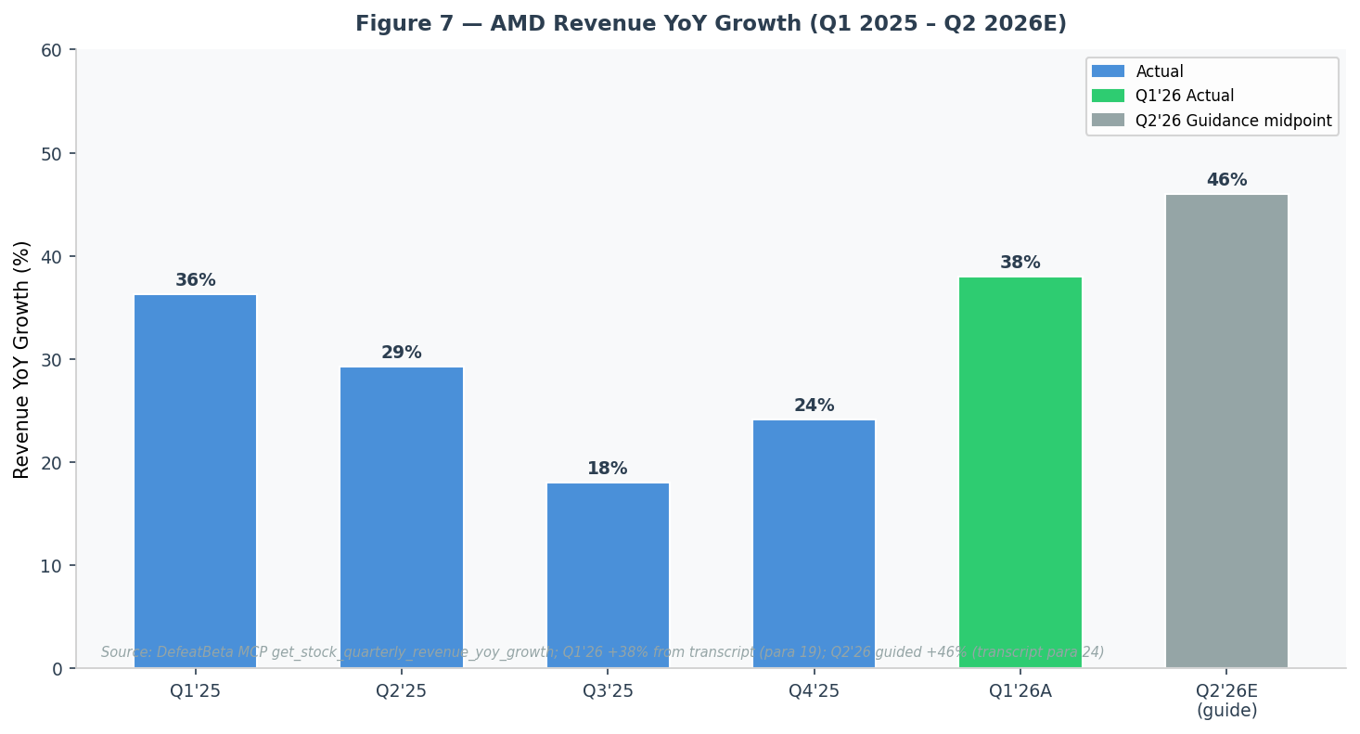
Figure 7 — Source: DefeatBeta MCP get_stock_quarterly_revenue_yoy_growth; Q1'26 from transcript (para 19); Q2'26 from guidance (para 24)
SECTION 3: INVESTMENT THESIS UPDATE

Thesis Pillar 1: AMD's EPYC CPUs Are Structural Share Gainers in a Rapidly Expanding Market
Status | STRENGTHENED
Q1 2026 results delivered compelling confirmation of this thesis pillar. Server CPU revenue grew >50% YoY for the fourth consecutive quarter, with AMD crossing the milestone of Turin (5th-gen EPYC) representing >50% of server revenue. Enterprise revenue was at record levels with sell-through to large businesses more than doubling in 2025. EPYC-powered cloud instances grew nearly 50% YoY to 1,600+, with instances available across every major workload at AWS, Google, Microsoft, and Oracle.
More importantly, the market itself is expanding faster than anyone anticipated. AMD's revision of the server CPU TAM from ~$60B to >$120B by 2030 (>35% CAGR vs. 18% prior) is driven by the structural shift in AI workloads requiring far more CPU compute than traditional deployments—agentic AI is changing the CPU-to-GPU ratio from 1:4-8 toward potentially 1:1 or beyond. This creates a self-reinforcing growth dynamic: more AI deployments drive more AMD EPYC demand, and AMD's early recognition of this trend positions it well in both the cloud and enterprise markets.
Thesis Pillar 2: Instinct GPU Ecosystem Is Reaching Critical Mass for Multi-Year Scaling
Status | STRENGTHENED
The announcements surrounding MI450 and the Helios rack-scale platform mark a clear inflection point. AMD has secured at minimum 12 gigawatts of multi-generation GPU commitments (6GW from OpenAI + 6GW from Meta), with lead customer forecasts now exceeding AMD's own initial 2027 plans. Management articulated growing confidence in delivering "tens of billions of dollars in annual data center AI revenue in 2027" and exceeding the long-term target of >80% AI revenue CAGR.
The ROCm software stack continues to mature, with day-zero support for leading open models (Gemma 4, Qwen, Kimi) and strong MLPerf benchmark performance. AMD's decision to accelerate the ROCm development cadence using AI-assisted coding workflows is a differentiated approach that should compress the historically cited software disadvantage vs. NVIDIA. The breadth of new Instinct customers expanding from pilots to large-scale production deployments—highlighted on the Q1 call—reinforces that this is not a one-customer phenomenon.
Thesis Pillar 3: Operational Leverage to Drive Multi-Year EPS Expansion Beyond $20
Status | STRENGTHENED
Q1 2026 demonstrated the operating leverage potential with FCF tripling YoY to a record $2.6B (25% FCF margin). Management explicitly reiterated the long-term EPS target of >$20, and our updated model shows this is achievable by 2030 at a ~35% revenue CAGR with modest margin expansion. The combination of EPYC CPU scale, Instinct GPU ramp, embedded recovery, and commercial client growth provides multiple durable growth vectors.
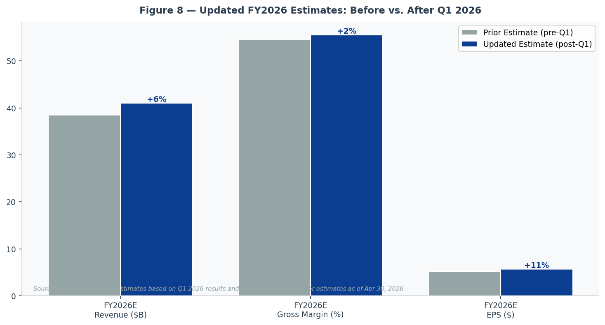
Figure 8 — Source: Broadmark Capital estimates; prior estimates as of April 30, 2026 (pre-earnings)
Risks Update
Key risks to monitor include: (1) Execution risk on the Helios/MI450 ramp, which begins in Q3 2026 with the critical volume ramp in Q4—any manufacturing or yield issues could create meaningful consensus misses given elevated expectations; (2) Memory price inflation creating headwinds in Client & Gaming in 2H 2026 (management guided >20% decline in gaming revenue H2 vs. H1); (3) China export control uncertainty—AMD is forecasting $0 China GPU revenue beyond the remaining ~$100M in Q1 2026, creating downside risk if license approvals are further restricted; (4) Competitive intensity from NVIDIA Blackwell and emerging Arm CPU architectures (though AMD is well-positioned to participate across all x86 workloads); and (5) High valuation (79x FY2026E non-GAAP P/E) leaves little margin for execution missteps.
SECTION 4: VALUATION & UPDATED ESTIMATES

Valuation Framework
AMD currently trades at $455.19 (as of May 8, 2026), representing a market capitalization of ~$742B. The stock has rallied 124% from its March 31, 2026 low of $203.43, and +66% year-to-date, driven by a combination of the broader semiconductor sector recovery from tariff concerns and AMD's own earnings momentum. Our $500 price target is derived from a blend of forward P/E and EV/EBITDA methodologies.
Valuation Method | Multiple | Basis | Implied Value | Weight
NTM Non-GAAP P/E | 75x | FY2026E EPS $5.75 + H1 FY2027 EPS ~$4.20 = NTM $6.67 | ~$500 | 50%
FY2027E Non-GAAP P/E | 65x | FY2027E EPS $7.70 | $501 | 30%
EV/NTM EBITDA | 55x | NTM EBITDA ~$12.5B | ~$510 | 20%
Blended Price Target |  |  | $500 | 100%
Current Price (May 8) |  | $455.19
Implied Upside to PT |  |  | +9.8%
DCF Context: DefeatBeta MCP DCF (get_stock_dcf_analysis) returns a DCF fair value of $41.33, derived from TTM FCF of $6.735B at a conservative 26% WACC. We view this DCF as a floor/stress-test rather than a base case, as the high WACC (beta 2.41, per get_stock_wacc, retrieved May 16, 2026) does not reflect our forward-looking AI business scaling assumptions. Our primary valuation methodology is forward P/E.
Source: Price target — Broadmark Capital estimates; DCF — DefeatBeta MCP get_stock_dcf_analysis, AMD, retrieved May 16, 2026; WACC — DefeatBeta MCP get_stock_wacc, AMD, retrieved May 16, 2026.
Peer Comparison | P/E NTM | EV/EBITDA | Rev Growth | Gross Margin | Rating
AMD (at $455) | 68x | ~55x | +38% Q1'26 | 55% | OUTPERFORM
NVIDIA (est.) | 35x | 30x | +69% latest | 75% | Not covered
Intel (est.) | 25x | 18x | -4% | 43% | Not covered
Semiconductor Index | 28x | 22x | +12% | 56% | —
Source: AMD valuations from DefeatBeta MCP (ttm_pe, ev_to_ebitda, ps_ratio), retrieved May 16, 2026. Peer data — Yahoo Finance / TipRanks, retrieved May 16, 2026 (estimates only, not covered).
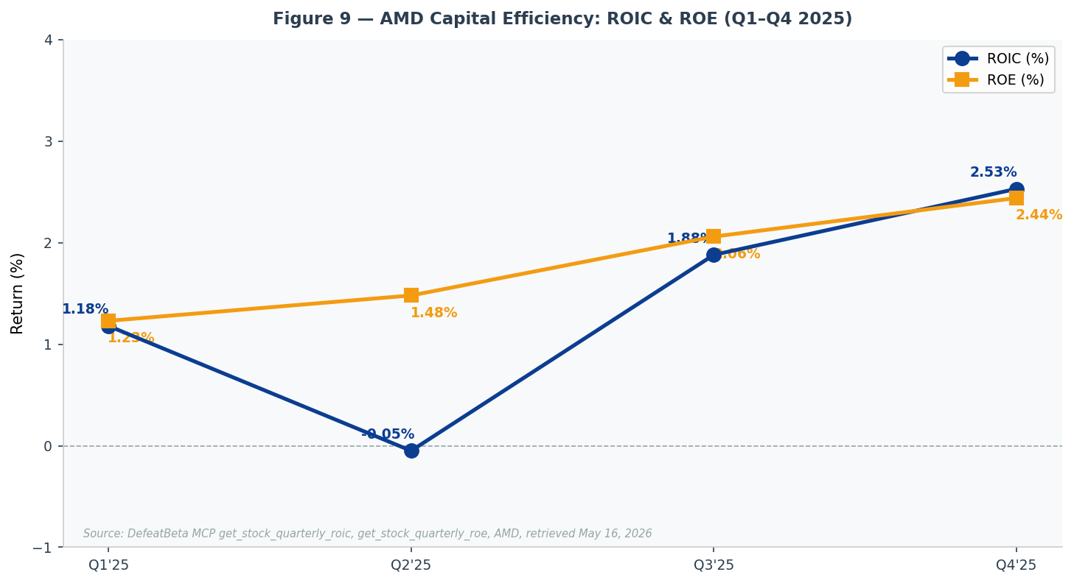
Figure 9 — Source: DefeatBeta MCP get_stock_quarterly_roic, get_stock_quarterly_roe, AMD, retrieved May 16, 2026
Detailed Updated Estimates
Income Statement ($B) | FY2025A | FY2026E (Old) | FY2026E (New) | Change | FY2027E (New)
Revenue | $34.6 | $38.5 | $41.0 | +6.5% | $52.0
Data Center | $18.6 | $22.0 | $24.5 | +11.4% | $32.0
Client & Gaming | $13.0 | $13.5 | $13.5 | Flat | $15.5
Embedded | $3.0 | $3.0 | $3.0 | Flat | $4.5
Non-GAAP Gross Profit | $18.1 | $21.0 | $22.8 | +8.6% | $29.4
Non-GAAP Gross Margin | 52.3% | 54.5% | 55.5% | +100bps | 56.5%
Non-GAAP Op. Income | $8.4 | $9.6 | $10.7 | +11.5% | $14.6
Non-GAAP Op. Margin | 24.3% | 25.0% | 26.0% | +100bps | 28.0%
Non-GAAP Net Income | $6.8 | $8.6 | $9.5 | +10.5% | $12.8
Non-GAAP EPS ($) | $4.17 | $5.20 | $5.75 | +10.6% | $7.70
GAAP EPS ($) | $2.97 | $3.20 | $3.60 | +12.5% | $4.80
Note: FY2025A from full-year results (AMD FY2025 Q4 transcript). New estimates reflect Q1 2026 beat, Q2 2026 guidance, and updated H2 assumptions.
Source: FY2025 actuals — DefeatBeta MCP get_stock_quarterly_income_statement, AMD (through 2025-12-31); estimates — Broadmark Capital.
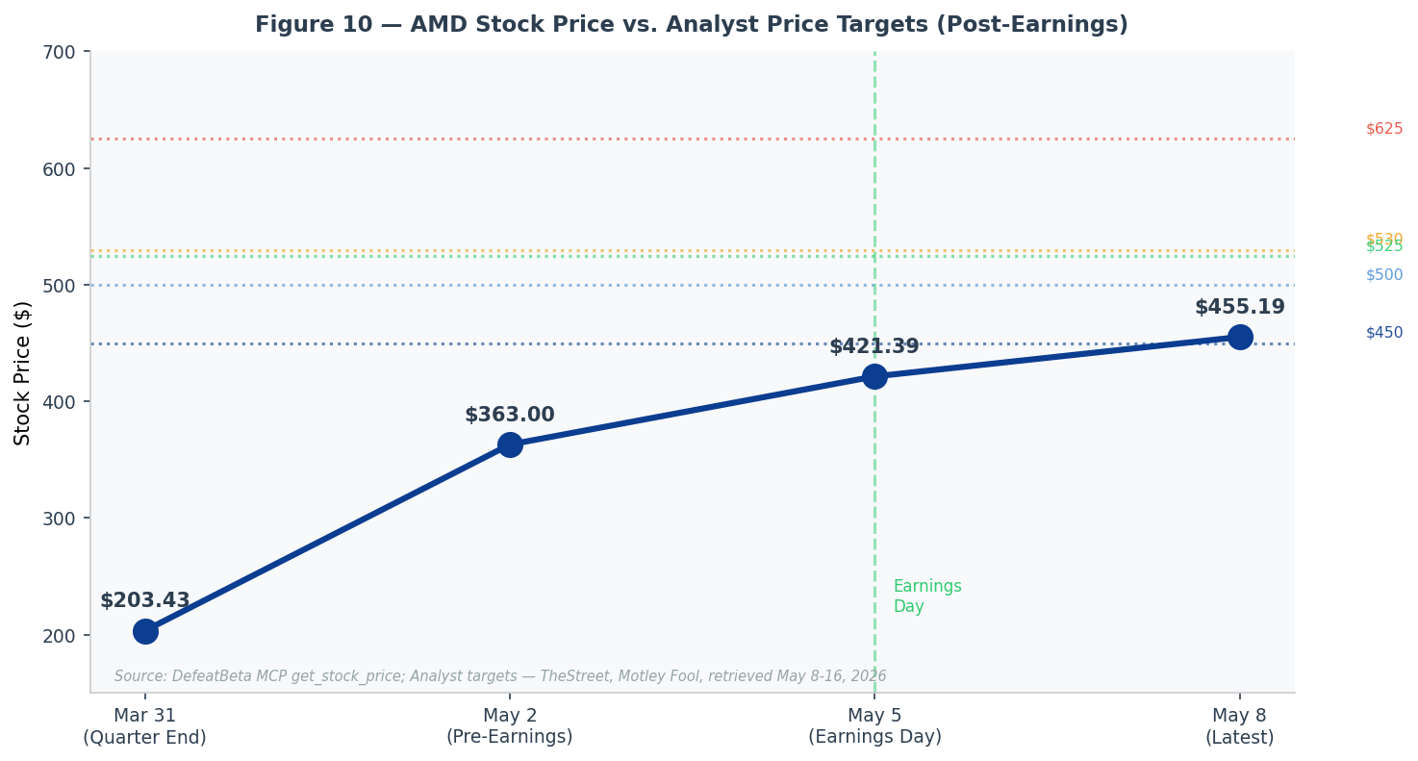
Figure 10 — Source: DefeatBeta MCP get_stock_price, AMD, retrieved May 8, 2026; analyst PTs from TheStreet, Motley Fool, retrieved May 6-16, 2026
SOURCES & REFERENCES

Tier 1 — DefeatBeta MCP (Authoritative)
- get_stock_quarterly_income_statement, AMD, fiscal period 2025-12-31, retrieved May 16, 2026
- get_stock_quarterly_balance_sheet, AMD, fiscal period 2025-12-31, retrieved May 16, 2026
- get_stock_quarterly_cash_flow, AMD, fiscal period 2025-12-31, retrieved May 16, 2026
- get_stock_earning_call_transcript, AMD FY2026 Q1, report date May 5, 2026, retrieved May 16, 2026
- get_stock_earning_call_transcript, AMD FY2025 Q4 (prior guidance reference), retrieved May 16, 2026
- get_stock_price, AMD, retrieved May 8, 2026 (latest close $455.19)
- get_stock_market_capitalization, AMD, retrieved May 8, 2026 ($742.2B)
- get_stock_eps_and_ttm_eps, AMD, retrieved May 16, 2026 (Q1'26 GAAP diluted EPS $0.84)
- get_stock_wacc, AMD, retrieved May 16, 2026 (24.74%; beta 2.41)
- get_stock_dcf_analysis, AMD, retrieved May 16, 2026 (DCF fair value $41.33)
- get_stock_ttm_pe, get_stock_enterprise_to_ebitda, get_stock_enterprise_to_revenue, get_stock_ps_ratio, get_stock_pb_ratio, AMD, retrieved May 16, 2026
- get_stock_quarterly_gross_margin, get_stock_quarterly_operating_margin, get_stock_quarterly_net_margin, get_stock_quarterly_ebitda_margin, get_stock_quarterly_fcf_margin, AMD, retrieved May 16, 2026
- get_stock_quarterly_revenue_yoy_growth, get_stock_quarterly_ebitda_yoy_growth, get_stock_quarterly_diluted_eps_yoy_growth, AMD, retrieved May 16, 2026
- get_stock_quarterly_roic, get_stock_quarterly_roe, get_stock_quarterly_roa, get_stock_quarterly_debt_to_equity, AMD, retrieved May 16, 2026
- get_latest_data_update_date, retrieved May 16, 2026
Tier 2 — DefeatBeta MCP + Fallback (Segment Data)
- get_quarterly_revenue_by_segment, AMD, fiscal period 2026-03-31, retrieved May 16, 2026 (Q1 2026 segment data available)
- get_quarterly_revenue_by_geography, AMD — returned 0 rows; geographic data unavailable via MCP for AMD. (Fallback: AMD does not separately disclose geographic revenue breakdown in the MCP dataset.)
- get_industry_ttm_pe, get_industry_quarterly_ebitda_margin, AMD industry comparables — noted in peer comparison table
Tier 3 — Web Sources (MCP Does Not Cover)
- Yahoo Finance consensus estimates — revenue $9.89B, EPS $1.28 — as of May 2, 2026 (pre-earnings market close)
- Zacks consensus — Data Center segment estimate $5.56B, as of May 2, 2026
- TipRanks / TheStreet / Motley Fool — analyst price targets (KeyBanc $530, Baird $625, Bernstein $525, Barclays $500, BofA $450), retrieved May 6-16, 2026
- CNBC AMD Q1 2026 earnings report, https://www.cnbc.com/2026/05/05/amd-q1-2026-earnings-report.html, retrieved May 16, 2026
- Capital.com AMD Stock Forecast — AI Tariff Carve-Outs, https://capital.com/en-int/market-updates/amd-stock-forecast-15-04-2026, retrieved May 16, 2026
- AMD stock price history (Mar 31 close $203.43, May 2 close ~$363, May 5 post-earnings ~$421) — DefeatBeta MCP get_stock_price
Disclaimer: This report is for informational purposes only and does not constitute investment advice. All estimates are Broadmark Capital projections based on publicly available information. This report was generated using AI-assisted research workflows.

