Student-Trainee: **Florendo Cyrus Nathaniel P.**  Course: **BSIS-NS-4A**

Name of Company­: **S.P. Madrid & Associates**

Address of Company: **5th Floor Tower 2, Parañaque Integrated Terminal Exchange, No.1 Kennedy Road, Barangay Tambo, Parañaque City**

Period of Training: From: **February 26, 2025** To: **May 30, 2025**

1. **Introduction (One paragraph only.) What is SIT all about?**

SIT, or Supervised Industrial Training, is a program that provides us students the opportunity to experience hands-on the life of a professional, in a proper environment, and in a given amount of time. It aims to connect the knowledge you build from your university to the actual industry, allowing students like me to apply my foundational and theoretical knowledge, develop and improve essential workplace skills, while also be able to gain better understanding into the field we chose. SIT is not only a requirement like a project that you just need to finish, but it is more importantly an opportunity to prepare ourselves for the actual demands of the industry, more specifically for me, the IT industry.

1. **Job/s performed in the Company**

My overall training done at S.P. Madrid & Associates is actually very helpful, as I was able to experience many different parts of software development, such as being assigned to data handling, UI modification, debugging workflows, and constant participating in team meetings and project planning. Even with a low-code setup, I was able to contribute to the front-end and back-end settings within the Bubble.io platform, helping improve app UI/UX, usability, while also doing quality assurance testing of various websites.

1. **Experience earned in terms of:**
2. **Knowledge (Principles, Theories and Concepts) – State here the things learned in school that was applied in the job and that knowledge that was learned while undergoing the training.**

During my internship, I was able to put to use some of the knowledge I learned in the university, such as being able to apply the concepts of system design, data structures, and web development fundamentals mainly, as we designed and made a number of processes that has the database interacting with the front-end. I also encountered a different type of version control, with Bubble.io’s own merging process. Throughout the training, I expanded my understanding of no-code platforms, API and 3rd party connections, and learned the software development life-cycle in an actual project environment.

1. **Skills (Applied and Developed.)**

Throughout my internship, I was able to apply various skills I have learned from the university to the actual work in the company. Not only was I able to apply them, I was also able to improve existing ones and develop new skills, some of which I will state below.

* 1. **Skills learned in school are useful in the job.**
  2. My background in HTML, CSS, JS, and front-end frameworks helped me understand the structure and behavior of Bubble.io much easier, using basically containers. Basic database concepts and knowledge of CRUD operations, most especially from my capstone project, proved to play a vital role in performing my assigned tasks with ease, or at least with the proper direction.
  3. **Skills learned in the company while on training.**
  4. I became familiar with the use of low code applications such as Bubble.io for developing web applications, learned how to organize workflows, use conditional formatting, and create responsive, easy to understand interfaces. I also was able to take part and improve my communication skills and problem-solving skills by collaborating with my team, and handling tasks under supervision

1. **Values (Learned and Applied.)**  
   I learned the value of discipline, accountability, assurance, and being proactive in a work environment. Time management and consistency were also very essential in completing the daily tasks, as this has actual effect on the clients/users. I also learned better the importance of openness to feedback and the humility to take criticism and ask questions when unsure, as it is always better to ask now than to regret later.
2. **Human Relationship (Observed and Applied.)**  
   I observed and experienced first-hand the importance of good teamwork, clear communication, and mutual respect among colleagues of different positions. Everyone’s contribution was valued, even those in a different field from mine, whether it be HR, security, or maintenance, having a positive attitude made life easier. Collaboration was key in achieving daily and weekly goals, and by applying these lessons by being open, cooperative, asking for guidance wen needed, and giving feedback during discussions, I was able to grow in a way that helps me prepare for the industry.

**IV. Problems met while on training.**

1. School related problems

Fortunately, there was no real school-related challenge as the communication from my SIT director and company HR were as smooth as I could have hoped. I would say that some challenges did occur such as having to organize and prepare for our capstones’ concerns while I had internship ongoing, making me have to be absent for some days to address said concerns.

1. Company-related problems.

For the company, the only problem I had was adjusting first-hand at a work environment with new technologies, but this only took a few days before I got a good idea on how I will be operating on a day-to-day basis. Being with a classmate also helped in terms of having someone to talk to, while also debating and addressing some concerns. But since the people here are easy to approach, together with co-interns who helped the process be a lot smoother. As such, company-related problems did not really appear, as the workload I received is I think fair.

**V.**  **Suggestions and Recommendations (For the improvement of the curricula.)**

For the improvement of SIT, I would like it if there was a way to make students take their internship at an earlier date, possibly having it start during the semester break, so the hours can be rendered in at an earlier rate allowing for better time management in terms of fixing other responsibilities such as Capstone/Thesis workloads. I believe this will prove to be helpful not only for the students but also the supervisors and directors as there would be more time to set things, while also allowing the students to experience the internship with less problems in mind.

**VI.**  **Documents/ Requirements**

* 1. IRJP Form for Daily Work Activities
  2. Daily Time Record
  3. Evaluation Sheet Record
  4. Certificate of Completion

**VII. This narrative report should be typewritten w/ Training in Action (3 to 5 pcs. of photo), placed in clear book (short size), at least 20 to 25 pages and to be submitted immediately one week after the training.**

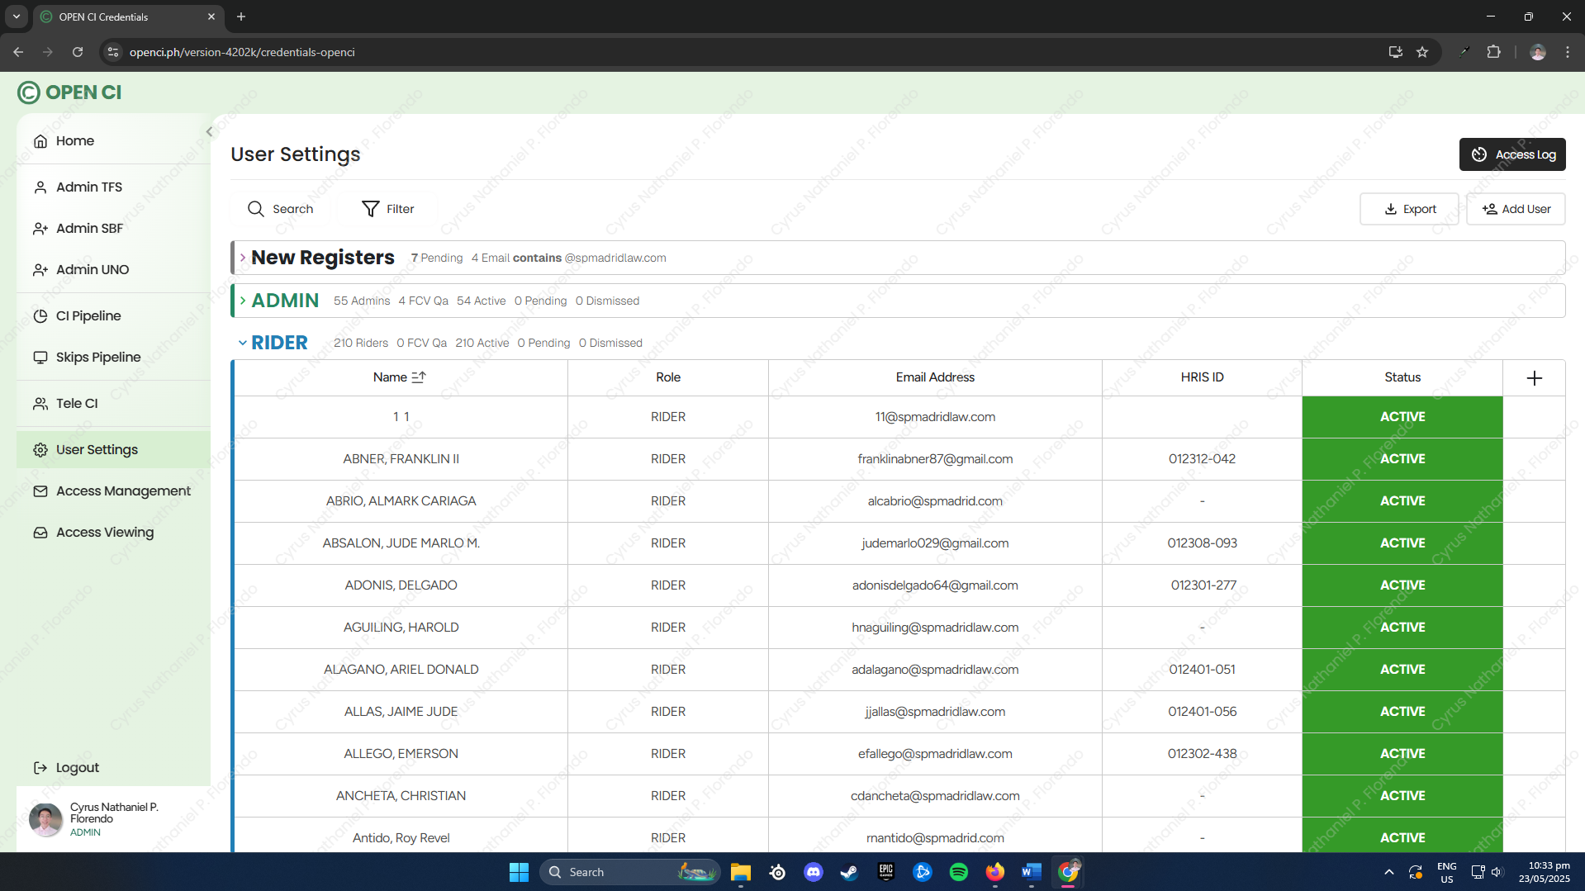  
Photo 1 - One of the Many UI/UX I Co-Designed

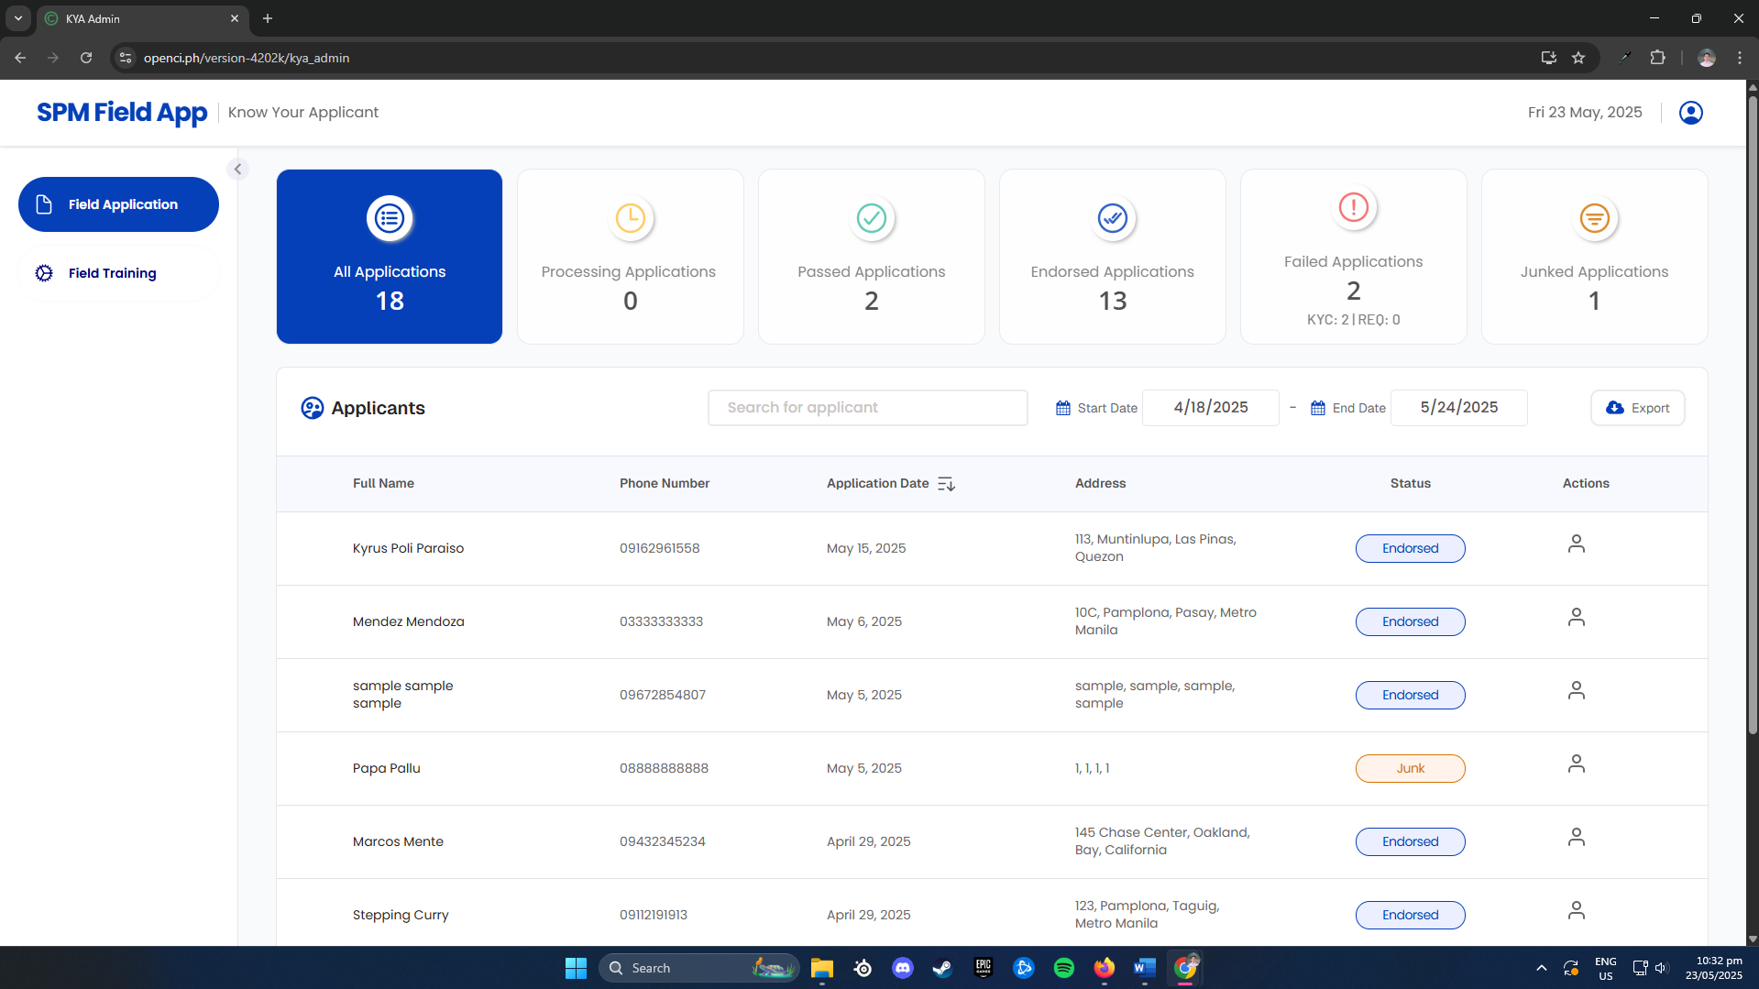  
Photo 2 - Admin Dashboard of the KYC/KYA I Co-Developed

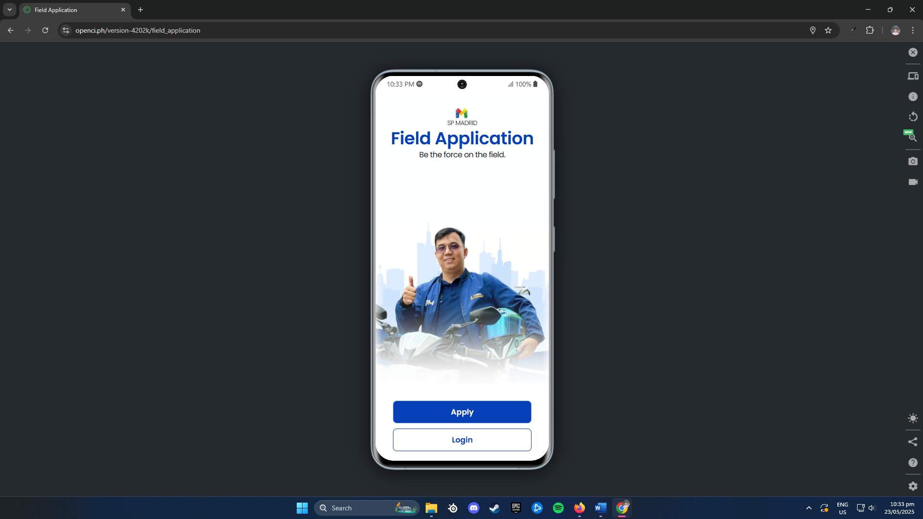  
Photo 3 - Landing Page of the KYC/KYA WebApp I Co-Developed

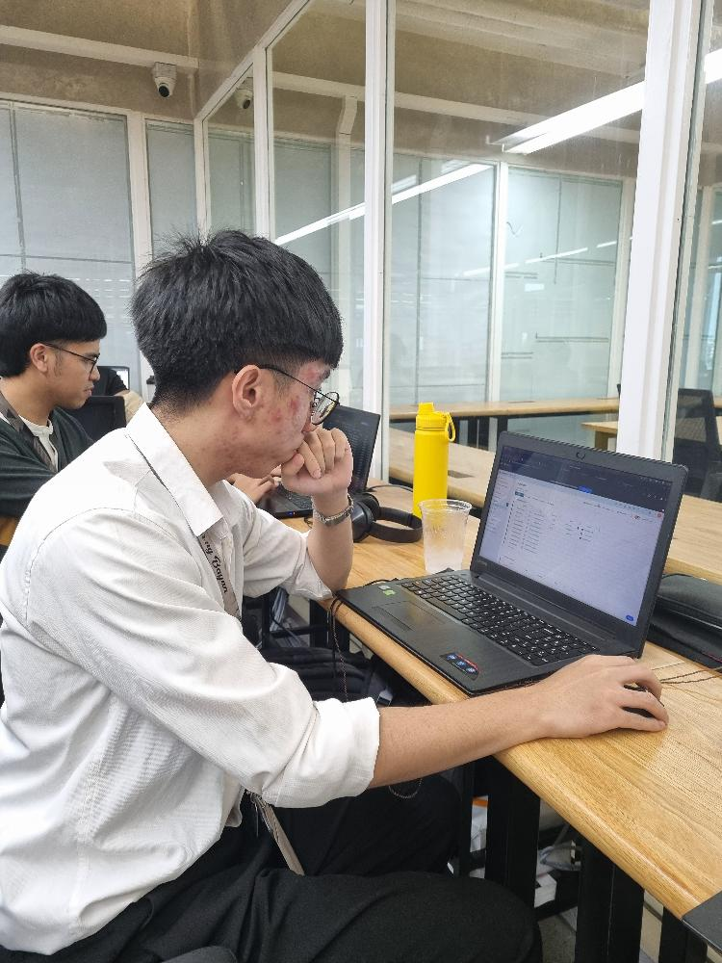   
Photo 4 - Myself Working  
  
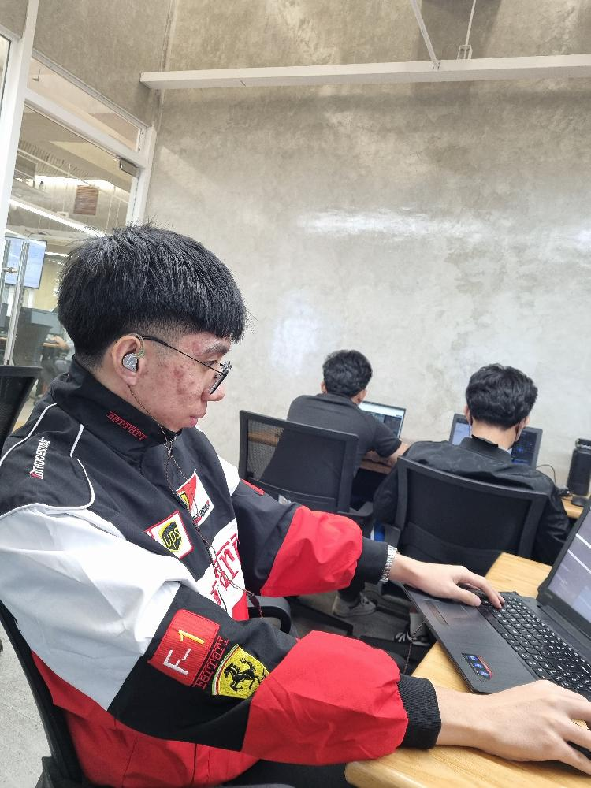  
Photo 5 - Myself Working 2