Champaign Police Department
82 E. University Avenue
Champaign IL 61820
(217) 351-4545
police@champaignil.gov
www.champaignpolice.com


MEMORANDUM

To: Chief Timothy T. Tyler
From: Interim Deputy Chief Kevin Olmstead
Date: July 22, 2022
Subject: Automatic License Plate Reader Program Evaluation

Summary:

The information provided in this report is dedicated to reviewing the effectiveness of the Department's Automatic License Plate Reader (ALPR) program. Based on the information contained herein, it is recommended that the Department consider purchasing additional ALPRs.

Background:

The purchase of 46 Automatic License Plate Readers (ALPRs) from Flock was authorized by Council on December 21, 2021 (CB2021-178). The purchase and implementation of the ALPRs was in response to a significant increase in violent crime, focusing largely on gun violence, which continued to trend up since 2013. Once contract issues were resolved in March 2022, the installation of 32 ALPRs, those not requiring permitting from the Illinois Department of Transportation (IDOT), were anticipated to start in late spring 2022. The installation of 14 ALPRs requiring IDOT permitting were anticipated to start in late summer 2022.

The term of the agreement with Flock was for two years, which does not commence until the last ALPR is installed. It is important to note that ALPRs can be relocated based on changes in crime trends so that the technology can be best positioned to have a meaningful impact on areas of the community experiencing the highest levels of violence and crime. However, there is a relocation fee for each move, and relocations can require several weeks to months to complete. An ALPR assigned for relocation can remain operational in its current location until being relocated.

The Department developed the recommended locations for the 46 ALPRs in consultation with a Flock representative. The deployment plan included analyzing five (5) years of data on shooting incidents and associated locations. The primary goal of the ALPR location recommendations was to provide adequate coverage to the neighborhoods most frequently affected by gun violence. ALPRs were located outside of the neighborhoods most frequently affected by gun violence, not within them. Preliminary deployment plans focused on arterial streets and the routes most likely to be traveled by those committing acts of gun violence. ALPRs were also designated for major entry and exit points to the city.

Through July 11, 2022, there was a 51% reduction in shooting incidents in Champaign compared to the same timeframe last year. During the same period in 2021, there were 145 shooting incidents in Champaign, but so far in 2022, that number has dropped to 71. The shooting incidents have continued to occur nearly city-wide but are more concentrated north of University Avenue within the Department's North and Northwest Districts. Two additional clusters of shooting incidents, one in the area of the Gramercy Park and the Countrybrook Apartment complexes and one in the area of Campustown, exist in the remainder of the city. The concentration of shooting incident locations in 2022 remains broadly consistent with trends observed over the past five years. The locations of the 2022 shooting incidents are outlined on the following map:

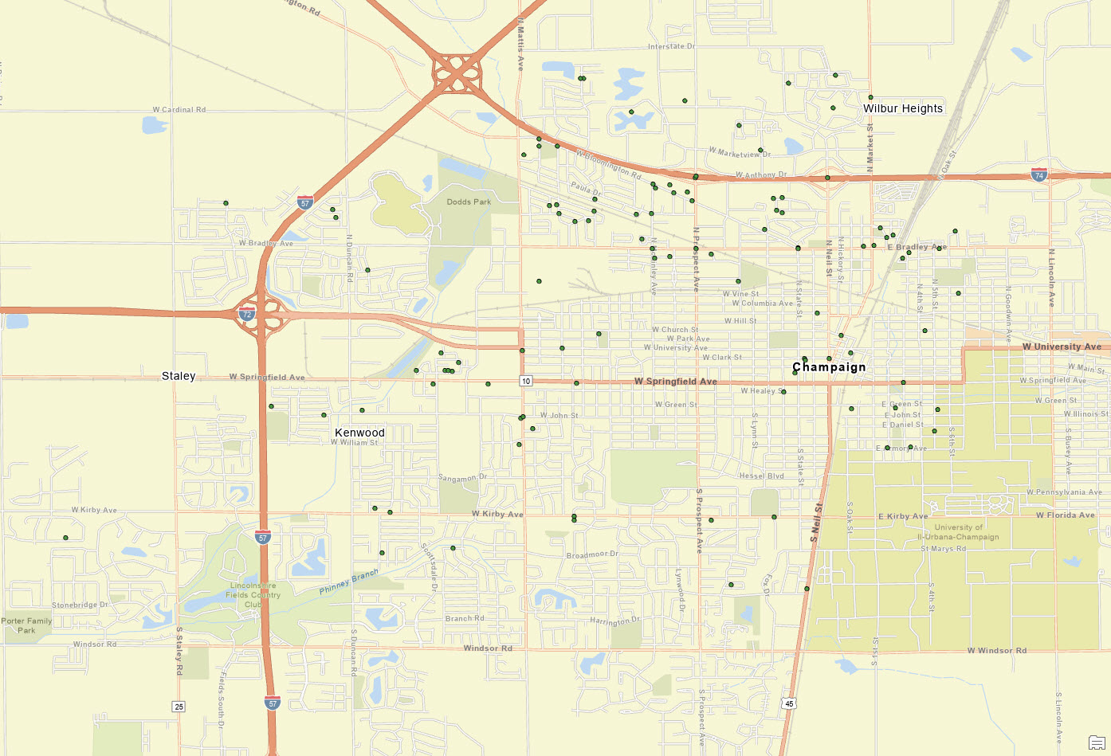

Maps documenting the shooting incident locations for the previous four years are attached.

Current ALPR Locations:

The following table and map outline the locations of all ALPR locations, those currently operational and the ones pending installation. The table includes the direction of travel the ALPR is designed to capture.

Camera | Location | Direction |  | Camera | Location | Direction
#01 | Prospect @ 74 | SB |  | #24 | Neil @ Hill | SB
#02 | Bloomington @ Mattis | EB |  | #25 | Bradley @ Crispus | WB
#03 | Prospect @ Bradley | NB |  | #26 | Bradley @ Sixth | EB
#04 | Bradley @ Prospect | EB |  | #27 | Market @ Marketview | SB
#05 | Francis @ McKinley | EB |  | #28 | Marketview @ Neil | EB
#06 | Neil @ Bradley | NB |  | #29 | Marketview @ Neil | WB
#07 | Neil @ 74 | SB |  | #30 | Neil @ Marketview | NB
#08 | McKinley @Paula | SB |  | #31 | Marketview @ Prospect | EB
#09 | Neil @ Kenyon | NB |  | #32 | Olympian @ Boardwalk | EB
#10 | Bloomington @ Prospect | WB |  | #33 | Prospect @ Marketview | NB
#11 | Bradley @ Prospect | WB |  | #34 | Prospect @ Marketview | SB
#12 | Mattis @ Bradley | NB |  | #35 | University @ Wright | EB
#13 | Bradley @ Mattis | EB |  | #36 | Main @ Chestnut | WB
#14 | Bradley @ Country Fair | EB |  | #37 | Staley @ Kirby | NB
#15 | Bloomington @ Prospect | EB |  | #38 | Staley @ Springfield | SB
#16 | Country Fair @ University | NB |  | #39 | Kirby @ Prospect | WB
#17 | Paula @ McKinley | WB |  | #40 | Kirby @ Mattis | EB
#18 | Kenwood @ John | SB |  | #41 | Windsor @ Galen | EB
#19 | Springfield @ Country Fair | EB |  | #42 | Windsor @ Mattis | WB
#20 | Springfield @ Ginger Bend | WB |  | #43 | Curtis @ Duncan | EB
#21 | Bradley @ Neil | EB |  | #44 | Curtis @ Mattis | WB
#22 | Walnut @ Chester | NB |  | #45 | Neil @ St. Mary | NB
#23 | Mattis @ Glen Burnie | SB |  | #46 | Church @ Country Fair | WB

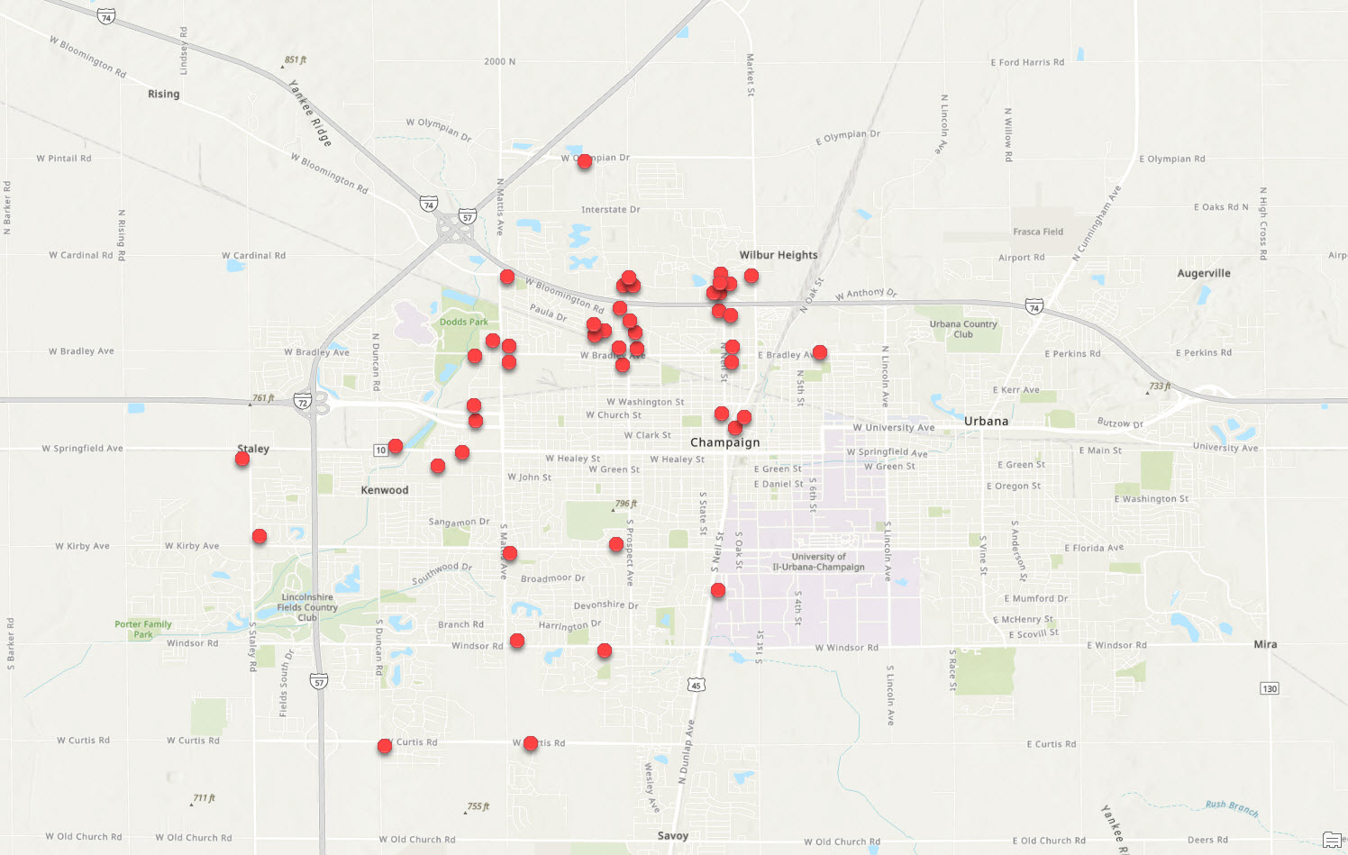

On May 4, 2022, the Department's ALPR program was implemented. At that time, nine ALPRs were installed and operational. However, ALPR #26 – Bradley @ Sixth (EB), was installed on the wrong side of the street, approximately one block down from ALPR #25 – Bradley @ Crispus (WB), resulting in two ALPRs capturing nearly identical data. Over the following three weeks, 19 additional ALRPs were installed and became operational, with the last ALPR initial installation occurring on May 24, 2022. The relocation of ALPR #26 – Bradley @ Sixth (EB) occurred on June 16, 2022. However, due to a programming error, the Department has not been receiving data from that ALPR, a problem Flock continues to address.

Four non-IDOT permit-required ALPRs have not been installed due to underground utility conflicts. Those four ALPRs will be installed on Ameren utility posts, which requires permitting with Ameren. No additional ALPRs have been installed since May 24, 2022; therefore, only 27 of 46 authorized ALPRs are currently operational.

The Department received the IDOT permit for the 14 ALPRs requiring permitting in July 2022. The 14 ALPR locations requiring permitting and four ALPRs being installed on Ameren utility posts were scheduled for site surveys on July 21, 2022, and July 22, 2022. Provided there are no additional site conflicts, the pending ALPRs should be installed within 30 days.

ALPR Policy and Training:

The Department's ALPR policy provides that ALPRs are to be used for "official law enforcement purposes, including identifying the license plate numbers of or associated with stolen vehicles, wanted subjects, missing persons, AMBER Alerts, or other criteria as determined by a Deputy Chief of Police. ALPRs may also be used to gather information related to active warrants, homeland security, electronic surveillance, suspect interdiction, stolen property recovery, or other legitimate law enforcement purposes."

Department training for sworn and civilian staff coincided with the launch of the ALPR program. Ahead of the ALPR program's launch, information was disseminated to staff via email, which included policy, procedures, and required training on the ALPR program. The email also noted the restriction that training was required prior to ALPR use.

The majority of staff received training during the four training sessions offered from May 4 through May 12. The training presented to staff was presented by a Flock trainer and Department ALPR administrators. The ALPR policy's language related to use was recited to staff verbatim by Department administrators. Department administrators also provided clarifying instruction, which advised staff that ALPRs could be used for criminal offenses for which they would make a custodial arrest.

ALPR Program Evaluation:

In July 2022, a working group, which included patrol officers, was established to evaluate and make recommendations on the ALPR program. The working group agreed the implementation of the ALPR program has served as a valuable investigative resource for the Department despite only having 27 of 46 ALPRs operational. Nonetheless, the group identified potential locations ALPRs should be considered, either through the relocation of existing underperforming ALPRs or the purchase of additional ALPRs. In all, the group recommended a minimum of 36 new ALPR locations and five ALPR relocations.

The areas patrol representatives considered of highest priority for the need for additional ALPR coverage were as follows:

- Gramercy Park Apartment and Countrybrook Apartment complexes
- Green Street corridor
- Oakwood Trace Apartment complex
- Mattis North Apartment complex
- Garden Hills Neighborhood

The working group recommended the following eight locations be considered of the highest importance for new ALPR placement:

Location | Direction | Support
McKinley @ Beardsley | SB | Heavily traveled to avoid Bradley and Prospect.
Green @ Chestnut | EB | Two recent shootings, one homicide in the last month. Campus has higher incidents of reported stolen vehicles.
Green @ Chestnut | WB
Country Fair @ University | SB | Location is used to enter Gramercy Apartments and as a pass through to Countrybrook Apartments.
Country Fair @ Springfield | WB | Heavily traveled to reach Blackhawk Liquors, Kenwood Road, and Gramercy and Countrybrook Apartments.
Kenwood @ Springfield | SB | Generally a hotspot and would cove the east exit from Countrybrook Apartments and the west exit of Gramercy Apartments.
Market @ Bradley | WB | Heavily traveled intersection to reach northwest portions of the city with no ALPRs until Bradley/Prospect.
Paula @ Mattis | SB | Heavily traveled area south from Mattis North Apartments and is used to avoid ALPRs to east on McKinley/Bradley.

These additional 28 locations were also identified for consideration for new ALPR placement:

Location | Direction | Support
Duncan @ Springfield | SB | Heavily traveled for access from NW to SW and to avoid Mattis and those leaving the Countrybrook and Gramercy Apartment complexes.
Duncan @ Springfield | NB
University @ Mattis | EB | Arterial route from west to east in the city.
McKinley @ Church | SB | Heavily traveled to avoid Prospect.
McKinley @ Church | NB
Mattis @ Bloomington | SB | An alternative route to the North Prospect shopping district, several apartment complexes, and the Dobbins Downs subdivision from SW Champaign.
Mattis @ Bloomington | NB
Mattis @ Springfield | SB | Heavily traveled with traffic from SW Champaign to other parts of the city, including those leaving the Countrybrook and Gramercy Apartment complexes.
Mattis @ Springfield | NB
Washington @ First | EB | Alternative route used to avoid Bradley and University.
Washington @ First | WB
Washington @ Fourth | EB | Alternative route used to avoid Bradley and University.
Washington @ Fourth | WB
Grove @ Wright | EB | Alternative route used to avoid Bradley and University.
Beardsley @ Sixth | EB | Alternative route used to avoid Bradley.
Springfield @ First | EB | Arterial route to Campus and to/from Urbana.
Springfield @ First | WB
Springfield @ First | SB
Springfield @ First | NB
Walnut @ Washington | NB | Departure route from the downtown business district.
Market @ Roper/I-74 | NB | Route to avoid Neil and used to access North District neighborhoods.
Market @ Bradley | SB | Route to avoid Neil and used to access North District neighborhoods.
Neil @ Edgebrook | SB | Heavily traveled route to/from I-74, shopping district, apartment complexes, and North District neighborhoods.
Neil @ Edgebrook | NB
Fourth @ University | SB | Heavily traveled an alternative route to Campus.
Fourth @ University | NB
Bradley @ Redwood | EB | Heavily traveled route to and from Garden Hills Neighborhood and arterial street.
Bradley @ James | WB

Detectives requested that additional ALPRs also be considered for current ALPR locations where traffic is captured in only one direction, as it has been observed that they have missed out on identifying numerous vehicles during their investigations. That request would involve a majority of the existing ALPR locations.

Working group representatives recommended the following ALPRs be relocated, citing they are not located in areas experiencing high crime rates:

Camera# | Location | Direction
#41 | Windsor @ Galen | EB
#42 | Windsor @ Mattis | WB
#43 | Curtis @ Duncan | EB
#44 | Curtis @ Mattis | WB
#45 | Neil @ St. Mary | NB

The cost for one ALPR is $2,500 annually. The installation cost of an ALPR is based on IDOT permitting requirements. An ALPR requiring permitting is $750, while all others are $350. The relocation fees mimic the installation cost schedule.

The number of ALPR reads for each operational ALPR was reviewed for a 30-day period; June 17 through July 16. The total number of ALPR reads was 3,246,246. As should be expected, the ALRPs with the highest number of reads were those on arterial streets. At this time, there is no data to confirm that the quantity of ALPR reads per unit would necessarily result in more success. However, more reads could lead to overall more investigative success for crime generally just based on probability. Though, those successes may not involve as many violent crimes. The following table documents the number of reads per ALPR:

 | Location |  | 30-Day  Plate Reads | Daily Average | % Plate Reads | Installation Date
#05 | Francis @ McKinley | EB | 33,646 | 1,122 | 1.04% | 5/12/2022
#06 | Neil @ Bradley | NB | 176,594 | 5,886 | 5.44% | 5/10/2022
#08 | McKinley @Paula | SB | 126,508 | 4,217 | 3.90% | 5/10/2022
#13 | Bradley @ Mattis | EB | 164,692 | 5,490 | 5.07% | 5/2/2022
#14 | Bradley @ Country Fair | EB | 134,214 | 4,474 | 4.13% | 5/2/2022
#15 | Bloomington @ Prospect | EB | 97,986 | 3,266 | 3.02% | 5/2/2022
#16 | Country Fair @ University | NB | 165,982 | 5,533 | 5.11% | 5/9/2022
#17 | Paula @ McKinley | WB | 34,628 | 1,154 | 1.07% | 5/10/2022
#18 | Kenwood @ John | SB | 78,371 | 2,612 | 2.41% | 5/10/2022
#21 | Bradley @ Neil | EB | 174,902 | 5,830 | 5.39% | 5/10/2022
#22 | Walnut @ Chester | NB | 193,488 | 6,450 | 5.96% | 5/2/2022
#24 | Neil @ Hill | SB | 36,012 | 1,200 | 1.11% | 5/2/2022
#25 | Bradley @ Crispus | WB | 92,062 | 3,069 | 2.84% | 5/2/2022
#26 | Bradley @ Sixth | EB | 0 | 0 | 0.00% | 6/15/2022
#27 | Market @ Marketview | SB | 146,118 | 4,871 | 4.50% | 5/12/2022
#28 | Marketview @ Neil | EB | 136,105 | 4,537 | 4.19% | 5/13/2022
#29 | Marketview @ Neil | WB | 97,812 | 3,260 | 3.01% | 5/12/2022
#30 | Neil @ Marketview | NB | 200,566 | 6,686 | 6.18% | 5/9/2022
#31 | Marketview @ Prospect | EB | 138,294 | 4,610 | 4.26% | 5/11/2022
#32 | Olympian @ Boardwalk | EB | 83,529 | 2,784 | 2.57% | 5/9/2022
#33 | Prospect @ Marketview | NB | 292,321 | 9,744 | 9.00% | 5/11/2022
#36 | Main @ Chestnut | WB | 39,109 | 1,304 | 1.20% | 5/2/2022
#37 | Staley @ Kirby | NB | 111,480 | 3,716 | 3.43% | 5/20/2022
#38 | Staley @ Springfield | SB | 153,308 | 5,110 | 4.72% | 5/10/2022
#41 | Windsor @ Galen | EB | 74,429 | 2,481 | 2.29% | 5/11/2022
#42 | Windsor @ Mattis | WB | 89,557 | 2,985 | 2.76% | 5/2/2022
#43 | Curtis @ Duncan | EB | 111,095 | 3,703 | 3.42% | 5/9/2022
#44 | Curtis @ Mattis | WB | 63,438 | 2,115 | 1.95% | 5/24/2022
 |  |  | 3,246,246
It should be noted that #24, #26, and #44 were not operational during the entire 30-day evaluation period.

Documented Champaign ALPR Program Successes:

ALPR cameras have been utilized regularly by staff as an investigative tool, assisting in the resolution of numerous criminal offenses. For the purposes of this report, resolved incidents are defined as those resulting in an arrest, recovered property, or the final disposition or resolution of a call for service. Staff has been requested to report those ALPR camera successes to the administration for reporting purposes. The most notable success is related to a shooting incident (C22-20047) on June 19, 2022. That incident resulted in one homicide and two other subjects being shot. In that case, the ALPRS identified the involved vehicles, which ultimately led to the identification of the suspect and witness statements resulting in the arrest of the suspect; the case is pending trial. The following table documents incidents that staff reported ALPR data assisted with resolving an incident.

 | Incident# | Incident Date | Offense(s) / Incident | Arrest# | Cited#
1 | C22-10962 | 4/8/2022 | Leaving Scene of Accident - Property Damage | 0 | 1
2 | C22-14238 | 5/4/2022 | Theft-Motor Vehicle | 0 | 0
3 | C22-15869 | 5/17/2022 | Theft-Motor Vehicle  BMV | 1 | 0
4 | C22-18024 | 6/2/2022 | Endangered Missing Person | 0 | 0
5 | C22-18211 | 6/4/2022 | Aggravated Assault | 0 | 0
6 | C22-06734 | 3/4/2022 | Attempted Arson | 0 | 0
7 | C22-06739 | 3/4/2022 | Arson | 0 | 0
8 | C22-15185 | 5/11/2022 | Reckless Discharge of a Firearm | 1 | 0
9 | C22-16779 | 5/24/2022 | Aggravated Arson | 0 | 0
10 | C22-18471 | 6/5/2022 | Theft-Motor Vehicle | 0 | 0
11 | C22-20047 | 6/19/2022 | Homicide | 1 | 0
12 | C22-22106 | 7/4/2022 | Theft-Motor Vehicle | 0 | 0
13 | C22-22451 | 7/7/2022 | Theft-Motor Vehicle | 1 | 0
14 | C22-22680 | 7/1/2022 | Criminal Sexual Assault (pending SAO review) | 0 | 0
15 | C22-23153 | 7/12/2022 | UUW by Felon (stolen firearm)  Theft-Motor Vehicle | 2 | 0
16 | C22-23486 | 7/14/2022 | Search Warrant Service  Man/Delivery Cannabis (state NTA) | 0 | 1
17 | C22-23289 | 7/16/2022 | Theft-Motor Vehicle | 0 | 0

The following map identifies the originating (red pin) and ending (purple pin) incident locations for the majority of the above-identified incidents. The ALPR successes have been largely concentrated in the areas where ALPRs are located, as would be expected.
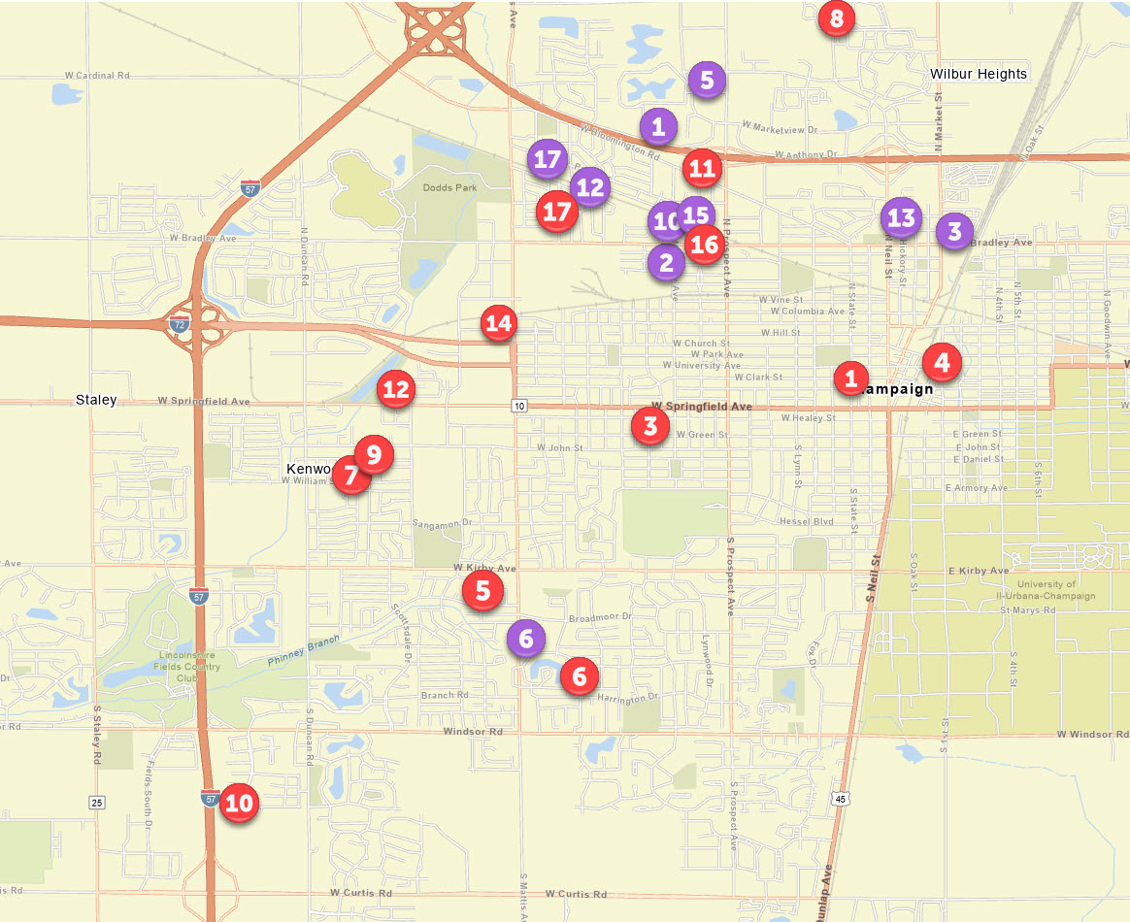

While these are the reported successes, they may not be all-inclusive and do not include incidents involving open investigations. ALPRs have proven extremely useful in tracking, documenting, and locating witnesses and suspects during criminal investigations.

Other Communities Notable ALPR Programs and Successes:

ALPR use in other communities was utilized in the report to council in support of the then proposed Department's ALPR program. One of those communities cited was Decatur, which implemented its ALPR program on July 1, 2021. Decatur's ALPR program initially consisted of 60 ALPRs, for which installs continued past July 1, similar to our situation. Decatur reported an increase in investigative leads for various crimes, including gun violence and motor vehicle thefts. Based on their successes, Decatur added 40 ALPRs to their program for a total of 100 ALPRs. Decatur is in the process of evaluating its ALPR program and the effectiveness of each ALPR camera location to determine if any relocations are recommended.

Bloomington had eight ALPRs installed on May 1, 2022. Bloomington has two additional IDOT permit-required ALPRs pending installation. Bloomington has reported numerous ALPR successes, which include the following:

- Located a suspect vehicle in a Domestic Abduction, which led to finding the victim and the suspect at a local hotel; the suspect was arrested.
- Located a suspect vehicle in an Armed Robbery/Attempted Murder, which led to the arrest of the suspect. ALPRs located the suspect vehicle in another jurisdiction two hours away from Bloomington.
- Located the suspect vehicle in a Business Burglary on its ALRPs as well as networked ALPRs in another jurisdiction.
- Recovered four stolen vehicles.
- Located and arrested a subject in an Aggravated DUI complaint.
- Located three wanted subjects (felony warrants).
- Located a suspect vehicle in an Armed Robbery based only on the unique characteristics of the suspect vehicle.
- Located an Armed Robbery suspect vehicle in another city after it fled from the incident in Bloomington.
- Identified an out-of-town suspect in business burglaries.
- Used in three different suicidal subject calls for service.
- Used to corroborate investigative data in a drug-induced homicide case.
- Used in multiple drug distribution investigations.
- Used to locate and arrest a subject wanted by another jurisdiction for Aggravated Arson and Criminal Sexual Abuse case.
- Used to assist an external jurisdiction in the search for a fugitive from a homicide case in that jurisdiction.

ALPR Options:

The Department is due for the replacement of 36 in-car cameras in the patrol fleet. The potential sole source purchase currently being evaluated is from Axon, which offers a camera equipped with Flock ALPR technology. This would result in more ALPRs on city streets, a better tool for officers responding to a crime, and could also provide for a movable fixed ALPR for short-term use. The licensing fee per in-car camera would be $49.00 per month per vehicle or $21,168 annually for all 36 vehicles.

Additionally, Flock does offer a location-flexible ALPR, the Falcon Flex. The Falcon Flex operates on a rechargeable battery that is readily deployable for temporary installations. The Falcon Flex has a read capacity of approximately 30,000-40,000 reads, with an operating time of up to one week before requiring a recharge. The cost per Falcon Flex is $3,000 annually.

Conclusion:

In less than three months of operation, the Department's ALPR program has proven to be a valuable investigative tool, despite having only 27 of 46 ALPRs operational. From its inception, the Department has recognized that there were several areas that would benefit from the presence of ALPRs, as several arterial roads and neighborhoods impacted by higher crime rates could not receive ALPRs. Recent shooting incidents in neighborhoods that lack ALPRs have energized community interest in expanding the program. The City of Champaign, its residents and visitors, and the Department would benefit from the program's expansion.

Courses of Action:

There are four courses of action being recommended for further consideration: purchase additional ALPRs, purchase and relocate ALPRs, only relocate ALPRs, or take no action and continue to evaluate.

Course of Action #1: Purchase Additional ALPRs

The working group recommended expanding the ALPR program up to 36 additional ALPRs. The annual cost for 36 additional ALPRs would be $90,000 based on $2,500 per ALPR. Ten ALPRs would require IDOT permitting, which would cost $7,500. The remaining installations would cost $9,100, for a total installation cost of $16,600. While 36 ALPRs were recommended by the working group, an expansion of the ALPR program beyond even that number would prove even more effective, as it is clear more coverage would result in more success.

Course of Action #2: Purchase and Relocate ALPRs

Expand the ALPR program with up to 44 additional ALPRs and relocate the five ALPRs identified by the working group. This course of action would be the costliest if all 44 ALPRs were authorized, as the relocation fees for the five existing ALPRs would be an additional expenditure, which would be as high as $3,750 if all ALPRs required IDOT permitting.

Course of Action #3: Relocate ALPRs

The relocation of five ALPRs would be a cost-effective course of action but would be less impactful and would remove ALPRs from arterial streets in the southern half of the city. While these ALPRs are not in areas experiencing high crime rates, they are in several key locations that experience increased traffic and act as gateways to the city.
Course of Action #4: Continue to Evaluate

While the ALPR program has proven successful, it was implemented less than three months ago, and it has been operating with only up to 27 of 46 ALPRs. This option would be the most cost-effective but would provide the least impactful.

Recommendation:

I recommend Course of Action #1, Purchase Additional ALPRs. Expanding the number of ALPRs will improve coverage and increase investigative solvability. The placement of the original 46 ALPRs were calculated and appropriate. However, due to Champaign's expansive area and the distance or spread between neighborhoods experiencing higher rates of violence and other crime, the program is limited in its ability to be as effective as is certainly possible.

Attachment A – 2018 Shooting Incidents

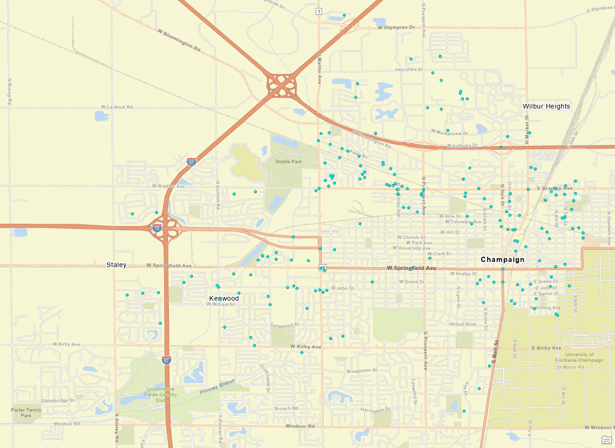

Attachment B – 2019 Shooting Incidents

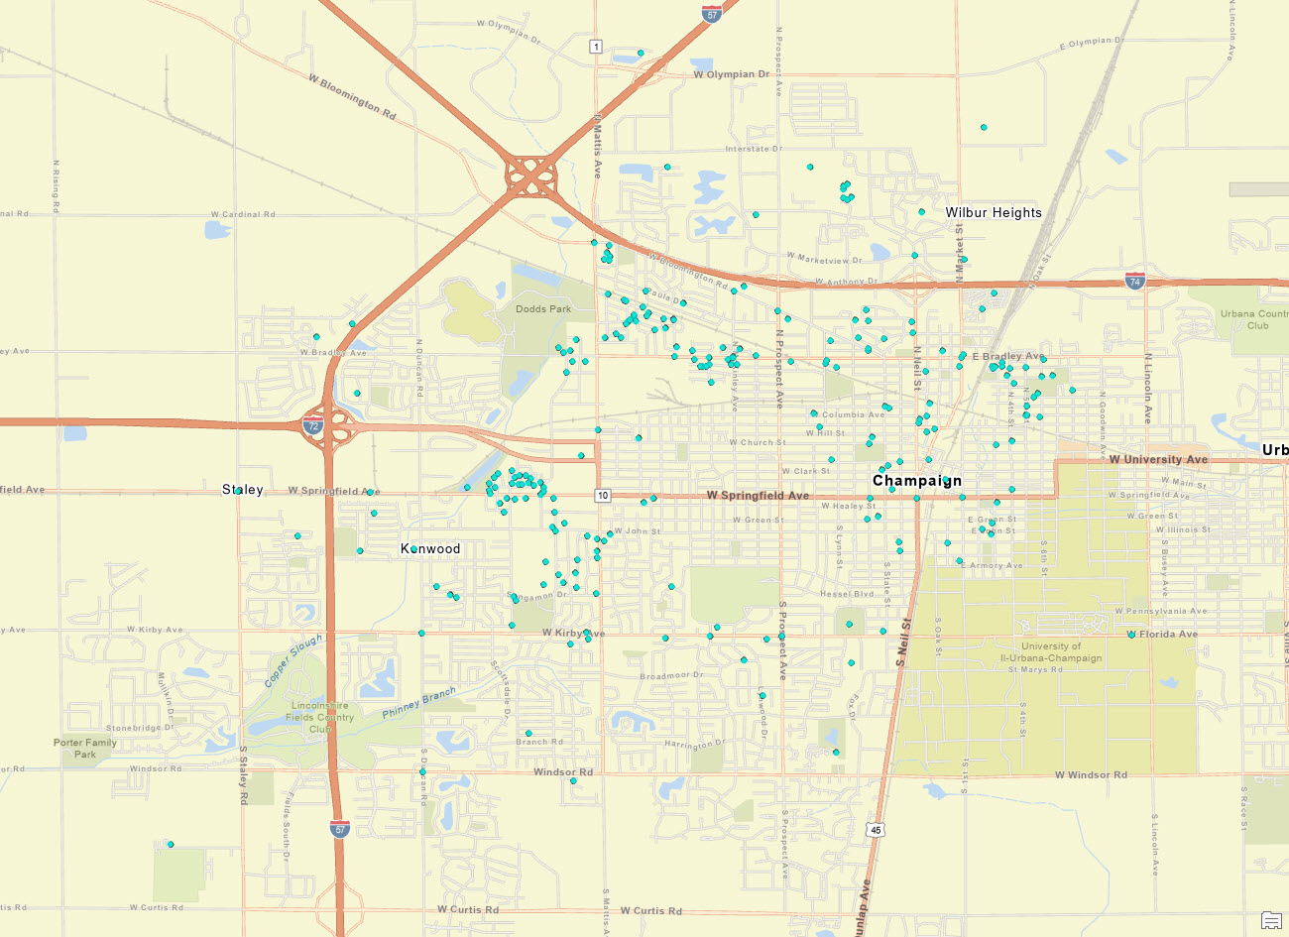

Attachment B – 2020 Shooting Incidents

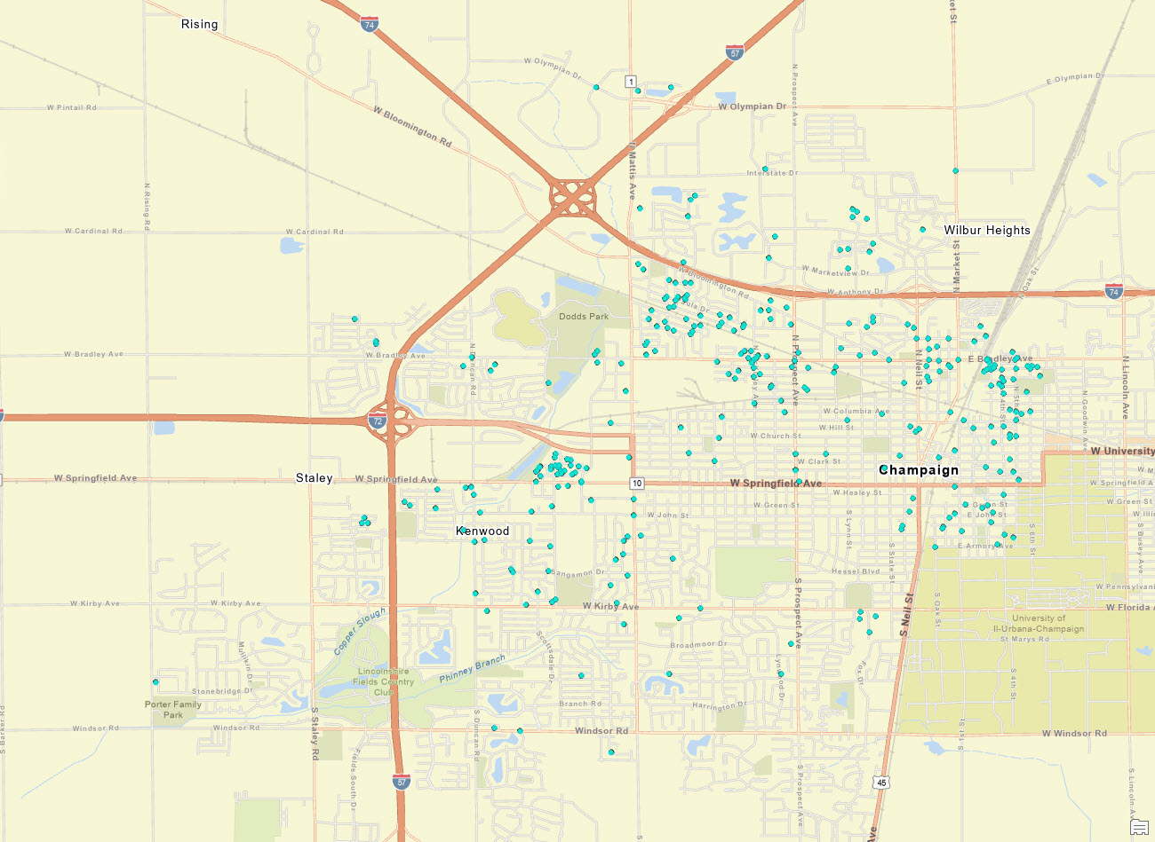

Attachment D – 2021 Shooting Incidents

