EEE 313- Electronic Circuit Design
-Lab 01-

Defne Yaz Kılıç
Section 003
22102167
30.09.2023

Introduction
The purpose of this lab was to built a circuit which converts the AC input into DC as the output and which uses light as connection. The light emission is achieved by a Led and the detection by a photodiode both operating in the IR range. Components such as OPAMP, capacitor, diodes and resistors are used for amplification, rectification and current control purposes.

LED
Led e.g. light emitting diode is a semiconductor device which converts current into light. Light is produced when the electrons are combined with the holes inside the semiconductor material. For direct bandgap semiconductors, the combination of electrons with holes does not require any change in momentum hence photons can be emitted. What determines the energy of the light is the bandgap of the material, different leds with different bandgaps produce light at different energies hence at different wavelengths [1,2]. The Led used in this lab (SB-5010IRB) was operating at 940 nm wavelength which corresponds to IR range [3].

Photodiodes
Contrary to leds, photodiodes detect optical signals and convert them to electrical signals. They can be categorized as current-based sensors. With the light hitting the space-charge region of the pn junction photodiode, electrons and holes are generated and due to the electric field, they are quickly swept out of the space-charge region creating a “photocurrent”. Photodiodes are very similar to solar cells except that the pn junction is operated with a reverse-biased voltage [1]. The photodiode used in this lab (pd333-3b/h0/l2) detects the IR light at 840-1100 nm wavelength, its peak sensitivity is 940 nm which overlaps with the led’s light emission wavelength [4].

The IR range is chosen to eliminate the disturbance coming from outside light sources such as the lamps in the lab. If we have chosen the visible light range the photodiode could have detected signals that weren’t coming from the led as well.

Hardware Implementation and Analysis

The following figure shows the circuit design:

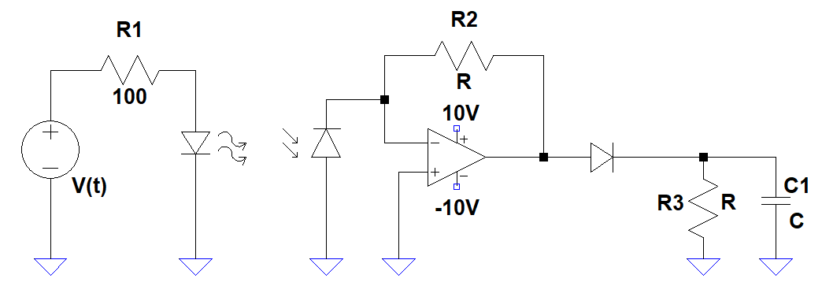
Fig.1. Circuit Schematic

Working Principle & Theory

We can divide the circuit into three main parts 1)LED 2)Transimpedance amplifier
3) Envelope Detector.

- LED
When the threshold voltage is satisfied, the forward biased Led seen Fig.2. emits infrared radiation. For the time interval where the input voltage is higher than the threshold voltage, the LED acts as a voltage source hence Vout will be constant and equal to the threshold voltage of the LED.

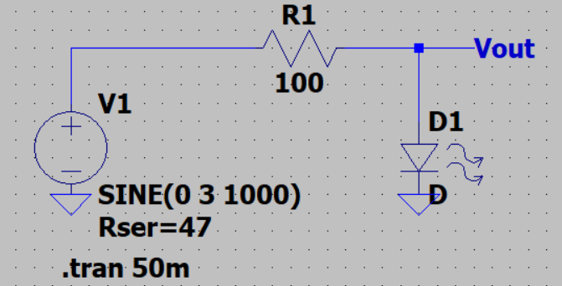
Fig.2. LED Circuit Schematic

For the time where the input voltage is smaller than the threshold voltage, the LED will be in the OFF state, hence will act as open circuit.Vout will therefore imitate the input signal. The simulated circuit behavior can be seen in Fig.3.

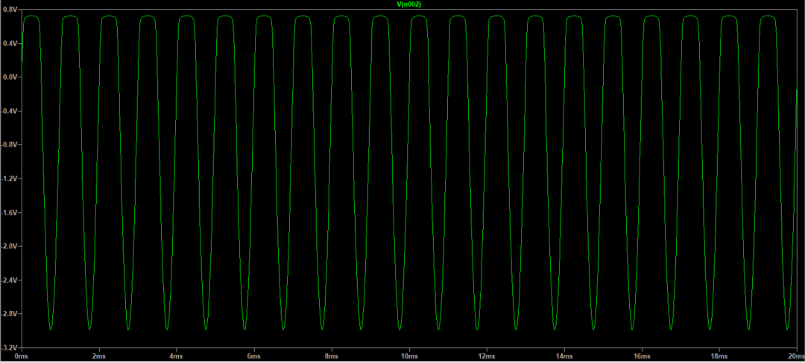
Fig.3. Simulation result of the LED part

It should be noted that the LED used in the simulation is not the actual one used in the Hardware implementation, the simulation is made only to get a general idea about the circuit’s behavior. The threshold values of the LEDs may differ.

- Transimpedance amplifier

The photodiode produces photocurrent as the Led emits infared radiation. The Opamp helps to create a voltage difference at its output node using the photocurrent. The output voltage of the Opamp can be written as:

(1)

Since the Opamp becomes saturated when Vout is higher than 10V or lower than
-10V the R₂ value should be chosen accordingly so that the Opamp doesn’t get saturated. During the hardware implementation the R2 value is chosen as 15KΩ by trial and error method, further explanation can be found in the hardware implementation part of this report.

- Envelope Detector

The last part of the design consist of a diode, capacitor and a resistor. This part takes the V_{out} of the Opamp as the input and gives the demodulated envelope of the signal. By the time the input signal is rising, the diode is forward biased hence it acts as a voltage source therefore the capacitor charges. During the falling period of the input the diode becomes off and acts as an open circuit. The charged capacitor starts to discharge at that period of time. Since the input frequency is not very high we can use this design as an AC to DC converter. The diode here helps to one way current pass and to see the discharge effect of the capacitor on R3.

In order to see an output close to DC we want that the capacitor discharges very slowly so by the time another rising time comes the capacitor won’t be fully discharged. In other words, the discharging rate of the capacitor should be greater than the input period: 10⁻³ s. The discharging time of the capacitor can be defined by the time constant which is in this case:
(2)
With larger time constant the capacitor won’t be able to discharge completely hence the output voltage will fluctuate between the peak charged voltage value and the discharged value when the diode starts to become ON. In order to obtain a larger time constant C value is chosen as 1μF and R₃ is chosen as 100kΩ which makes
τ =0.1 sec.
In order to get a better understanding, the effect of time constant on a sinusoidal input is investigated using LTspice as well. In Fig.4. the envelope detector circuit is implemented for a sinusoidal input, althought the output of the OPAMP is not exactly like a pure sinusoid same logic can be applied for the real circuit as well. Theoretically as the time constant of the circuit gets smaller the ripple range gets higher, the simulation results below are in accordance with our theory.

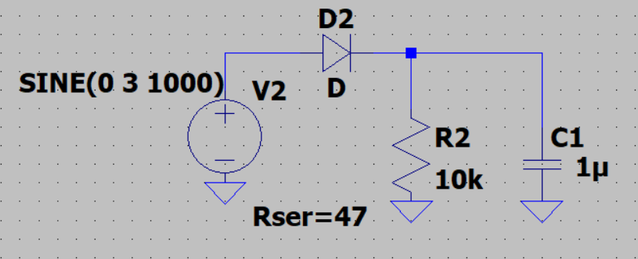
Fig.4. Simulation of envelope detector

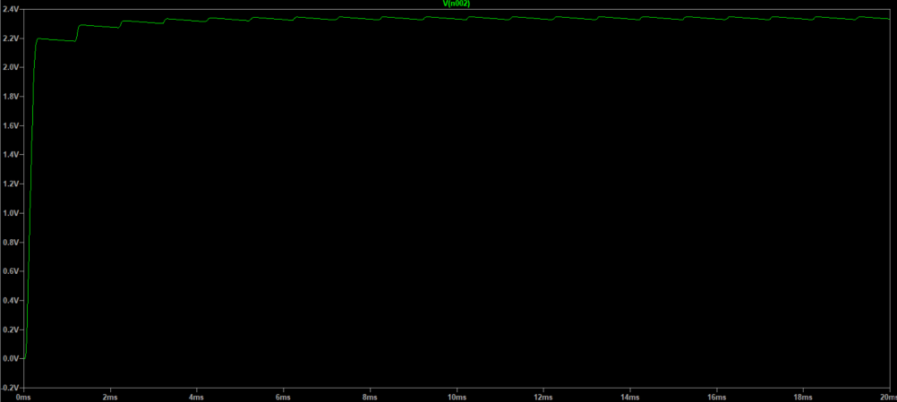
Fig.5. Simulation result for τ= 0.1 sec

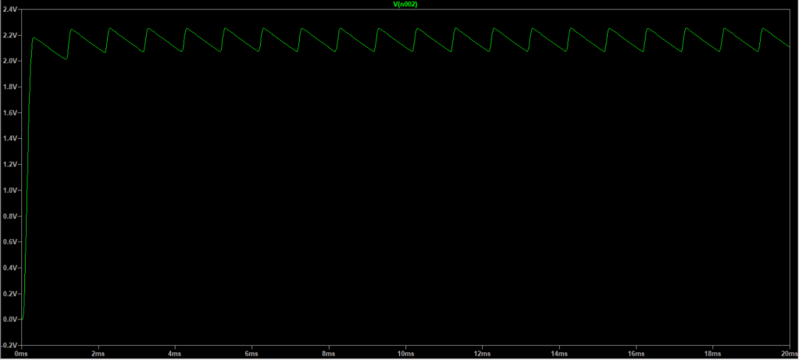
Fig.5. Simulation result for τ= 0.01 sec

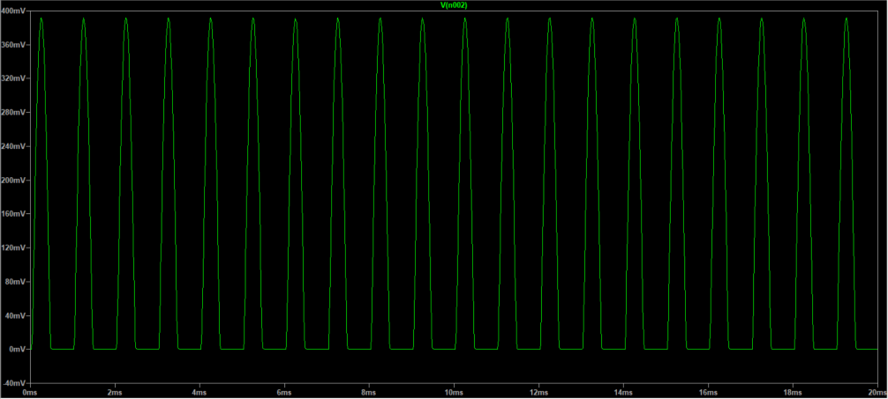
Fig.6. Simulation result for τ= 0.0001 sec

Hardware Implementation
The circuit is implemented on breadboard as in Fig.7.

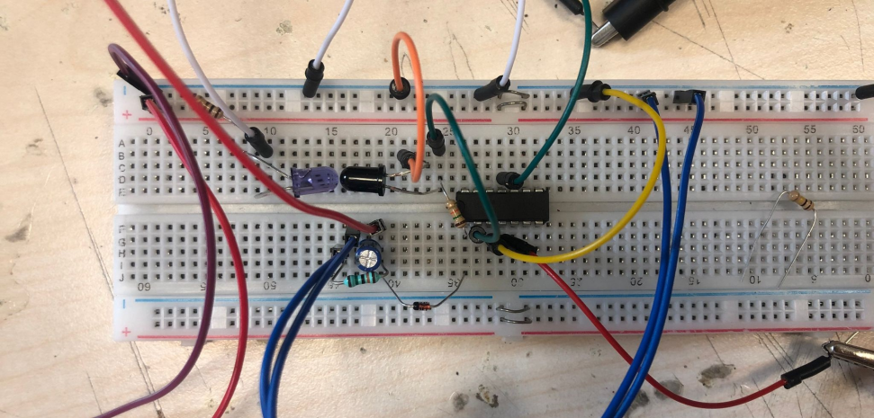
Fig.7. Hardware Circuit

Here are the hardware specifications:
-pd333-3b/h0/l2 photodiode
-SB-5010IRB LED
-V_{input}(t)= 3sin(2π*1000)
- 100Ω for R₁
-15KΩ for R₂
-100kΩ for R₃
-1μF for C₁
-LN 4148 Diode
-Opamp with -10,+10 saturation voltages

Output Voltage on LED:
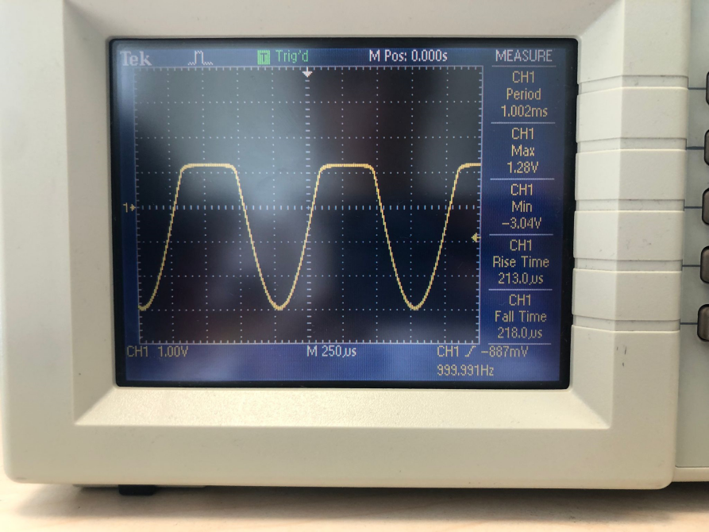
Fig.8. LED Output

Looking at Fig.8. one can see that V_{min} is approximately -3V and the sinusoidal signal becomes stabilized around 1.28 V. The results are in accordance with the simulation however since the LEDs are different, the threshold values e.g. the voltage values where the signal becomes stabilized changes.

Maximization of the IR radiation can be achieved by placing the LED and the Photodiode as close to each other as possible. As seen in Fig.7 two components are placed toward each other with a very small distance between them.

Output Voltage of the OPAMP:

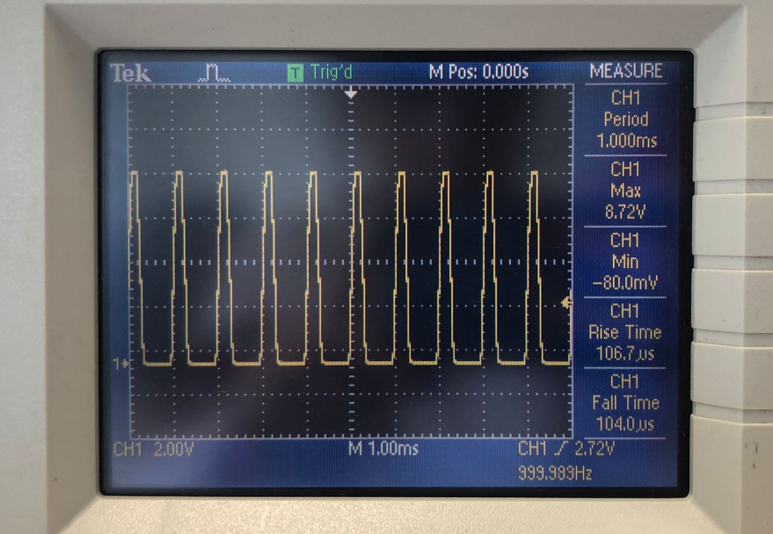
Fig.9. OPAMP Output

From Fig.9. one can see that with 15KΩ the output doesn’t get saturated. The peak value of the output is approximately 8.72V.

Output Voltage on R3 and C1:

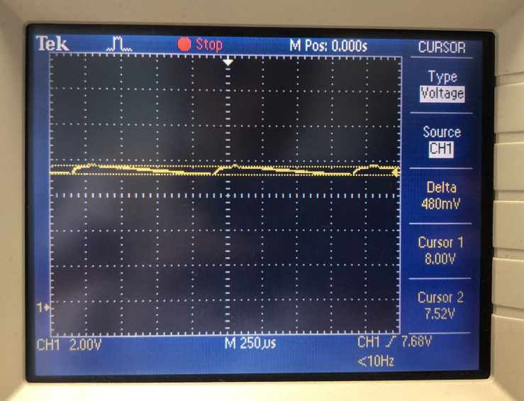
Fig.10. R3 and C1 Output

As can be seen from Fig.10. the output measured on R3 is very close to a DC signal, it fluctuates between 8V and 7.52V which creates a ΔV= 480 mV. Due to the diode, the output voltage of the Opamp drops a small amount.

Conlusion

This lab has thought me how to send and receive signals in IR range using sensors like a photodiode. The Opamp part was useful for understanding current- voltage conversion and scaling processes. The saturation factor was a bit challenging since it required trial and errors. After the first try, my results was saturated hence I directly dropped the resistance by half and got non saturated results, I know that some of my friends have used larger R values, larger R values could also been used however my Output voltage was in the right range therefore I didn’t feel the need to change my R value. As for the DC conversion, understanding the time constant relation with the input period required some research and reflection. I also found the R3 and C1 values by trial and error. Since there isn’t any error calculation requirements for this lab, the results satisfied the general lab conditions. More adjustments can always be made by using more precise measurement techniques and equipments and modifying the circuit according to their results.

References

- D. Neaman, Microelectronics Circuit Analysis and Design. McGraw-Hill Science Engineering, 2007.

- Byju’s, “Led Emitting Diode (LED)”, [Online]. Available:https://byjus.com/physics/light-emitting-diode/. [Accessed: Oct. 8,2023].

[3] PRO-AN Electronic Co., Ltd., “Infrared Emitting Diode Specification” http://www.proan.com.hk. [Accessed: Oct. 8,2023].

[4] 5mm Photodiode PD333-3B/H0/L2, https://www.mouser.com/datasheet/2/143/EVER_S_A0003536626_1-2548659.pdf [Accessed Oct. 8,2023].

