# WorkTrack: Employee Timesheet Tracker Database Project Documentation

By

FRANZ LLOYD A. DIAZ

ARJONEL M. MENDOZA, MIT

Lecturer

# PROJECT OVERVIEW

The Employee Timesheet Tracker is a system designed to record and manage employee work hours by tracking their clock-in and clock-out times. It aims to streamline attendance management, improve productivity monitoring, and ensure accurate payroll processing. This system was created by using Python, CustomTkinter, and MySQL.

# ENTITY-RELATIONSHIP DIAGRAM (ERD)

The ERD represents key entities in the Employee Timesheet Tracker such as employees and their attendance. Each entity has attributes essential for data management.

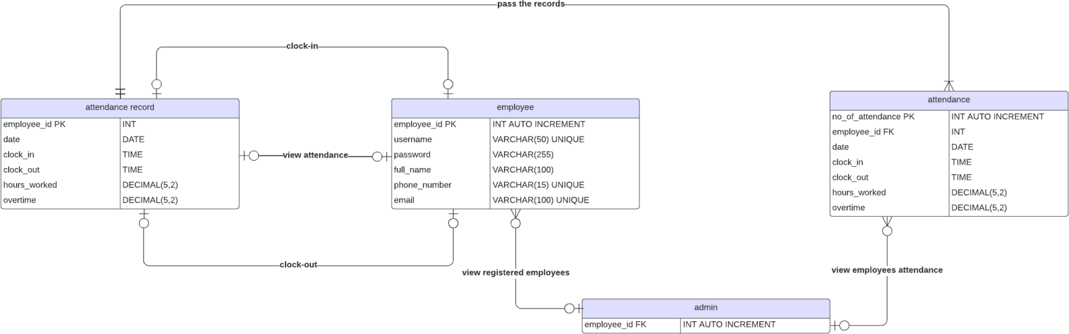

Figure 1. Entity Relationship Diagram

# Entities and their Relationships

## Employee & attendance record:

* + **Type**: One-to-One (1:1)
  + **Description**: An employee can clock-in once per day in • his/her attendance. Attendance record can be clocked in per employee once in a day. An employee can clock-out once per day in his/her attendance if and only if the employee clocked in. Attendance record can be clocked

out per employee once in a day. An employee can view his/her attendance. Attendance record can be viewed per employee. An employee can view his/her attendance. Attendance record can be viewed per employee.

## attendance record & attendance:

* + **Type:** One-to-Many (1:N)
  + **Description:** Attendance record must pass the records to attendance. Attendance can accept many attendance records.

## admin & attendance:

* + **Type:** One-to-One (1:1)
  + **Description:** Admin can view the attendance of all employees. Attendance can be viewed by one and only one admin.

## admin & employee:

* + **Type:** One-to-One (1:1)
  + **Description:** Admin can view all registered employees. Employees can be viewed by one and only one admin.

# SQL SCRIPTS

-- Create Database

CREATE DATABASE timesheet;

-- Use Database USE timesheet;

-- Create Tables CREATE TABLE employee (

employee_id INT(11) PRIMARY KEY, username VARCHAR(50) NOT NULL, password VARCHAR(50) NOT NULL,

full_name VARCHAR(255) NOT NULL, phone_number VARCHAR(15) NOT NULL, email VARCHAR(100) NOT NULL,

);

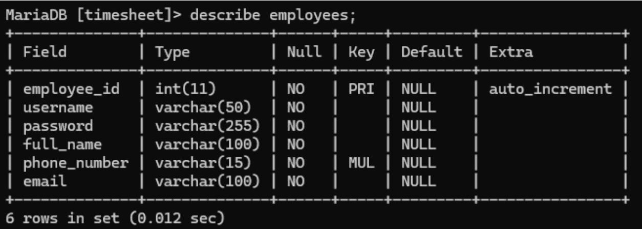

CREATE TABLE attendance (

no_of_attendance INT(100) AUTO INCREMENT PRIMARY KEY, date DATE NOT NULL,

clock_in TIME NOT NULL, clock_out TIME NOT NULL,

hours_worked DECIMAL(5,2) NOT NULL, overtime DECIMAL(5,2) NOT NULL

);

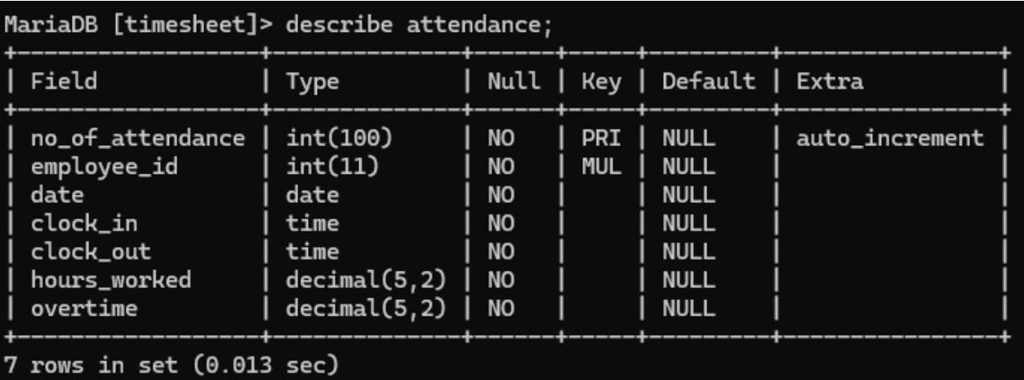

‘attendance’ table records:

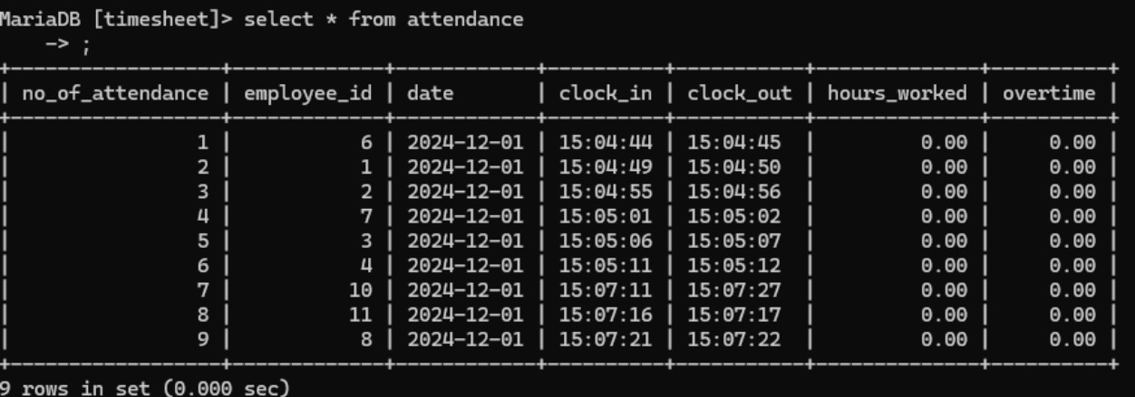

‘employees’ table records:

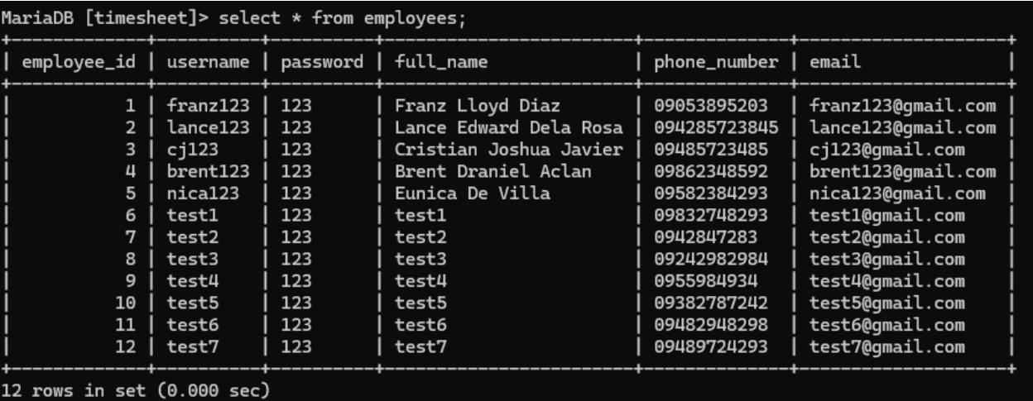

**CODE SNIPPETS**

connection of MySQL & python:

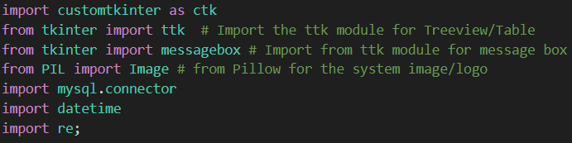

authentication of employee login:

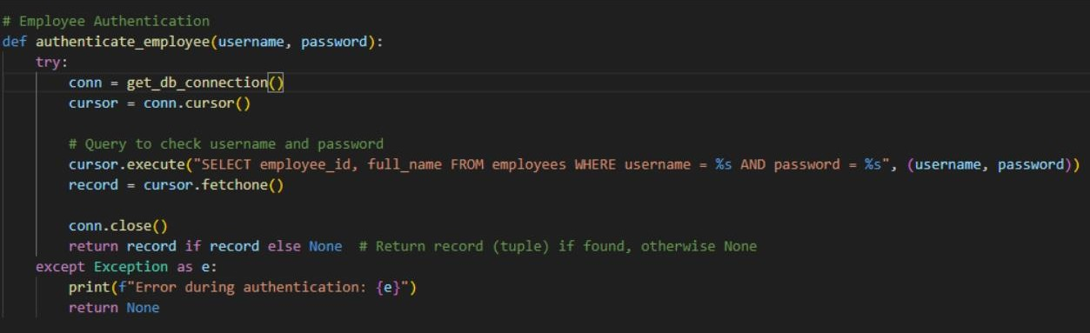

clock-in function:

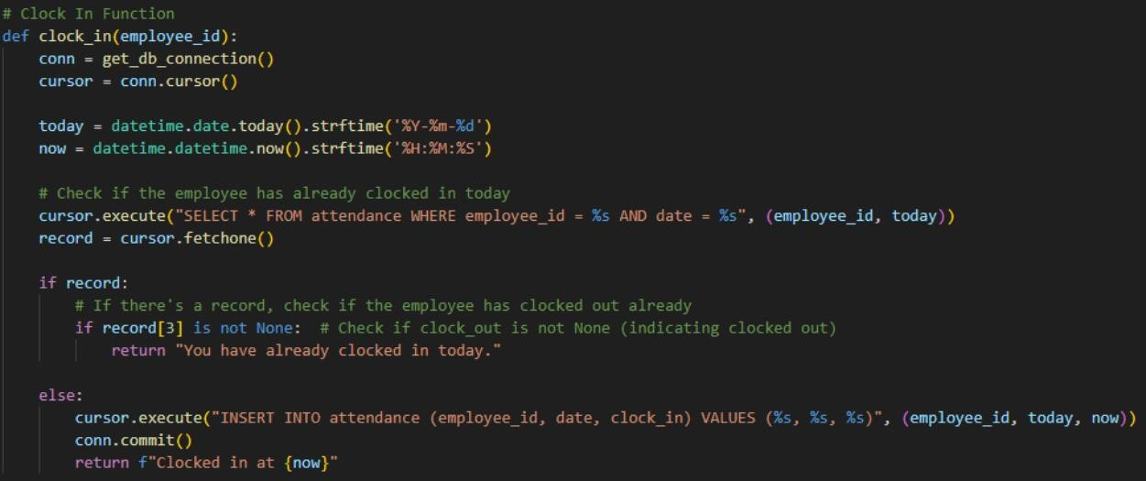

clock-out function:

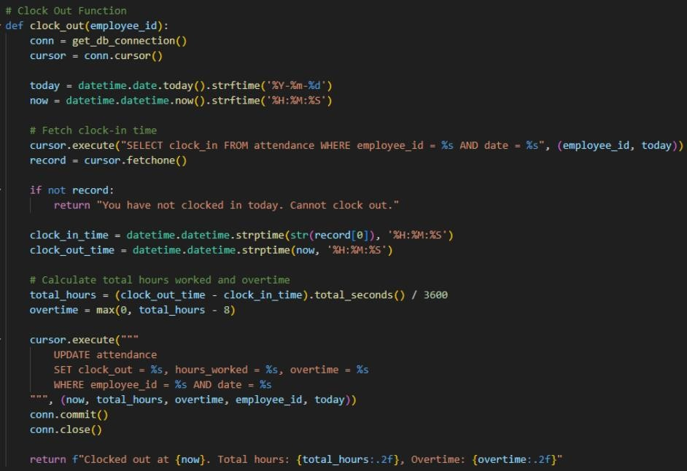

get the attendance of the logged-in employee

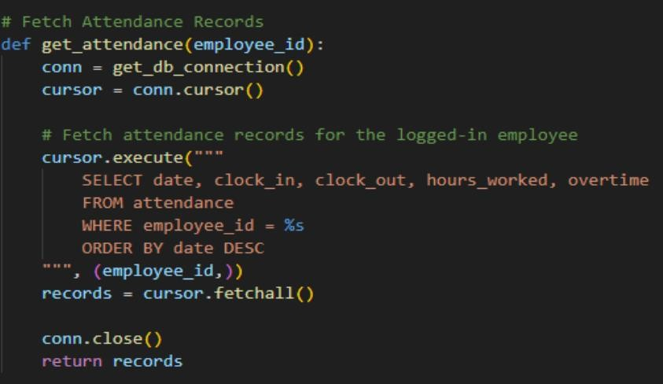

register employee

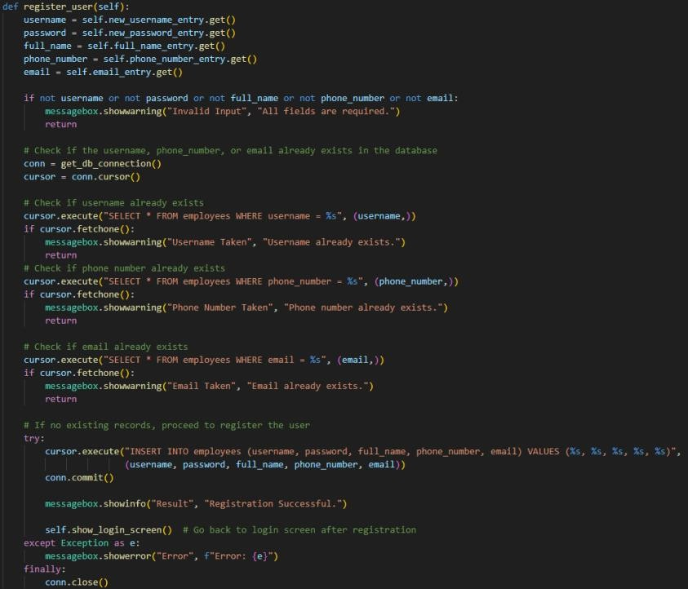

in admin mode, show all attendance records:

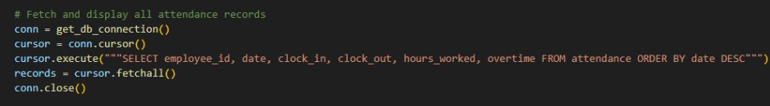

in admin mode, show all registered employees:

