FINAL PROJECT DOCUMENTATION

WORKTRACK: Employee Timesheet Tracker

CS121: ADVANCED COMPUTER PROGRAMMING

Submitted By: **FRANZ LLOYD A. DIAZ**

# PROJECT OVERVIEW: EMPLOYEE TIMESHEET TRACKER | WORKTRACK

WorkTrack: The Employee Timesheet Tracker, is created to provide a smooth, accurate, and efficient method for tracking employee working hours, attendance, and specific payroll allocations. Many traditional systems experience incapability, inaccuracies, and challenges in their management due to manual or outdated systems. Obstacles such as inaccurate payroll management, barely productivity, limited transparency, and compliance risks shows the need for a better solution. WorkTrack addresses these concerns through its core functionalities and a beginner-friendly graphical user interface. Despite its limitations, the system is open for feedback and future improvisation to enhance its usability and features.

Key functionalities include employee registration and profile management, allowing users to manage personal details and add contact information, but the users can’t update their personal information unless the system administration do so. Employees can log daily work hours, including time-ins/outs, total hours worked, and overtime, facilitating accurate payroll processing. The system is designed to be intuitive, with familiar buttons and keywords to ensure ease of use. However, certain features are excluded in the initial version, such as task management, scheduling, integration with other enterprise tools, mobile access, advanced security measures like biometric authentication, and performance tracking.

Target users include employees who need to track their work hours, system administrators managing user permissions and system maintenance, HR and payroll personnel using the data for compliance and payroll processing, and managers or supervisors responsible for approving

timesheets and reviewing attendance data. By enabling employees to log hours accurately, the system simplifies payroll for HR teams and ensures compliance with labor regulations.

The project aims to achieve specific, measurable outcomes: reducing payroll processing time by 30% within three months of implementation, increasing timesheet accuracy to 98% within six months, and decreasing timesheet discrepancies by 40% within four months. These goals align with the core objectives of the system, ensuring that WorkTrack enhances productivity, accuracy, and transparency for both employees and organizations.

# PYTHON CONCEPTS AND LIBRARIES

## Python and CustomTkinter



* + from “import customtkinter import as ctk” accesses the customtkinter library, Python’s tool for modernizing the creation of graphical user

interfaces (GUIs) in WorkTrack’s main windows.



* + “from tkinter import ttk”, I used the library of tkinter instead of customtkinter at making the table or the Treeview because of its traditional looks of it, of course my system has to look systemish.



* + “from tkinter import messagebox”, I also used the library of tkinter in order to show whenever the user is logging in and out, also for other function buttons
  + ​



* + “from PIL import Image”, from Pillow I used this submodule in order for the system to accept images and display them on how accordingly I want



* + “import datetime”, which provides classes for working with dates and times. I used this in order for the system to record the clock-ins/outs of the employee real time



* + “import re” or regex is for my exception handling.

## MySQL



* + “import mysql.connector” a module to connect mysql to python. This

module is needed in order to import registered users and their attendance per employee.

1. **SUSTAINABLE DEVELOPMENT GOALS**

The Employee Timesheet Tracker (WorkTrack) aligns with several Sustainable Development Goals (SDGs).

Firstly, it aligns with SDG 8: Decent Work and Economic Growth by helping efficient budget allocation and ensuring accurate payroll management, which guarantees a fair compensation for the employees. The system lessens administrative problems and smooth work processes, thus contributing to increased productivity and economic efficiency. It also helps ensure compliance with labor laws, fostering safe and secure working environments.

Secondly, the system supports SDG 9: Industry, Innovation, and Infrastructure by replacing traditional systems with modern systems, emphasizing innovation. It creates an efficient infrastructure for time and attendance management, facilitating smoother operations within organizations.

Thirdly, the system contributes to SDG 16: Peace, Justice, and Strong Institutions by enhancing transparency in time tracking and payroll processing, lowering potential disputes, and encouraging trust between employees and employers. By ensuring agreement with labor adjustment, it helps create just and accountable practices within the administration.

Lastly, SDG 10: Reduced Inequalities is indirectly supported by the system. By ensuring accurate time tracking and fair compensation, the system helps minimize payroll disparities and promotes equitable treatment of employees.

If additional features were incorporated, such as sustainability reporting like if they cannot attend due to certain weather or sickness, the system could further align with other SDGs, including SDG 3: Good Health and Well-being or SDG 13: Climate Action.

# PROGRAM/SYSTEM INSTRUCTIONS

## Project Overview

* + **WorkTrack:Employee Timesheet Tracker** provides a simple beginner-friendly user interface for the employees to interact with. The system offers a basic

structure towards the log-in window, navigating through the registration and admin window, then the main window.

* Splash Window

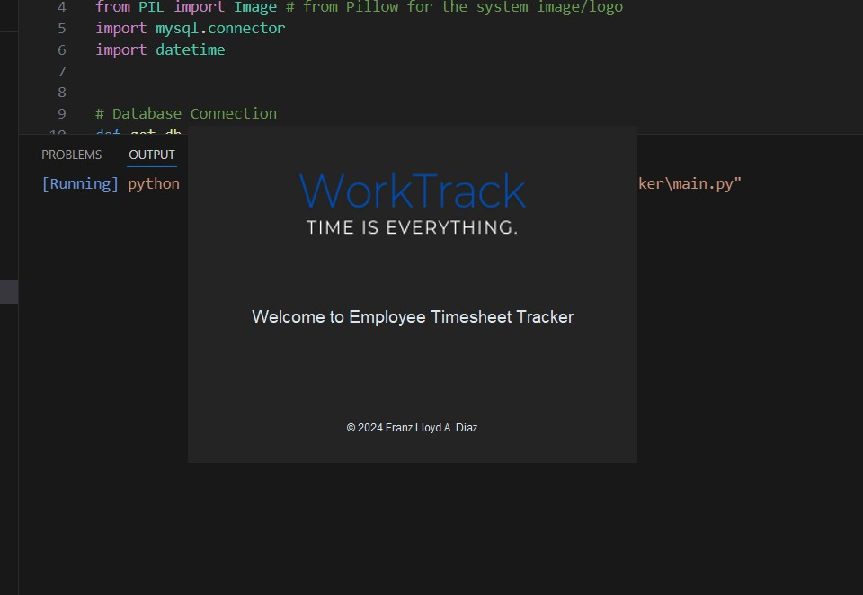

The system displays the system's logo or name to reinforce brand identity.

Also to give a professional touch to the application.

* Login Window

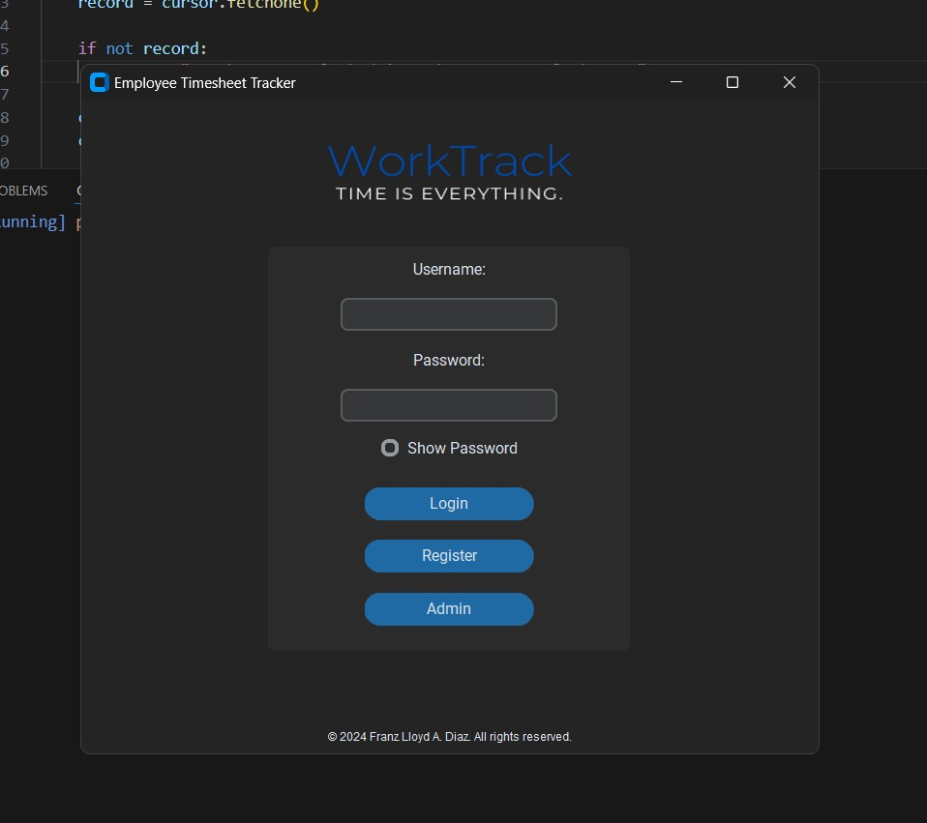

A login window shows up in order for the user to authenticate themselves if they are registered or not.

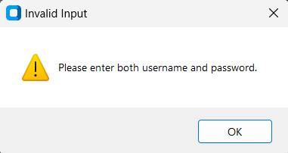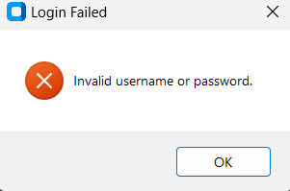

A simple error and warning message comes up whenever the input boxes are empty or the username and password are invalid

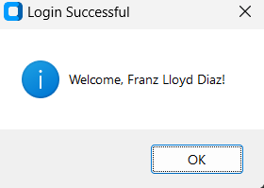

A login successfully message box shows up after the employee has logged in successfully.

* Main Window

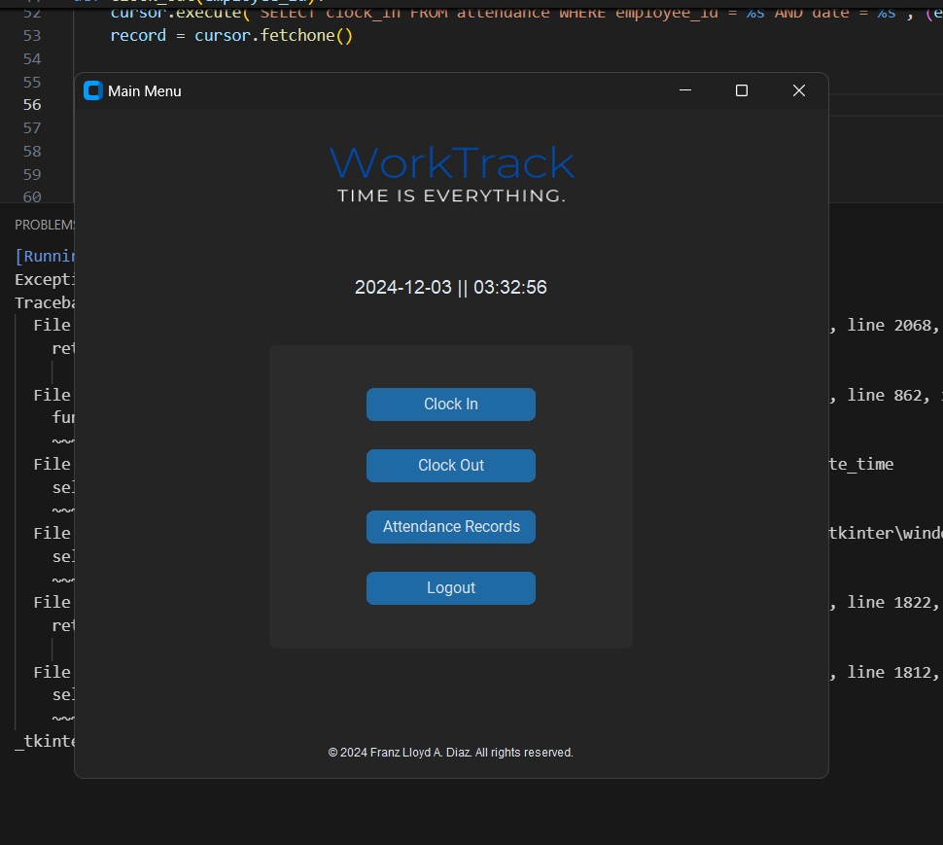

This is the main window where the employee can time in and out, and also check their attendance records.

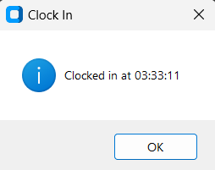

This message box appears after clicking on the clock in button.

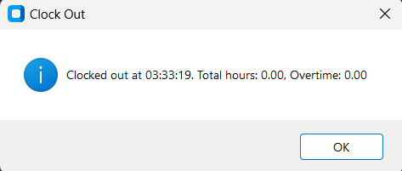

This message box appears after clicking on the clock out button.

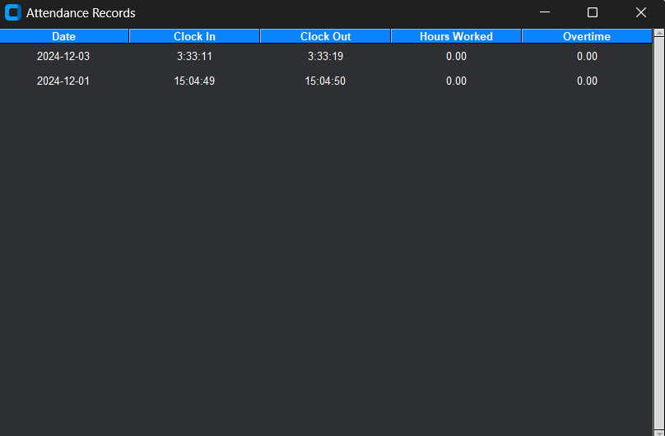

This tabular window displays after they click on the Attendance records.

* Registration window

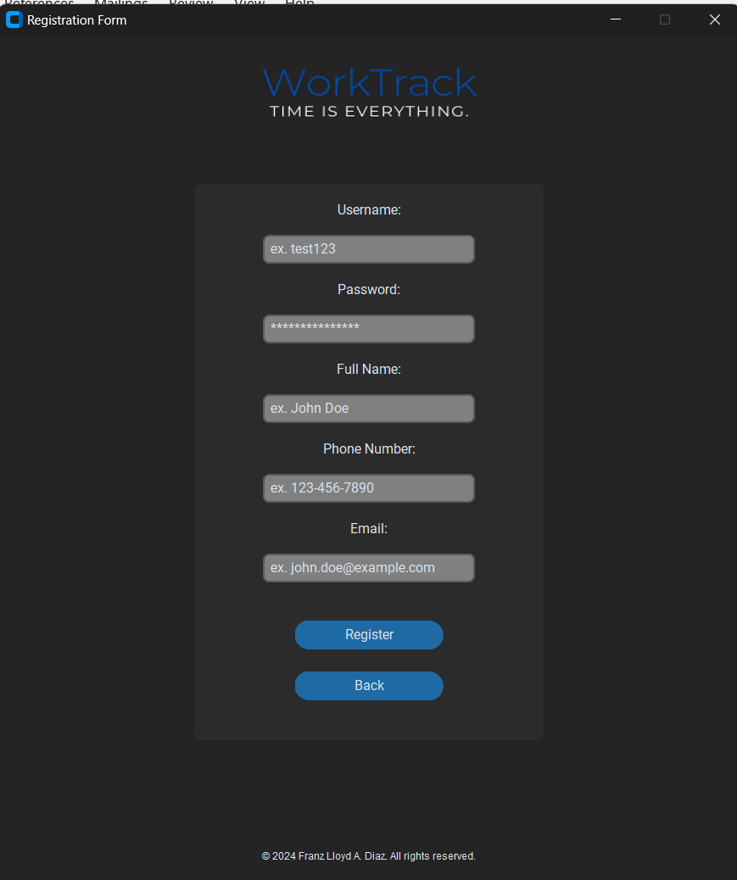

This window is where the employee has to go if they are not yet registered.

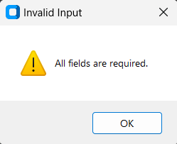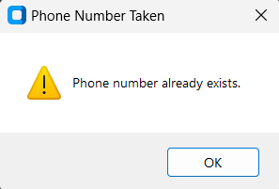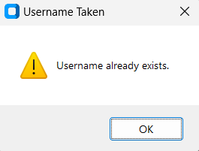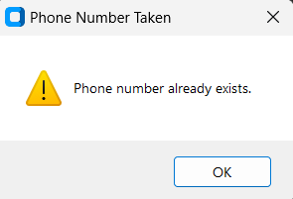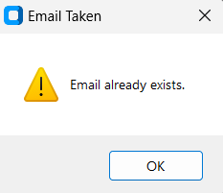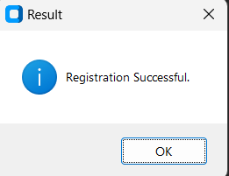

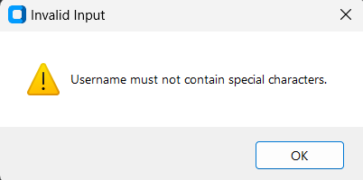 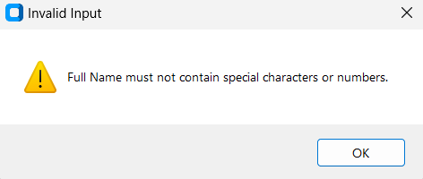 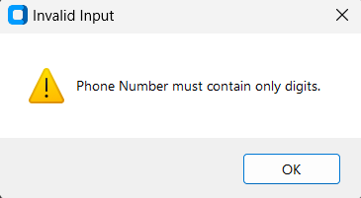

This warning message is displayed whenever the employee didn’t input anything, if the phone number was taken for the administrator can call the employee for emergency, if the

username exists for them to be unique, for the email to be unique, and the result message box will appear if they registered successfully.

* Admin Window

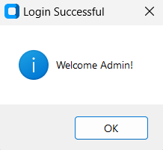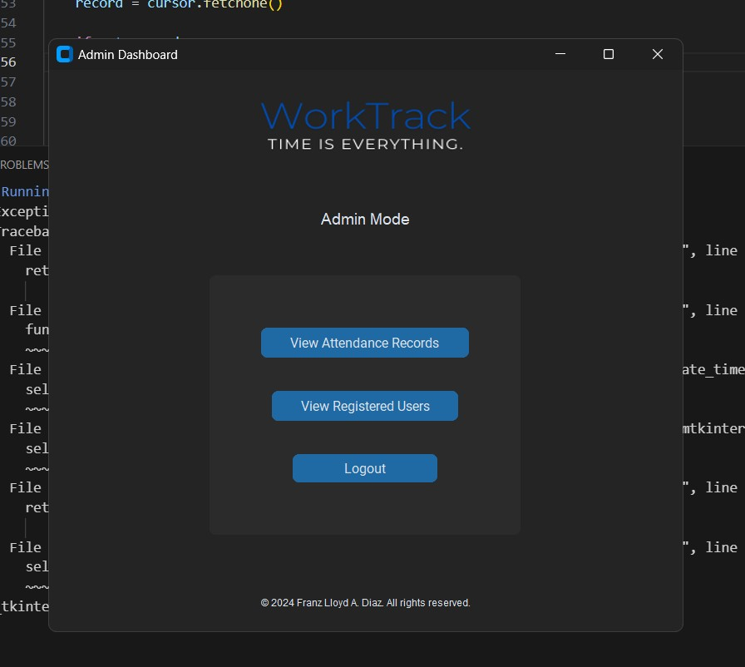

This is where the HR/System administrators/IT will be using to adjust the employees’ payroll system and check their attendance accordingly.

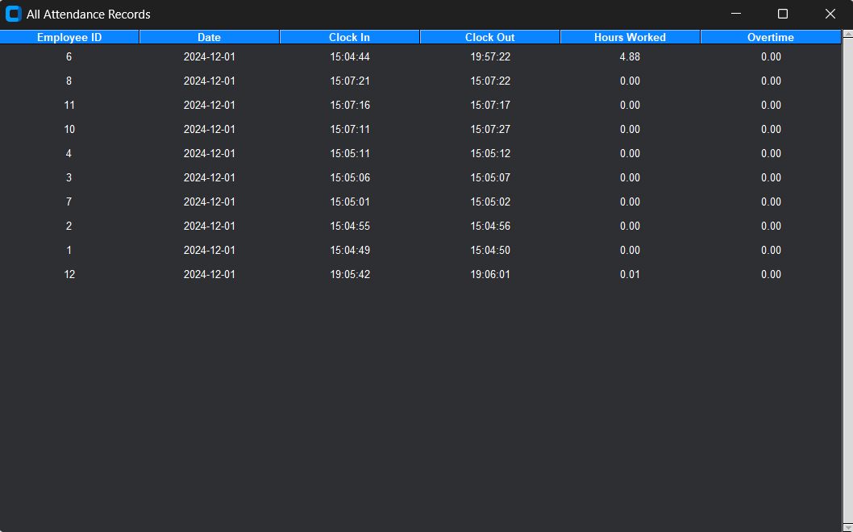

These are the attendance of all employees.

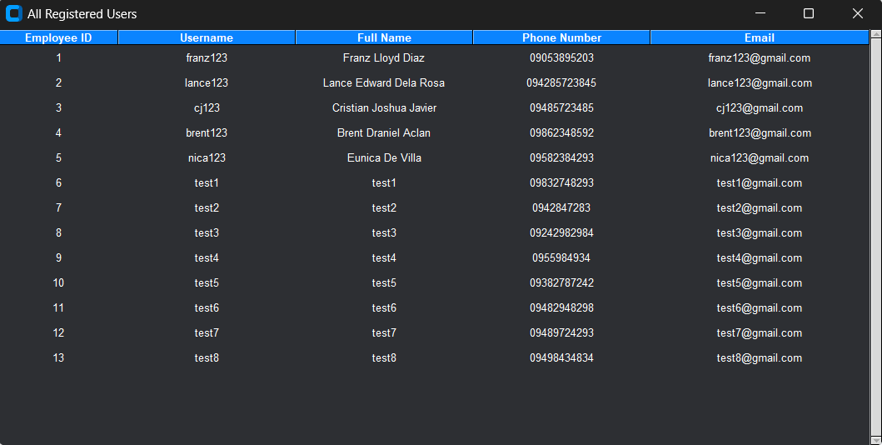

These are the registered employees.

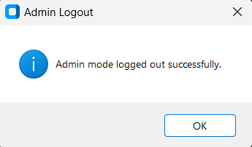

A message box will appear after the admin logged out.