RTCQI LOGBOOK
ADMINISTRATOR USER GUIDE

Dashboard

Provides a quick snapshot

- Over all Audits.
- Number of Audits(Last 12months).
- Number of Sites Audits(Last 12months).
- View map based on the sites.
- View Recent Monthly Logbook Entries.

By default, the dashboard map shows data for the last 30 days, but this can be easily changed by adjusting a date range and choose province in the field above the screen. Below the map we show the monitoring sitewise reports and the total count of email sitewise.Below the monitoring sitewise reports, shows 10 latest logbook entries. Then we show bar graph for monthly reports last 12 months. Then We show the bar graph sitewise last 12 months.
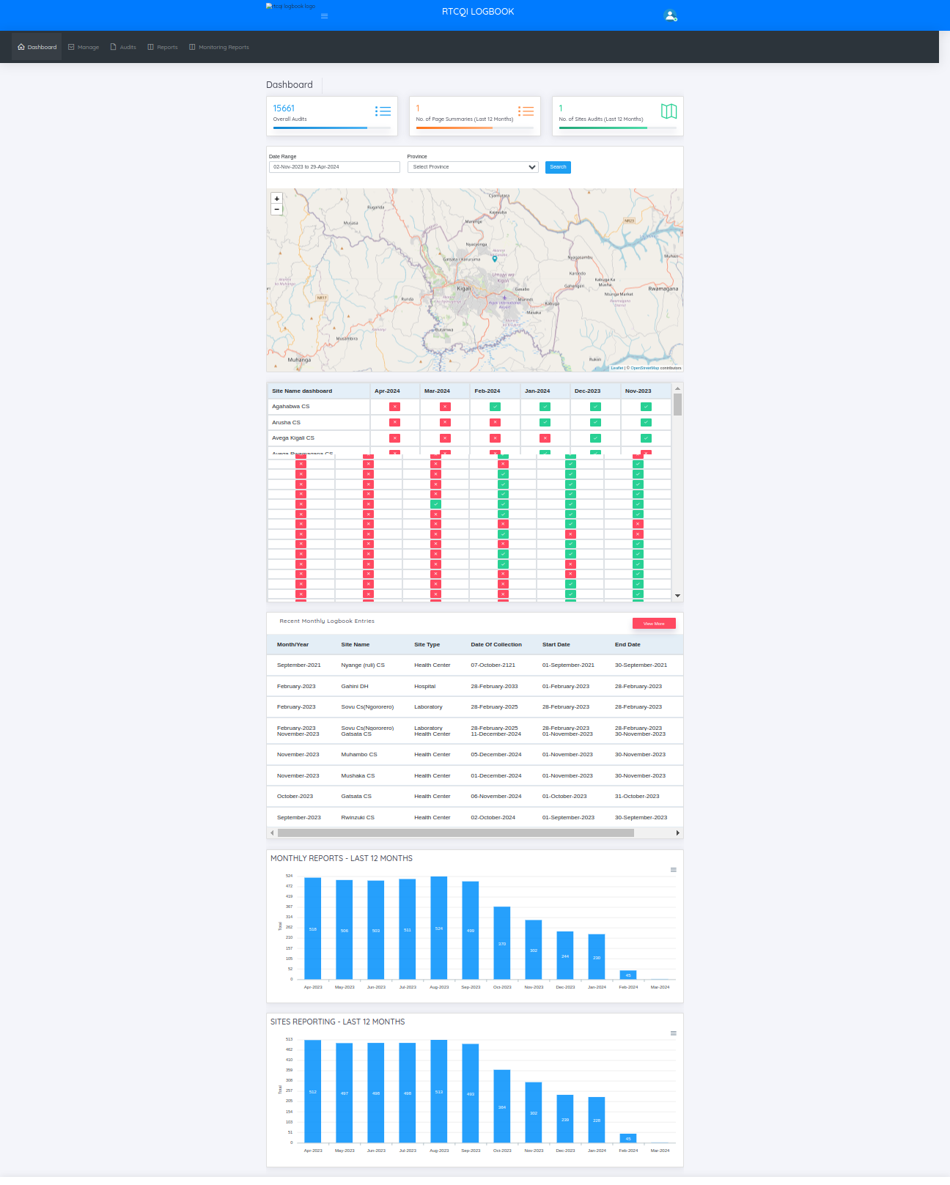

Manage Menu

This menu has the list of functionalities that are typically managed by the System Administrator (or simply, Admin)

Admin can modify users, global configuration.

- Access Control
  - Users
  - Roles
  - User Login History
  - User Activity Log
- Test Sites
- Locations
  - Provinces
  - Districts
  - Sub Districts
- Global Config
- Entry Point / Site Type
- Test Kits
- Allowed Test Kits
- Audit Trail
- Implementing Partners

ROLES

RTCQI LogBook uses Role-based access control (RBAC) to restrict access to authorized users. Administrators can define roles with specific permissions and assign those roles to users.

On the Roles page, administrator can:
  - View roles
  - Add role
  - Edit role

Add and Edit Role pages allow admin to create or edit roles respectively. On these pages, the admin can :
  - Enter a unique Role Name, Role Code, Default Landing Page, Status (active/inactive)
  - Check/uncheck privileges (only checked privileges are allowed for the users having this role)

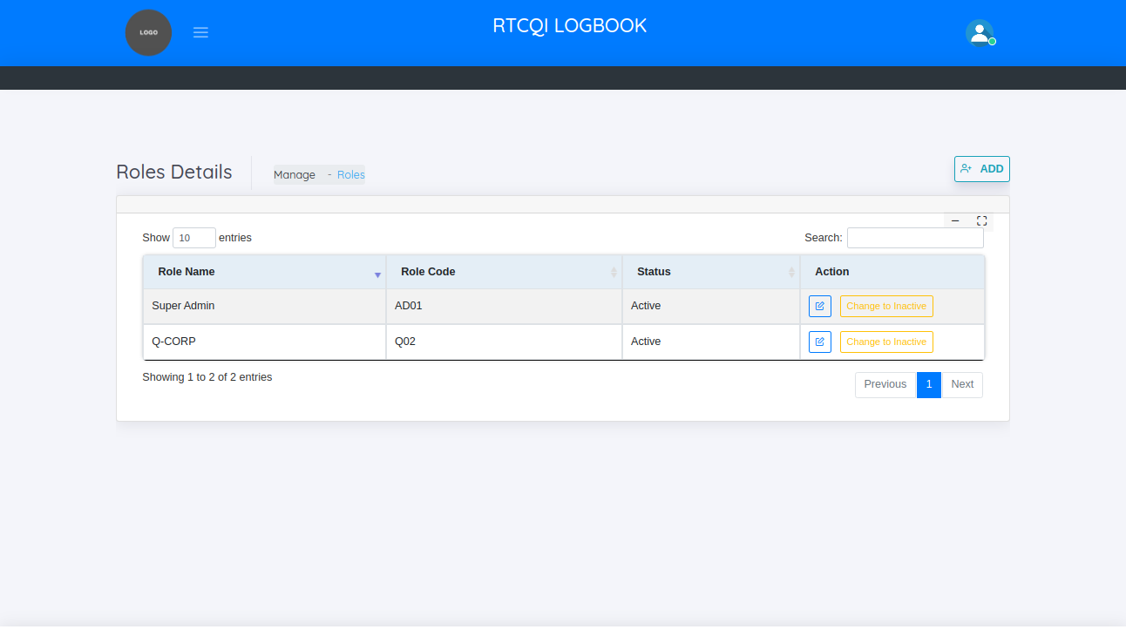

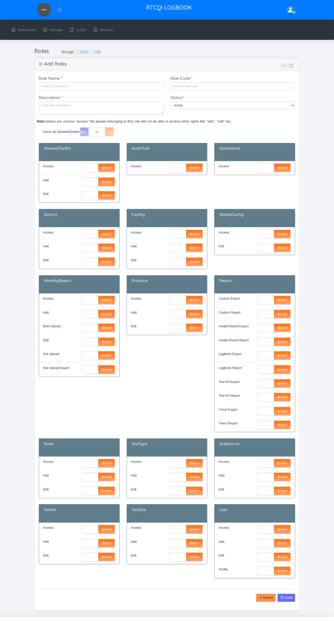

USERS
RTCQI LOGBOOK requires each user to have a separate login. Only the RTCQI LOGBOOK administrator can create users. This allows the admin to only allow authorized users to log in to the application.

On the Users page, administrator can:
  - View users
  - Add new user
  - Edit user

Add and Edit Users pages allow admin to create or edit users, respectively. On these pages, the admin can :
  - Enter the User’s First Name, Last Name, Password ,Confirm Password(Password must be at least 6 characters long and must include AT LEAST one number, one alphabet and one special character) ,Mobile Number, Email(Login ID), User Status(Active/Inactive), Role, Test Site User Map Details
  - The Login ID and Password entered here are to be shared with the users, which they can use to log into RTCQI Log Book
  - Admin can map the sites to the user. mapped sites only the user allow to create the monthly report
  - We can filter the mapped sites, on the basis of province name, district name, sub district name

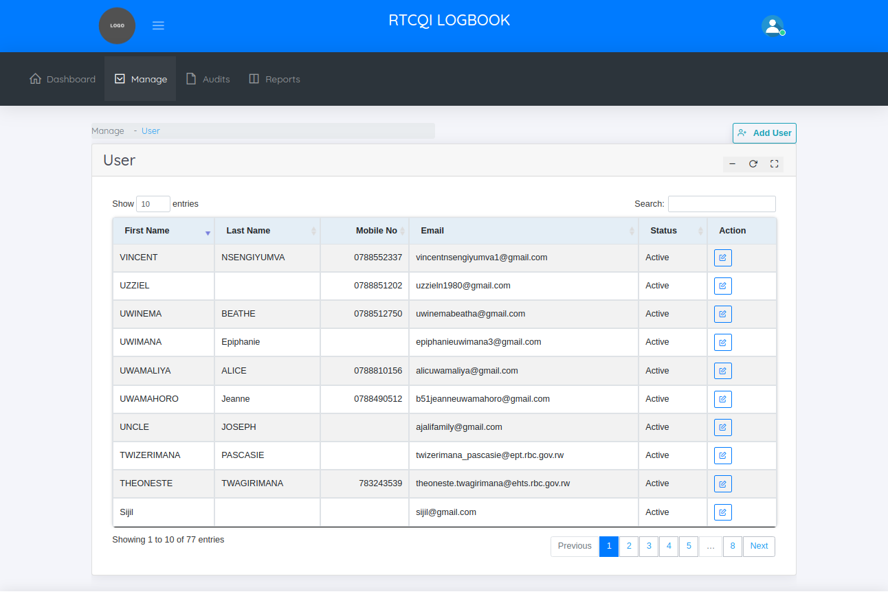

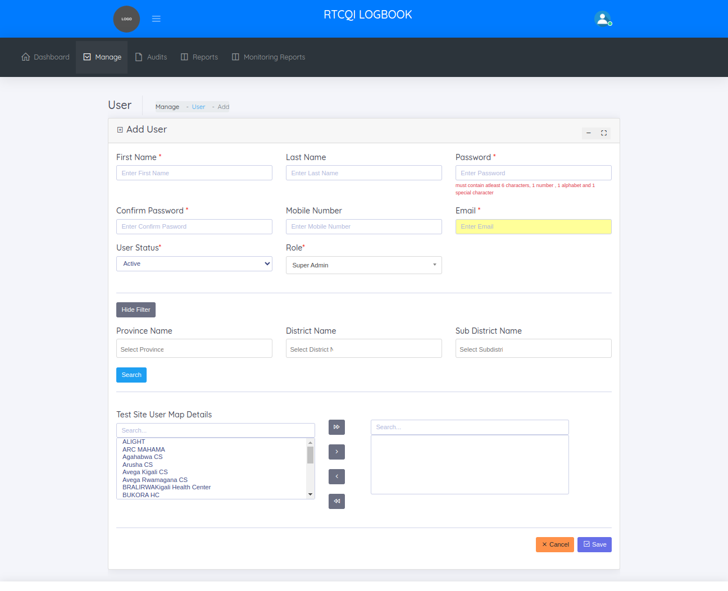

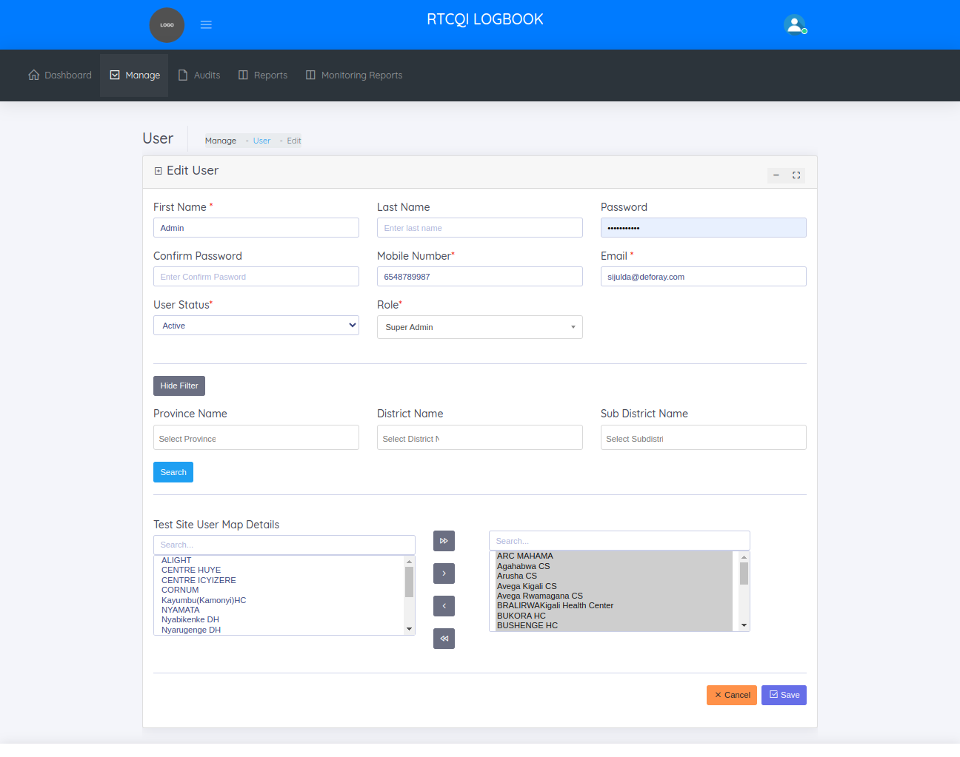
USER LOGIN HISTORY
This page helps to manage the user login histories. When the user login/logout that details show this page. Show the following columns in this page

  - Login Attempt Date & Time
  - Username
  - Login ID
  - IP Address
  - Browser
  - Operating System
  - Login Status

Two Filters added such as Date range , user name to filter the login/logout details in this page.
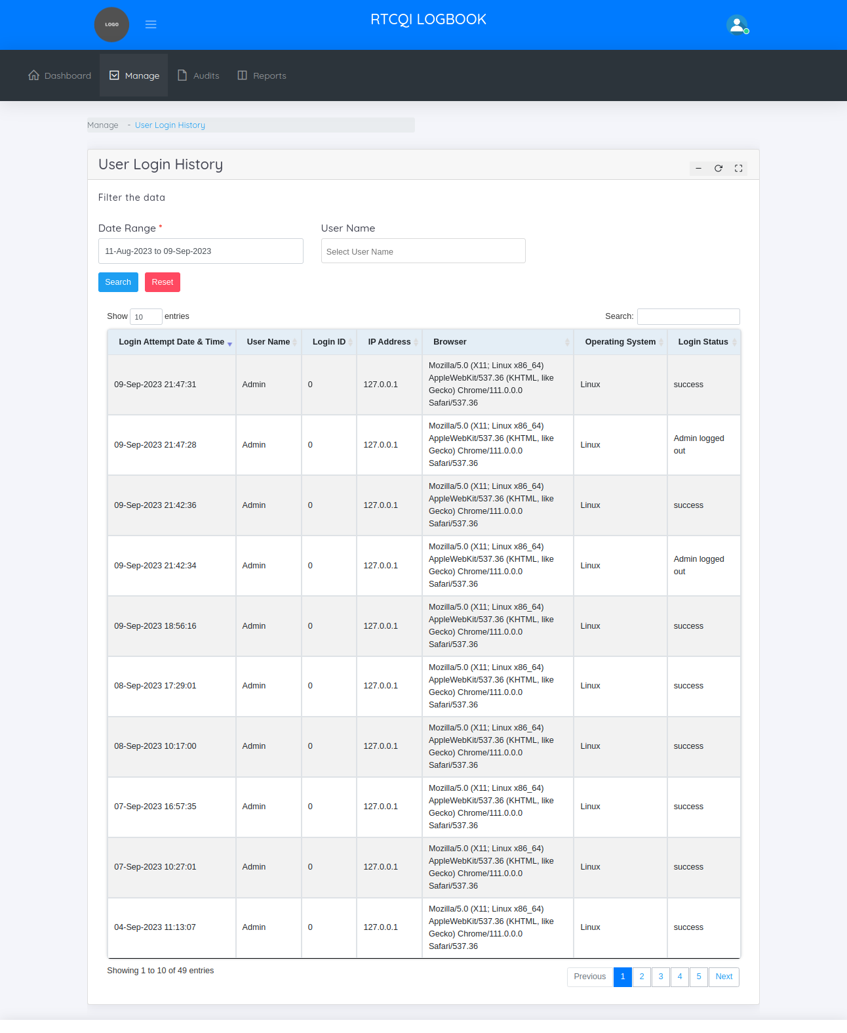

USER ACTIVITY LOG
This page helps to manage the user activity of entire application. When the user add, edit, and change anything , that details track and show this page following columns show this page.
  - Event Type
  - Action
  - Resource
  - IP Address
  - Date Time

Two Filters added such as Date range , user name to filter the user track details of entire application in this page

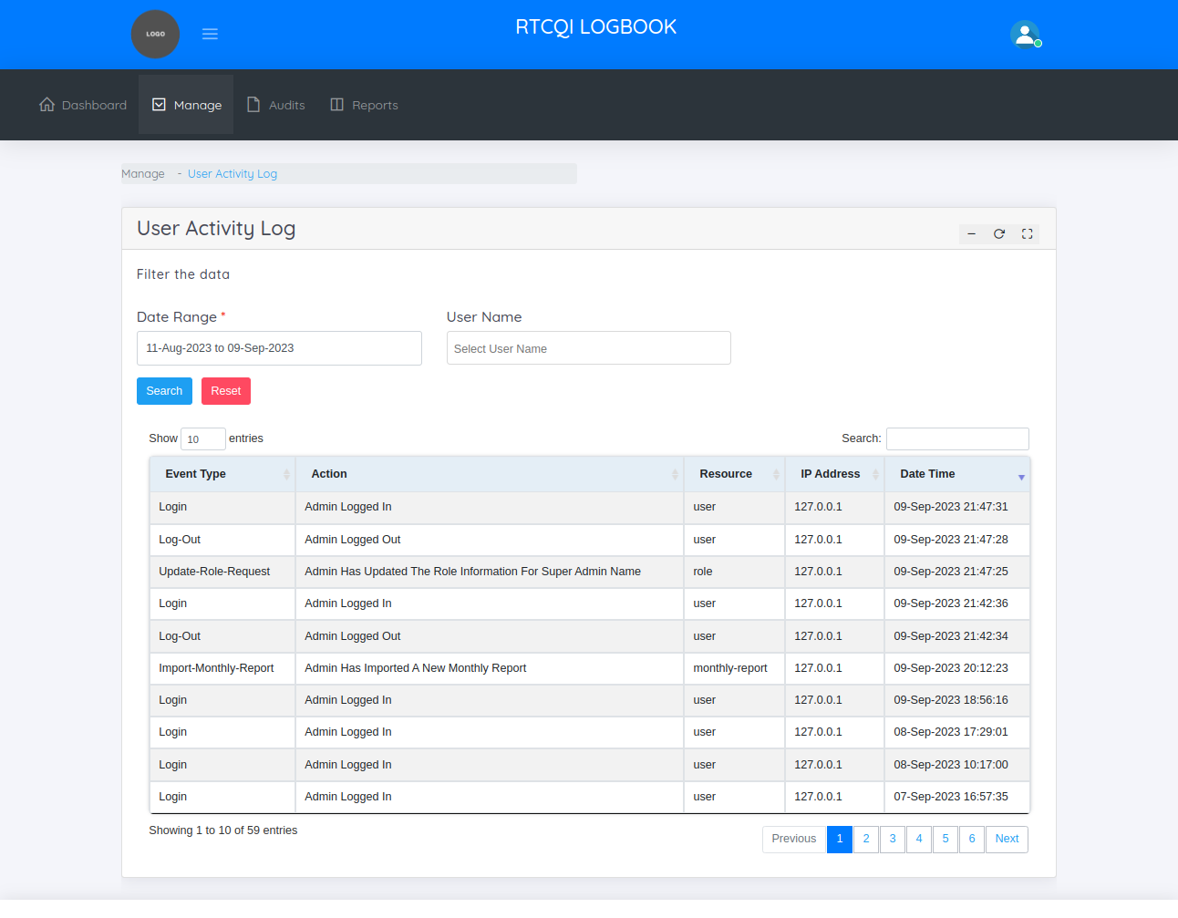

TEST SITES

Test Site refers to the specific location.

On the Test Sites Page, the administrator can:
  - View test sites
  - Add new test sites
  - Edit test sites

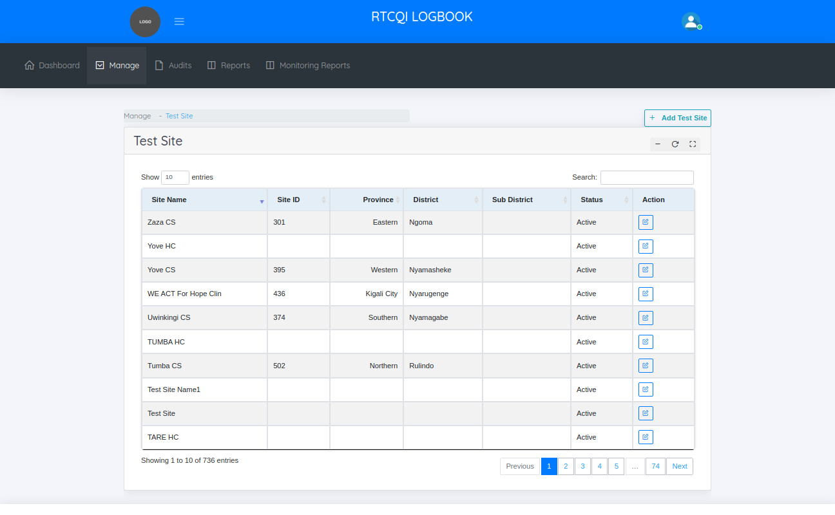

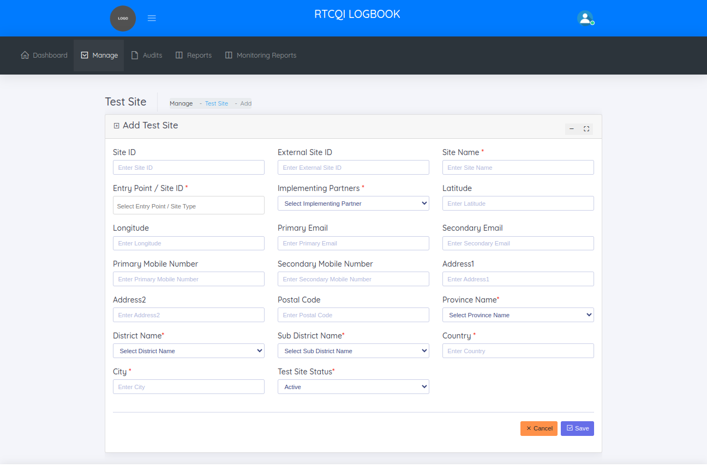
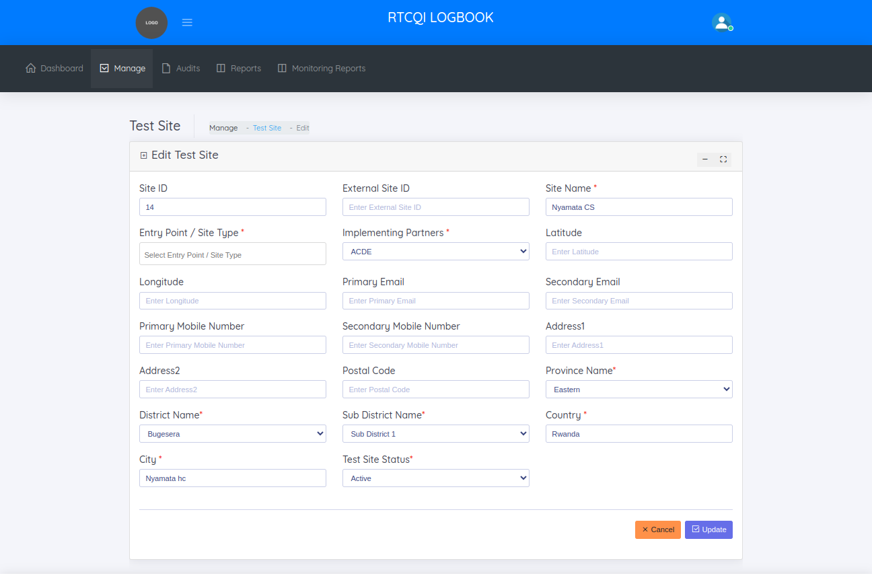
LOCATIONS
In Locations menu, there are 3 categories
  - Province
  - District
  - Sub District

PROVINCE
The Province page helps to manage the provinces across the country

On this page, administrator can:
  - View provinces.
  - Add New province.
  - Edit province
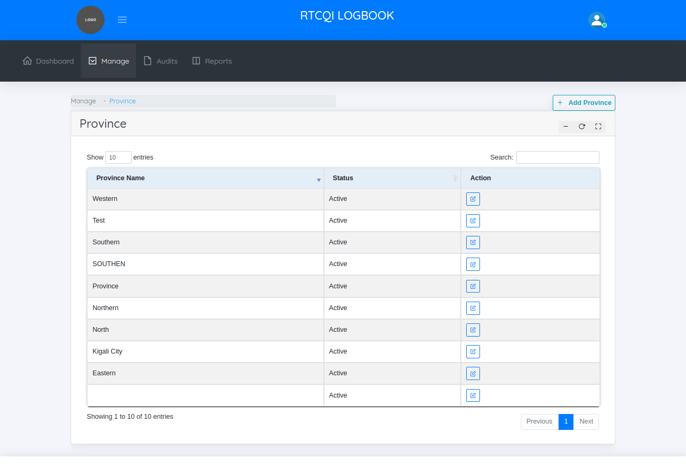

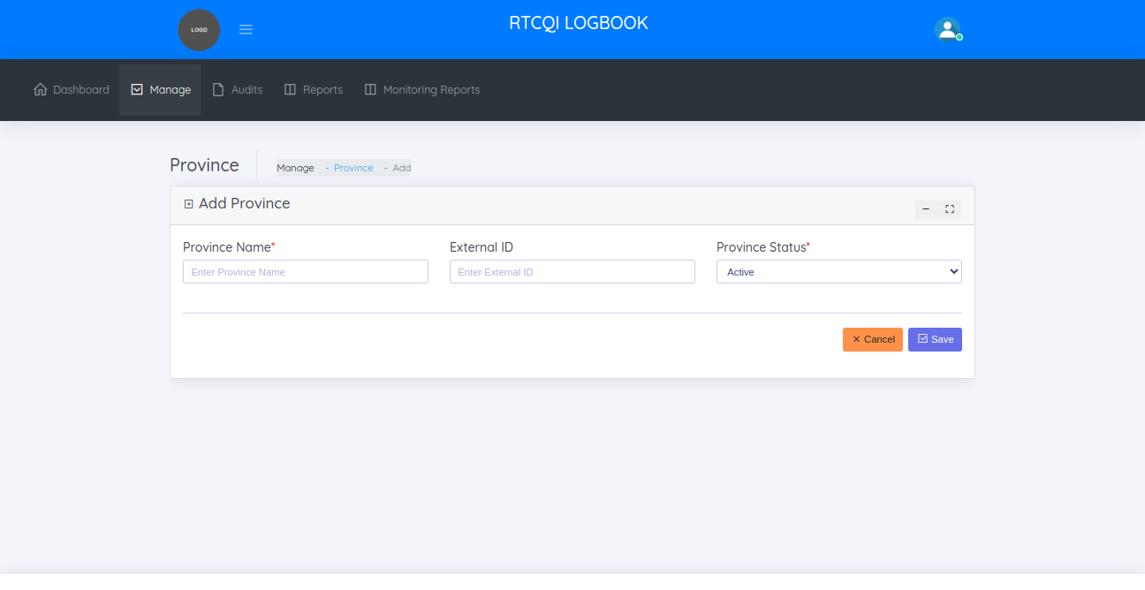

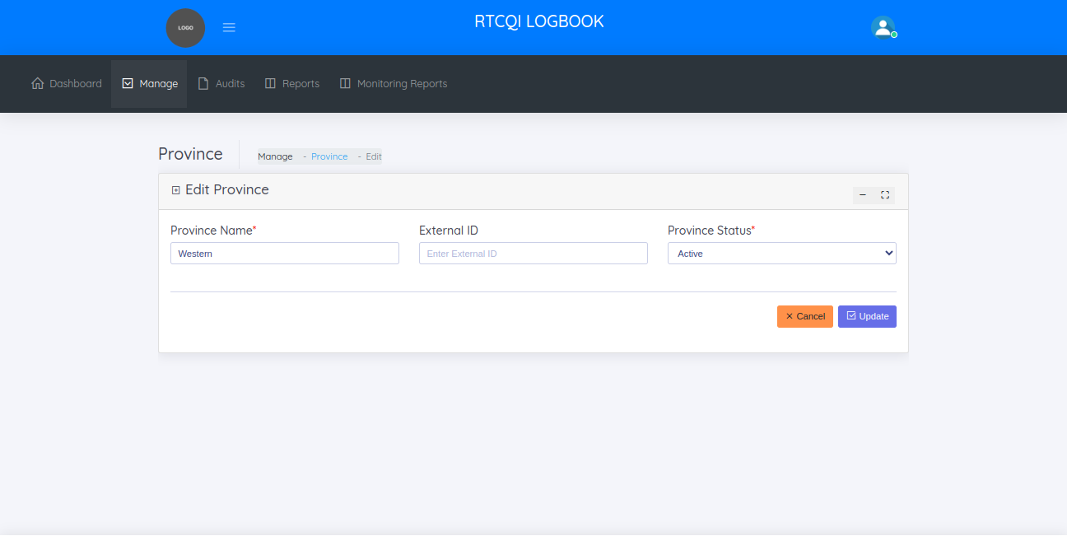

DISTRICTS
The distircts page helps to managing the various districts in the provinces

On the Districts page, the administrator can:
  - View districts
  - Add new district
  - Edit district

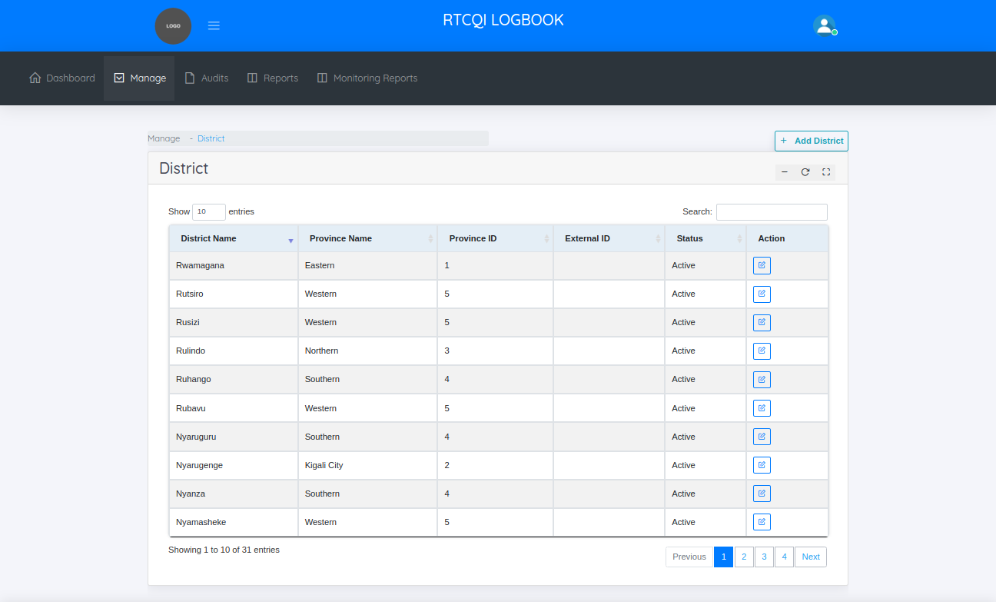

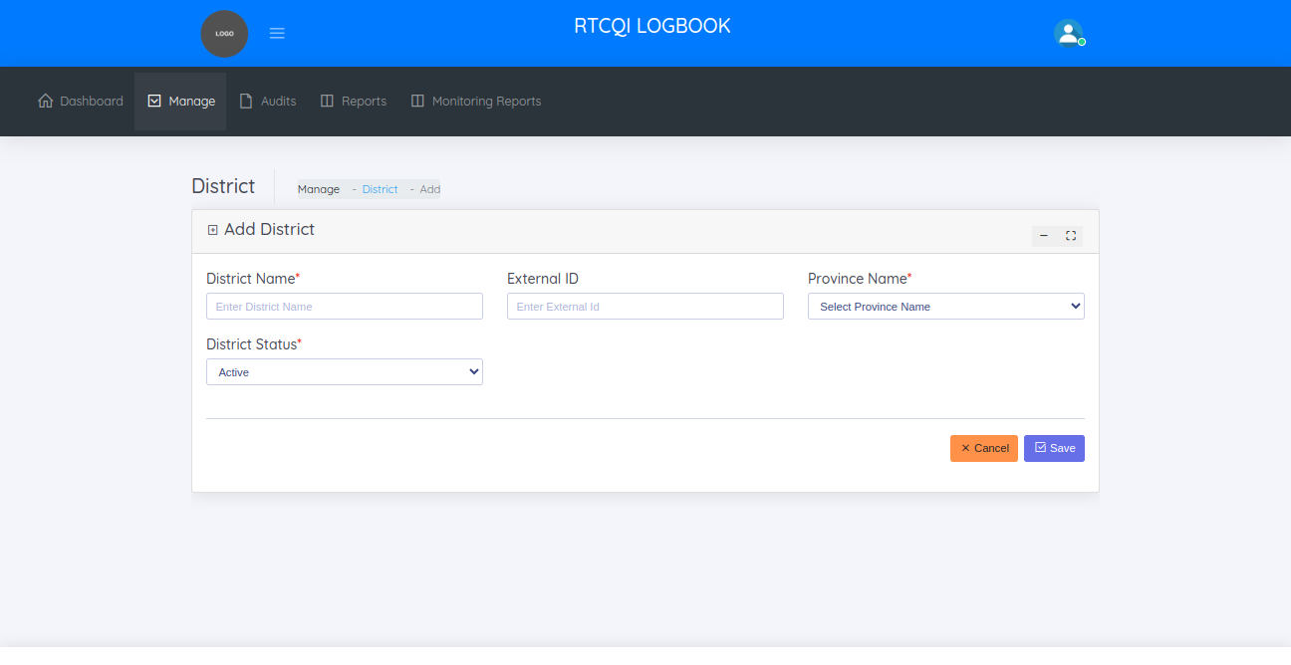

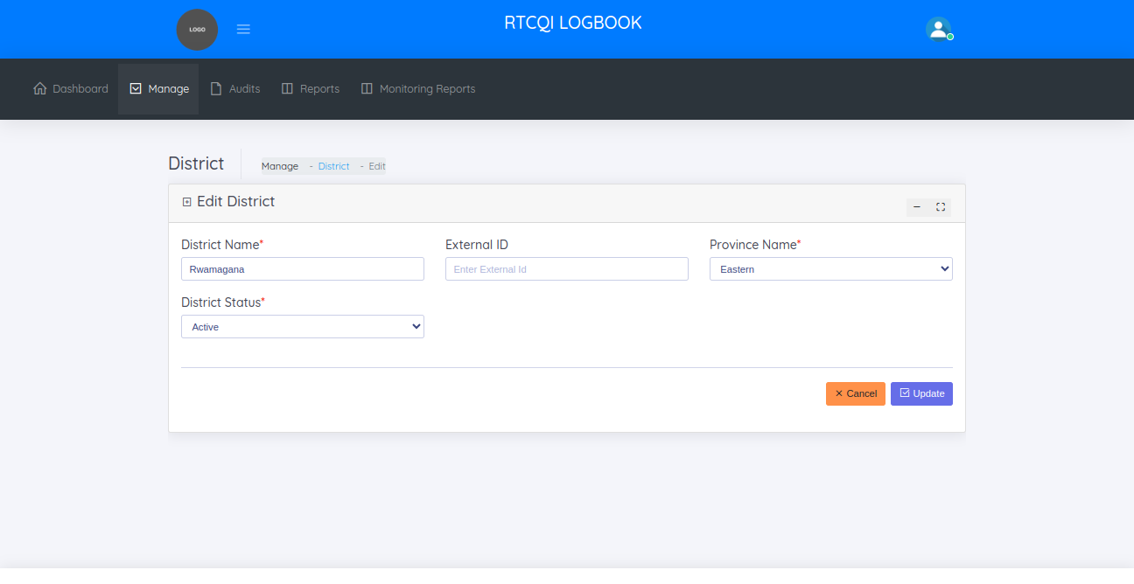

SUB DISTRICTS
The sub districts page helps to managing the various sub districts in the districts.

On the sub districts page, the administrator can:
  - View sub districts
  - Add new sub district
  - Edit sub district

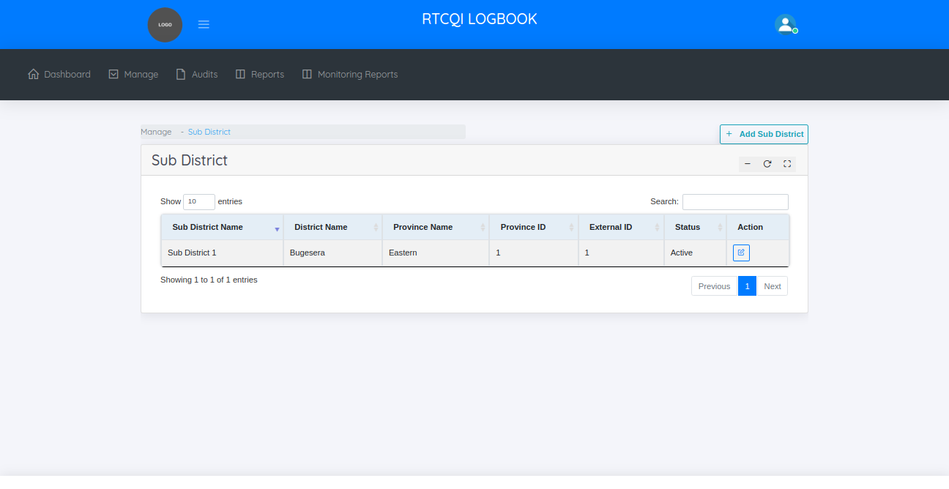

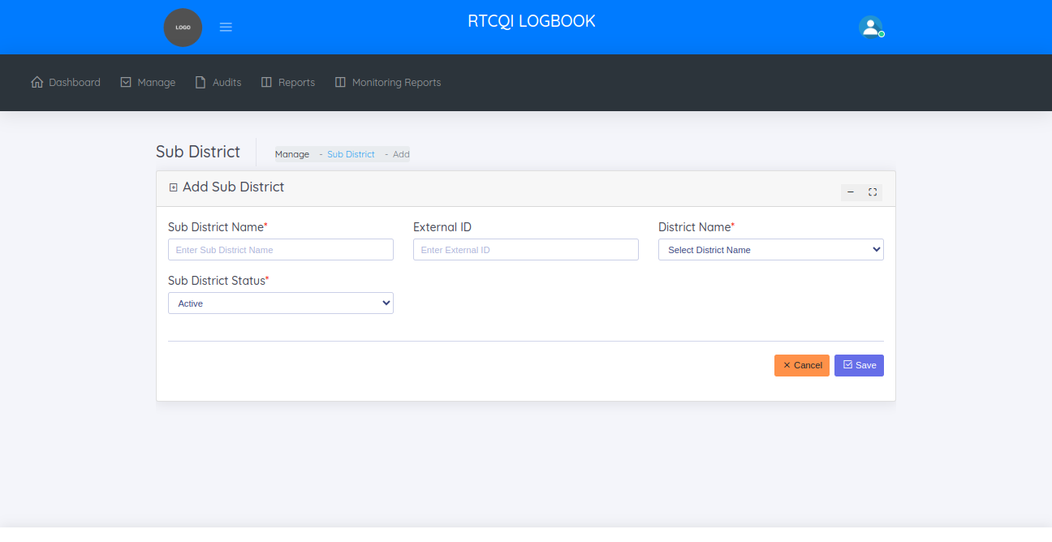

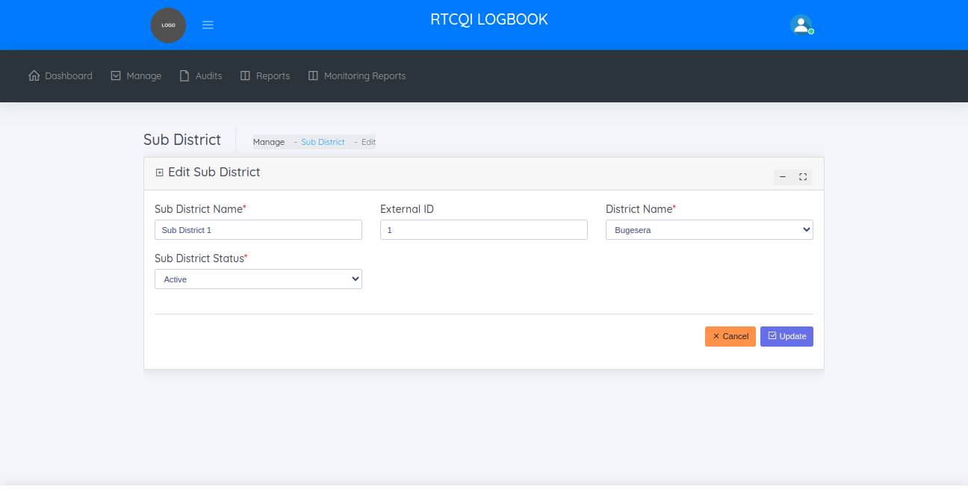

GLOBAL CONFIGURATION

This is the system default settings like instance name, institute name, admin name, admin email, admin phone, recency test, number of test, latitude, longitude, application title, map zoom level, testing algorithm, disable inactive users, no of months and logo

On this page, administrator can:
  - View Configuration Settings.
  - Edit Configuration Settings

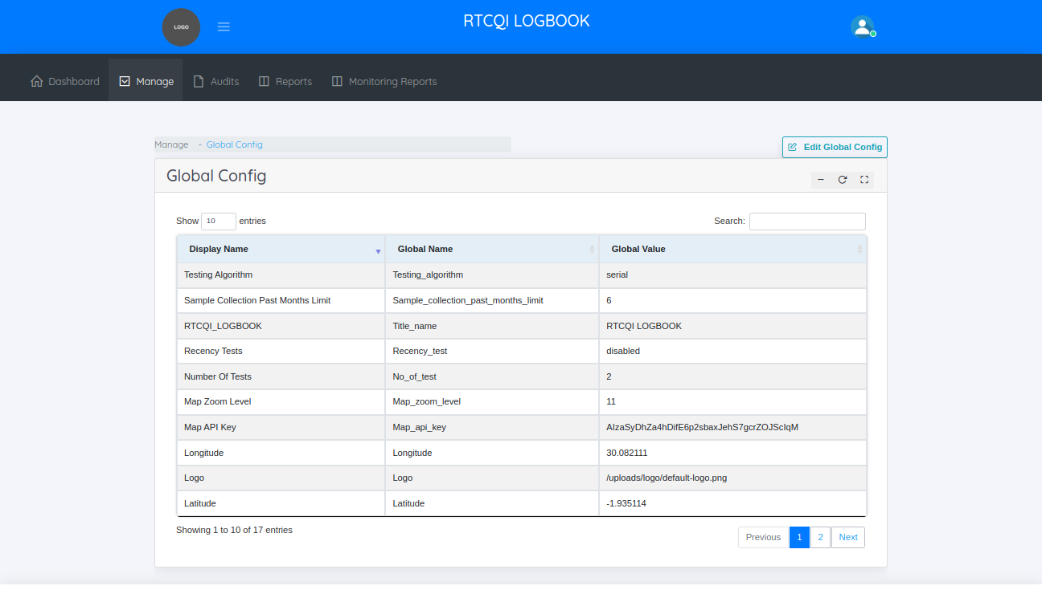

EDIT GLOBAL CONFIGURATION
In this page administrator can change these settings.
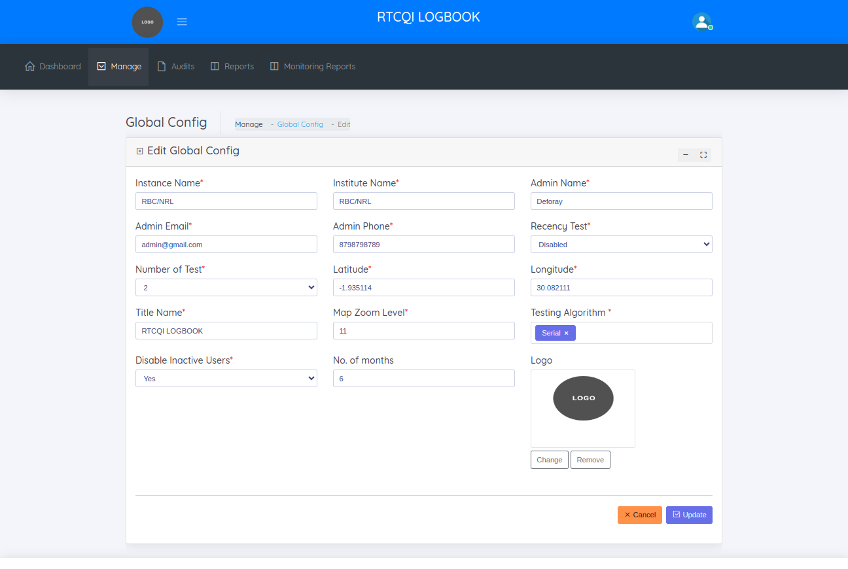

SITE TYPES
The site type helps to manage the site types.

On the site types page, the administrator can :

  - View entry Point / site types
  - Add new entry point / site type
  - Edit entry point / site type

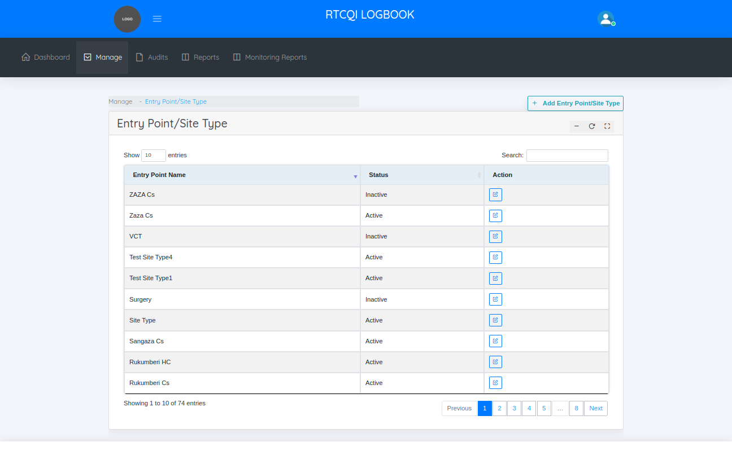

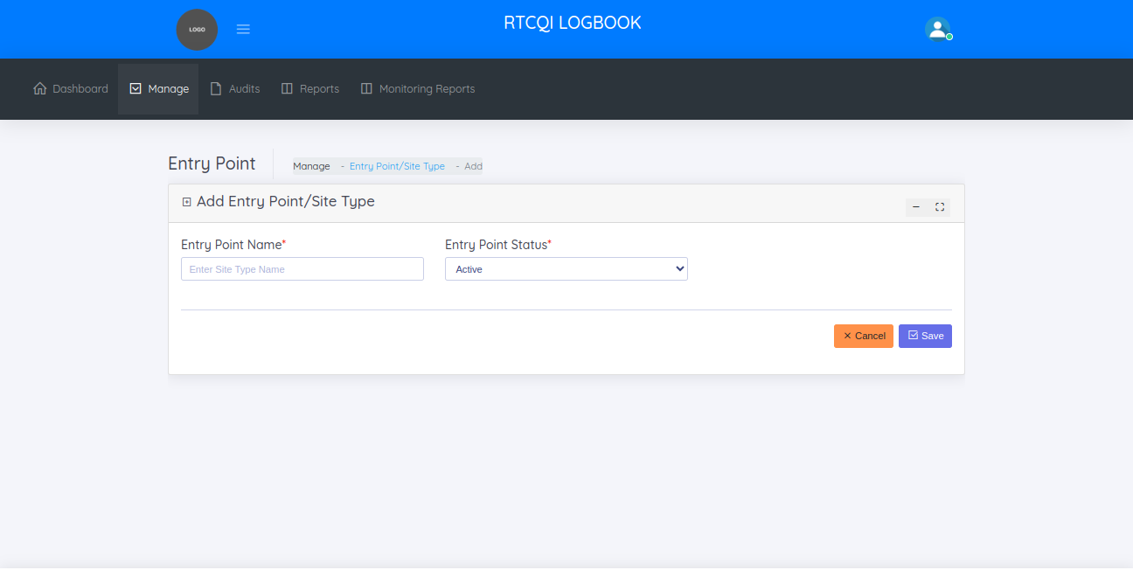

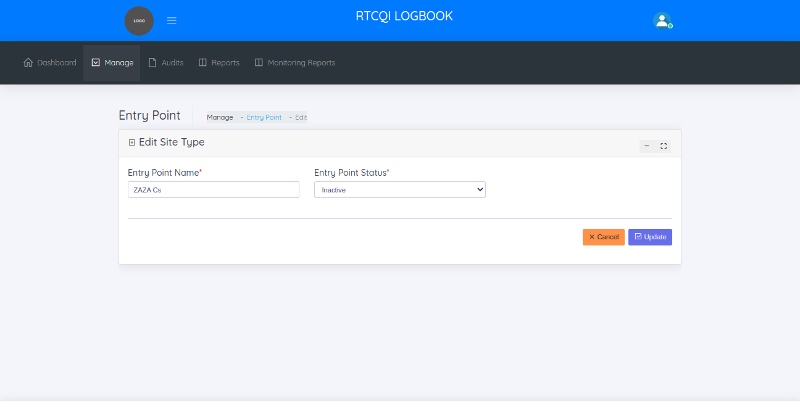

TEST KIT
The test kit helps to manage the test kit details like kit name, manufacturer, and kit name id

On the test kit page, the administrator can

  - View test kits
  - Add test kit
  - Edit test kit

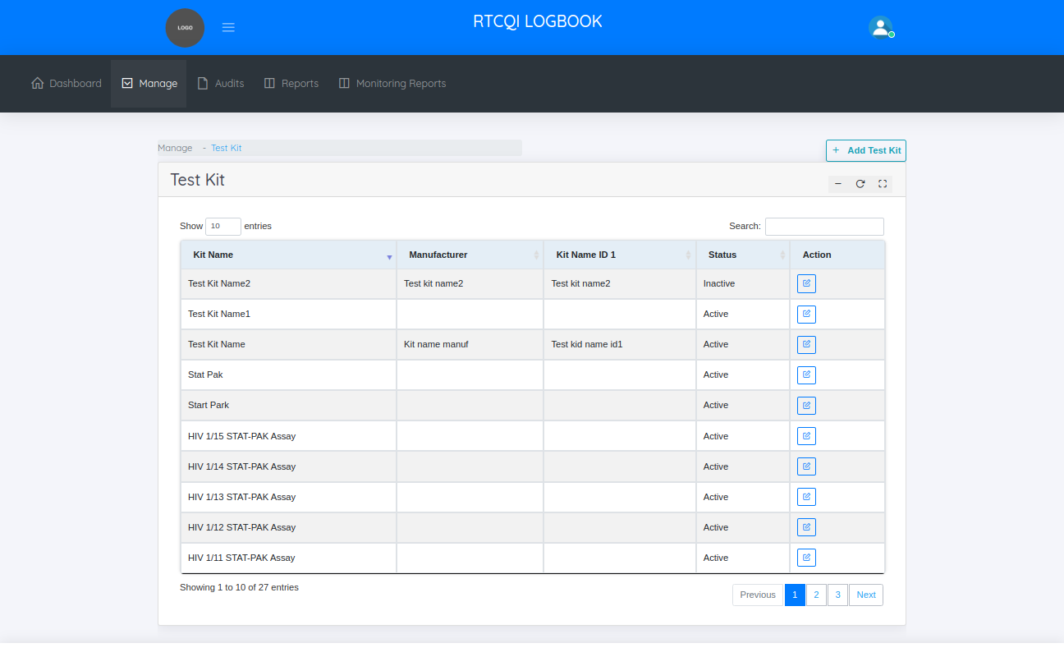

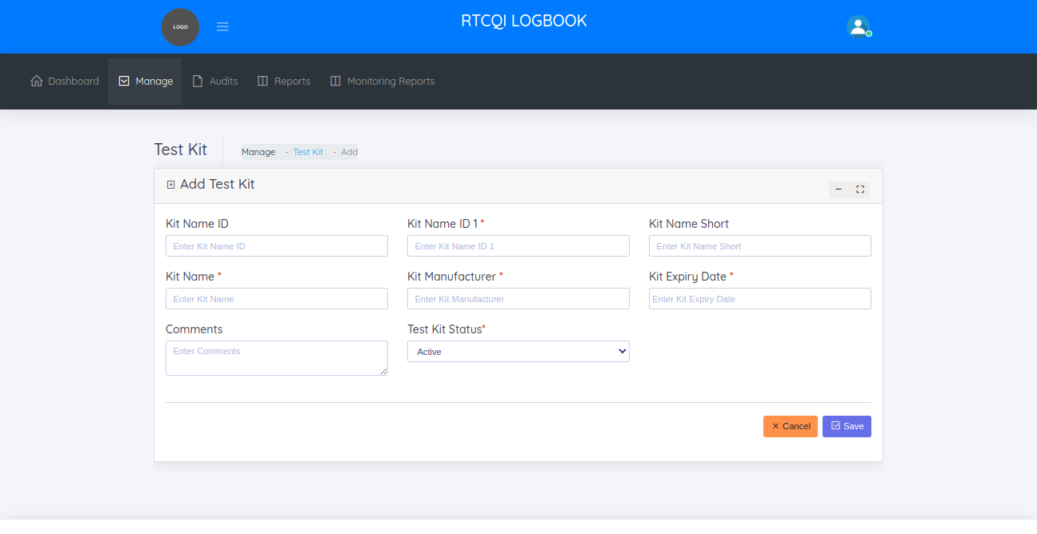

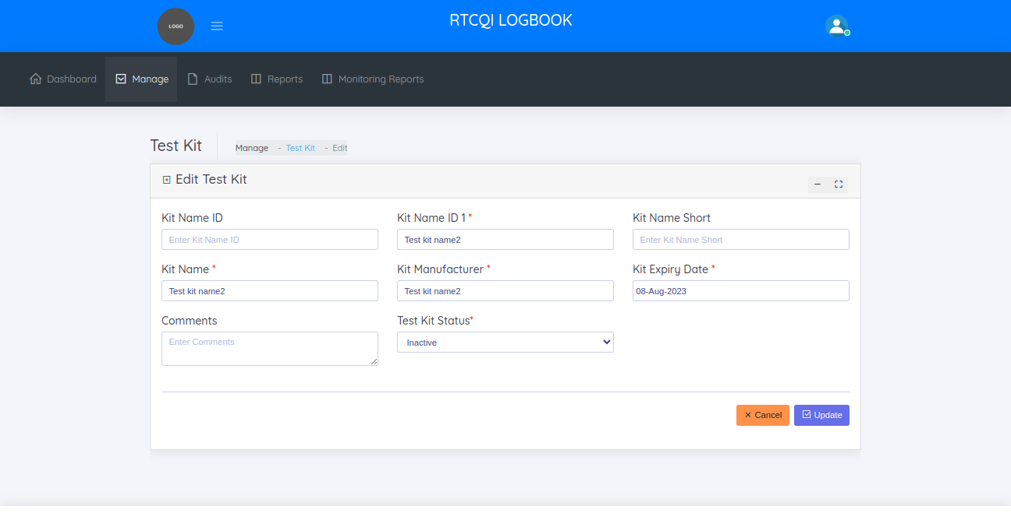

ALLOWED TEST KIT
The allowed test kit page helps in managing the allowed test kit details

On the allowed test kit page, the administrator can

  - View allowed test kits
  - Add allowed test kit
  - Edit allowed test kit

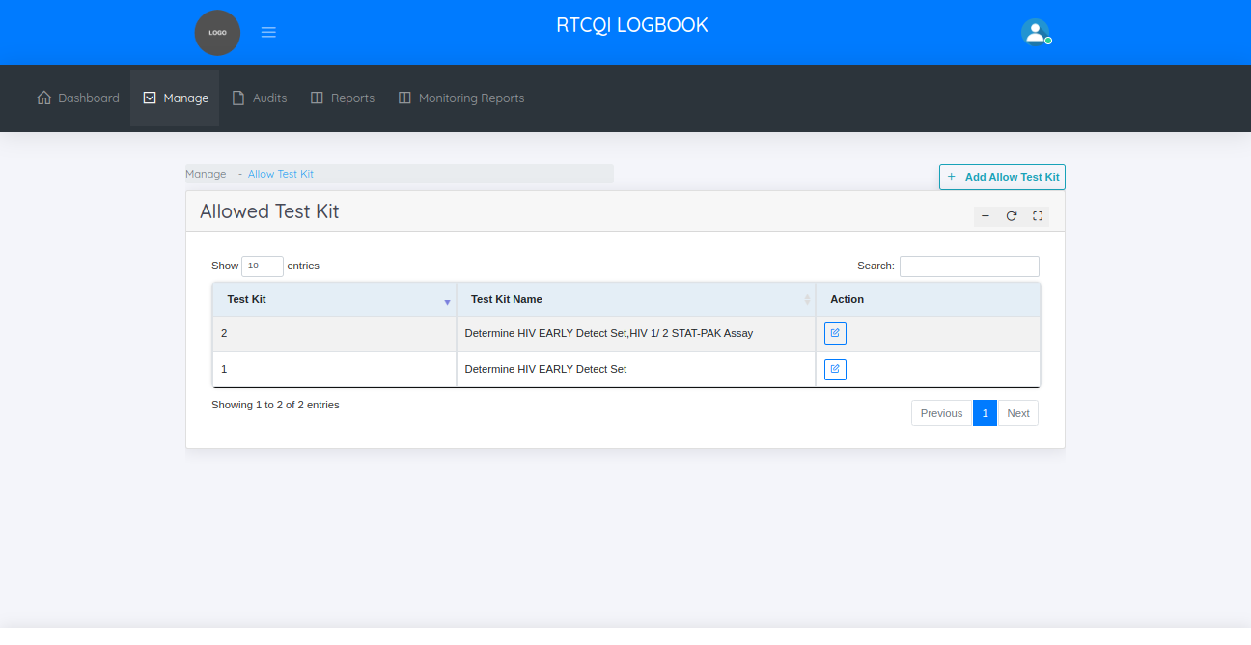

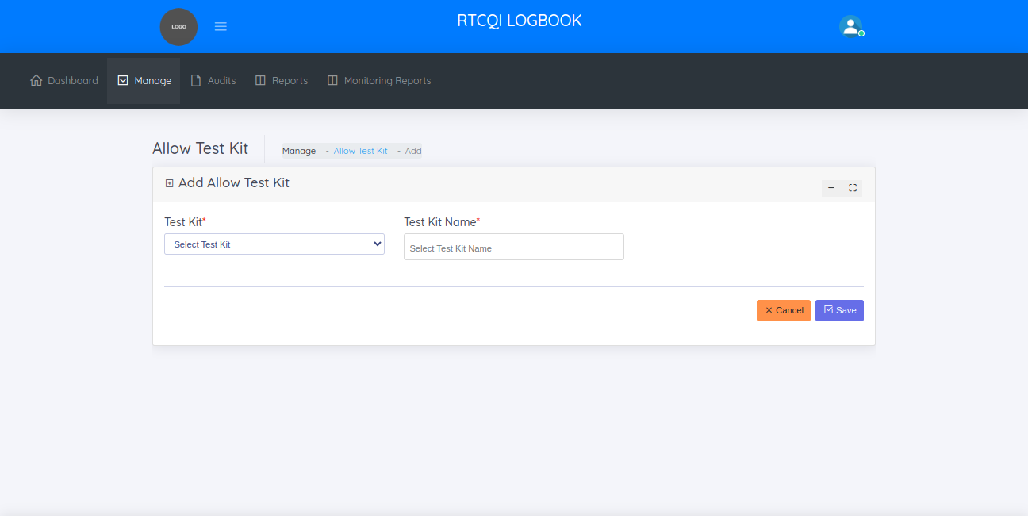

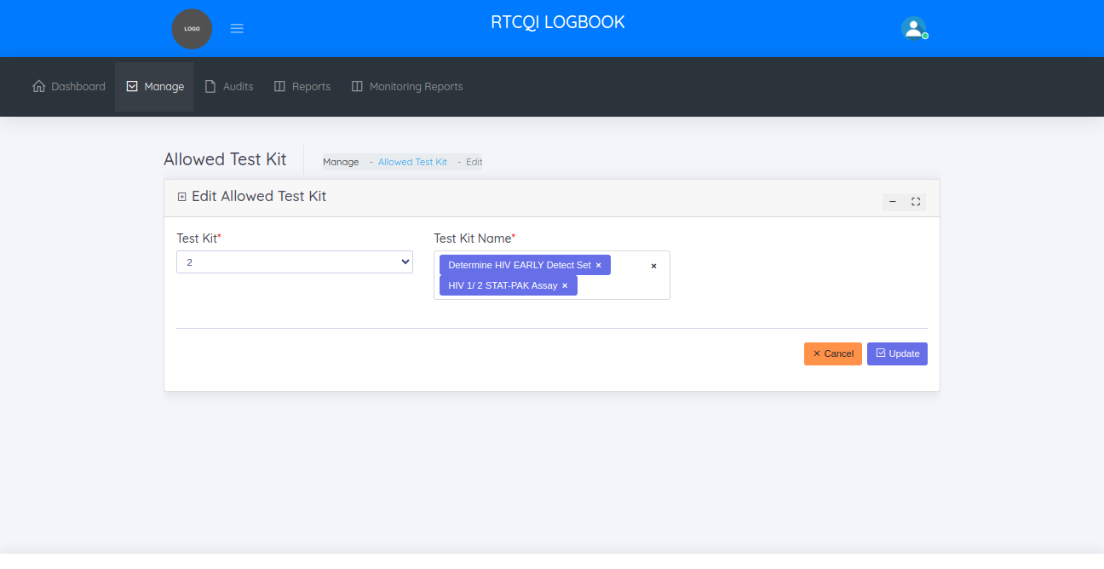

AUDIT TRAIL
The audit trail page helps to manage the history of monthly reports. It helps to know when monthly report was modified, how many column changed. This is the track of monthly reports.
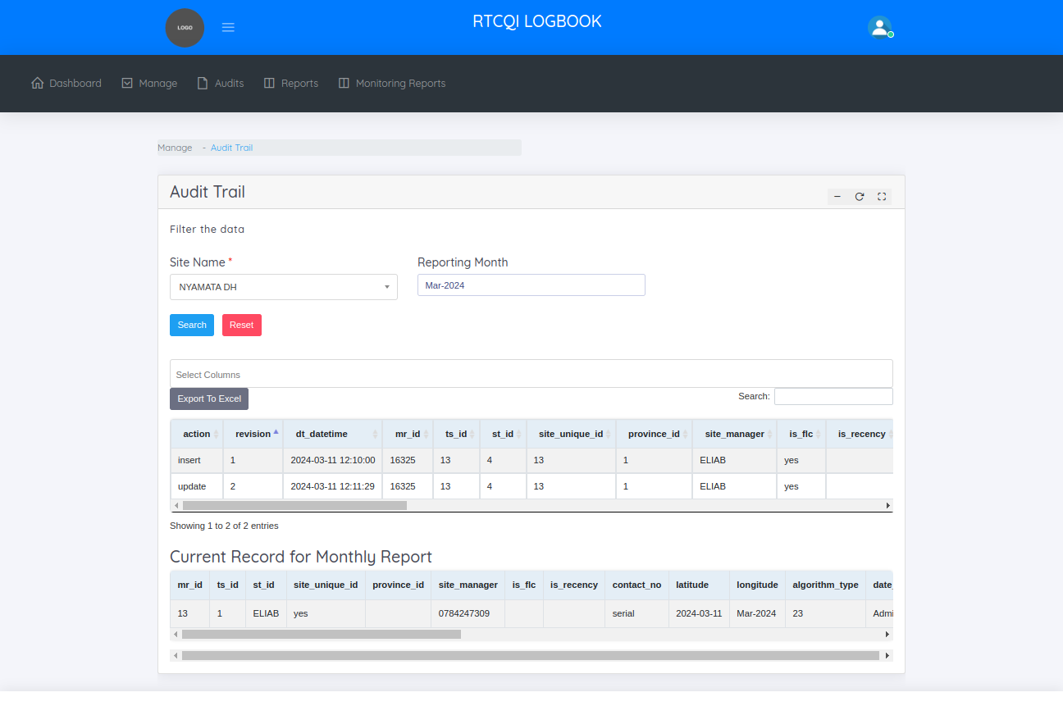

Implementing Partners
The implementing partners page helps to manage the partners.

On the implementing partners page, the administrator can

  - View implementing partners
  - Add implementing partners
  - Edit implementing partners
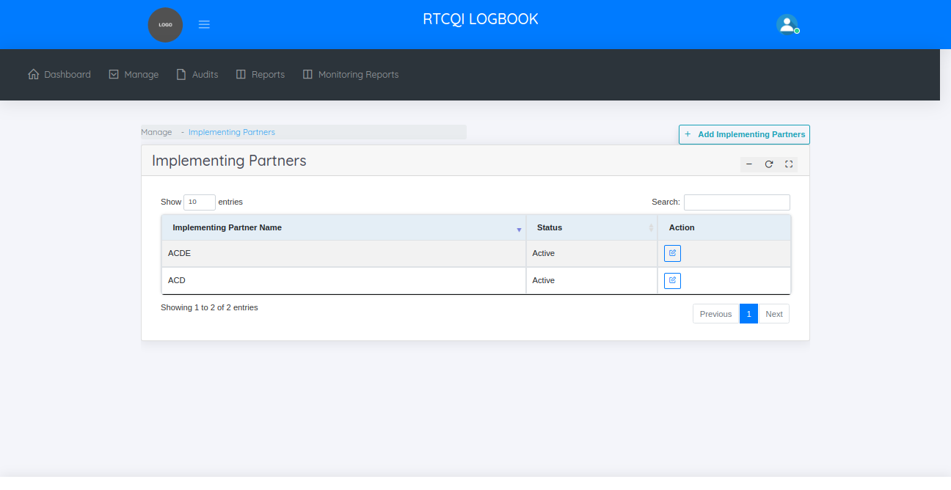
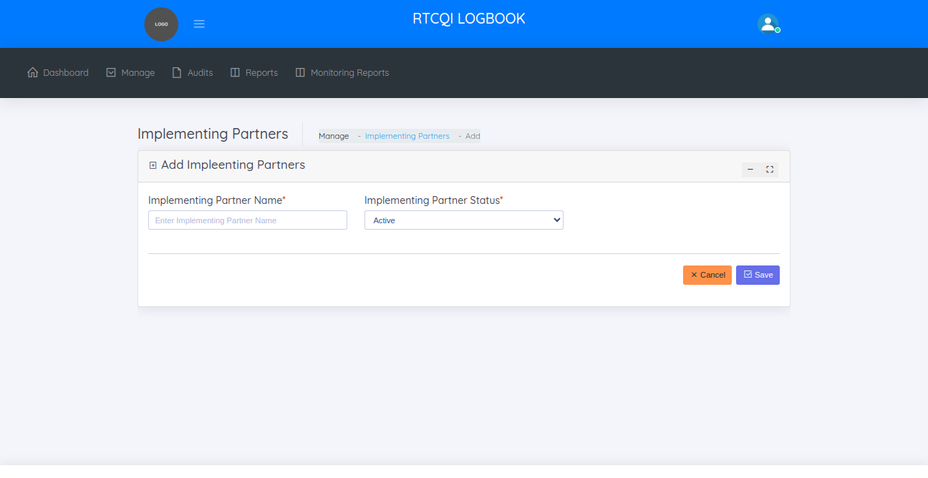
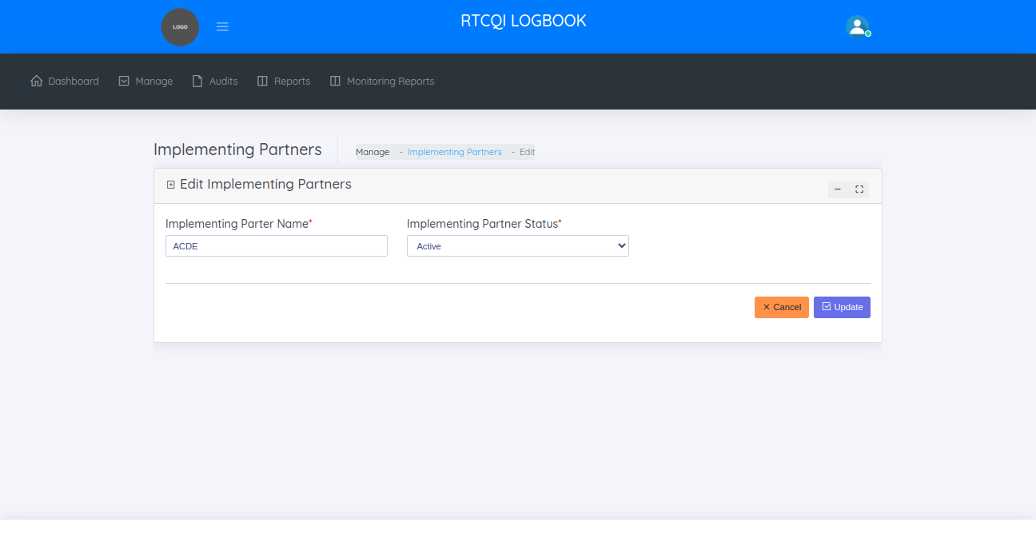

AUDITS

In audits menu, shows two sub categories
  - Monthly Reporting(Data Entry)
  - Failed Imports - Excel Upload

MONTHLY REPORTING

The monthly reports page helps to manage all monthly reports.

On the monthly reporting page, the administrator can
  - View Monthly Reports
  - Add Monthly Report
  - Edit Monthly Report
  - Bulk Upload Monthly Report

VIEW MONTHLY REPORTS
BY default, this page shows all the monthly reports of last 30 days. Filterwise also shows the reports like date range, province name, district name, sub district name, site name

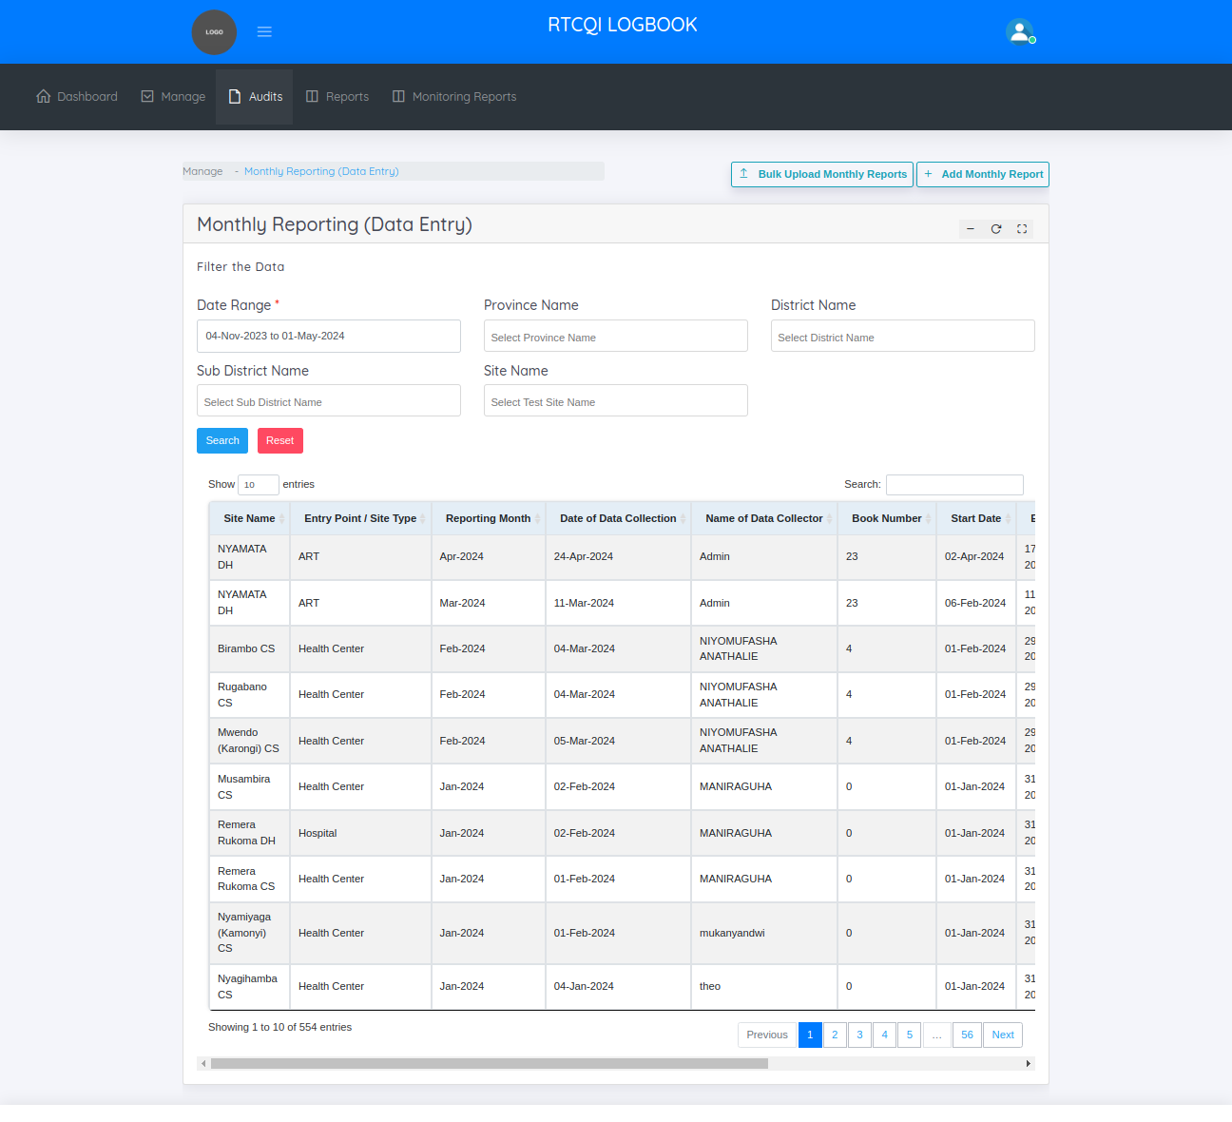
ADD MONTHLY REPORT
This is the add monthly reports page
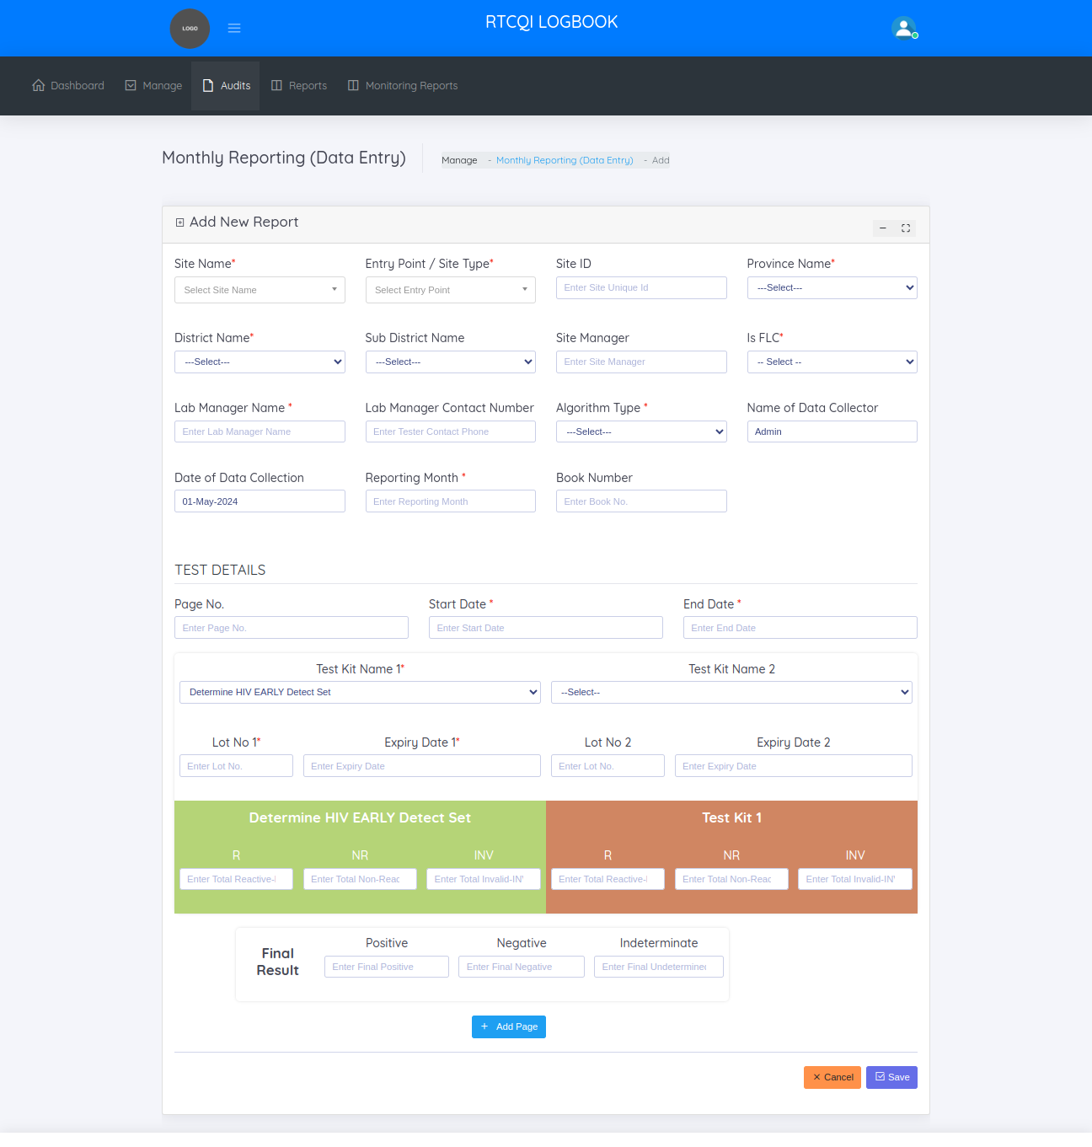
First select any of the site need to add monthly report, above the form shows recently added monthly reports for the selected site.
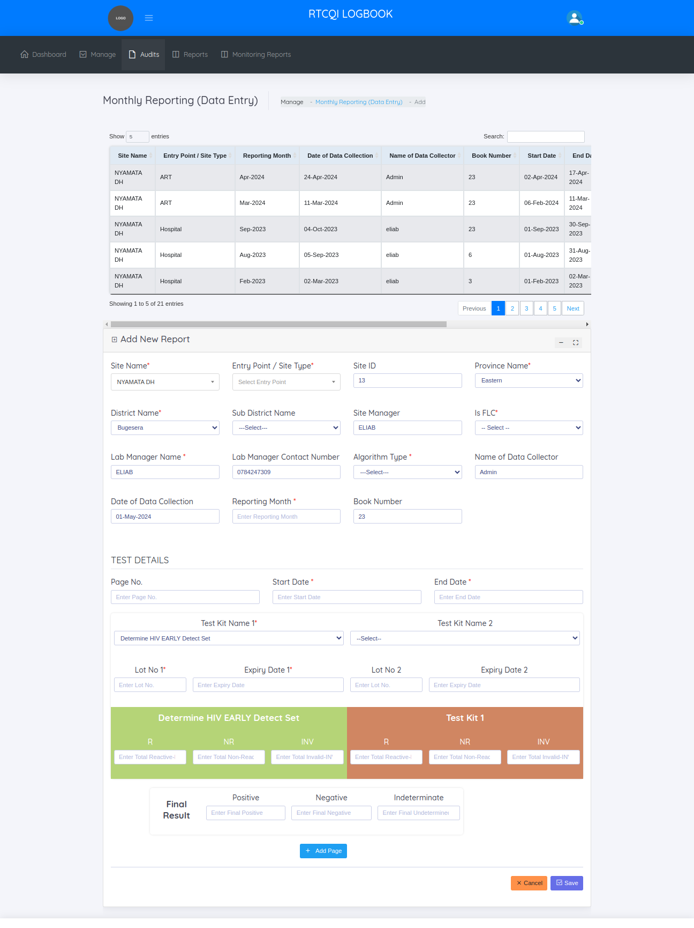

EDIT MONTHLY REPORT
This page helps to update if any changes needed in the already added monthly report.
Edit form below, shows the history of the report like when add, update. History grid we show the event type, action, resource, ip address, Date time.

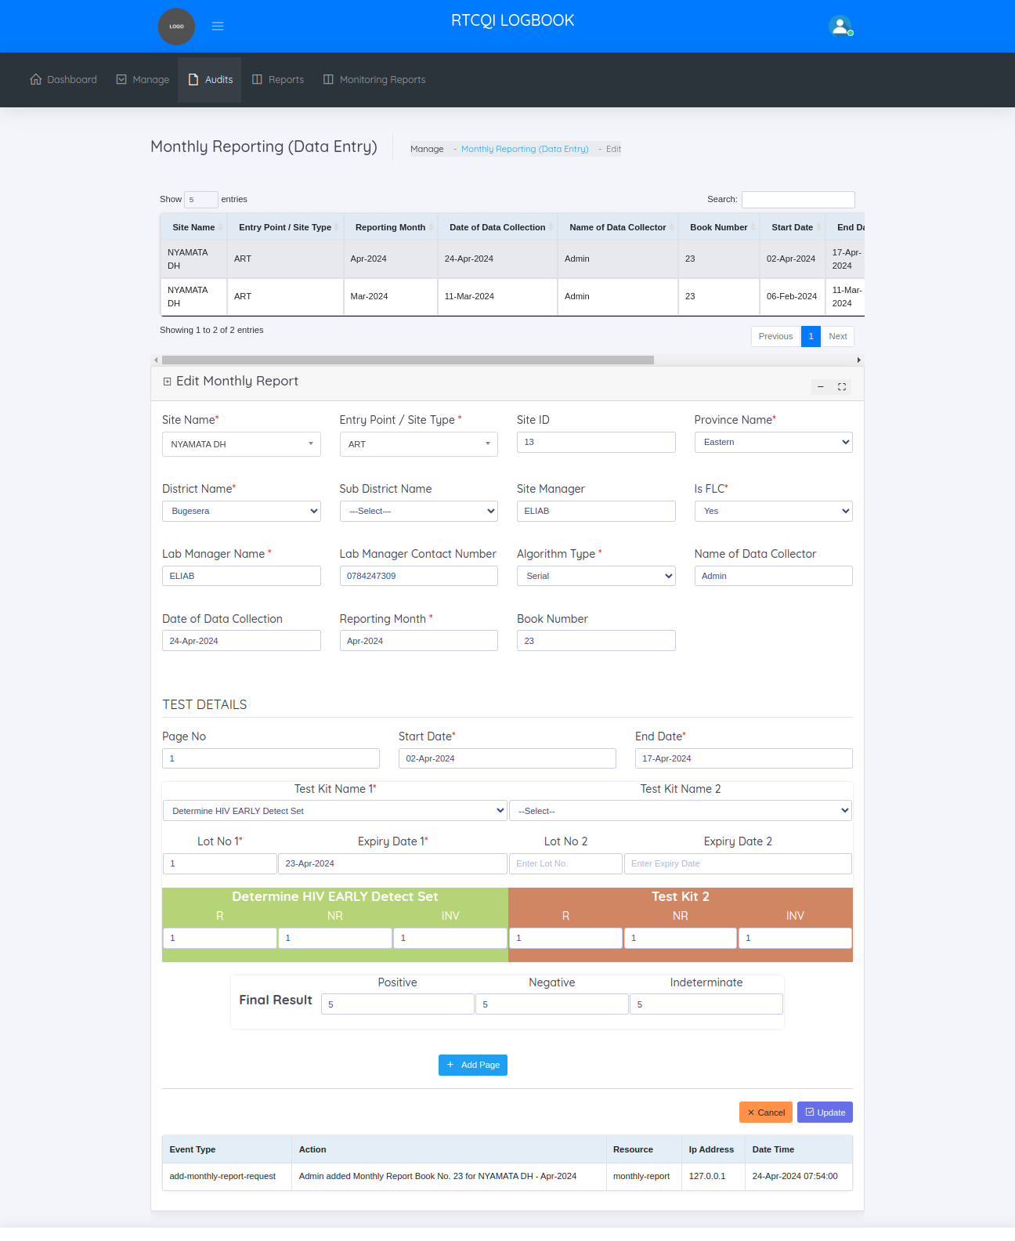

BULK UPLOAD MONTHLY REPORTS
This page helps to import multiple reports at a time. Follow the steps to import monthly report
- Click the download sample monthly report excel sheet button ,there one sample monthly report excel sheet downloaded.
- Enter the datas in the downloaded excel sheet
- Choose the file
- Click the Upload button
After upload display one success message ,
In that display message how many reports uploaded, then how many imported and how many not imported. Then the imported reports is display in the view monthly reports page. Failed imported reports view in the failed import monthly reports page

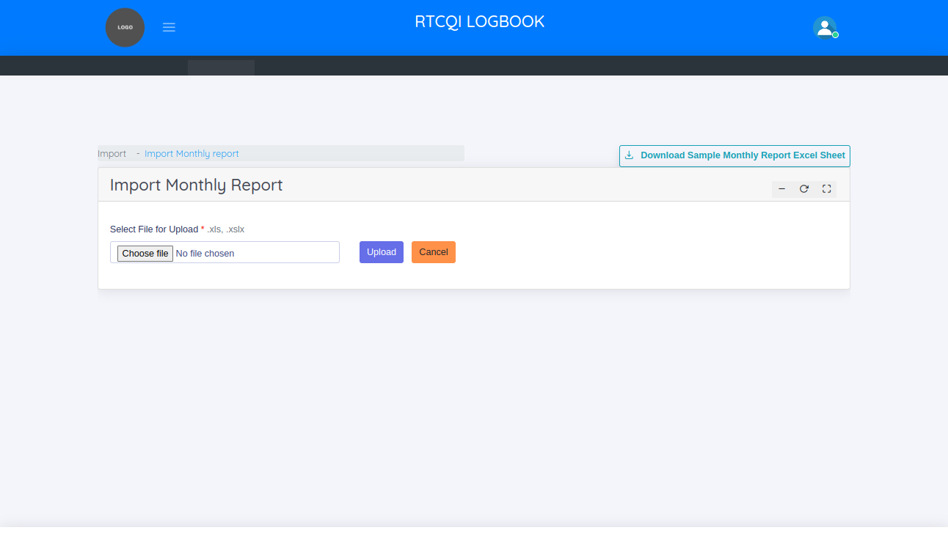

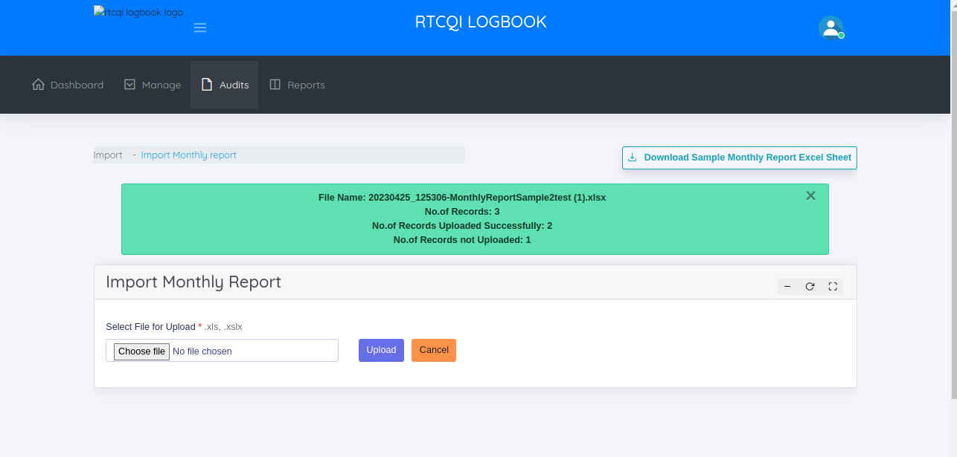
FAILED IMPORTS - EXCEL UPLOAD

This page helps to manage not uploaded monthly reports

In the failed imports - excel upload page, the administrator can

  - View Not uploaded Monthly Reports
  - Add Monthly Report
  - Bulk Upload Monthly Report

VIEW NOT UPLOADED MONTHLY REPORTS
This page shows the not uploaded monthly reports.

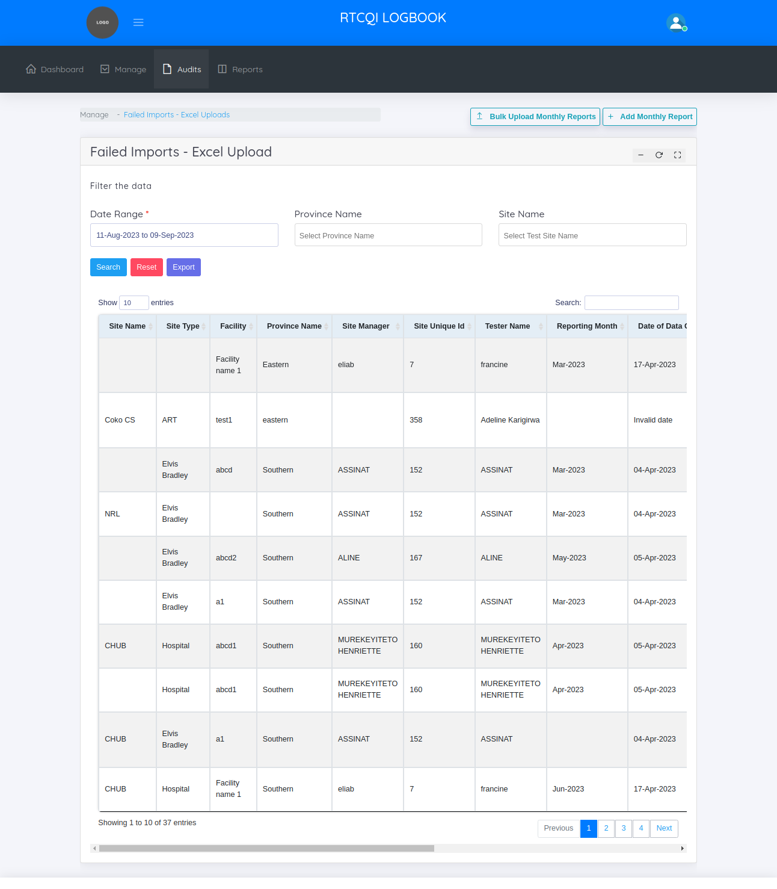

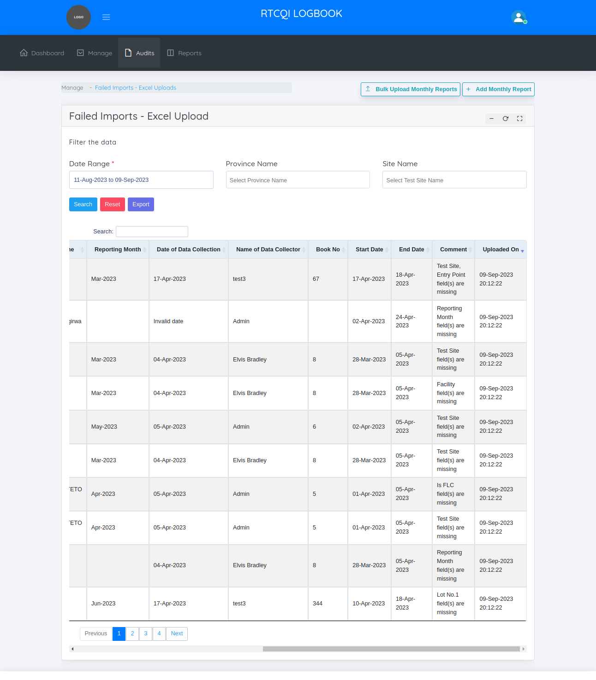

In the above screen shot, shows the comment column. The comment column mentioned, why the Report is not uploaded so easily find out the reason. Then export the data in the excel sheet using filters like date range, province name, site name then change/ miss the data as per the comment column then click the bulk upload button then just uploaded the excel sheet.

REPORTS
RTCQI Log Book shows 5 categories of reports.

  - Trend Report
  - Logbook Report
  - Test Kit Report
  - Invalid Result Report
  - Custom Report
  - Not Reported Sites

TREND REPORT
By default this page shows last 18 month report. This page helps to take a reports by filtering the data.

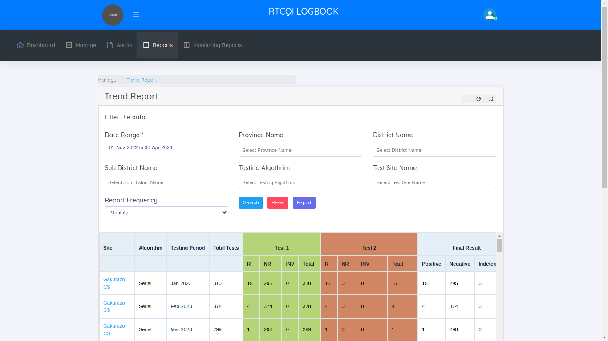
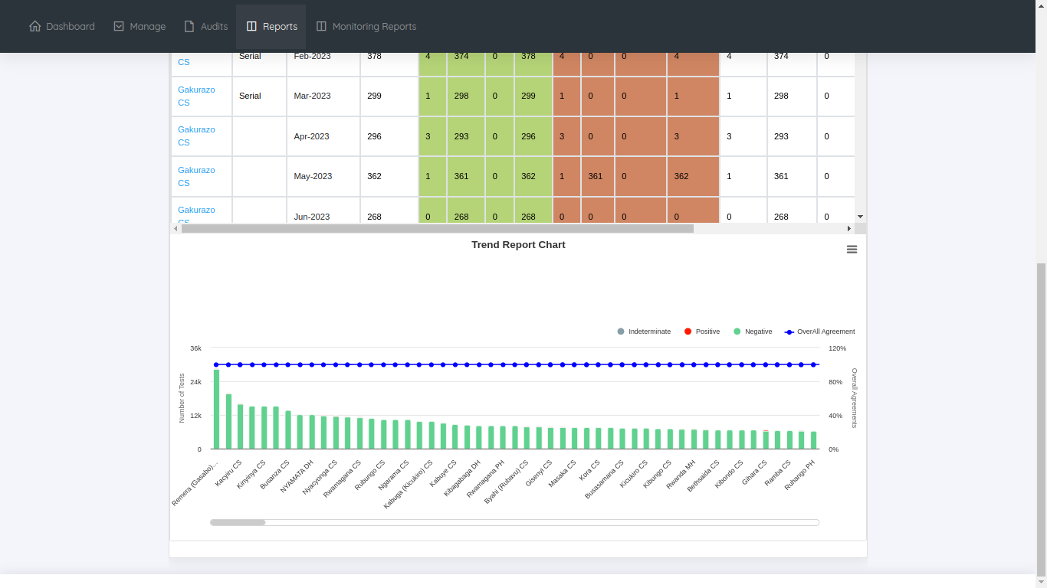

LOG BOOK REPORT
By default this page shows last 18 month report. This page helps to take a reports by filtering the data.
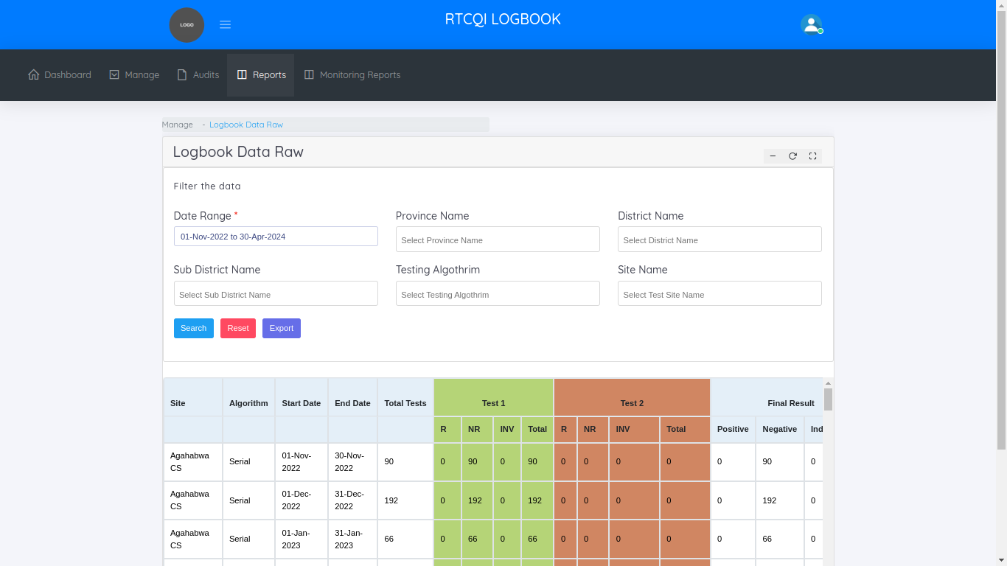

TEST KIT REPORT
By default this page shows last 18 month report. This page helps to take a reports by filtering the data.

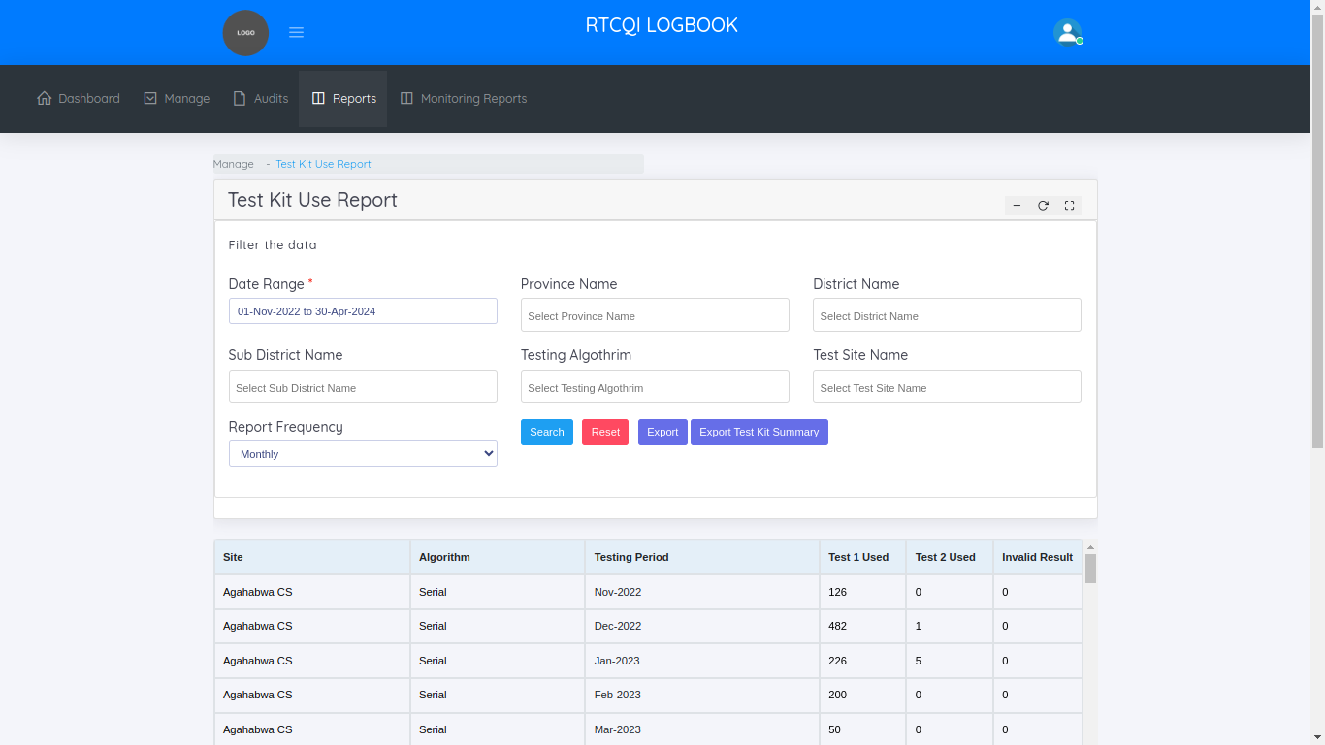
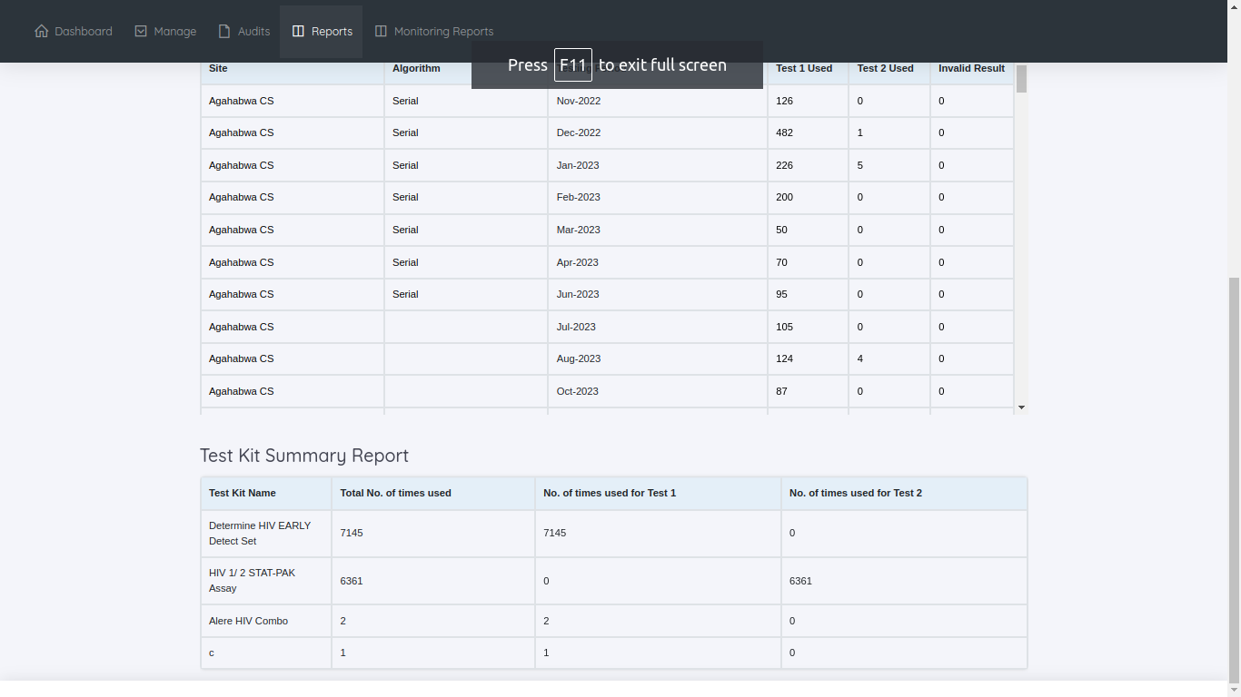

INVALID RESULT REPORT
By default this page shows last 18 month report. This page helps to take a reports by filtering the data.
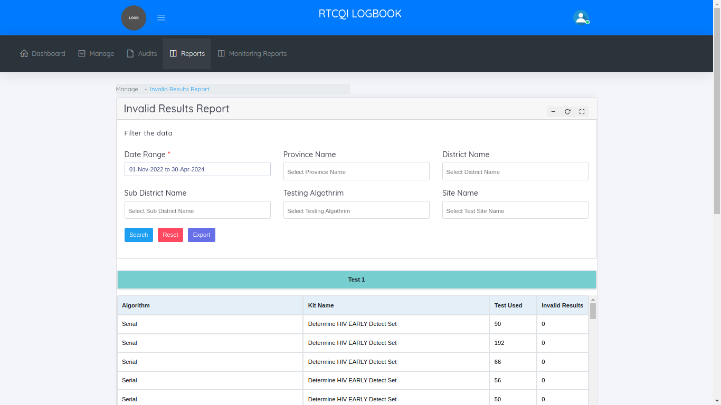
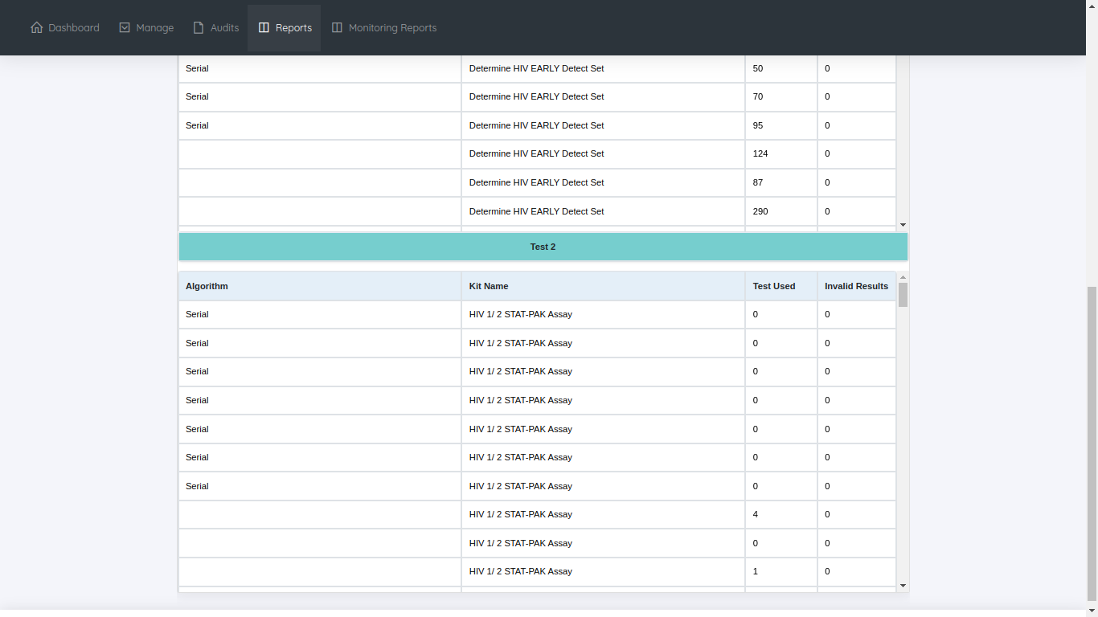

CUSTOM REPORT
By default this page shows last 18 month report. This page helps to take a reports by filtering the data.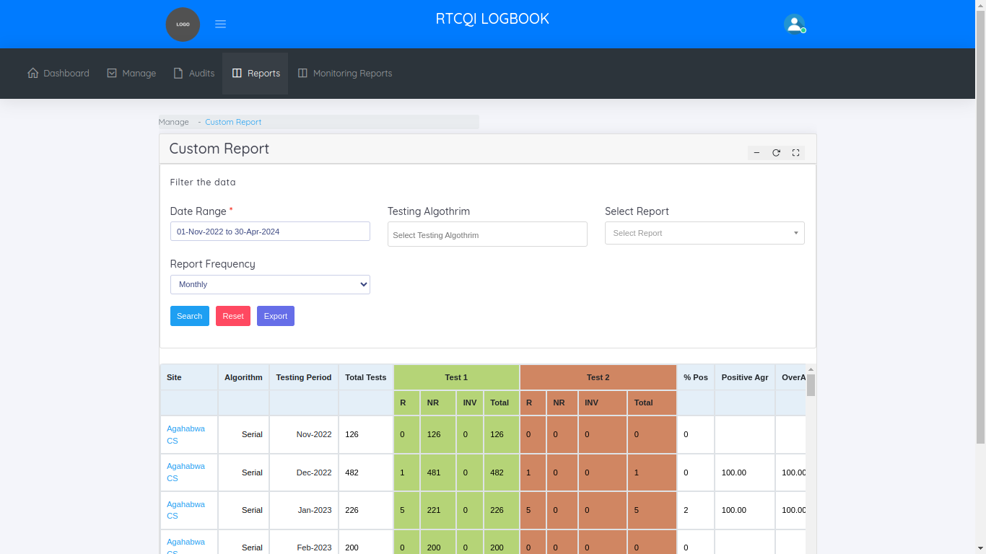

NOT REPORTED SITES REPORT
By default this page shows last 18 month report. This page helps to take a reports by filtering the data. Not reported sites we get for the particular Date Range.
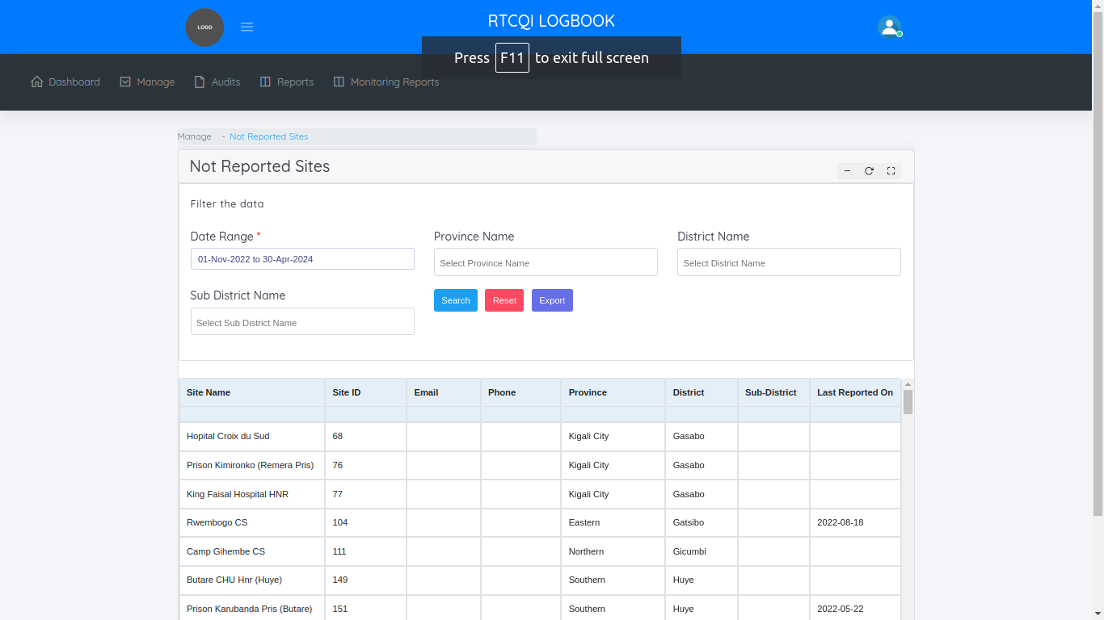
Monitoring Reports

In monitoring reports menu, shows one sub category
  - Site-Wise Reports
Site-Wise Reports
This page helps to manage the site wise monitoring monthly reports. By Default we show last 18 months monitoring report. We know, How many monthly reports we added per month for the particular site and how many total emails we sent to the particular sites.
Cross icon means not adding any monthly reports for the reporting month. Tick icon means added the monthly reports for the particular month. We mouse over the tick symbol we know the count of monthly reports.

