**RTCQI LOGBOOK**

USER GUIDE

**Dashboard**

Admin give the access to dashboard, user can view the dashboard page.

Provides a quick snapshot

* Over all Audits.
* Number of Audits(Last 12months).
* Number of Sites Audits(Last 12months).
* View map based on the sites.
* View Recent Monthly Logbook Entries.

By default, the dashboard map shows data for the last 30 days, but this can be easily changed by adjusting a date range and choose province in the field above the screen. Below the map we show the monitoring sitewise reports and the total count of email sitewise.Below the monitoring sitewise reports, shows 10 latest logbook entries. Then we show bar graph for monthly reports last 12 months. Then We show the bar graph sitewise last 12 months.

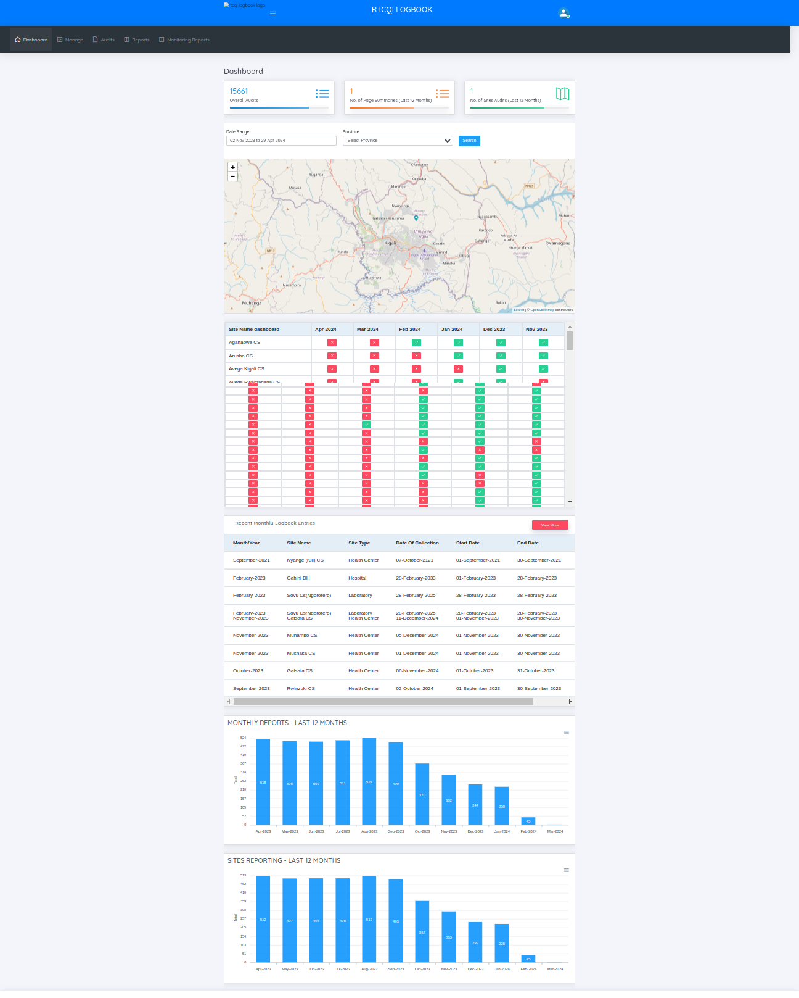

**MANAGE MENU**

The user cannot view the manage menu.

**EDIT PROFILE**

The user’s can update the profile details and change the password.

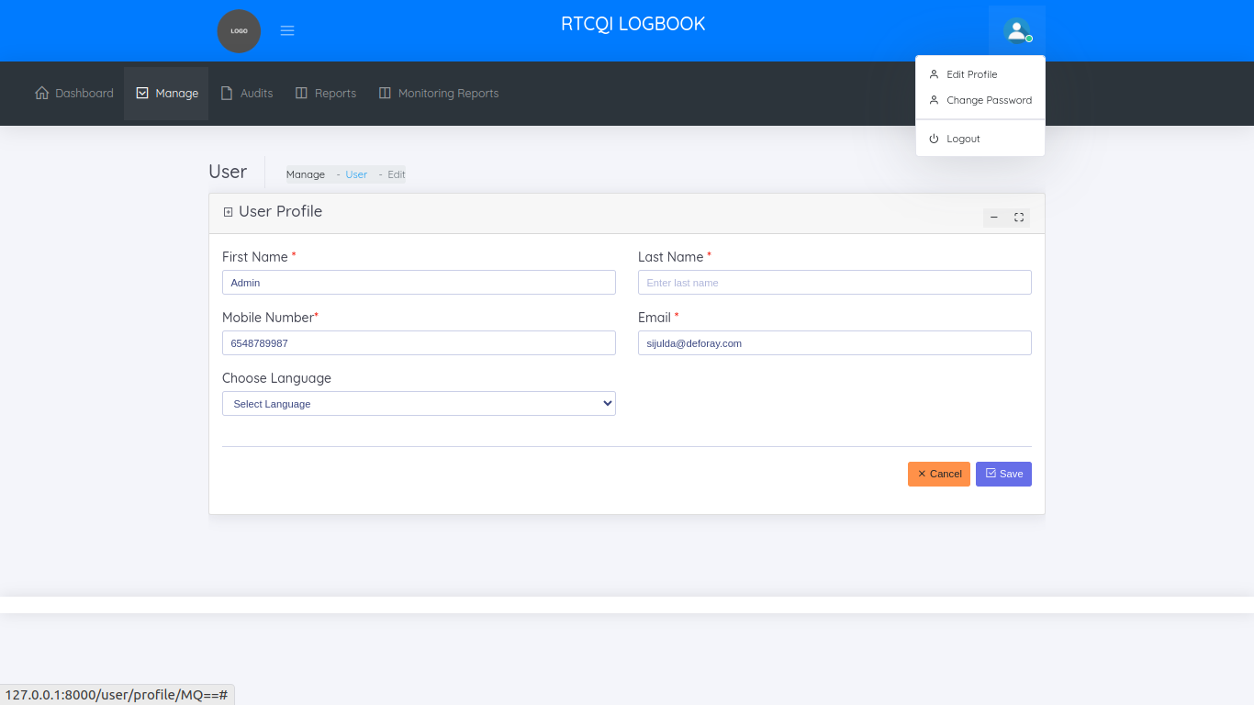

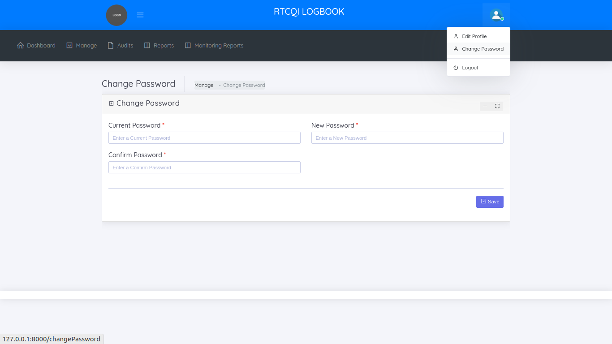

**AUDITS**

Admin can give the access to the Audits page to the user.

In audits menu, shows two sub categories

* + Monthly Reporting(Data Entry)
  + Failed Imports - Excel Upload

**MONTHLY REPORTING**

The monthly reports page helps to manage all monthly reports.

On the monthly reporting page, the admin can give access users to these pages

* + View Monthly Reports
  + Add Monthly Report
  + Edit Monthly Report
  + Bulk Upload Monthly Report

**VIEW MONTHLY REPORTS**

BY default, this page shows all the monthly reports of last 30 days. Filterwise also shows the reports like date range, province name, district name, sub district name, site name

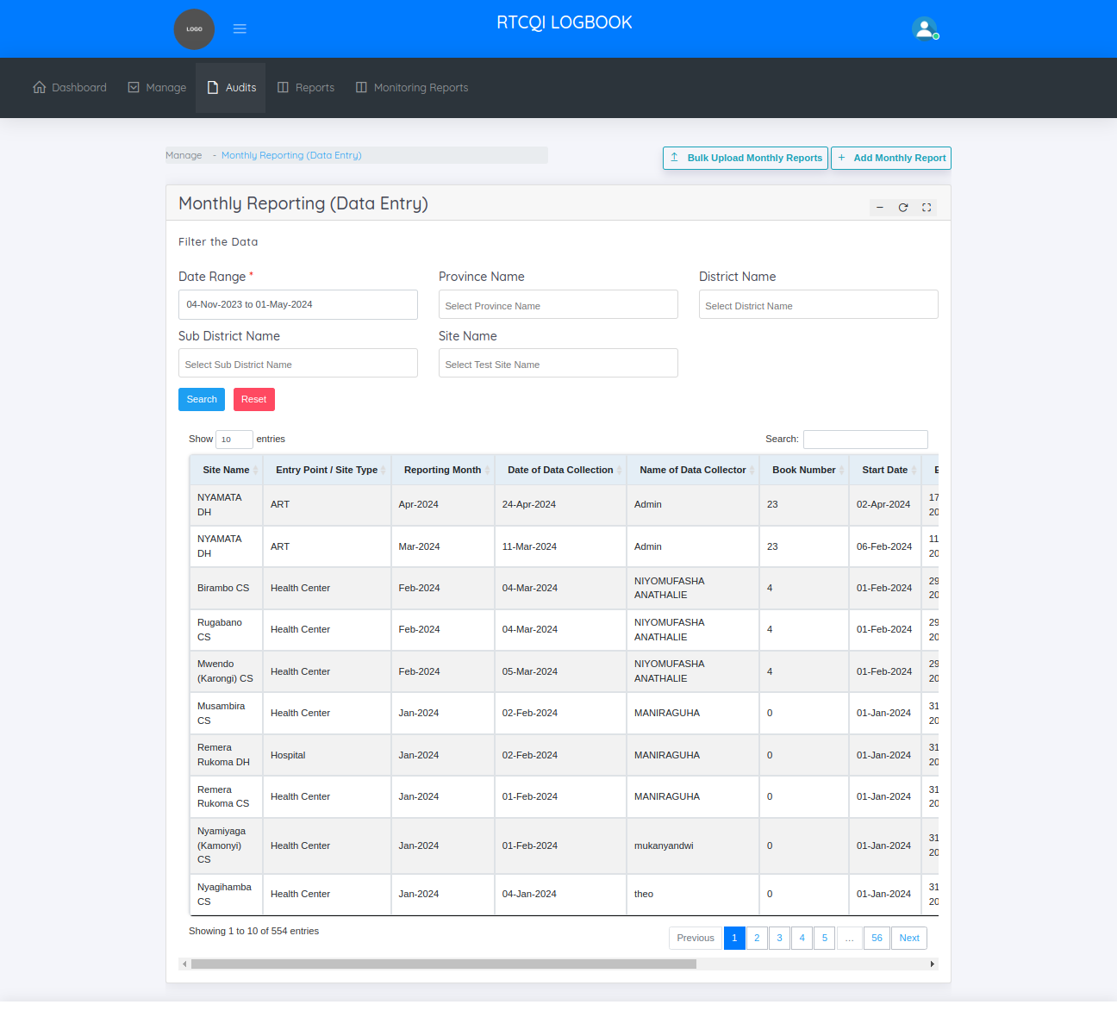

**ADD MONTHLY REPORT**

This is the add monthly reports page

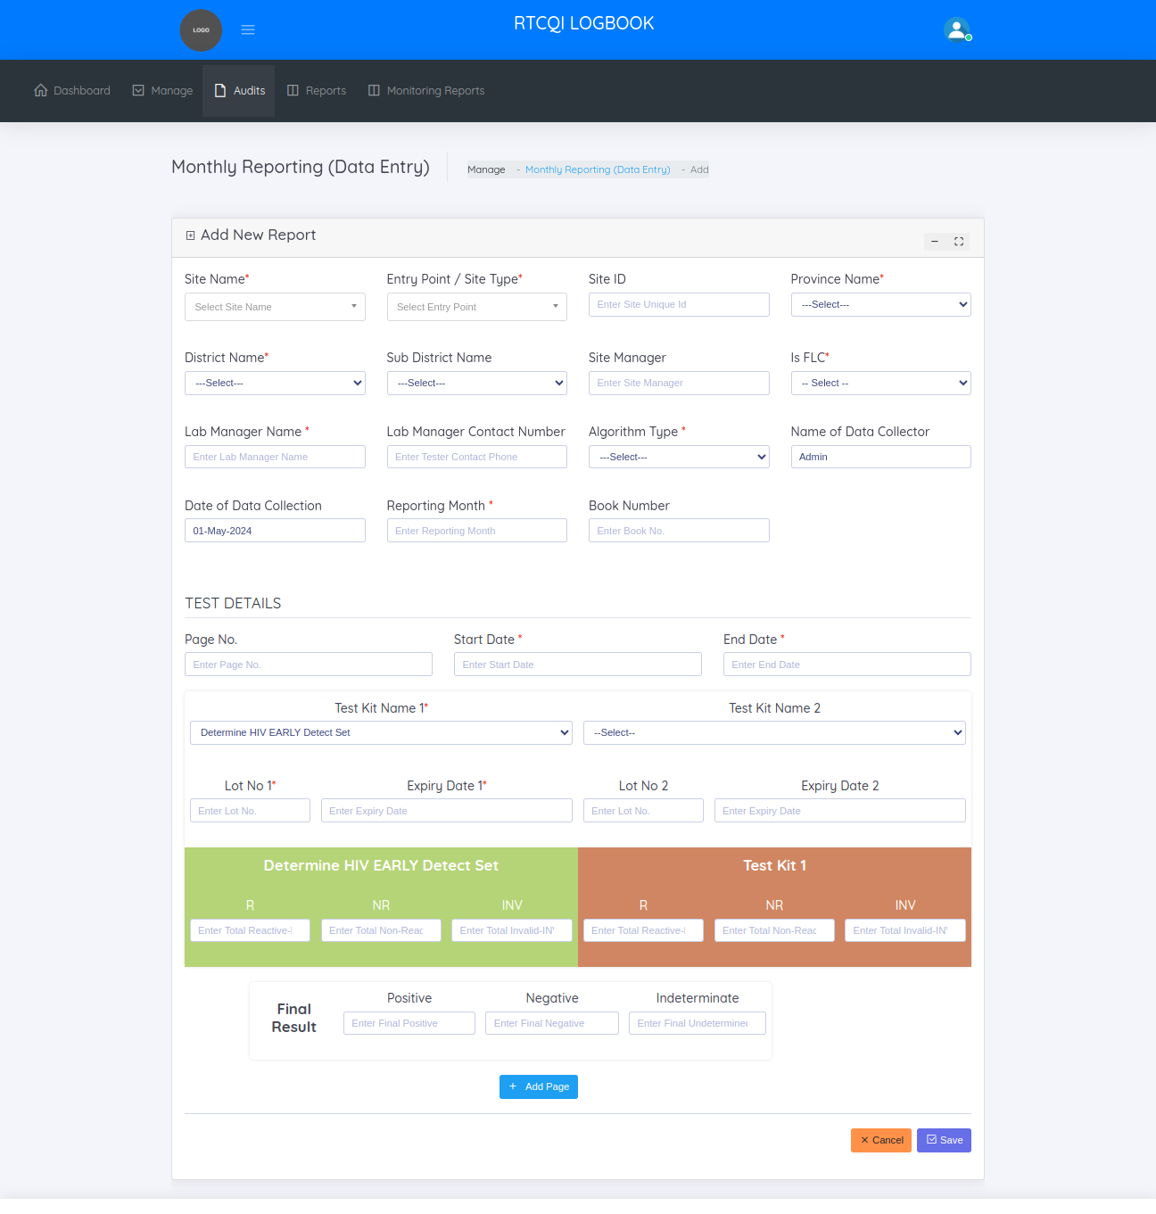

First select any of the site need to add monthly report, above the form shows recently added monthly reports for the selected site.

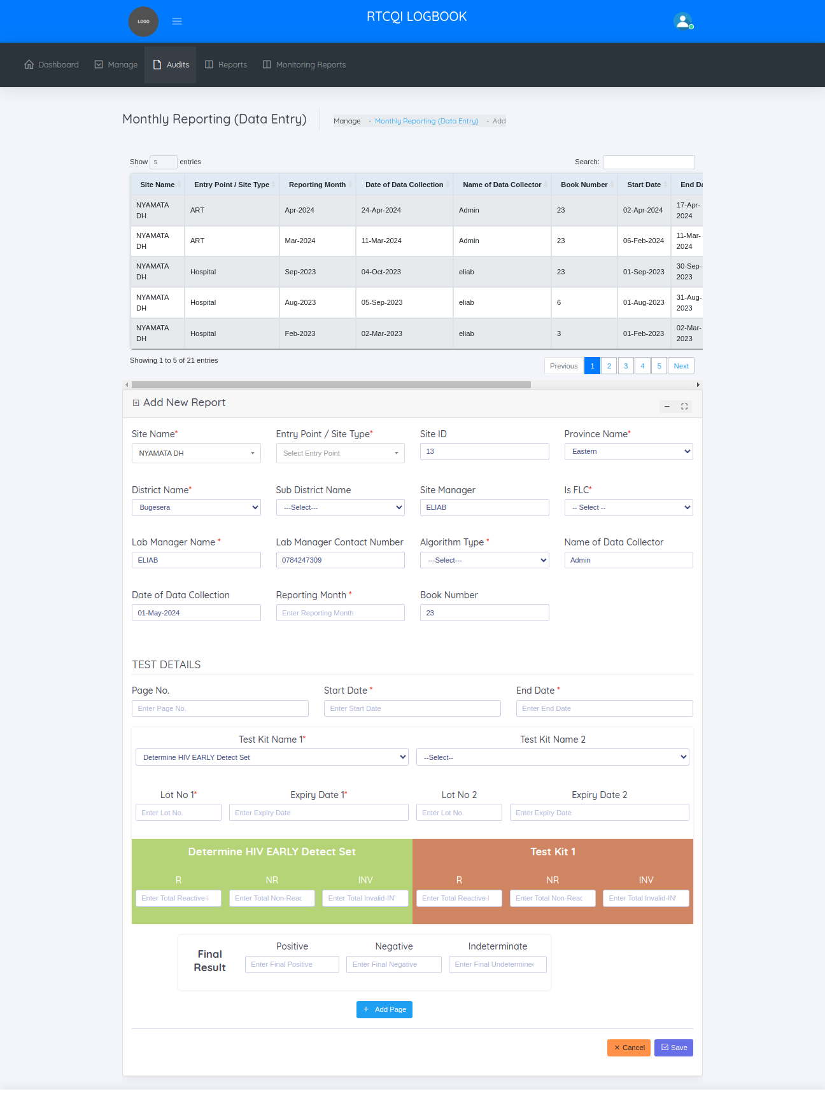

**EDIT MONTHLY REPORT**

This page helps to update if any changes needed in the already added monthly report.

Edit form below, shows the history of the report like when add, update. History grid we show the event type, action, resource, ip address, Date time.

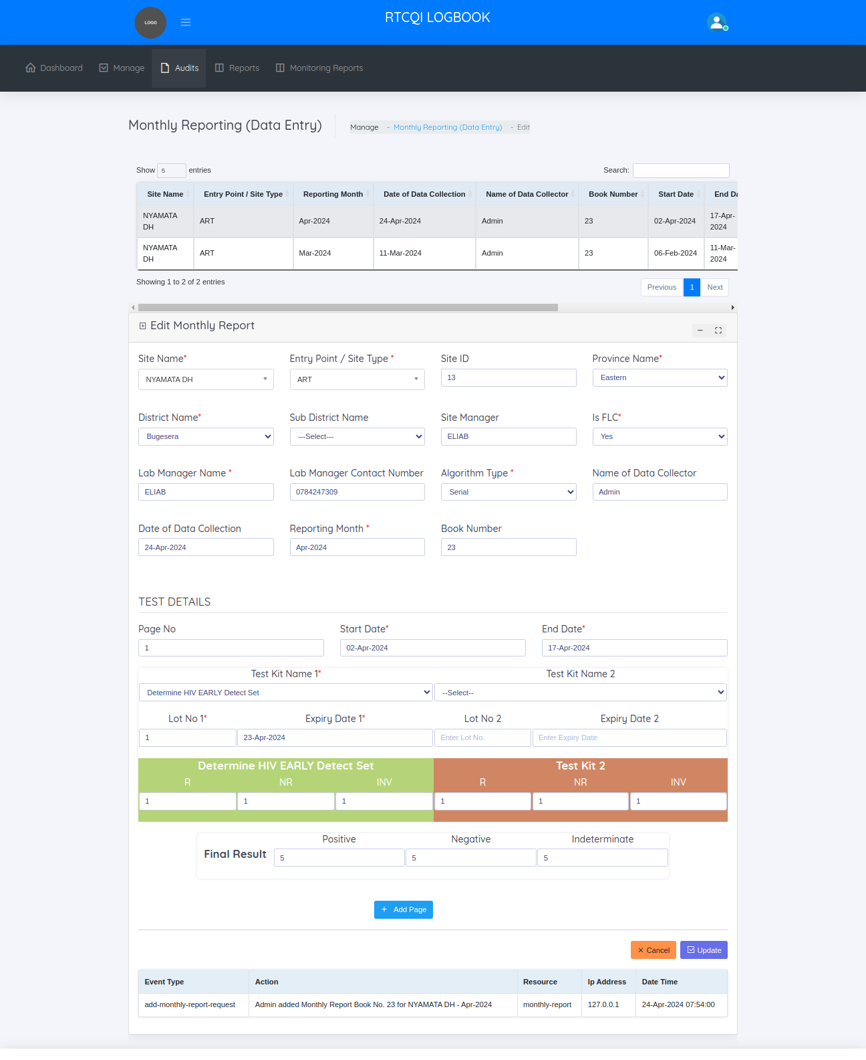

**BULK UPLOAD MONTHLY REPORTS**

This page helps to import multiple reports at a time. Follow the steps to import monthly report

1. Click the download sample monthly report excel sheet button ,there one sample monthly report excel sheet downloaded.
2. Enter the datas in the downloaded excel sheet
3. Choose the file
4. Click the Upload button

After upload display one success message ,

In that display message how many reports uploaded, then how many imported and how many not imported. Then the imported reports is display in the view monthly reports page. Failed imported reports view in the failed import monthly reports page

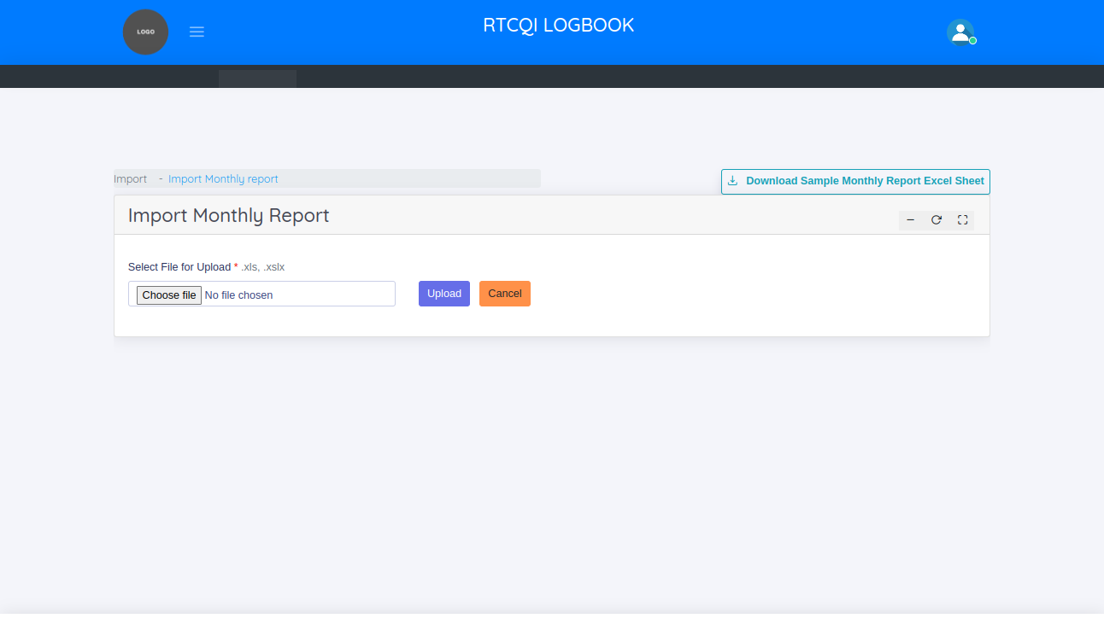

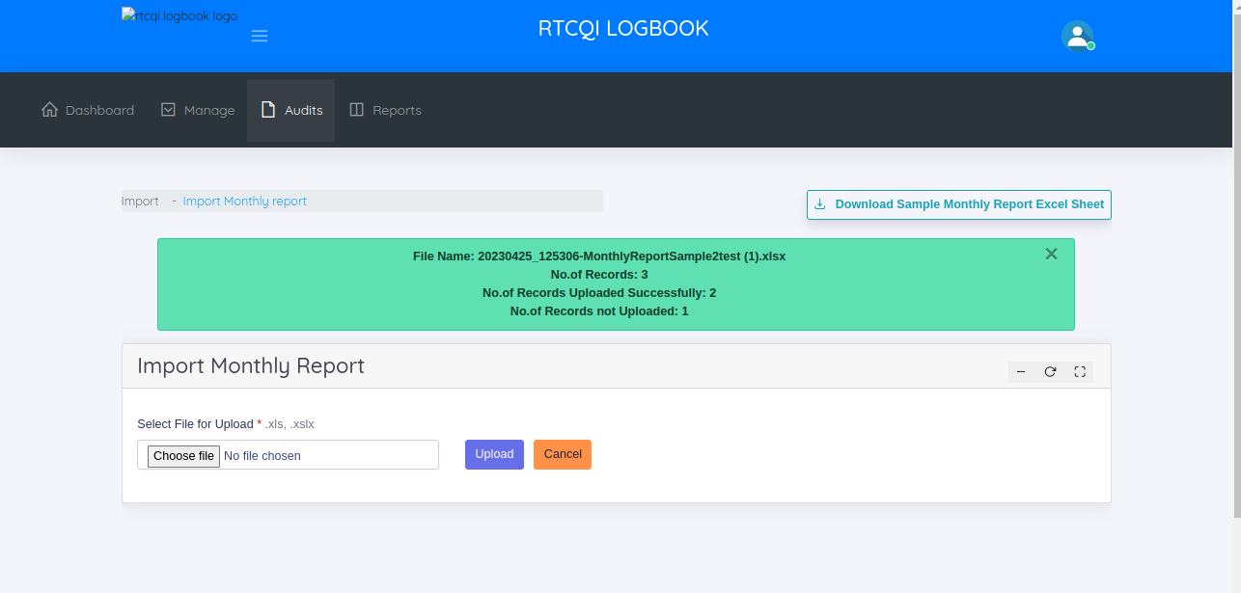

**FAILED IMPORTS - EXCEL UPLOAD**

This page helps to manage not uploaded monthly reports

In the failed imports - excel upload page, the administrator can

* + View Not uploaded Monthly Reports
  + Add Monthly Report
  + Bulk Upload Monthly Report

**VIEW NOT UPLOADED MONTHLY REPORTS**

This page shows the not uploaded monthly reports.

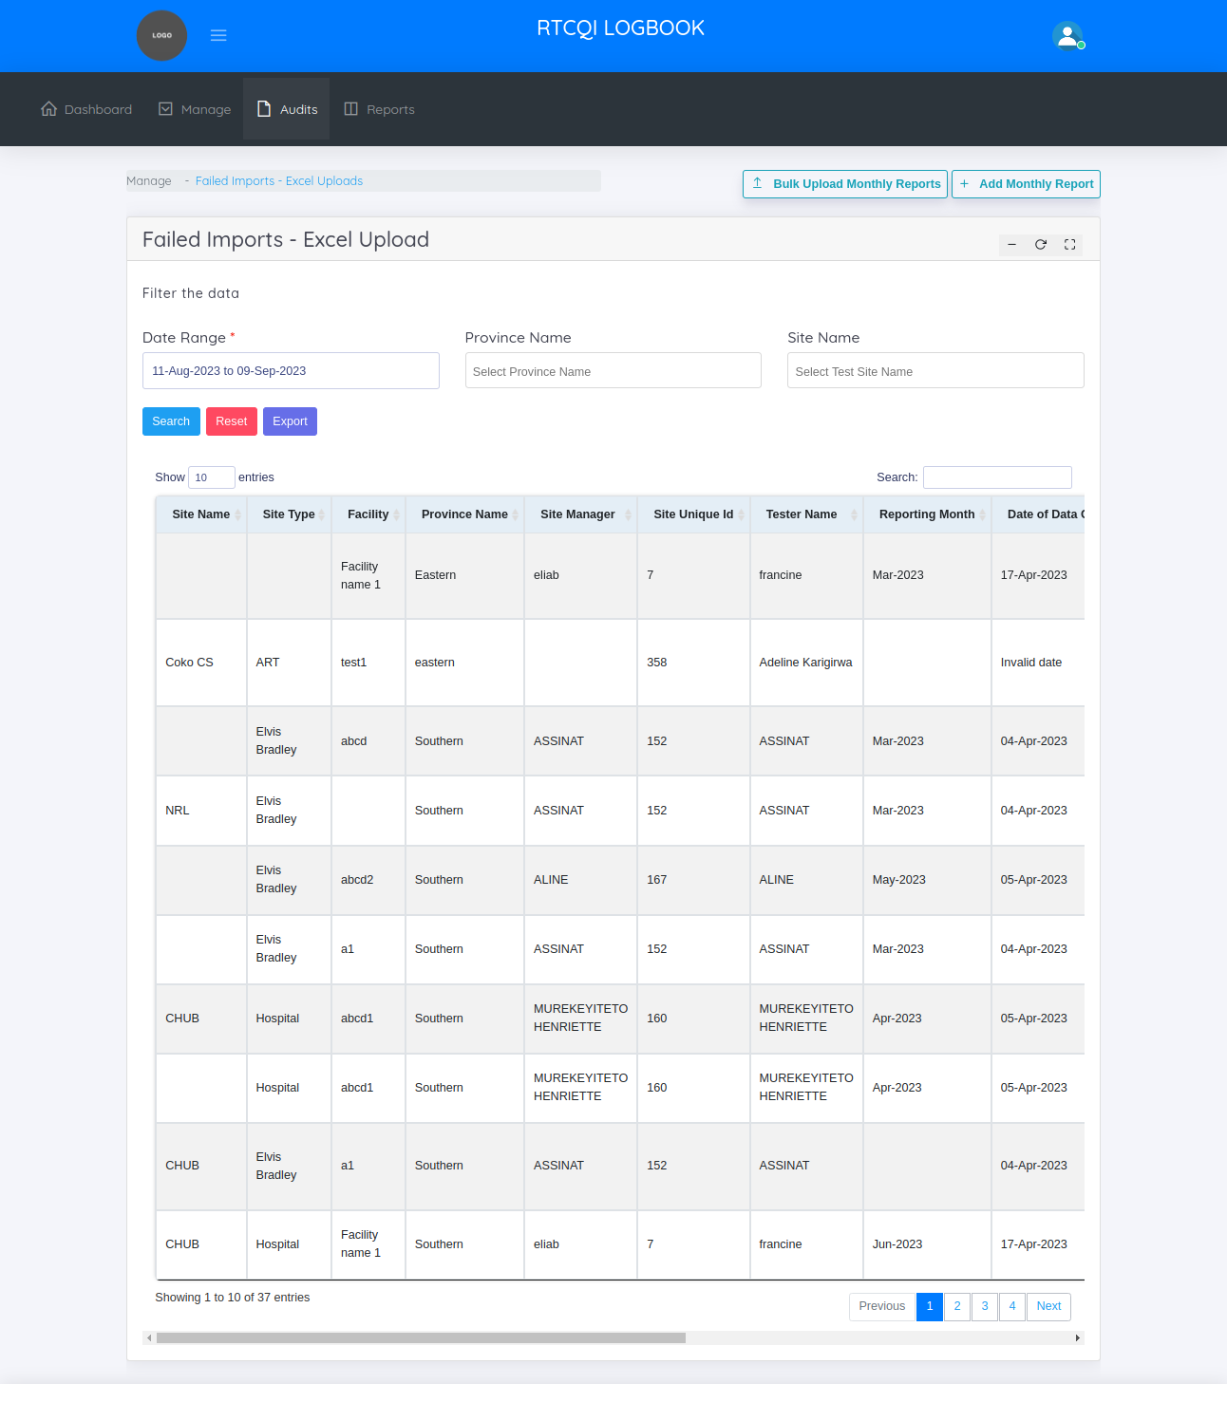

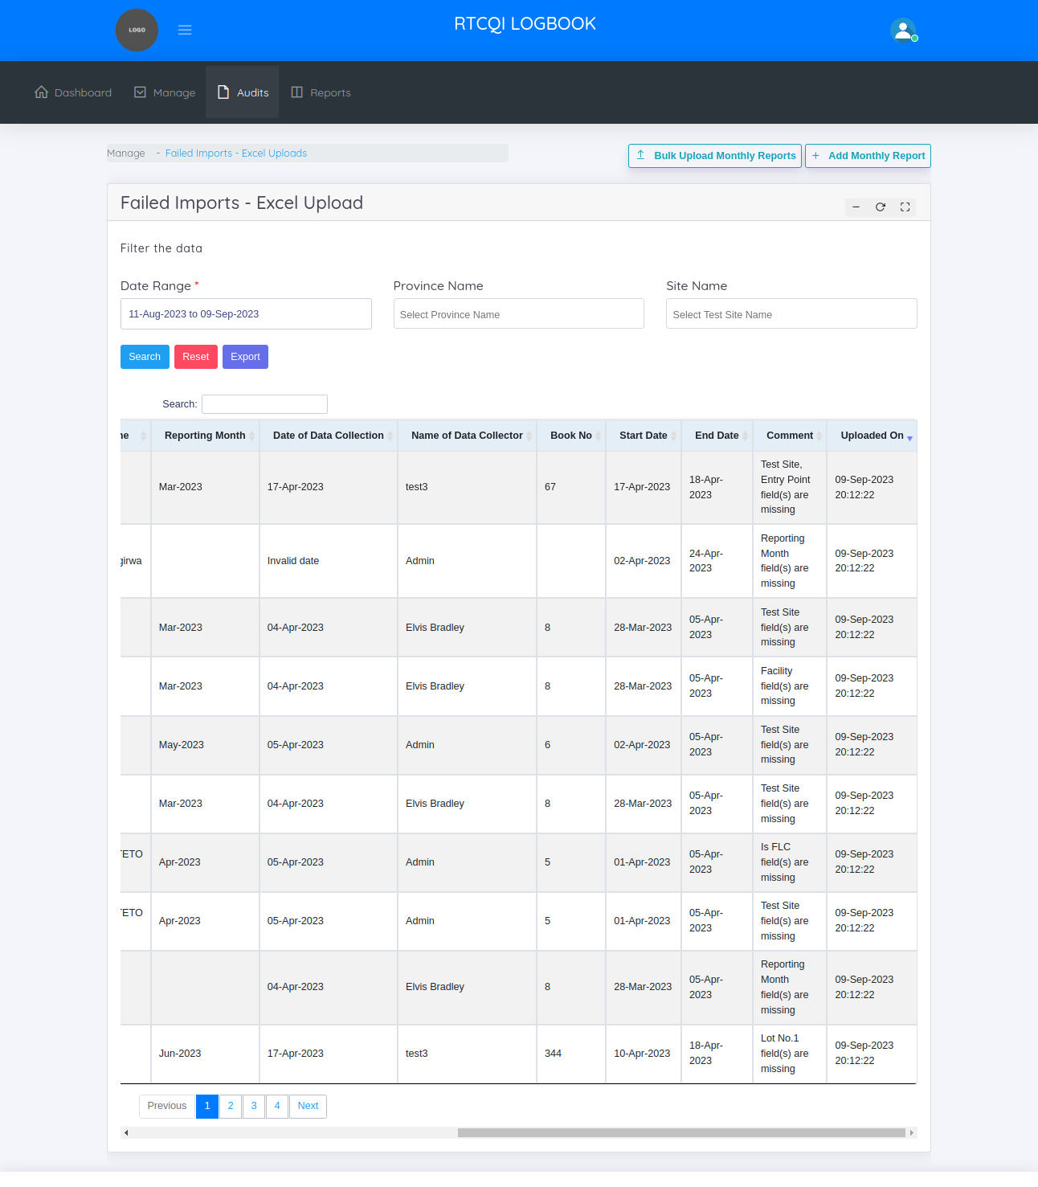

In the above screen shot, shows the comment column. The comment column mentioned, why the Report is not uploaded so easily find out the reason. Then export the data in the excel sheet using filters like date range, province name, site name then change/ miss the data as per the comment column then click the bulk upload button then just uploaded the excel sheet.

**REPORTS**

Admin can give access to the reports pages to the user.

RTCQI Log Book shows 5 categories of reports.

* + Trend Report
  + Logbook Report
  + Test Kit Report
  + Invalid Result Report
  + Custom Report
  + Not Reported Sites

**TREND REPORT**

By default this page shows last 18 month report. This page helps to take a reports by filtering the data.

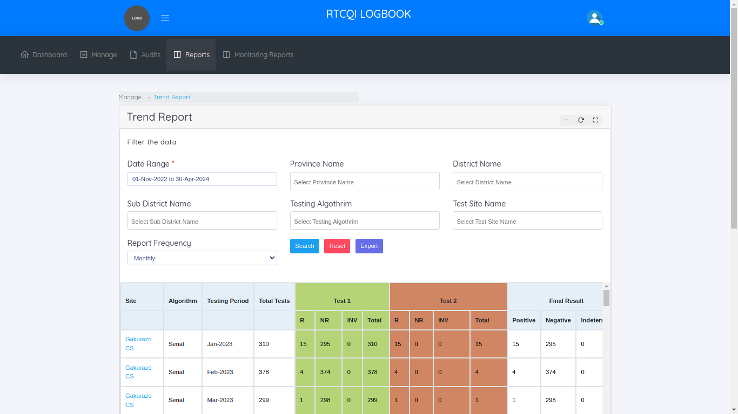

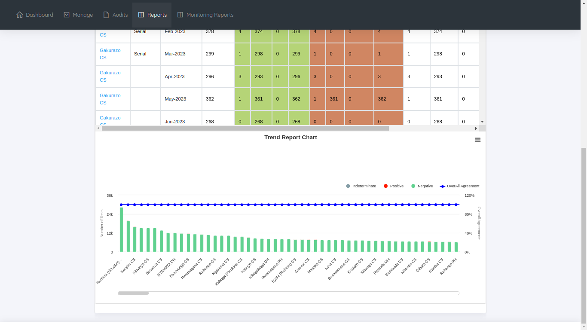

**LOG BOOK REPORT**

By default this page shows last 18 month report. This page helps to take a reports by filtering the data.

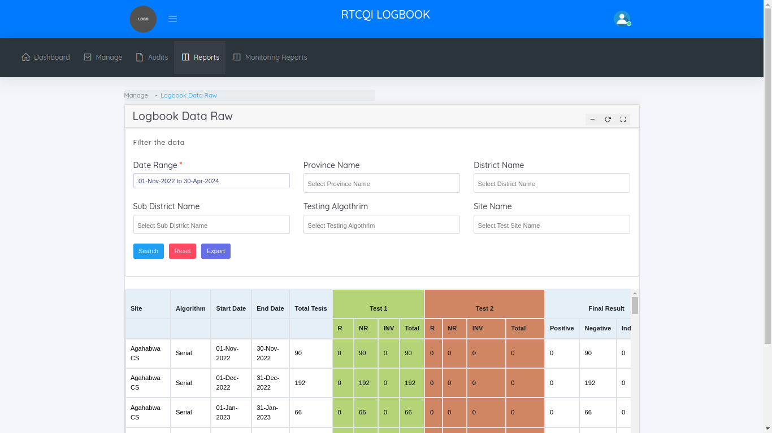

**TEST KIT REPORT**

By default this page shows last 18 month report. This page helps to take a reports by filtering the data.

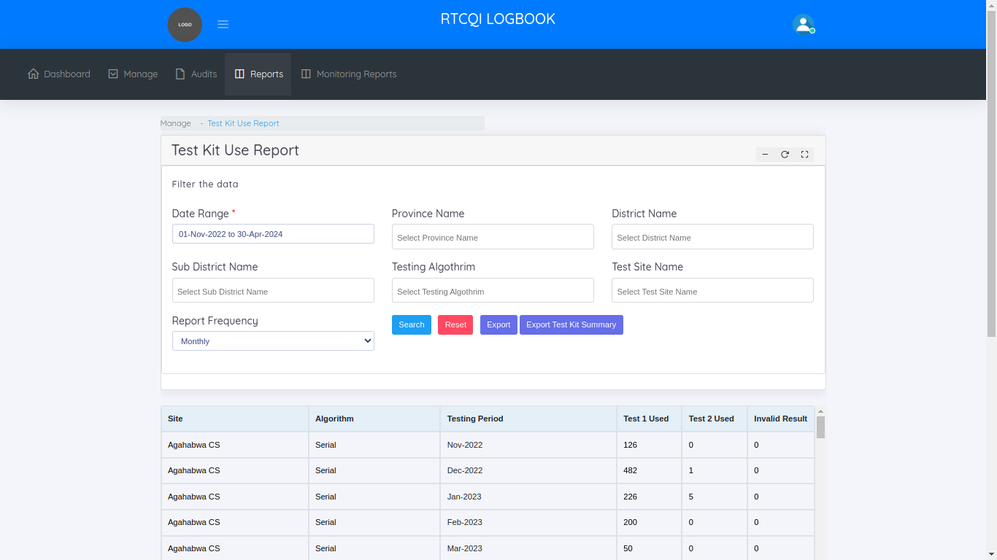

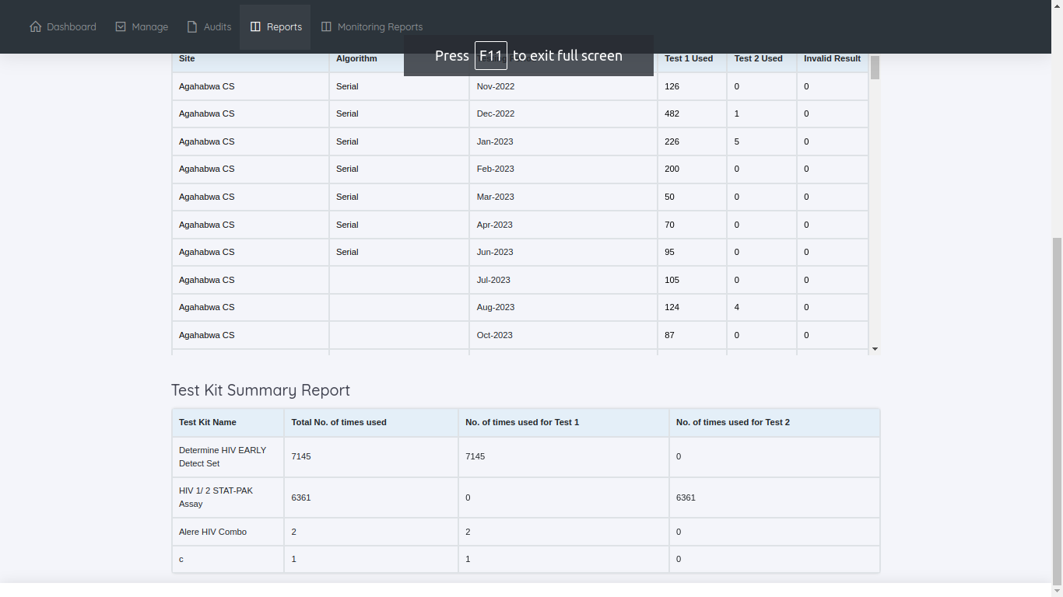

**INVALID RESULT REPORT**

By default this page shows last 18 month report. This page helps to take a reports by filtering the data.

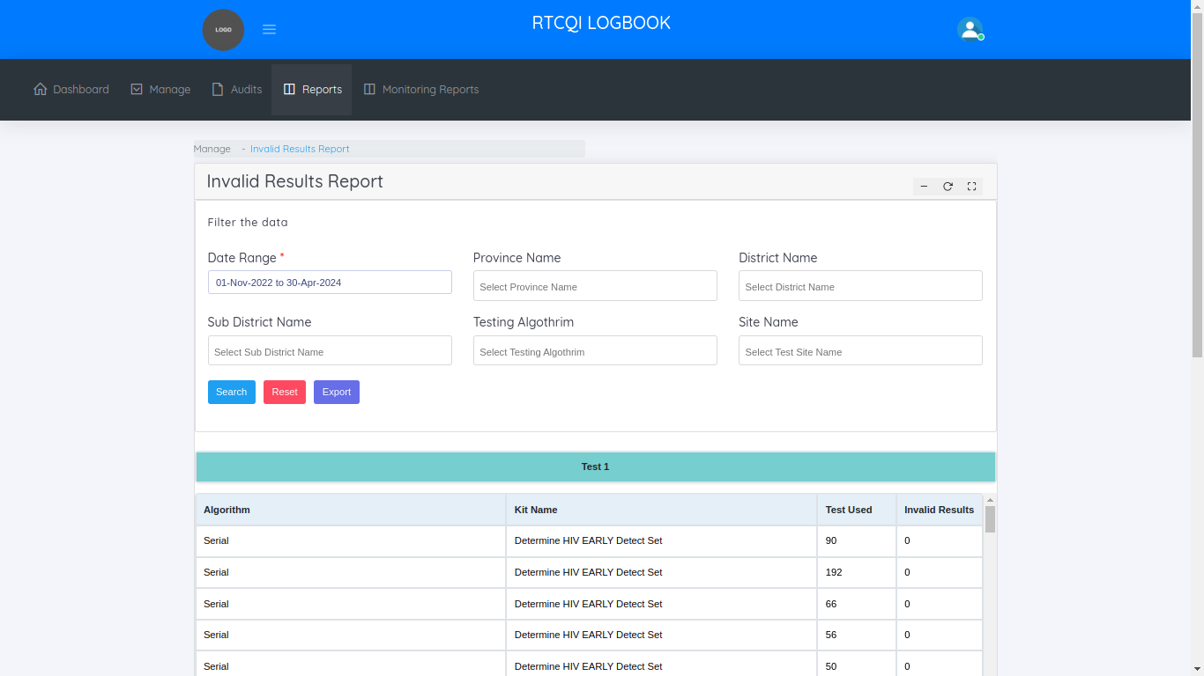

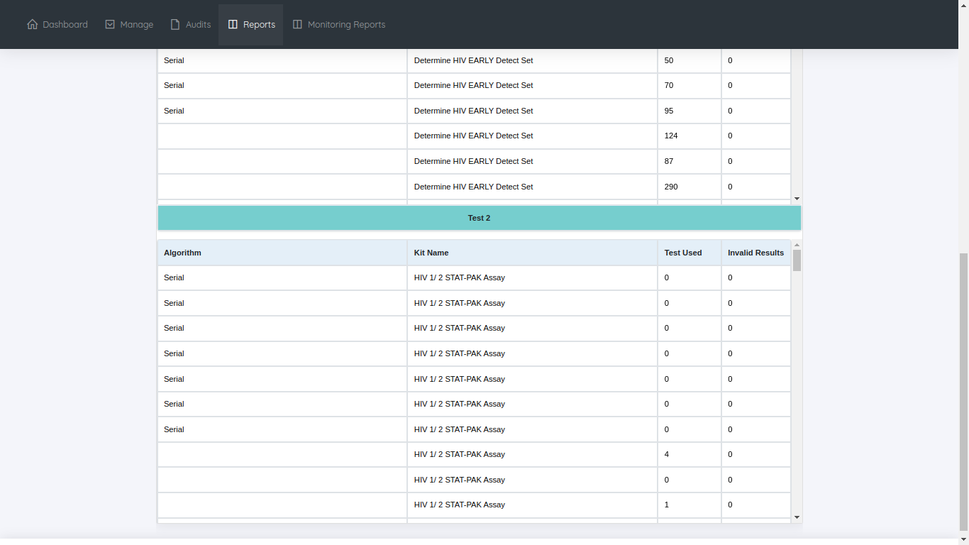

**CUSTOM REPORT**

By default this page shows last 18 month report. This page helps to take a reports by filtering the data.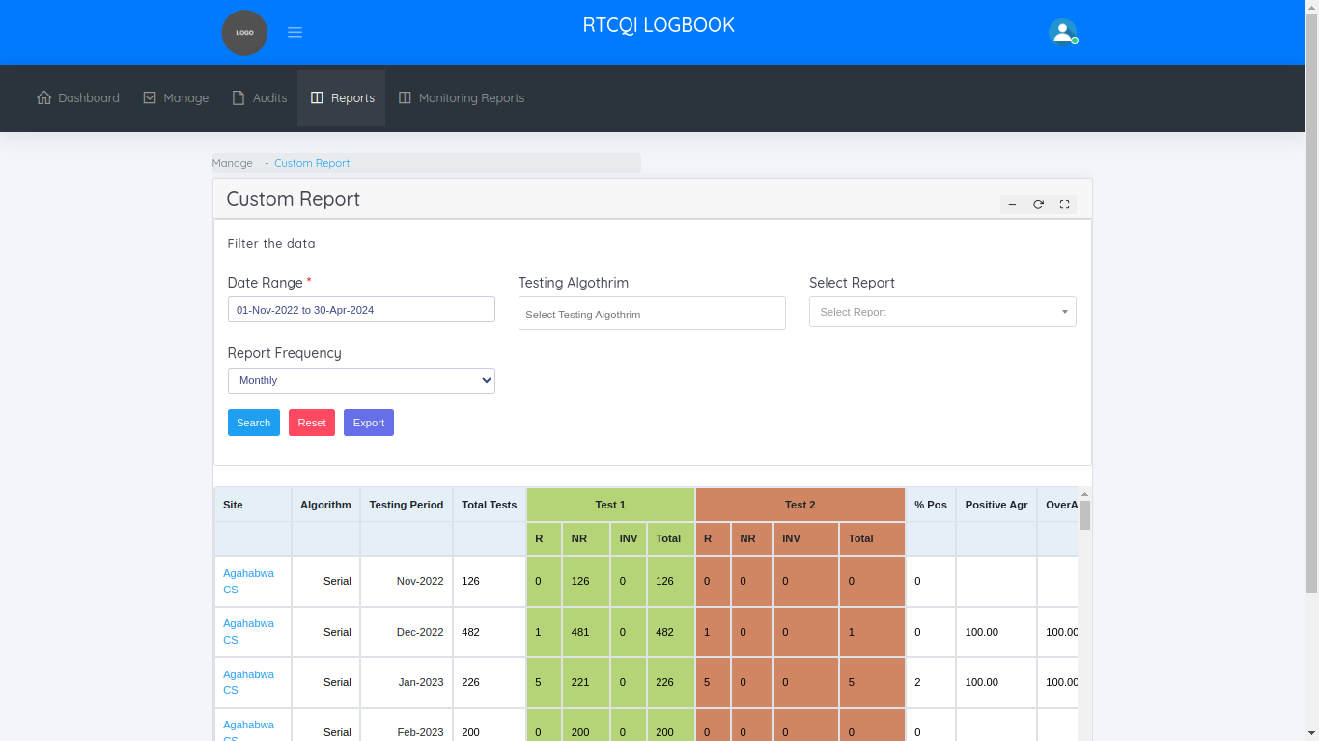

**NOT REPORTED SITES REPORT**

By default this page shows last 18 month report. This page helps to take a reports by filtering the data. Not reported sites we get for the particular Date Range.

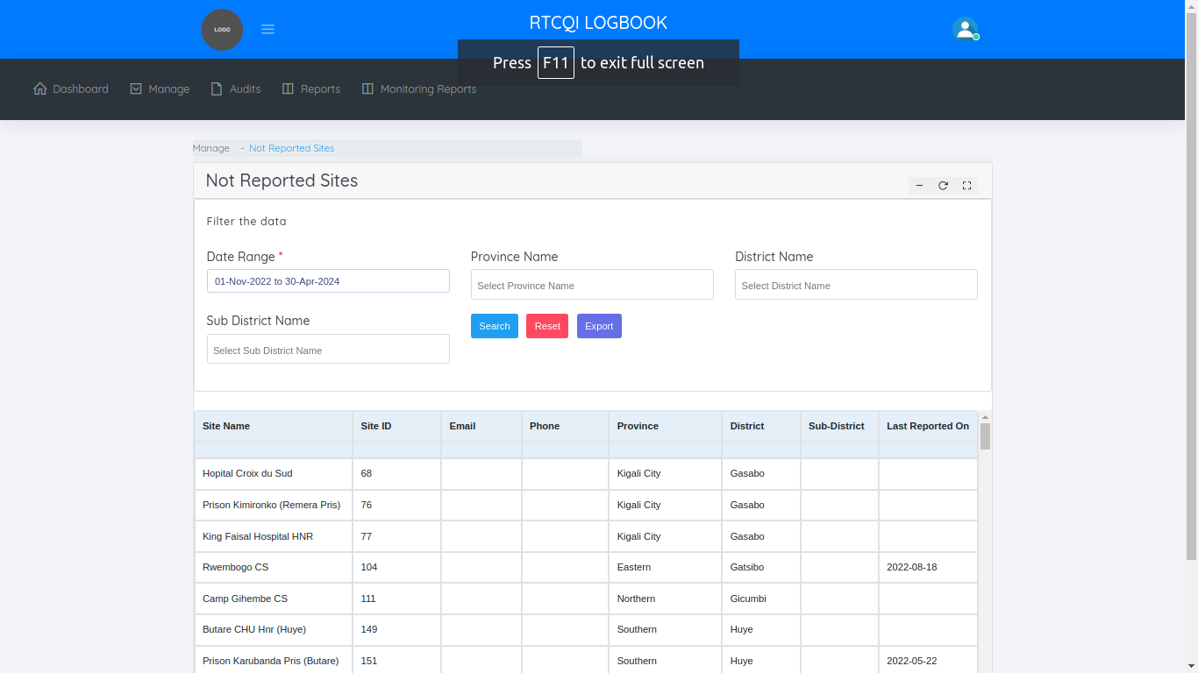

**Monitoring Reports**

Admin can give access to the monitoring reports pages to the user

In monitoring reports menu, shows one sub category

* + Site-Wise Reports

**Site-Wise Reports**

This page helps to manage the site wise monitoring monthly reports. By Default we show last 18 months monitoring report. We know, How many monthly reports we added per month for the particular site and how many total emails we sent to the particular sites.

Cross icon means not adding any monthly reports for the reporting month. Tick icon means added the monthly reports for the particular month. We mouse over the tick symbol we know the count of monthly reports.

