Ordine-Pico

DESIGN DOCUMENT
By deforris

Introduction 2
Game Summary 2
Player Experience 2
Platform 3
Development Software 3
Genre 3
Target Audience 3
Concept 3
Gameplay overview 3
Primary Mechanics 4
Secondary Mechanics 5
Research 3
Research summary 3
Paper Citations 3
Art 6
Theme Interpretation 6
Design 6
Audio 7
Music 7
Sound Effects 7
Game Experience 7
UI 7
Controls 7
Development Timeline 8

Introduction

Game Summary
A time based game that helps prioritize following ultradian cycles. The goal is to not need the program.

Player Experience
A timer is invisible to the player and they must guess when they have reached the end of an ultradian cycle (90-120 minutes). The closer the guess to the window and their previous days results the better the score. A following rest cycle of 15 to 20 minutes is also played. Previous scores and data are shown to the player to help them better achieve success in life.

Platform
The game is developed to be released on all PC platforms

Development Software
- C, C++ and Raylib for programming
- Aseprite for graphics and UI
- FL Studio 12 for all music and SFX

Genre
Singleplayer, casual, simulation

Target Audience
Gamers who are looking to ‘gamify’ their work flow and try to better understand their body. The goal is to eventually not use the game and to have a good internal understanding of your clock cycles.

Concept

Gameplay overview
The player controls a brain between a line of active and rest cycles. When the brain is moved from one of the zones to the next a score and data is generated to be displayed to the player. The previous days are displayed below as a guide/marker.

Primary Mechanics

Mechanic | Animated Mockup  (Art not necessarily final)
Walls a  A stopping force to prevent a player too large to access a certain area. Otherwise to simply restrict movement. | 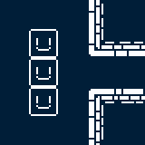
Spikes a  When a player cell walks on top of a spike, that cell will die and further simplify the player mass. | 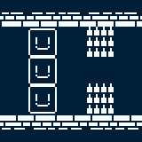
Holes a  The player mass can walk freely over a hole as long as at least one cell is on a floor tile. If the entire mass is over the hole, the entire player mass dies. | 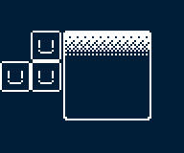
Fruit a  If a player cell moves over a fruit, it will eat the fruit and generate a new cell on the opposite side of the mass it is a part of. | 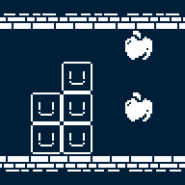

Secondary Mechanics

Mechanic | Animated Mockup  (Art not necessarily final)
Independence a  If two player masses happen to separate, they will still move synchronously but interact with the environment independently. If then connected again, the two masses will join to act as one. | 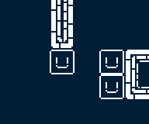
Set Spikes a  When a player cell walks on top of a set spike, after moving off of it, it will then become a regular spike trap | 

Art

Theme Interpretation

While maintaining the very limited color palette theme, the sole use of black in white seems way too common, and a bit harsh as a color scheme for a relaxing puzzle game. To circumvent this, a soft, dark blue color will act as the unique accent color as opposed to black with white being the primary, carrying color to base the sprites off of.

Design
A very minimalistic approach will go into the design of the game, heavily relying on the severe contrast of the limited colors to provide detail. Though, the design still is clean and smooth in the sense that, the use of many shades of a color will not be as present to confront the retro style and pixel art.

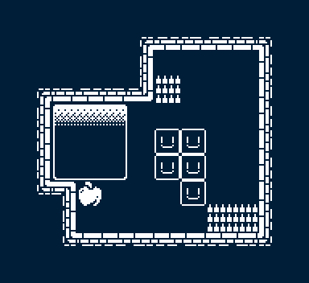
*Not an actual puzzle/level, merely a full example of the tileset and art style*

Audio

Music
To add to the overall theme and vibe of the game, there will be minimalism incorporated into the music. Heavy use of reverb and effects to fill space within the few instruments. Bass and drums will generally constitute the majority of tracks with accompanying softer sounds. Mainly through synthesized sounds rather than acoustic will further suggest the retro style.

Sound Effects
To add more flare and polish to the experience, a multitude of environmental sound effects will give weight and feedback to the player’s actions. Rather than foley, or otherwise realistic sounds, synthesized blips, bloops, and whooshes are used.

Game Experience

UI
On top of the rigid pixel art constituting the rest of the art, a more smooth, higher definition style will be incorporated in the UI. Utilizing many shades of white and black allowed in the art restriction, anti-aliasing is used to further emphasize the UI.

Controls
Keyboard
Arrow keys / WASD
Gamepad
Dpad

Development Timeline

MINIMUM VIABLE PRODUCT

# | Assignment | Type | Status | Finish By | Notes
1 | Design Document | Other | Finished | Jun 22, 2022
2 | Create player and wall assets | Art | Finished | Jun 23, 2022 | Prototype for GDD is done
3 | Main menu theme | Audio | Finished | Jun 23, 2022 | Can be really short, player won’t be on main menu for long
4 | UI / Main menu | Coding | Finished | Jun 23, 2022 | Button UI, screen transition, title screen
5 | Level theme | Audio | Finished | Jun 24, 2022 | Should be more substantial and not annoying
6 | Simple player movement | Coding | Finished | Jun 23, 2022 | Move single cells around and collide with walls
7 | Complex player movement | Coding | Finished | Jun 24, 2022 | Multi cell masses act together to collide with walls
8 | Spikes and holes with player interactions | Coding | Finished | Jun 24, 2022 | Implement spike and holes mechanics
9 | Fruit interaction | Coding | Finished | Jun 25, 2022
10 | Special effects | Art | Finished | Jun 25, 2022 | Dust particles during movement
11 | Player animation | Art | Finished | Jun 25, 2022 | Idle blinks, movement polish
12 | Sound effects | Audio | Finished | Jun 25, 2022 | Player movement, UI interaction
13 | Pause menu | Coding | Finished | Jun 26, 2022 | Access to the main menu or resetting the level
14 | Level select menu | Coding | Finished | Jun 26, 2022
15 | Level design (1-7) | Other | Finished | Jun 27, 2022 | Create levels 1 through 7
16 | Level design (8-15) | Other | Finished | Jun 28, 2022 | Create levels 7 through 15
17 | Any extra polish | Other | Finished | Jun 29, 2022
18 | SUBMIT | Other | Finished | Jun 29, 2022 | Create Itch Page and upload

BEYOND (if ahead of schedule / extra time)

Undo | Other | Not started | At any point, the player may undo their move, any movement, creation, or destruction of a player cell is reversed
Extra levels | Other | Not started
Settings Menu | Coding | Finished | Volume slider, fullscreen toggle

