D1. Exporter / Re-exporter  Montreval Cuir SA  Rue du Marché 18 1204  Geneva  Switzerland | PERMIT/CERTIFICATE  ☑ IMPORT  ☐ EXPORT  ☐ RE-EXPORT  ☐ OTHER: |  |  |  |   No. Click or tap here to enter text.
2. Last day of validity:
10/03/2026
3. Importer  Stratford & Hale Watch Company Ltd  Unit 14 Hatton Garden Business Centre  London  EC1N 8DL | 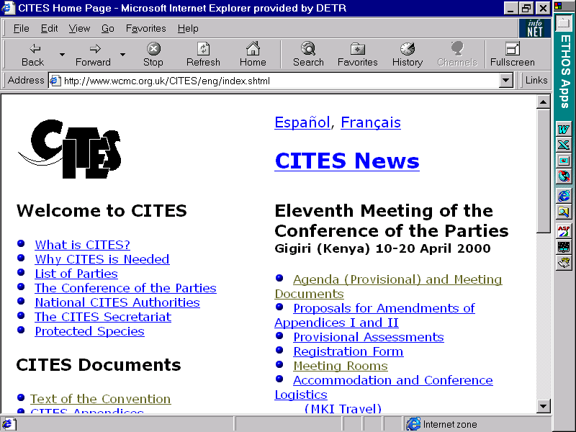 | Convention on International Trade in Endangered Species of Wild Fauna and Flora
4. Country of (re)-export
Switzerland
5. Country of import
United Kingdom
6. Location at which live specimens of Annex A species will be kept | 7. Issuing Management Authority25GBIMPEFPJOB  Animal and Plant Health Agency (APHA)  UK CITES Management Authority  Horizon House  Deanery Road  Bristol BS1 5AH  Tel 0044(0)117 372 3700  Website: https://www.gov.uk/cites-imports-and-exports
8. Description of specimens (including marks, sex/date of birth for live animals)  Watch straps made of Alligator skin | 9. Net mass (kg) |  |  | 10. Quantity  80
 | 11. CITES Appendix  II |  | 12. GB Annex  B | 13. Source  C |  |  | 14. Purpose  T
15. Country of origin
United States of America
 | 16. Permit No  24IMPBBY888 |  |  |  |  | 17. Date of issue  30/06/2025
18. Country of last re-export
Switzerland
 | 19. Certificate No  ITIMP98TT56 |  |  |  |  | 20. Date of issue  10/03/2026
21. Scientific name of species
Alligator Mississippiensis
22. Common name of species
American Alligator
23. Special conditions
This permit/certificate is only valid if live animals are transported in compliance with the CITES Guidelines for the transport and Preparation for Shipment of Live Wild Animals or, in the case of air transport, the Live Animals Regulations published by the International Air Transport Association (IATA)

24. The (re-)export documentation from the country of (re-)export  CITES Secretariat  Palais des Nations  Avenue de la Paix 8-14  1211 Genève 10  Switzerland | 25. The ☑ importation ☐ exportation ☐ re-exportation  of the goods described above is hereby permitted.  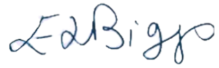  Signature and official stamp:  Emma Biggs  Head of International Trade and Customer Service  Name of issuing official: Jane Jameson  09/09/2025  Place and date of issue: Bristol. 10/09/2025
26. Bill of Lading/Air Waybill No:

27. For customs use only Signature and official stamp

Quantity/net mass (kg) actually imported or (re-) exported | Number of animals dead on arrival
Customs Document
Type

Number

Date

This permit is digitally endorsed and may not reflect its current status.
To check the validity of this permit scan the QR code or visit www.gov.uk/check-a-cites-permit

