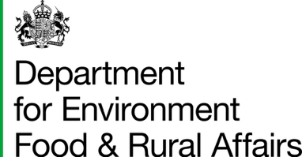

Poultry Biosecurity Review

Vet summary
You must use this template for the Poultry Biosecurity Review
This document:
- gives the information poultry keepers need to make a claim
- may be requested by the Rural Payments Agency (RPA) as evidence the review took place

Section 1: about the poultry keeper’s business
You will need to ask the poultry keeper for these details.

Single Business Identifier (SBI)

Name of business linked to this SBI

Agreement number

Section 2: tell us about this poultry site

Site name
This should be the name the poultry keeper uses to describe the location, for example West Farm.

County Parish Holding (CPH) number for this poultry site
This CPH can only be used for one site.

Section 3: biosecurity review details

Date of visit
Give the date you last attended the farm for this visit.

What type of poultry are kept on this site?
Tick all that apply:
Chickens: broilers

Chickens: laying hens

Chickens: breeders

Ducks

Geese

Turkeys

Does this site have the capacity to hold the minimum number of birds?
You need to confirm the site can hold the minimum number of birds for each poultry type.

The site might not have any birds at the time of the review.
Minimum number of birds for each species:

- Chickens: 1,000 broilers
- Chickens: 1,000 laying hens
- Chickens: 1,000 breeders
- 500 ducks
- 500 geese
- 500 turkeys

Answer either yes or no.

Vet’s name
Give the first and last name of the vet who did the visit, not the vet’s business name.

Vet’s Royal College of Veterinary Surgeons (RCVS) number

Have you done a biosecurity assessment on this site?
Answer either yes or no.

What was the main change you recommended to improve the farm’s biosecurity?
This won’t affect your review claim.

Housing, buildings, infrastructure and wild bird control
For example, repairs to sheds, improving building structure, improving separation between areas

People, visitors and hygiene procedures

For example, handwashing, visitor controls, staff routines

Bird movements and flock management
For example, bringing in birds, quarantine routines, movement of birds between sheds

Feed, water, bedding, eggs and waste handling
For example, water hygiene, storage improvements, carcass disposal

Cleaning, disinfection and disease control
For example, cleaning shed interiors, correct order of disinfection, disease monitoring

No recommendations were made in my review

Section 4: confirmation and signature

I confirm I followed the GOV.UK guidance on how to do a poultry biosecurity review.
Answer either yes or no.

I confirm I have given the poultry keeper a full written report. This includes issues we discussed and my recommendations.
Answer either yes or no.

Vet’s signature
This signature should be the vet who is responsible for this visit. By signing this form, you confirm the information you have given is accurate to the best of your knowledge.

Date of signature

