Runner sign-in v2 – all pages
Exported from the prototype on Thursday, 9 July 2026 at 16:00.
Source index: http://localhost:3000/runner-sign-in-v2/all-pages

Prototype

1. Start page
URL:http://localhost:3000/runner-sign-in-v2/start-page
Page title: Start – Runner sign-in v2 – GOV.UK
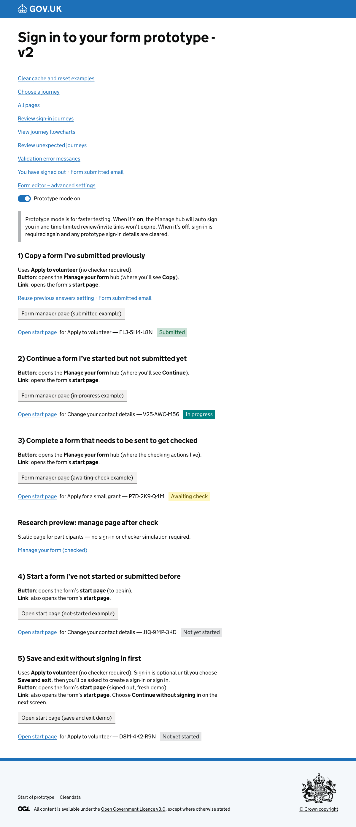

2. Choose a journey
URL:http://localhost:3000/runner-sign-in-v2/choose-journey
Page title: Choose a journey – Runner sign-in v2 – GOV.UK
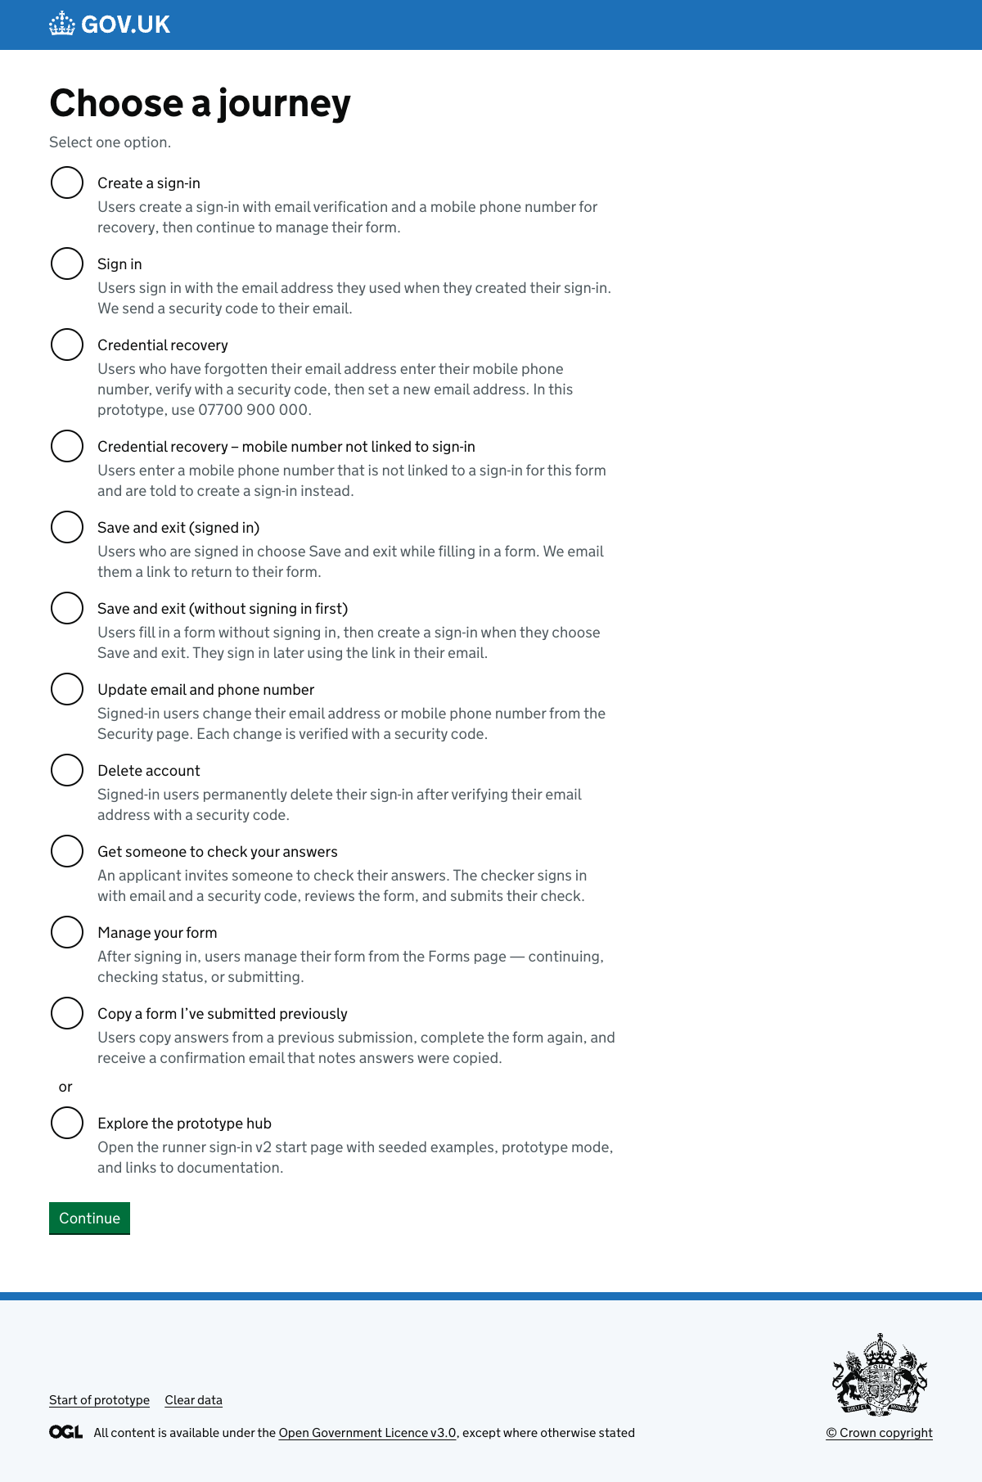

3. Journeys
URL:http://localhost:3000/runner-sign-in-v2/journeys
Page title: Sign-in journeys – Runner sign-in v2 – GOV.UK
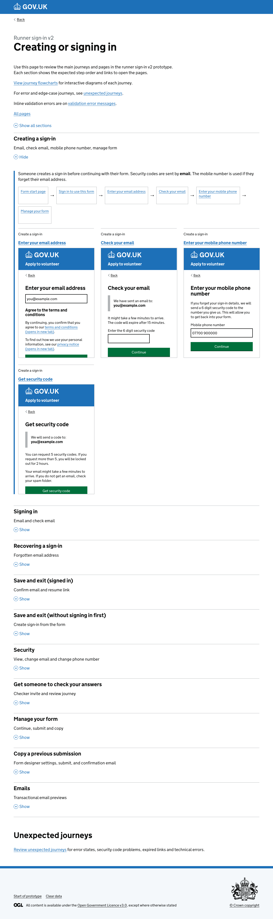

4. Journey flowcharts
URL:http://localhost:3000/runner-sign-in-v2/journey-flowcharts
Page title: Journey flowcharts – Runner sign-in v2 – GOV.UK
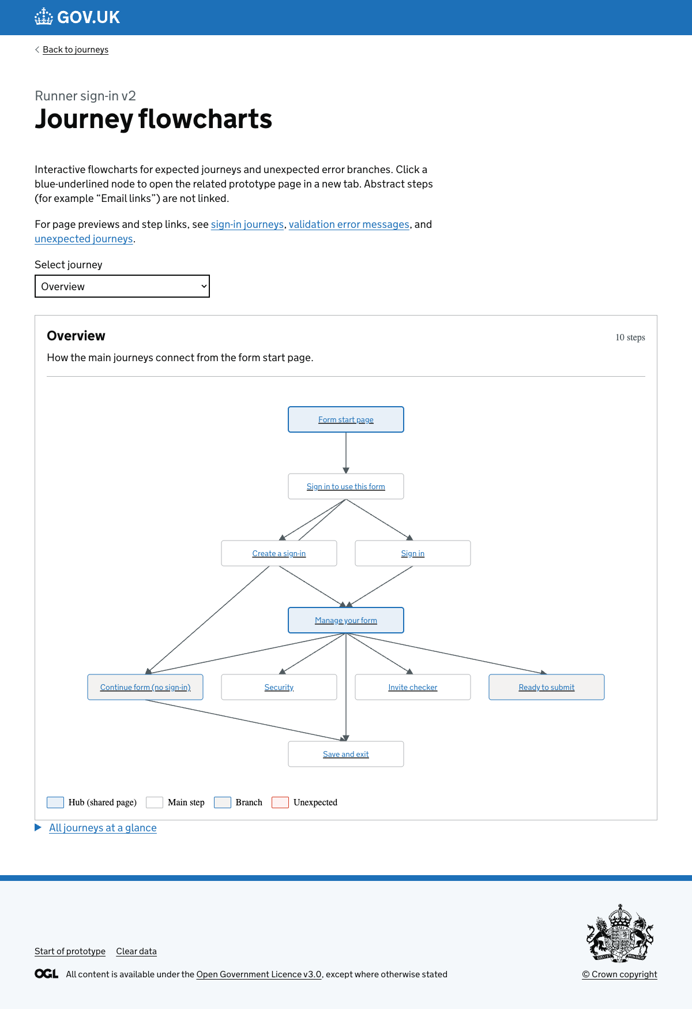

5. Unexpected journeys
URL:http://localhost:3000/runner-sign-in-v2/unexpected-journeys
Page title: Unexpected journeys - Runner sign-in v2 - GOV.UK
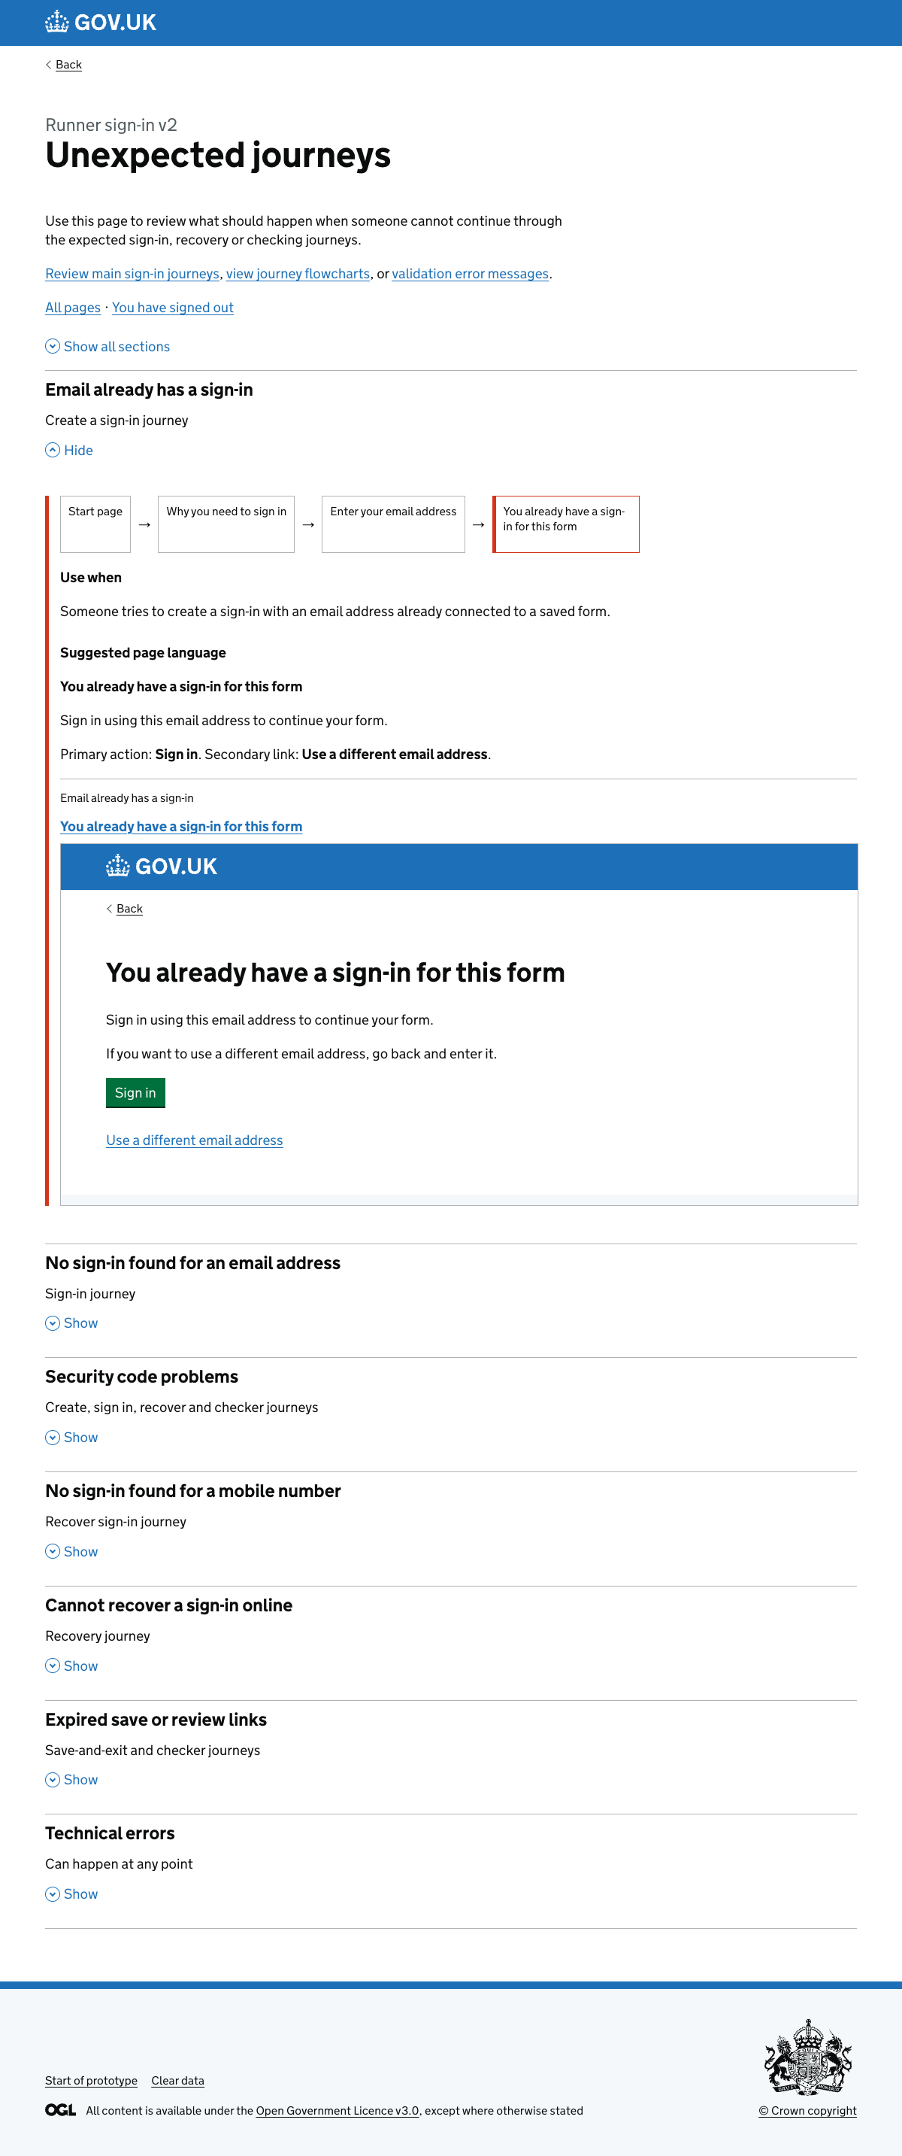

6. Validation error messages
URL:http://localhost:3000/runner-sign-in-v2/error-messages
Page title: Validation error messages – Runner sign-in v2 – GOV.UK
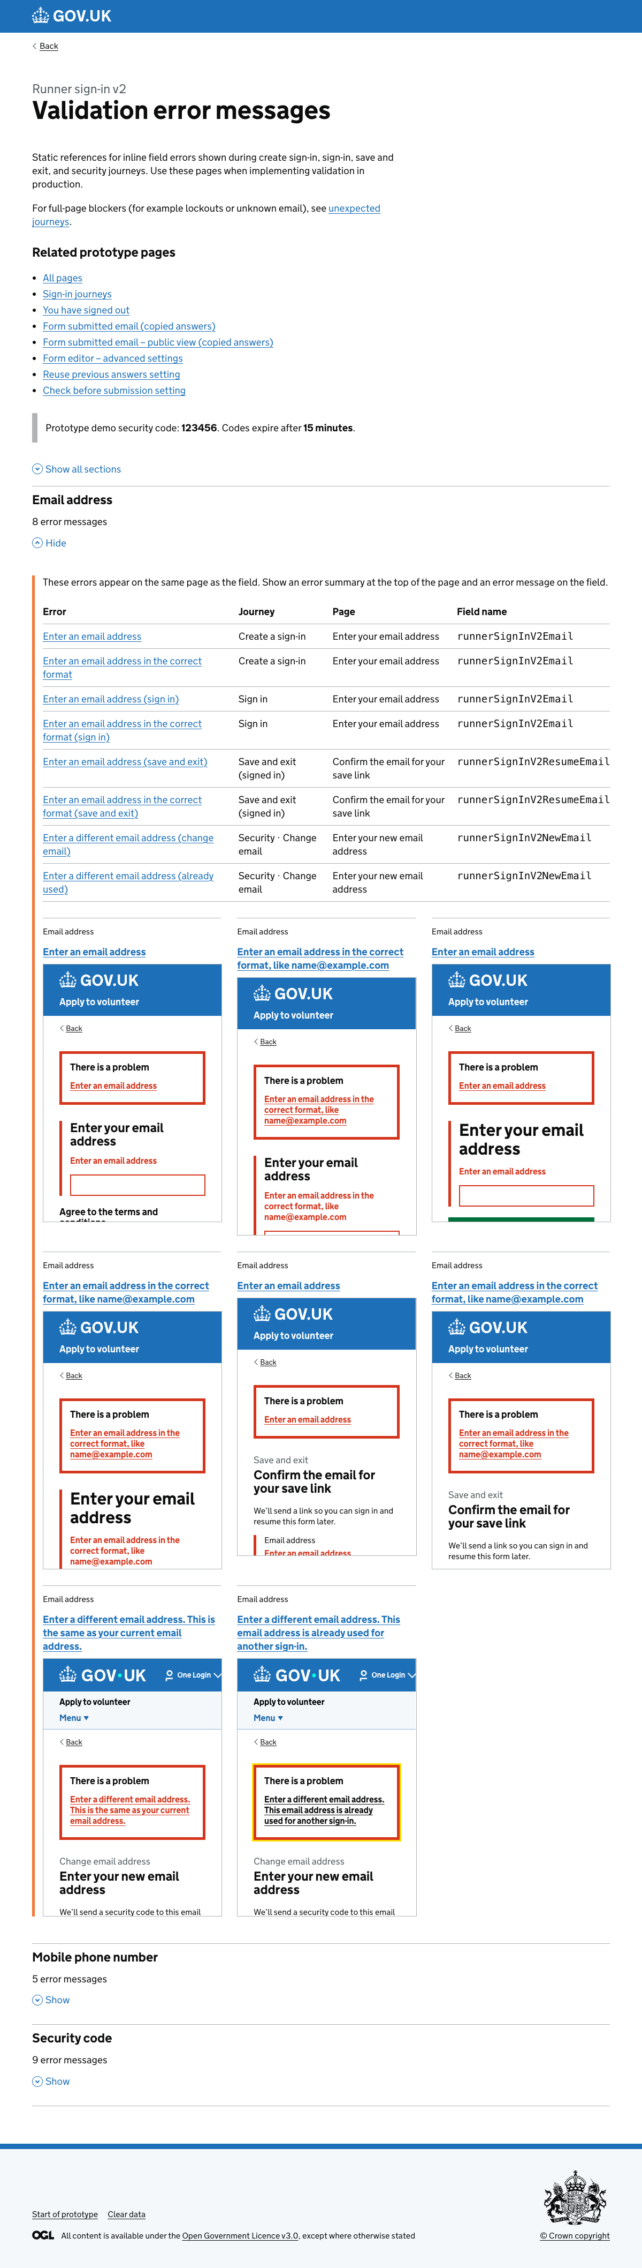

Form designer (advanced settings)

7. Advanced settings
URL:http://localhost:3000/titan-mvp-1.2/form-editor/advanced-settings
Page title: Advanced settings - Form name - Defra Forms Designer - GOV.UK
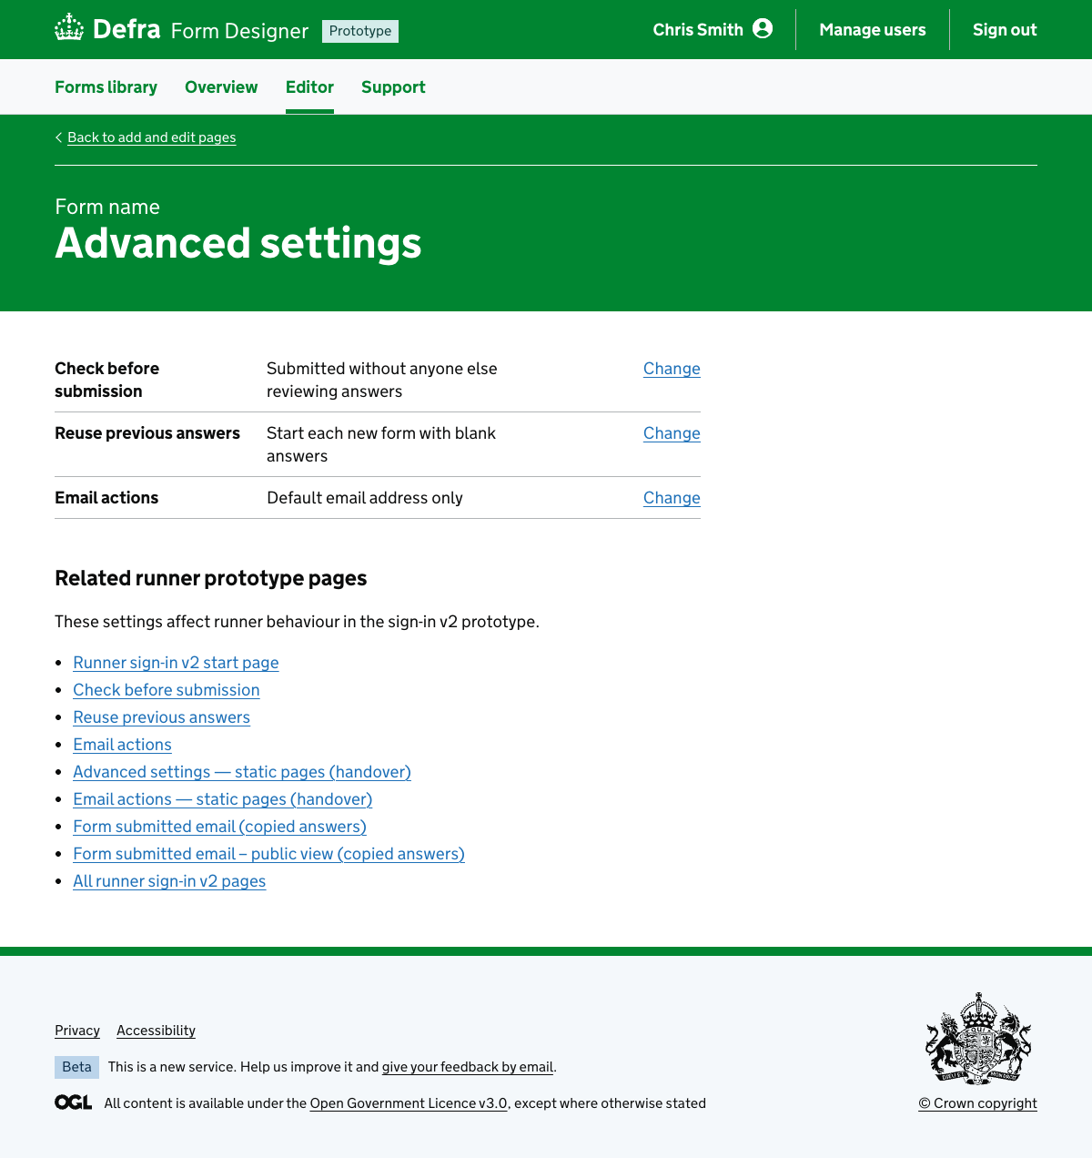

8. Advanced settings — static pages
URL:http://localhost:3000/titan-mvp-1.2/form-editor/advanced-settings/static
Page title: Advanced settings static pages - Apply for a county parish holding (CPH) number - Defra Forms Designer - GOV.UK
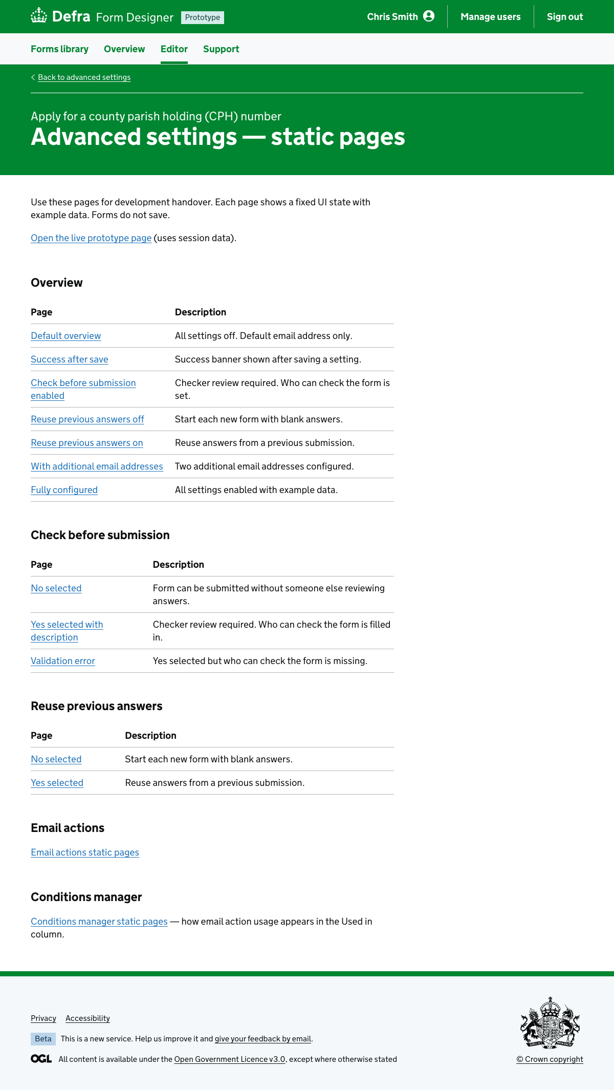

9. Check before submission
URL:http://localhost:3000/titan-mvp-1.2/form-editor/advanced-settings/check-before-submission
Page title: Does someone need to check the form before it is submitted? - Form name - Defra Forms Designer - GOV.UK
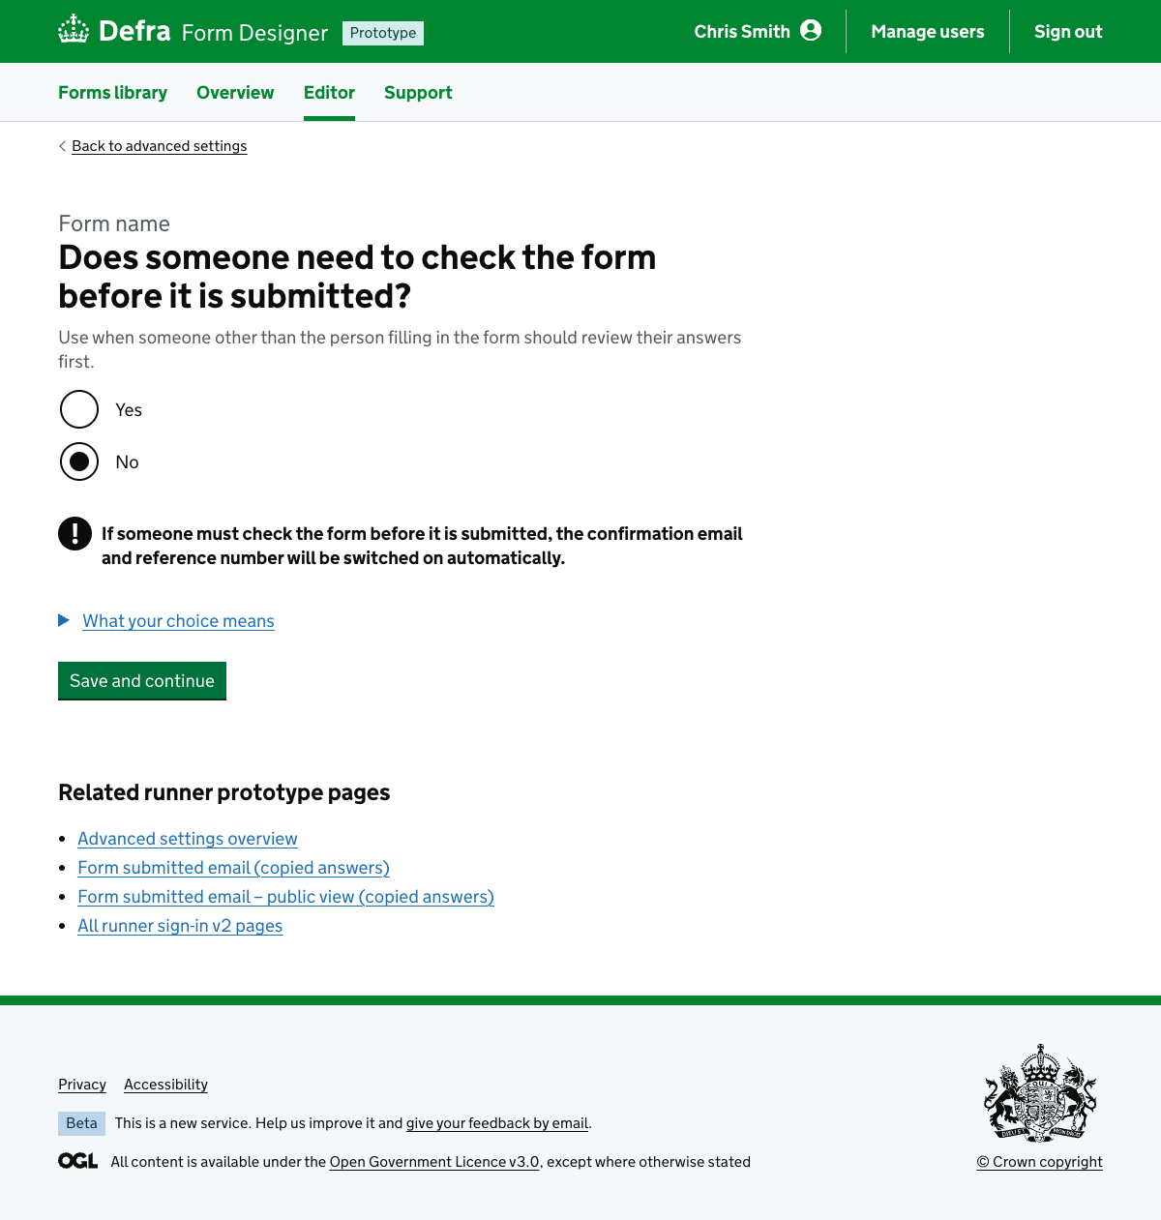

10. Reuse previous answers
URL:http://localhost:3000/titan-mvp-1.2/form-editor/advanced-settings/reuse-previous-answers
Page title: Can people reuse answers from a previous submission? - Form name - Defra Forms Designer - GOV.UK
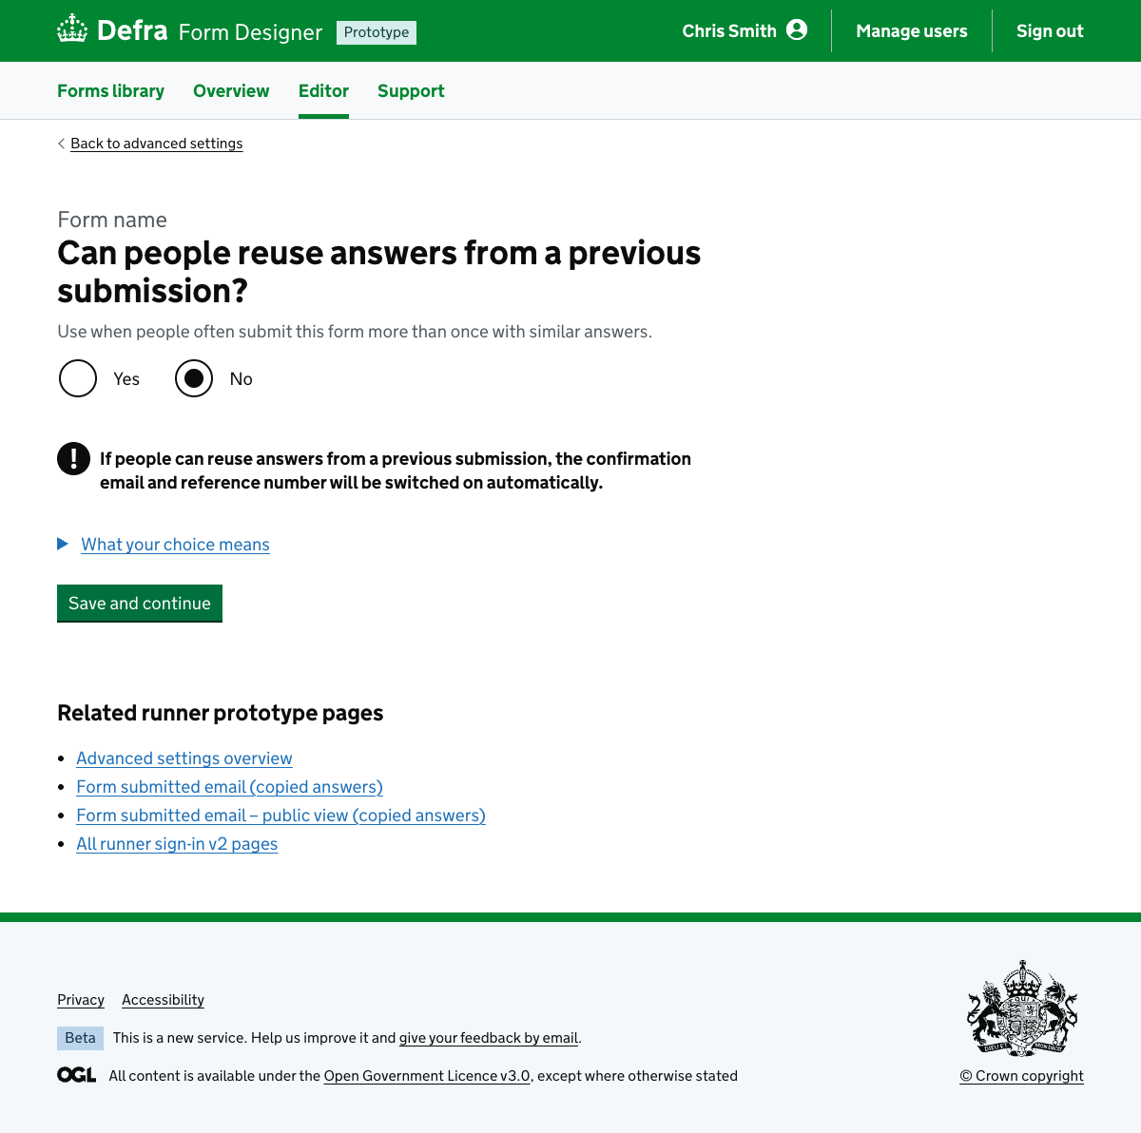

11. Reuse previous answers — no selected (static)
URL:http://localhost:3000/titan-mvp-1.2/form-editor/advanced-settings/static/reuse-previous-answers/no-selected
Page title: Can people reuse answers from a previous submission? - Apply for a county parish holding (CPH) number - Defra Forms Designer - GOV.UK
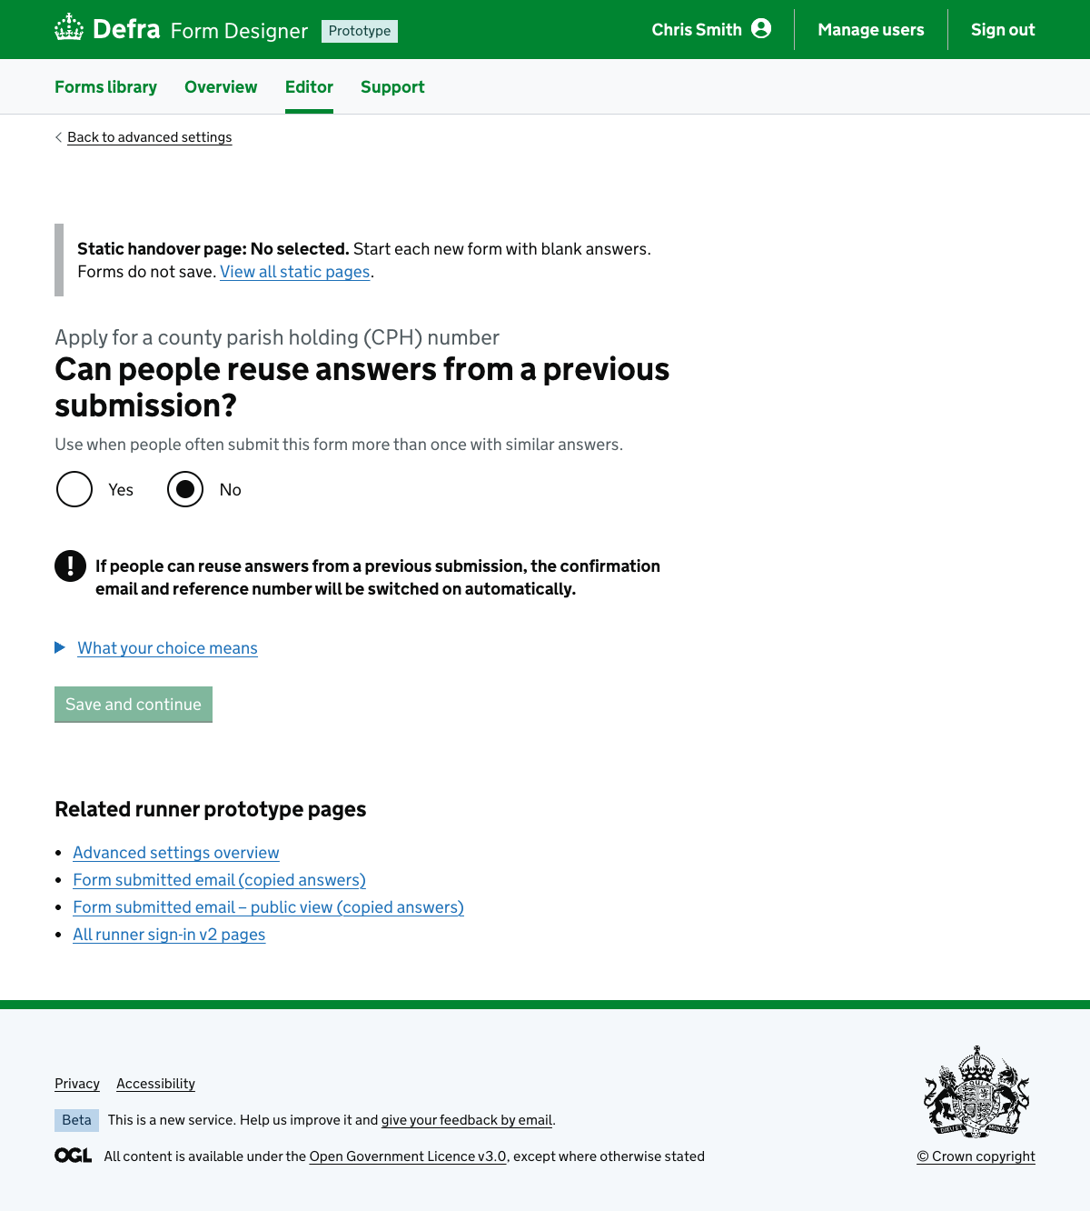

12. Reuse previous answers — yes selected (static)
URL:http://localhost:3000/titan-mvp-1.2/form-editor/advanced-settings/static/reuse-previous-answers/yes-selected
Page title: Can people reuse answers from a previous submission? - Apply for a county parish holding (CPH) number - Defra Forms Designer - GOV.UK
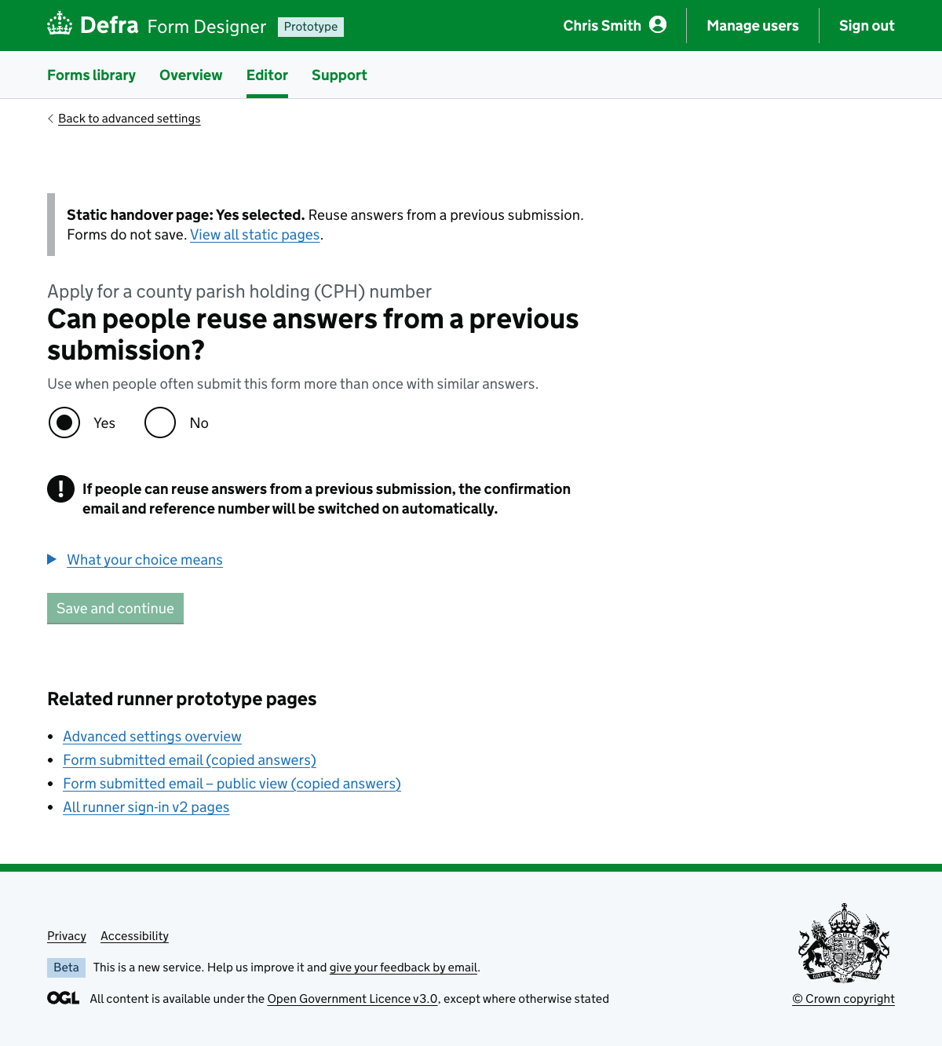

13. Advanced settings overview — reuse off (static)
URL:http://localhost:3000/titan-mvp-1.2/form-editor/advanced-settings/static/reuse-previous-answers-off
Page title: Advanced settings - Apply for a county parish holding (CPH) number - Defra Forms Designer - GOV.UK
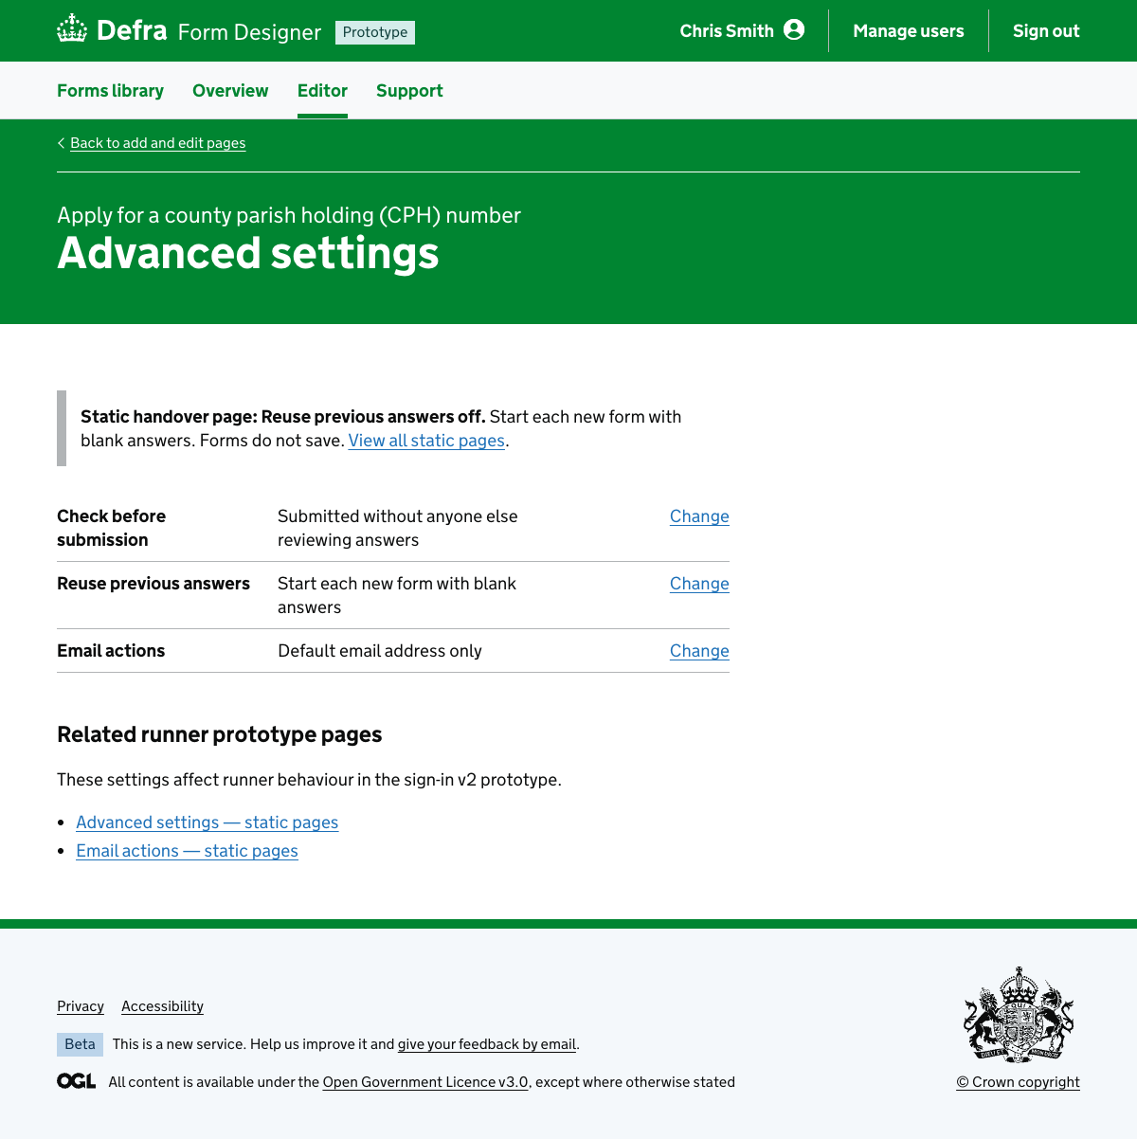

14. Advanced settings overview — reuse on (static)
URL:http://localhost:3000/titan-mvp-1.2/form-editor/advanced-settings/static/reuse-previous-answers-on
Page title: Advanced settings - Apply for a county parish holding (CPH) number - Defra Forms Designer - GOV.UK
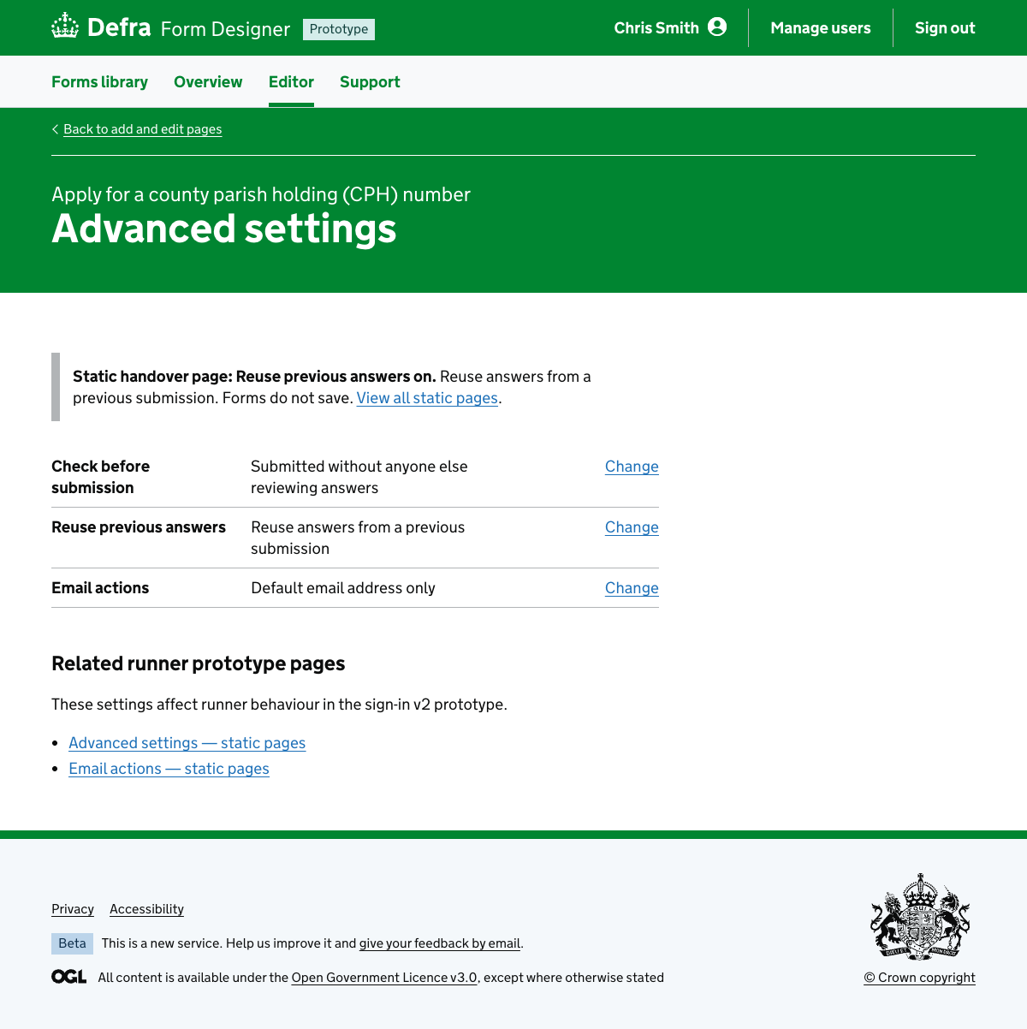

15. Email actions (live)
URL:http://localhost:3000/titan-mvp-1.2/form-editor/advanced-settings/conditional-mailbox-routing
Page title: Email actions - Form name - Defra Forms Designer - GOV.UK
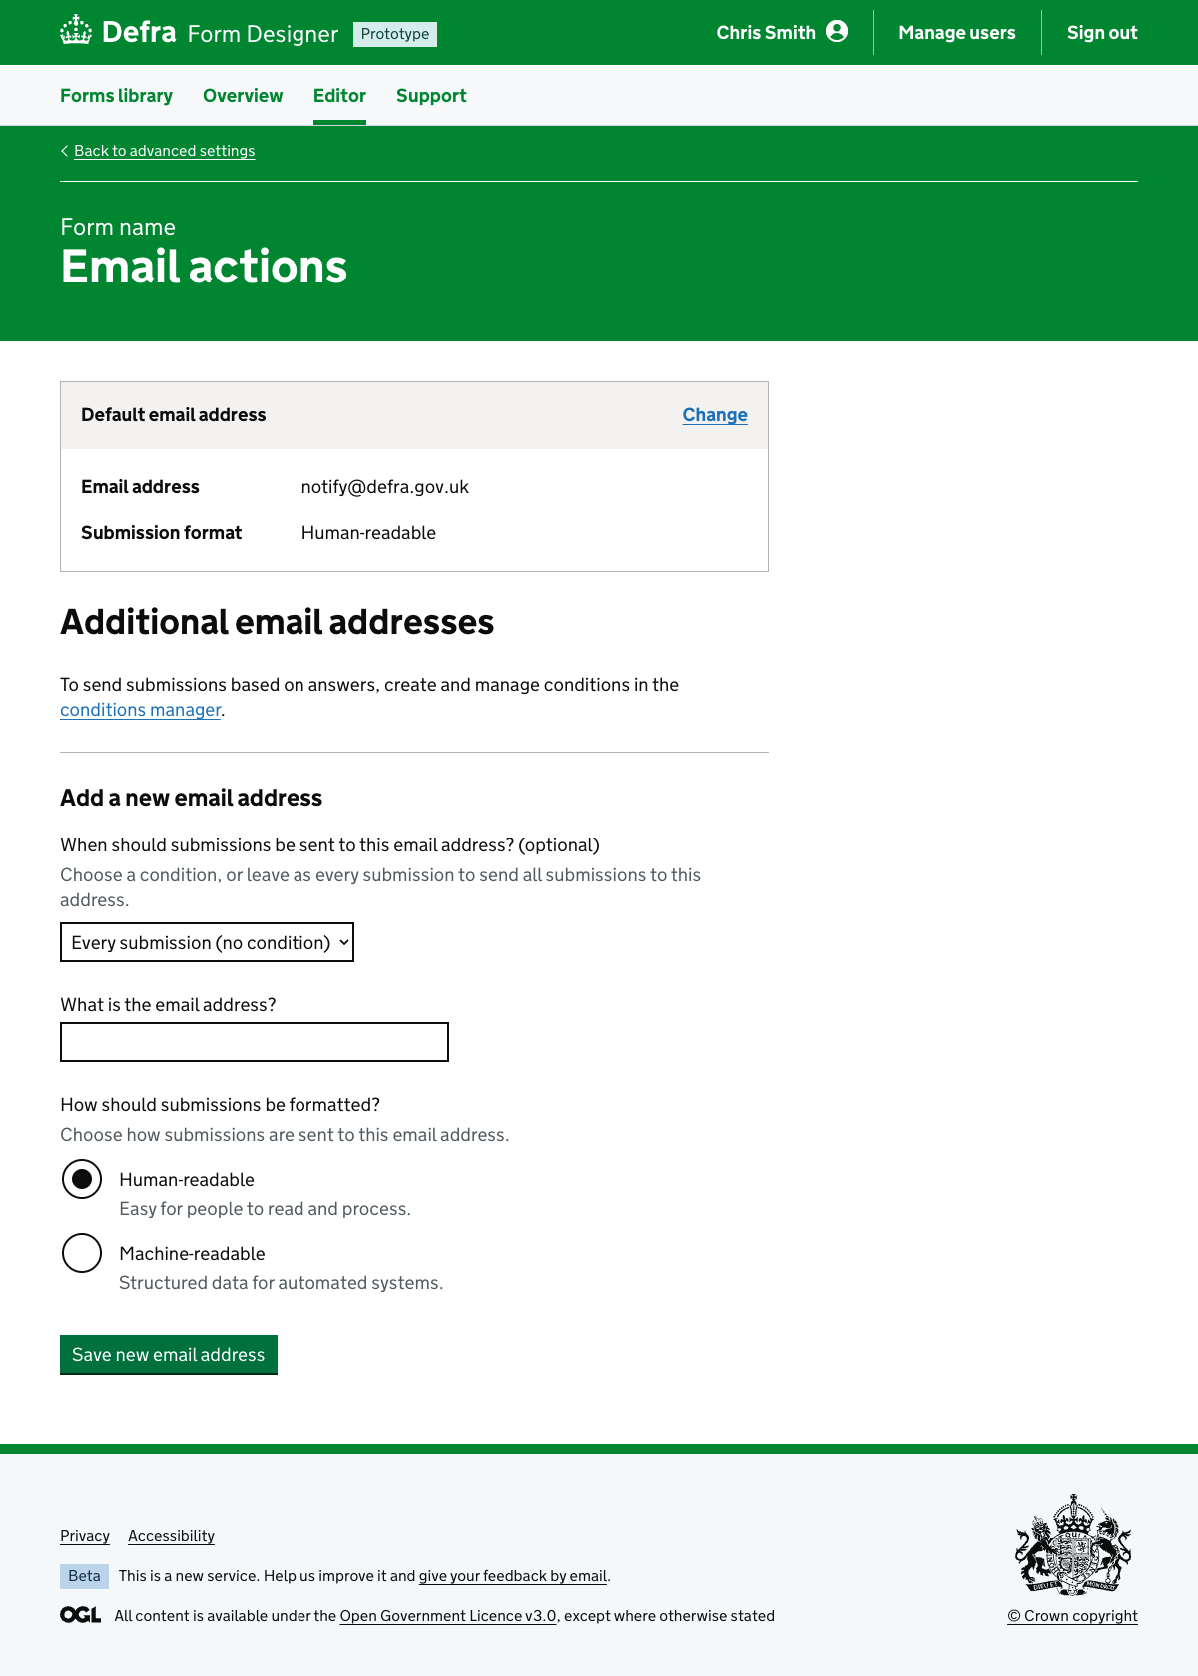

16. Email actions — static pages
URL:http://localhost:3000/titan-mvp-1.2/form-editor/advanced-settings/conditional-mailbox-routing/static
Page title: Email actions static pages - Apply for a county parish holding (CPH) number - Defra Forms Designer - GOV.UK
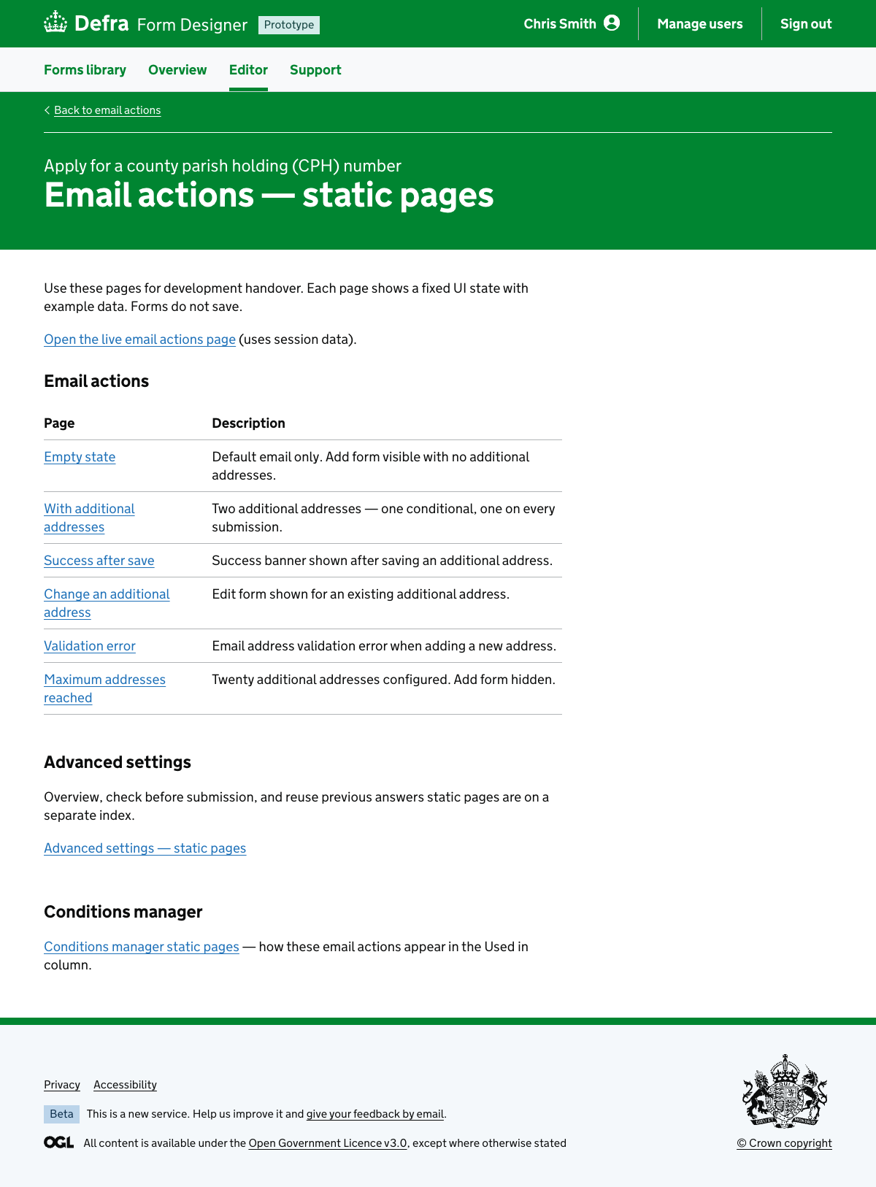

Form

17. Form start page
URL:http://localhost:3000/runner-sign-in-v2/forms/volunteer-application/app-save-exit-demo/start-page
Page title: Apply to volunteer – GOV.UK
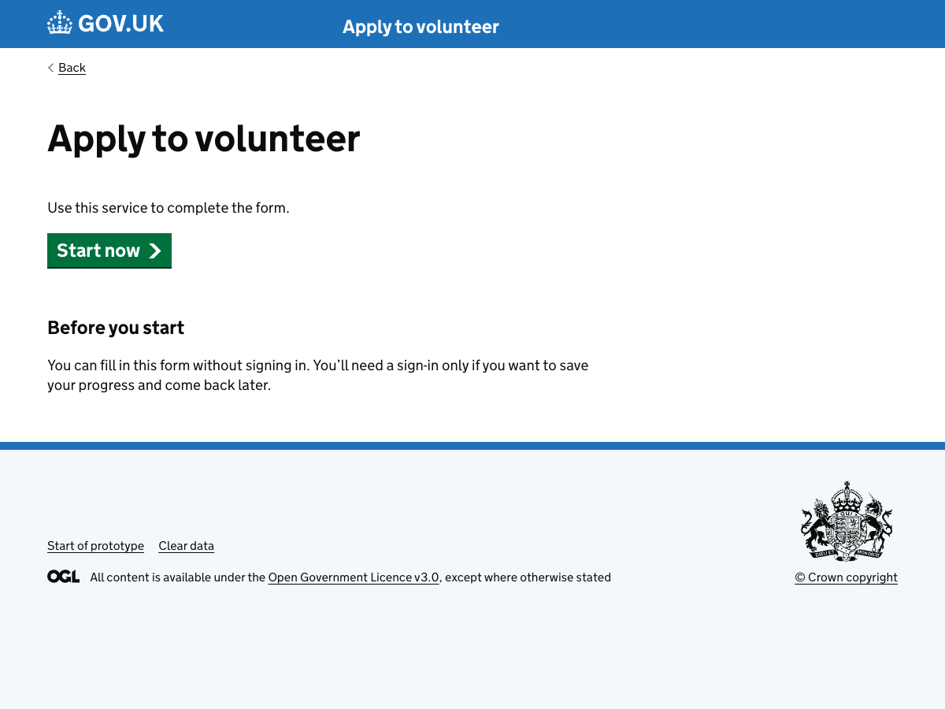

18. Sign in to use this form
URL:http://localhost:3000/runner-sign-in-v2/why-sign-in?formKey=volunteer-application&applicationId=app-save-exit-demo&next=%2Frunner-sign-in-v2%2Fforms%2Fvolunteer-application%2Fapp-save-exit-demo%2Fmanage
Page title: Sign in – form name – GOV.UK
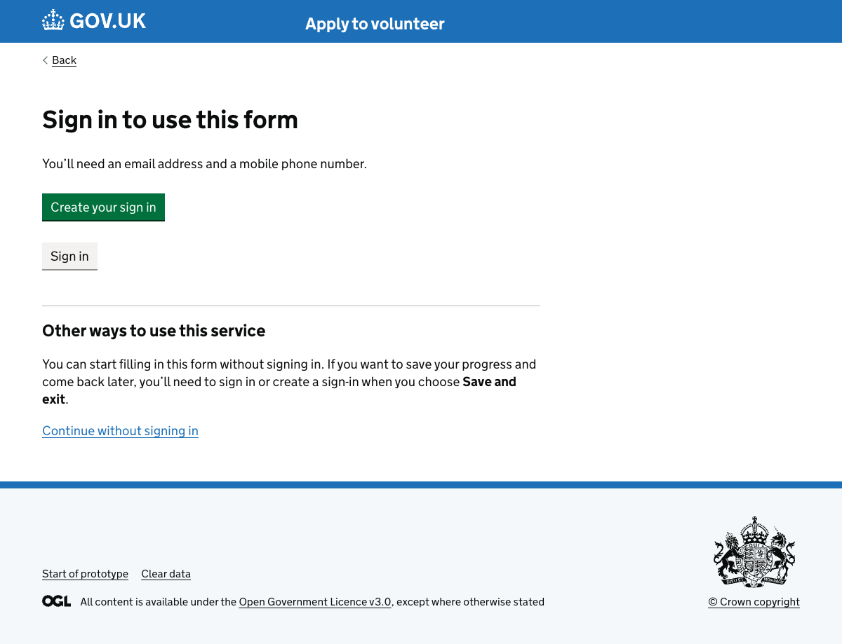

19. Manage your form
URL:http://localhost:3000/runner-sign-in-v2/forms/volunteer-application/app-save-exit-demo/manage
Page title: Sign in: email – GOV.UK
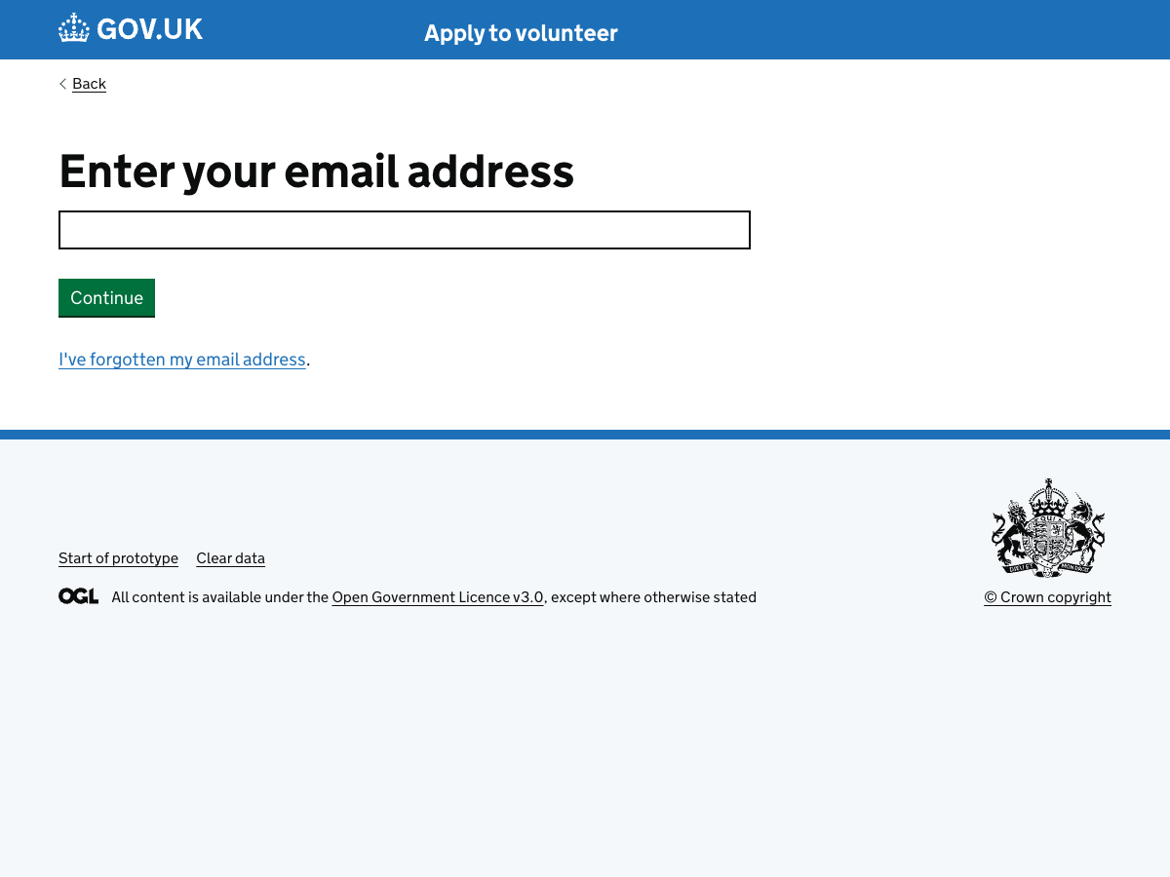

20. Ready to submit
URL:http://localhost:3000/runner-sign-in-v2/forms/volunteer-application/app-save-exit-demo/ready-to-submit
Page title: Sign in: email – GOV.UK


21. Form submitted
URL:http://localhost:3000/runner-sign-in-v2/forms/volunteer-application/app-save-exit-demo/submitted
Page title: Sign in: email – GOV.UK


22. Form submitted confirmation email
URL:http://localhost:3000/runner-sign-in-v2/emails/form-submitted?formKey=volunteer-application&applicationId=app-save-exit-demo&next=%2Frunner-sign-in-v2%2Fforms%2Fvolunteer-application%2Fapp-save-exit-demo%2Fmanage
Page title: Form submitted email – prototype
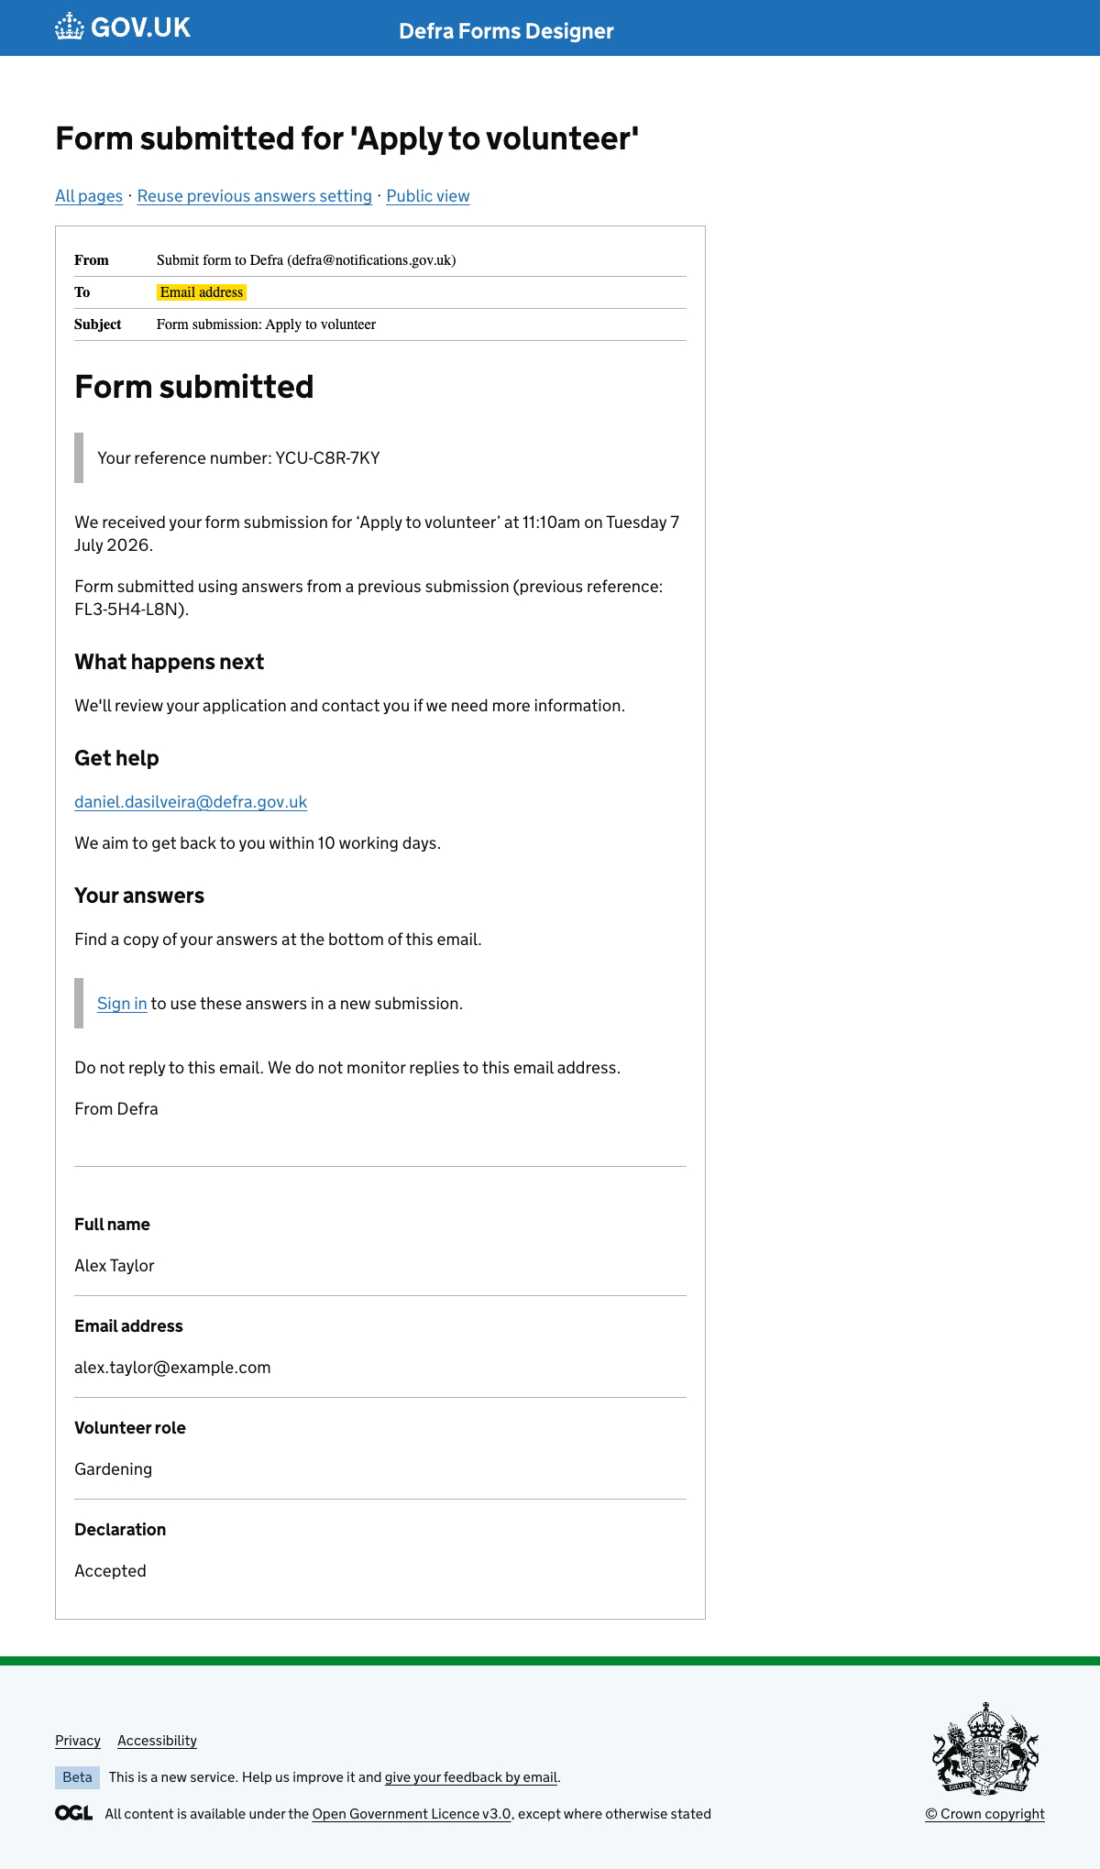

23. Start a new application
URL:http://localhost:3000/runner-sign-in-v2/forms/volunteer-application/app-save-exit-demo/start-new
Page title: Sign in: email – GOV.UK


24. Manage your form (checked example)
URL:http://localhost:3000/runner-sign-in-v2/static/manage-form-checked
Page title: Manage your form – Apply for a small grant – GOV.UK
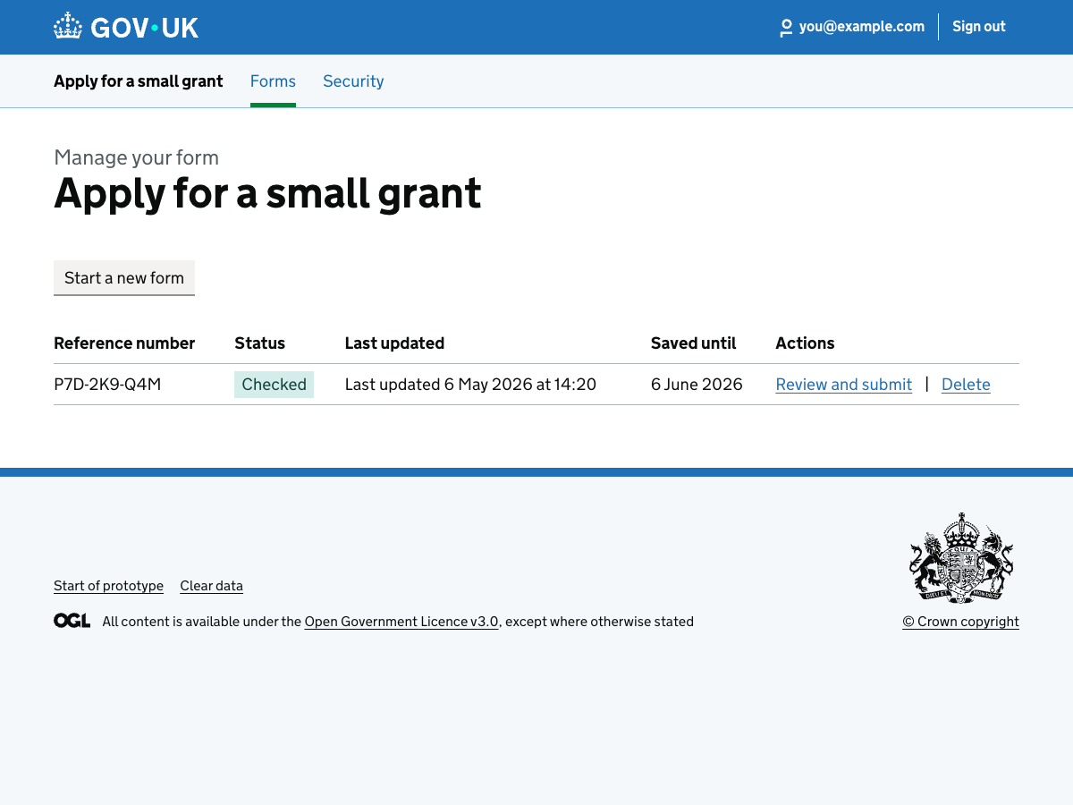

Copy a previous submission

25. Advanced settings
URL:http://localhost:3000/titan-mvp-1.2/form-editor/advanced-settings
Page title: Advanced settings - Form name - Defra Forms Designer - GOV.UK


26. Reuse previous answers
URL:http://localhost:3000/titan-mvp-1.2/form-editor/advanced-settings/reuse-previous-answers
Page title: Can people reuse answers from a previous submission? - Form name - Defra Forms Designer - GOV.UK


27. Reuse previous answers — no selected (static)
URL:http://localhost:3000/titan-mvp-1.2/form-editor/advanced-settings/static/reuse-previous-answers/no-selected
Page title: Can people reuse answers from a previous submission? - Apply for a county parish holding (CPH) number - Defra Forms Designer - GOV.UK


28. Reuse previous answers — yes selected (static)
URL:http://localhost:3000/titan-mvp-1.2/form-editor/advanced-settings/static/reuse-previous-answers/yes-selected
Page title: Can people reuse answers from a previous submission? - Apply for a county parish holding (CPH) number - Defra Forms Designer - GOV.UK


29. Advanced settings overview — reuse off (static)
URL:http://localhost:3000/titan-mvp-1.2/form-editor/advanced-settings/static/reuse-previous-answers-off
Page title: Advanced settings - Apply for a county parish holding (CPH) number - Defra Forms Designer - GOV.UK


30. Advanced settings overview — reuse on (static)
URL:http://localhost:3000/titan-mvp-1.2/form-editor/advanced-settings/static/reuse-previous-answers-on
Page title: Advanced settings - Apply for a county parish holding (CPH) number - Defra Forms Designer - GOV.UK


31. Manage your form (submitted example)
URL:http://localhost:3000/runner-sign-in-v2/forms/volunteer-application/app-1721152526408/manage
Page title: Manage your form – Apply to volunteer – GOV.UK
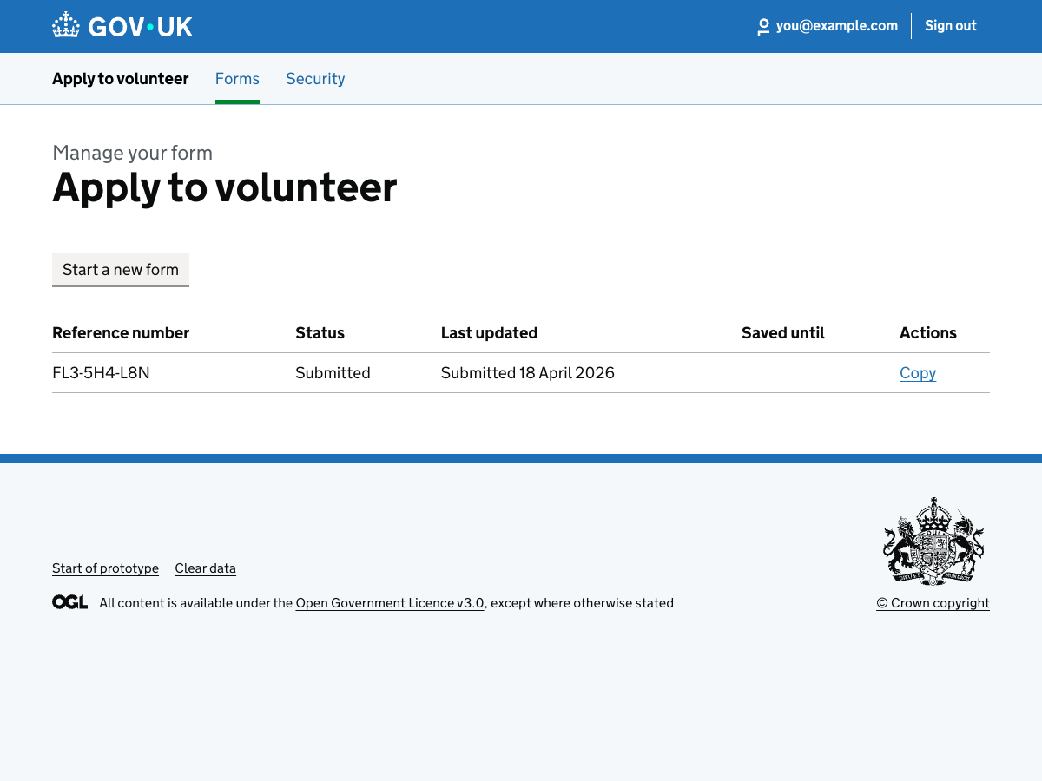

32. Copy answers confirmation
URL:http://localhost:3000/runner-sign-in/applications/app-1721152526408/clone
Page title: You are about to clone this application – Defra Forms Designer – GOV.UK
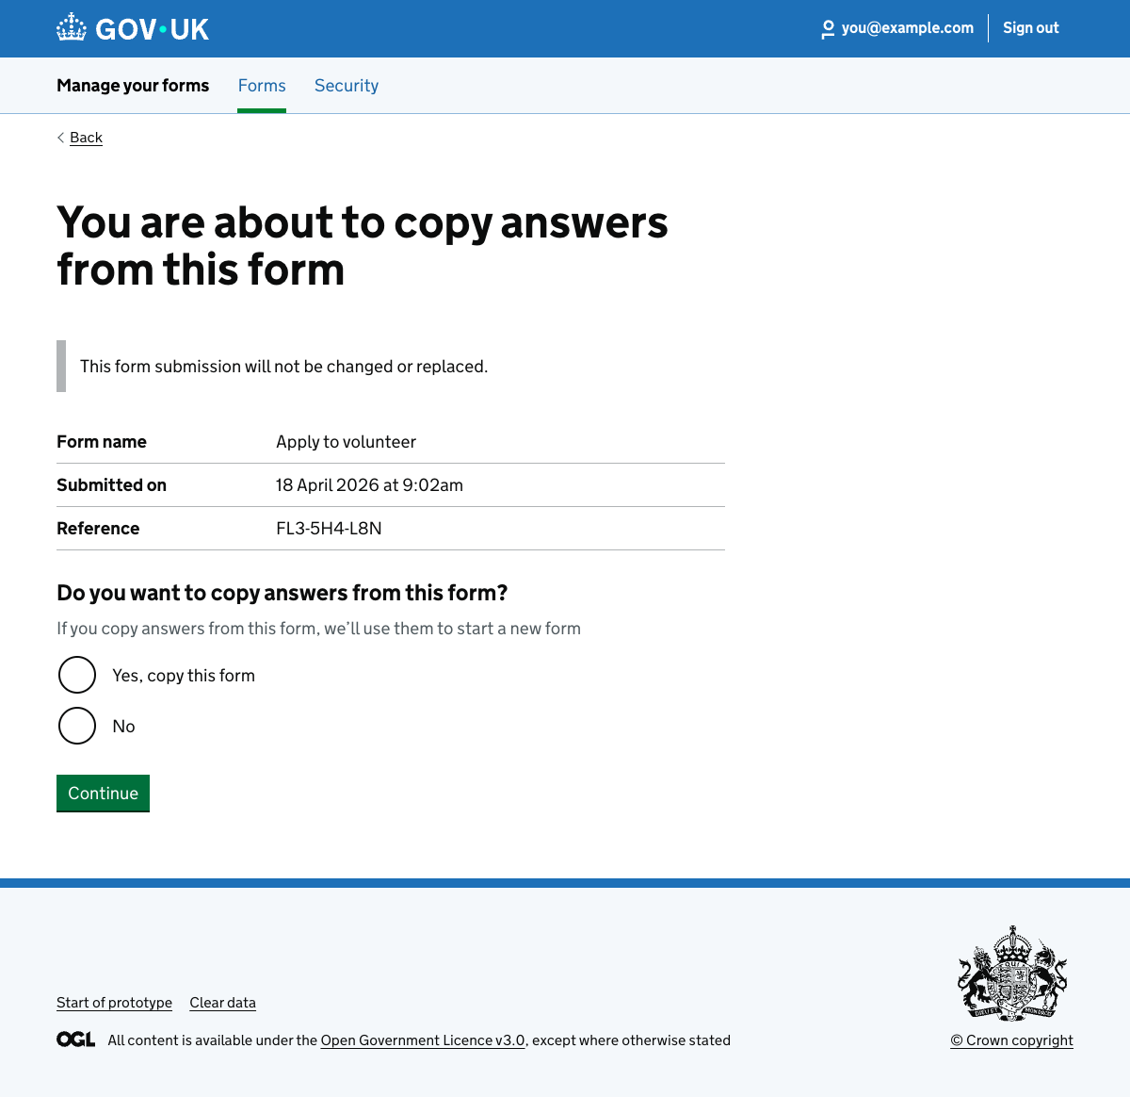

33. Check answers (copied)
URL:http://localhost:3000/runner-sign-in/forms/volunteer-application/app-copy-volunteer-draft/check-answers?copied=1
Page title: Check your answers – Apply to volunteer – GOV.UK
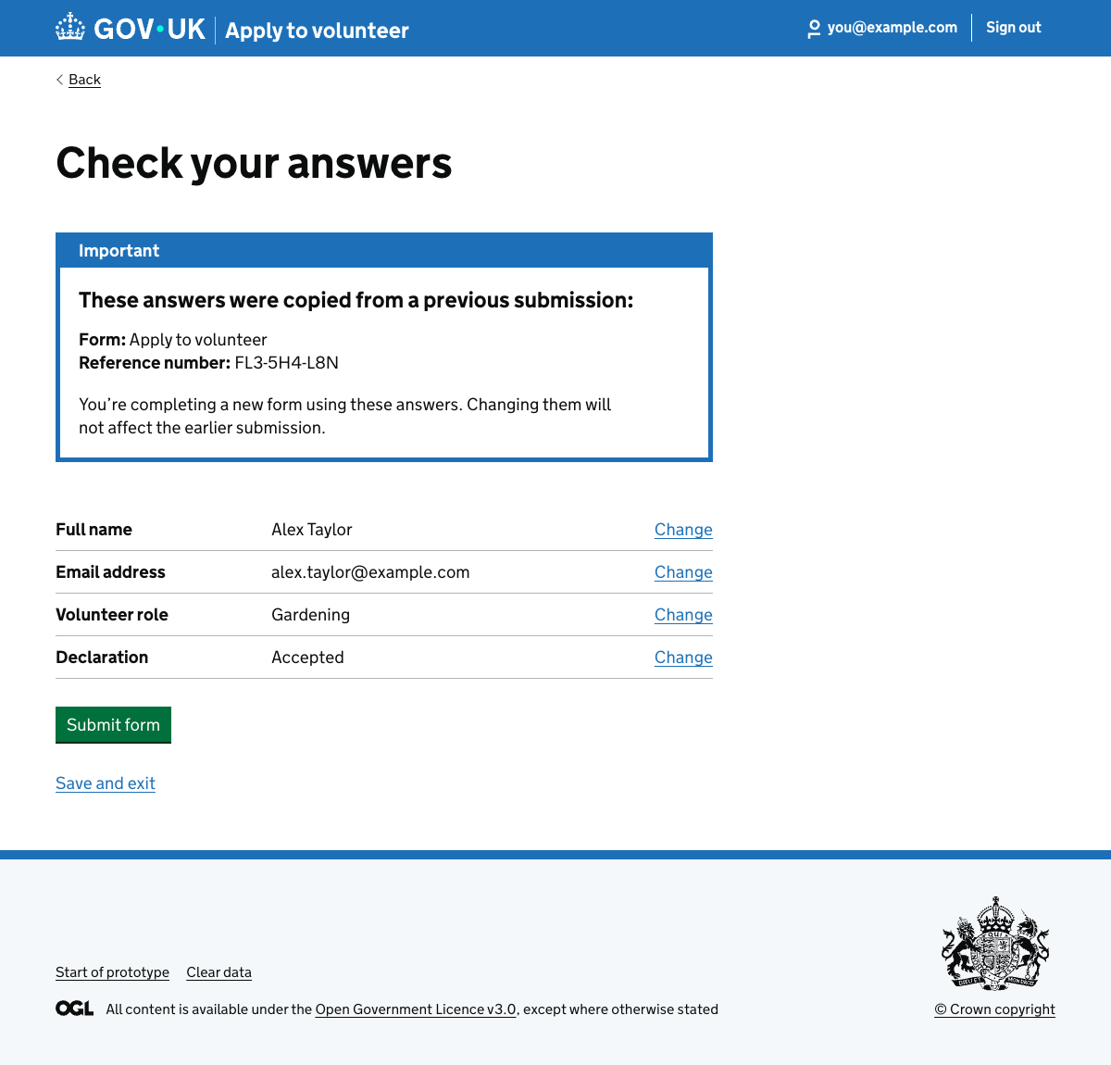

34. Your previous submission (new or changed questions)
URL:http://localhost:3000/runner-sign-in/intervention-copied?formKey=volunteer-application&applicationId=app-copy-volunteer-declaration&step=declaration
Page title: Your previous submission – Defra Forms Designer – GOV.UK
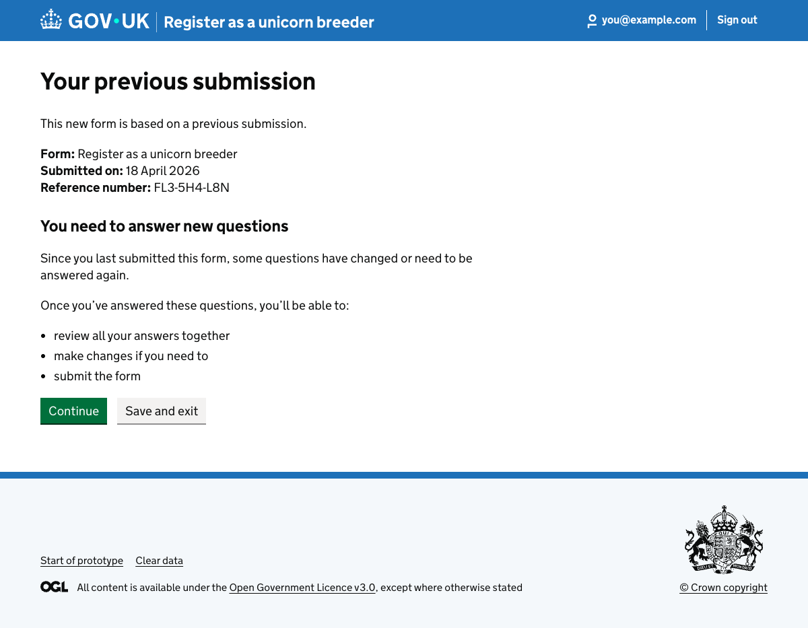

35. Your details (copied form)
URL:http://localhost:3000/runner-sign-in/forms/volunteer-application/app-copy-volunteer-draft/details?copied=1
Page title: Your details – Apply to volunteer – GOV.UK
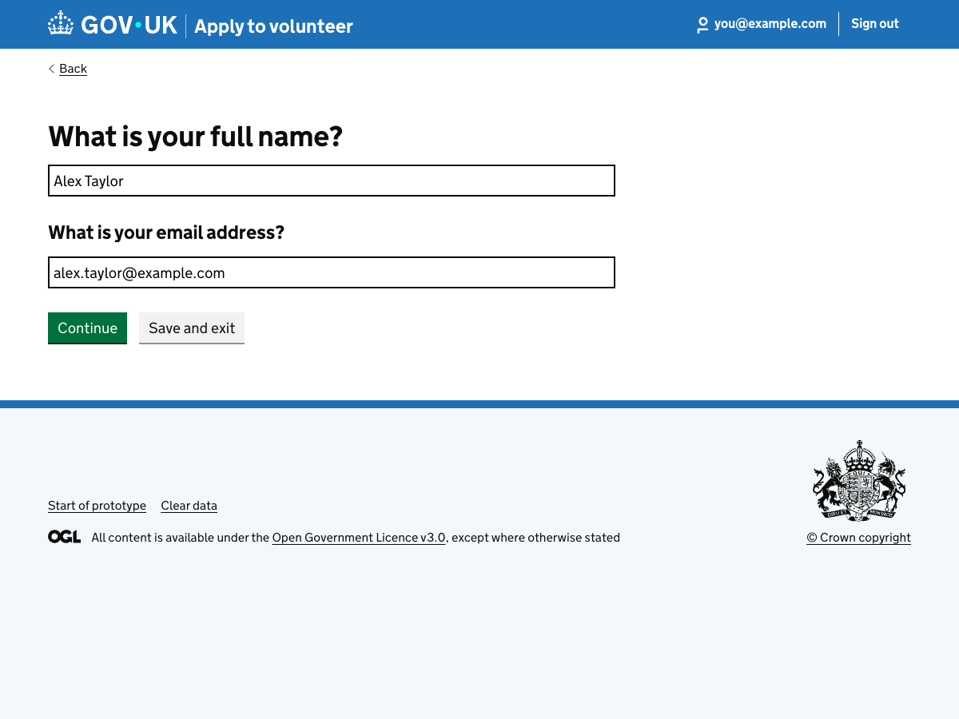

36. Volunteer role (copied form)
URL:http://localhost:3000/runner-sign-in/forms/volunteer-application/app-copy-volunteer-draft/role?copied=1
Page title: Volunteer role – Apply to volunteer – GOV.UK
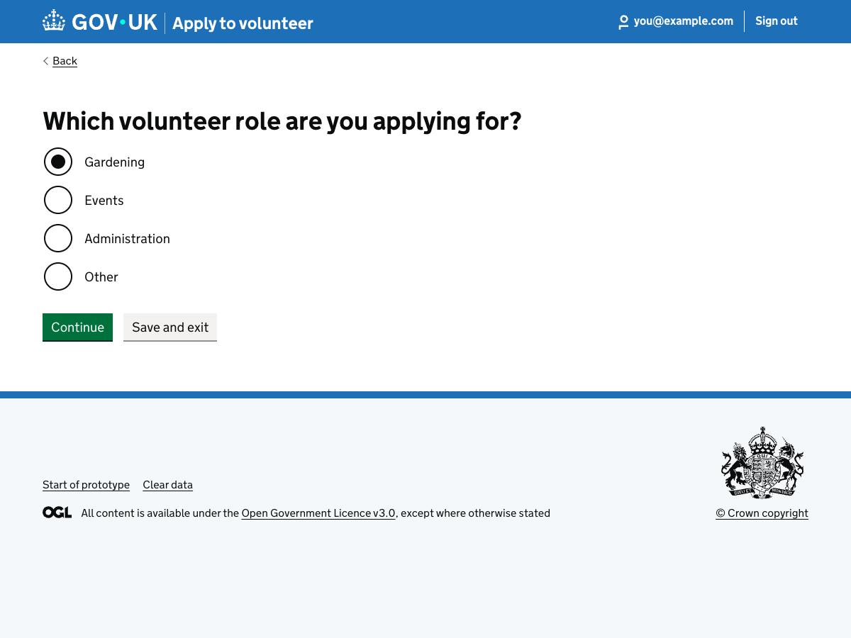

37. Declaration (copied form)
URL:http://localhost:3000/runner-sign-in/forms/volunteer-application/app-copy-volunteer-draft/declaration?copied=1
Page title: Declaration – Apply to volunteer – GOV.UK
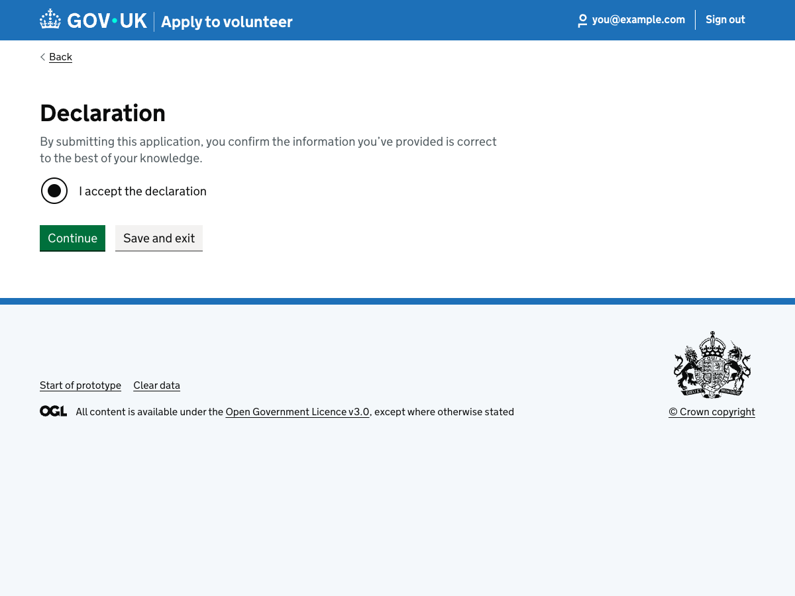

38. Declaration (answer again)
URL:http://localhost:3000/runner-sign-in/forms/volunteer-application/app-copy-volunteer-declaration/declaration?copied=1
Page title: Declaration – Apply to volunteer – GOV.UK
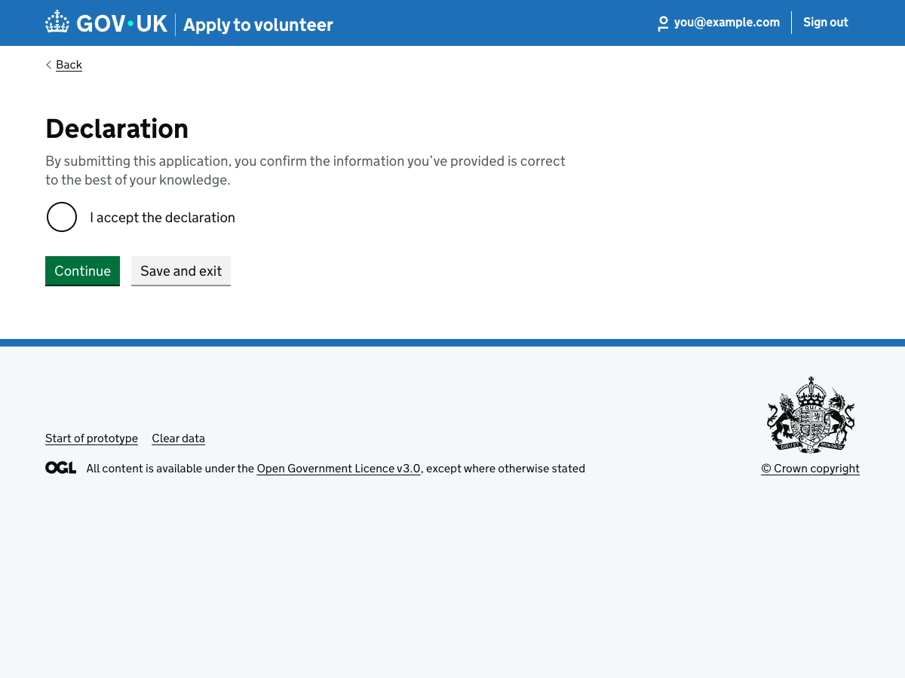

39. Ready to submit (copied form)
URL:http://localhost:3000/runner-sign-in-v2/forms/volunteer-application/app-copy-volunteer-draft/ready-to-submit
Page title: Manage your form – Apply to volunteer – GOV.UK
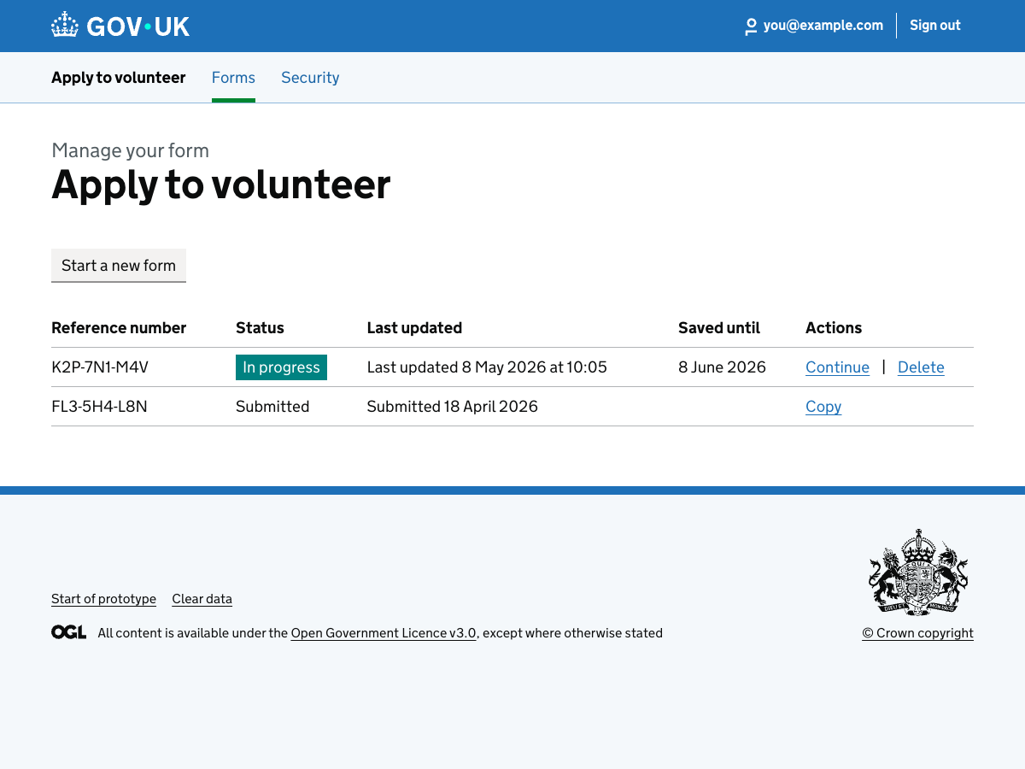

40. Manage your form (after copy)
URL:http://localhost:3000/runner-sign-in-v2/forms/volunteer-application/app-copy-volunteer-draft/manage?cloned=1
Page title: Manage your form – Apply to volunteer – GOV.UK
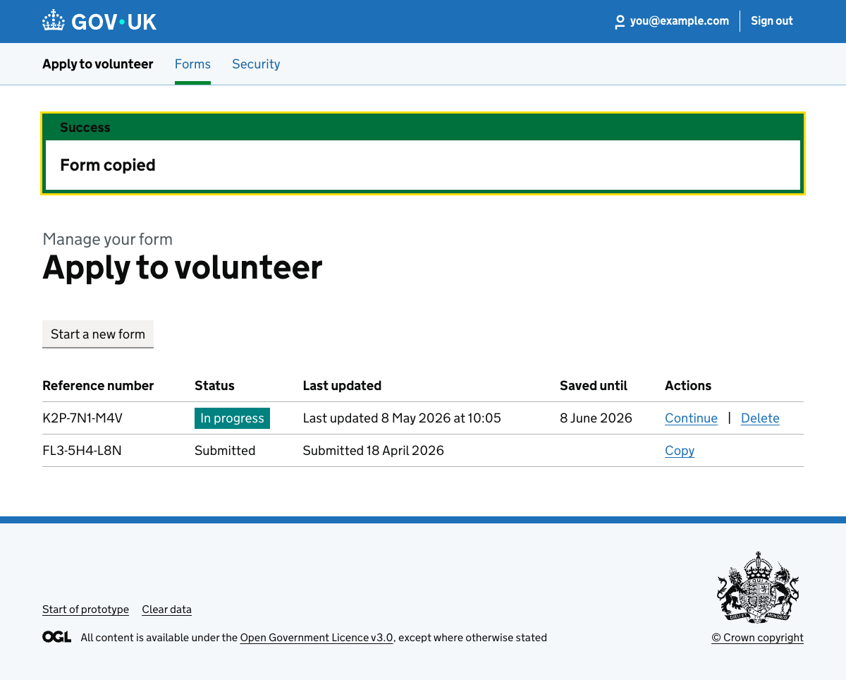

41. Form submitted
URL:http://localhost:3000/runner-sign-in-v2/forms/volunteer-application/app-1721152526408/submitted
Page title: Form submitted – GOV.UK
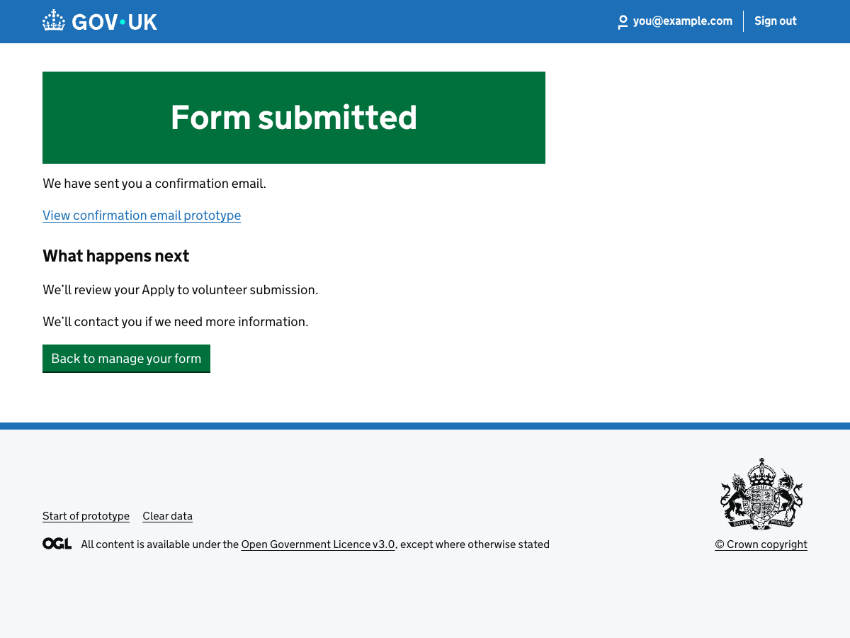

42. Form submitted confirmation email (copied answers)
URL:http://localhost:3000/runner-sign-in-v2/emails/form-submitted?formKey=volunteer-application&applicationId=app-1721152526408&next=%2Frunner-sign-in-v2%2Fforms%2Fvolunteer-application%2Fapp-1721152526408%2Fmanage
Page title: Form submitted email – prototype
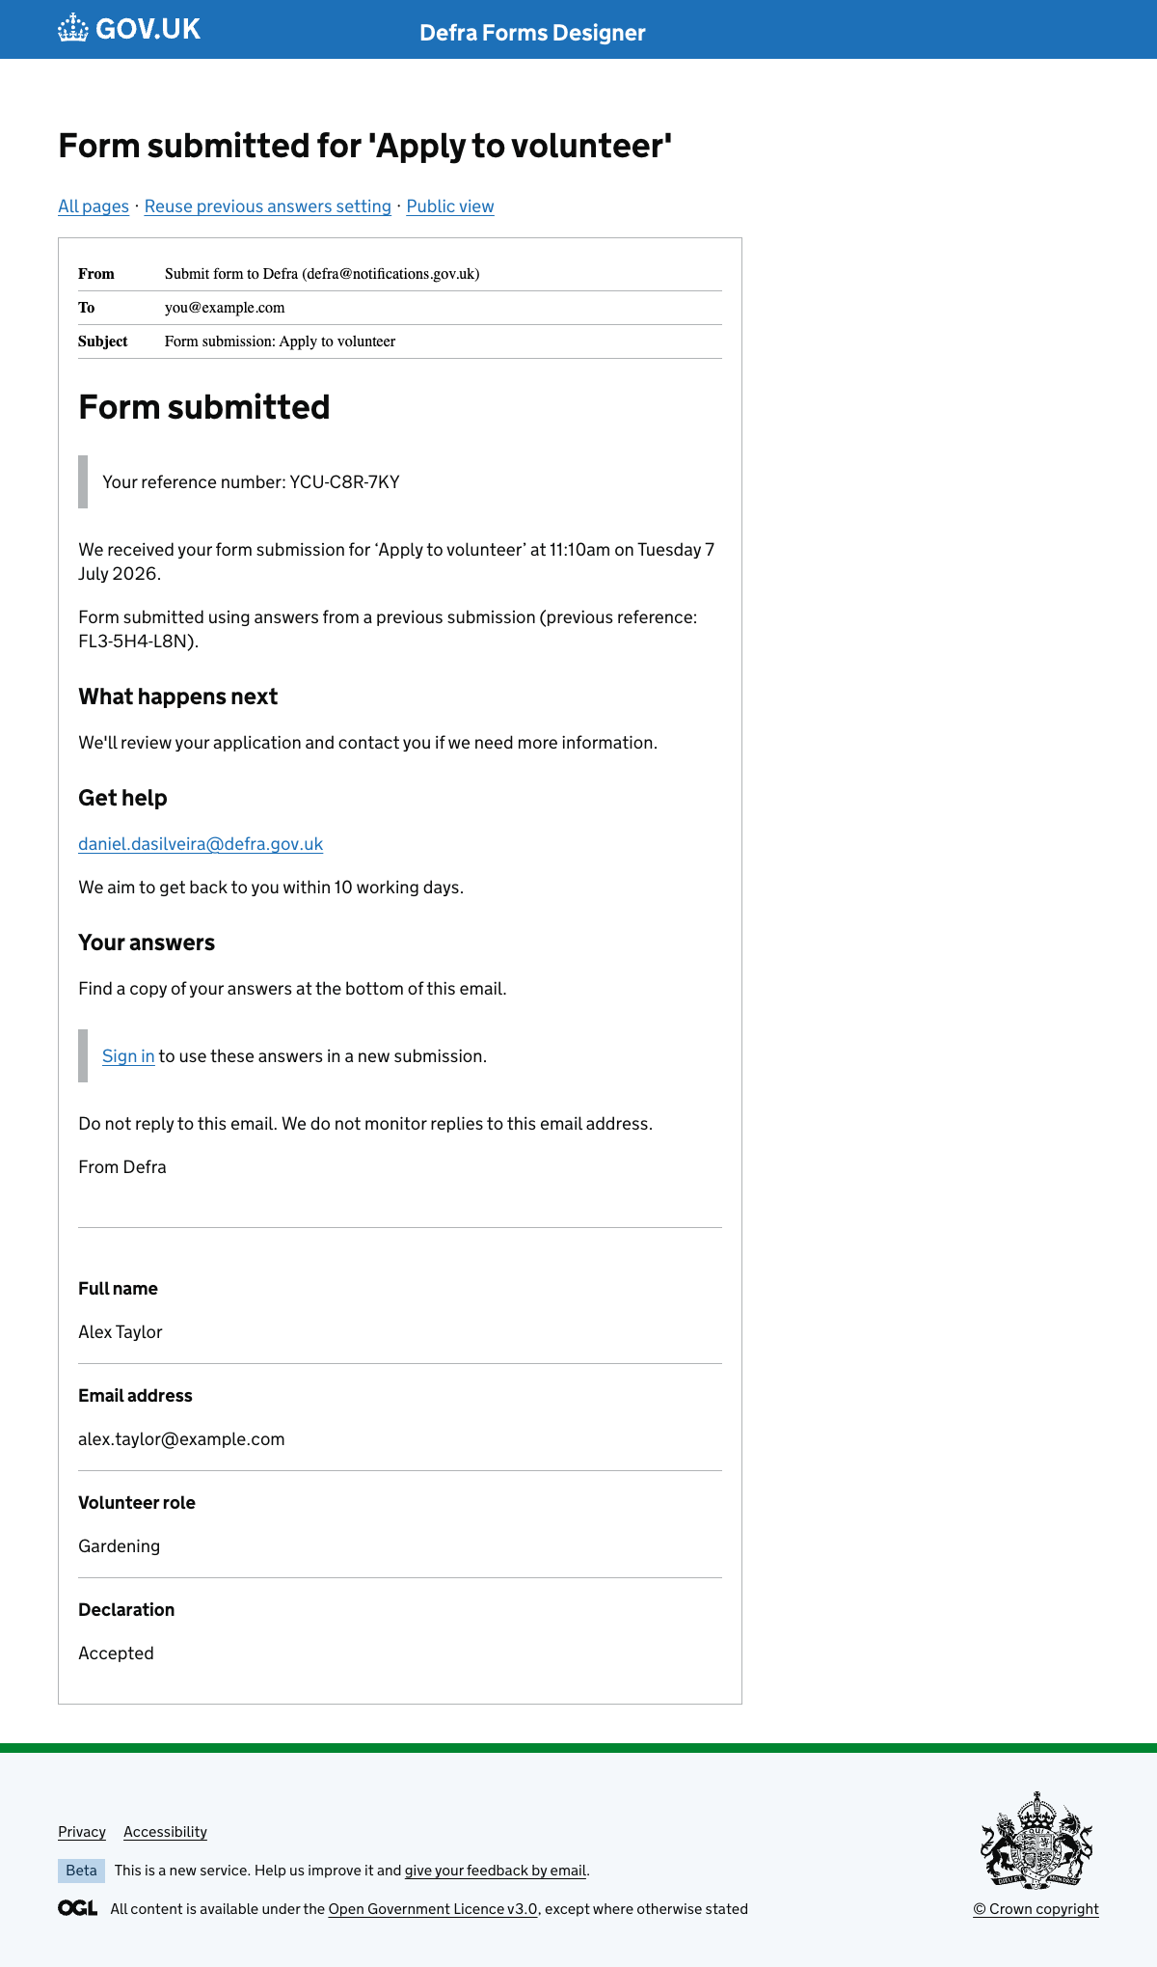

43. Form submitted email – public view (copied answers)
URL:http://localhost:3000/runner-sign-in-v2/emails/form-submitted/public?formKey=volunteer-application&applicationId=app-1721152526408&next=%2Frunner-sign-in-v2%2Fforms%2Fvolunteer-application%2Fapp-1721152526408%2Fmanage
Page title: Form submitted – Apply to volunteer
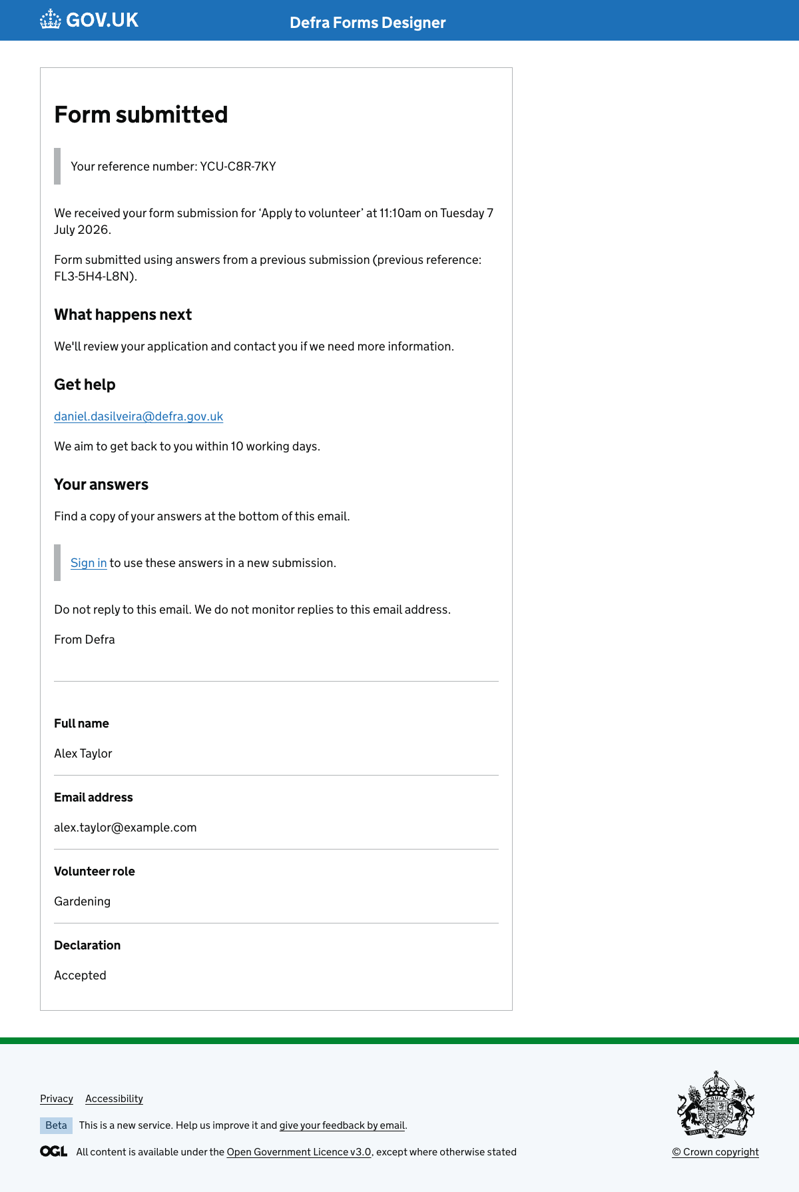

Create a sign-in

44. Enter your email address
URL:http://localhost:3000/runner-sign-in-v2/create-sign-in/email?formKey=volunteer-application&applicationId=app-save-exit-demo&next=%2Frunner-sign-in-v2%2Fforms%2Fvolunteer-application%2Fapp-save-exit-demo%2Fmanage
Page title: Create a sign-in: email – GOV.UK
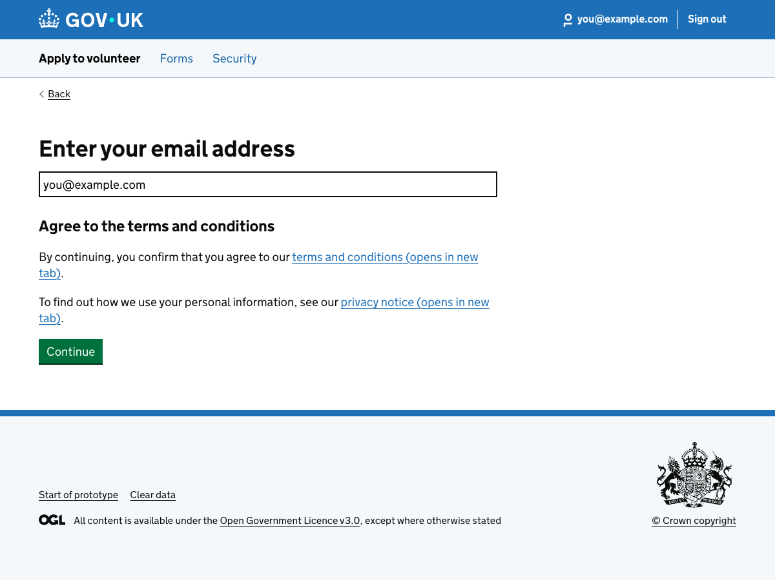

45. Check your email
URL:http://localhost:3000/runner-sign-in-v2/create-sign-in/check-email?formKey=volunteer-application&applicationId=app-save-exit-demo&next=%2Frunner-sign-in-v2%2Fforms%2Fvolunteer-application%2Fapp-save-exit-demo%2Fmanage
Page title: Create a sign-in: email – GOV.UK


46. Get security code
URL:http://localhost:3000/runner-sign-in-v2/create-sign-in/get-security-code?formKey=volunteer-application&applicationId=app-save-exit-demo&next=%2Frunner-sign-in-v2%2Fforms%2Fvolunteer-application%2Fapp-save-exit-demo%2Fmanage
Page title: Create a sign-in: email – GOV.UK


47. Enter your mobile phone number
URL:http://localhost:3000/runner-sign-in-v2/create-sign-in/mobile?formKey=volunteer-application&applicationId=app-save-exit-demo&next=%2Frunner-sign-in-v2%2Fforms%2Fvolunteer-application%2Fapp-save-exit-demo%2Fmanage
Page title: Create a sign-in: email – GOV.UK


48. Your sign-in has been created
URL:http://localhost:3000/runner-sign-in-v2/create-sign-in/created?formKey=volunteer-application&applicationId=app-save-exit-demo&next=%2Frunner-sign-in-v2%2Fforms%2Fvolunteer-application%2Fapp-save-exit-demo%2Fmanage
Page title: Manage your form – Apply to volunteer – GOV.UK
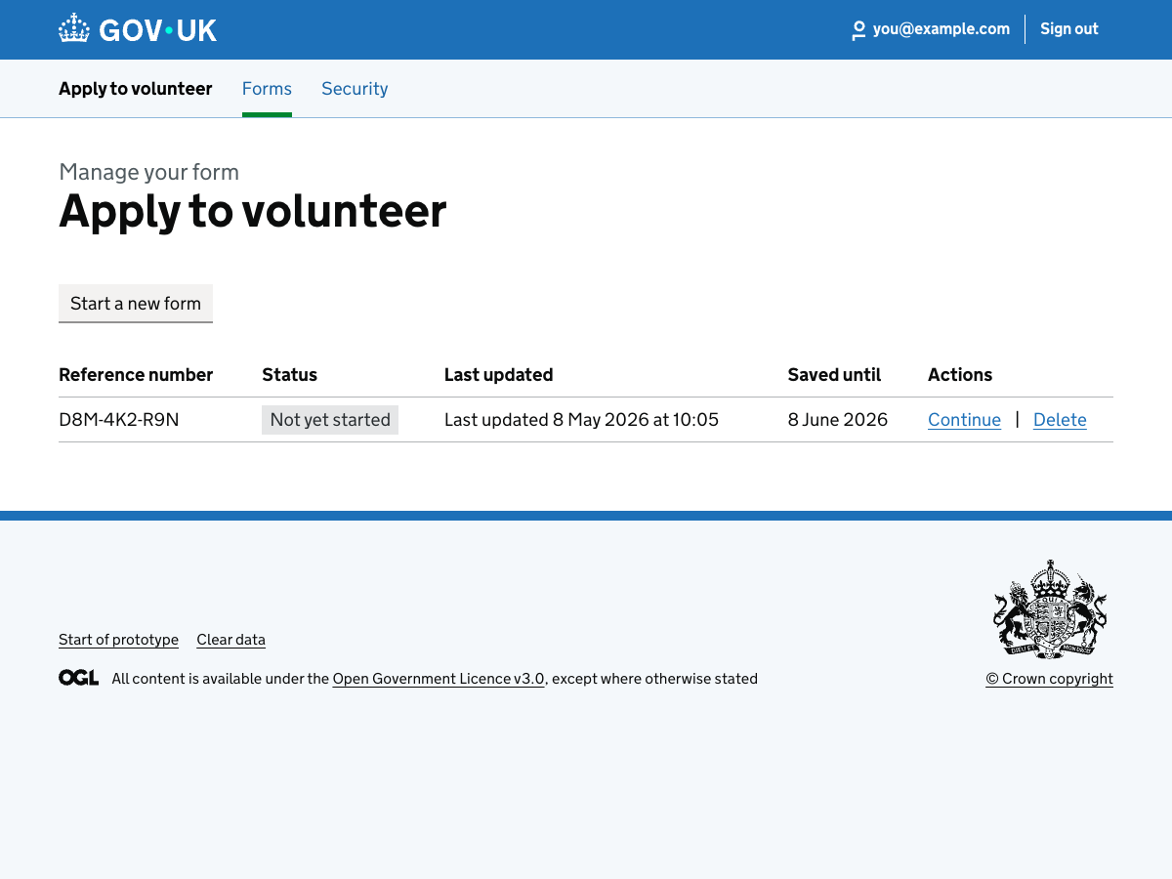

Sign in

49. Enter your email address
URL:http://localhost:3000/runner-sign-in-v2/sign-in/email?formKey=volunteer-application&applicationId=app-save-exit-demo&next=%2Frunner-sign-in-v2%2Fforms%2Fvolunteer-application%2Fapp-save-exit-demo%2Fmanage
Page title: Sign in: email – GOV.UK
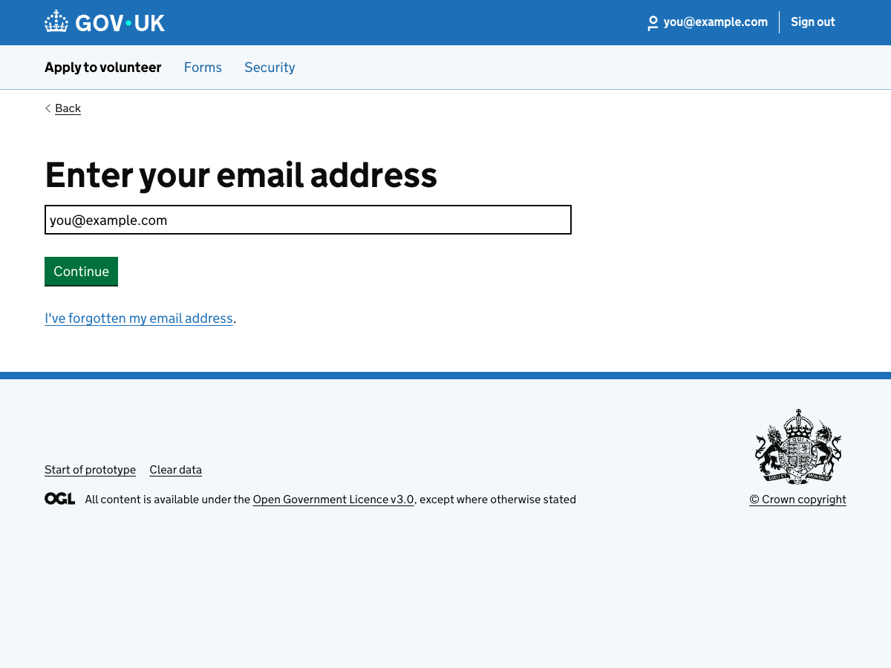

50. Check your email
URL:http://localhost:3000/runner-sign-in-v2/sign-in/check-email?formKey=volunteer-application&applicationId=app-save-exit-demo&next=%2Frunner-sign-in-v2%2Fforms%2Fvolunteer-application%2Fapp-save-exit-demo%2Fmanage
Page title: Sign in: email – GOV.UK


51. Get security code
URL:http://localhost:3000/runner-sign-in-v2/sign-in/get-security-code?formKey=volunteer-application&applicationId=app-save-exit-demo&next=%2Frunner-sign-in-v2%2Fforms%2Fvolunteer-application%2Fapp-save-exit-demo%2Fmanage
Page title: Sign in: email – GOV.UK


52. You have signed out
URL:http://localhost:3000/runner-sign-in-v2/sign-out
Page title: You have signed out – GOV.UK
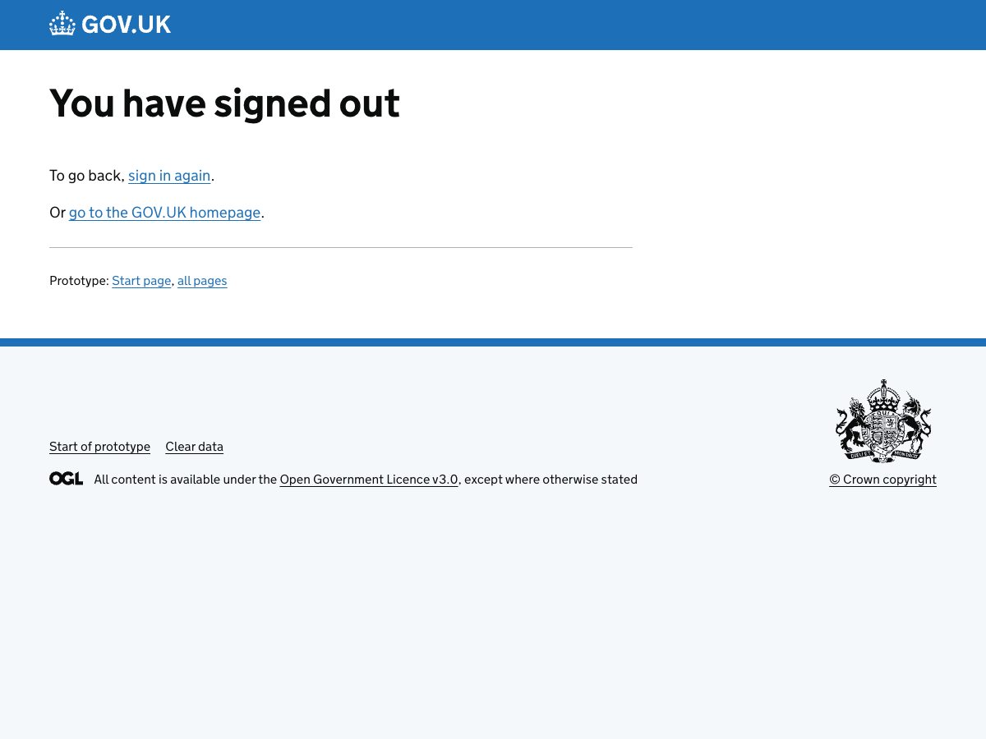

Recover a sign-in

53. Enter your mobile phone number
URL:http://localhost:3000/runner-sign-in-v2/recover/phone?formKey=volunteer-application&applicationId=app-save-exit-demo&next=%2Frunner-sign-in-v2%2Fforms%2Fvolunteer-application%2Fapp-save-exit-demo%2Fmanage
Page title: Recover my sign-in: mobile phone number – GOV.UK
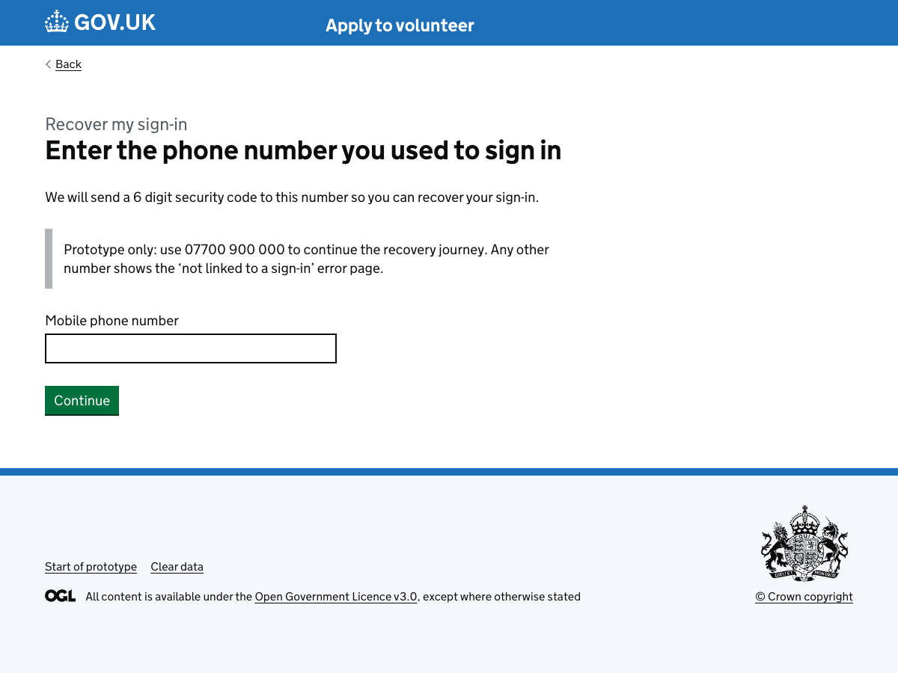

54. No sign-in found for mobile number
URL:http://localhost:3000/runner-sign-in-v2/static/recover-no-sign-in-for-mobile
Page title: Recover my sign-in – GOV.UK
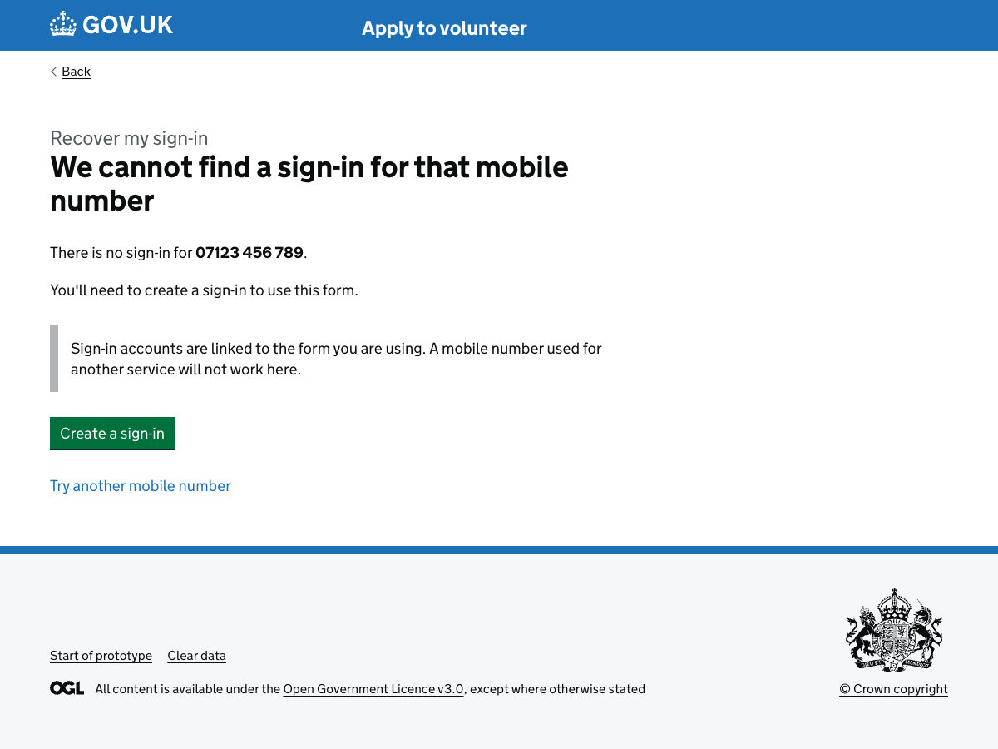

55. Get security code
URL:http://localhost:3000/runner-sign-in-v2/recover/get-security-code?formKey=volunteer-application&applicationId=app-save-exit-demo&next=%2Frunner-sign-in-v2%2Fforms%2Fvolunteer-application%2Fapp-save-exit-demo%2Fmanage
Page title: Recover my sign-in: mobile phone number – GOV.UK


56. Check your phone
URL:http://localhost:3000/runner-sign-in-v2/recover/start?formKey=volunteer-application&applicationId=app-save-exit-demo&next=%2Frunner-sign-in-v2%2Fforms%2Fvolunteer-application%2Fapp-save-exit-demo%2Fmanage
Page title: Recover my sign-in: mobile phone number – GOV.UK


57. Check your phone (alternate)
URL:http://localhost:3000/runner-sign-in-v2/recover/check-mobile?formKey=volunteer-application&applicationId=app-save-exit-demo
Page title: Recover my sign-in: mobile phone number – GOV.UK


58. Enter your new email address
URL:http://localhost:3000/runner-sign-in-v2/recover/new-email?formKey=volunteer-application&applicationId=app-save-exit-demo&next=%2Frunner-sign-in-v2%2Fforms%2Fvolunteer-application%2Fapp-save-exit-demo%2Fmanage
Page title: Recover my sign-in: new email – GOV.UK
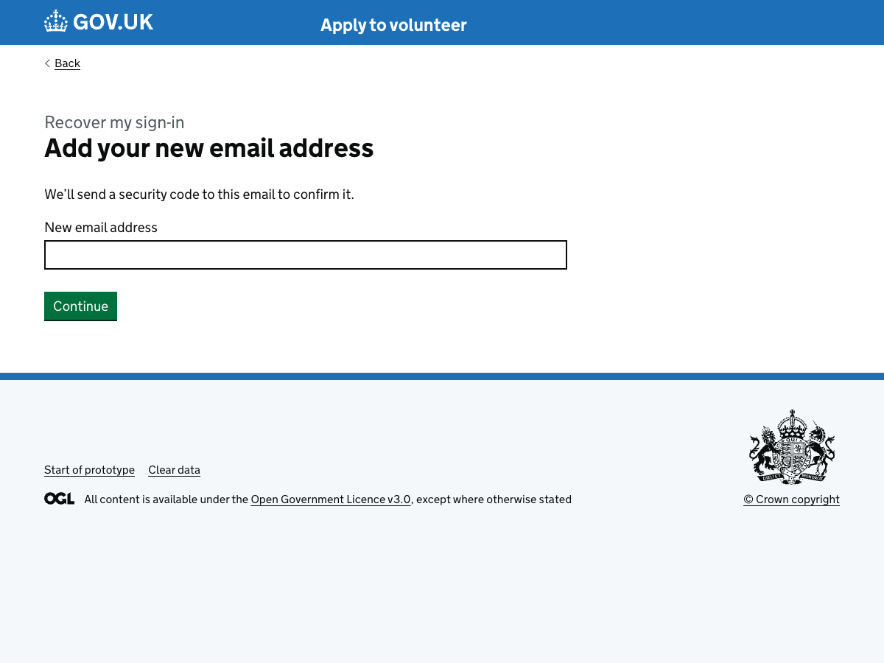

59. Check your email
URL:http://localhost:3000/runner-sign-in-v2/recover/check-new-email?formKey=volunteer-application&applicationId=app-save-exit-demo&next=%2Frunner-sign-in-v2%2Fforms%2Fvolunteer-application%2Fapp-save-exit-demo%2Fmanage
Page title: Recover my sign-in: new email – GOV.UK


Save and exit (signed in)

60. Confirm email to save and exit
URL:http://localhost:3000/runner-sign-in-v2/save-and-exit/with-sign-in/confirm-email?formKey=volunteer-application&applicationId=app-save-exit-demo&next=%2Frunner-sign-in-v2%2Fforms%2Fvolunteer-application%2Fapp-save-exit-demo%2Fmanage
Page title: Start – Runner sign-in v2 – GOV.UK
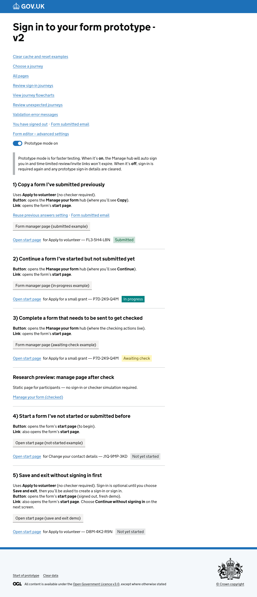

61. We've emailed you a link to come back
URL:http://localhost:3000/runner-sign-in-v2/save-and-exit/with-sign-in/leave?formKey=volunteer-application&applicationId=app-save-exit-demo&email=you@example.com
Page title: Save and exit – GOV.UK
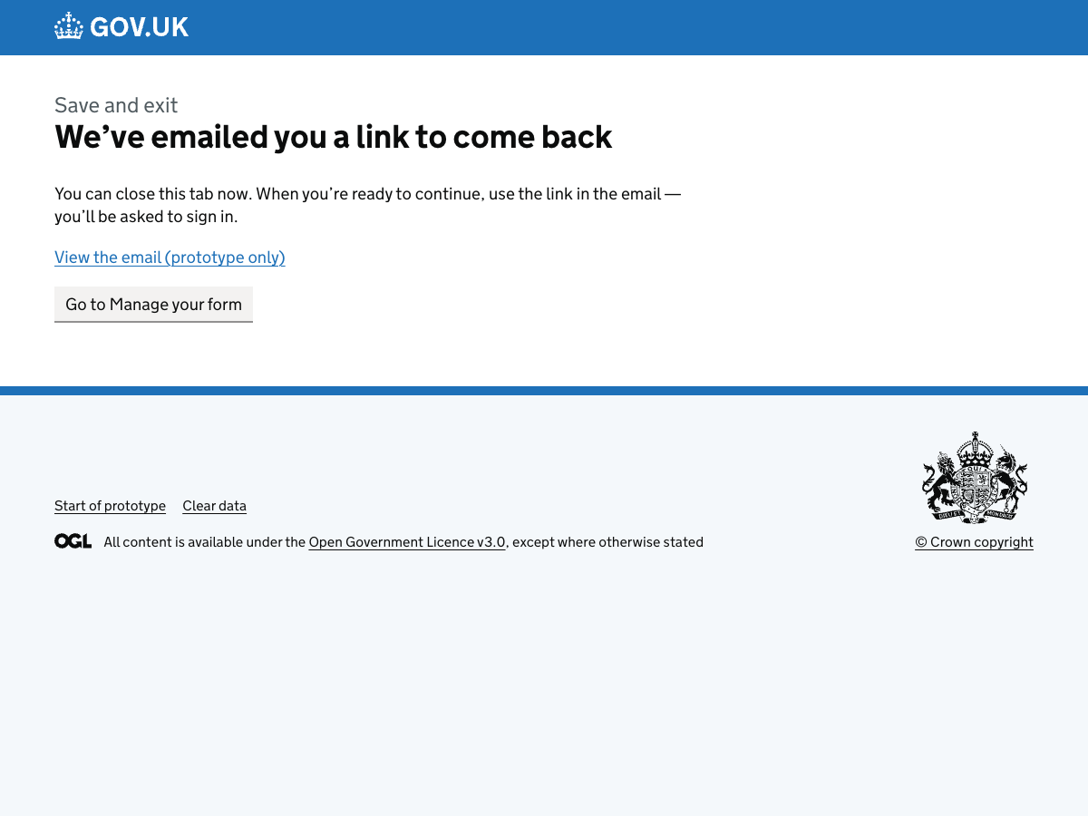

62. Save and exit email
URL:http://localhost:3000/runner-sign-in-v2/emails/save-and-exit?formKey=volunteer-application&applicationId=app-save-exit-demo&next=%2Frunner-sign-in-v2%2Fforms%2Fvolunteer-application%2Fapp-save-exit-demo%2Fmanage&variant=with-sign-in
Page title: Save and exit email – prototype
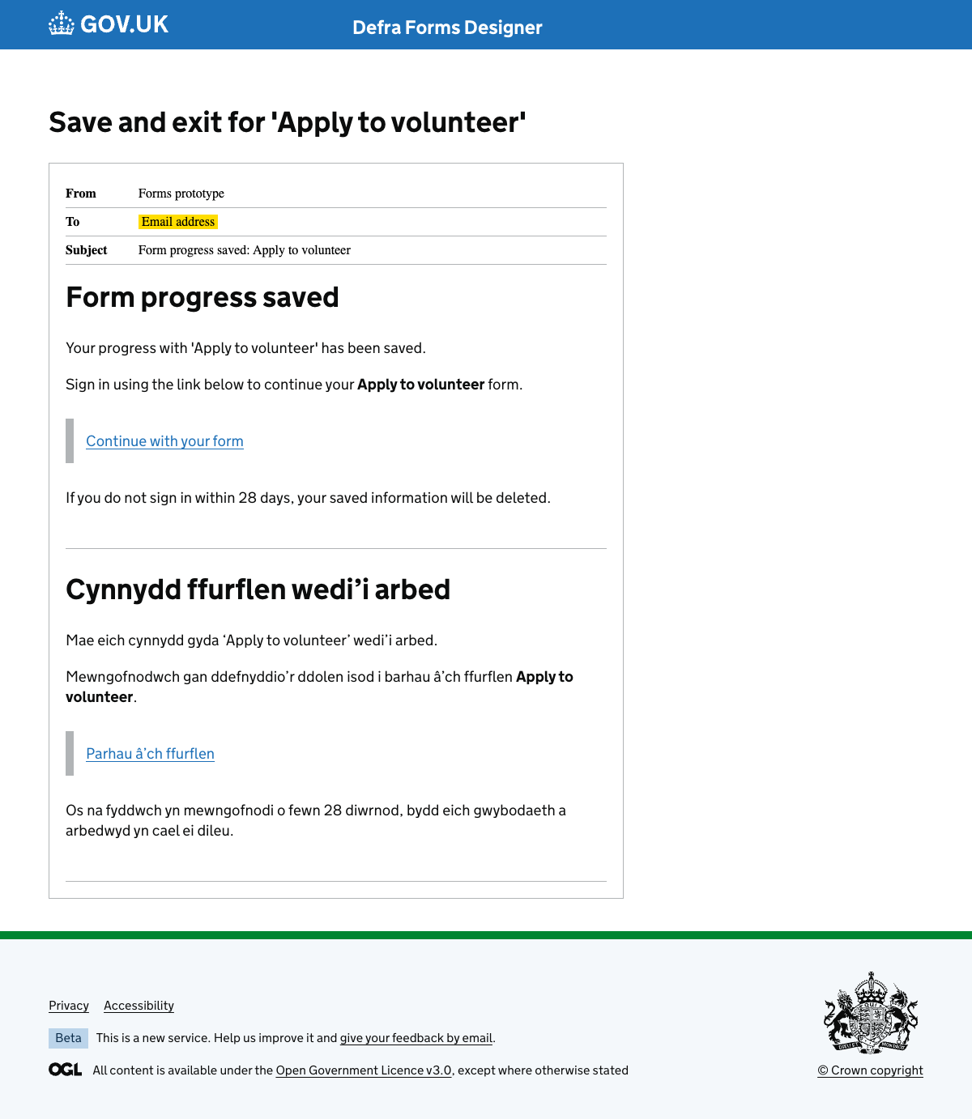

63. Welcome back (from email)
URL:http://localhost:3000/runner-sign-in-v2/save-and-exit/with-sign-in/resume?formKey=volunteer-application&applicationId=app-save-exit-demo
Page title: Resume your form – GOV.UK
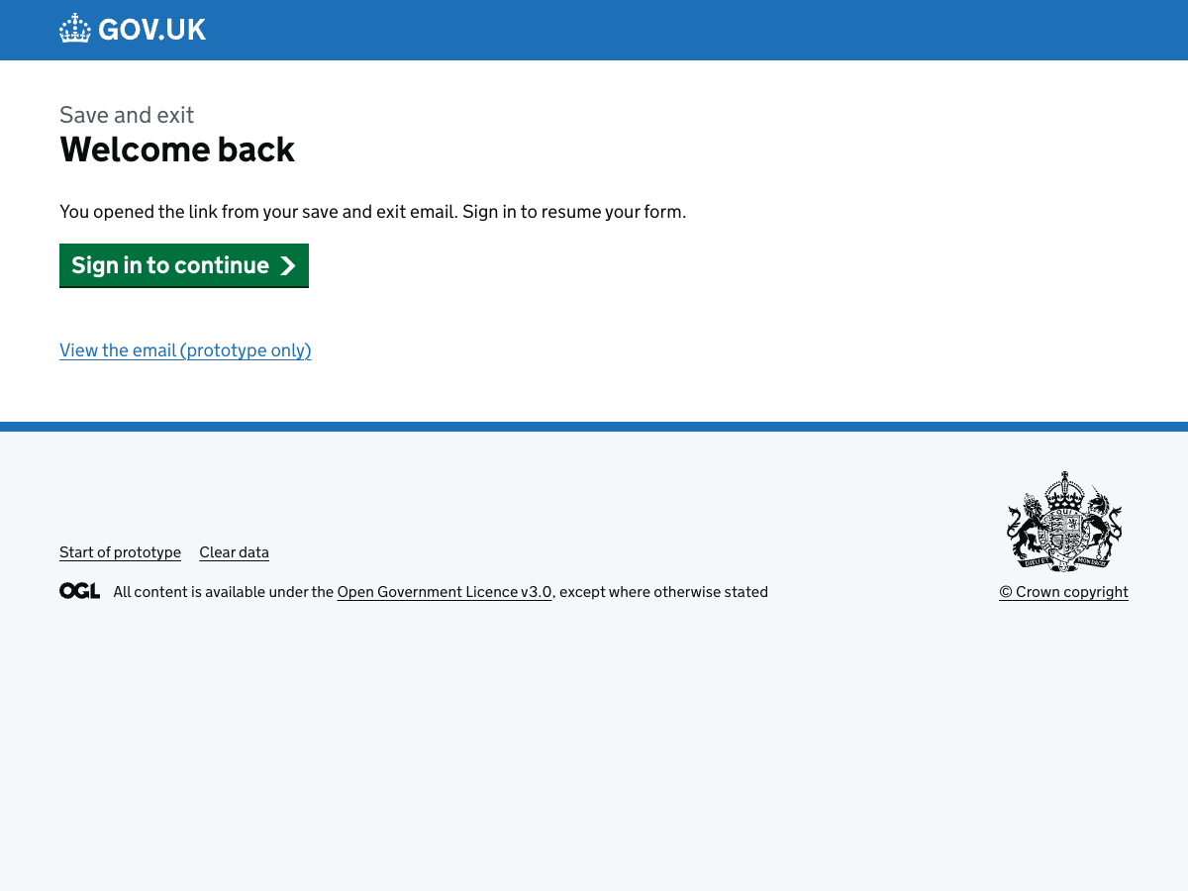

64. Sign in from email link
URL:http://localhost:3000/runner-sign-in-v2/sign-in/email?formKey=volunteer-application&applicationId=app-save-exit-demo&next=%2Frunner-sign-in-v2%2Fforms%2Fvolunteer-application%2Fapp-save-exit-demo%2Fmanage
Page title: Sign in: email – GOV.UK


Save and exit (without signing in)

65. Sign in to save your progress
URL:http://localhost:3000/runner-sign-in-v2/save-and-exit/without-sign-in/choose?formKey=volunteer-application&applicationId=app-save-exit-demo&next=%2Frunner-sign-in-v2%2Fforms%2Fvolunteer-application%2Fapp-save-exit-demo%2Fmanage
Page title: Sign in to save your progress – GOV.UK
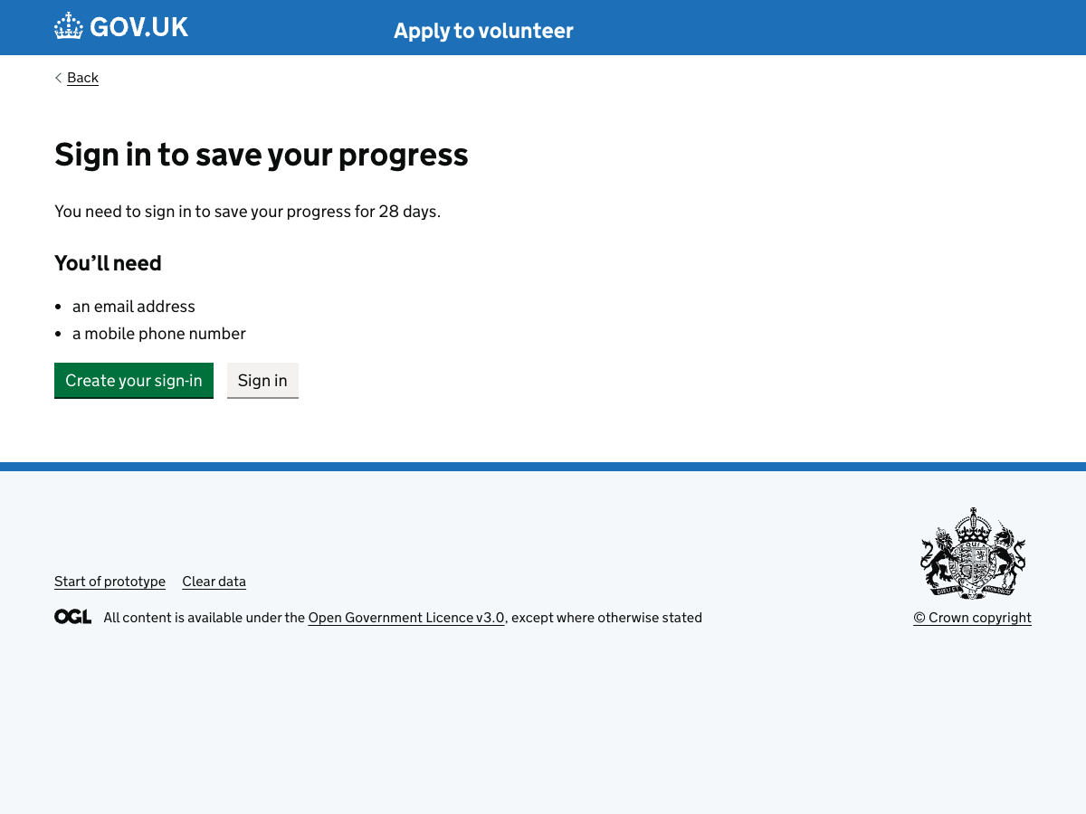

66. Create a sign-in
URL:http://localhost:3000/runner-sign-in-v2/save-and-exit/without-sign-in/create-sign-in?formKey=volunteer-application&applicationId=app-save-exit-demo&next=%2Frunner-sign-in-v2%2Fforms%2Fvolunteer-application%2Fapp-save-exit-demo%2Fmanage
Page title: Create a sign-in: email – GOV.UK
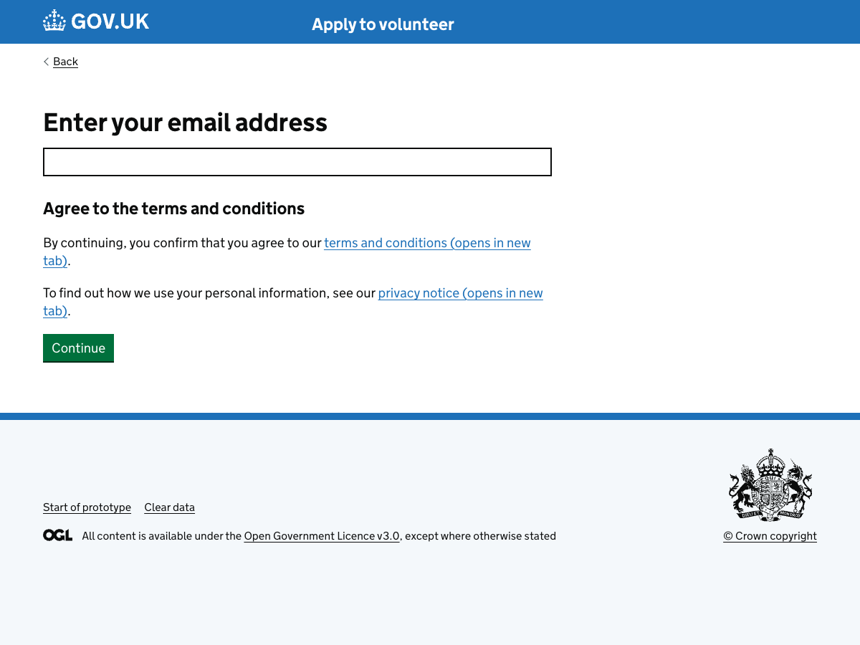

67. Check your email
URL:http://localhost:3000/runner-sign-in-v2/save-and-exit/without-sign-in/check-email?formKey=volunteer-application&applicationId=app-save-exit-demo&prototype=1
Page title: Save and exit: check your email – GOV.UK
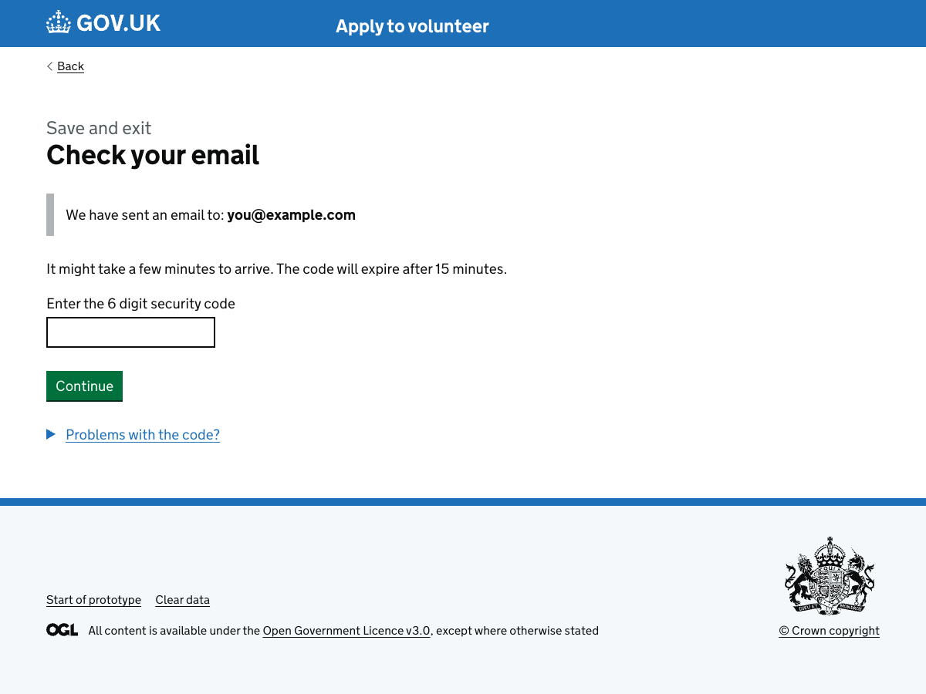

68. Your progress has been saved
URL:http://localhost:3000/runner-sign-in-v2/create-sign-in/created?formKey=volunteer-application&applicationId=app-save-exit-demo&next=%2Frunner-sign-in-v2%2Fsave-and-exit%2Fwithout-sign-in%2Fleave%3FformKey%3Dvolunteer-application%26applicationId%3Dapp-save-exit-demo
Page title: Create a sign-in: email – GOV.UK
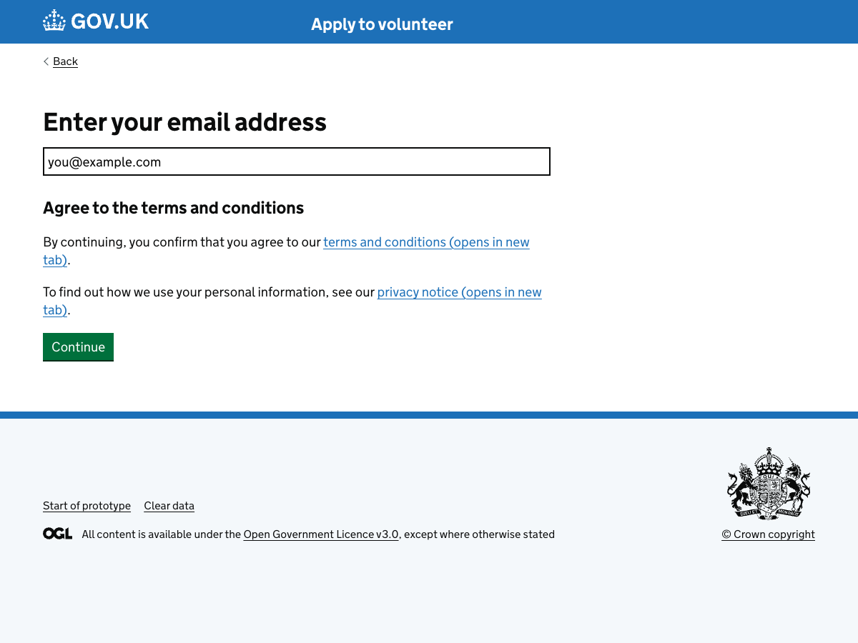

69. We've emailed you a link to resume
URL:http://localhost:3000/runner-sign-in-v2/save-and-exit/without-sign-in/leave?formKey=volunteer-application&applicationId=app-save-exit-demo
Page title: Save and exit – GOV.UK
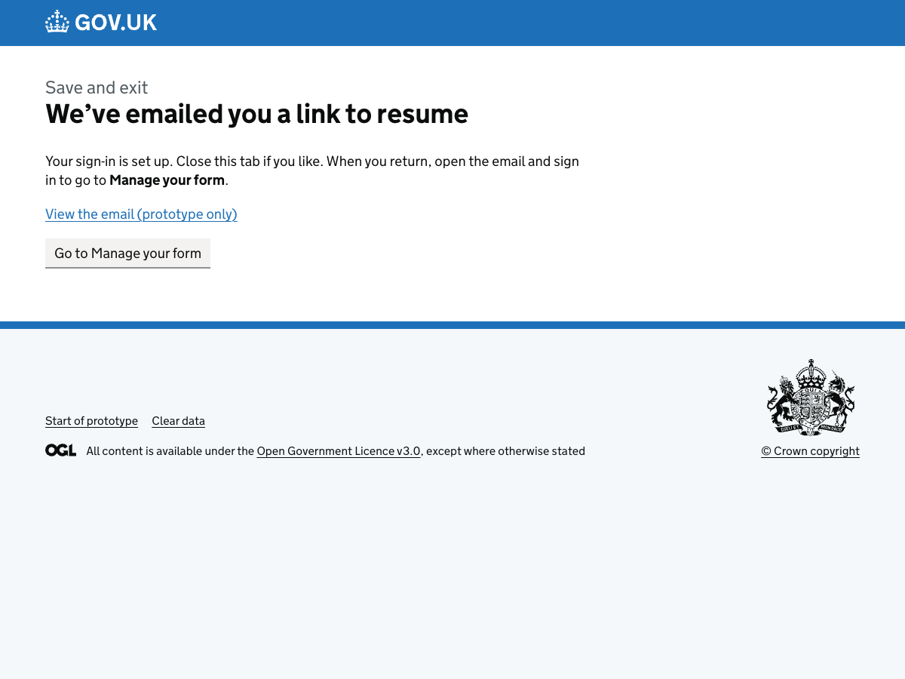

70. Save and exit email
URL:http://localhost:3000/runner-sign-in-v2/emails/save-and-exit?formKey=volunteer-application&applicationId=app-save-exit-demo&next=%2Frunner-sign-in-v2%2Fforms%2Fvolunteer-application%2Fapp-save-exit-demo%2Fmanage&variant=without-sign-in
Page title: Save and exit email – prototype
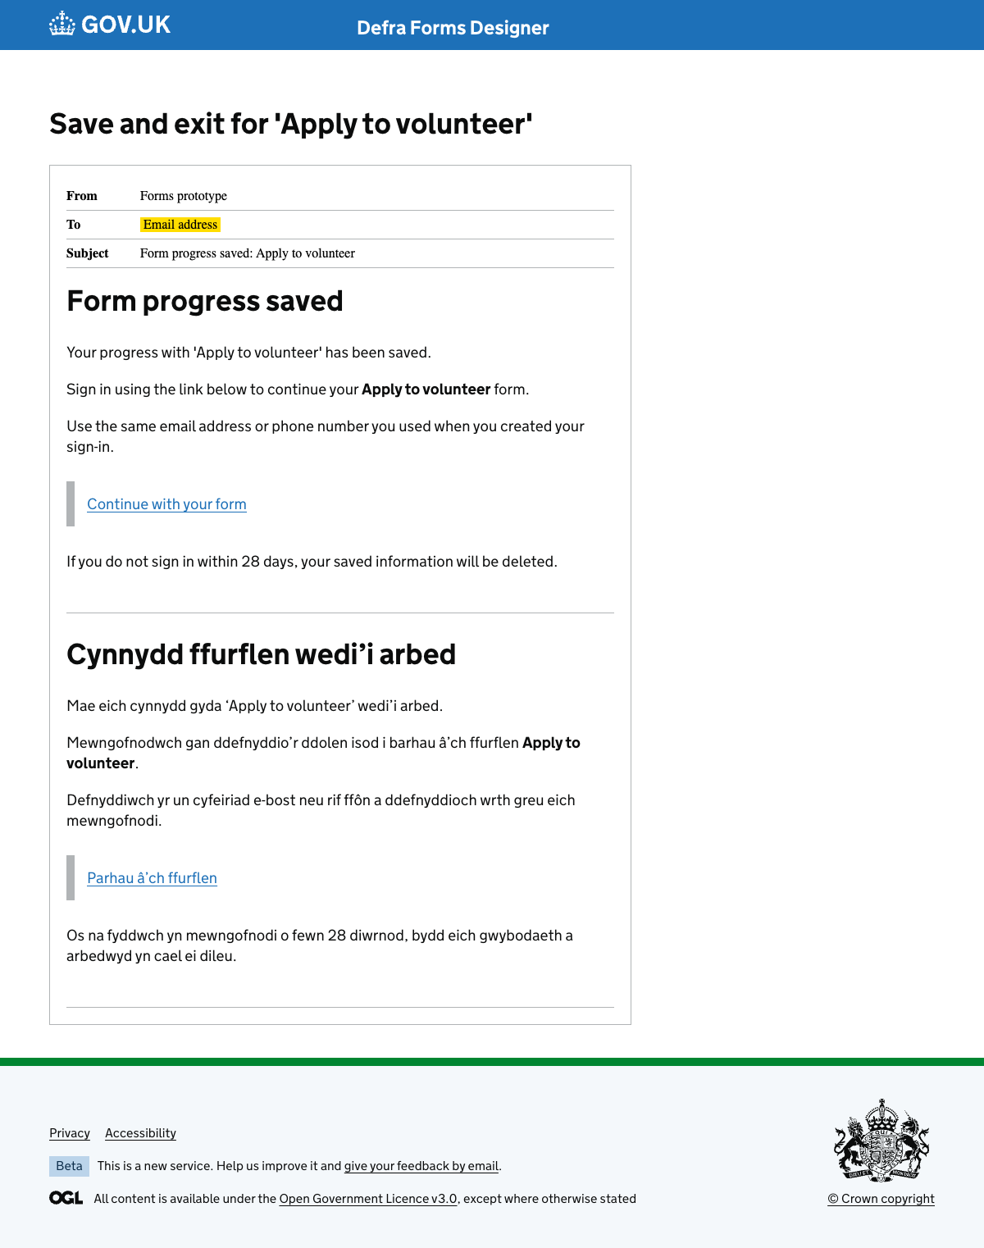

71. Welcome back (from email)
URL:http://localhost:3000/runner-sign-in-v2/save-and-exit/without-sign-in/resume?formKey=volunteer-application&applicationId=app-save-exit-demo
Page title: Resume your form – GOV.UK
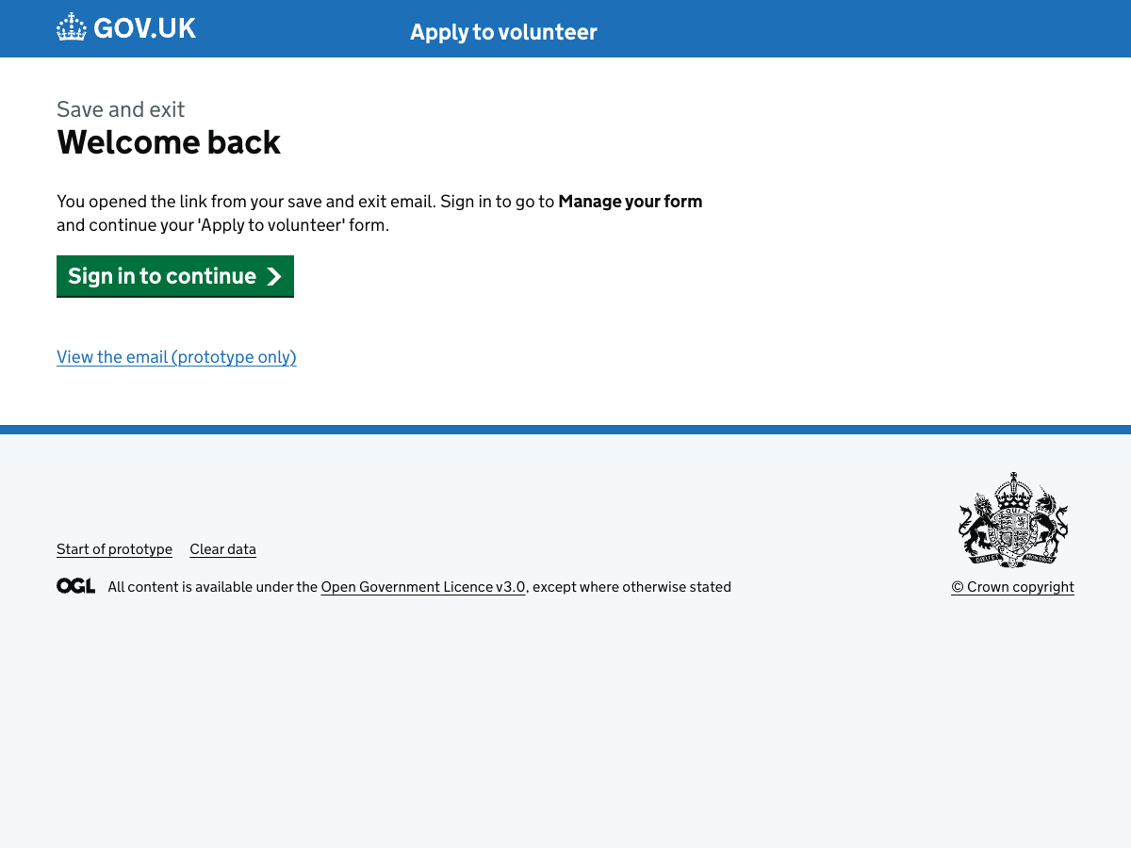

72. Delete draft confirmation
URL:http://localhost:3000/runner-sign-in-v2/forms/volunteer-application/app-save-exit-demo/delete
Page title: Sign in: email – GOV.UK


Security

73. Security
URL:http://localhost:3000/runner-sign-in-v2/forms/volunteer-application/app-save-exit-demo/security
Page title: Security – GOV.UK
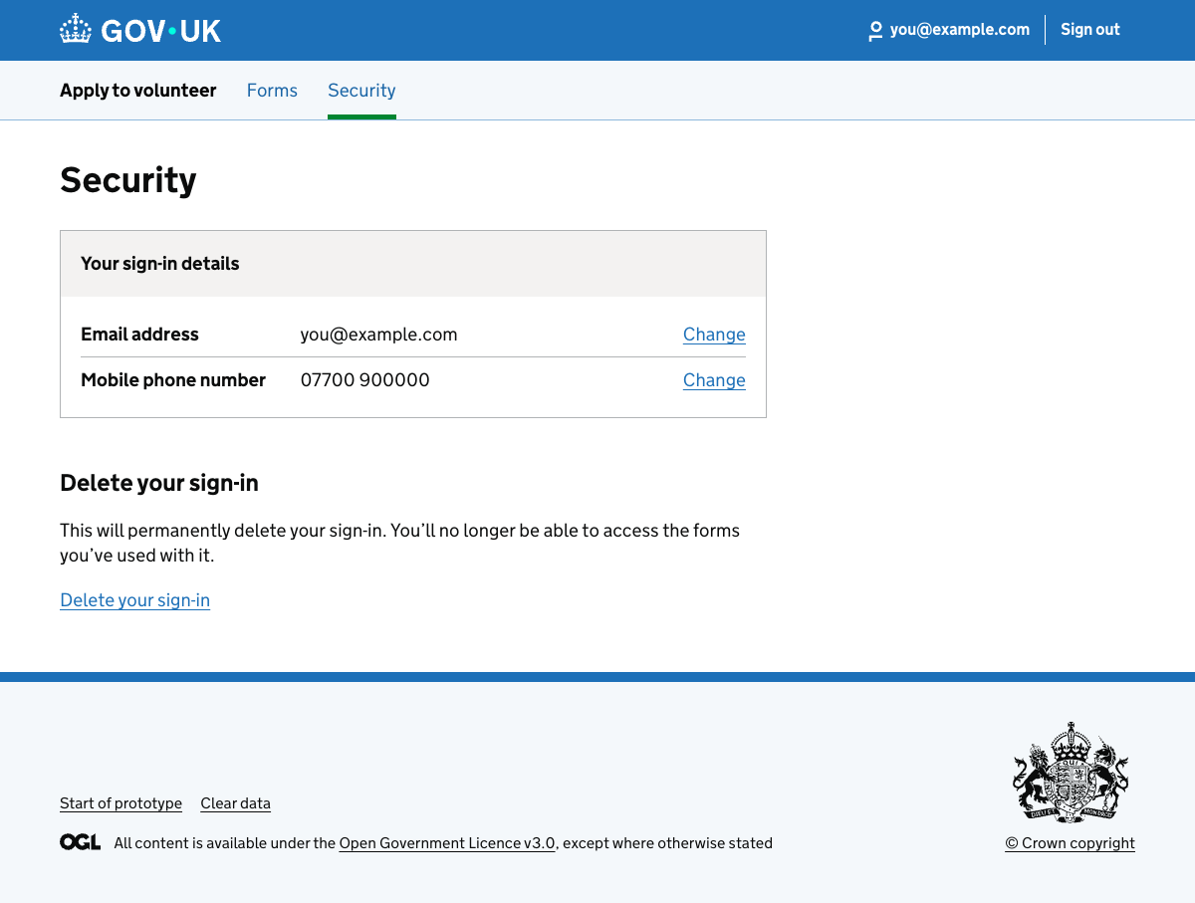

74. Change email: get security code (phone)
URL:http://localhost:3000/runner-sign-in-v2/forms/volunteer-application/app-save-exit-demo/security/change-email/get-security-code
Page title: Change email address: get security code – GOV.UK
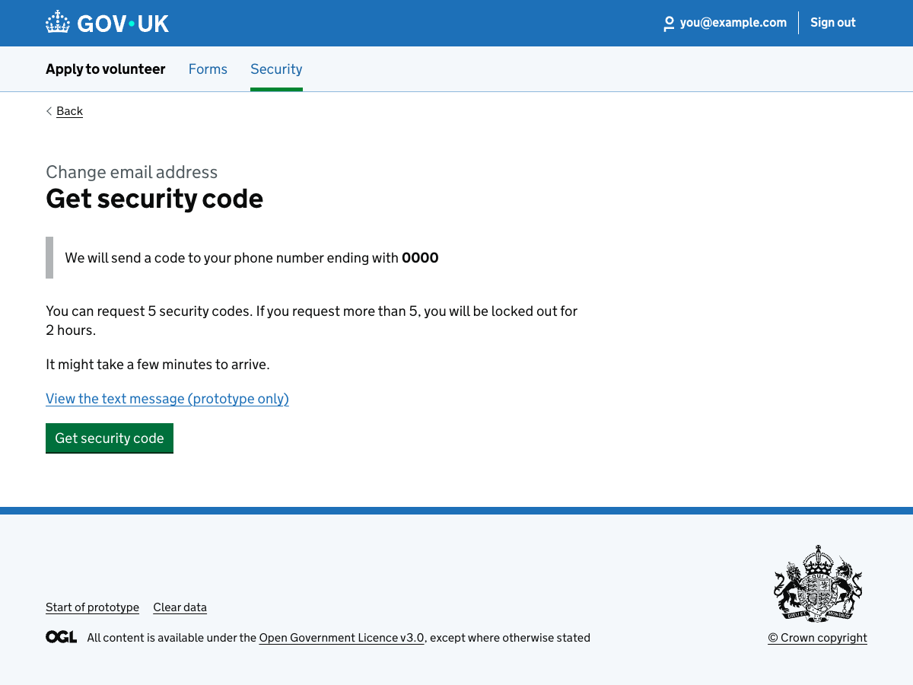

75. Change email: check your phone
URL:http://localhost:3000/runner-sign-in-v2/forms/volunteer-application/app-save-exit-demo/security/change-email/check-phone
Page title: Change email address: check your phone – GOV.UK
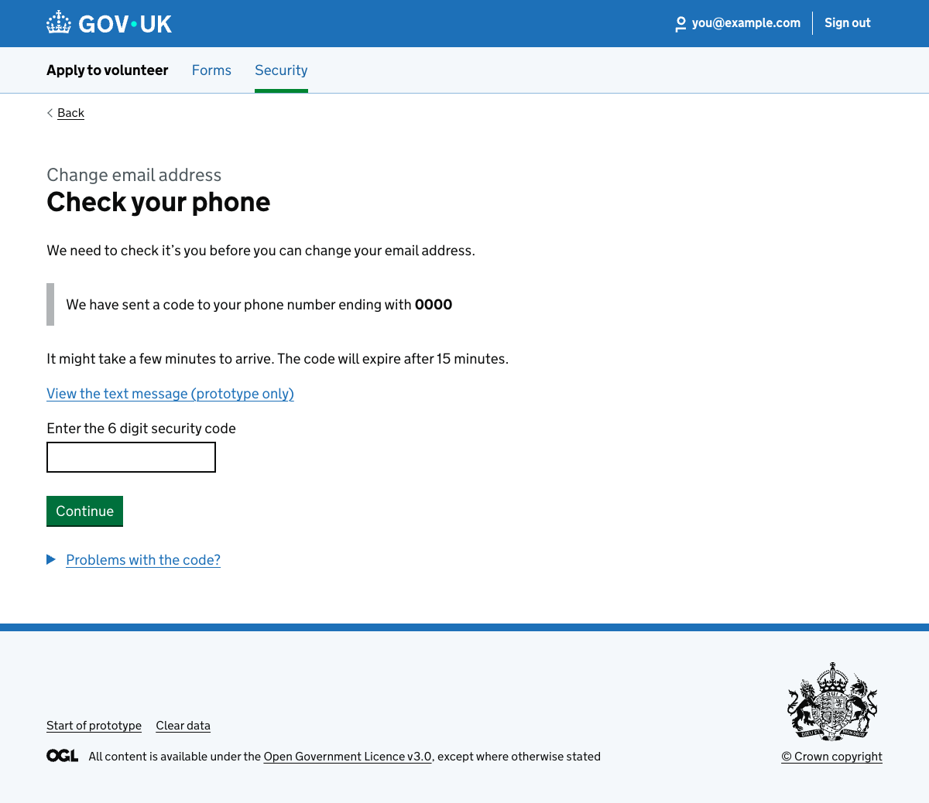

76. Change email: enter new email address
URL:http://localhost:3000/runner-sign-in-v2/forms/volunteer-application/app-save-exit-demo/security/change-email/new-email
Page title: Change email address: get security code – GOV.UK


77. Change email: enter new email address (same as current error)
URL:http://localhost:3000/runner-sign-in-v2/static/change-email-new-email-same-as-current
Page title: Change email address – GOV.UK
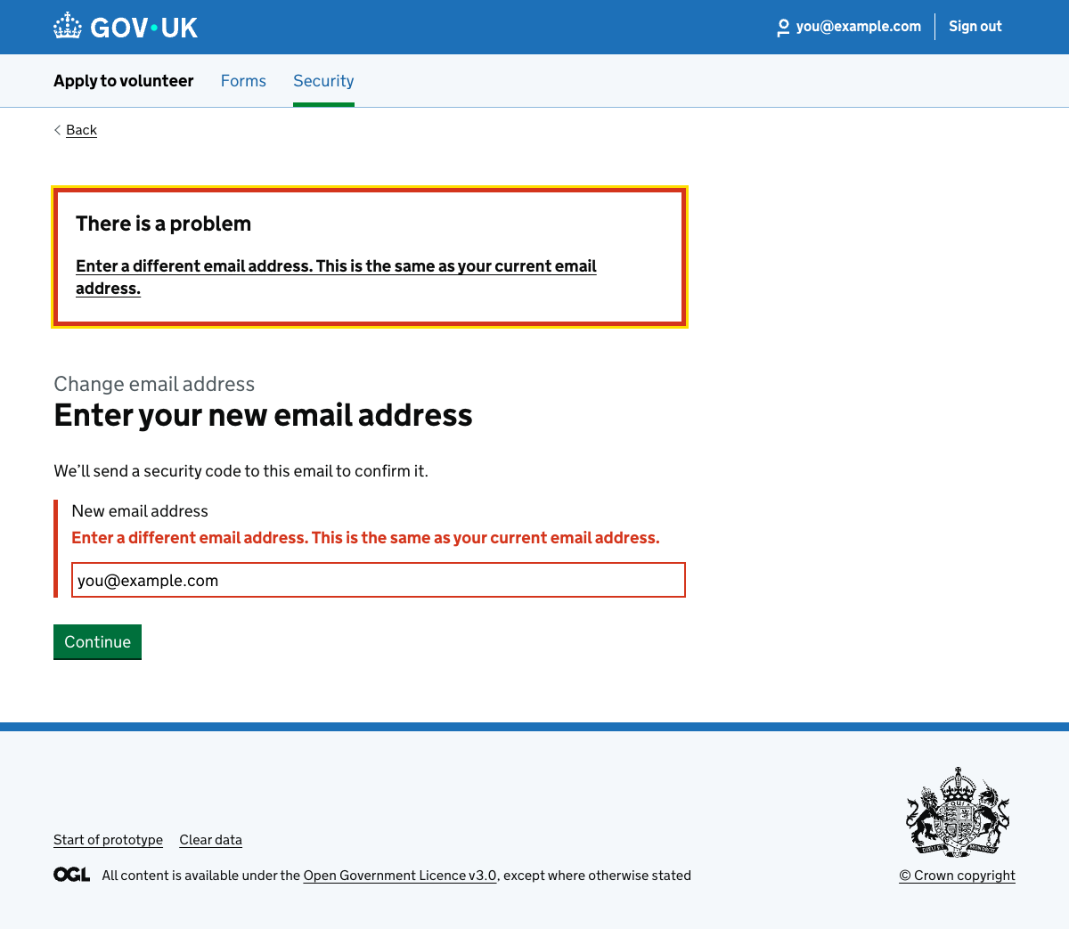

78. Change email: check your email
URL:http://localhost:3000/runner-sign-in-v2/forms/volunteer-application/app-save-exit-demo/security/change-email/check-new-email
Page title: Change email address: get security code – GOV.UK


79. Change phone: get security code (email)
URL:http://localhost:3000/runner-sign-in-v2/forms/volunteer-application/app-save-exit-demo/security/change-phone/get-security-code
Page title: Change phone number: get security code – GOV.UK
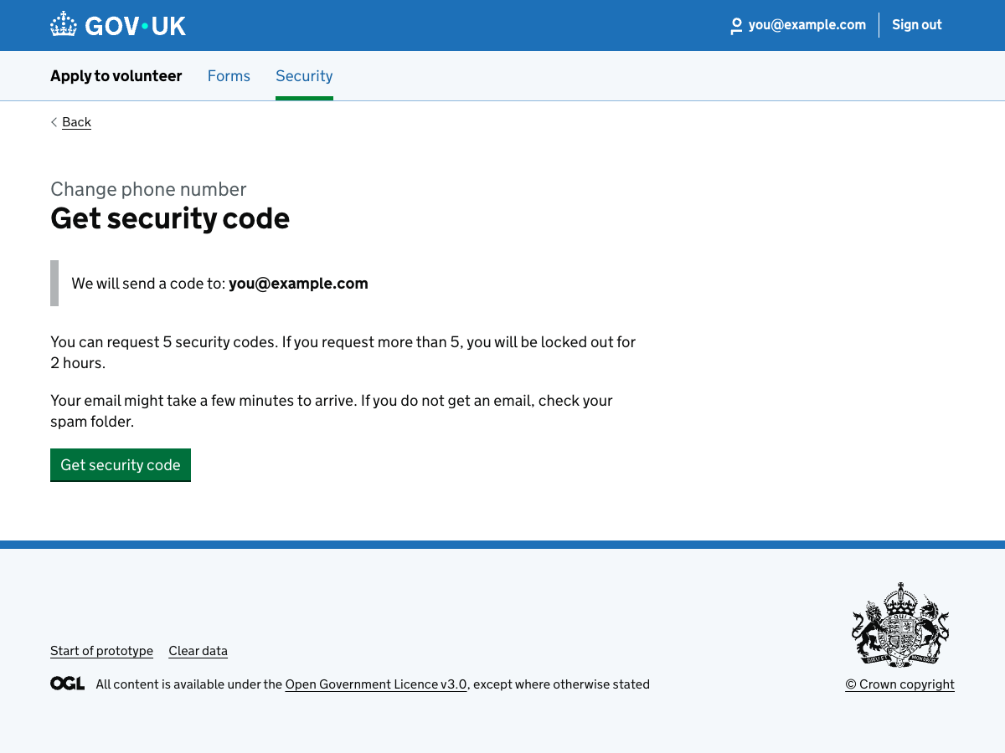

80. Change phone: check your email
URL:http://localhost:3000/runner-sign-in-v2/forms/volunteer-application/app-save-exit-demo/security/change-phone/check-email
Page title: Change phone number: check your email – GOV.UK
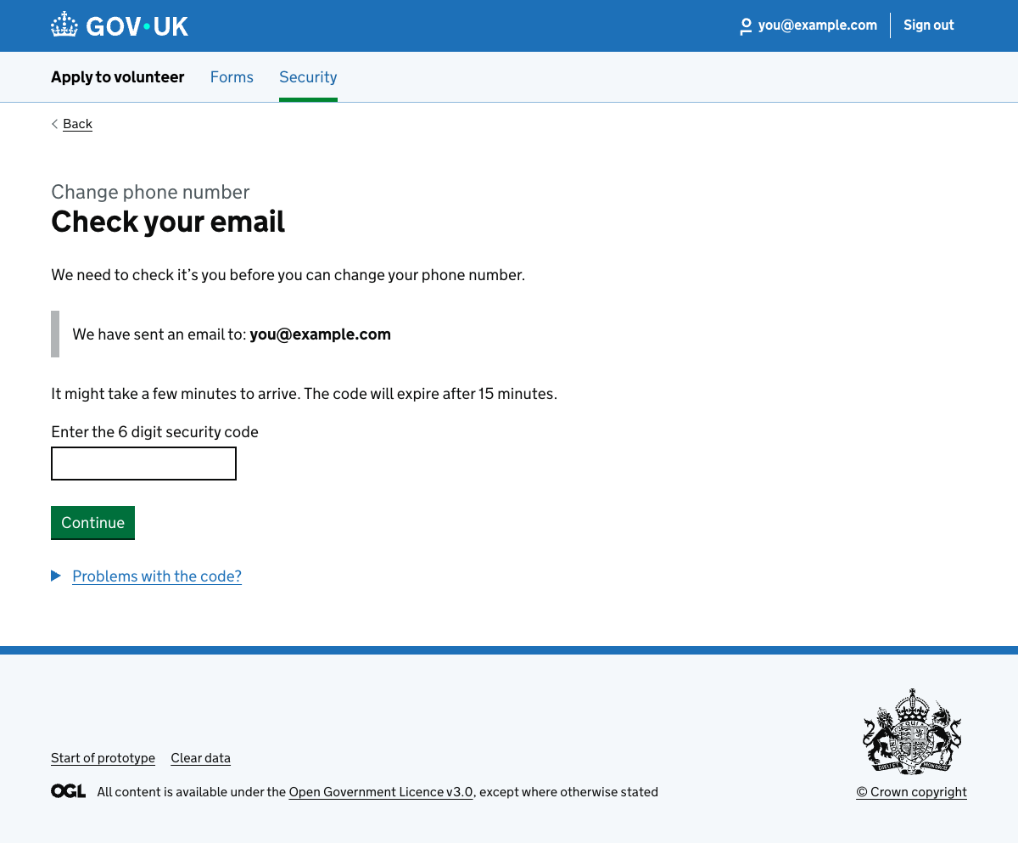

81. Change phone: enter new phone number
URL:http://localhost:3000/runner-sign-in-v2/forms/volunteer-application/app-save-exit-demo/security/change-phone/new-phone
Page title: Change phone number: get security code – GOV.UK


Checker

82. Invite a checker
URL:http://localhost:3000/runner-sign-in-v2/forms/volunteer-application/app-save-exit-demo/checker/invite
Page title: Manage your form – Apply to volunteer – GOV.UK


83. Checker invite sent
URL:http://localhost:3000/runner-sign-in-v2/forms/volunteer-application/app-save-exit-demo/checker/invite/invite-sent?checkerEmail=checker@example.com
Page title: Page not found – Defra Forms Designer – GOV.UK Prototype Kit
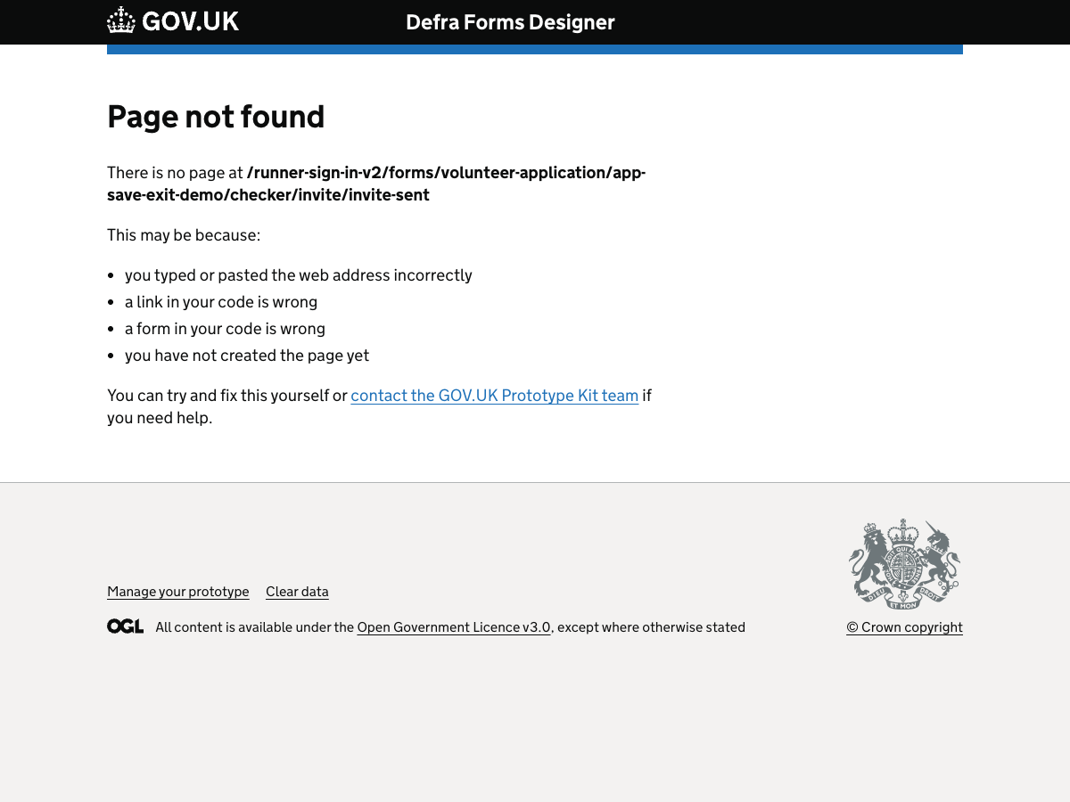

84. Checker invite email
URL:http://localhost:3000/runner-sign-in-v2/emails/checker-invite-v2?formKey=volunteer-application&applicationId=app-save-exit-demo&next=%2Frunner-sign-in-v2%2Fforms%2Fvolunteer-application%2Fapp-save-exit-demo%2Fmanage
Page title: Checker invite email – prototype
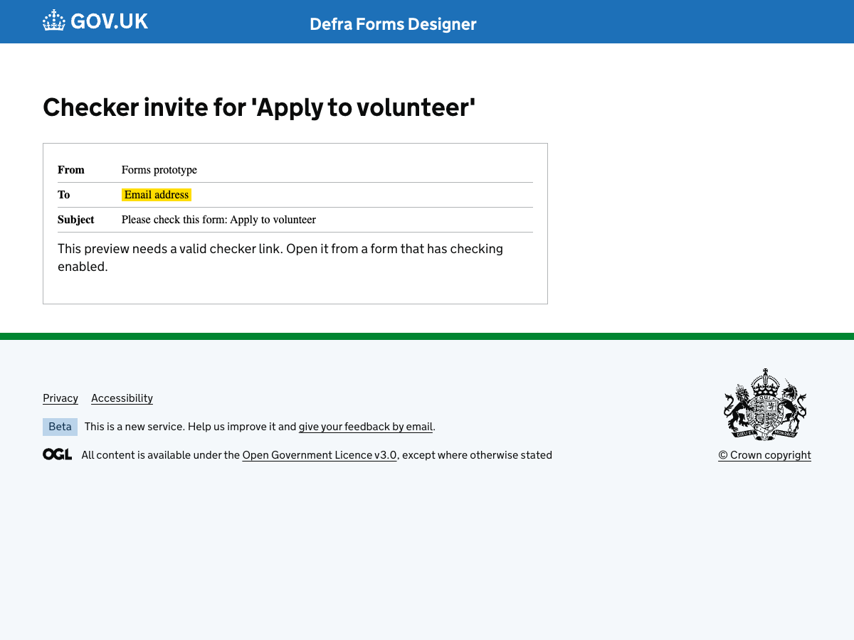

85. Checker landing page
URL:http://localhost:3000/runner-sign-in-v2/checker/start?token=RSI-STATIC-CHECKED&prototype=1&allowApplicant=1
Page title: Check someone’s form – GOV.UK
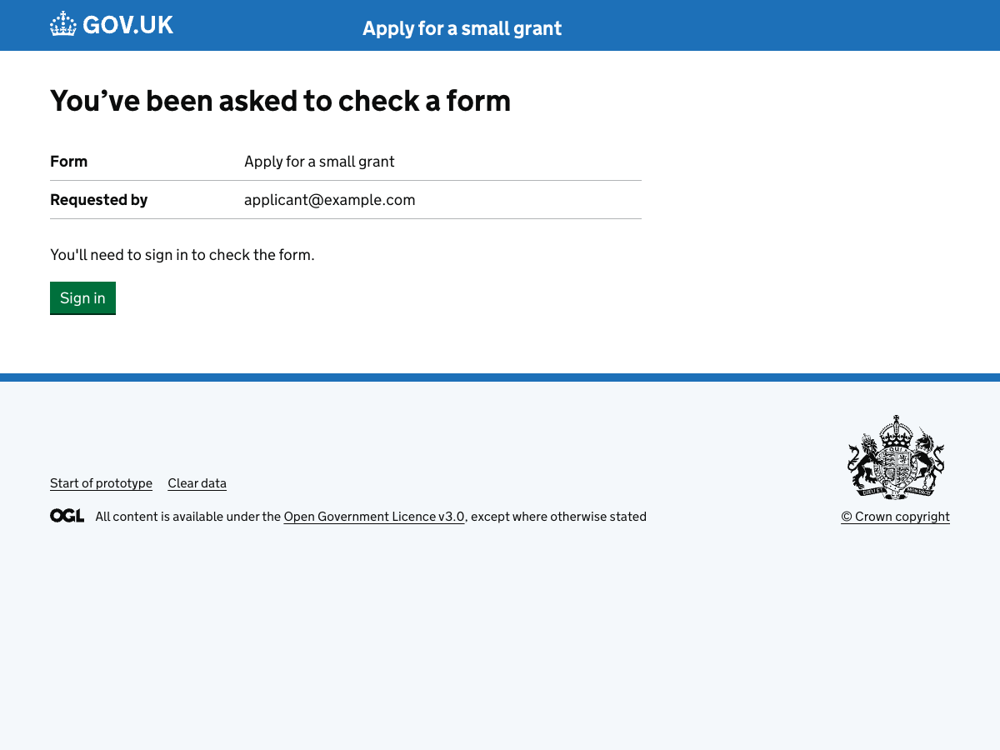

86. Sign in to check answers
URL:http://localhost:3000/runner-sign-in-v2/checker/why-sign-in?token=RSI-STATIC-CHECKED
Page title: Sign in to check this form – GOV.UK
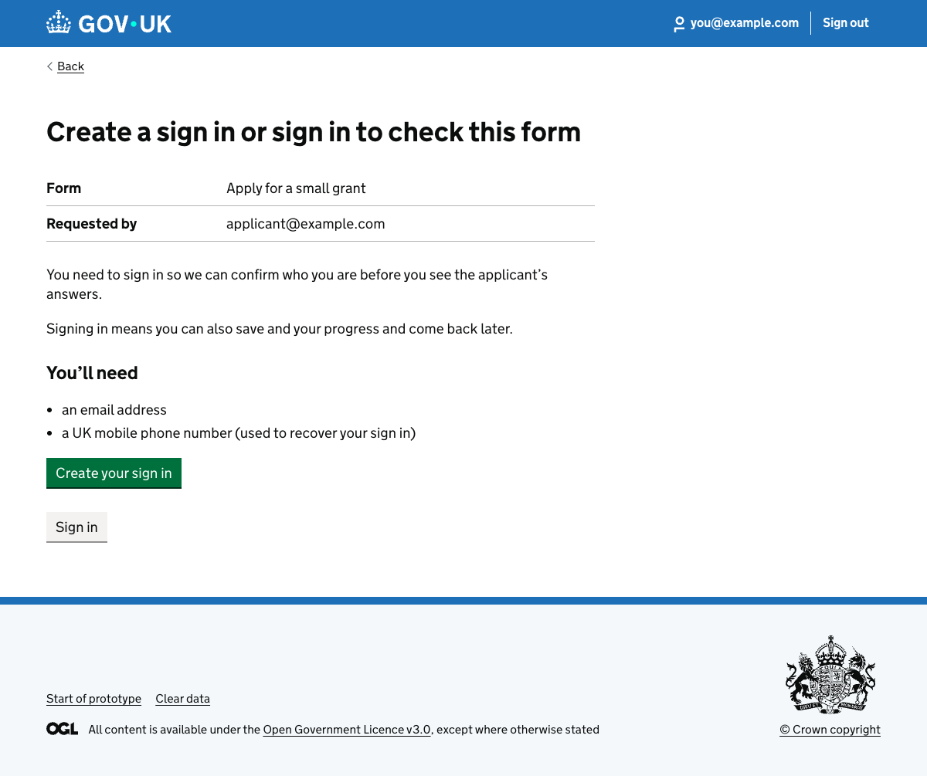

87. Check your email
URL:http://localhost:3000/runner-sign-in-v2/checker/check-email?token=RSI-STATIC-CHECKED&prototype=1&allowApplicant=1
Page title: Enter security code – GOV.UK
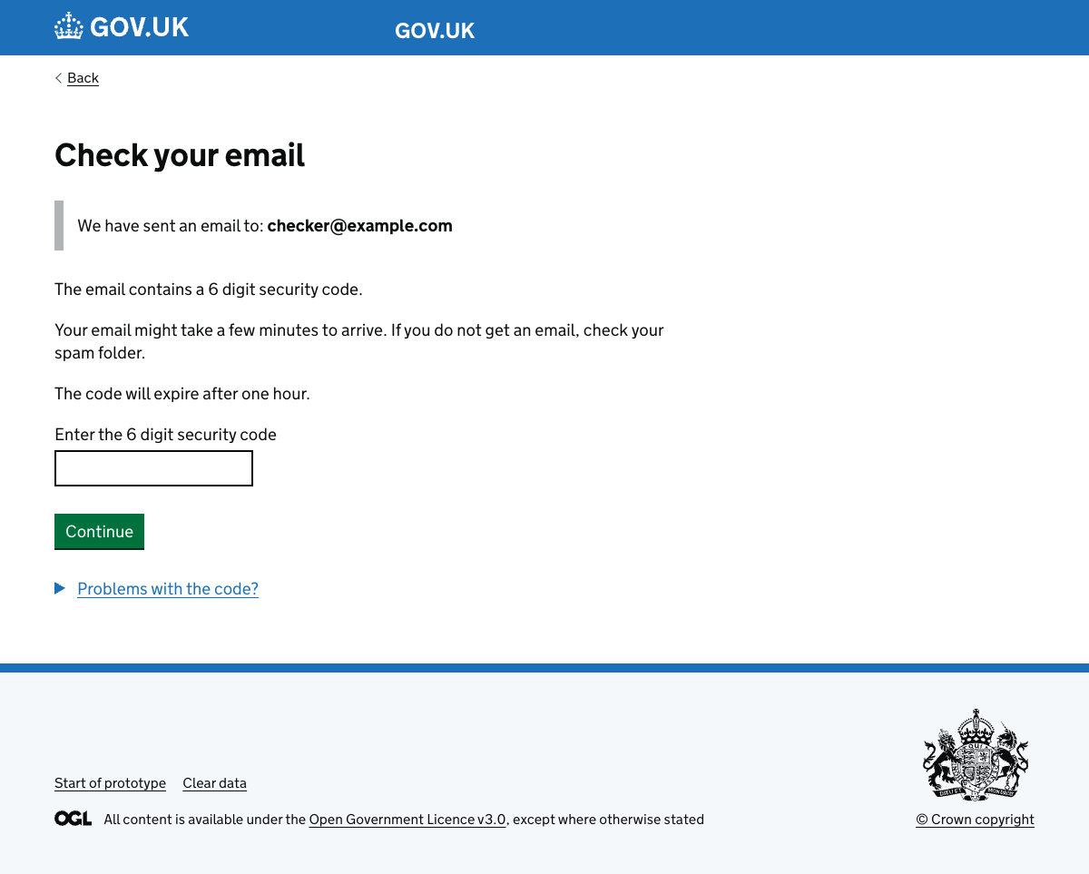

88. Check answers
URL:http://localhost:3000/runner-sign-in-v2/checker/check-answers?token=RSI-STATIC-CHECKED&prototype=1&allowApplicant=1
Page title: Check this form – GOV.UK
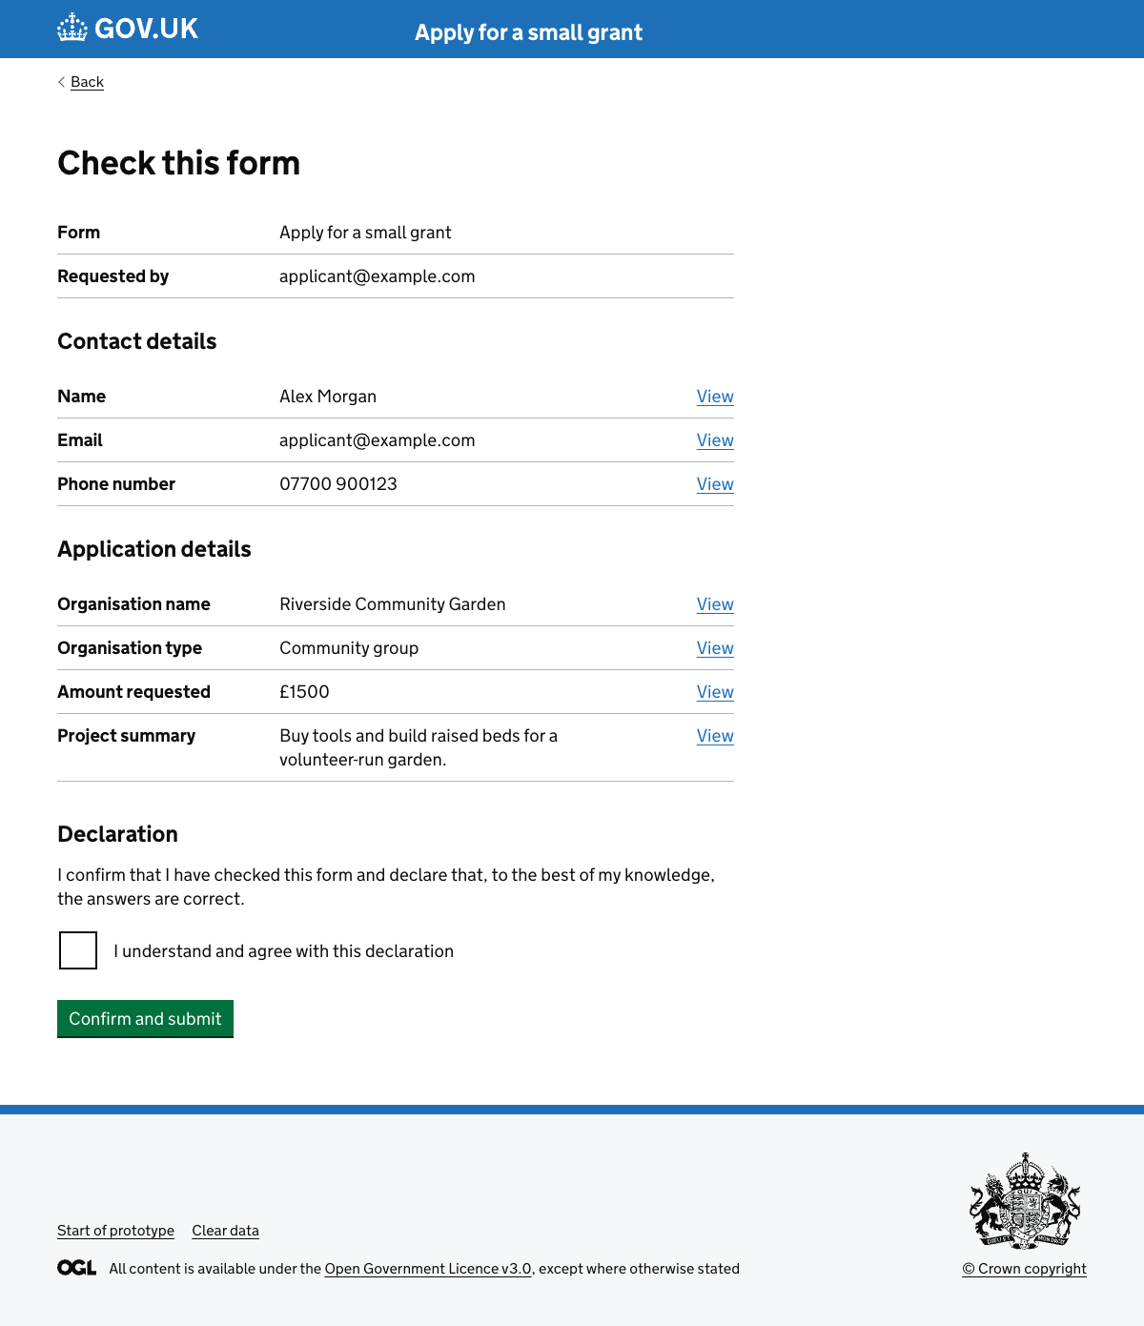

89. Change answers
URL:http://localhost:3000/runner-sign-in-v2/checker/change-answers?token=RSI-STATIC-CHECKED&prototype=1&allowApplicant=1
Page title: Change answers – GOV.UK
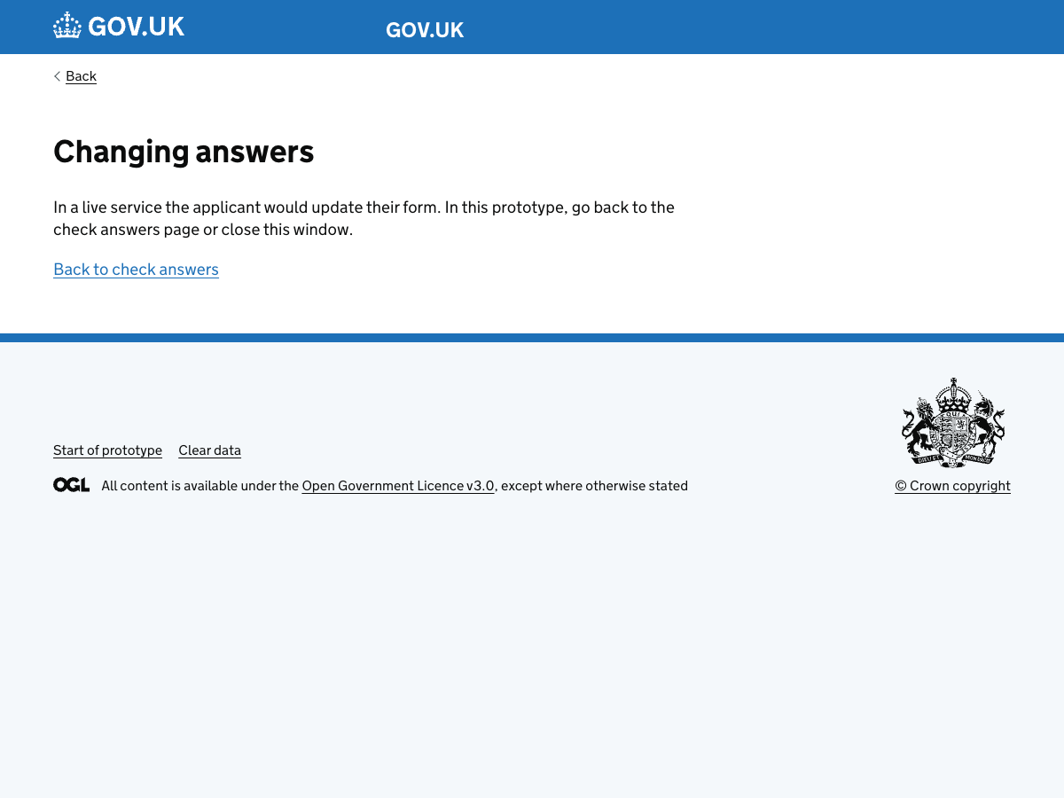

90. Check complete
URL:http://localhost:3000/runner-sign-in-v2/checker/complete/success?token=RSI-STATIC-CHECKED&prototype=1&allowApplicant=1
Page title: Check complete – GOV.UK
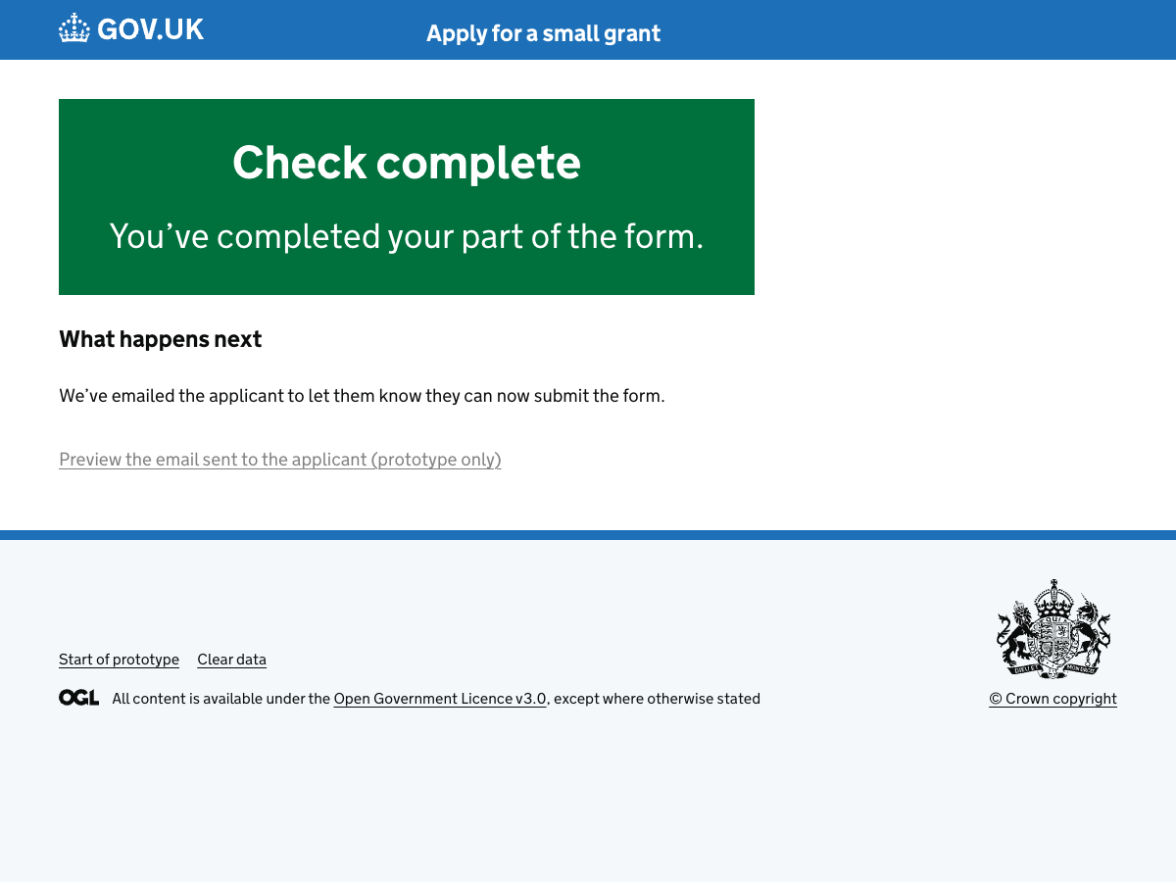

91. Applicant notified email
URL:http://localhost:3000/runner-sign-in-v2/emails/applicant-form-checked?formKey=volunteer-application&applicationId=app-save-exit-demo
Page title: Your form has been checked – email prototype
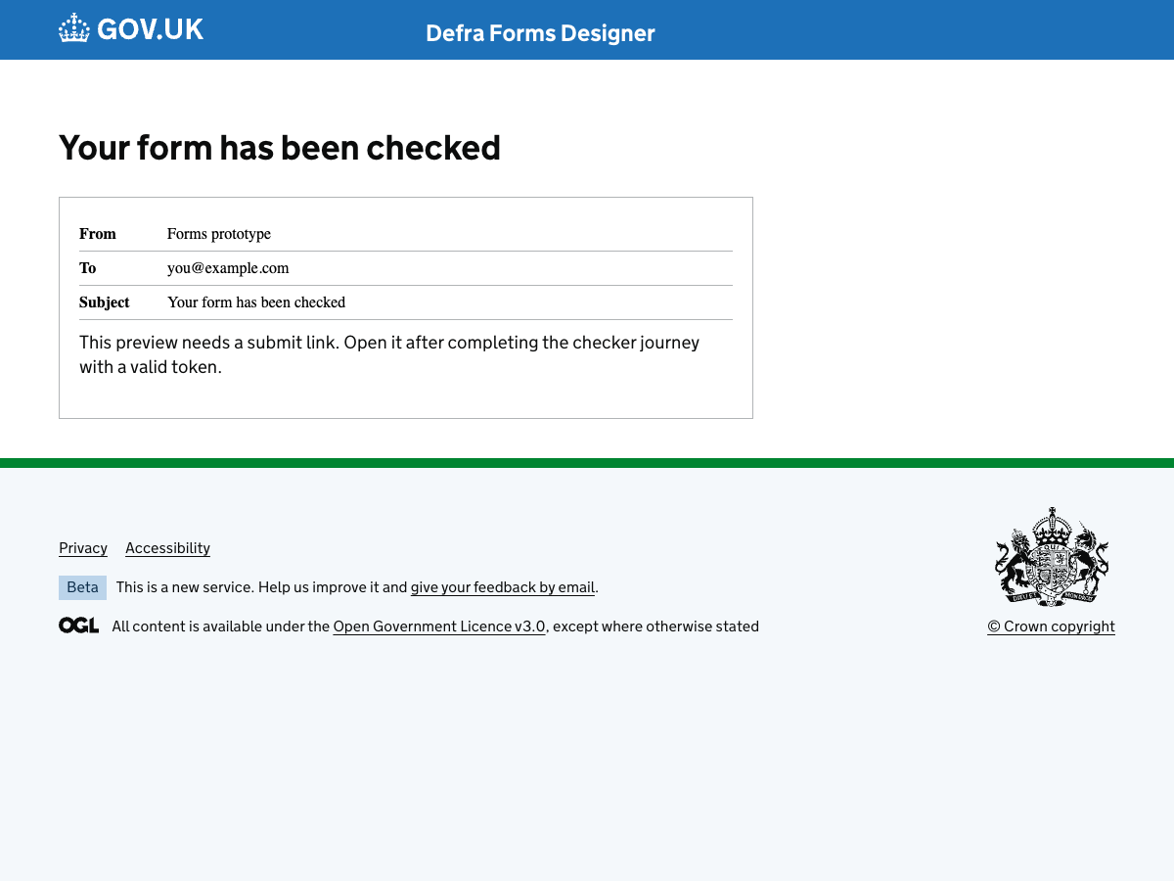

Emails

92. Save and exit email (signed in)
URL:http://localhost:3000/runner-sign-in-v2/emails/save-and-exit?formKey=volunteer-application&applicationId=app-save-exit-demo&next=%2Frunner-sign-in-v2%2Fforms%2Fvolunteer-application%2Fapp-save-exit-demo%2Fmanage&variant=with-sign-in
Page title: Save and exit email – prototype


93. Save and exit email (without sign-in)
URL:http://localhost:3000/runner-sign-in-v2/emails/save-and-exit?formKey=volunteer-application&applicationId=app-save-exit-demo&next=%2Frunner-sign-in-v2%2Fforms%2Fvolunteer-application%2Fapp-save-exit-demo%2Fmanage&variant=without-sign-in
Page title: Save and exit email – prototype


94. Security code email
URL:http://localhost:3000/runner-sign-in-v2/emails/email-confirmation-code?formKey=volunteer-application&applicationId=app-save-exit-demo
Page title: Security code email – prototype
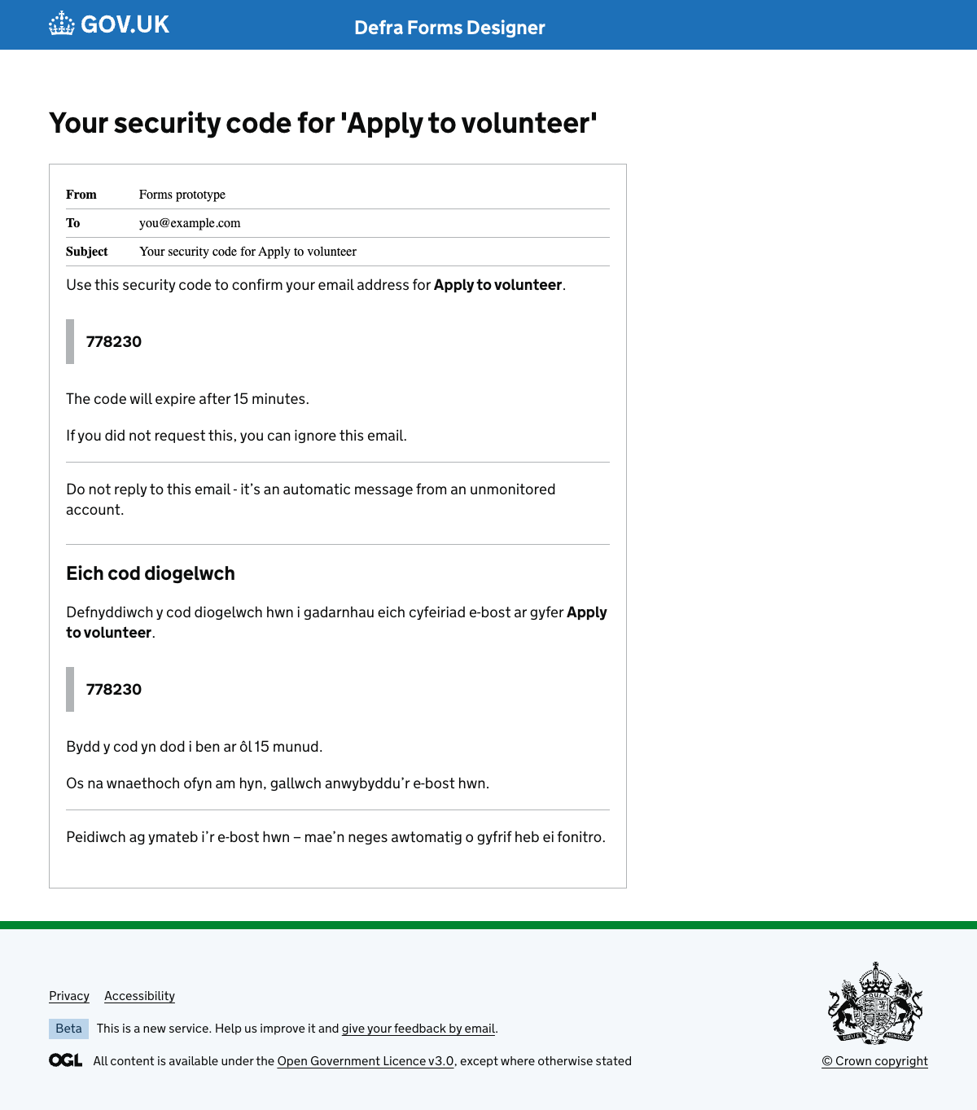

95. Sign-in created email
URL:http://localhost:3000/runner-sign-in-v2/emails/one-login-created?formKey=volunteer-application&applicationId=app-save-exit-demo&email=you@example.com
Page title: Account created email – prototype
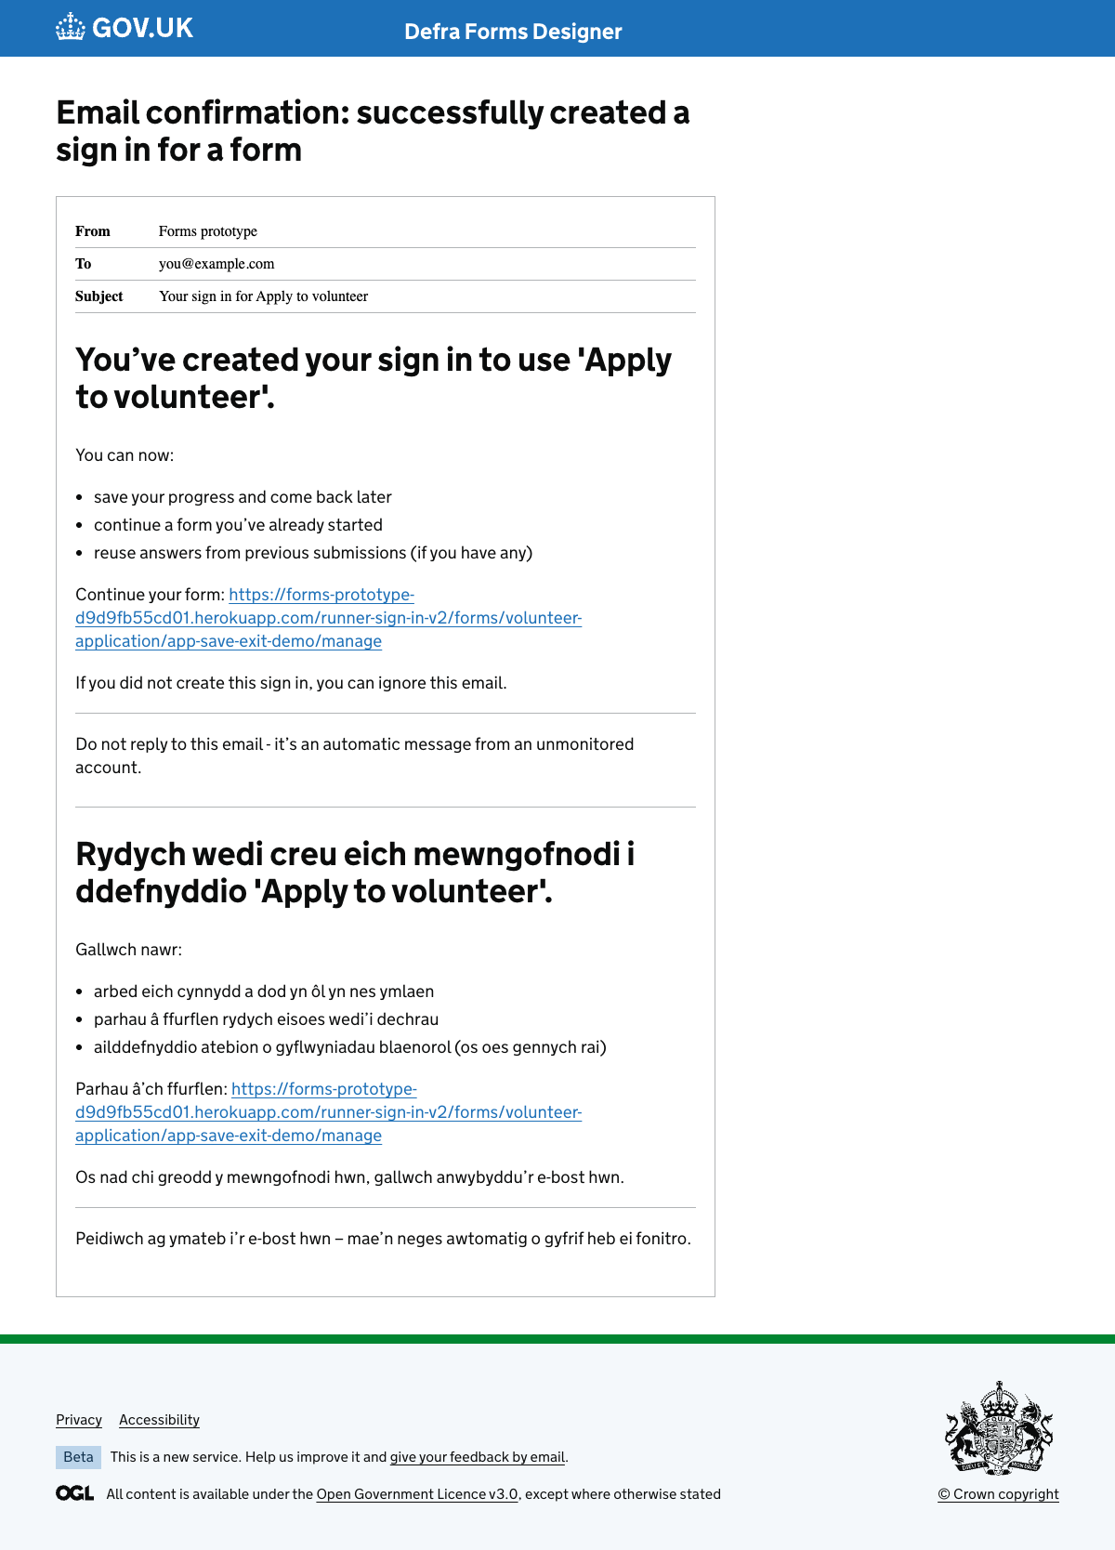

96. Checker invite email
URL:http://localhost:3000/runner-sign-in-v2/emails/checker-invite-v2?formKey=volunteer-application&applicationId=app-save-exit-demo&next=%2Frunner-sign-in-v2%2Fforms%2Fvolunteer-application%2Fapp-save-exit-demo%2Fmanage
Page title: Checker invite email – prototype


97. Applicant form checked email
URL:http://localhost:3000/runner-sign-in-v2/emails/applicant-form-checked?formKey=volunteer-application&applicationId=app-save-exit-demo
Page title: Your form has been checked – email prototype


98. Form submitted email (copied answers)
URL:http://localhost:3000/runner-sign-in-v2/emails/form-submitted?formKey=volunteer-application&applicationId=app-save-exit-demo&next=%2Frunner-sign-in-v2%2Fforms%2Fvolunteer-application%2Fapp-save-exit-demo%2Fmanage
Page title: Form submitted email – prototype


99. Form submitted email – public view (copied answers)
URL:http://localhost:3000/runner-sign-in-v2/emails/form-submitted/public?formKey=volunteer-application&applicationId=app-save-exit-demo&next=%2Frunner-sign-in-v2%2Fforms%2Fvolunteer-application%2Fapp-save-exit-demo%2Fmanage
Page title: Form submitted – Apply to volunteer


Text messages

100. Security code text (recover sign-in)
URL:http://localhost:3000/runner-sign-in-v2/texts/recover-security-code
Page title: Security code text message – prototype
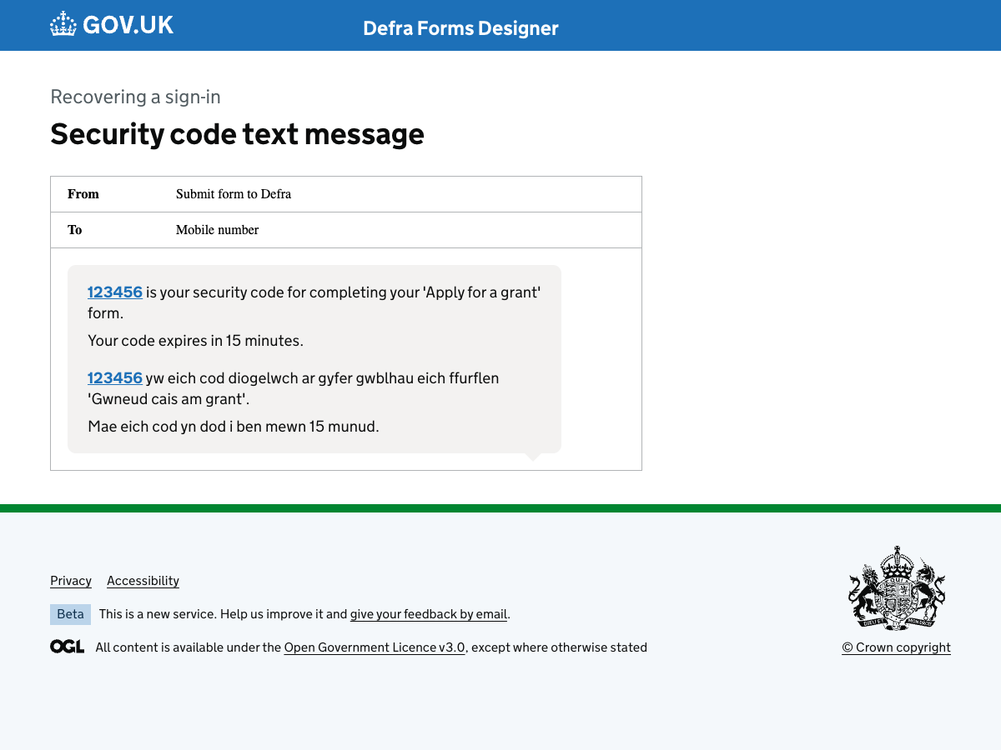

101. Security code text (change email address)
URL:http://localhost:3000/runner-sign-in-v2/texts/change-email-security-code
Page title: Security code text message – prototype
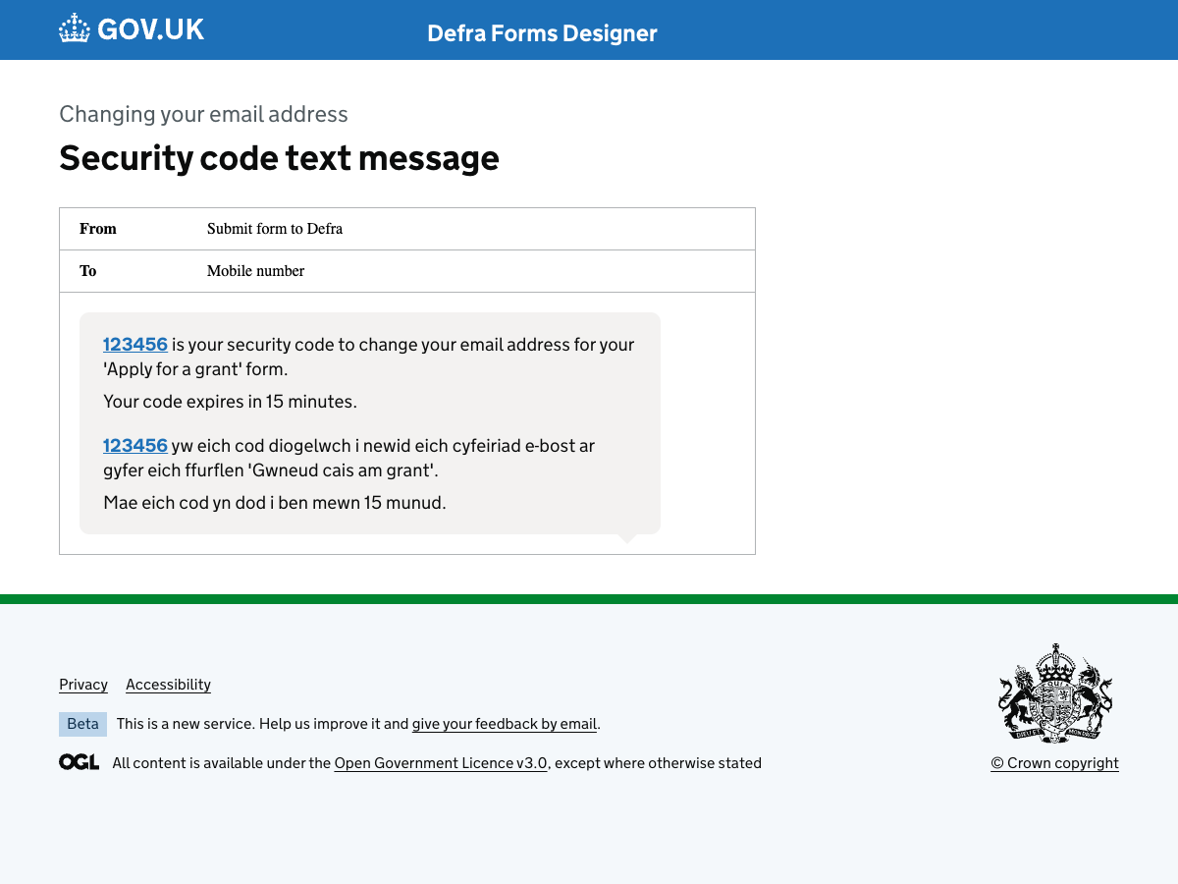

Unexpected journeys

102. You already have a sign-in for this form
URL:http://localhost:3000/runner-sign-in-v2/unexpected-journeys/email-already-has-sign-in
Page title: You already have a sign-in for this form - Runner sign-in v2 - GOV.UK
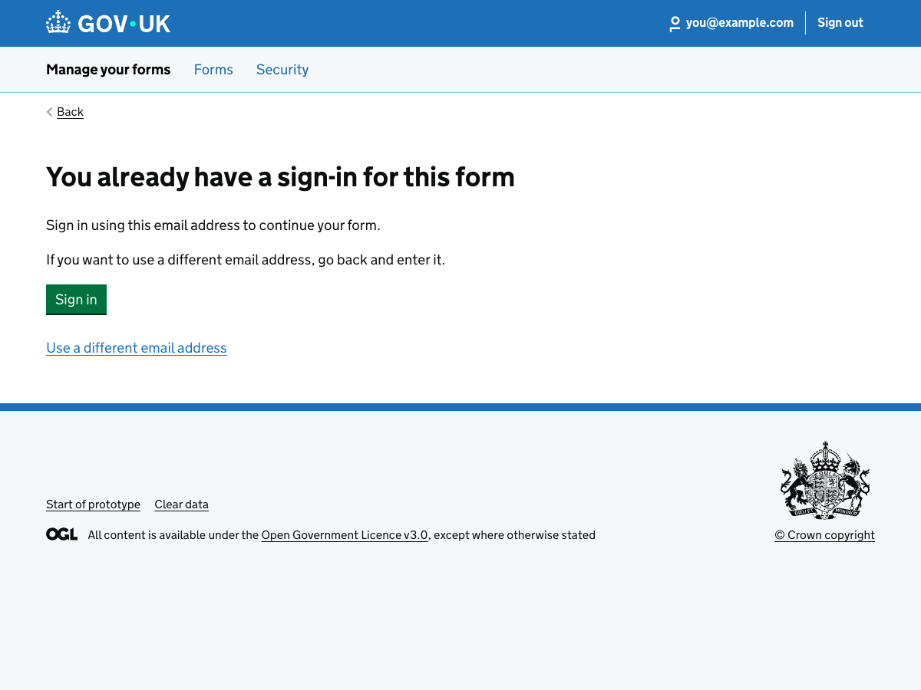

103. We cannot find a sign-in for that email address
URL:http://localhost:3000/runner-sign-in-v2/unexpected-journeys/no-sign-in-found
Page title: We cannot find a sign-in for that email address – Apply to volunteer – GOV.UK
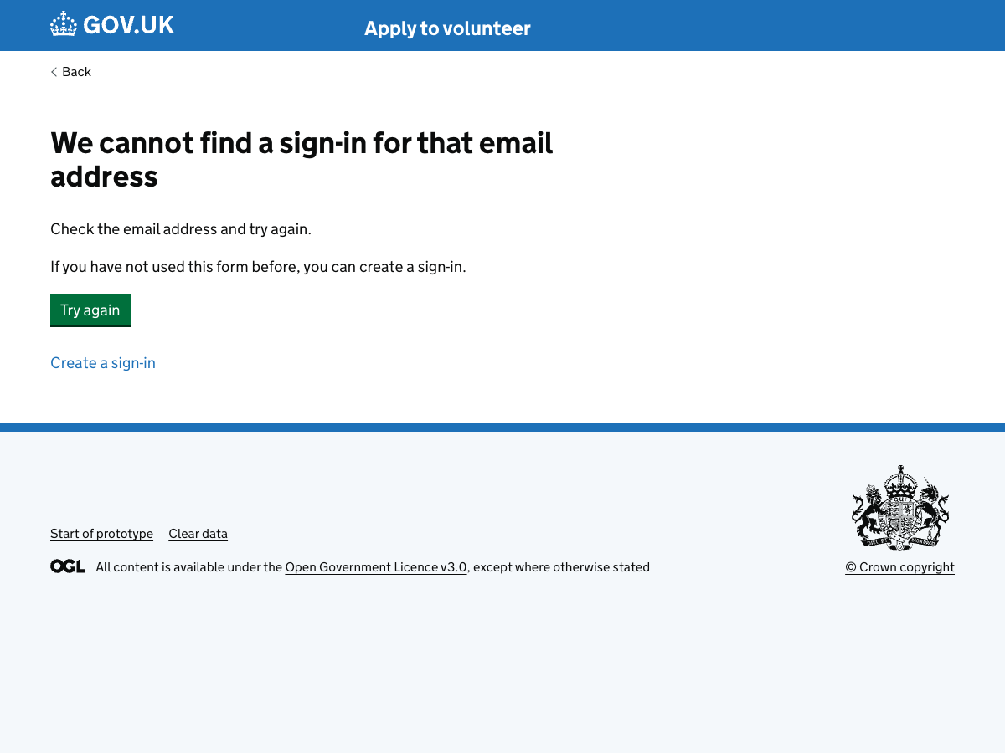

104. Your security code has expired
URL:http://localhost:3000/runner-sign-in-v2/unexpected-journeys/security-code-expired
Page title: Your security code has expired - Runner sign-in v2 - GOV.UK
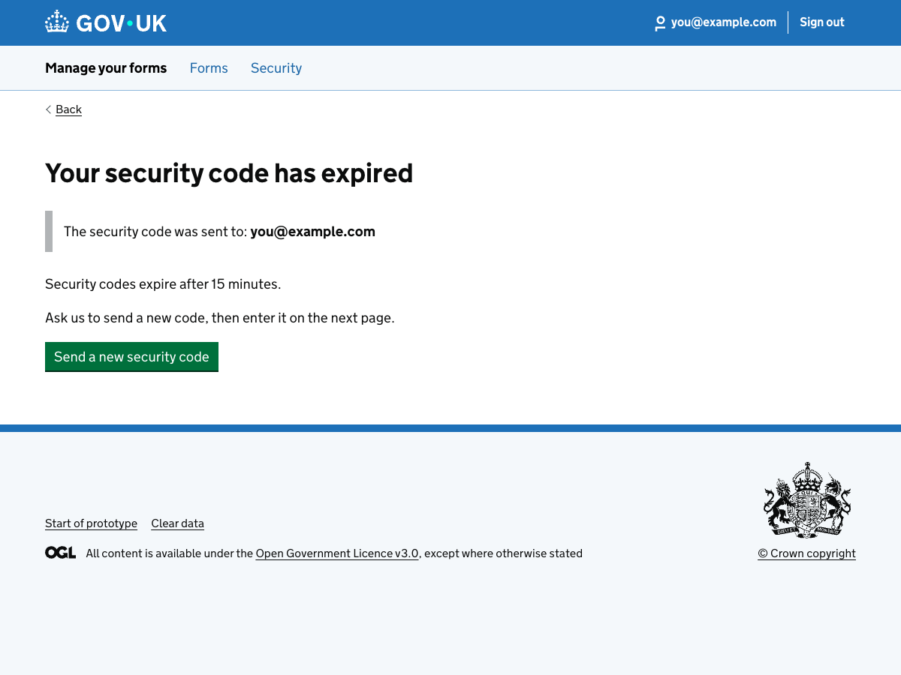

105. You entered the wrong security code too many times
URL:http://localhost:3000/runner-sign-in-v2/unexpected-journeys/wrong-security-code-too-many-times
Page title: You entered the wrong security code too many times - Runner sign-in v2 - GOV.UK
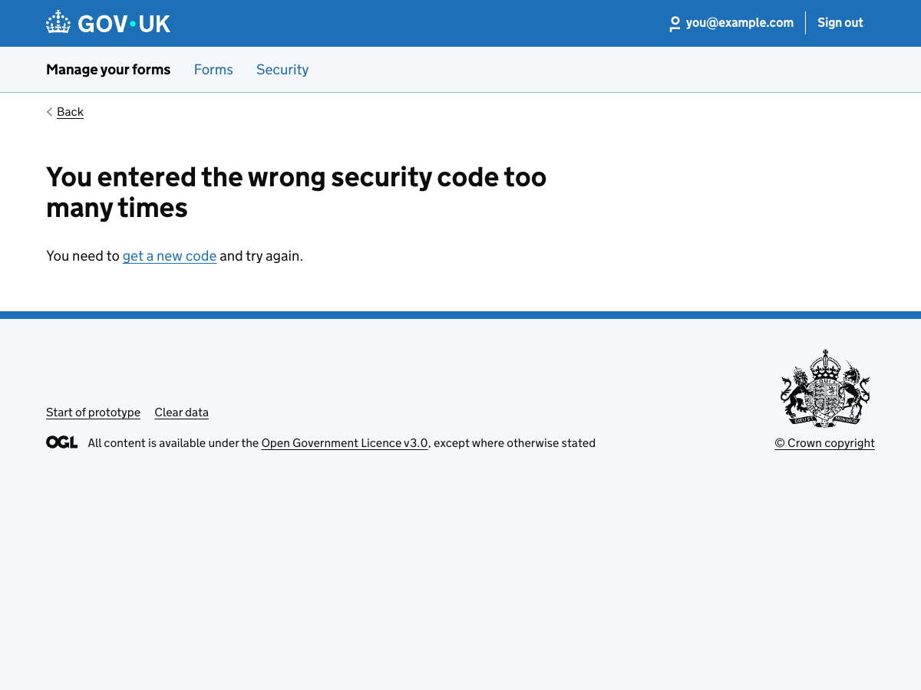

106. You entered the wrong security code too many times
URL:http://localhost:3000/runner-sign-in-v2/unexpected-journeys/wrong-security-code-locked-out
Page title: You entered the wrong security code too many times - Runner sign-in v2 - GOV.UK
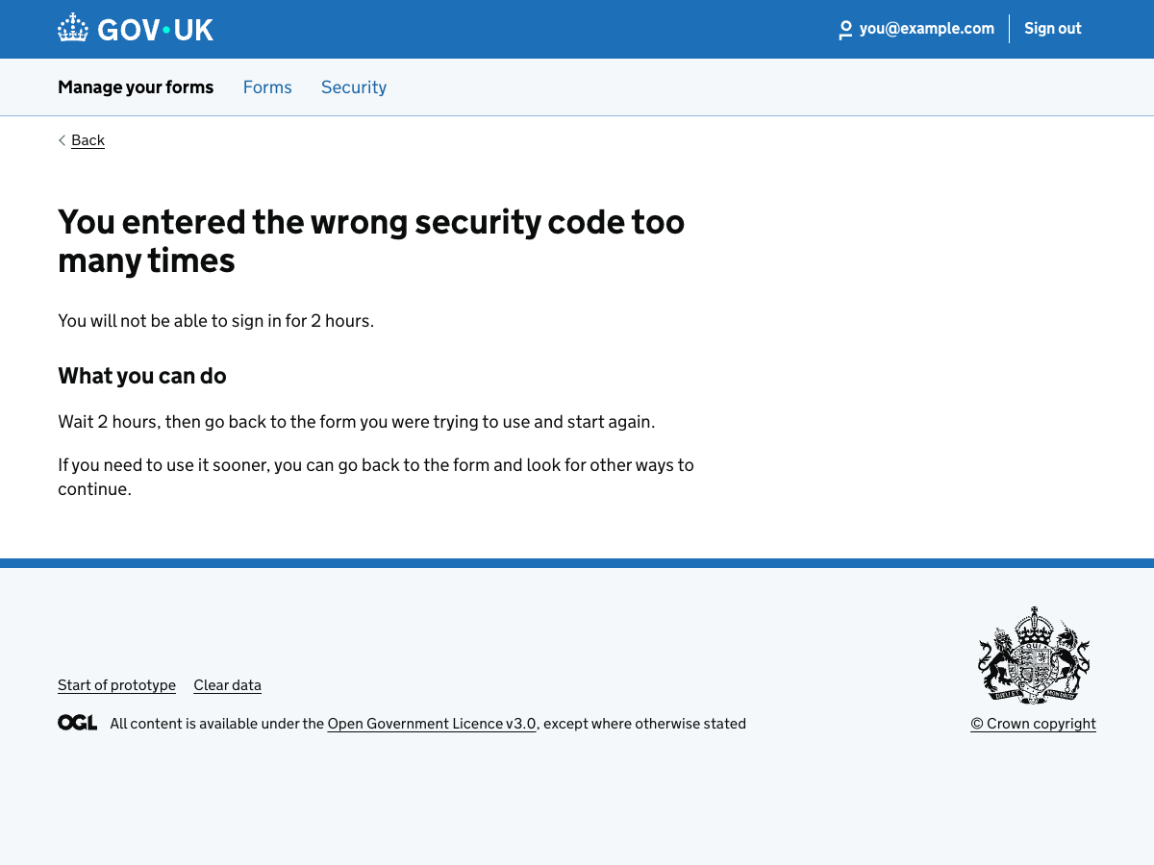

107. You asked to resend the security code too many times
URL:http://localhost:3000/runner-sign-in-v2/unexpected-journeys/too-many-security-codes
Page title: You asked to resend the security code too many times - Runner sign-in v2 - GOV.UK
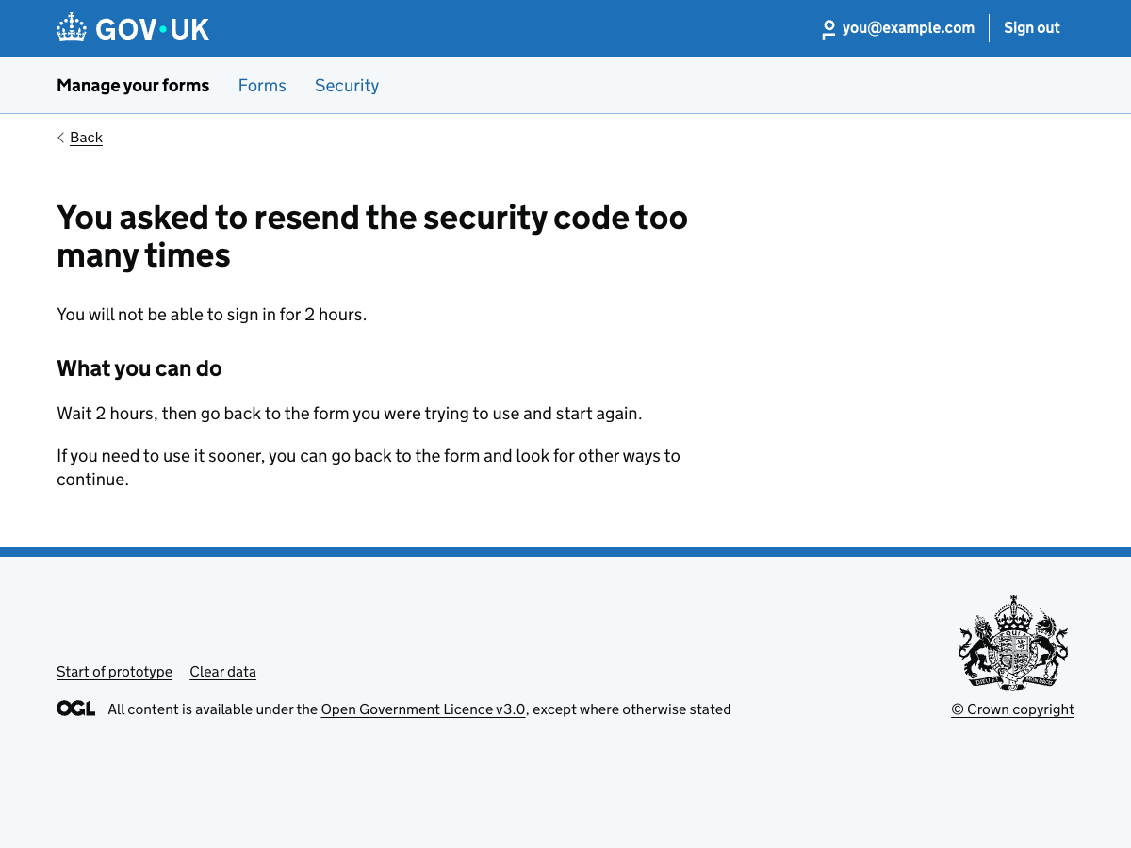

108. We cannot recover your sign-in online
URL:http://localhost:3000/runner-sign-in-v2/unexpected-journeys/cannot-recover-online
Page title: We cannot recover your sign-in online - Runner sign-in v2 - GOV.UK
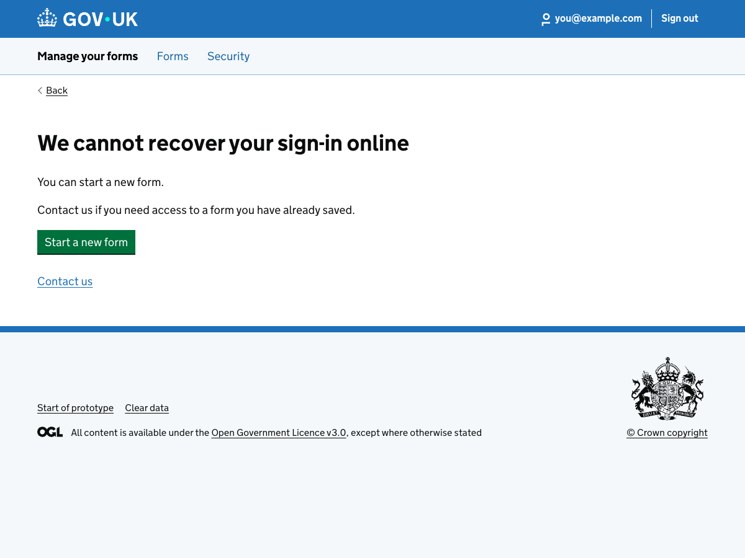

109. We cannot find a sign-in for that mobile number
URL:http://localhost:3000/runner-sign-in-v2/unexpected-journeys/no-sign-in-found-for-mobile
Page title: Recover my sign-in – GOV.UK
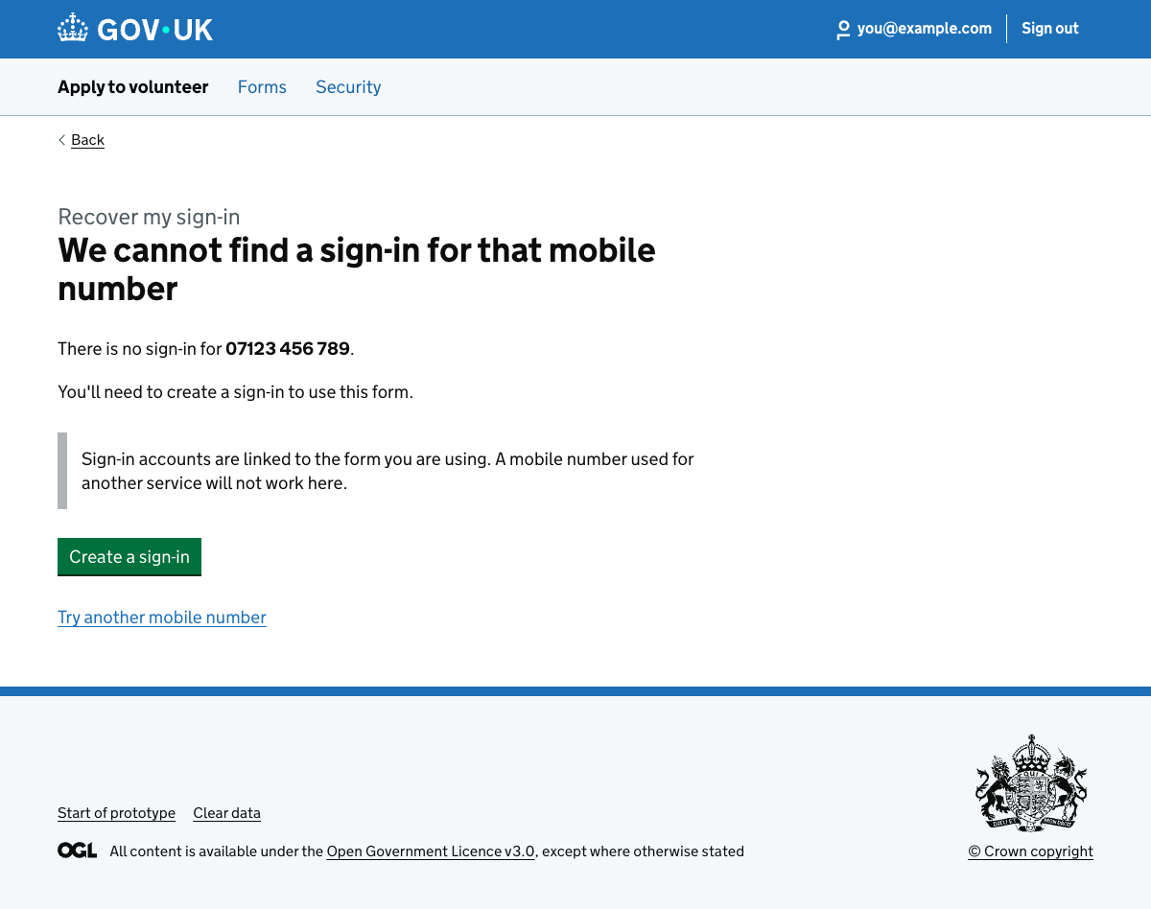

110. Your link has expired
URL:http://localhost:3000/runner-sign-in-v2/unexpected-journeys/save-link-expired
Page title: Your link has expired - Runner sign-in v2 - GOV.UK
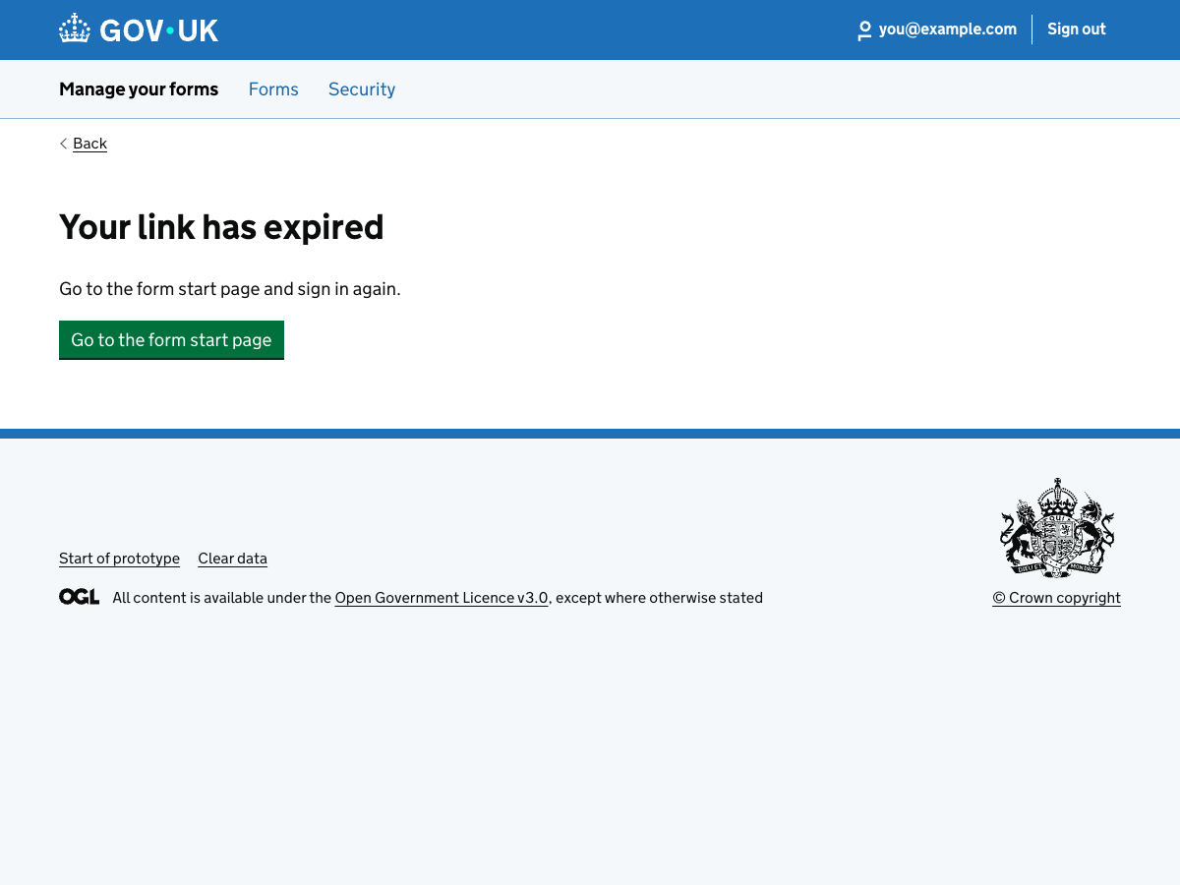

111. This link has expired
URL:http://localhost:3000/runner-sign-in-v2/unexpected-journeys/review-link-expired
Page title: This link has expired - Runner sign-in v2 - GOV.UK
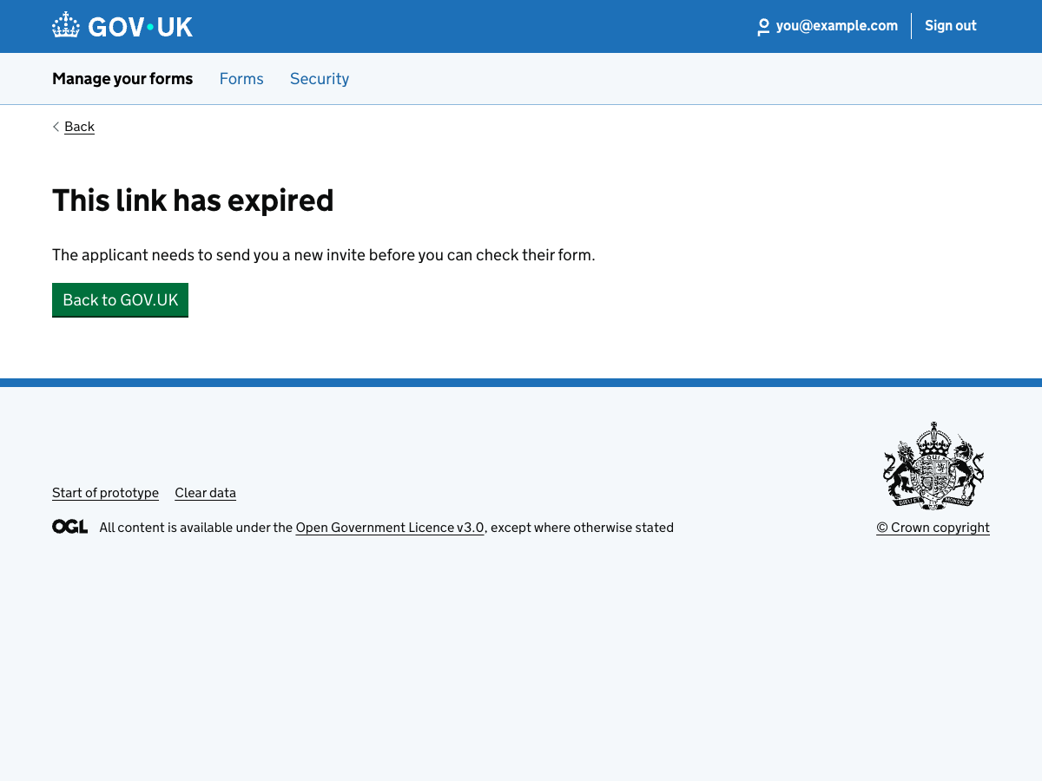

112. Sorry, the form is unavailable
URL:http://localhost:3000/runner-sign-in-v2/unexpected-journeys/service-unavailable
Page title: Sorry, the form is unavailable - Runner sign-in v2 - GOV.UK
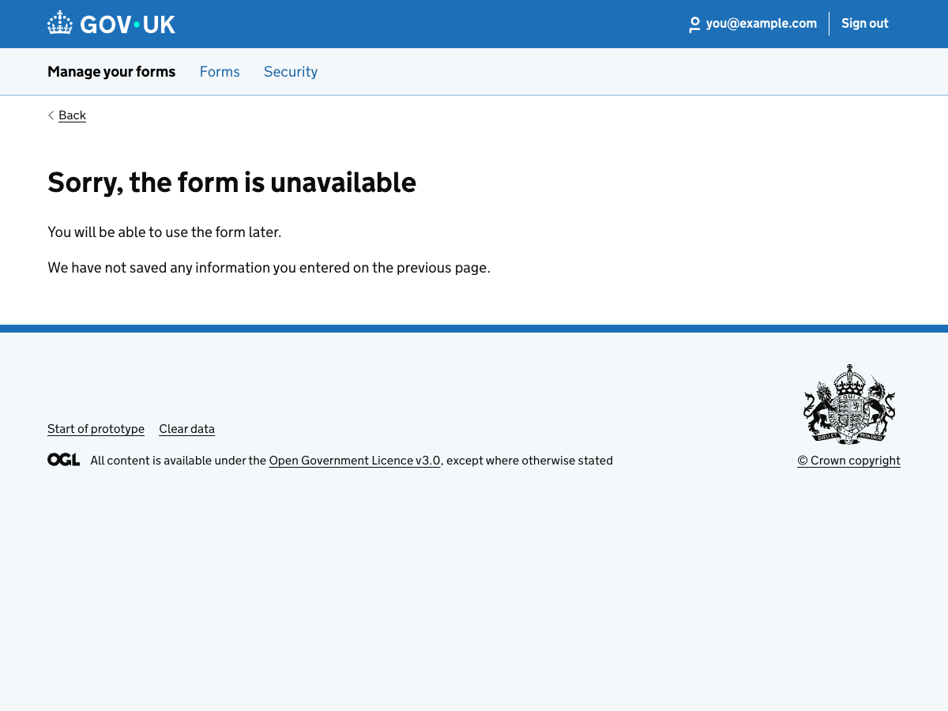

113. Page not found
URL:http://localhost:3000/runner-sign-in-v2/unexpected-journeys/page-not-found
Page title: Page not found - Runner sign-in v2 - GOV.UK
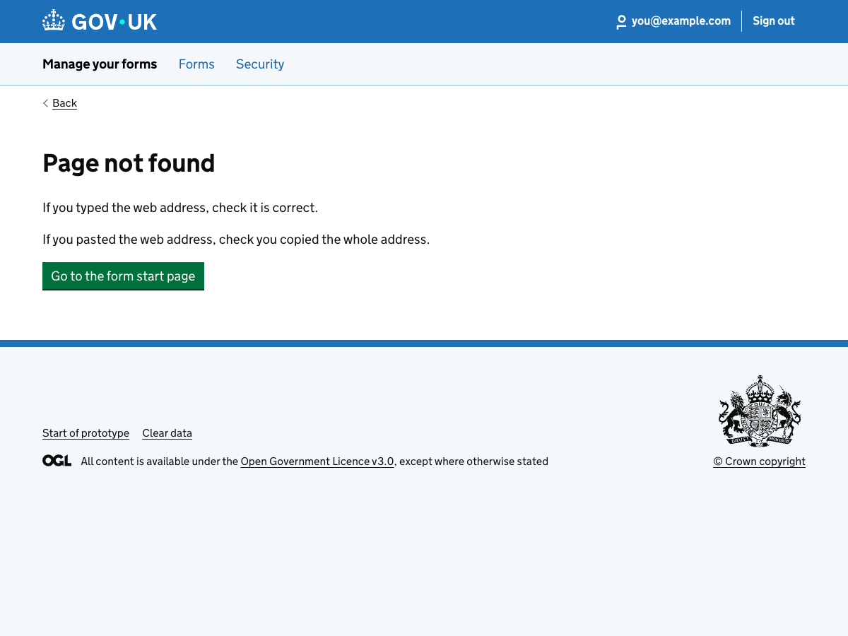

114. Sorry, there is a problem with the form
URL:http://localhost:3000/runner-sign-in-v2/unexpected-journeys/problem-with-service
Page title: Sorry, there is a problem with the form - Runner sign-in v2 - GOV.UK
