Derek Frank
dmfrank@ucsc.edu
AMS 147
Due: 1/27/10
Homework #2

Part B:
(1):
i) The problem I am to solve is the non-linear equation
(exp(-x)-1)/x+(x-c-2*sin(c))=0. I am also to plot the function's root as a function of c contained in [-10,0].
ii) Using Matlab, I am to use Newton's method to solve the given equation. Newton's method will produce a root as a function of c.
iii)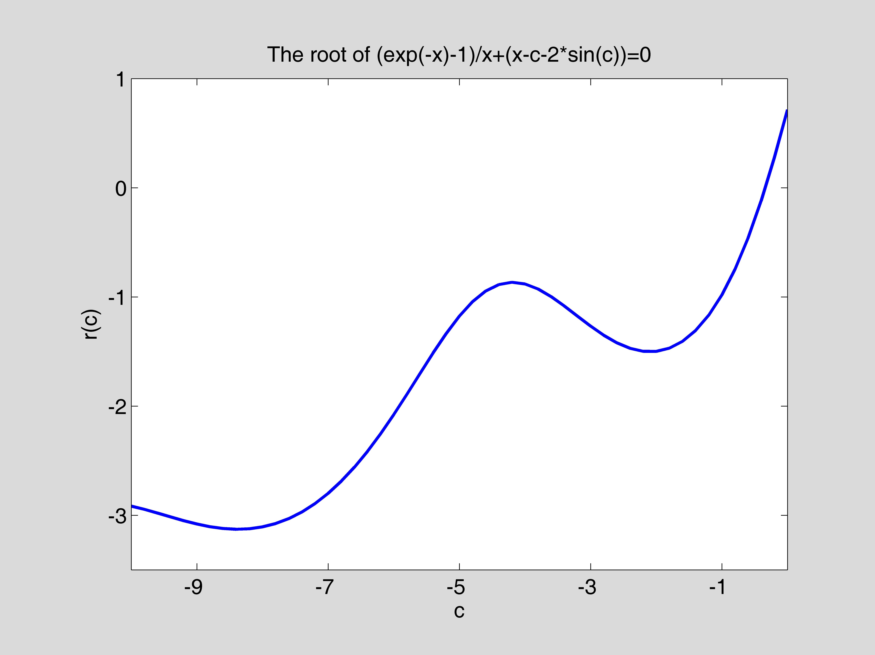
iv) The root of the given function is shown above contained on an interval where c is
between [-10,0]. The root, on this interval, does not exceed a value above 1 or below -4. Although the root is wave-like and slightly decreases after a steady increase, it overall becomes increasingly larger as c gets bigger.
(2):
- The problem I am to solve is to find the distance between data points found in "data1.txt" and the fitting function
f(x)=exp(-c*x)*cos(2*x). I am to plot this distance function,
dd(c)=sqrt(sum of (f(x(i))-y(i))^2) (i=0,1,…,50), as a function of c in [0,1].
- Using Matlab, I am to graph the distance between the data and fitting function
with a varying c value. Using a for loops to increment the c vector and its corresponding d (distance) vector. Each time around the loop I send to “dd.m” a c and all x and y values. The funtion calculates the fitting function y value and sends back a distance which I store in the d vector according to its corresponding c value. I am able to save information in the form of vectors and use these vectors to plot the curve.
iii)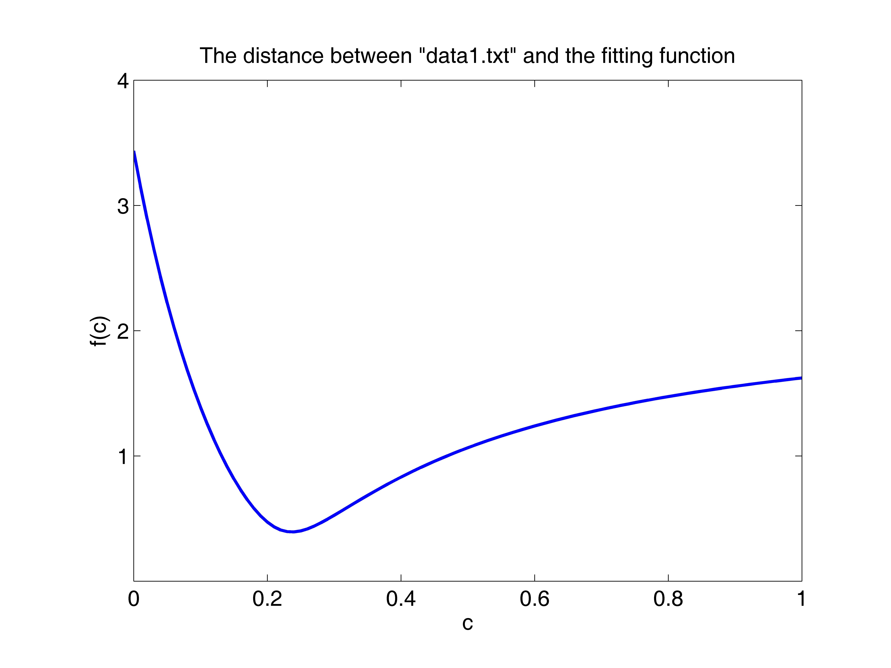
- These results show the distance (f(c)) between the fitting funcion and the given data points. This graph only shows the values of f(c) when c is between [0,1]. The greatest distance, on this graph, between the data points and the fitting function is greatest when c is 0 and quadratically decreases to a minimum (optimal value) at a little after c=.2. After the distance reaches a minimum and c keeps increasing, it does not grow like a quadratic funtion, but much more slowly and even appears to possibly be asymptotic at around y=1.8.

(3):
i) The problem I am to solve is find the optimal fitting function from the previous problem. That is find the best value of c that minimizes the distance between the given data in "data1.txt" and the fitting function f(x)=exp(-c*x)*cos(2*x).
ii) Using the golden search method to find the best value for c, I enter code in Matlab to calculate and graph my problems.
iii)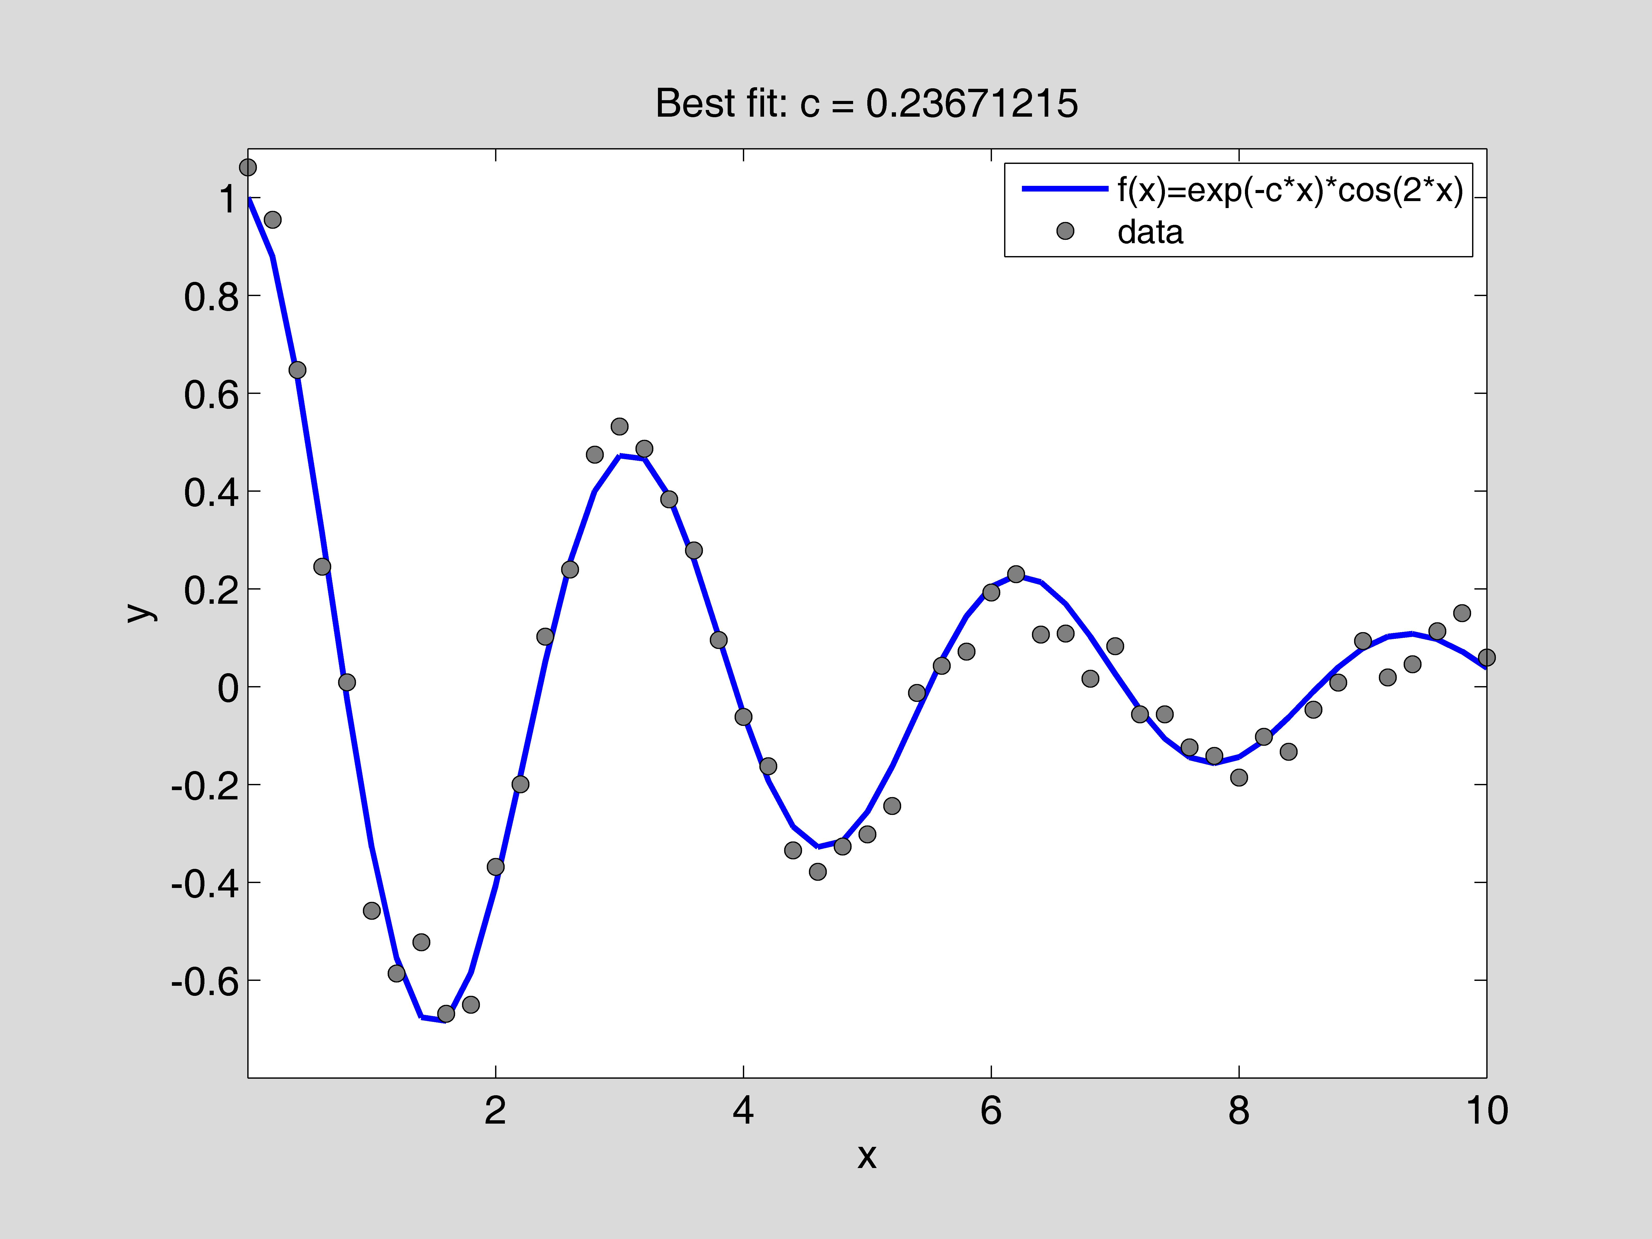
iv) The results show that the best value for c to optimize the distance is
c = .23671215 (this value is very close to the average for c in homework assignment #1).

APPENDIX
(Part B1):
"f.m"
function [y]=f(x,c)
%
% This function calculates f(x) for a given x and a parameter c.
%
y=(exp(-x)-1)./x+(x-c-2.*sin(c));
%

"fp.m"
function [y]=fp(x,c)
%
% This function calculates df(x)/dx for a given x and a parameter % c.
%
y=-1.*(exp(-x)./(x.^2))-1.*(exp(-x)./x)+1./(x.^2)+2;
%

"fp_2.m"
function [y]=fp_2(x,c)
%
% This function calculates df(x)/dx for a given x and a parameter % c.
%
h=1.0e-5;
y=(f(x+h,c)-f(x-h,c))/(2*h);
%

"newton.m"
function [r, n]=newton(funct_name, deriv_name, c, x0, tol)
%
% This function finds a root of f(x) = 0 using Newton's method.
%
% Input:
% funct_name: the name of the .m file for calculating the
% function f(x)
% deriv_name: the name of the .m file for calculating df(x)/dx
% c: a parameter in functions "f" and "fp"
% x0: the starting point for Newton's method
% tol: the error tolerance
% Output:
% r: the root found
% n: the number of iterations
%
err=1.0;
n=0;
%
while(err > tol),
n=n+1;
f_x0=feval(funct_name,x0,c);
fp_x0=feval(deriv_name,x0,c);
x1=x0-f_x0/fp_x0;
err=abs(x1-x0);
x0=x1;
end
%
r=x0;
%

"calc_data.m"
%
% Consider the non-linear equation (exp(-x)-1)/x+(x-c-2*sin(c))=0.
% Here "c" is a parameter in the equation. The root of the
% equation varies with "c" and thus the root is a function of "c".
% This code calculates the root for "c" in [-10,0] and stores the
% data in data1.mat. Later on the data is used in "plot_curve.m
% to plot the root as a function of "c".
%
clear
%
c_v=[-10:0.2:0];
nc=size(c_v,2);
r_v=zeros(1,nc);
tol=1.0e-10;
r=1;
%
for i=1:nc,
c=c_v(i);
[r, n]=newton('f', 'fp_2', c, r, tol);
r_v(i)=r;
end
%
save data1 c_v r_v
%

"plot_curve.m"
%
% Consider the non-linear equation (exp(-x)-1)/x+(x-c-2*sin(c))=0.
% Here "c" is a parameter in the equation. The root of the
% equation varies with "c" and thus the root is a function of "c".
% The code "calc_data.m" calculates the root for "c" in [-10,0]
% and stores the data in data1.mat.
% This code loads in data1.mat and plots the root as a function
% of "c".
%
clear
clf
axes('position',[0.15,0.13,0.75,0.75])
%
load data1.mat
plot(c_v, r_v,'linewidth',2.0)
axis([-10,0,-3.5,1.0])
set(gca,'xtick',[-9:2:0])
set(gca,'ytick',[-3:1:1])
set(gca,'fontsize',14)
xlabel('c')
ylabel('r(c)')
title('The root of (exp(-x)-1)/x+(x-c-2*sin(c))=0')
%

(Part B2):
"data1.txt"
% x y
%
0.0000000e+00 1.0616627e+00
2.0000000e-01 9.5438313e-01
4.0000000e-01 6.4726669e-01
6.0000000e-01 2.4543142e-01
8.0000000e-01 8.6474234e-03
1.0000000e+00 -4.5847332e-01
1.2000000e+00 -5.8629116e-01
1.4000000e+00 -5.2270060e-01
1.6000000e+00 -6.6897708e-01
1.8000000e+00 -6.5025323e-01
2.0000000e+00 -3.6829629e-01
2.2000000e+00 -1.9946104e-01
2.4000000e+00 1.0214847e-01
2.6000000e+00 2.3939828e-01
2.8000000e+00 4.7441685e-01
3.0000000e+00 5.3204202e-01
3.2000000e+00 4.8645531e-01
3.4000000e+00 3.8277756e-01
3.6000000e+00 2.7859469e-01
3.8000000e+00 9.5304196e-02
4.0000000e+00 -6.1937557e-02
4.2000000e+00 -1.6264995e-01
4.4000000e+00 -3.3465224e-01
4.6000000e+00 -3.7848057e-01
4.8000000e+00 -3.2684557e-01
5.0000000e+00 -3.0202142e-01
5.2000000e+00 -2.4418751e-01
5.4000000e+00 -1.2606921e-02
5.6000000e+00 4.2709432e-02
5.8000000e+00 7.1364914e-02
6.0000000e+00 1.9256373e-01
6.2000000e+00 2.2975779e-01
6.4000000e+00 1.0651973e-01
6.6000000e+00 1.0873230e-01
6.8000000e+00 1.6313790e-02
7.0000000e+00 8.2753168e-02
7.2000000e+00 -5.6705147e-02
7.4000000e+00 -5.6552321e-02
7.6000000e+00 -1.2417349e-01
7.8000000e+00 -1.4140695e-01
8.0000000e+00 -1.8606224e-01
8.2000000e+00 -1.0253530e-01
8.4000000e+00 -1.3337982e-01
8.6000000e+00 -4.7083796e-02
8.8000000e+00 8.5379099e-03
9.0000000e+00 9.3244738e-02
9.2000000e+00 1.8795176e-02
9.4000000e+00 4.5569780e-02
9.6000000e+00 1.1312777e-01
9.8000000e+00 1.5024618e-01
1.0000000e+01 5.9238496e-02
%

"dd.m"
function [dist]=dd(c,x,y)
%
% This function calculates the distance between the data
% and the function f(x)=exp(-c*x)*cos(2x)
%
fx=exp(-c*x).*cos(2*x);
dist=norm(fx-y);

"calc_data.m”
%
% Consider the non-linear equation sqrt(sum of (f(x(i))-y(i))^2), % where, depending on c, x(i) is an array of values produced by
% the fitting funtion found in "dd.m" and y(i) is an array of
% values found in "data1.txt". Here "c" is a parameter in the
% equation. The distance of the equation varies with "c" and thus
% the distance is a function of "c".
% This code calculates the distance for "c" in [0,1] and stores
% the data in data1.mat. Later on the data is used "plot_curve.m"
% to plot he distance as a function of "c".
%
load -ascii data1.txt

% vector of x values found in "data1.txt"
x=data1(:,1);
% array/vector of y values found in "data1.txt"
y1=data1(:,2);
% array/vector of 100 c values between [0,1]
c_v=[0:.01:1];
% scalar number of c values in array/vector c_v
nc=size(c_v,2);
% initialization for array/vector of distance values
d_v=zeros(1,nc);

for i=1:nc,
c=c_v(i);
d(i)=dd(c,x,y1);
end
%
save data1 c_v y_v
“plot_curve.m”
%
% Consider the non-linear equation fitting function
% f(x)=exp(-c*x)*cos(2*x). With a given x, "c" is a parameter in
% the equation. The code "calc_data.m" calculates
% sqrt(sum of (f(x(i))-y(i))^2), the distance between the data
% given in "datal.txt" and the fitting function for "c" in [0,1]
% and stores the data in data1.mat. This code loads in data1.mat
% and plots the distance as a function of "c".
%
clear
figure(3)
clf
axes('position',[0.15,0.13,0.75,0.75])
%
load data1.mat
plot(c_v, y_v,'linewidth',2.0)
axis([0,1,0,4])
set(gca,'xtick',[0:.2:1])
set(gca,'ytick',[1:1:4])
set(gca,'fontsize',14)
xlabel('c')
ylabel('f(c)')
title('The distance between "data1.txt" and the fitting function')
%

(Part B3):
"dd.m"
function [dist]=dd(c,x,y)
%
% This function calculates the distance between the data
% and the function f(x)=exp(-c*x)*cos(2x)
%
fx=exp(-c*x).*cos(2*x);
dist=norm(fx-y);

"golden.m"
%
% This code first reads in data (x, y) from "data1.txt."
% Then it uses the golden search method to find the value of c
% such that the distance between the data and the function
% f(x)=exp(-c*x)*cos(2*x) is minimized.
% Finally, it plots the data along with the best fit.
%
clear
clf reset
axes('position',[0.15,0.13,0.75,0.75])
%
load -ascii data1.txt
x=data1(:,1);
y=data1(:,2);
%
a=0;
b=2;
tol=1.0e-10;
n=0;
%
g=(sqrt(5)-1)/2;
r1=a+(b-a)*(1-g);
f1=dd(r1,x,y);
r2=a+(b-a)*g;
f2=dd(r2,x,y);
%
while (b-a) > tol,
n=n+1;
if f1 < f2,
b=r2;
r2=r1;
f2=f1;
r1=a+(b-a)*(1-g);
f1=dd(r1,x,y);
else
a=r1;
r1=r2;
f1=f2;
r2=a+(b-a)*g;
f2=dd(r2,x,y);
end
end
c0=(a+b)/2;
%
fx=exp(-c0*x).*cos(2*x);
plot(x,fx,'b-','linewidth',2.0)
hold on
plot(x,y,'ko','markerfacecolor',[0.5,0.5,0.5])
axis([0,10,-.8,1.1])
set(gca,'xtick',[2:2:10])
set(gca,'ytick',[-.6:0.2:1.1])
set(gca,'fontsize',14)
xlabel('x')
ylabel('y')
title(['Best fit: c = ',num2str(c0,8)])
h1=legend('f(x)=exp(-c*x)*cos(2*x)','data');
set(h1,'fontsize',12)
%
disp(' ')
disp([' The function attains a minimum at c0 = ',num2str(c0,'%24.16e'),'.'])
disp([' It takes n = ',num2str(n),' iterations to reach err <= ',num2str(tol),'.'])
disp(' ')

