Derek Frank
dmfrank@ucsc.edu
AMS 147
Due: 2/3/10
Homework #3

Part B:
(1):
i) In this problem, I am to graph three functions: first, second, and fourth order error functions as functions of h.
ii) Using Matlab, I set the vector/array h to values between [10⁻¹³, 10⁻¹]. I then create the three functions of h and plot them.
iii)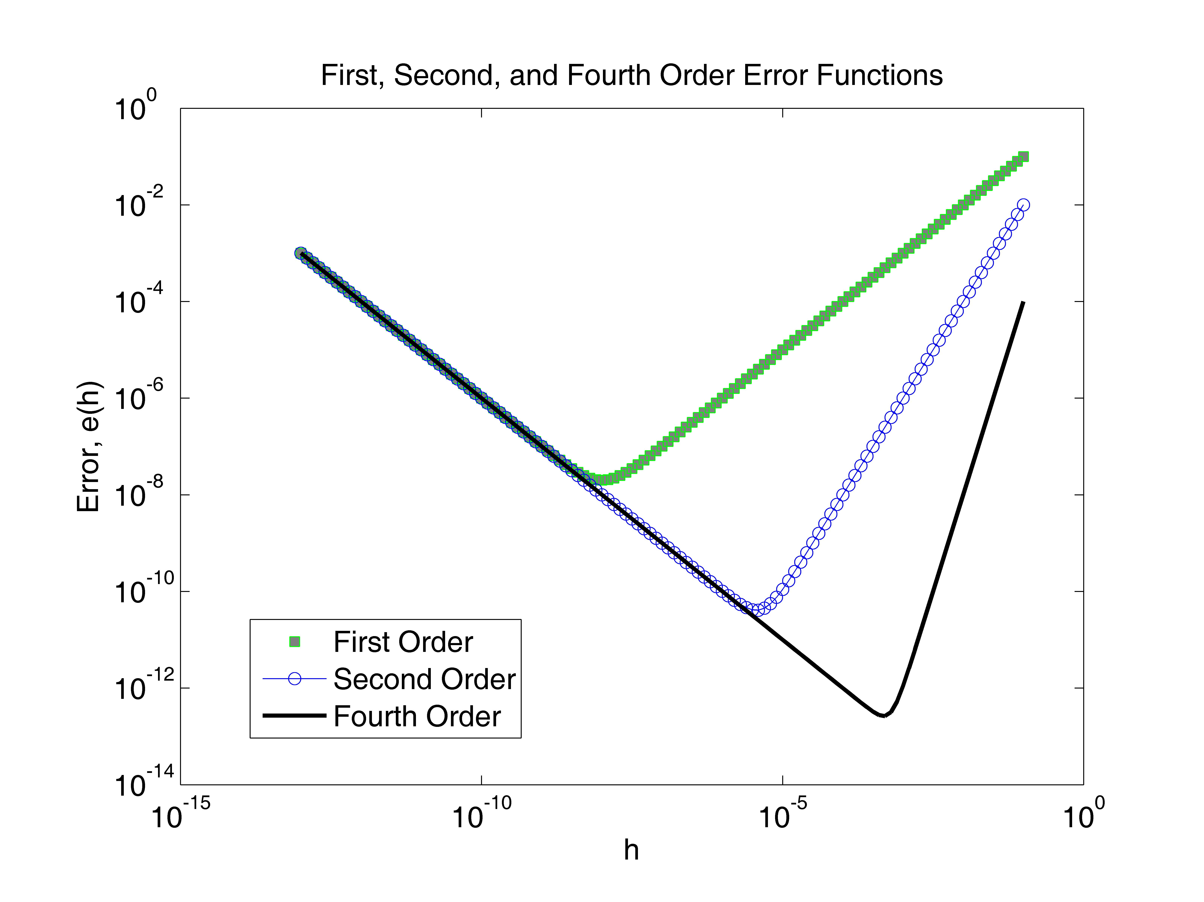
iv) The results show that the higher the order of total error, the smaller the error is. As well, there is a value h, which is not too big nor too small, that produces the smallest total error for each order function. The minimum for the first order total error is approximately E_{T} 2*10⁻¹⁶ when h 10⁻⁸. The minimum for the second order total error is approximately E_{T} 10^{-10.4} when h 10^{-5.4}. The minimum for the fourth order total error is approximately E_{T} 10^{-12.6} when h 10^{-3.3}.

(2):
- The problem I am to solve is to take the non-linear system:
e^{u} - cos(v) + u - v - c = 0
e^{v} + sin(u) + u + v = 0
u and v are functions of c and I am to plot the vectors corresponding to c values.
c is between [-10,30].
- I use Newton’s method to solve the system. I attain a 2N matrix (N is the number of c values inputted so it is 40 in this case). Values for u and v are stored in each row of the root vector solved by Newton’s method and I simply plot the points for each c.

- 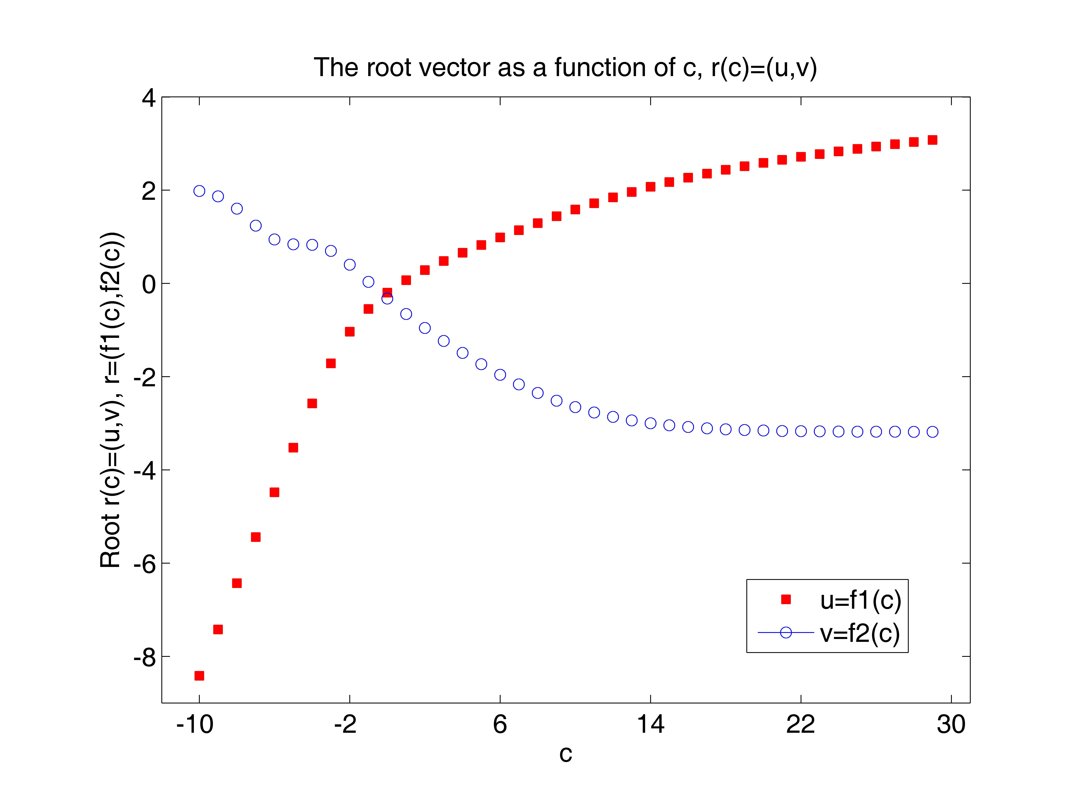The results I obtain plot a root vector r(c)=(u, v) for each c. Since are 40 values of c, there exists 40 plotted roots. c is between [-10, 30]. The root vector is broken into two curves, one for u=f1(c) and the other for v=f2(c). The length of the root vector approaches a minimum, u≈-0.198562977 and v≈-0.325989234, when c≈1. As c is small, the length of the vector is very large, but as c gets larger (but not too big) the length becomes smaller until it reaches the minimum around c≈1, then the length the of vector increases again, although not as rapid as before the minimum value.

(3):
i) In this problem I am to plot the root vector of a given “g.m” file for about 40 values of c between [5.8, 10].
ii) Using Matlab and Newton’s method, I will solve the system for g(r, c)=0
(g1(r, c=0, g2(r, c)=0). Incrementing c by 0.1, I attain 42 points that graph r(c)=(u, v).
iii)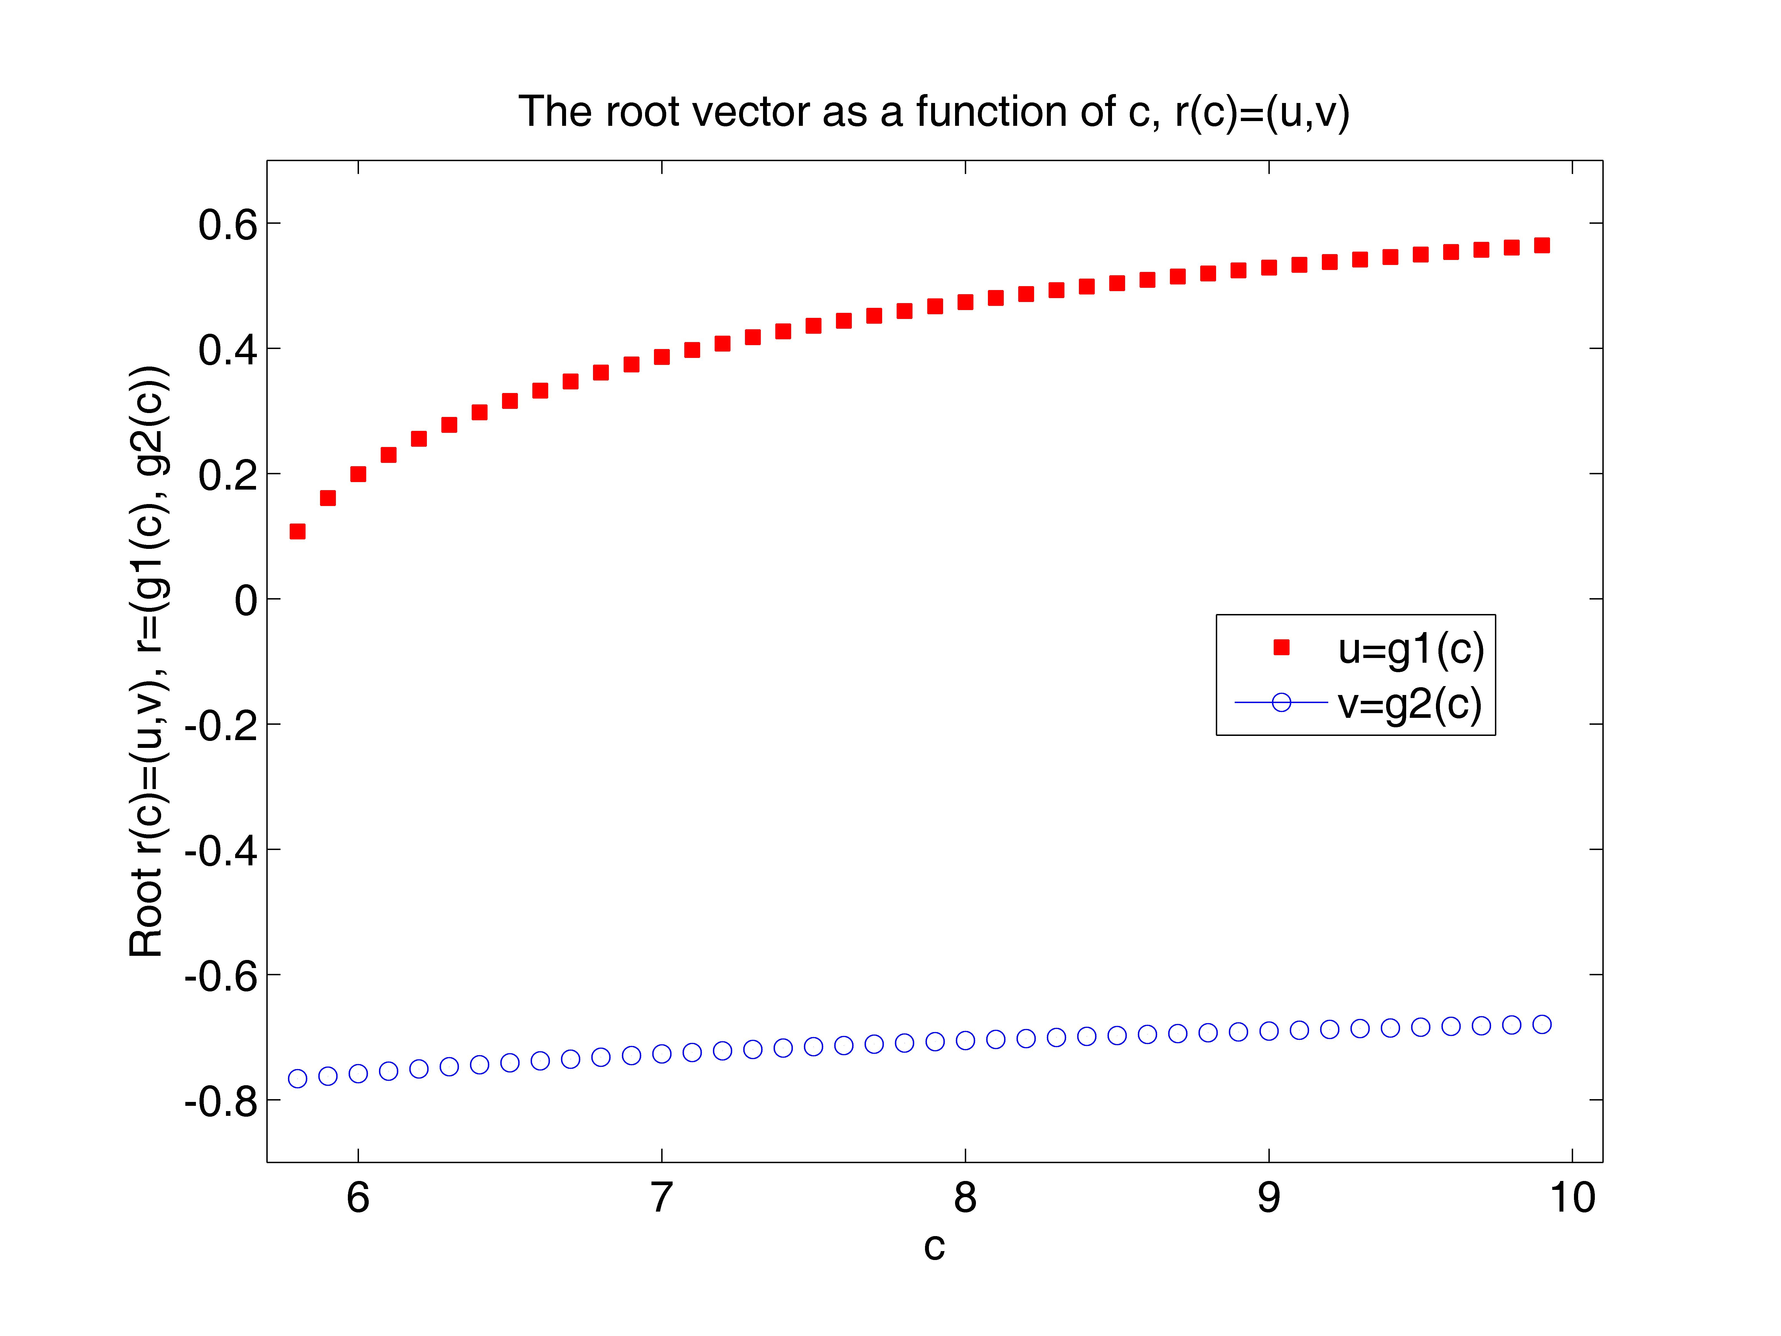
iv) The results show the root vector as a function of c (u(c) resembles the graph of y=√x, while v(c) resembles y=x/a, but slightly curved and not a straight line). As c increases, the length of the root vector increases, but not rapidly. A minimum on this plot occurs when c=5.8, resulting in u≈.107426025 and v≈-0.766365027.

APPENDIX
(Part B1):
“plot_error.m”
% The first, second, and fourth order errors are calculated
% and plotted as a function of h.

clear
figure(1)
clf
axes('position',[0.15,0.13,0.75,0.75])

% h is between [10.^-13, 10.^-1]
h=10.^([-13:.1:-1]);
% This function calculates the first order error error as a
% function of h.
e1=h+(1*(10.^-16))./h;
% This function calculates the second order error error as a
% function of h.
e2=(h.^2)+(1*(10.^-16))./h;
% This function calculates the fourth order error error as a
% function of h.
e4=(h.^4)+(1*(10.^-16))./h;

loglog(h, e1, 'gs', 'markerfacecolor', [.5,.5,.5])
hold on
loglog(h, e2, 'b-o')
hold on
loglog(h, e4, 'k-', 'linewidth',2.0)
set(gca,'fontsize',14)
xlabel('h')
ylabel('Error, e(h)')
title('First, Second, and Fourth Order Error Functions')
legend('First Order', 'Second Order', 'Fourth Order')

(Part B2):
“f.m”
function [y]=f(x,c)
% This function calculates f(x) for a given x and a parameter c.

u=x(1);
v=x(2);
y=zeros(2,1);
y(1)=exp(u)-cos(v)+u-v-c;
y(2)=exp(v)+sin(u)+v+u;

“fp_2.m”
function [D]=fp_2(x,c)
% This function calculates df(x)/dx for a given x and a parameter
% c, using a second finite difference method.

D=zeros(2,2);
h=1.0e-5;
D(:,1)=(f(x+[h,0]',c)-f(x-[h,0]',c))/(2*h);
D(:,2)=(f(x+[0,h]',c)-f(x-[0,h]',c))/(2*h);

“newton_sys.m”
function [ru, rv, n]=newton_sys(funct_name, deriv_name, c,u,v,tol)
% This function finds a root of f(x) = 0 using Newton's method.
%
% Input:
% funct_name: the name of the .m file for calculating the
% function f(x)
% deriv_name: the name of the .m file for calculating df(x)/dx
% c: a parameter in functions "f" and "fp"
% u, v: the starting point for Newton's method
% tol: the error tolerance
% Output:
% r: the root found
% n: the number of iterations

err=1.0;
n=0;
x0=[u v]';
%
while(err > tol),
n=n+1;
f_x0=feval(funct_name,x0,c);
fp_x0=feval(deriv_name,x0,c);
Dx=-fp_x0\f_x0;
x0=x0+Dx;
err=norm(Dx);
end
%
ru=x0(1);
rv=x0(2);

“run_newton.m”
% Consider the non-linear system
% exp(u) - cos(v) + u - v - c = 0
% exp(v) + sin(u) + v + u = 0
% This code calculates the root vector (u, v) for c = [-10, 30]

clear
figure(2)
clf
axes('position',[0.15,0.13,0.75,0.75])
%
c=[-10:1:30];
N=40;
r_u=zeros(N);
r_v=zeros(N);
n=zeros(N);
tol=1.0e-10;
%
for i=1:N,
r_u(i)=1;
r_v(i)=1;
[r_u(i), r_v(i), n(i)]=newton_sys('f', 'fp_2', c(i), r_u(i), r_v(i), tol);
end
%
for j=1:N,
r=[r_u(j) r_v(j)]';
disp(' ')
disp([' The root found is (u, v) = (',num2str(r(1),'%16.8e'),', ',num2str(r(2),'%16.8e'),').'])
disp([' It takes n = ',num2str(n(j)),' iterations to reach err <= ',...
num2str(tol),'.'])
disp(' ')
plot(c(j), r_u(j), 'sr', 'MarkerFaceColor', 'r')
hold on
plot(c(j), r_v(j), 'b-o')
end
%
axis([-12,31,-9,4])
set(gca,'xtick',[-10:8:30])
set(gca,'ytick',[-8:2:4])
set(gca, 'fontsize', 14)
xlabel('c')
ylabel('Root r(c)=(u,v), r=(f1(c),f2(c))')
title('The root vector as a function of c, r(c)=(u,v)')
legend('u=f1(c)','v=f2(c)')

(Part B3):
“g.m”
function [z]=g(r,c)
% r=(u,v)'
% z=g(r,c)=(g1(u,v,c), g2(u,v,c))'
%
% DO NOT MODIFY THIS FILE!!!!!

N=128;
da=pi/N;
a=[0:N]*da;
[x,y]=meshgrid(a,a);
%
alpha=c;
mu=0.6;
alpha0=1;
E=1;
r1=r(1);
r3=r(2);
%
h1=sin(y).*cos(x);
h3=cos(y);
g0=sin(y).*exp(alpha*r1*h1+(alpha*r3+mu*E)*h3+0.5*alpha0*E^2*h3.^2);
%
g=g0;
g(:,1)=0.5*(g(:,1)+g(:,N+1));
u1=sum(g(:,1:N),2)*da;
%
g=h1.*g0;
g(:,1)=0.5*(g(:,1)+g(:,N+1));
u2=sum(g(:,1:N),2)*da;
%
g=h3.*g0;
g(:,1)=0.5*(g(:,1)+g(:,N+1));
u3=sum(g(:,1:N),2)*da;
%
u=[u1, u2, u3];
u(1,:)=0.5*(u(1,:)+u(N+1,:));
v1=sum(u(1:N,:),1)*da;
v2=sum(u(1:2:N,:),1)*2*da;
v3=sum(u(1:4:N,:),1)*4*da;
v4=sum(u(1:8:N,:),1)*8*da;
v5=sum(u(1:16:N,:),1)*16*da;
v6=sum(u(1:32:N,:),1)*32*da;
v1=(4*v1-v2)/3;
v2=(4*v2-v3)/3;
v3=(4*v3-v4)/3;
v4=(4*v4-v5)/3;
v5=(4*v5-v6)/3;
v1=(16*v1-v2)/15;
v2=(16*v2-v3)/15;
v3=(16*v3-v4)/15;
v4=(16*v4-v5)/15;
v1=(64*v1-v2)/63;
v2=(64*v2-v3)/63;
v3=(64*v3-v4)/63;
v1=(256*v1-v2)/255;
v2=(256*v2-v3)/255;
v1=(512*v1-v2)/511;
err=(v1-v2)/norm(v1);
%
z=[v1(2)/v1(1)-r1; v1(3)/v1(1)-r3];

“gp_2.m”
function [D]=gp_2(r,c)
% This function calculates df(x)/dx for a given x and a parameter
% c, using a second finite difference method.

D=zeros(2,2);
h=1.0e-5;
D(:,1)=(g(r+[h,0]',c)-g(r-[h,0]',c))/(2*h);
D(:,2)=(g(r+[0,h]',c)-g(r-[0,h]',c))/(2*h);

“run_newton_g.m”
% Consider the non-linear system
% g1(u,v,c)=0
% g2(u,v,c)=0
% This code calculates the root vector (u, v) for c = [5.8, 10]

clear
figure(3)
clf
axes('position',[0.15,0.13,0.75,0.75])
%
c=[5.8:.1:10];
N=42;
r_u=zeros(N);
r_v=zeros(N);
n=zeros(N);
tol=1.0e-10;
%
r_u(1)=0.1;
r_v(1)=-0.8;
[r_u(1), r_v(1), n(1)]=newton_sys('g', 'gp_2', c(1), r_u(1), r_v(1), tol);
for i=2:N,
r_u(i)=r_u(i-1);
r_v(i)=r_v(i-1);
[r_u(i), r_v(i), n(i)]=newton_sys('g', 'gp_2', c(i), r_u(i), r_v(i), tol);
end
for j=1:N,
r=[r_u(j) r_v(j)]';
disp(' ')
disp([' The root found is (u, v) = (',num2str(r(1),'%16.8e'),', ',num2str(r(2),'%16.8e'),').'])
disp([' It takes n = ',num2str(n(j)),' iterations to reach err <= ',...
num2str(tol),'.'])
disp(' ')
plot(c(j), r_u(j), 'sr', 'MarkerFaceColor', 'r')
hold on
plot(c(j), r_v(j), 'b-o')
end
%
axis([5.7,10.1,-.9,.7])
set(gca,'xtick',[6:1:10])
set(gca,'ytick',[-.8:.2:.6])
set(gca, 'fontsize', 14)
xlabel('c')
ylabel('Root r(c)=(u,v), r=(g1(c), g2(c))')
title('The root vector as a function of c, r(c)=(u,v)')
legend('u=g1(c)','v=g2(c)')

