Derek Frank
dmfrank@ucsc.edu
AMS 147
2/17/10
Homework #5

  - The first problem I am to solve is to estimate the error caused by the numerical estimation of ²₀ e^{sinx}x using both the composite Trapezoidal rule and the composite Simpson rule. The spatial step size, h, depends on N=2^{[1:1:10]}.
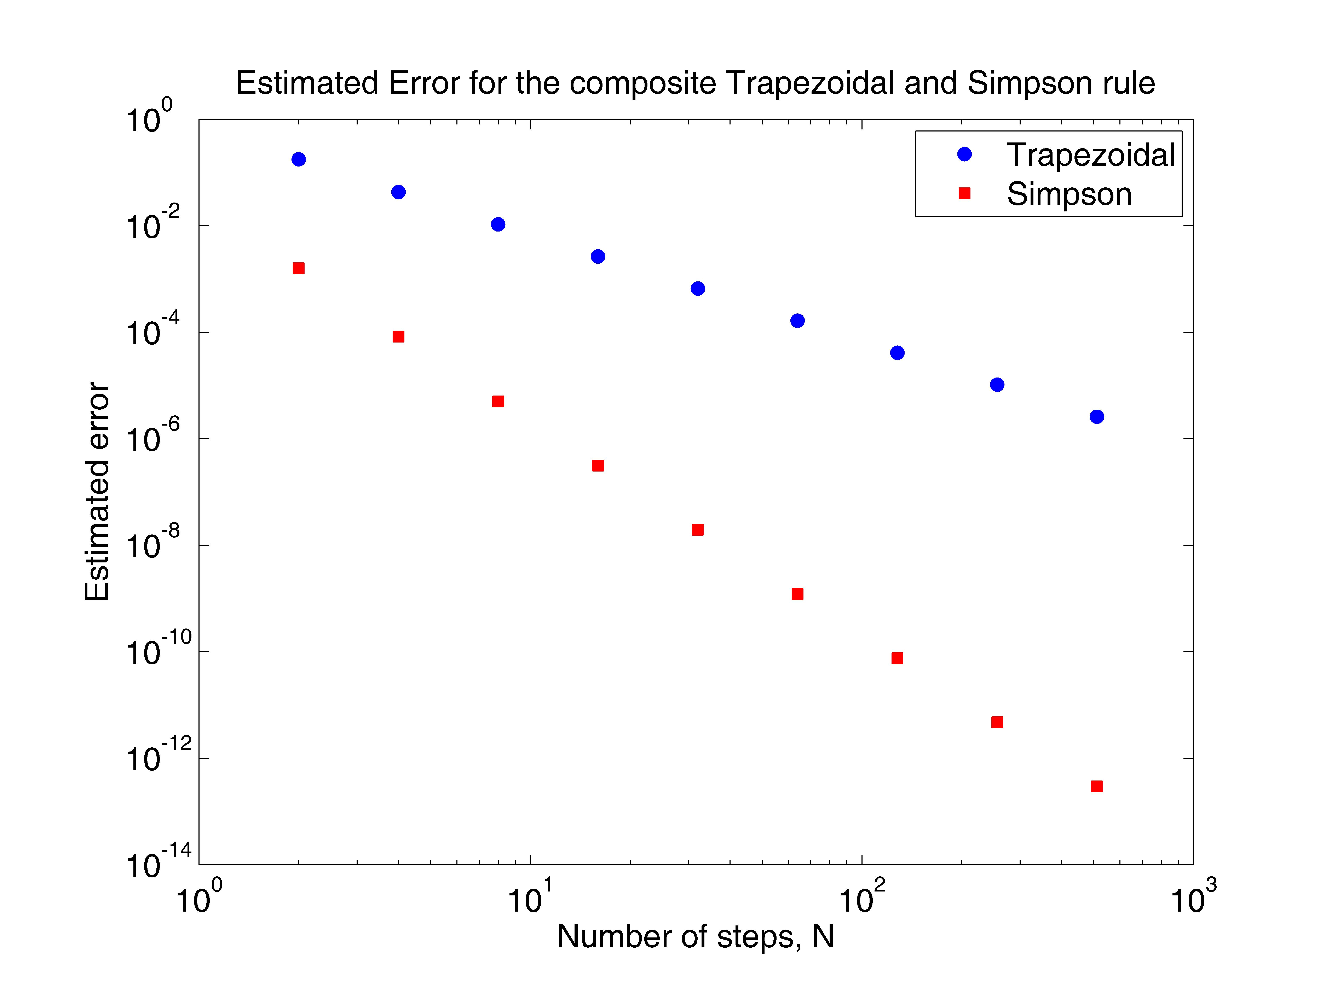
  - To solve this problem, I implement both methods in Matlab as functions to determine the numerical estimation of each rule. The rules are treated as functions so that I can vary the value of h and call on them multiple times. Now I implement the numerical estimation, E(h)=(T(h)-T(^{h}/₂))/(1-(¹/₂)^{p}), in Matlab. I find the numerical values for each N and h and solve for the error. The composite Trapezoidal rule is a second order method, while the composite Simpson rule is a fourth order method.

  - Both the composite Simpson rule, the fourth order method, and the composite Trapezoidal rule, the second order method, appear linear on the log-scale. Nevertheless, the Simpson rule attains more accuracy than the Trapezoidal rule on this plot. Both methods become more accurate as N gets larger, however, the Simpson rule becomes accurate more quickly than the Trapezoidal rule.

  - In this problem I am to estimate the order of accuracy of the numerical estimation of ²₀ e^{-x}x using the composite Simpson rule. The spatial step size, h, depends on N=2^{[1:1:10]}.
  - Using Matlab, I first implement the Simpson rule, then the estimation of the order of accuracy. The order of accuracy, p, can be estimated by calculating p=log₂[(T(h)-T(^{h}/₂))/ (T(^{h}/₂)-T(^{h}/₄))].

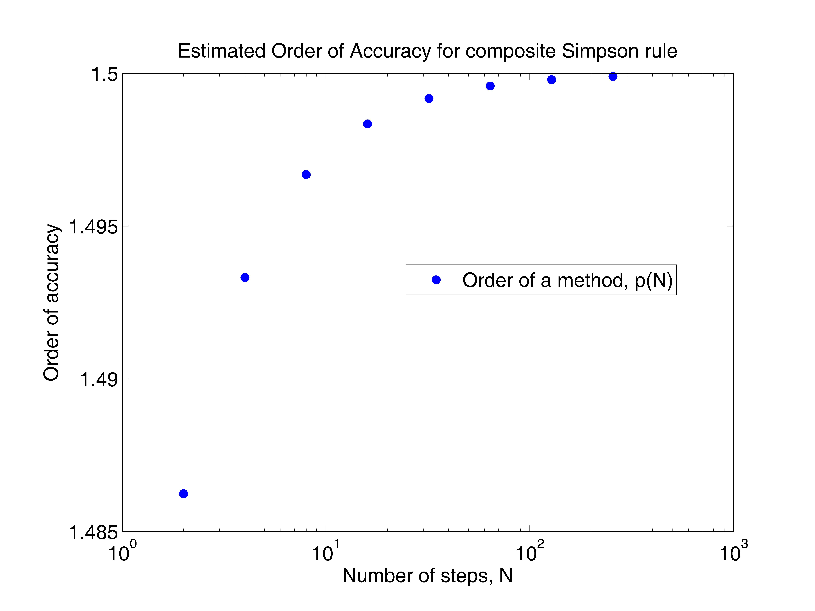
  - The results show the order of accuracy, p, approaching 1.5 as N gets bigger.

  - In the final problem, I am to solve y`=-sin(y)+2(t)sin(4t) for t=[0,5] given y(0)=1.
  - Using Matlab, I implement Euler’s method, y_{n+1}=y_{n}+hF(y_{n},t_{n}), to solve for y(t) on the interval for t=0 to t=5 with a time step h=0.1. I then implement the error estimation on Eulers method by solving for y(t), with h and ^{h}/₂, and calculate E(h)=(T(h)-T(^{h}/₂))/(1-(¹/₂)). I can now plug in any value of h to plot the error.

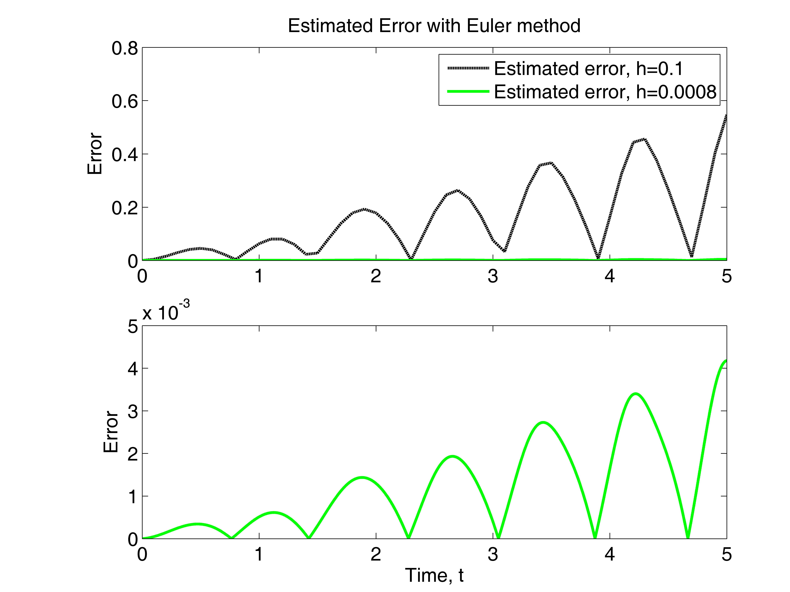
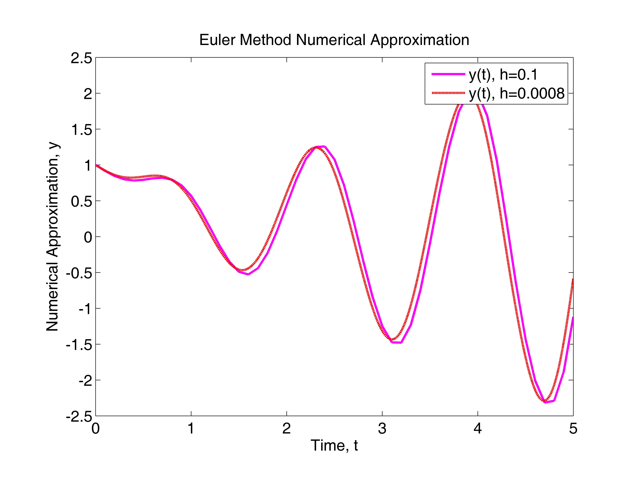

  - The results show, in particular, that the more time steps that occur, the more accurate the numerical approximation. After noticing the error approximated, with h=0.1 and t=5, was err(5)=.546756721, I quickly found that either h=.0008 or h=.0005 produce an error<0.005. I used h=0.0008 to attain the err(5)=0.00417846983 and indeed the error is less than 0.005.

Appendix:
- “err_est.m”
% This code estimates the error of the numerical integration
% method and plots it as a function of the number of steps, N,
% per spatial step, h.
%
clear
figure(1)
clf reset
axes('position',[0.15,0.13,0.75,0.75])
%
a=0.0; b=2.0;
N=2.^([1:1:10]);
Nsize=10;
h=(b-a)./N;
%
T=zeros(Nsize); S=zeros(Nsize);
for i=1:Nsize,
[T(i)]=trap_num_est(h(i),N(i));
[S(i)]=simp_num_est(h(i),N(i));
end
% second order
errT=abs(T(1:Nsize-1)-T(2:Nsize))/(1-0.5^2)+1.0e-16;
% fourth order
errS=abs(S(1:Nsize-1)-S(2:Nsize))/(1-0.5^4)+1.0e-16;
%
loglog(N(1:Nsize-1), errT,'bo', 'markerfacecolor', 'b')
hold on
loglog(N(1:Nsize-1), errS,'rs', 'markerfacecolor', 'r')
hold on
%
set(gca,'fontsize',14)
xlabel('Number of steps, N')
ylabel('Estimated error')
title('Estimated Error for the composite Trapezoidal and Simpson rule')
legend('Trapezoidal', 'Simpson')

“trap_est.m”
function [T]=trap_num_est(h,N)
% This code uses the composite Trapezoidal rule to calculate
% int_{a}^{b} f(x) dx.
%
a=0.0; b=2.0;
nsize=10;
%
x=a+[0:N]*h;
y=f(x);
T=(y(1)+y(N+1)+2*sum(y(2:N)))*h/2;

“simp_est.m”
function [T]=simp_num_est(h, N)
% This code uses the composite Simpson rule to calculate
% int_{a}^{b} f(x) dx.
%
a=0.0; b=2.0;
%
x=a+[0:N]*h;
y=f(x);
x2=a+[0:N-1]*h+h/2;
y2=f(x2);
T=(y(1)+y(N+1)+2*sum(y(2:N))+4*sum(y2))*h/6;

“f.m”
function [y]=f(x)
% This function calculates f(x).
%
y=exp(sin(x));

- “simp_ord_acc.m”
% This code determines the order of accuracy for the
% int_a^b f(x)=exp(-sqrt(x)) dx
% using the composite Simpson rule.
%
clear
figure(2)
clf reset
axes('position',[0.15,0.13,0.75,0.75])
%
a=0.0; b=2.0;
Nsize=10;
N=2.^[1:1:Nsize];
h=(b-a)./N;
S=zeros(Nsize);
for i=1:Nsize,
[S(i)]=simp_num_est(h(i),N(i));
end
%
err1=abs(S(1:Nsize-1)-S(2:Nsize))+1.0e-16;
p=log2((err(1:Nsize-2))./(err(2:Nsize-1)));
%
semilogx(N(1:Nsize-2),p,'bo','markerfacecolor','b')
set(gca,'fontsize',14)
xlabel('Number of steps, N')
ylabel('Order of accuracy')
title('Estimated Order of Accuracy for composite Simpson rule')
legend('Order of a method, p(N)')
%
disp(['p = [',num2str(p),']'])
for i=1:Nsize,
disp(['S = [',num2str(S(i)),']'])
end

“simp_num_est.m”
function [T]=simp_num_est(h, N)
% This code uses the composite Simpson rule to calculate
% int_{a}^{b} f(x) dx.
%
a=0.0; b=2.0;
%
x=a+[0:N]*h;
y=f(x);
x2=a+[0:N-1]*h+h/2;
y2=f(x2);
T=(y(1)+y(N+1)+2*sum(y(2:N))+4*sum(y2))*h/6;

“f.m”
function [y]=f(x)
% This function calculates f(x) for a given x.
%
y=exp(-sqrt(x));

- “run_euler.m”
% Calculate and plot the error estimation for h=.1 and h=.0008
%
clear
figure(4)
clf reset
[y t1]=est_err(.1);
[y2 t2]=est_err(.0008);
%
axes('position',[0.18,0.56,0.74,0.36])
plot(t1,y,'k--','linewidth', 2.0)
hold on
plot(t2,y2,'g-','linewidth',2.0)
legend('Estimated error, h=0.1','Estimated error, h=0.0008')
set(gca,'fontsize',14)
ylabel('Error')
title('Estimated Error with Euler method')
%
axes('position',[0.18,0.09,0.74,0.36])
plot(t2,y2,'g-','linewidth',2.0)
set(gca,'fontsize',14)
xlabel('Time, t')
ylabel('Error')

“est_err.m”
function [err_est, t1]=est_err(h)
% This code uses the Euler method to solve y'=-sin(y)+2*t*sin(4*t)
% with time step h=0.1 and h=0.05. Then it estimates the error
% and plots the estimated error as a function of time.
%
y0=1;
%h=.1;
%
% Run with h
%
n=5/h;
t=[0:n]*h;
y=zeros(1,n+1);
y(1)=y0;
for j=1:n,
y(j+1)=y(j)+h*(-sin(y(j))+2*t(j)*sin(4*t(j)));
end
h1=h;
n1=n;
t1=t;
y1=y;
%
% Run with h/2
%
h=h/2;
n=5/h;
t=[0:n]*h;
y=zeros(1,n+1);
y(1)=y0;
for j=1:n,
y(j+1)=y(j)+h*(-sin(y(j))+2*t(j)*sin(4*t(j)));
end
h2=h;
n2=n;
t2=t;
y2=y;
%
% Error at t=5
err_t5=abs(y1(n1+1)-y2(n2+1))/(1-0.5);
disp(' ')
disp([' The estimated error for h = ',num2str(h1),' at t = 5 is'])
disp([' Error = ',num2str(err_t5,'%16.8e'),'.'])
disp(' ')
%
% Error as a function of time
err_est=abs(y1-y2(1:2:n2+1))/(1-0.5);

“Euler.m”
% This code uses the Euler method to solve y'=-sin(y)+2*t*sin(4*t)
% from t=0 to t=5. Then it plots the numerical solution
%
clear
figure(3)
clf reset
axes('position',[0.15,0.13,0.75,0.75])
%
y0=1;
h=0.1;
%
n=5/h;
t=[0:n]*h;
y=zeros(1,n+1);
y(1)=y0;
%
for j=1:n,
y(j+1)=y(j)+h*(-sin(y(j))+2*t(j)*sin(4*t(j)));
end
% h=.0008
h2=0.0008;
%
n2=5/h2;
t2=[0:n2]*h2;
y2=zeros(1,n2+1);
y2(1)=y0;
%
for j=1:n2,
y2(j+1)=y2(j)+h2*(-sin(y2(j))+2*t2(j)*sin(4*t2(j)));
end
%
plot(t,y,'m-','linewidth',2.0)
hold on
plot(t2,y2,'r--','linewidth',2.0)
%
set(gca,'fontsize',14)
xlabel('Time, t')
ylabel('Numerical Approximation, y')
title('Euler Method Numerical Approximation')
legend('y(t), h=0.1','y(t), h=0.0008')

