Derek Frank
dmfrank@ucsc.edu
AMS 147
Due: 1/20/10
Homework #1

PartB:
(1):
i) The given quadratic equation, x^2+b*x+c=0, has two roots,
r1(b)=(-b+sqrt(b^2-4*c))/2 and r2(b)=(-b-sqrt(b^2-4*c))/2.
Since c is set to equal 1, c=1, the two roots are functions
of b. Using Matlab, I have to plot these functions for when
b is between [2,3].

ii) Using Matlab code to plot 100 points for each function, I
attain a 2-dimensional graph with two lines.
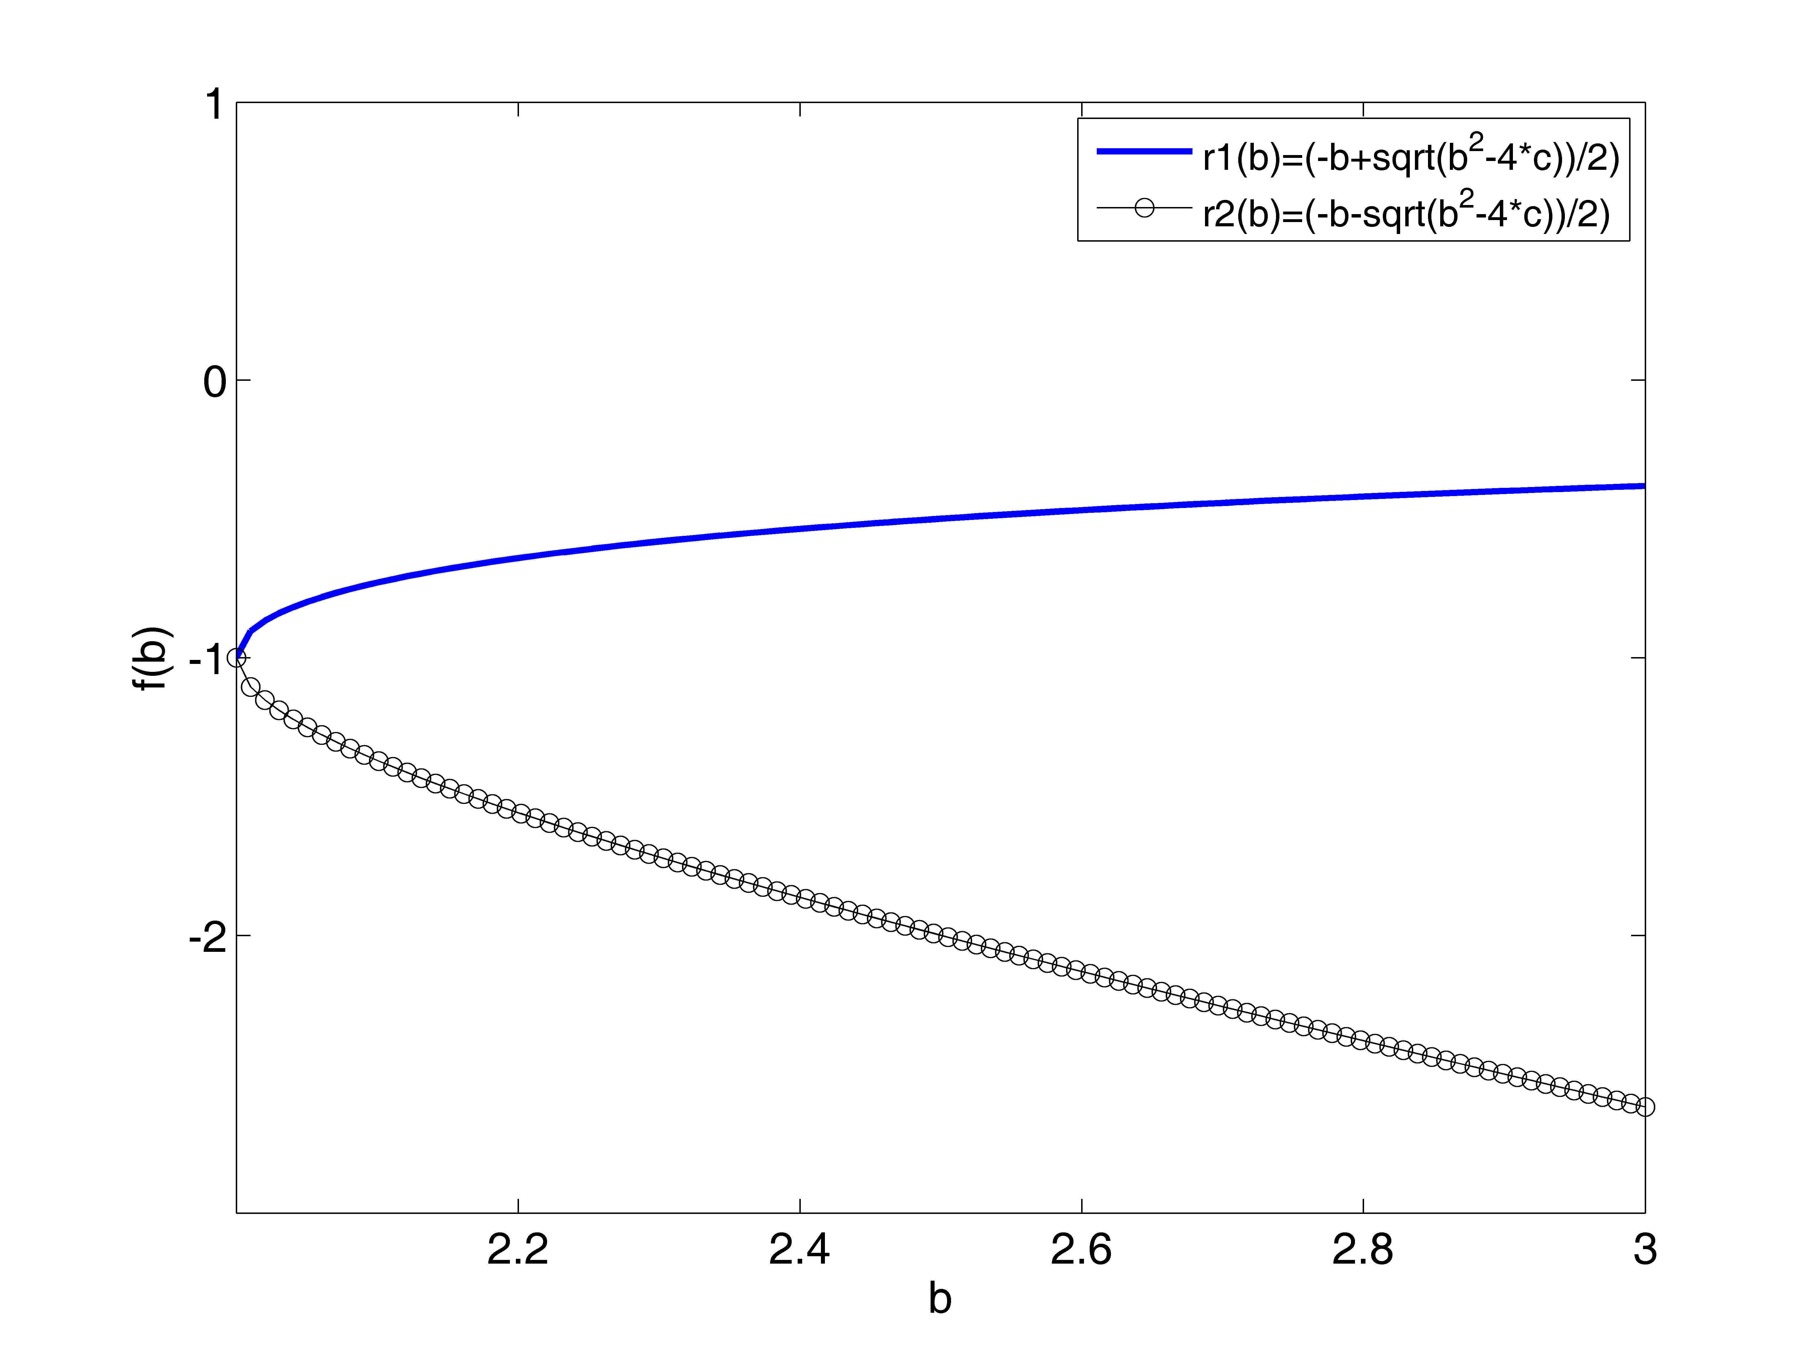
iii) The resulting graph is that of a sideways parabola opening
to the right. The vertex is at (2,-1). The roots, r1 and r2,
are reflections of the other over the line y=-1.

(2):
i) Given f(x,y)=sin(x^2+y^2)*exp(-sprt(x^2+y^2)), I am going
to use Matlab to plot the function when x is between [-3,3]
and y is between [-3,3].

ii) Using Matlab code to plot the function with 30 points, I
attain a 3-dimensional graph of a surface.
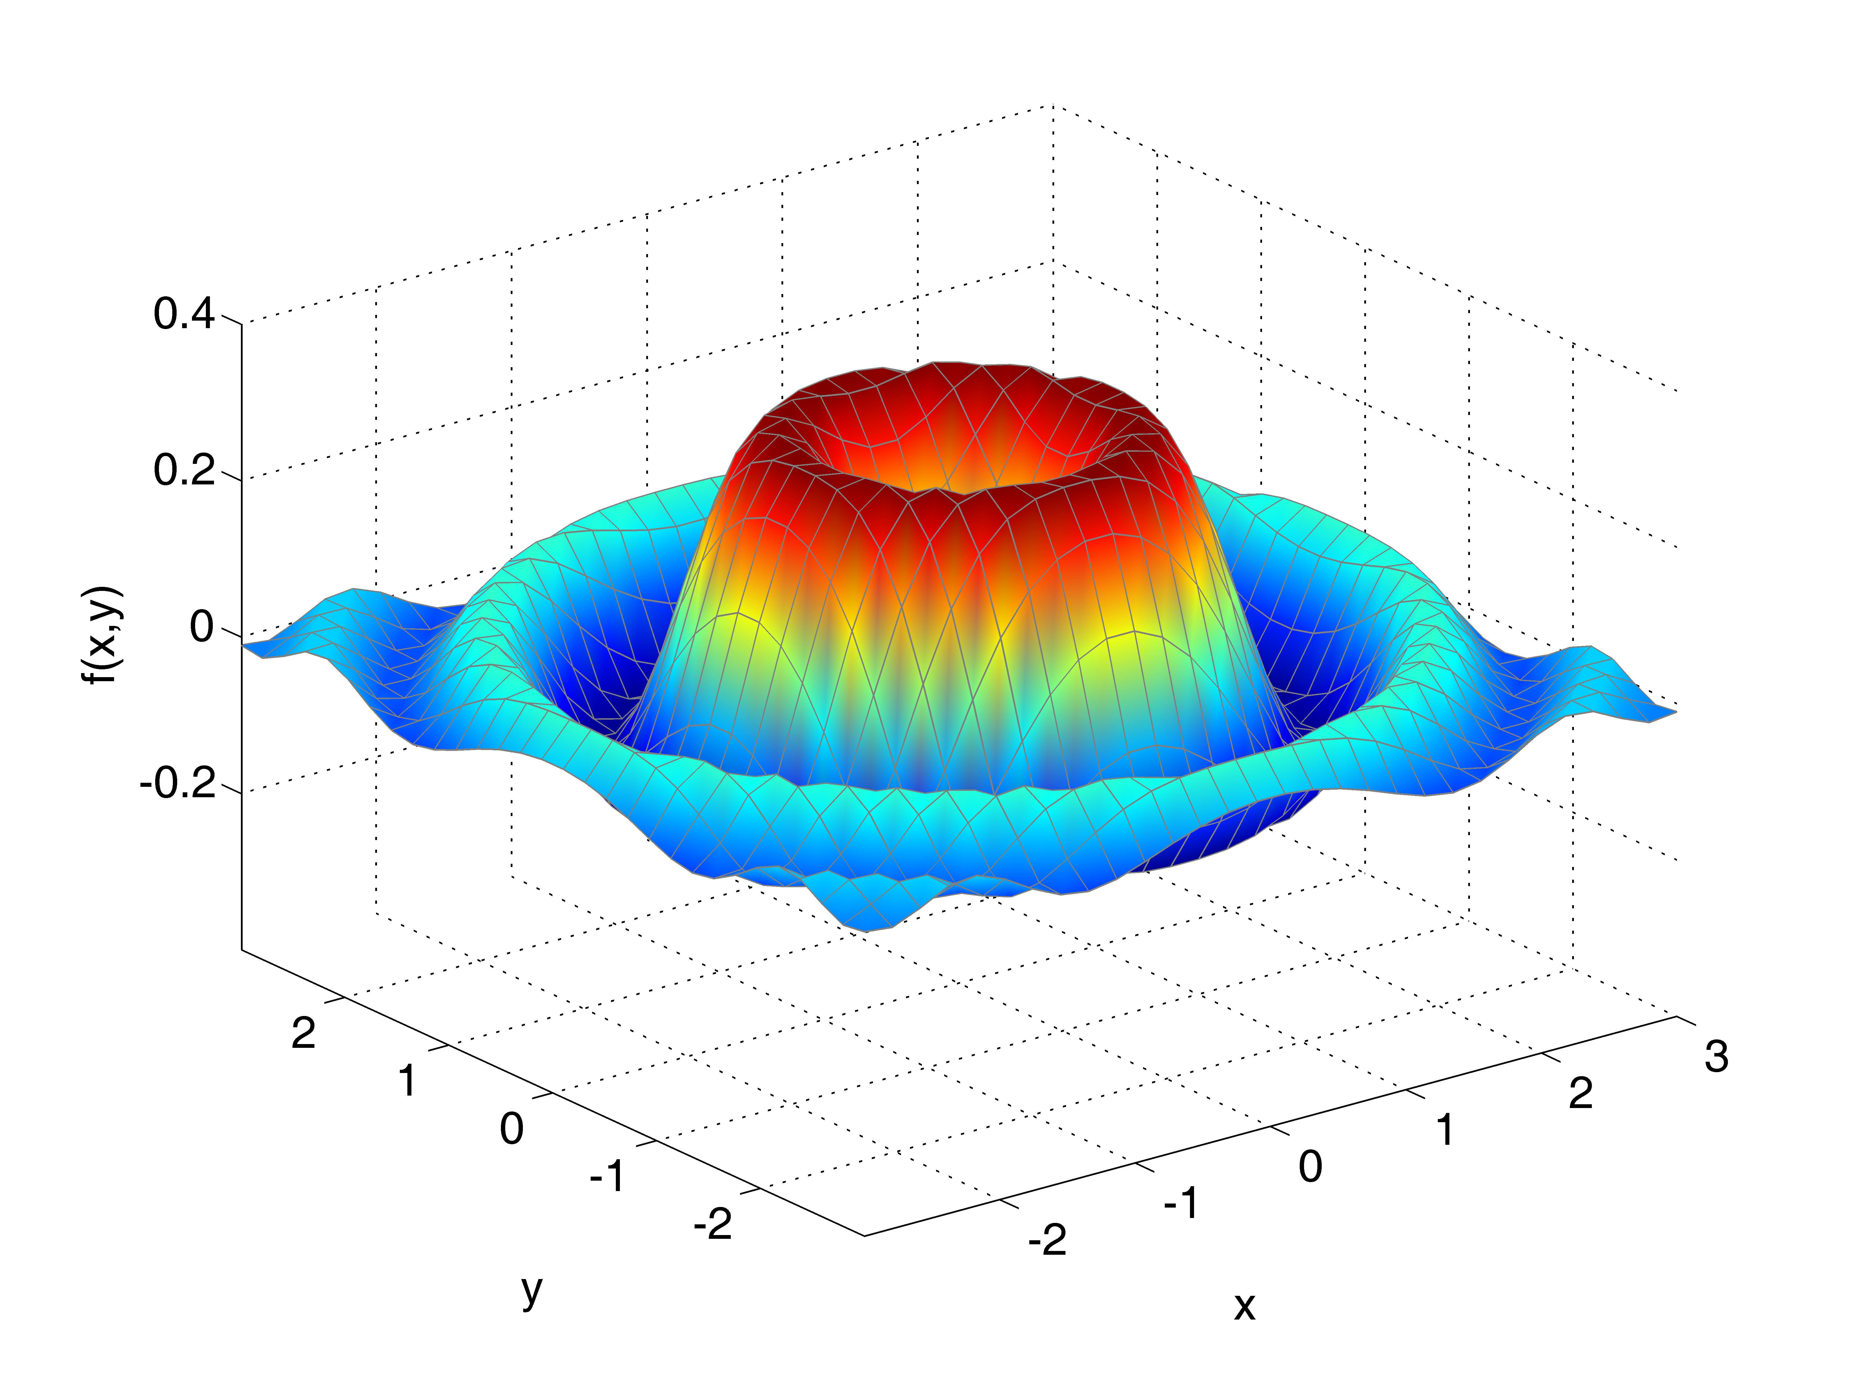
iii) The resulting graph appears like the look of water after
dropping something heavy into it. A large ring, like a wave,
is surrounded by smaller wave rings with a cave-in in the
center. The surface is limited in height to under .4 and
contained above -.4.

(3):
i) Given a file "data1.txt" and a fitting function (a function
that resembles the given data points when plotted),
f(x)=exp(-c*x)*cos(2*x), I need to find an approximation for
the value of c and use Matlab to plot the given data and
fitting function.

ii) To find an approximation for c I take a look at the values
for x and y in the file "data1.txt" and plug them into the
given fitting function and solve for c. I do this for when
x=2,3,4,5,6 and attain five different values of c. I take
the average of these values to attain the best approximation
and find that c approximately equals .2295528077. I use this
value of c in Matlab to plot the function and after loading
and plotting the data in "data1.txt" I attain a 2-dimensional
graph.
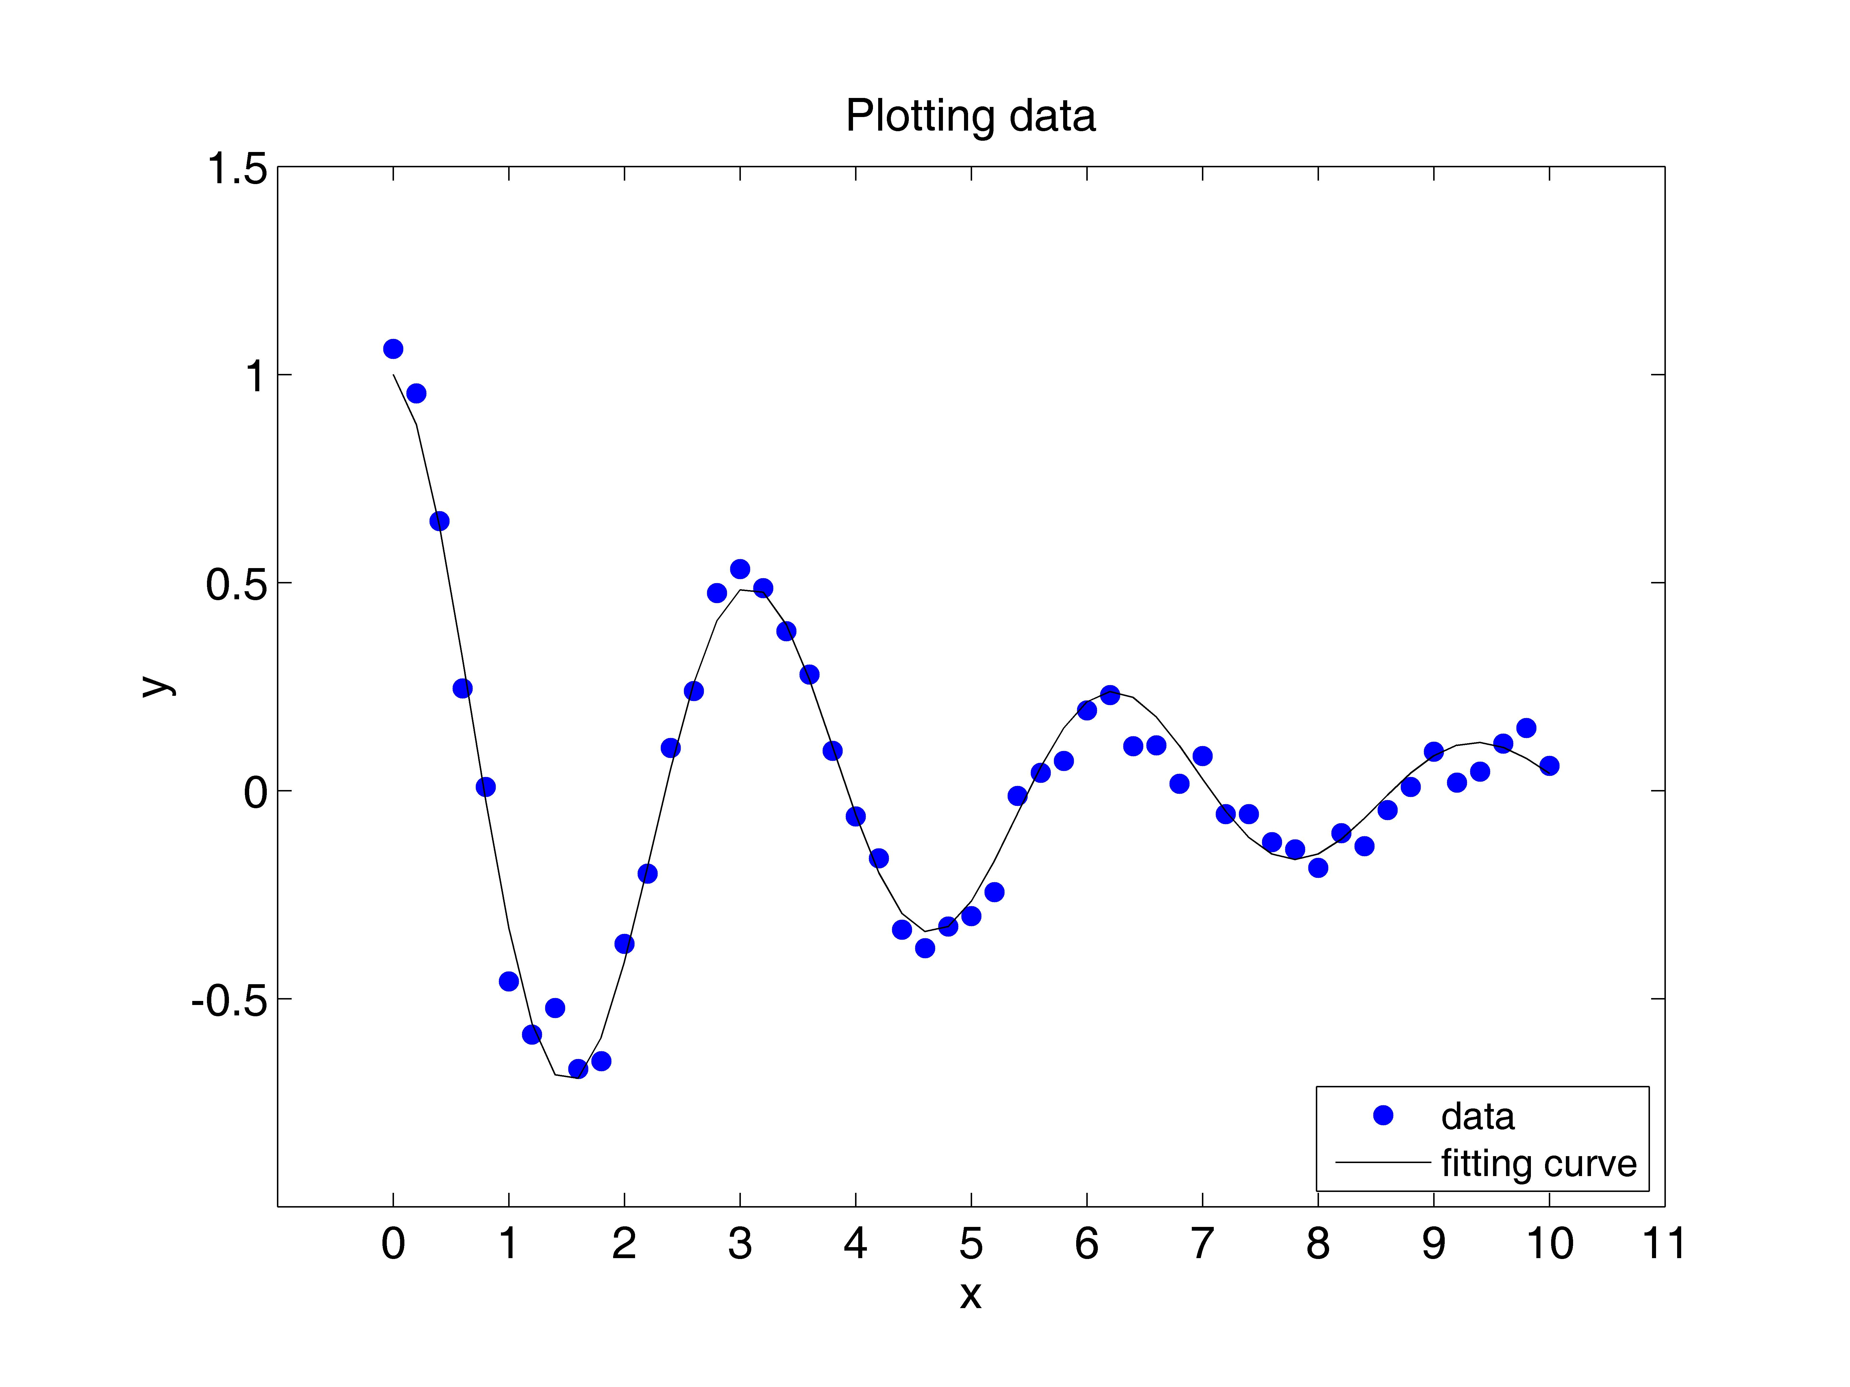
iii) The fitting curve is not perfect so that is contains the
exact same data points as plotted from "data1.txt," but it
follows the same shape. The curve is similar to a cosine
function because it is wave-like, yet the wave gets smaller
as x gets bigger. y appears to be approaching 0 as x gets
large.

APPENDIX (1): “plot_rb.m”
%
% Plot r1 = f1(b) = (-b+sqrt(b^2-4*c))/2) and
% r2 = f2(b) = (-b-sqrt(b^2-4*c))/2) for b in [2,3]
%
clear;
clf;
%
n=100;
db=1/(n-1);
b=[2:db:3];
c=1;
r1=(-b+sqrt((b.^2)-4*c))/2;
r2=(-b-sqrt((b.^2)-4*c))/2;
%
plot(b,r1,'b-','linewidth',2.0)
hold on
plot(b,r2,'k-o')
axis([2.0,3.0,-3.0,1.0])
set(gca,'xtick',[2.2:.2:3])
set(gca,'ytick',[-2:1:1])
set(gca,'fontsize',14)
xlabel('b')
ylabel('f(b)')
h1=legend('r1(b)=(-b+sqrt(b^2-4*c))/2)','r2(b)=(-b-sqrt(b^2-4*c))/2)');
set(h1,'fontsize',12)
%

APPENDIX (2): “plot_fxy.m”
%
% Plot f(x,y) = sin(x^2+y^2)*exp(-sqrt(x^2+y^2))
% for x in [-3,3] and y in [-3,3].
%
clear;
clf;
%
m=30;
n=30;
dx=6/(n-1);
dy=6/(m-1);
x1=[-3:dx:3];
y1=[-3:dy:3];
%
[x,y]=meshgrid(x1,y1);
%
f=sin(x.^2+y.^2).*exp(-sqrt(x.^2+y.^2)) ;
%
h=surf(x,y,f);
set(h,'facecolor','interp')
set(h,'edgecolor',[0.5,0.5,0.5])
%
axis([-3.0,3.0,-3.0,3.0,-.4,.4])
set(gca,'xtick',[-2:1:3])
set(gca,'ytick',[-2:1:2])
set(gca,'ztick',[-.2:.2:.4])
set(gca,'fontsize',14)
xlabel('x')
ylabel('y')
zlabel('f(x,y)')
%

APPENDIX (3): “plot_fx_data.m”
% Derek Frank, dmfrank@ucsc.edu
% HW1: PartB (3)
% Due: 1/20/10
%
% This code reads in data from data1.txt and plots
% f(x) = exp(-c*x)*cos(2*x) along with the data from data1.txt
%
clear
figure(3)
clf reset
axes('position',[0.15,0.13,0.75,0.75])
%
load -ascii data1.txt
x=data1(:,1);
y=data1(:,2);
%
% fit the data to f(x)
x2=[0:.2:10];
C=.2295528077;
y2=exp(-C.*x2).*cos(2.*x2);
%
plot(x,y,'bo','markerfacecolor','b')
hold on
plot(x2,y2,'k-')
set(gca,'fontsize',14)
axis([-1.0,11.0,-1.0,1.5])
set(gca,'xtick',[0:1:11])
set(gca,'ytick',[-.5:.5:1.5])
xlabel('x')
ylabel('y')
title('Plotting data')
h1=legend('data','fitting curve',4);
set(h1,'fontsize',12)
%

APPENDIX (4): “data1.txt”
% x y
%
0.0000000e+00 1.0616627e+00
2.0000000e-01 9.5438313e-01
4.0000000e-01 6.4726669e-01
6.0000000e-01 2.4543142e-01
8.0000000e-01 8.6474234e-03
1.0000000e+00 -4.5847332e-01
1.2000000e+00 -5.8629116e-01
1.4000000e+00 -5.2270060e-01
1.6000000e+00 -6.6897708e-01
1.8000000e+00 -6.5025323e-01
2.0000000e+00 -3.6829629e-01
2.2000000e+00 -1.9946104e-01
2.4000000e+00 1.0214847e-01
2.6000000e+00 2.3939828e-01
2.8000000e+00 4.7441685e-01
3.0000000e+00 5.3204202e-01
3.2000000e+00 4.8645531e-01
3.4000000e+00 3.8277756e-01
3.6000000e+00 2.7859469e-01
3.8000000e+00 9.5304196e-02
4.0000000e+00 -6.1937557e-02
4.2000000e+00 -1.6264995e-01
4.4000000e+00 -3.3465224e-01
4.6000000e+00 -3.7848057e-01
4.8000000e+00 -3.2684557e-01
5.0000000e+00 -3.0202142e-01
5.2000000e+00 -2.4418751e-01
5.4000000e+00 -1.2606921e-02
5.6000000e+00 4.2709432e-02
5.8000000e+00 7.1364914e-02
6.0000000e+00 1.9256373e-01
6.2000000e+00 2.2975779e-01
6.4000000e+00 1.0651973e-01
6.6000000e+00 1.0873230e-01
6.8000000e+00 1.6313790e-02
7.0000000e+00 8.2753168e-02
7.2000000e+00 -5.6705147e-02
7.4000000e+00 -5.6552321e-02
7.6000000e+00 -1.2417349e-01
7.8000000e+00 -1.4140695e-01
8.0000000e+00 -1.8606224e-01
8.2000000e+00 -1.0253530e-01
8.4000000e+00 -1.3337982e-01
8.6000000e+00 -4.7083796e-02
8.8000000e+00 8.5379099e-03
9.0000000e+00 9.3244738e-02
9.2000000e+00 1.8795176e-02
9.4000000e+00 4.5569780e-02
9.6000000e+00 1.1312777e-01
9.8000000e+00 1.5024618e-01
1.0000000e+01 5.9238496e-02
%

