**SELCOV Concept Document**

1. **Introduction**

SELCOV is an open source program that will work with the GCC compiler to display the control flow of a program and its test coverage information. It assists developers in ensuring that their test cases satisfy whether or not all tests have sufficient coverage.

1. **Problem Statement**

It is difficult to completely map out and display all test coverage data. This results in occurrences of untested code and leads to error-prone software. As a result, test engineers do not have a standardized method for checking whether or not all test requirements have been met. SELCOV provides solutions to these problems.

1. **Key Features**
   1. SELCOV detects whether or not any particular branch of code has been executed.  
         
      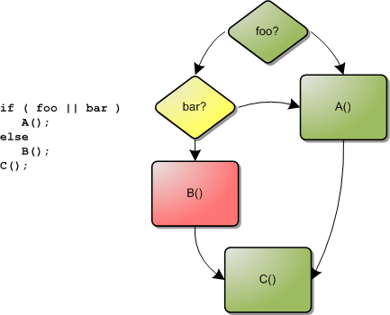
   2. SELCOV checks test cases versus source code and outputs test coverage data. Example output:

* 1. SELCOV will be cross platform compatible and work with multiple computer architectures.  
      
* PowerPC
* Intel x86
  1. SELCOV will save a parsed results file into a cache where it will remain while the corresponding source files are not changed. This parsed file will allow so that redundant runs can be avoided and provides the following customizable options:
     1. Output format and options
     2. Directory path options
     3. Ignore specified branch types

1. **Stakeholders**

* Nick Terry – Employee of SEL, group mentor, software end user
* Dennis Gammel – Nick Terry’s supervisor, manager, will provide the software to his teams
* SELCOV team – Software developers
* Future developers – Will rely on our software design and documentation
* End users – Will use the software to diagnose test coverage of their own programs

1. **Limitations**

Programs must be compiled using GCC version 4 and above, therefore SELCOV is restricted to working with C and C++ source code. The SELCOV source code is licensed under the open source MIT License and all restrictions from said license are therefore inherited.