EchoSign UI guide
Home page / Test ping
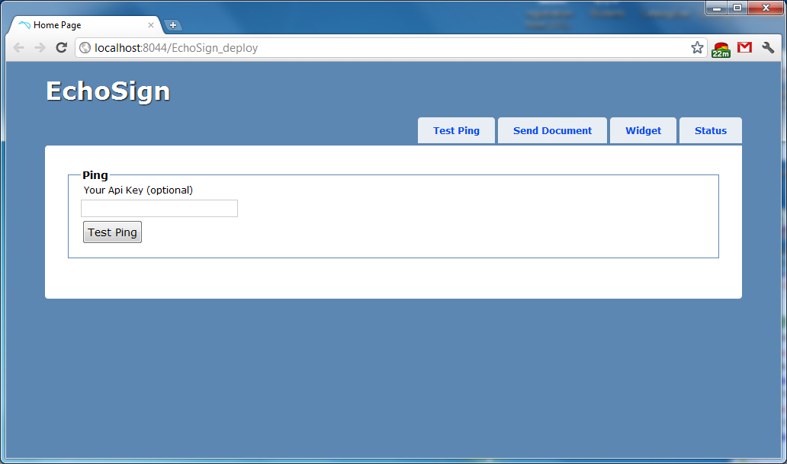

Your Api Key - The personal API access key that you've been assigned.
Test Ping - test method that can be used to confirm that your have the URL for a valid EchoSign Document Service gateway, are able to successfully communicate with it using SOAP, and have a valid apiKey. If all these conditions are met, you will receive a friendly success message. If you are not able to call this method successfully, all issues must be resolved before you should attempt calling any of the non-test methods described above.
Result will be displayed under Test Ping button.

Send Document
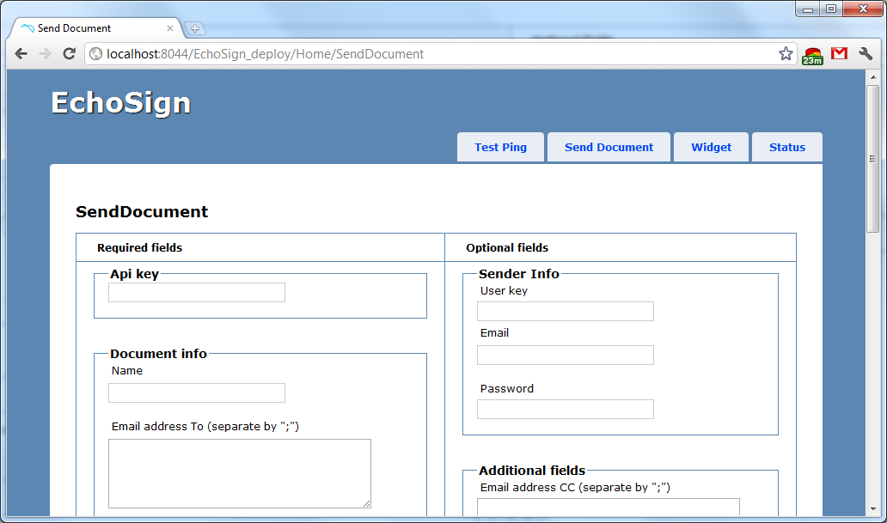
Required fields:
Your Api Key - The personal API access key that you've been assigned.
Document info
Name - The name of the agreement, which will be used to identify it in the emails and on the website.
Email address To - A list of one or more recipient's email addresses. Each recipient will be sent an email asking them to sign this document. For regular (non-MegaSign) documents, there is a limit of 6 signers for esignature documents and 4 signers for written signature documents. This limit includes the sender if the sender is also a signing party.
Signature Type - Selects which type of signature you'd like to request - written or e-signature.
Signature flow - Selects which workflow you'd like to use - whether the signer needs to sign before the recipient, after the recipient, or not at all.
Select documents - A list of one or more files that will be sent out for signature. If more than one file is provided, they will be combined into one PDF before being sent out.
Optional fields:
Sender info
Either a userKey or an email/password combination is required. If both are passed in, the userKey is used.
Email - The email address of the user that's sending the agreement.
Password - The password of the user that's sending the agreement.
User Key - Unique user identifier .
Other fields
Email address CC - A list of one or more email addresses that you want to CC on this transaction. They will each get an email at the beginning and also when the final document is signed, with a copy of the document attached as a PDF.
Message - An optional message to the recipient(s) describing to them what is being sent and/or why their signature is required.
Call Back Url - The url to which EchoSign will do a HTTP PUT operation with the final signed document key. Also you must provide email address to which you want receive notifications. Example: http://your-server.com/callback.php?mail=tets@test.com
We recommend to use gmail email address for testing purposes (don`t forget to check junk folders).
Localization - The locale associated with this agreement - specifies the language for the signing page and emails, for example en_US or fr_FR. If none specified, defaults to the language configured for the widget's sender.
Days Until Signing Deadline - The number of days until the signers are no longer able to sign this agreement. If none provided, defaults to the sender's account default, if any.
Merge fields - Optional default values for fields to merge into the document. The values will be presented to the signers for editable fields; for read-only fields the provided values will not be editable during the signing process.
If document contains for example : {{ Title }} {{ Name }}, to merge them you must enter next information -
Merge Fields Names : Title;Name (The name of the fields)
Merge Fields Values: YourTitleValue;YourNameValue (The default value of the fields)
Reminder frequency - Optional parameter which sets how often you'd like the recipient(s) to be reminded to sign this document.
Security Options
Password - The secondary password that will be used to secure the document. Note that EchoSign will never show this password to anyone, so you will need to separately communicate it to any relevant parties.
At least one of these must be set to true in order for any secondary security to be applied.
protectSignature - If this is set to true, recipients will be required to type in the password before signing.
protectOpen - If this is set to true, the document will always be encrypted with this password whenever it is emailed to any party, and receiving parties will be required to provide it in order to view the PDF files.

Widget
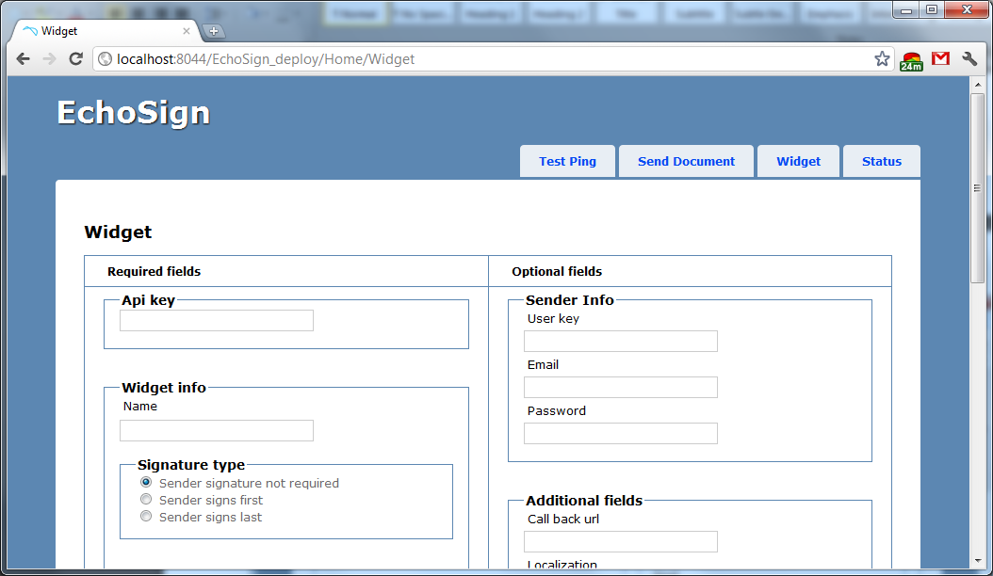
Widget completion info
URL and associated properties for the success page the user will be taken to after filling out the widget.
Url - The url to which the user will be sent after successfully completing the widget.If the URL you provide includes information that allows you to identify the specific transaction, such as your own unique identifier, you can use the browser request to this URL as a callback to notify you that this transaction is completed.In addition, EchoSign will append a documentKey parameter to the URL which will contain the EchoSign DocumentKey for this signed widget, but only if the sender is the same as the API key user. Your application can use this value to get the form data for this widget.
Delay - The delay (in seconds) before the user is taken to the success page. If this value is greater than 0, the user will first see the standard EchoSign success message, and then after a delay will be redirected to your success page.Note that this parameter has no effect for embedded widgets when deframe is true.
For other fields look at “Send Document” page.

Status
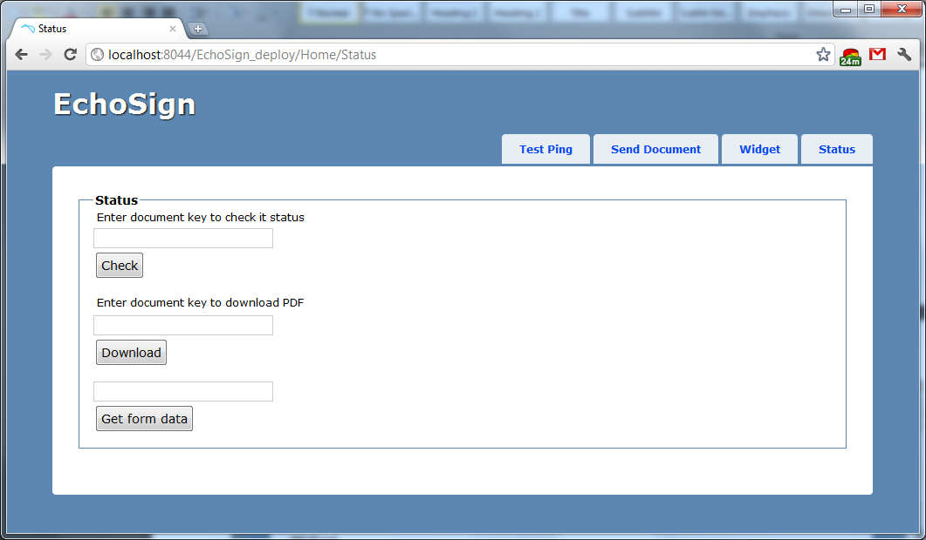
At this page you can enter document key and:
- Check the status of a document(or a widget) (Message will be displayed under Check button)
- Download pdf file.
- Get form data –(Result will be displayed in a table below Get form data button)
getFormData can be used to retrieve data entered by the user into interactive form fields at the time they signed the document. It can be used to get data for one specific document or for a group of documents that were created from one reusable document (i.e. a form).

