1. Accept button should be dark and decline light.

**QA status** – **Done**

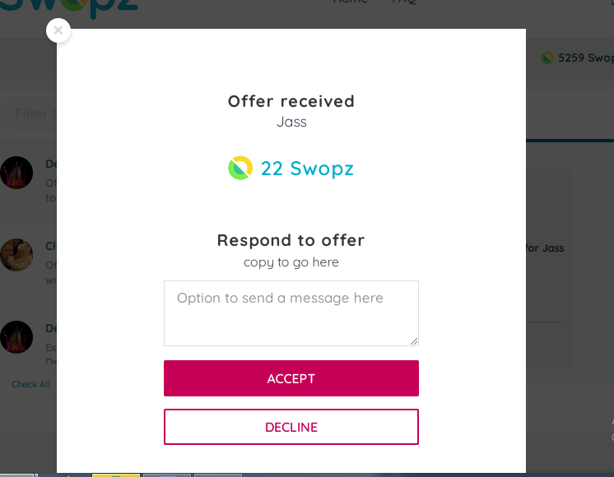

1. No extra space below ‘copy to go here’.

**QA status** - **Done**

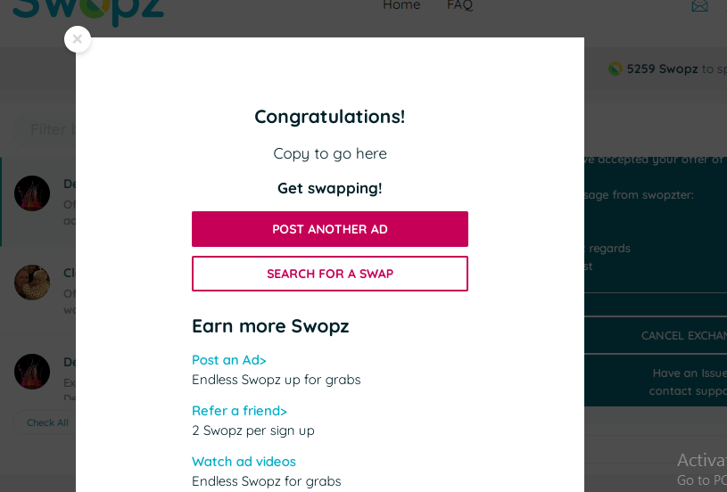

**23 rd Dec**

1. Align load icon on ALL buttons

**QA status** - **Done**

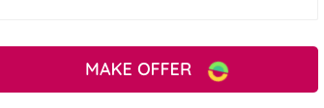

1. No email is being sent when a message is sent via the below

**QA status** – **Done**

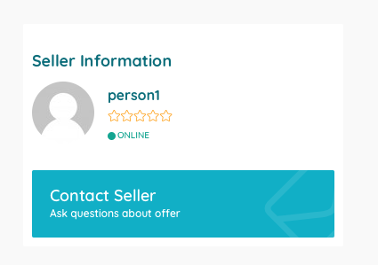

1. Button order is still wrong. Accept, followed buy decline

**QA status** – **Done**

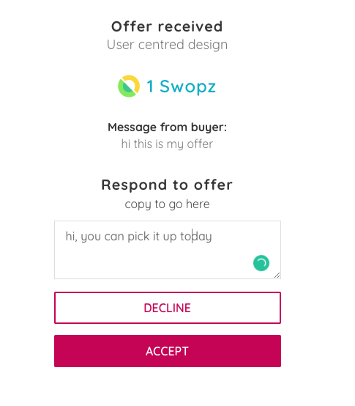

1. Contact support link in inbox and email to open up email to [hello@swopzshop.com](mailto:hello@swopzshop.com)
2. Update swopzer to swopzter please - can i amend email copy myself?
3. The spacing around the content isn’t equal. See bottom under links.

Where is say “Copy will go here” this needs to be a dynamic area.  It needs to look great with 1 line of text or even 10 lines of text.  Sorry my wireframes should of shown it better.

This logic should be used across the whole site which i will test when i can amend copy. Please remove the white space underneath. Here is a better example

QA Status -**Done**

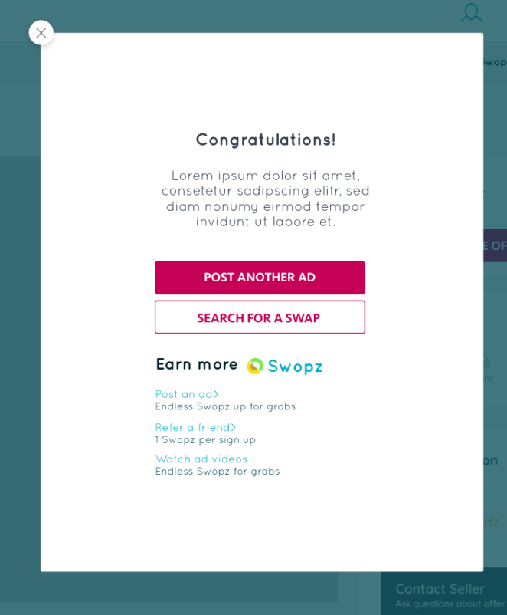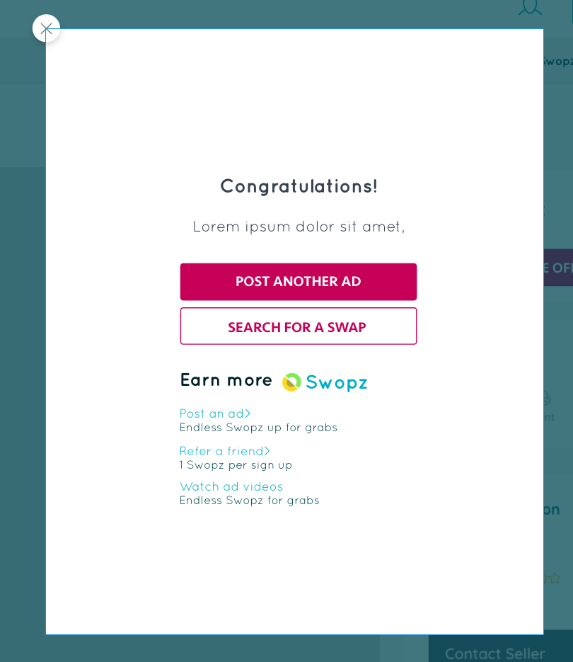

1. Cancel exchange button in email  doesn’t open form to cancel exchange. It opens a profile page??
2. Please stop using this grey. My designs are using #374252 **QA Status** - **Done**
3. QA Status - **Done**
4. 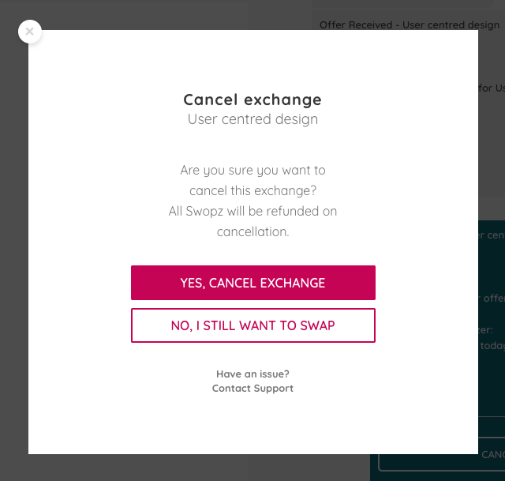
5. Please mirror the font size, colour and form layout QA Status - **Done**
6. 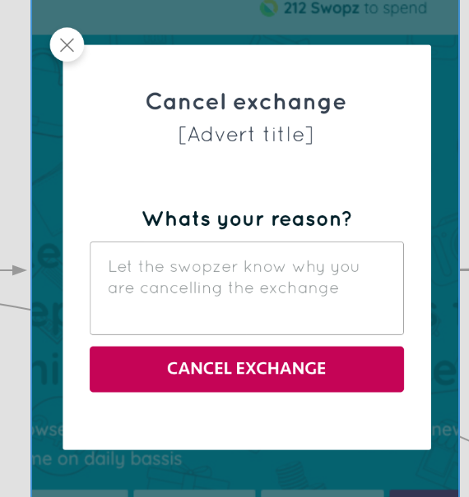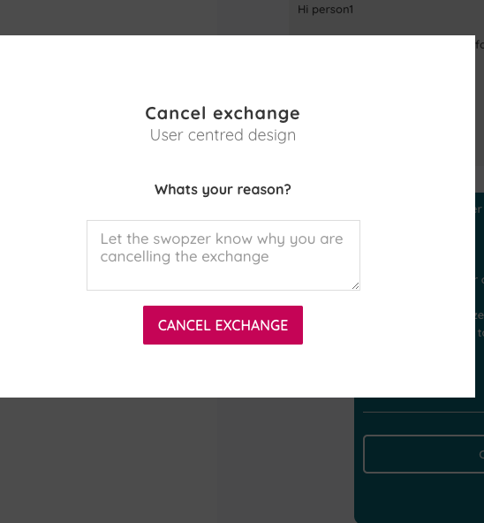
7. You are still implementing buttons on hover like this??? Please make sure ALL buttons are as discussed **QA Status** - **Done**
8. \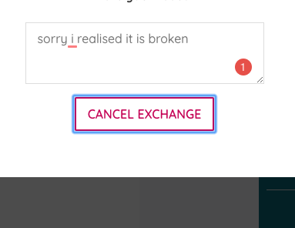
9. Please don’t show this window when cancelling an exchange as it is only relevant to a seller and anyone can cancel an exchange so it doesn’t work in this scenario. I think you are right it needs a confirmation.  Please see design here **QA Status** - **Done** <https://idoc.mockplus.com/app/FN6xMIfZx/specs/RROfVTLs->
10. 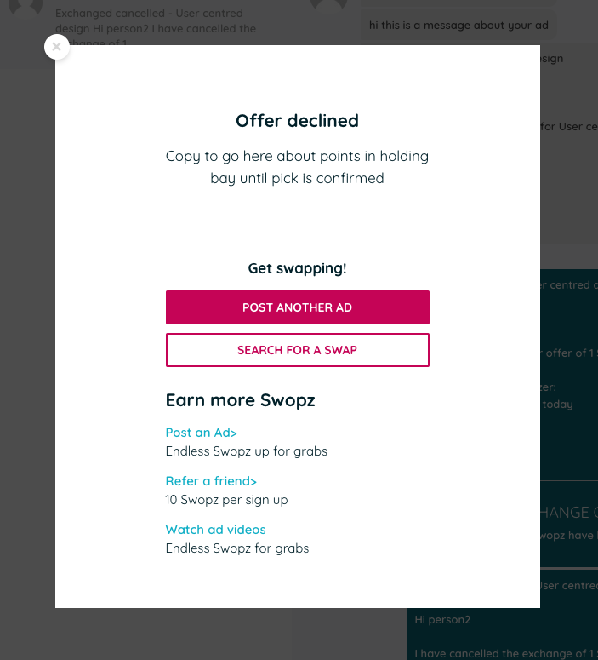
11. Am I able to update this as its not right? QA status – **Pending** 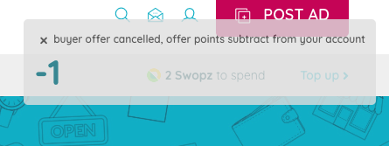
12. You are missing the message that was entered by the person who cancels the exchange

**QA Status** - **Done**

1. 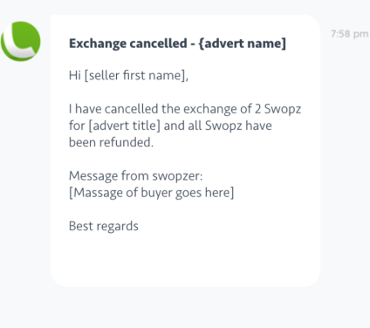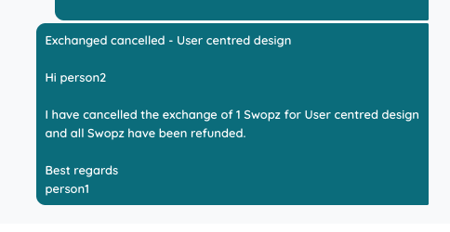
2. In all emails Can we please make the advert title a clickable link to the advert please as we do in the inbox. QA Status - **Done**
3. Still got an issue with cancel exchange. Below shows person 2 (The buyer) cancelling the exchange but the message is addressed to themselves. The message should be addressed to the other person receiving the cancellation. **QA Status** – **Done**
4. 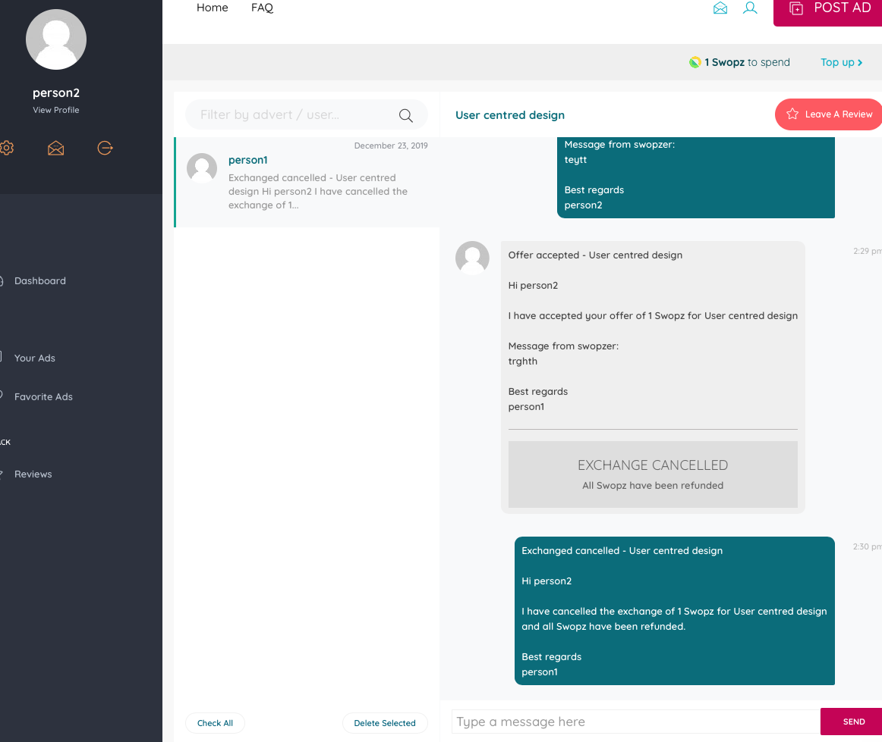
5. When in top up - earn points section. When navigating to refer a friend/videos please allow the user to naviagate back to where they came from by providing a back button <Back

**QA Status** – **Done**

Outstanding to test

Admin