UI / UX & Screen Implementation Specification
  - 2.5D room experience • Product screens • Interactive states • Responsive and accessible design
Personal Growth Space | v1.1 | 30 October 2026 | Engineering handoff

1. Purpose and design decision
This document supersedes the real-time 3D requirement for the MVP, while preserving the original emotional design direction. Use a pre-rendered, layered 2.5D cozy room plus semantic HTML/CSS interface overlays. The room is a navigational environment, not a container in which the functional UI appears on a computer screen. The Home and Today references are design intent, not production assets or a source of implementation measurements.
Principle | Requirement
Emotion | Warm, sunlit, reflective, welcoming, calm; gentle gamification; desktop first.
Room | Room overview has object-linked hotspots. Focused views use pre-rendered close-ups of the SAME room.
UI | Full functional UI appears in readable overlay panels in front of a soft-focused room.
Navigation | Persistent top nav: Today, Journal, Growth Map, Skills, Self Care; back-to-room control.
Motion | Cinematic transition using transform, crop, crossfade, blur, staged panel reveal; reduced-motion alternative.
Persistence | Navigation must not silently discard a dirty draft; saving states visible.

2. Frame templates and layout tokens
Token | Starting specification (validate in implementation)
Desktop reference | 1440 × 810 px; fluid at >= 1024 px. Test 1280 × 720 and 1920 × 1080.
Content boundary | Desktop max-width ~1360 px; horizontal gutter 32–48 px.
Spacing | 4 / 8 / 12 / 16 / 24 / 32 / 48 px scale.
Cards | Cream/ivory surfaces, 14–22 px radius, high enough opacity for readable text.
Type | Display: elegant soft serif or rounded display; controls/body: legible sans. Confirm licensed fonts before build.
Palette | Ivory #FFF9EF, sand #D7C4A5, sage #AEBFA8, dark ink #44392D; tokens must be confirmed against the source renders.
Room wash | Separate scene backdrop from UI; darken/lighten as needed; avoid card transparency that causes text contrast failure.
Mobile/tablet | Use static room crop and simplified nav; do not depend on hover or wide 3-column grids.

3. Screen inventory and detailed compositions
ID | Screen | Layout and interactions
R01 | Home / Room Overview | Full-bleed warm room; editable space name top-center; persistent nav; 5 object-linked hotspot badges. Hover/focus highlights object and label; click navigates by transition controller.
R02 | Today Dashboard | Zoom target: coffee table/desk area, NOT computer monitor. Soft blurred physical room behind overlay. Header greeting; focus and challenge; mood/energy; gentle habits; quick journal; weekly progress.
J01 | Journal Landing | Close-up of notebook zone. Left quick-check-in card; central journal editor; right recent entries/calendar. Two clear CTAs: Quick Check-in / Write Freely.
J02 | Quick Check-in | Optional mood/emotion chips, energy, one good thing, a difficult moment, what to remember. Skip fields; save state and privacy language.
J03 | Free Journal Editor | Title, optional guided prompt, tag picker, long-form entry, autosave indicator, history navigation, delete confirmation, writing focus mode.
J04 | Weekly Reflection & Patterns | Date range, mood trend only if sufficient data, repeated tags, entry count, specific reflection prompts. AI insight opt-in with source entry scope and dismiss/correct controls.
G01 | Growth Map Overview | Journey header, initial baseline vs current snapshot, growth-area chips, active milestones, evidence timeline, create/edit/pause journey.
G02 | Goal Setup | Step-by-step goal, why it matters, current state, observable outcome, available time, constraints, milestone review, confirm.
G03 | Inspiration Inbox | URL/manual text/screenshot input, source-status labels, extracted material preview, summarize, select goal, review AI suggested plan before commit.
G04 | Plan Detail | Goal > milestones > actions; frequency and due date; completion check-in; source citations; edit/archive; linked reflections.
SC01 | Self Care Hub | Question-led state picker, duration/energy filters, 2–3 suggested activities, separate sections Recharge & Play, Reset Your Space, Personal Care, Mindset and Connection.
SC02 | Activity / Routine Detail | Goal, estimated time, steps/checklist, start/pause/complete/skip, safety notes, optional helpful-neutral-not helpful post-activity rating.
SK01 | Skills Library | Topic cards, search/filters, featured resources, saved list and learning log; no infinite feed.
SK02 | Resource Detail | Source/creator, duration and objective, official video embed or external link, bookmark, completion self-report, takeaway and apply-it prompt.
P01 | Profile, Privacy & AI | Room style preference, reduced motion, data export/deletion, opt-in AI controls scoped per feature, analytics/reminder settings.

Reference placement
Home screen visual reference
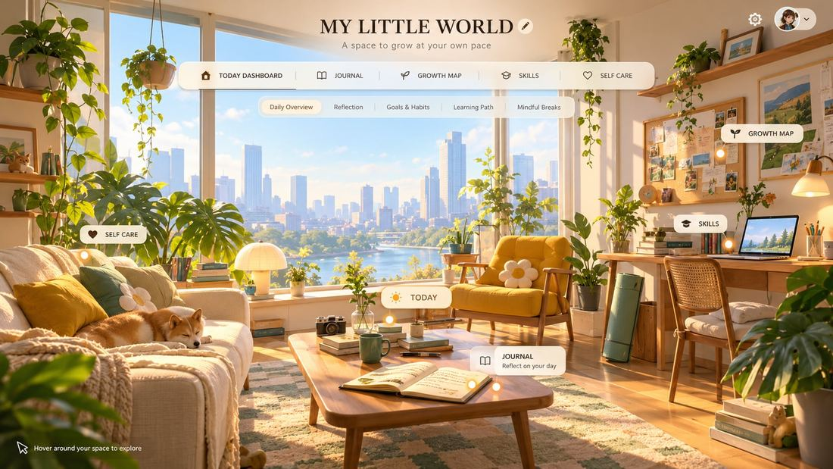
Today Dashboard visual reference
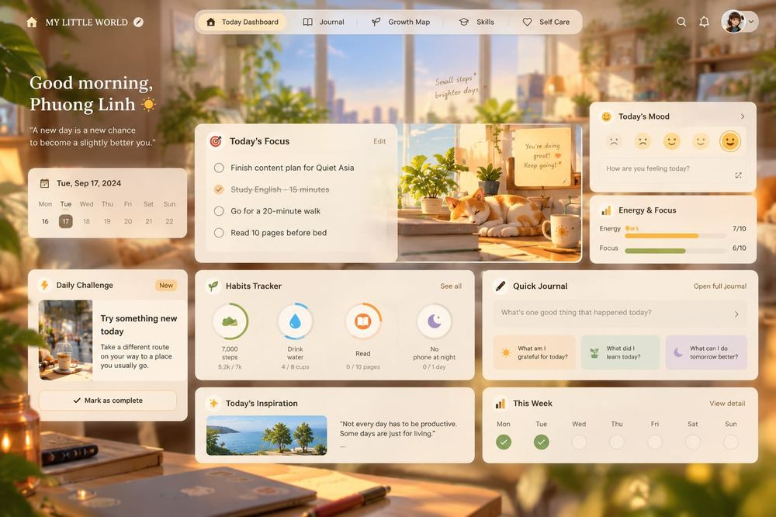
Source images are raster visual references. All interactive navigation, text, cards, forms and states must be rebuilt as semantic components; do not place the screenshot as the functional screen.

4. Component contract
Component | Variants/states | Developer contract
Top navigation | default / selected / hover / focus / mobile | Semantic links; active aria-current; persistent in focused views.
Hotspot | idle / hover / focus / active / disabled | Image-coordinate anchoring in normalized coordinates; keyboard trigger; visible accessible label.
Glass card | default / prominent / inset | Responsive padding and meaningful DOM; backdrop blur is enhancement only.
Action button | primary / secondary / quiet; idle/loading/disabled | Minimum actionable target; never show success before backend confirmation.
Mood selector | unselected / selected / keyboard focus | Optional self-report, never evaluative or diagnostic.
Checklist row | unchecked / checked / saving / error | Optimistic update only with rollback and user feedback.
Editor | empty / typing / saving / saved / offline / conflict | Persist draft locally until server confirms; restore recovery.
AI suggestion card | pending / source partial / ready / edited / approved / failed | Clearly identify generated content and source; no automatic task commit.

5. Room transition choreography
- HOME: user sees full room with discoverable labels and fixed navigation.
- On object click, lock navigation state for one transition transaction; prefetch relevant close-up image; preserve selected hotspot.
- Animate a short transform/pan of overview toward object; crossfade with close-up asset from matching camera; simultaneously increase background blur/wash.
- Display overlay structure first, followed by a subtle panel opacity/translate reveal. Nav remains accessible; do not nest module UI within an in-scene monitor/book.
- Back-to-room reverses or uses a brief blended transition; direct tab-to-tab switch may crossfade between focus scenes without returning to overview.
Initial motion tokens for usability testing: 450–800 ms room transition; 120–200 ms panel fade; ease-in-out/ease-out. These are proposed not mandatory. Respect prefers-reduced-motion by using immediate image swap and panel presentation.

6. Required states, accessibility and QA
- Room: loading, scene missing, poor network, image fallback, hotspot hover/focus, transition interrupted, reduced motion.
- Modules: empty, loading, partial data, success, validation error, unauthorized, save error, session expiry, offline recovery.
- Contrast: body copy should meet WCAG 2.2 AA; overlays must not rely on photographic background for legibility.
- Keyboard: tab to all hotspots; Enter/Space activation; escape/back where appropriate; focus restored on transition.
- Responsive: fixed desktop nav collapses on tablet/mobile; layout cards reflow to a single column; room hotspot locations recalibrated by aspect ratio.
- Visual QA: compare frames against references; verify continuity of furniture across Home and focus images; check 1280/1440/1920 widths.

7. Figma handoff and source of truth
Editable Figma foundation: https://www.figma.com/design/5AYqsHBJBV8QSKtmIQCSJA . Existing frames include Home, Today, Journal, Growth Map, Self Care, Skills and a starter Card component. Current frames are layout foundations and 3D background placeholders, not a finished high-fidelity deliverable. Engineering should treat approved design tokens, component states and annotated acceptance criteria as source of truth after design QA.

8. UI acceptance criteria
- All six major destinations accessible from persistent navigation even when the scene fails.
- Today click produces close-up of the physical table and foreground UI; never renders the dashboard on the computer monitor.
- At least one interactive Home→Today→Home prototype passes mouse, keyboard and reduced-motion testing.
- All input forms communicate saving and error states; missing content is not lost on transition.
- Every focused scene has consistent prop positions and art direction with the Home overview.

