UI / UX Specification
Detailed design handoff | Room interactions, screens, layout blueprints and component states
PERSONAL GROWTH SPACE | VERSION 1.0 | 29 OCTOBER 2026

1. Design intent and source-of-truth reference screens
The two supplied references establish the visual direction: sunlit 3D apartment, warm cream translucent UI, honey/sage accents, serif editorial heading plus readable sans-serif controls, and persistent navigation. The Home reference is an overview room; the Today reference is a close-up of the desk/table zone with the physical background defocused and floating dashboard cards. These are conceptual visual references, not final pixel-accurate design tokens.

Reference A — Home / room overview
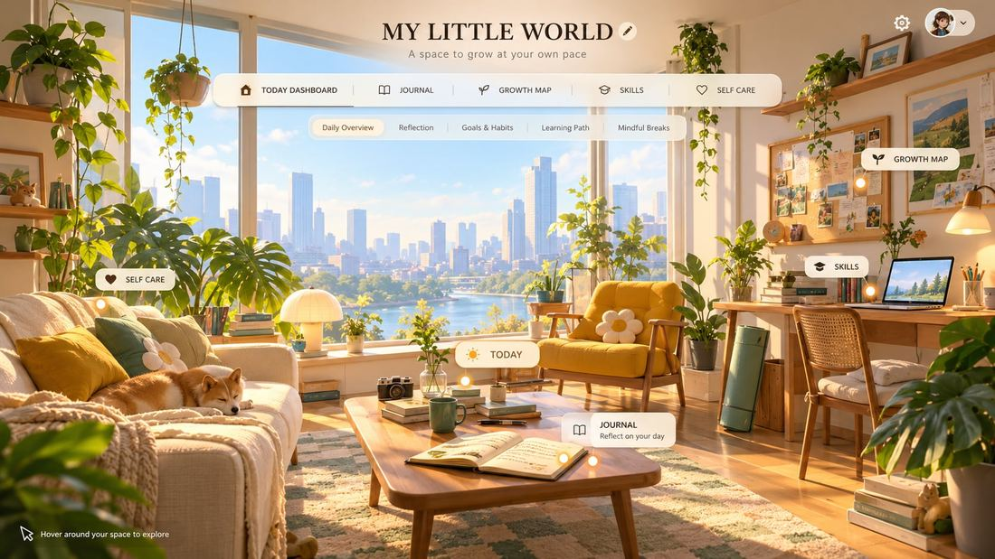

Reference B — Today Dashboard / zoomed desk scene
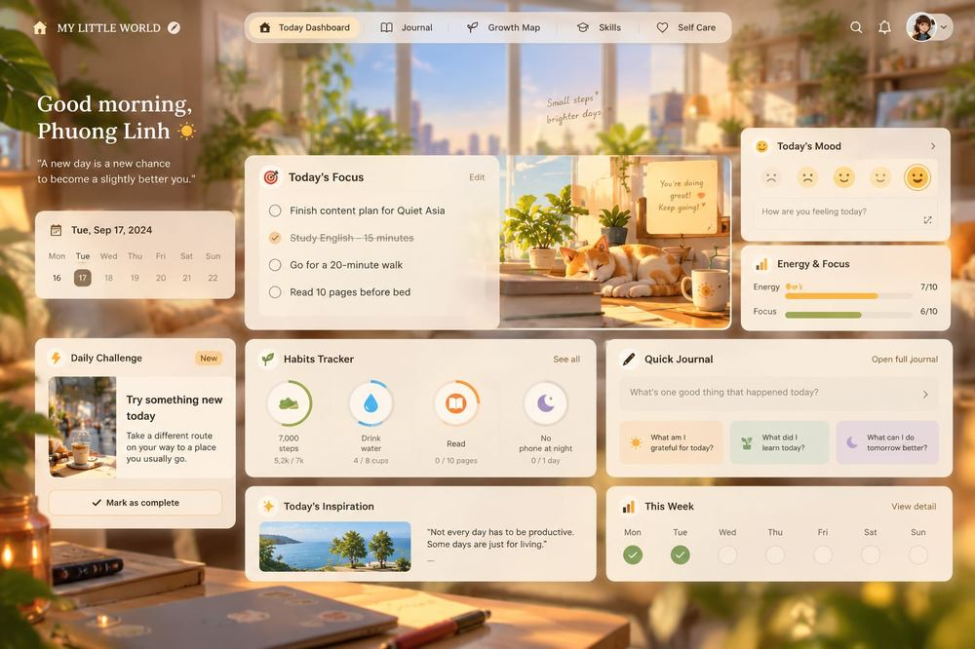

2. Navigation and camera interaction
A user clicks the TODAY label/hotspot in the whole-room view. The actual 3D camera travels closer to the desk/table anchor, resulting in a tight spatial crop of table items and surrounding light. THEN the background becomes softly defocused and the website UI floats above the room as HTML layers. Do not place dashboard inside the monitor/laptop or retain a wide, distant room wallpaper. Other category anchors: Journal → physical open notebook on coffee table; Growth Map → inspiration board at right wall; Skills → right-hand desk/books; Self Care → couch/plant/reading zone.
State | Visual and interaction contract
Overview | Full room 3D; hovering/focusing hotspots displays small capsule title; click enters category. Brand centered at top on overview, horizontal nav beneath.
Transition | Move camera from current position to category anchor, smooth ease-in-out; target duration approx. 650–950 ms to prototype/test. Camera movement is spatial, not screen zoom CSS.
Focused | Close-range 3D composition, background depth-of-field/soft blur plus subtle ivory tint. Interface panels appear above scene; physical selected object need not remain visible under every card.
Switch category | Persistent nav changes selected category; camera may travel to new anchor without unnecessary reset to full-room overview.
Back home | Room button reverses to overview; draft preservation rules apply.
Fallback | prefers-reduced-motion removes travel; static themed image if 3D unavailable; nav and content remain functional.

3. Visual design system
Token | Suggested specification
Canvas | Warm ivory #F7F0E5; parchment #FFF9EF; scene highlights natural golden-hour sunlight.
Text | Dark botanical #26392F; secondary #647168; interactive sage #587660; accent honey #D6AA75.
Type hierarchy | Display: elegant readable serif (e.g. Georgia or licensed alternative); Body/UI: modern sans (e.g. system/Aptos/Inter). H1 32–40 px, H2 22–26, card headings 16–19, body 14–16, captions 12–13.
Grid | 1440 px baseline; content max width approx. 1360 px with 32–48 px margins; 12-column grid, 16–20 px gaps. Adapt to real browser viewport.
Cards | Ivory with ~88–95% opacity or strong accessible background; radius 14–20 px; 1 px warm border; restrained blur and soft shadow. Text contrast must survive bright background.
Controls | Pill top nav; filled primary, outlined secondary, text tertiary; 40–44 px common height; accessible focus ring and state change.
Motion | Translate / fade cards in slight stagger after camera settles; avoid parallax with interactive content; provide reduced motion.
Illustration | Soft realistic stylized 3D room, natural houseplants, warm wood, mustard chair, morning light; keep decorative details outside key text zones.

4. Global page shell and responsive rules
- Overview header: centered editable space title + subtitle; profile/settings top right; category bar centered. Focused header: left Home/brand, center category nav, right search/notifications/avatar as needed.
- Focused page: maintain a clear visual separation between UI planes and softly blurred 3D setting. Use a scrollable content layer, not scroll the entire room camera with the form.
- Cards use same padding/typography/status patterns across all modules. Persistent navigation highlights current section; optional secondary nav is contextual, never the only route to important content.
- Desktop ≥ 1200 px: two or three meaningful columns. Tablet: two columns or stacked. Mobile: content-first, compact nav, static room hero; replace hover with tap and never depend on elaborate 3D.
- Accessibility: focus order, hover/focus equivalence, alt text for illustrations, reduced-motion, high-contrast content cards; avoid solely color-based mood states.

5. Detailed screen blueprints
The following diagrams are original annotated layout wireframes. They convey composition and hierarchy rather than final artwork. All category screens retain a close-up version of the shared room, not an interface rendered on a physical computer screen.

5.1 Journal — home + quick/deep editor
The camera settles near the open notebook. 3-column canvas: navigation/library left, dominant writing surface center, prompt/recent entry right. Primary CTA Quick Check-in; alternate Free Writing; prompt picker is optional. Empty: kind invitation, not “0 day streak.”
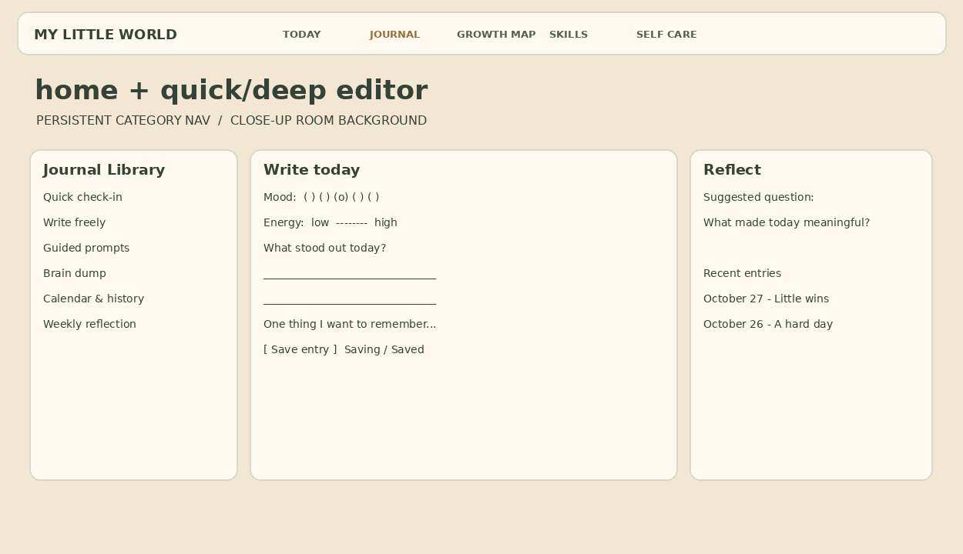
Component / interaction | Details / states
Quick entry | Mood & energy optional; fast save; switch to long-form without losing draft.
Main editor | Focus mode; prompt inserts question, not mandatory answer; save state Pending/Saved/Retry.
History sidebar | Search, date, topic; long text stays in main editor, not tooltip.

5.2 Journal — history + weekly reflection
Calendar/history accessible from Journal subnav. Mood/energy trends as descriptive charts with denominators; topic insights display dated evidence links and dismiss control. AI panel is clearly off until opted in; entry-level consent before request.
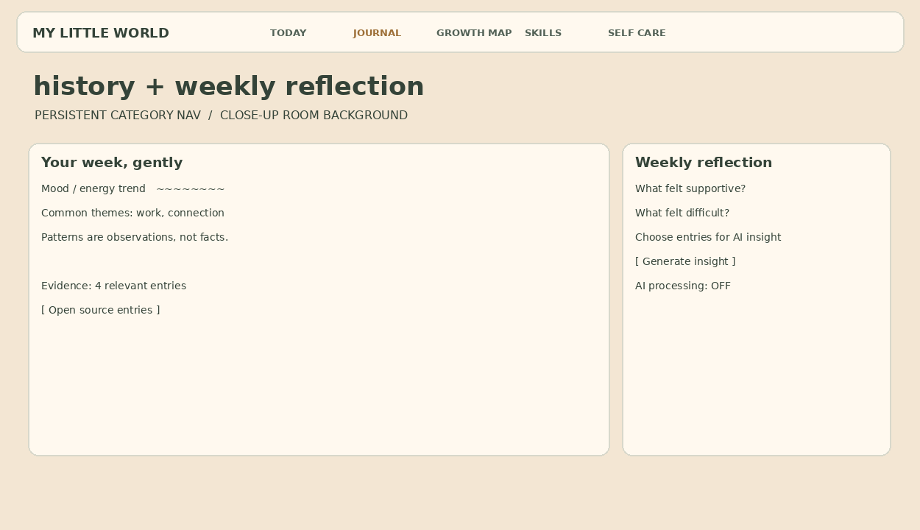
Component / interaction | Details / states
Trend panel | Show count/time window; no causality claims; insufficient-data empty state.
Evidence | Click observation → originating private entries; AI insight may be corrected/dismissed.
Consent | Opt-in displayed beside generate action, not buried in global terms.

5.3 Growth Map — overview + goal detail
Camera moves close to wall inspiration board. Left growth areas; central active journey with baseline, milestones and evidence timeline; right quick tools. Before/Now comparison shows user-authored snapshots, never a score of personal worth.
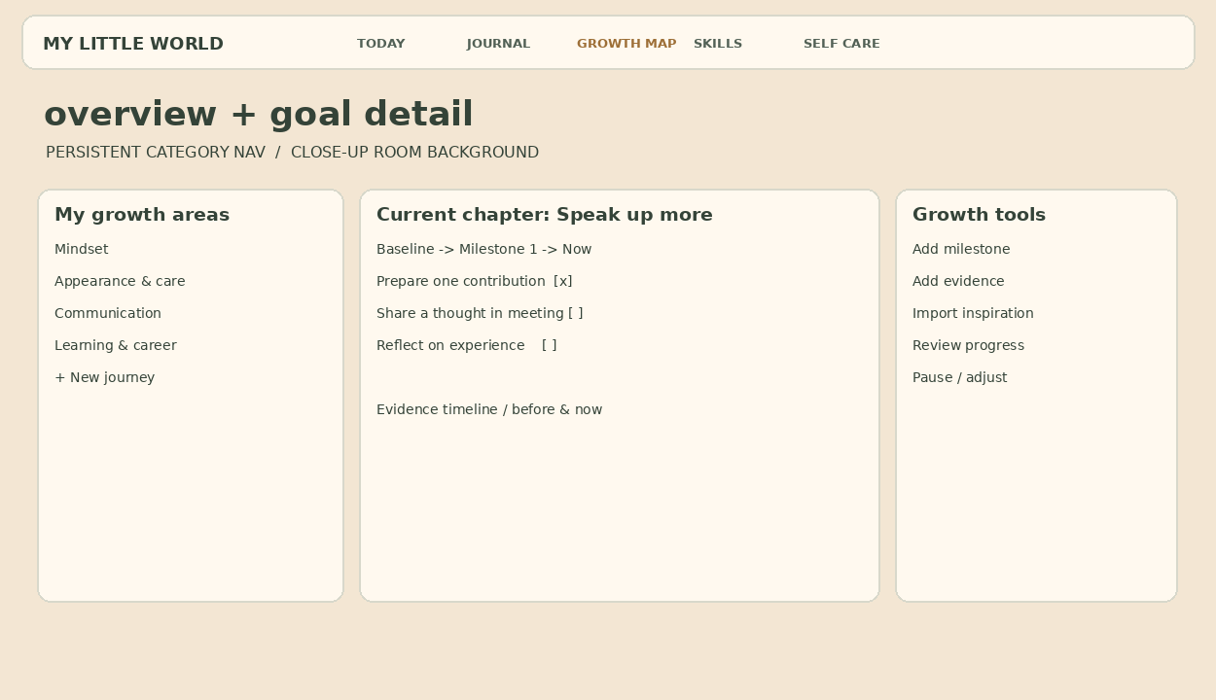
Component / interaction | Details / states
Journey | Title, why, baseline, desired observable outcome and optional deadline.
Actions | Due today/this week; Done/Skip/Pause; source badge for linked inspirations.
Timeline | Evidence references and user-authored before/now snapshots.

5.4 Growth Map — Inspiration Inbox + AI plan review
Capture pane supports link/text/screenshot, with explicit source-available status. Middle panel shows actual source versus AI proposed actions. Right panel provides edit/approve; no tasks enter a plan until confirmed.
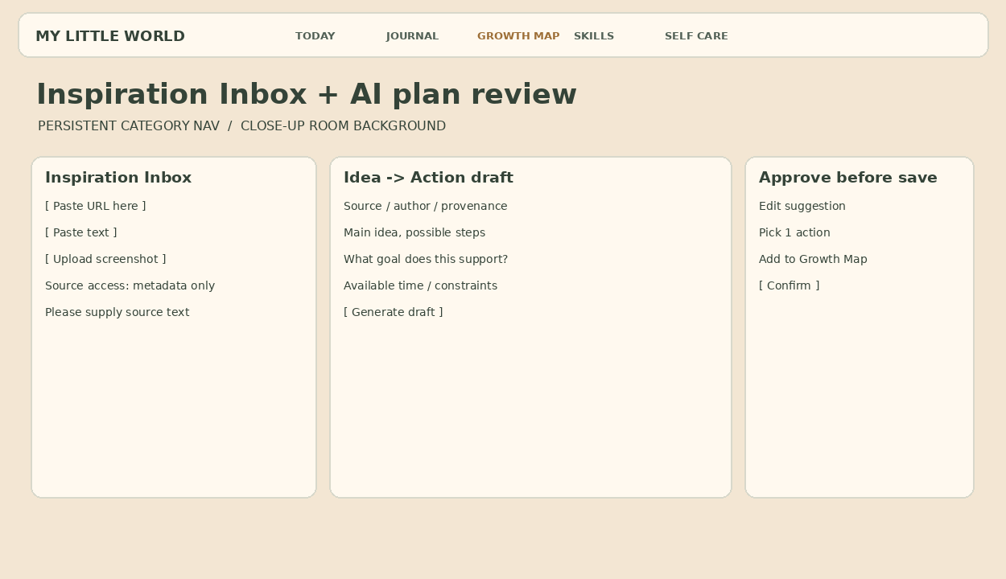
Component / interaction | Details / states
Source capture | URL metadata-only/access denied/user supplied text statuses visible.
Draft review | Editable idea, constraints, plan actions, milestone, provenance.
Approval | No save to plan until review; loading/error/duplicate/source removed states.

5.5 Self Care — discovery + routine hub
Camera moves toward sofa/plant cozy corner. Left selects current need, time, energy, context; center 2–3 curated activity cards and “show another”; right shows routine progress with no penalties. Avoid infinite scrolling.
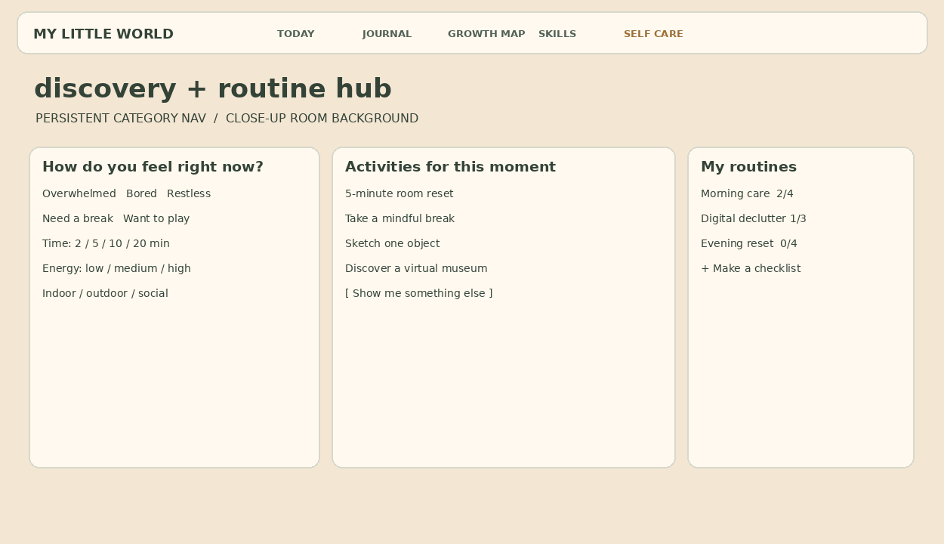
Component / interaction | Details / states
Need picker | Non-diagnostic state labels; time, energy and context refinements.
Cards | Duration, setup, why try it; open activity/skip/show alternative.
Routines | User-created checklists and optional schedule; no punitive streak.

5.6 Self Care — activity + checklist detail
Dedicated focused overlay with brief purpose, stepwise checklist, optional timer, stop/skip/complete; after activity, simple helpful/neutral/not helpful response and optional reflection-to-Journal.
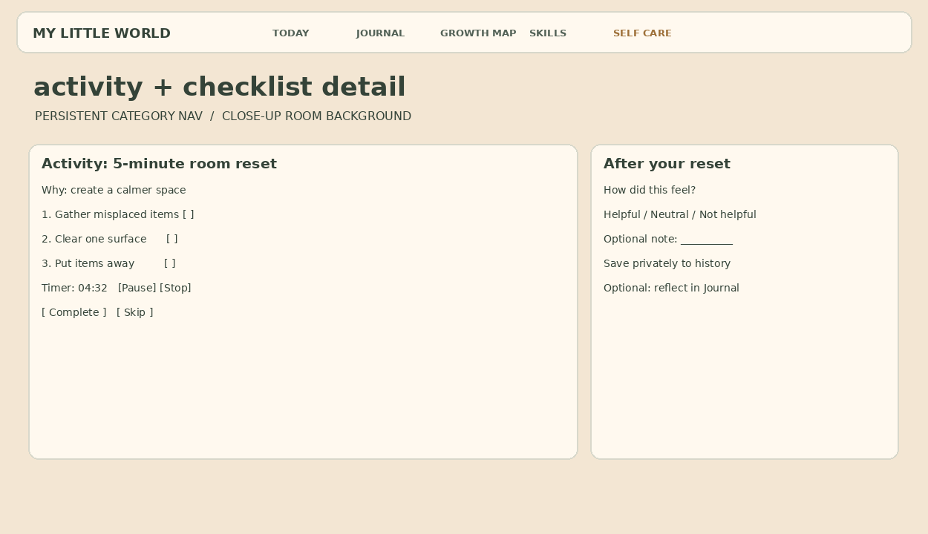
Component / interaction | Details / states
Session | Step progress, stop/restart, timer optional; explicit completion.
Feedback | Helpful/neutral/not helpful plus private note, optional Journal link.
Safety | Clear stop action and editorial note for appropriate content.

5.7 Skills — curated library
Camera anchors by the side desk/books. Left topic tree, center curated searchable cards/filter row, right My Learning status. No YouTube clone feed; surface goals and brief application prompts.
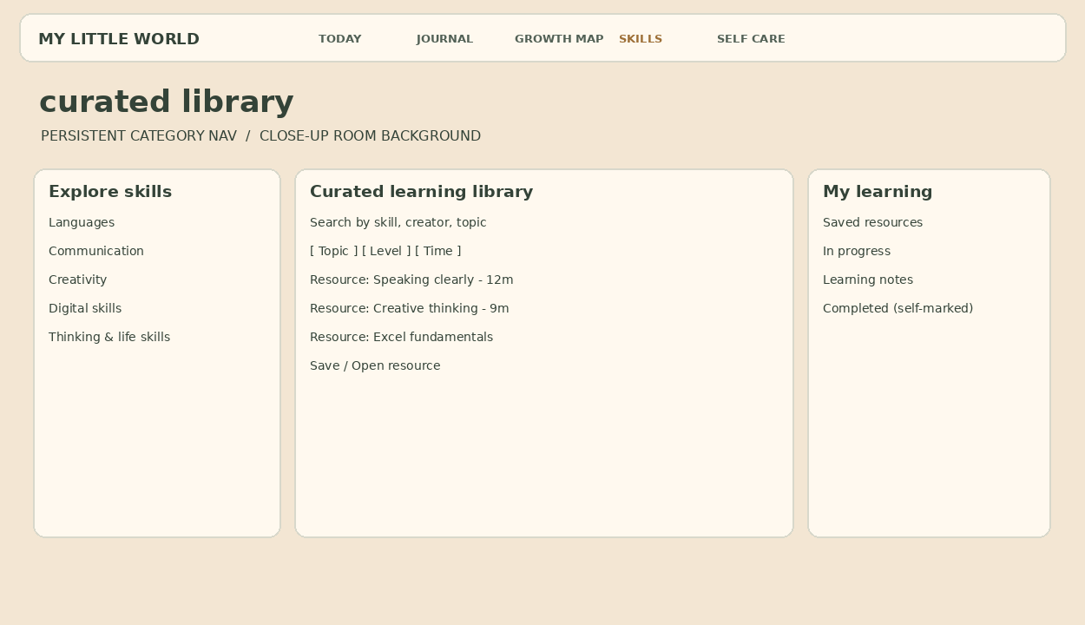
Component / interaction | Details / states
Search/list | Topic, level, language, duration; save and provenance.
My learning | Saved/In progress/Completed are self-reported.
Empty/unavailable | No matches reset filters; broken source marked unavailable.

5.8 Skills — resource detail + learning log
Official video embed or external source remains discrete from product UI. Source and creator visible; takeaway editor, self-marked progress and optional “turn into Growth action” approval. Missing content has explicit fallback.
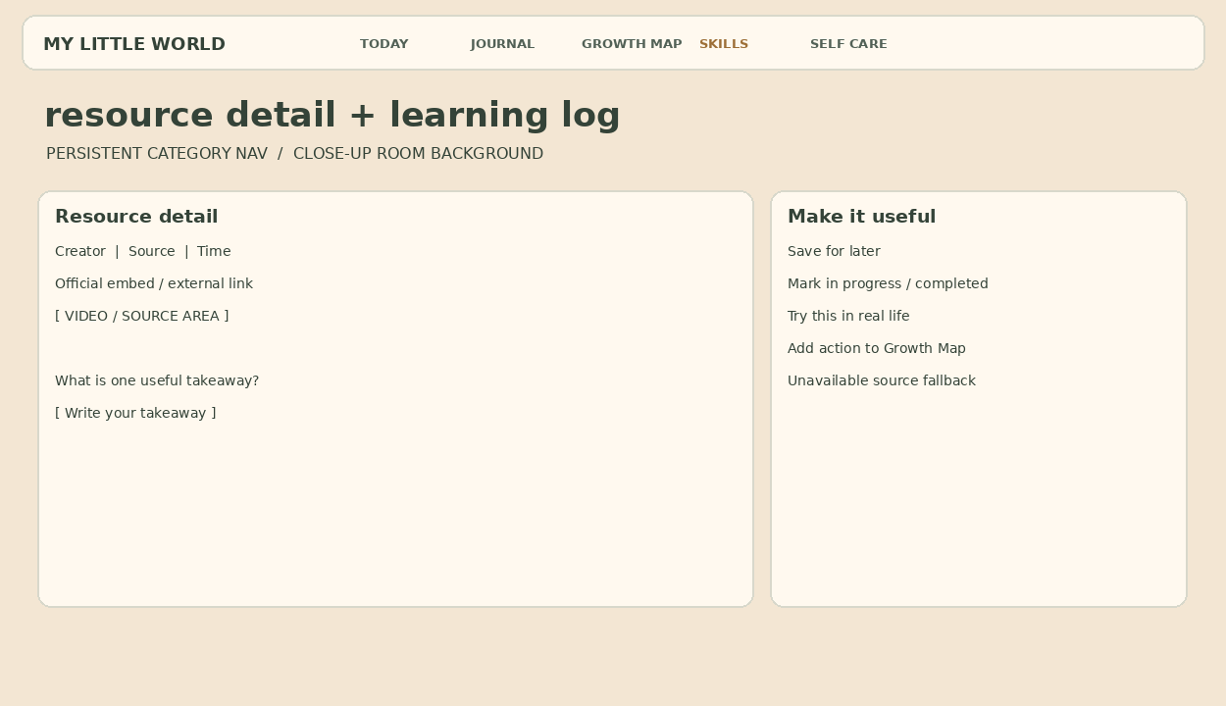
Component / interaction | Details / states
Source panel | Compliant official embed or external link with creator and citation.
Learning note | Takeaway, application idea; notes owner-only and editable.
Goal connection | User approves converting takeaway to action.

5.9 Profile / Settings — privacy, AI and room controls
This screen may use a softened static room. AI permissions separated by module, scope picker for private entry analysis, export/delete flows, room style preset and reduced motion.
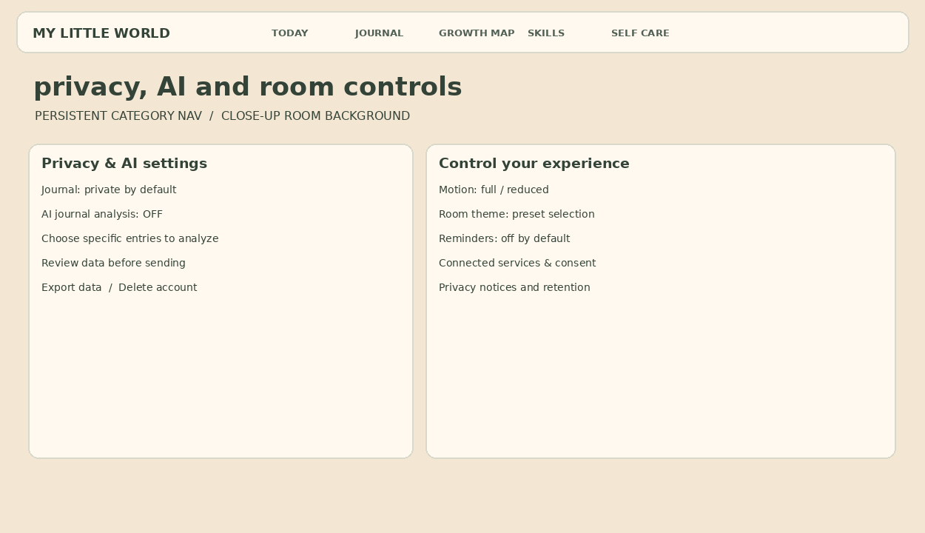
Component / interaction | Details / states
Privacy | Export/delete status and account data policy.
AI consent | Disabled by default; separate for journal and growth source conversion; preview of scope.
Experience | Reduced motion and room presets; fallback retains full module access.

6. Today Dashboard reference: production-state inventory
Treat the supplied second screenshot as the visual benchmark for the main dashboard, while ensuring date and copy are dynamic (mockup values are examples). The camera zooms toward the TABLE AREA: books/mug/plant visible in background, gentle blur, overlay cards. Do not constrain UI to the computer display.
Widget | States & links
Focus list | Editable tasks, empty/completed/loading; deep link to associated Growth action.
Mood / Energy | Optional check-in stored with local date; user can edit; Journal links for deeper reflection.
Challenge | Suggested contextual action; accept/skip/complete; avoid aggressive gamification.
Habits / This week | Visible progress with accurate denominators; missed days neutral; click opens source routines/goals.
Quick Journal | Prompt and compact input or link to Journal; user must see saving/saved/error state.
Today inspiration | Curated short content/quote with source where applicable.

7. Components, states and microcopy
Component | Required states / design rule
Cards | Default/hover/focus/loading/empty/error; background solid enough for contrast.
Form | Idle/dirty/autosaving/saved/failed; leave confirmation before losing unsaved text.
Action completion | Pending/done/skipped/paused; subtle acknowledgment, never punitive shame copy.
Source capture | Retrieving/metadata only/full content accessible/manual text needed/failed/duplicate.
AI insight | Off/consent pending/processing/result/error/dismissed; source evidence, not absolute claims.
Animation | Ready/transition/focused/exiting/fallback; nav remains keyboard-accessible.

Do say | Avoid
“A small step counts.” | “You failed your streak.”
“This may be a pattern worth exploring.” | “AI has discovered your personality.”
“Not enough entries to draw a trend yet.” | Fabricated trends from insufficient data.
“Source could not be read. Paste the relevant text.” | A fabricated summary of an inaccessible link.
“Take a different kind of break?” | “Stop wasting time.”

8. Design deliverables required before build
- Figma components: nav, buttons, card types, editor, prompt picker, mood scale, progress/timeline, checklists, video resource, dialogs and toast states.
- Click-through prototype: overview → Today, Journal, Growth board, Skills desk and Self Care couch; focused → focused navigation; return home; reduced-motion fallback.
- Screen variants for initial/empty/loaded/loading/error; auth first-run, consent, export/delete and inaccessible source states.
- Responsive frames at desktop 1440, smaller laptop 1280, tablet 768, mobile 390; developer to validate effective breakpoints with assets.
- Scene assets: licensed GLB/GLTF models/textures, camera anchor transforms by category, blur/lighting settings, compressed fallback stills; performance review.
- Handoff notes: spacing/type/color tokens; text contrast checks; interaction and animation notes; copy localization; content governance owner.

9. Screen-level acceptance checklist
- A click on TODAY makes the camera move physically toward the table, then blurs the closer scene and overlays cards; no app interface appears inside the monitor.
- Every module is reachable from nav without hover and without WebGL.
- The focused module has visible Home/back control and persistent category nav.
- The writing screen has a dominant readable editor; background art never compromises field legibility.
- Growth source unavailable state is explicit; AI suggestions are editable and not auto-committed.
- Self-care sessions have stop/skip controls and neutral feedback.
- Skills shows provenance and usable fallback for unavailable media.
- AI consent is explicit, separate and revocable.
- Keyboard, reduced-motion, contrast and responsive variants are included before sign-off.

