***Flash card game***

Starting off

When you start off, you input all the words that you need to learn and their translation (dictionary). After that, the game asks you how many words you want in a cycle and after how many correct answers it should add another word into the cycle (change).

The actual game

A card appears on the screen with a word. The player has to submit an answer (depending on the option, the answer will be displayed differently). If the answer is right, he gets x points (depending on the option), if the answer is wrong he loses x points. If he gets ten answers correct (not necessarily the same word) the score multiplier goes up by one (max of 7). When he gets two answers wrong in a row the score multiplier restarts counting the ten correct answers. If he gets 5 answers wrong in a row, the score multiplier goes down by one. The game continues forever, but every five minutes you are asked if you want to quit. If you do, the game displays the score the player got and the five top scores he has been able to reach in the past.

Extensions

Options

1. How you answer – there are two ways you can answer,
   * 1. Multiple choices, you get four different answers and you have to choose the right one.
     2. You type in the correct answer, you are given a keyboard, in the language that the answer needs to be in, and you type in the answer.
2. In what language are the flash cards presented – there are three ways,
   * 1. In the new language, the cards are all in the new language and the answers are in the native language.
     2. Either in the native language or the new language, this way you start learning to translate also from your native language to the new language. The answers and keyboard would be in the other language as the flash card.
     3. In the native language, once you get a hang of translating from the native language, challenge yourself and only translate from the native language. The answers would be in the new language.

Extras

* Timer – if you don’t submit an answer with in x amount of time the game gives you another word, but takes off 10 points. When you choose to use the timer you can determine how long until the time runs out, between 10 seconds to 90 seconds and default is 50 seconds.
* Hear the word – if you don’t know the word and you want to know how it sounds you press the extension and it says the word for you. The recordings come from Google Translate (or any other place) when you first submit the words into the dictionary and if a recording can’t be found you are asked to record yourself saying the word.

Points (once the game is written I’ll adjust the point so they are perfect)

In all the options if you get all the answers correct you get another 100 points

Option 1.i with –

* option 2.i. every right answer gives 30 points and every wrong answer takes off 10 points.
* option 2.ii. every right answer gives 40 points and every wrong answer takes off 7 points.
* option 2.iii. every right answer gives 50 points and every wrong answer takes off 7 points.

Option 1.ii with –

* option 2.i. every right answer gives 35 points and every wrong answer takes off 7 points.
* option 2.ii. every right answer gives 45 points and every wrong answer takes off 5 points.
* option 2.iii. every right answer gives 55 points and every wrong answer takes off 5 points.

When using the timer, if you use the timer between

* 10-30 sec. you get another 20 points for every right word (depends on the options you are playing) and if you get all the word correct you get 75 points. If you manage to get 5 words correct in 10 seconds you get an additional 50 points.
* 30- 60 sec. you get another 15 points for every right word (depends on the options you are playing) and if you get all the word correct you get 85 points. If you manage to get 5 words correct in 10 seconds you get an additional 50 points.
* 60-90 sec. you get another 10 points for every right word (depends on the options you are playing) and if you get all the word correct you get 95 points. If you manage to get 5 words correct in 10 seconds you get an additional 50 points.

Layout

Option 1.i.

The score multiplier

The score

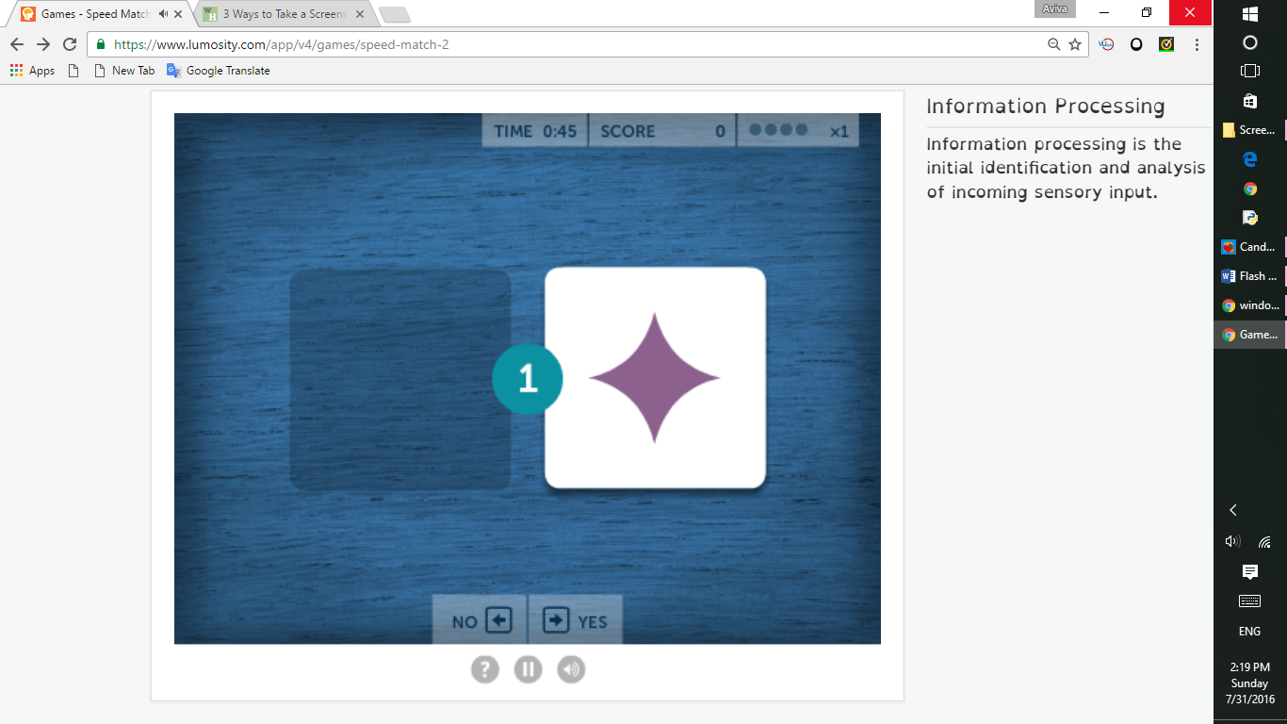

The four answers1

The timer

The flash card

Option 1.ii.

The score multiplier

The score



Keyboard with which you enter your answer.

Where you enter the answer

The timer

The flash card

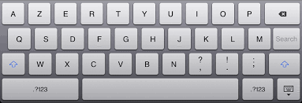

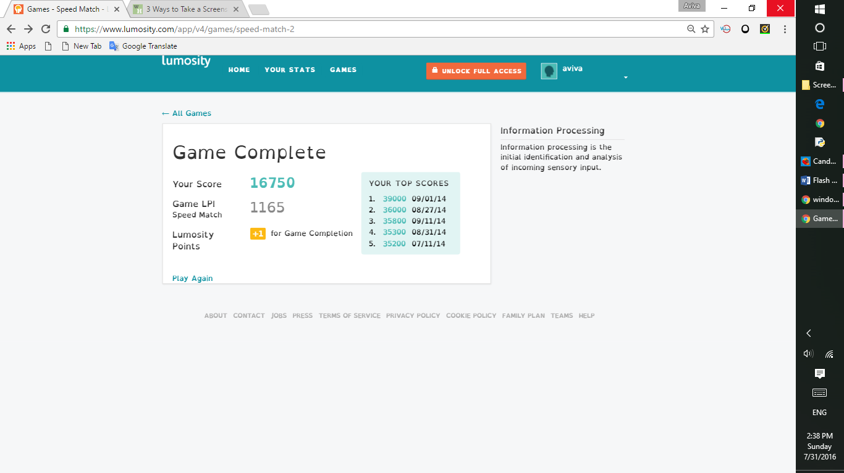

The five top scores you have gotten in the past

A way to play again

The score you got this game

Sharing and buying dictionaries

You can buy already-made dictionary so you don’t have to insert them yourself.

You can also share with your friends, so that if you all have the same assignment, one person can insert the whole dictionary and share it with the whole class.

You can also divide the assignment between the whole class and then save it in one dictionary, so that the hard job of inserting the whole dictionary doesn’t fall on one person.

Terms

New language – the language you are trying to learn (Arabic)

Native language – the language which you already know (Hebrew)

Dictionary – where all your words are stored.

Cycle – amount of words that are you study at a time, since it’s hard to study all the words at once.

Change – the game counts how many times you are able to correctly translate each word, once you correctly answer x amount of times (what you decided at the beginning) then the game replaces that word with another word from your dictionary, so that you can learn that word too.

Score multiplier – multiplies the score by a certain amount, ex. If the sore multiplier is at 5 then each time you get a correct answer instead of getting 50 points you get 250 points.

Comments

* Fine-tune scoring later