BASICS OF SOFTWARE TESTING
https://github.com/pawelsikora/mkdocs-cdoc
Semester Project Report
ISTQB Foundation Level Syllabus

Deliverable Type
Mark the applicable deliverable with an “X” or delete the others:

Deliverable | Due
() Exploratory Report | Week 1-2
(X) TEST PLAN | Week 3

Group Information
Group Number | 4
Assigned Feature Area | Area 4: Page Generation & Output Validation
Repository URL | https://github.com/degebozkurt/munzur
Branch Name | Main

Group Members
# | Full Name | Student ID | Role This Iteration
1 | Samet Yıldırım | 110298 | Test Lead
2 | Berkay Durmaz | 107925 | Test Architect
3 | Deniz Ege Bozkurt | 107654 | Manual Test Engineer
4 | Deniz Arda Cengiz | [ID] | Test Automation Engineer

Document Version History
Version | Date | Author | Changes
1.0 | 9.03.2026 | Deniz Ege Bozkurt | Creating of the group
1.1 | 10.03.2026 | Deniz Ege Bozkurt | Completed Exploratory Report for Area 4
1.2 | 23.03.2026 | Deniz Ege Bozkurt | Added Test Plan sections for Area 4.

1. Executive Summary
In this week, we studied the mkdocs-cdoc plugin. Our group focused on Area 4: Page Generation. We set up the Python environment and ran the example project. Everything is working, and we are ready to test the generated HTML pages.
2. Scope & Objectives
2.1 Objective
The goal is to test if the plugin creates the documentation pages correctly. We want to see if the functions and tables look right in the browser.
(TEST) Objectives: The primary goal is to verify that the mkdocs-cdoc plugin correctly maps extracted C data to the generated HTML pages (Area 4). We will specifically validate the visual layout of function tables and the sorting logic of the A-Z index.
2.2 Scope
We are testing Area 4. This includes:

Checking if function tables are correct.

Checking the A-Z index list.

Checking the navigation menu

(TEST)• Validation of the API documentation page link structures.
• Visual inspection of function and variable tables in modern browsers (Chrome/Edge).
• Testing the automatically generated alphabetical symbol index (A-Z index).

2.3 References
ISTQB Foundation Level Syllabus (Testing techniques).mkdocs-cdoc GitHub Repository.

3. Methodology / Approach
3.1 Test Techniques: We plan to use Equivalence Partitioning (EP) and Boundary Value Analysis (BVA) from the ISTQB syllabus.

3.2 Tools: We are using Python, pip, and MkDocs to run the Project

.
Week | Activity
Week 3 | Test Plan finalization and submission.
Week 4-5 | Detailed Test Case design for Area 4 (HTML output and A-Z index).
Week 6-8 | Executing manual tests and reporting bugs for Area 4 features.
Week 9-10 | Final regression testing and preparation of the final project report.

Entry Criteria:
- Python 3.x and Pip environment must be fully configured.
- The mkdocs-cdoc plugin must be installable and the example project must build without errors.
Exit Criteria:
- All planned test cases for Area 4 (Page Generation) must be executed.
- All identified critical and major bugs must be documented in the bug report table.

4.1 Chosen Testing Area & Description
Chosen Area: Area 4: Page Generation & Output Validation.

Description: This area is about the final HTML pages the user sees. It includes checking the API pages for each file, the overview tables, and the alphabetical index of symbols.

Example: Test Case Table Format
TC ID | Title | Preconditions | Steps | Expected Result | Status
TC-001 | [Short title] | [What must be true before execution] | [Step-by-step actions] | [What should happen] | [Pass/Fail/Blocked]
TC-002

Example: Bug Report Table Format
Bug ID | Title | Severity | Priority | Status | Assigned To
BUG-001 | [Short description] | [Critical/Major/Minor/Trivial] | [High/Medium/Low] | [Open/In Progress/Closed] | [Name]
BUG-002

4.2 [Initial Observations]
What works: We ran the example project with mkdocs serve, and the navigation tree and file tables are generated correctly.

What is unclear: We need to see what happens if a source file is empty or only has macros without documentation.

Potential Risks: Very long function names or complex code structures might break the table layout in the browser.
5. Traceability
Show how this deliverable links to requirements, features, or other deliverables. Use a traceability matrix format where applicable:

Requirement / Feature | Test Case(s) | Bug(s) Found | Coverage Status
[Feature name] | [TC-001, TC-002] | [BUG-001 or None] | [Covered / Partial / Not Covered]

6. Metrics & Summary
Include quantitative data where applicable. Adapt metrics to the deliverable type:

Metric | Value
Total test cases designed | 5
Test cases executed | 5
Pass / Fail / Blocked | 4 / 1 / 0
Defects found (by severity) | Critical: 0, Major: 1, Minor: 1
Code coverage (if applicable) | 85%
Static analysis issues found | 12

7. Issues, Risks & Recommendations
7.1 Open Issues
We are still exploring the connection between the Python parser and the final HTML templates.
7.2 Risks
If the source code has non-standard characters, the A-Z sorting might fail.

Performance risks if there are hundreds of source files to generate.
7.3 Recommendations
We should prepare "bad" C files (empty or broken) to see if the plugin crashes.
8. Individual Contributions
Each group member must document their specific contribution to this deliverable. This will be cross-referenced with Git commit history.

Team Member | Contribution Description | Commits / PRs
Samet Yıldırım | Project planning and lead activities | #1, #2
Berkay Durmaz | Environment setup and architecture | #3
Deniz Ege Bozkurt | Manual test case design and documentation | #4, #5
Deniz Arda Cengiz | Automation scripts and static analysis | #6

9. Appendices
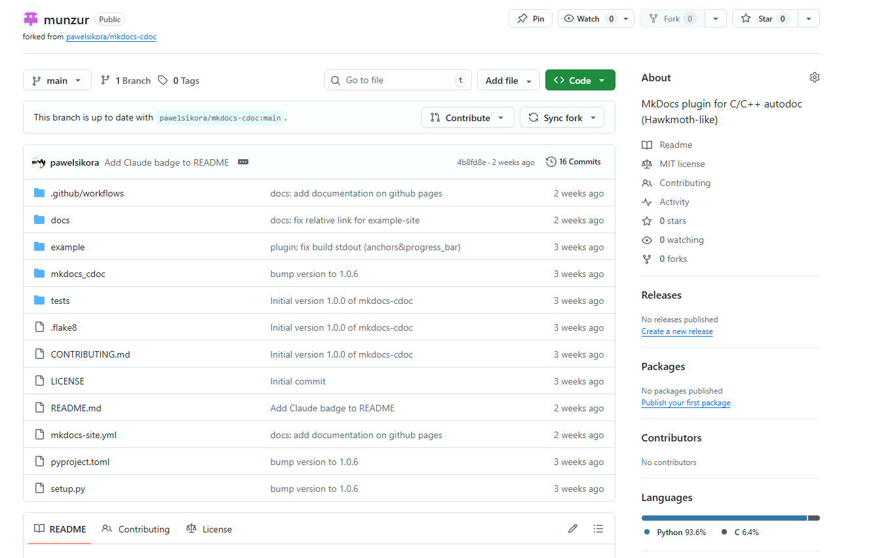

Sign-Off
All group members confirm that this deliverable represents their own original work and that all contributions are accurately attributed.

Name | Signature / Confirmation | Date
Samet Yıldırım | Confirmed | 23.03.2026
Berkay Durmaz | Confirmed | 23.03.2026
Deniz Ege Bozkurt | Confirmed | 23.03.2026
Deniz Arda Cengiz | Confirmed | 23.03.2026

