ARENA
Provably Fair On-Chain PvP Wagering
Concept Specification — Ideation Phase
Built on Solana · Inspired by the OSRS Duel Arena

1. Concept Overview
Arena is a browser-based PvP combat game built on the Solana blockchain, designed in two distinct phases. V1 launches as a free-to-play experience — no real-money wagering, no wallet connection required to fight. Players battle for fun, build records, compete on leaderboards, and purchase cosmetics with $ARENA tokens. V2 introduces peer-to-peer wagering once the protocol has secured appropriate licensing, completed a smart contract audit, and built a real player base. In V2, two players challenge each other, lock in an equal stake, and watch their characters fight to the death in real time. The outcome is determined by a provably fair random seed committed to the blockchain before the fight begins. The winner collects 95–97% of the total pot. The loser walks away with nothing.

The core design philosophy is borrowed from the Old School RuneScape Duel Arena — strip out every variable, equalize every stat, and let pure RNG decide the victor. This makes every match a true 50/50 coin flip, accessible to any player regardless of experience, and impossible to game through skill or knowledge.

The One-Line Pitch
V1: Build the audience. V2: Let them wager. The blockchain doesn’t lie.

2. Inspiration: The OSRS Duel Arena
Old School RuneScape's Duel Arena — colloquially known as 'The Sand Casino' — was one of the most culturally significant features in MMO history. At its peak it processed millions of GP in wagers daily, spawned its own meta-economy, and created some of the most memorable moments in gaming. Understanding why it worked is essential to building Arena.

2.1 The Tick System
OSRS runs on a game engine where every action is processed in discrete units called ticks, each lasting 0.6 seconds. Combat is not continuous — it is a series of rolls that happen at fixed intervals. Each weapon has an attack speed measured in ticks (a scimitar attacks every 4 ticks / 2.4 seconds, a whip every 6 ticks / 3.6 seconds). Between attack ticks, nothing happens. This deterministic, clock-driven structure is what makes the combat simulatable and, crucially, reproducible from a seed.

2.2 The Hit Roll
On each attack tick, two sequential random rolls occur:

- Accuracy Roll: Does the attack connect, or is it a zero-damage miss? This is determined by rolling a random number against the attacker's attack level versus the defender's defence level. With identical stats on both sides, this is a fixed probability that applies equally to both players.
- Damage Roll: If the accuracy roll succeeds, a second roll determines damage — a random integer from 0 up to the attacker's maximum hit. With identical max hits on both sides, this range is symmetric.

The result of any single tick is therefore: miss (0 damage), or a random integer from 0 to max_hit. Summed across many ticks, the fight resolves when one player's HP reaches zero. Because both players have exactly equal stats, neither has a mathematical edge. It is a pure race between two identical random processes.

2.3 Player ID (PID) — The Tiebreaker
In OSRS, two players attacking each other on the same tick creates a logical conflict: whose hit resolves first? The engine resolves this using a Player Identification Number (PID). The lower PID is processed first within that tick. This matters most in the scenario where both players would die on the same tick — only one of them actually does.

In the Duel Arena, PID was effectively a random advantage assigned at the start of each fight. In Arena, we replicate this cleanly: at match start, a random coin flip determines which player has 'low PID' — i.e., whose hit resolves first on any contested tick. This is a one-time random determination per match and is baked into the provably fair seed.

3. Core Game Mechanics

3.1 Combat Parameters (Fixed)
In V1, all players share identical base combat parameters — no levels, no gear, no advantages. The full stat and leveling system is built into the algorithm from day one, designed so that future skill and gear progression slots in seamlessly without architectural changes. V1 is simply every player at the base state of that system.

Parameter | Value
Starting HP | 100 for each player
Attack Speed | Every 4 ticks (2.4 seconds real-time)
Max Hit | 5 (V1 base player, no levels or gear). Maximum possible: 25 (level 100 Strength + best-in-slot gear)
Accuracy | 40% (V1 base player, no levels or gear). Range: 25% minimum (vs maxed defense opponent) to 80% maximum (level 100 Attack + best gear vs no defense)
PID | Randomly assigned per match via the provably fair seed
Fight Cap | None — fight ends only on a kill. No draws. No timeout.

3.2 The Tick Loop
A single fight plays out as follows, tick by tick:

- Tick 0 (Match Start): PID is assigned. Both players begin their attack cycle simultaneously on Tick 1.
- Every 4 ticks: Both players roll an accuracy check, then (if accurate) a damage roll. The lower-PID player's hit is resolved first within that tick.
- HP Reduction: Damage is subtracted from the target's current HP. HP cannot go below 0.
- Kill Check: After both hits resolve on a given tick, if either player is at 0 HP, the fight ends. The other player wins. If both players hit 0 HP on the same tick, the lower-PID player wins — their hit resolved first.
- Loop: If no player is dead, the cycle repeats on the next attack tick.

3.3 Provably Fair Resolution
This is the architectural heart of the product. The full fight sequence is deterministic once a seed is known. The seed encodes everything: PID assignment, every accuracy roll, every damage roll, for every tick, for both players.

Pre-Fight (On-Chain)
- Player A and Player B both lock their wager into an on-chain escrow smart contract on Solana.
- Once both wagers are confirmed, the contract generates and commits a fight seed to the blockchain. This seed is the hash of a server-side random value combined with a player-contributed random value — a standard commit-reveal scheme that prevents either party from knowing the seed in advance.
- The committed seed hash is publicly visible on-chain before the fight plays out. Neither player nor the protocol can alter it.

Fight Resolution (Off-Chain Computation)
- The full fight is simulated server-side using the committed seed. This produces a complete, deterministic fight log: every tick, every roll, every HP value, the winner.
- The fight log is not revealed to the players yet.

Fight Playback (Client-Side)
- The client receives the fight log and plays it back in real time — animating each tick at the correct interval (2.4 seconds per attack cycle).
- Players watch damage numbers appear, HP bars drain, and their character fight. Even though the outcome is already known server-side, the experience feels live.
- A 'Skip to Result' button can be offered without breaking anything.

Post-Fight (On-Chain Settlement)
- Once the fight concludes, the smart contract releases the pot: winner receives 95–97% of total wager, protocol retains 3–5%.
- The full seed and fight log are published on-chain or to a public data store. Any player can independently verify the outcome by re-running the simulation with the published seed.

Why This Architecture Matters
The fight is already over the moment you watch it. But you don't know that. The visual playback is not deceptive — the seed was committed before you even clicked play, and you can verify it after. This is provably fair gambling with a cinematic wrapper. The blockchain is the referee.

3.4 Full Combat Formula
All calculations are strictly linear. There are no multiplicative factors, no hidden modifiers, and no interaction effects between stats. Every bonus and penalty is additive. The full formula for each value is below.

Player Stats (Three Skills)
Players have three skills: Attack, Strength, and Defense. Each runs from level 0 to level 100. All three are independent and trained separately.

Gear Stats
Armour provides Accuracy, Strength, and Defense stat bonuses. Weapons provide Accuracy and Strength stat bonuses only. Stat values range from 0 (no gear) to a maximum of +150 per stat (best-in-slot gear for that stat). Stat bonuses from all equipped items are summed linearly before applying to the formula.

Accuracy (Chance to Hit)
Final Accuracy % = 40% + (Attack level x 0.25%) + (Total Accuracy gear stat / 10) - (Opponent Defense level x 0.1%) - (Opponent Defense gear stat / 30)
- Base: 40%
- Attack skill bonus: +0.25% per level (0% at level 0, +25% at level 100)
- Accuracy gear bonus: +1% per 10 stat points (0% at +0, +15% at +150)
- Opponent Defense skill penalty: -0.1% per opponent level (0% at level 0, -10% at level 100)
- Opponent Defense gear penalty: -1% per 30 opponent defense stat points (0% at +0, -5% at +150)
- Minimum possible accuracy: 25% (base 40% vs maxed defense opponent: -10% skill -5% gear = -15%). No hard floor rule needed - this emerges naturally from the caps.
- Maximum possible accuracy: 80% (base 40% + 25% Attack + 15% gear vs opponent with no defense). Ceiling enforced by stat caps.

Maximum Hit
Max Hit = 5 + floor(Strength level / 10) + floor(Total Strength gear stat / 15)
- Base: 5
- Strength skill bonus: +1 max hit per 10 levels (0 at level 0, +10 at level 100)
- Strength gear bonus: +1 max hit per 15 stat points (0 at +0, +10 at +150)
- Maximum possible max hit: 25 (base 5 + 10 Strength skill + 10 gear combined weapon and armor)
- Max hit is determined solely by the attacker's Strength skill and gear. Defense does not reduce incoming damage - it only reduces the opponent's accuracy. This is intentional.

Stat Ceiling & Floor Summary
- V1 base player (no levels, no gear): 40% accuracy, max hit 5
- Minimum accuracy (vs maxed defense opponent): 25%
- Maximum accuracy (level 100 Attack + best gear vs no defense): 80%
- Maximum defense reduction to opponent accuracy: 15% (10% from Defense skill + 5% from gear)
- Maximum max hit (level 100 Strength + best gear): 25
- Maximum gear stat per category: +150 (accuracy, strength, or defense). Only achievable with best-in-slot gear for that stat.

3.5 Levels, XP, and the Training Grounds

XP Curve Formula
XP required to advance from level N to level N+1 follows an exponential curve with two fixed boundary conditions: 250 XP at level 1, 1,000,000 XP at level 99.
XP(N) = round(229.71 x e^(0.084633 x N))
Total XP to reach level 100 in a single skill: approximately 12.3 million. Key checkpoints:
- Level 1 to 2: 250 XP
- Level 10 to 11: 535 XP | Cumulative to level 10: 3,232 XP
- Level 20 to 21: 1,248 XP | Cumulative to level 20: 11,302 XP
- Level 50 to 51: 15,811 XP | Cumulative to level 50: 176,197 XP
- Level 70 to 71: 85,918 XP | Cumulative to level 70: 970,000 XP
- Level 90 to 91: 466,873 XP | Cumulative to level 90: 5,283,458 XP
- Level 99 to 100: 1,000,000 XP | Cumulative to level 100: ~12,320,000 XP

Training Styles
Before attacking a dummy, the player selects a training style. The style determines which skill receives XP from each hit. The XP value of a hit is always equal to the damage dealt multiplied by the dummy's XP multiplier.
- Attack style: 100% of XP goes to Attack skill.
- Strength style: 100% of XP goes to Strength skill.
- Defense style: 100% of XP goes to Defense skill. Defense is trained by attacking, not by being hit. This is intentional.
- Balanced style: XP is split equally across all three skills, rounded up to the nearest whole number per skill. A 50 XP hit distributes 17 XP to each skill (17+17+17=51 total - the rounding-up bonus is a small reward for choosing this style).

The Training Grounds
The Training Grounds sit adjacent to the Arena lobby. Players train each skill independently by attacking dummies. Dummies have 100 HP and no defense stats. Combat against dummies follows the same tick system as PvP - the same attack speed, same accuracy rolls, same damage rolls. When a dummy reaches 0 HP it resets to 100 HP and combat pauses, requiring the player to re-engage. One tick of dead time exists between kills.

Dummy Tiers, Unlock Levels, and XP Multipliers
Dummies are unlocked when the relevant skill being trained reaches within 10 levels of the dummy tier. A player can attack any dummy at or below their current skill level +10. The Lv1 and Lv10 dummies have guaranteed hit (100% accuracy, damage rolls 1 to max hit, never 0) to smooth the new player experience. All higher dummies use normal accuracy calculation.
- Lv1 dummy: unlocks at skill level 0. XP multiplier x1 (1 XP per damage point). Guaranteed hit. Avg ticks to kill at base stats: ~34 (~1.4 min). XP/hr: ~4,370.
- Lv10 dummy: unlocks at skill level 10. XP multiplier x5. Guaranteed hit. Avg ticks to kill: ~29 (~1.2 min). XP/hr at level 10: ~25,400.
- Lv20 dummy: unlocks at skill level 20. XP multiplier x10. Normal accuracy. XP/hr at level 20: ~23,300.
- Lv30 dummy: unlocks at skill level 30. XP multiplier x15. Normal accuracy. XP/hr at level 30: ~42,000.
- Lv40 dummy: unlocks at skill level 40. XP multiplier x20. Normal accuracy. XP/hr at level 40: ~66,000.
- Lv50 dummy: unlocks at skill level 50. XP multiplier x25. Normal accuracy. XP/hr at level 50: ~96,000.
- Lv60 dummy: unlocks at skill level 60. XP multiplier x30. Normal accuracy. XP/hr at level 60: ~132,000.
- Lv70 dummy: unlocks at skill level 70. XP multiplier x35. Normal accuracy. XP/hr at level 70: ~175,000.
- Lv80 dummy: unlocks at skill level 80. XP multiplier x40. Normal accuracy. XP/hr at level 80: ~226,000.
- Lv85 dummy: unlocks at skill level 85. XP multiplier x45. Normal accuracy.
- Lv90 dummy: unlocks at skill level 90. XP multiplier x50. Normal accuracy.
- Lv100 dummy: unlocks at skill level 90 (accessible from 90+). XP multiplier x55. Normal accuracy. XP/hr at level 90+: ~347,000-359,000.

Realistic Time to Max (Single Skill)
- Level 2: ~4 minutes active (3 kills of the Lv1 dummy). First level up is intentionally fast.
- Level 10: ~0.7 active hours (~1.5 hrs at 50% uptime)
- Level 30: ~1.8 active hours (~3.7 hrs at 50% uptime)
- Level 50: ~4.4 active hours (~8.7 hrs at 50% uptime). Meaningful competitive milestone.
- Level 70: ~10.9 active hours (~21.8 hrs at 50% uptime)
- Level 90: ~30.4 active hours (~60.7 hrs at 50% uptime)
- Level 100: ~50.3 active hours (~100 hrs at 50% uptime). All three skills maxed: ~150 active hours / ~300 hrs realistic.

3.6 Gear, Weapons, and Stat Progression
Arena has two categories of equippable items: armour and weapons. Armour requires a minimum Defense level to equip. Weapons require a minimum Attack level to equip. All items within a tier share the same stat values regardless of appearance. Cosmetic skins (Section 3.7) alter visuals only and have no effect on stats.

Armour Slots
Four armour slots: Helmet, Chestplate, Platelegs, Shield. Each piece provides Accuracy, Strength, and Defense stat bonuses. The total stat budget per tier is distributed across slots proportionally: Chestplate 40%, Platelegs 30%, Shield 20%, Helmet 10%.

Weapon Types
Four weapon types: Kopesh, Stiletto, Battleaxe, Warhammer. All weapon types within the same tier share identical stats and attack speed (every 4 ticks / 2.4 seconds). Weapon type is a cosmetic-equivalent choice within a tier. Weapons provide Accuracy and Strength stat bonuses only — no Defense bonus. Future tiers may introduce weapon-type-specific mechanics but V1 through T4 all share identical parameters.

Gear Tier Progression — Full Table
Gear stat formula: total stat = round(150 x (tier/10)^1.5). This power curve ensures early tiers provide modest bonuses while high tiers provide meaningful upgrades. Tiers 1-4 are planned for launch. Tiers 5-10 are future additions with placeholder level requirements. Tier 10 is the permanent maximum — +150 stat in every category at best-in-slot.
Armour tier table (total stat per tier, split across all 4 slots):
- T1 Bronze | Defense level 0 | Total stat: 5 | Chest: 2, Legs: 2, Shield: 1, Helm: 1 | PLANNED
- T2 Iron | Defense level 20 | Total stat: 13 | Chest: 5, Legs: 4, Shield: 3, Helm: 1 | PLANNED
- T3 Steel | Defense level 30 | Total stat: 25 | Chest: 10, Legs: 8, Shield: 5, Helm: 3 | PLANNED
- T4 Titanium | Defense level 50 | Total stat: 38 | Chest: 15, Legs: 11, Shield: 8, Helm: 4 | PLANNED
- T5 Tungsten | Defense level 60 | Total stat: 53 | Chest: 21, Legs: 16, Shield: 11, Helm: 5 | FUTURE
- T6 Obsidian | Defense level 70 | Total stat: 70 | Chest: 28, Legs: 21, Shield: 14, Helm: 7 | FUTURE
- T7 Dragonite | Defense level 80 | Total stat: 88 | Chest: 35, Legs: 26, Shield: 18, Helm: 9 | FUTURE
- T8 Celestial | Defense level 85 | Total stat: 107 | Chest: 43, Legs: 32, Shield: 21, Helm: 11 | FUTURE
- T9 Void | Defense level 90 | Total stat: 128 | Chest: 51, Legs: 38, Shield: 26, Helm: 13 | FUTURE
- T10 [Name TBD — ultimate tier] | Defense level 100 | Total stat: 150 | Chest: 60, Legs: 45, Shield: 30, Helm: 15 | FUTURE — permanent maximum
Weapon tier table (accuracy and strength bonuses, all weapon types identical within tier):
- T1 Bronze | Attack level 0 | Acc bonus: +0.5% | Str bonus: +0 max hit | PLANNED
- T2 Iron | Attack level 20 | Acc bonus: +1.3% | Str bonus: +1 max hit [override] | PLANNED
- T3 Steel | Attack level 30 | Acc bonus: +2.5% | Str bonus: +1 max hit [override] | PLANNED
- T4 Titanium | Attack level 50 | Acc bonus: +3.8% | Str bonus: +2 max hit [override] | PLANNED
- T5 Tungsten | Attack level 60 | Acc bonus: +5.3% | Str bonus: +1 max hit [formula] | FUTURE
- T6 Obsidian | Attack level 70 | Acc bonus: +7.0% | Str bonus: +2 max hit [formula] | FUTURE
- T7 Dragonite | Attack level 80 | Acc bonus: +8.8% | Str bonus: +2 max hit [formula] | FUTURE
- T8 Celestial | Attack level 85 | Acc bonus: +10.7% | Str bonus: +3 max hit [formula] | FUTURE
- T9 Void | Attack level 90 | Acc bonus: +12.8% | Str bonus: +4 max hit [formula] | FUTURE
- T10 [Name TBD] | Attack level 100 | Acc bonus: +15.0% | Str bonus: +5 max hit [formula] | FUTURE — permanent maximum

Combined Max Hit Progression (Gear Only, Level 0 Skills)
The alternating pattern below is intentional: odd tiers are primarily accuracy upgrades, even tiers deliver damage jumps. No tier is ever a regression.
- T1 Bronze: max hit 5, accuracy 41.0% — accuracy-only upgrade over base
- T2 Iron: max hit 6 (+1), accuracy 42.6% — first damage upgrade
- T3 Steel: max hit 6 (same), accuracy 45.0% — accuracy upgrade, steel hits more often not harder
- T4 Titanium: max hit 8 (+2), accuracy 47.6% — biggest early damage jump, weapon and armor str both increase
- T5 Tungsten: max hit 8 (same), accuracy 50.6% — accuracy upgrade
- T6 Obsidian: max hit 10 (+2), accuracy 54.0% — damage jump
- T7 Dragonite: max hit 10 (same), accuracy 57.6% — accuracy upgrade
- T8 Celestial: max hit 12 (+2), accuracy 61.4% — damage jump
- T9 Void: max hit 13 (+1), accuracy 65.6% — bridge tier, both accuracy and small damage gain
- T10 [Ultimate]: max hit 15 (+2) from gear, accuracy 70.0% — final gear tier. Combined with level 100 skills: max hit 25, accuracy up to 80%

3.7 The Group Boss
At the back of the Training Grounds sits the Group Boss — a large monster (designed as a Minotaur or similarly imposing creature) that any number of players can attack simultaneously. Unlike training dummies, the boss fights back. It is designed as a community event: powerful enough to require coordinated groups, rewarding enough to draw players on a regular cycle.

Boss Parameters
- HP: 2,000. Validated by simulation: a group of 5 level-50 players kills it in ~6 minutes, a group of 10 in ~3 minutes, a 20-player raid in ~90 seconds.
- Boss level: 150 (arbitrary — sets the tone as a serious threat). Designed for players with Attack and Strength level 50+.
- Defense stats: none. Players hit the boss using standard accuracy calculation against zero defense. Boss HP is the sole challenge on the offensive side.
- Respawn timer: 20 minutes after death. The boss functions as a scheduled community event — players can see the respawn countdown in the lobby and Training Grounds UI.
- On death: all players who dealt more than 25 damage during the fight receive a loot roll (see Reward Table below). Players who dealt 25 damage or less receive nothing.

AOE Attack Mechanic
The boss has one attack type only: an Area of Effect (AOE) stomp that hits every player within a 5-tile radius. The AOE is its only offensive mechanic — it does not target individual players and does not make single-target attacks. This keeps the encounter clean and fair regardless of group size.
- Damage: 10 per hit. Accuracy: 100% for all players within range — no roll, guaranteed damage to anyone who has not stepped outside the radius.
- Interval: every 8 ticks (19.2 seconds). A player who never moves dies in 3.2 minutes (10 hits x 10 damage). This creates genuine pressure without being instantly lethal.
- Warning animation: 2 ticks (4.8 seconds) before each AOE fires, a visible ground ring appears around the boss showing the 5-tile radius. The ring pulses and expands as the attack charges. Players have 4.8 seconds to step outside the ring. This rewards attentive players and punishes AFK farming.
- Player death: if a player reaches 0 HP from AOE damage they are removed from the fight and respawn in the lobby, identical to death in PvP combat. Their accumulated damage toward the loot threshold is retained — if they dealt more than 25 damage before dying they still qualify for the loot roll.

Boss Loot Table
Each qualifying player receives an independent loot roll. Rolls are separate — one player getting a rare drop does not affect other players' rolls. The table sums to exactly 100%.
- 35% — Nothing
- 30% — Random T1 (Bronze) armour piece (helmet, chestplate, platelegs, or shield — equal chance of each)
- 15% — Random T1 (Bronze) weapon (kopesh, stiletto, battleaxe, or warhammer — equal chance of each)
- 15% — Random T2 (Iron) armour piece
- 5% — Random T2 (Iron) weapon
Note: T2 (Iron) requires Attack/Defense level 20 to equip. A player who receives a T2 drop before reaching level 20 retains it in their inventory until they meet the requirement.

Scaling Note
The boss does not scale with group size. A 3-player group fighting a 2,000 HP boss for 6 minutes faces 9 AOE pulses — genuinely dangerous and a real test of coordination. A 20-player raid burns it in 90 seconds and faces fewer than 5 pulses — a fast reward for community turnout. Both experiences are valid. The 20-minute respawn timer naturally regulates how frequently large groups can farm it.
As higher gear tiers are released in future updates, the boss loot table will expand to include T3 and T4 drops with correspondingly lower drop chances. Boss HP and AOE damage may also be tuned upward to maintain challenge as the player base progresses.

3.8 Cosmetics & Seasonal System
Cosmetics are purely visual items with zero stat impact. They are worn in the standard gear slots (helmet, chestplate, platelegs, shield, weapon) and replace the visual appearance of whatever stat gear the player has equipped in that slot — or are worn alone as a pure flex with no defensive benefit. They do not override stats. A player wearing a full cosmetic set with no real armour underneath is making a deliberate prestige choice at the cost of all defensive bonuses.
A skin overlay system (cosmetic appearance layered on top of equipped stat gear without sacrificing stats) is a future development consideration. The slot-based model is the V1 implementation.

Cosmetic Slots
- Helmet — cosmetic head piece
- Chestplate — cosmetic body piece
- Platelegs — cosmetic leg piece
- Shield — cosmetic off-hand piece
- Weapon — cosmetic weapon skin (kopesh, stiletto, battleaxe, or warhammer visual — one weapon type per set, matching the set’s aesthetic)

Seasonal System
Cosmetics are released in seasons. Each season has a defined theme and duration. Within each season, one new cosmetic set drops per week — creating a weekly engagement hook and social media moment rather than dumping all sets at once. Once a season closes, those cosmetics leave the shop and become permanently scarce. The team reserves the right to re-release specific sets as special event drops (e.g., boss loot) in future, but the season shop window is intentionally limited to create genuine scarcity and early-adopter prestige.
- Cosmetics are purchased as full sets only. No individual pieces. This keeps the visual identity of each set coherent and drives higher per-transaction revenue.
- Price: fixed token amount set per season by the team, reviewed before each season opens. Target: 250,000 $ARENA per set for Season 1. The team reviews token price before each subsequent season and adjusts to keep the USD equivalent within a reasonable and accessible band. The new price is announced publicly before the season shop opens.
- Token split on every cosmetic purchase: 50% burned immediately and permanently, 50% routed to team treasury wallet (same policy as all in-game purchases — never sold, only redeployed as liquidity).
- At 250,000 tokens per set: every 100 sets sold burns 12,500,000 tokens and sends 12,500,000 to treasury. At 1,000 sets sold in a season, 125,000,000 tokens are permanently removed from supply — 12.5% of total supply in a single season at full demand.

Season 1 — Precious Gems (Weeks 1–5, one set per week)
Theme: precious gemstones. Five sets dropping one per week across the 5-week season. Each set is available to purchase for its drop week only — once the next week opens, the previous week’s set is gone from the shop. Each set covers all 5 cosmetic slots (helmet, chestplate, platelegs, shield, weapon). Visual identity is gem-encrusted armour and weapons with the gem’s characteristic colour palette and internal glow animation.
- Sapphire Set — Week 1 drop. Deep blue gem armour with silver trim. Subtle blue inner glow on weapon and helm. Entry prestige tier and the first set most players will see — sets the visual tone for the season.
- Ruby Set — Week 2 drop. Deep red gem armour with gold trim. Pulsing red glow on weapon edge and visor. Aggressive, fiery aesthetic.
- Emerald Set — Week 3 drop. Deep green gem armour with dark gold trim. Slow emerald pulse on chest and shield face. Regal, composed aesthetic.
- Amethyst Set — Week 4 drop. Purple gem armour with silver-black trim. Shimmering violet aura across the full set. Mystical, otherworldly feel.
- Diamond Set — Week 5 drop. Crystal-clear gem armour with bright platinum trim. Prismatic light refraction effect across all pieces. Season 1 finale set — highest visual prestige of the season. Players who held off until week 5 are rewarded with the most striking set; players who bought early have rarer earlier sets. Both are valid flex.
Price: 250,000 $ARENA per set (fixed for Season 1, same price for all five sets). Each set available for its drop week only. Season 1 runs weeks 1–5 of live game.

Season 2 — Elemental (Weeks 6–7, one set per week)
Theme: elemental forces, specifically ice and fire/lava. Two sets dropping one per week across the 2-week season. Each set available for its drop week only. The visual contrast between the two sets is intentional — players will identify at a glance which elemental allegiance a player chose. Token price reviewed and announced before Season 2 opens.
- Frost Set — Week 6 drop. Ice-encrusted armour in pale blue and white. Frozen crystal formations on shoulders and helm. Weapon leaves a faint frost trail on swing animation. Shield face shows cracked ice texture with backlit glow.
- Lava Set — Week 7 drop. Black volcanic armour with glowing lava cracks running across every piece. Weapon glows orange-red at the edges. Helmet styled as a lava hood with ember particle effect. Shield shows an active magma surface animation. Pairs thematically with the Lava Hood as a cosmetic helm variant if implemented later.
Price: reviewed and announced before Season 2 opens. Each set available for its drop week only. Season 2 runs weeks 6–7 of live game.

Season 3 — [TBD] (Weeks 8–9, one set per week)
Theme and content to be determined based on community feedback and engagement from Seasons 1 and 2. Design will begin during the Season 2 window. One set per week for the duration of the season. Price reviewed and announced before Season 3 opens. Season 3 begins week 8 of live game.

Future Cosmetic Directions
- Cape slot — a purely decorative back slot not tied to any stat gear. First candidates: Lava Cape, Shadow Cape, Storm Cape, Celestial Cape. Capes sold individually or as add-ons to seasonal sets.
- Skin overlay system — cosmetic appearance layered over equipped stat gear so players do not sacrifice stats to wear prestige cosmetics. Development complexity to be assessed; lower priority than core gameplay features.
- Boss drop cosmetics — rare cosmetic items added to the Group Boss loot table in future seasons, giving non-purchasable cosmetics that are earned through gameplay rather than $ARENA spend. Creates a parallel prestige track for active players who prefer earning over buying.
- Re-release policy — season sets may be re-released as limited boss drops or special event rewards at the team’s discretion. Shop re-releases will not occur — each weekly window is a firm commitment to buyers of that week's set.

4. User Flow4. User Flow

4.1 The Full Loop

Step | Description
1. Connect Wallet | Player connects a Solana wallet (Phantom, Backpack, etc.). No account creation required — the wallet is the identity.
2. Enter the Lobby | Player enters the public Arena lobby. They can see all other connected players, their win/loss records, and any open challenges posted publicly.
3. Challenge | Player A sends a challenge to Player B specifying a stake amount in USDC or SOL (V2 only). Player B sees the challenge and accepts or declines. In V1, challenges carry no monetary stake.
4. Escrow Lock | Both players' stake amounts are locked into the on-chain escrow contract. Neither can withdraw until the fight resolves.
5. Seed Commit | The contract commits the fight seed on-chain. Both players can see the seed hash.
6. Fight | The fight plays back in real time. Both players watch simultaneously — same tick-by-tick animation, same damage numbers.
7. Settlement | Winner receives their payout. Loser's stake is distributed. The fight log and seed are published for verification.
8. Back to Lobby | Both players return to the lobby. The cycle repeats.

4.2 Challenge Mechanics
Arena uses a peer-to-peer direct challenge model. Only wager (real-money) PvP combat exists — there is no free-to-play challenge system. All PvP is 1v1 only. The full wager flow is defined in Section 4.3.

- Any player in the lobby can challenge any other player.
- The challenger specifies the stake amount and the token (USDC / SOL / $ARENA).
- The challenged player must match the exact stake amount in the same token.
- Challenges expire after a configurable timeout (e.g., 60 seconds) if not accepted.
- A player may have only one active challenge or fight at a time.

An 'open challenge' feature can be added post-launch: post a stake amount publicly and let any lobby participant accept it — functioning like a limit order book for fights.

4.3 Wager Flow (V1 and V2)
Food cannot be used in wagers. The wager fight is a pre-computed seed simulation replayed client-side — there is no live combat moment where a player can click to eat. Food is a real-time mechanic for training and boss combat only. There is no food toggle on the wager interface.

Step 1 — Challenger Creates Wager
- Right-click any player in the lobby — select Wager from the context menu.
- If the target player is busy (in a wager, in training, or fighting the boss) the game displays "Player is busy" and no interface opens.
- Wager creation interface opens for the challenger only. Settings: currency (USDC or SOL), wager amount ($1–$5,000 USDC or 0.01–equivalent SOL, adjustable by up/down button or manual entry in $1 / 0.01 SOL increments).
- V1: challenger clicks Send Wager. A wallet message signing prompt appears (zero gas — pure signature, no funds move). The signature confirms the challenger's stat snapshot from the server database at that moment. Challenge is sent to the accepter's inbox.
- V2 addition: clicking Send Wager also deposits the minimum wager amount into escrow (e.g., $1 USDC or 0.01 SOL). This deposit is at risk if the challenger cancels after the accepter has signed (see Step 4).

Step 2 — Accepter Reviews
- Accepter receives an inbox notification. Opening it shows a static interface: challenger's display name, challenger's skill levels, wager amount, and currency. No editable fields.
- Decline: challenge is cancelled. No signatures, no funds. Challenge disappears from both inboxes.
- Accept (V1): wallet message signing prompt. Accepter signs to confirm their stat snapshot. No funds move. Notification sent to challenger's inbox that the wager has been accepted.
- Accept (V2 addition): wallet transaction prompt. Accepter signs AND deposits full wager amount into escrow. Both the signature and the escrow transaction must succeed for acceptance to complete.

Step 3 — Challenger Confirms
- Challenger receives inbox notification. Interface shows accepter's display name, accepter's skill levels, and the agreed wager settings. Two options: Confirm Wager or Cancel Wager.
- Confirm (V1): wallet message signing. Challenger signs to confirm final stat snapshot. Combined with accepter's signature and server entropy, the fight seed is now fully committed. Fight begins.
- Confirm (V2 addition): wallet transaction. Challenger signs AND deposits full wager amount into escrow. Seed is committed. Fight begins.
- Cancel (V1): challenge voided. No consequences. Both players return to normal state.
- Cancel (V2): challenger forfeits their minimum escrow deposit to the accepter as a penalty for cancelling after the accepter committed funds. Accepter's full deposit is returned. Penalty amount equals the minimum wager amount in the chosen currency ($1 USDC or 0.01 SOL).

Step 4 — Fight and Settlement
- Fight simulation runs server-side using the committed seed. Client animates the playback in real time. Neither player needs to be logged in or interact for the fight to complete — the outcome is predetermined.
- V2 settlement: smart contract releases escrow to winner automatically. Winner receives 95–97% of total pot (exact fee rate per tier). Loser receives nothing. No player action required to receive winnings — funds are sent directly to the winning wallet from escrow.
- Result screen: shows winner name, loser name, wager amount, and amount won. Visible to both players. Both players reset to full HP and respawn at the lobby spawn zone.
- Gas costs: determined during testing. V1 wager flow uses only zero-cost message signing. V2 escrow transactions incur standard Solana network fees, confirmed during smart contract testing phase.

4.4 Player Data Model
Each player record stored in the server database contains the following fields. Player data is global across all servers — a player carries the same stats, inventory, and record regardless of which server they log into.
- Wallet address — primary identifier. Unique. Cannot be changed.
- Display name — set at character creation. Changeable via player info page. Shown everywhere in-game instead of wallet address.
- Character model — gender (male/female), hair colour (blonde, brunette, black, white), skin tone (light, tan, dark tan, deep), clothing base colour (4 options). Set at character creation.
- Skill levels and XP — Attack level (0–100), Attack XP; Strength level (0–100), Strength XP; Defense level (0–100), Defense XP. XP is stored as the raw cumulative value. Level is derived from XP using the formula. Written to DB after every confirmed kill.
- Current HP — persists across zones and sessions. Starts at 100 on account creation. Only restored by food, death, or winning a wager fight.
- Equipped gear — references to item IDs in each slot: helmet, chestplate, platelegs, shield, weapon, helmet cosmetic, chestplate cosmetic, platelegs cosmetic, shield cosmetic, weapon cosmetic. Null if slot is empty.
- Inventory — 20 slots. Each slot holds one item. No stacking in inventory. Gold and food are items like any other — each unit occupies one slot.
- Bank — 100 slots. Items stack in bank with a quantity counter. Gold and food stack. Gear does not stack (each is a unique item). Bank saves to DB on close — no duplicate items can exist between inventory and bank for the same item instance.
- Fight record — total wager wins, total wager losses, total USDC-equivalent wagered (V2), total $ARENA spent on cosmetics (V1).
- Gold — starts at 1 on account creation (one-time, never repeated). Treated as a stackable item in inventory and bank. Earned by selling gear to the merchant. Spent at shops.
- Tutorial completed flag — boolean. False on creation, set to true when player clicks Done on final tutorial box. Tutorial never re-triggers.
- Active server ID — which server the player is currently logged into. Null when offline.

4.5 World Layout, Movement, and HP

World Layout
- Arena Lobby — the central hub. Contains: spawn zone (3x3 tile area, geographically centred), bank NPC, trading merchant NPC, cosmetics shop NPC, player list, chat, leaderboard access, and the wager interface. Lobby doors lead out to the Training Grounds.
- Training Grounds — directly outside the lobby doors. Contains all dummy tiers (3 dummies per tier for scalability, each attackable by multiple players simultaneously). Dummies auto-reset on death. The boss cave entrance is at the far end of the Training Grounds.
- Boss Cave — cave entrance at the back of the Training Grounds. Contains the Group Boss and the open combat area around it. The 5-tile AOE radius is defined relative to the boss's fixed position in the centre of this area. Respawn timer countdown is visible on entry.

Movement
- Point-and-click movement identical to OSRS. Left-click a tile to walk to it. Character pathfinds automatically around obstacles.
- Camera: mouse scroll to zoom in/out. Arrow keys rotate camera in 4 directions. No free-look camera.
- Zone transitions: walking through the lobby doors enters Training Grounds. Walking to the cave entrance enters the Boss Cave. No loading screens — transitions are seamless tile-based.
- Desktop only. Browser-based. No mobile support.

HP Persistence and Death
HP is a persistent global stat. It does not reset between zones or sessions. A player who takes AOE damage in the Boss Cave and walks back to the lobby retains that reduced HP. HP is stored in the player database record and loaded on each login.
- HP restoration: eating food (+5 HP per chicken, capped at 100), dying and respawning (full 100 HP on respawn), or winning a wager fight (full 100 HP reset for winner only).
- Death: character is halted immediately at 0 HP. Player is teleported to the lobby spawn zone (3x3 tile area, random tile within it). HP is restored to 100 on respawn. Currently possible only from boss AOE damage or losing a wager fight. Future monster content may add additional death sources.
- Wager fight death: both players see the result screen (winner, loser, wager amount, amount won). Both respawn at lobby spawn zone. Winner HP restored to 100. Loser HP restored to 100.

4.6 Food and Healing
One food type exists at launch: Cooked Chicken. Food can be eaten anywhere in the game world at any time, including during active combat (training dummies or boss). Food cannot be used in wager fights (pre-computed simulation, no real-time interaction possible).
- Heal amount: +5 HP per chicken. Capped at 100 HP maximum. Overheal is not possible — eating at 98 HP restores to 100, not 103.
- Eat cooldown: 1 tick (2.4 seconds) between each chicken consumed. Cannot eat again until cooldown expires.
- Attack delay: eating costs 1 full attack tick. The player's next scheduled attack is skipped. This is the deliberate tradeoff: +5 HP costs one missed hit. Strategic timing of food is a skill element in training and boss combat.
- Acquisition: purchased from the food shop NPC in the lobby. Price: 1 gold per 10 cooked chickens.
- Inventory behaviour: food does not stack in inventory (each chicken occupies one slot). Food stacks in the bank with a quantity counter. Players must plan inventory space when heading to the boss — carrying 10 chickens uses 10 of 20 inventory slots.

4.7 Gold, Shops, Merchants, and Trading

Gold
- Gold is the in-game currency. It is an item — it occupies inventory slots and stacks in the bank with a quantity counter. No separate gold UI element. Starting balance: 1 gold on account creation (one-time, never repeated). Earned by selling gear to the trading merchant. Spent at shop NPCs.
- Gold can be traded directly between players as a regular item (dropped or traded). Gold cannot be converted to $ARENA, USDC, or SOL — it is a purely in-game currency with no on-chain value.

Trading Merchant NPC (Lobby)
Players can sell gear (armour and weapons) to the trading merchant for gold at fixed prices per tier. Cosmetics are soulbound and cannot be sold. Food cannot be sold. Gold cannot be sold (redundant).
- T1 gear: 1 gold per piece. T2 gear: 2 gold per piece. T3 gear: 3 gold. T4: 4 gold. T5: 5 gold. T6: 6 gold. T7: 7 gold. T8: 8 gold. T9: 9 gold. T10: 10 gold. Pattern: tier number equals gold value.

Food Shop NPC (Lobby)
- Sells Cooked Chicken only. Price: 1 gold per 10 chickens. Player selects quantity in multiples of 10 (up to their available inventory space and gold balance). Transaction is instant.

Cosmetics Shop NPC (Lobby)
- Sells active seasonal cosmetic sets for $ARENA. Only the current week's set is available. Previous weeks' sets are not shown. Requires connected Solana wallet. Purchase triggers on-chain $ARENA transaction: 50% burn, 50% treasury. Cosmetics are soulbound on receipt — cannot be traded, sold, or transferred.
- If player has insufficient $ARENA, a popup displays the $ARENA contract address and a message directing them to purchase $ARENA on a DEX.

Bank NPC (Lobby)
- 100 bank slots. Items stack in the bank with quantity counters (food, gold). Gear does not stack. Bank saves fully to DB on close — item duplication prevention enforced server-side. Items can be deposited or withdrawn freely.
- Bank capacity note: 100 slots accommodates all launch items comfortably (68 unique items). Future gear tiers and cosmetic seasons will approach the limit. Bank expansion mechanic (additional tabs or increased slot count) to be added before T5+ gear is released.

Player-to-Player Trading
Right-click any player — select Trade. Opens a two-panel trade interface: player's offered items on one side, other player's offered items on the other. Both players must confirm before items exchange. Either player can cancel at any time before final confirmation. Tradeable items: gear (armour and weapons) and gold. Non-tradeable: cosmetics (soulbound), food (no trade value by design, prevents gold-for-food arbitrage loops).
- Marketplace: a public listing board accessible from the lobby. Players list gear for a gold price. Other players browse listings and purchase. The seller sets the price in gold. No auction mechanic at launch — fixed-price listings only. The protocol takes no cut of player-to-player trades in V1. Marketplace cut percentage TBD for V2.

4.8 XP Architecture and Data Persistence
XP lives entirely off-chain in the server database. The blockchain only handles money (V2 wager escrow) and cosmetic purchases ($ARENA burn). This separation keeps training frictionless, eliminates gas costs for gameplay, and ensures instant XP feedback after every kill.

Training XP Flow
- Every hit in training is processed server-side in real time. The server maintains an in-memory damage log per active training session.
- On confirmed kill (dummy or boss HP reaches zero): XP is calculated from the in-memory log and written to the player database in a single batch write. No per-hit writes. No blockchain transaction. Kill is the atomic unit of XP reward.
- If a player disconnects mid-kill: the in-memory damage log is discarded. No XP is awarded for incomplete kills. No partial credit. This prevents exploit scenarios where a player damages a dummy and disconnects repeatedly to gain XP without completing kills.
- Boss XP and loot: server maintains a per-boss-fight damage map of {player_id: total_damage}. On boss death, all players with more than 25 damage receive XP and a loot roll simultaneously. XP and loot written to DB in a single batch. Damage contributions are tracked even for players who died during the fight and respawned — their accumulated damage before death is retained in the map.

Wager Stat Snapshot
- When a wager is confirmed, the server reads both players' current stats from the database and produces a signed attestation for each: a server-signed message containing skill levels, equipped gear, and a timestamp.
- Any active training session is committed and paused before the snapshot is taken. A player cannot be in active training and in a wager simultaneously — the busy flag enforces this. This guarantees the snapshot always reflects fully committed XP state.
- Both signed snapshots plus a server-generated random value combine to produce the fight seed. The seed is fully committed once both players have signed. Trust model: server is authoritative for game state (XP, inventory, stats). Blockchain is authoritative for financial settlement. Signed snapshots bridge the trust gap cryptographically.

4.9 Server Architecture
Arena uses a shared-world, instanced-server model. Each server is a fully independent game world with its own lobby, chat, and player population. Player data (XP, inventory, bank, gold, fight record) is stored in a shared global database — a player carries the same stats across all servers. Only their social presence (lobby visibility, local chat, who they can challenge) is server-specific.
- Server capacity: target 200–500 concurrent players per server. New servers spin up automatically as player count grows.
- Server assignment: players are auto-assigned to the least-populated server that is not full on login. Players can manually switch servers from a server select screen to join friends on a specific server.
- Wagers are server-local: players can only challenge players on their current server. Cross-server wagers are not supported.
- Leaderboard: global across all servers. Daily snapshot at midnight EST. Leaderboard reads from the shared global database. Each player entry shows display name and server tag (e.g., "PlayerName — Server 3"). Blacklisted wallets do not appear.
- Chat: server-local world chat. Text appears in the collapsible chat log and above the player's head for 3.5 seconds in yellow. Profanity filter replaces classic swear words with ******. No cross-server chat at launch.

4.10 Character Creation and Tutorial

Character Creation
Shown on first login only. Player creates their character before entering the game world. Four customisation categories, 4 choices each:
- Gender: male or female character model.
- Hair colour: blonde, brunette, black, white.
- Skin tone: light, tan, dark tan, deep.
- Clothing colour: 4 neutral base colour options (exact palette TBD by art team).
- Display name: text input. Shown everywhere in-game. Changeable later via player info page. Profanity filter applied on creation and on change.
- On completion, 1 gold is added to inventory and the player spawns at the lobby spawn zone for the first time.

Tutorial
Triggers immediately after character creation, on first login only. Cannot be replayed. Each step is a separate info box with a Next button. Final box has a Done button. Tutorial does not block gameplay — player can move and interact while boxes are open. Info boxes are styled with a subtle border — less visually intense than level-up notifications.
Tutorial sequence (one box per topic):
- Welcome to Arena — what the game is, the core loop.
- Movement — point and click to move, scroll to zoom, arrow keys to rotate camera.
- The Lobby — bank, merchants, cosmetics shop, player list, wager system location.
- Skills — Attack, Strength, Defense. What each does to your combat stats.
- The Training Grounds — location, how to attack dummies, training styles (Attack/Strength/Defense/Balanced).
- XP and leveling — XP is awarded on kill, levels unlock new dummies and gear tiers.
- Gear — armour and weapons, how to equip them, level requirements, stat bonuses.
- Food and healing — how to buy chicken, eat it, the heal amount, the eat cooldown, and the attack delay tradeoff.
- HP and death — HP persists everywhere, how to die, respawn location, HP restoration.
- The Bank — location, how to deposit and withdraw, stacking behaviour.
- Gold and merchants — how to earn gold (sell gear), how to spend it (food shop), the trading merchant.
- The Group Boss — location (cave at back of Training Grounds), how the AOE works, the warning ring, loot drops, 20-minute respawn.
- The Wager System — right-click to challenge, the wager flow, currency, minimum amounts, how the fight is determined (provably fair seed), result screen.
- $ARENA token and cosmetics — what $ARENA is, seasonal cosmetic sets, where to buy $ARENA if needed.
- Chat — how to use world chat, text appears above head and in log, expandable/collapsible log.
- Player interface panels — inventory, levels, equipment, player info (name change here).

5. Token Economy

5.1 $ARENA Token — Launch & Revenue Model

Token | Role
Bonding curve launch (pump.fun) | Launched via pump.fun bonding curve paired with USDC (placeholder — final pair TBD). Total supply: 1,000,000,000 $ARENA, fixed permanently with mint authority revoked at launch. Team purchases 25% of supply (~250M tokens) via the bonding curve as first buyers at the lowest possible valuation. Estimated total team cost: ~$1,500–$2,000 inclusive of LP seeding. Creator fees accrue on every trade perpetually — scaling with volume and market cap, not a one-time event.
Meteora DAMM & DLMM liquidity pools | 20% of total supply (200,000,000 tokens) deployed immediately into a Meteora DAMM pool paired with SOL — the opposite asset to the pump.fun pair, enabling natural arbitrage between venues that generates fee revenue on both pools simultaneously. A Meteora DLMM (concentrated liquidity) pool may be added later for additional fee efficiency. Team-owned LP position; fees accrue in $ARENA and SOL. Active range management required for DLMM; DAMM is lower-maintenance.
$ARENA | Every in-game cosmetic purchase is made exclusively in $ARENA. The purchase is split 50/50 at point of transaction: 50% is immediately routed to the Solana burn address (permanent, on-chain, irreversible) and 50% is routed to the team treasury wallet. Treasury tokens are never sold for USDC or SOL — they are only ever redeployed as additional liquidity into Meteora pools, growing LP depth over time. The remaining 5% of team supply (50M tokens) is held as a locked strategic reserve for exchange listings, market maker agreements, and holder reward programs.

5.2 Protocol Fee
V1 has no protocol fee — there are no wagers. The protocol fee is a V2 mechanism only. Base rate is 5% of every fight pot. Reduced for $ARENA holders by tier (see below). Single wager hard cap: $5,000 USD equivalent. Fee is always displayed to both players before challenge acceptance.

Fee Tier | Rate
Standard (no hold) | 5% of total pot (base rate, no $ARENA required)
Bronze tier (1M $ARENA) | 4% — hold 1,000,000 $ARENA (0.1% of supply). Bronze lobby badge.
Silver tier (5M $ARENA) | 3% — hold 5,000,000 $ARENA (0.5% of supply). Silver badge + priority challenge queue. Future: 10M holders (1% of supply) Gold tier, perks TBD. All tiers checked passively at session start — no staking or locking required. Grandfathering policy applies at any future threshold restructure.
Gold tier (10M $ARENA — TBD) | Protocol treasury (USDC or SOL). Used for operational costs, licensing fees, and LP depth. Not used to buy or sell $ARENA on the open market.

5.3 $ARENA Token Utility (Phased)
The $ARENA token is the ecosystem token. Utility is intentionally phased — launch with minimal complexity, add utility as the protocol grows.

V1 — Free to Play (No Wagering)
- $ARENA launched via pump.fun bonding curve (USDC pair, placeholder). 1B fixed supply, mint revoked. Team buys 25% (~250M tokens) as first purchasers at ~$1,500–$2,000 total cost. Creator fees active immediately and persist perpetually.
- 20% of supply (200M tokens) immediately seeded into Meteora DAMM pool paired with SOL. Opposite pair to pump.fun creates arbitrage flow generating fees on both venues. 5% of supply (50M tokens) held as locked team treasury for listings, market making, and holder rewards.

V2 — Real-Money Wagering (Post-Licensing)
- USDC and SOL accepted as wager currencies. $ARENA explicitly excluded from wagering to maintain clean token utility classification.
- 5% base protocol fee on every fight. Hard wager cap $5,000 USD equivalent. Fee tiers: 4% at 1M $ARENA (Bronze), 3% at 5M $ARENA (Silver), Gold TBD at 10M. Grandfathering policy locks in early tier holders at any future restructure.

V3 — Skill Component & Ecosystem Expansion
- Skill-based combat elements introduced (weapons, armor with real stat variance). Meaningfully changes fight outcomes — not a cosmetic layer. This is the key legal transition from game of chance toward game of skill.
- Seasonal leaderboards with $ARENA prize pools. Governance rights over protocol parameters.
- Expanded jurisdiction licensing supported by established revenue from V2 wagering fees and token ecosystem.

6. The Lobby
The lobby is the social heart of Arena. It should feel like a place — not a menu. Players should be able to see each other, talk trash, and issue challenges in a shared public space. The lobby is always-on and persistent.

6.1 Core Lobby Features (v1)
- Live player list showing all connected wallet addresses (truncated) or chosen display names
- Each player shows their current record: wins, losses, total volume wagered
- Challenge button on any player's listing — opens stake configuration modal
- Incoming challenge notifications — accept or decline with one click
- Live fight feed: a ticker showing recent completed fights (Player A defeated Player B — V2: with wager amount and currency displayed)
- Leaderboard panel: sortable by total wins, total losses, total volume wagered

6.2 Leaderboards
Leaderboards are persistent and public. At launch, three leaderboard categories:

Category | Definition
Total Wins | Lifetime win count per wallet
Win Rate | Wins / (Wins + Losses) — minimum fight threshold to qualify
Volume Wagered | Total USDC-equivalent wagered across all tokens, lifetime (V2 metric — in V1 tracks total $ARENA spent on cosmetics)

7. Visual Design Direction
The visual language should reference OSRS — pixelated, classic, slightly gritty — while feeling modern and crypto-native. Think dark backgrounds, gold accents, chunky UI elements, HP bars, damage splats. Deliberately nostalgic.

7.1 Fight Animation
- Two character sprites face each other on a simple arena floor
- On each attack tick, the attacker's sprite plays a swing animation
- A damage splat appears over the defender — white numbers for a hit, a blue '0' for a miss (matching OSRS convention)
- HP bars above each character drain in real time as damage accumulates
- Death animation plays for the loser — character falls, screen flashes, result card appears
- Audio: tick-synced combat sounds, crowd reactions, a win fanfare

7.2 Weapon / Cosmetics
- All players start with the Arena Blade — the protocol's branded weapon. Visual only; all weapons share identical combat parameters.
- Cosmetic weapon skins are purchasable with $ARENA — seasonal drops, limited editions, themed collections.
- Weapon skin is visible to both players during the fight, adding a social status layer.

7.3 Visual Reference Assets
The following reference renders define the visual direction for the Arena game world, lobby space, and player character model. These are provided as art direction reference for the development and design team.

Reference 1 — The Arena (Wager Combat Zone)
Circular sandstone colosseum with stone block walls, torches, teal/green banner decorations, and a mosaic floor with the Arena emblem at centre. Two gated entrances (north and south) serve as the player entry points for wager fights. Spectator stands line the outer walls. The overall aesthetic is ancient desert colosseum — weathered, grand, functional.
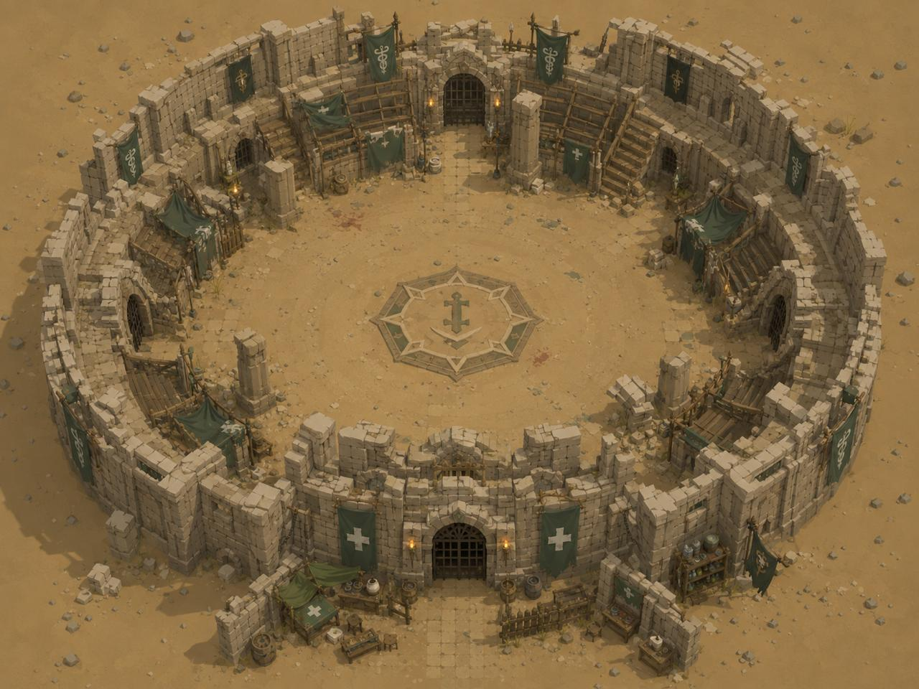

Reference 2 — The Lobby Interior
The lobby interior shows a stone-floored courtyard with teal banner decorations, several NPC interaction stations (shop counters, tables), and an open central space for player movement and socialising. The Arena building is visible at the north entrance. The aesthetic matches the Arena exterior — sandstone, torchlit, ancient desert town. NPC stations line the walls. The large central floor rug with the cross emblem marks the geographic centre and spawn zone reference point.
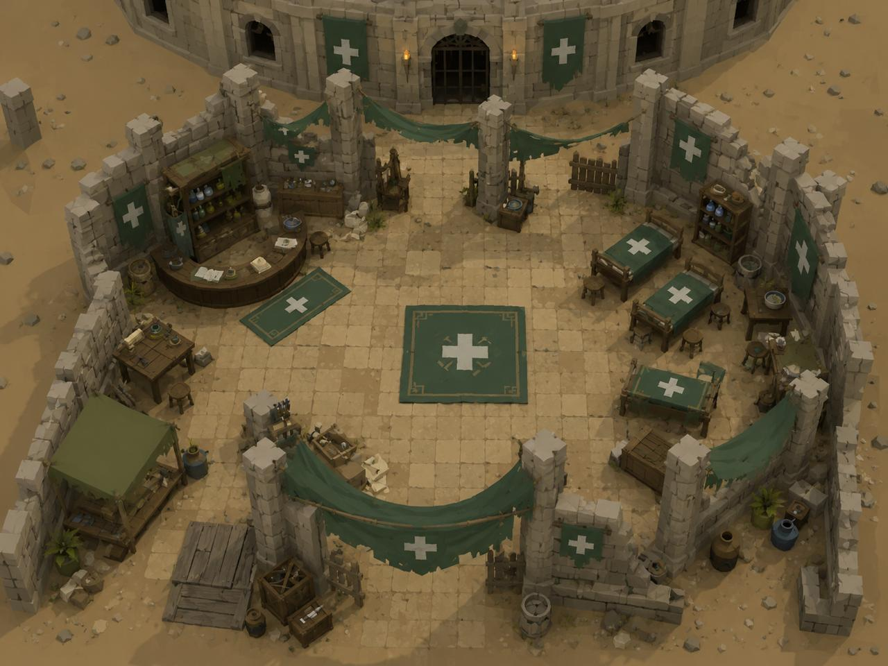

Reference 3 — Player Character Model and Equipment Screen
Low-poly 3D character model shown in four rotations (front, three-quarter, side, back). The character stats panel on the left shows the attribute layout. The equipment panel on the right shows the gear slot arrangement: helmet (top), necklace slot, weapon (left), body (centre), shield (right), legs, boots, and ring slots. Note: Arena's equipment slots differ from this reference — Arena uses helmet, chestplate, platelegs, shield, and weapon only. The panel layout and character rotation display style are the reference direction. The in-game view (bottom right) shows the character rendered in the Arena world environment, confirming the sandstone desert aesthetic and isometric-adjacent camera angle.
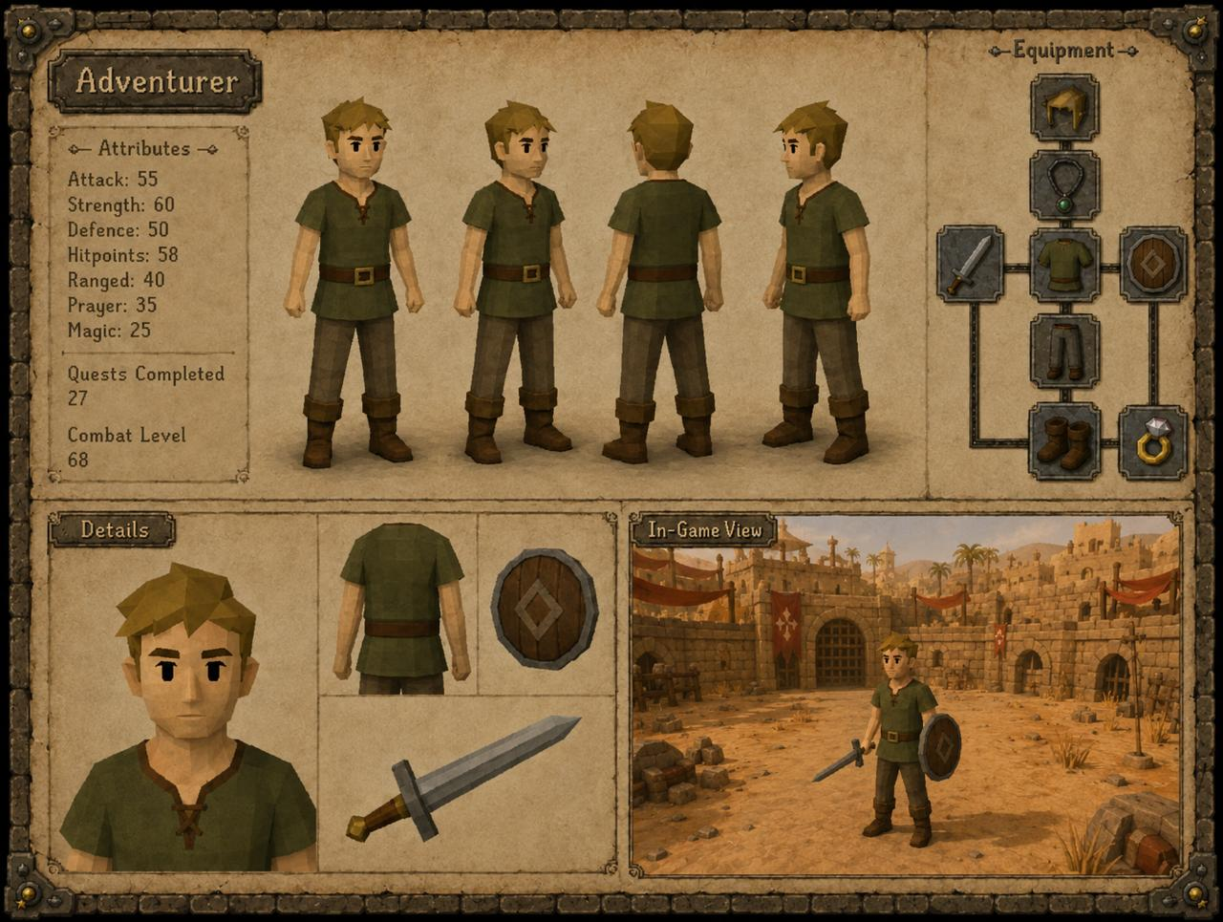

Reference 4 — Boss Cave Interior (Perspective View)
Dark stone cave interior with an ancient Egyptian/desert-occult aesthetic. Gold-trimmed black obelisks with purple ankh symbols and carved runes line the entrance corridor. Purple flame lanterns hang from heavy chains between pillars. A raised stone throne area sits at the far end, flanked by bull skull motifs and a golden scarab banner. The central combat floor is a circular stone platform with a bull skull mosaic inlaid in gold. Purple crystal outcroppings emerge from the cave floor. Bull skulls with curved horns are scattered throughout as environmental decoration. The colour palette is near-black stone, gold trim, and purple flame — distinct from the sandy gold of the lobby and training grounds. The cave entrance corridor narrows into this ceremonial chamber.
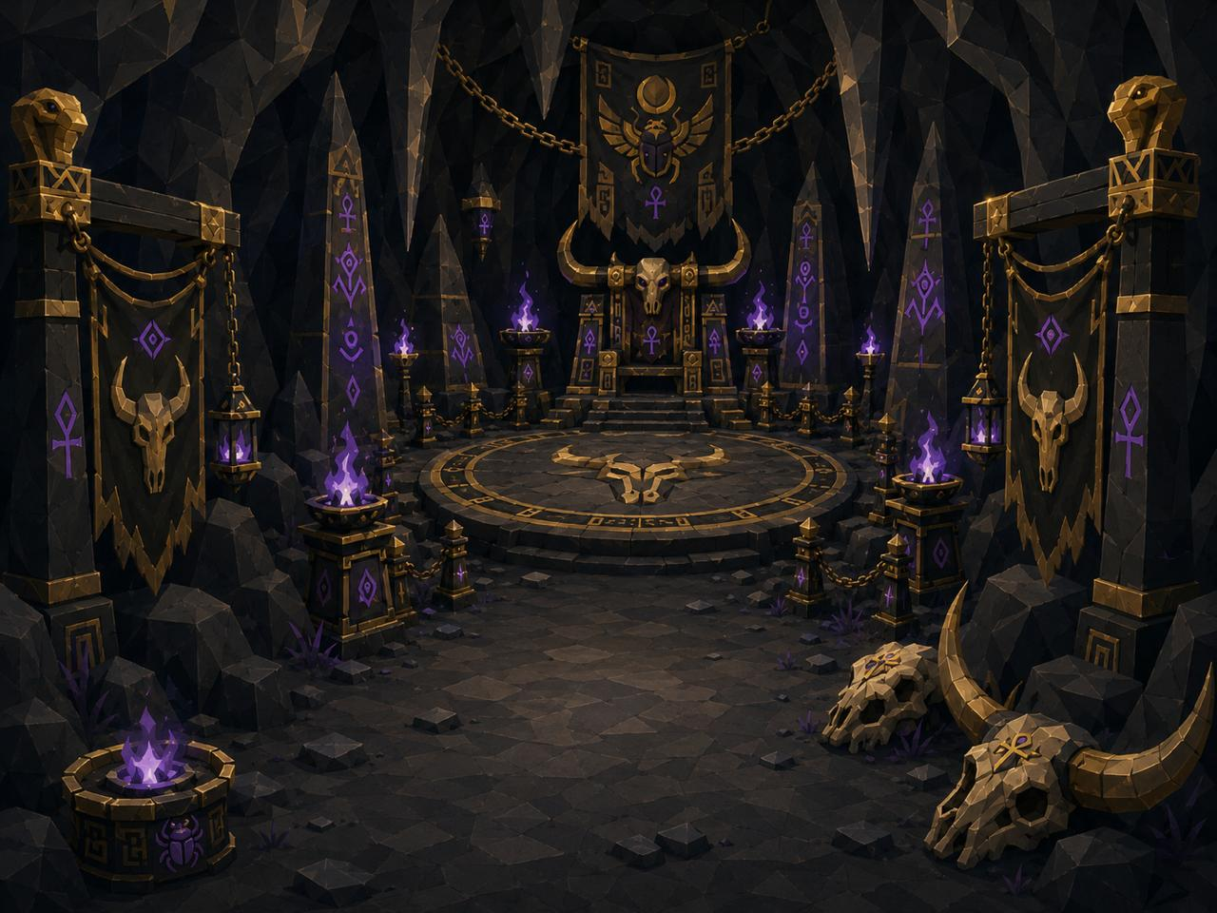

Reference 5 — The Boss: Ancient Egypt Cow (Character Model Sheet)
The Group Boss is a large cursed bovine sentinel — a bull/minotaur hybrid clad in ancient Egyptian gold armour. Key visual features: jet black body with glowing purple eyes, gold-plated armour bands on all four legs and across the chest/face, purple runic markings etched across the body, heavy gold horns with decorative tips, a hanging skull ornament on the chest, and a tattered gold-trimmed cloth draped from the back. Three attack animations are referenced (Headbutt, Cursed Stomp, Dark Roar) — the Cursed Stomp is the AOE ground slam animation that fires every 8 ticks (the purple energy burst emanating from the ground around the boss). Four rotation views are provided (front, side, back, three-quarter). The close-up head shot shows the glowing purple eye detail and the gold nose-ring. Note: the stat card on the reference sheet (Level 20, HP 750) reflects the concept art source and does NOT match the Arena spec — in Arena the boss is Level 150 with 2,000 HP.
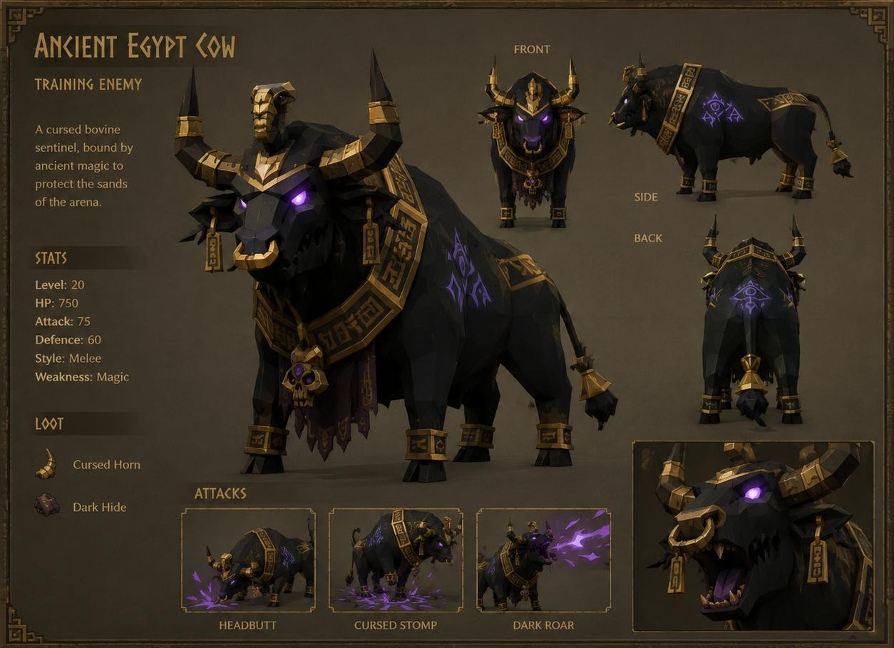

Reference 6 — Boss Cave Overhead (Game Camera Angle)
The boss cave shown from the top-down game camera angle — the closest reference to how the zone will appear in-game. The circular combat arena is clearly visible: a large gold bull skull mosaic on the dark stone floor marks the boss spawn point at centre. Gold-trimmed black pillar structures with purple orbs ring the outer wall. The throne/altar at the north end is visible at the top of the frame. Two entry paths at the south corridor lead into the arena. This overhead view defines the spatial layout the developer should reference when building the Boss Cave tilemap zone: circular open combat area, boss centred on the floor emblem, decorative pillars at the perimeter (non-walkable), entry corridor from the south (connecting to Training Grounds), altar/throne at the north (non-walkable decoration).
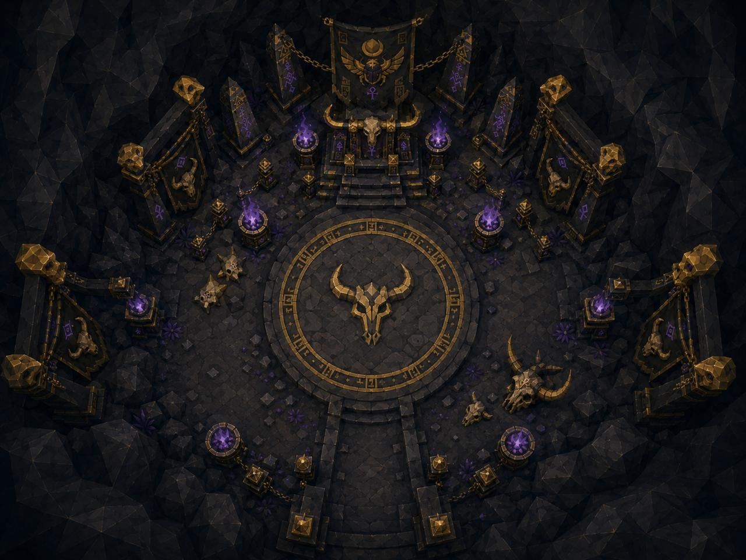

Reference 7 — The Training Grounds
An open desert sand area arranged in a loose circular layout. Green canvas military tents with gold Arena insignia provide shelter at the north and west sides — these are the NPC/equipment tent structures. Weapon racks holding spears and swords are positioned near the tents. Training dummies (wooden cross-post figures in green cloth wrappings) are distributed around the open centre at various positions. Archery targets and barrels of equipment fill the right side. A central compass rose mosaic is inset into the sand floor, marking the geographic centre of the training area. Torches on wooden tripods provide light at the perimeter. The overall aesthetic is a functional desert military training camp — sandy, weathered, practical, matching the Arena’s Egyptian/ancient world theme. The cave entrance to the Boss Cave would be placed at the far north of this space (not shown in this render).
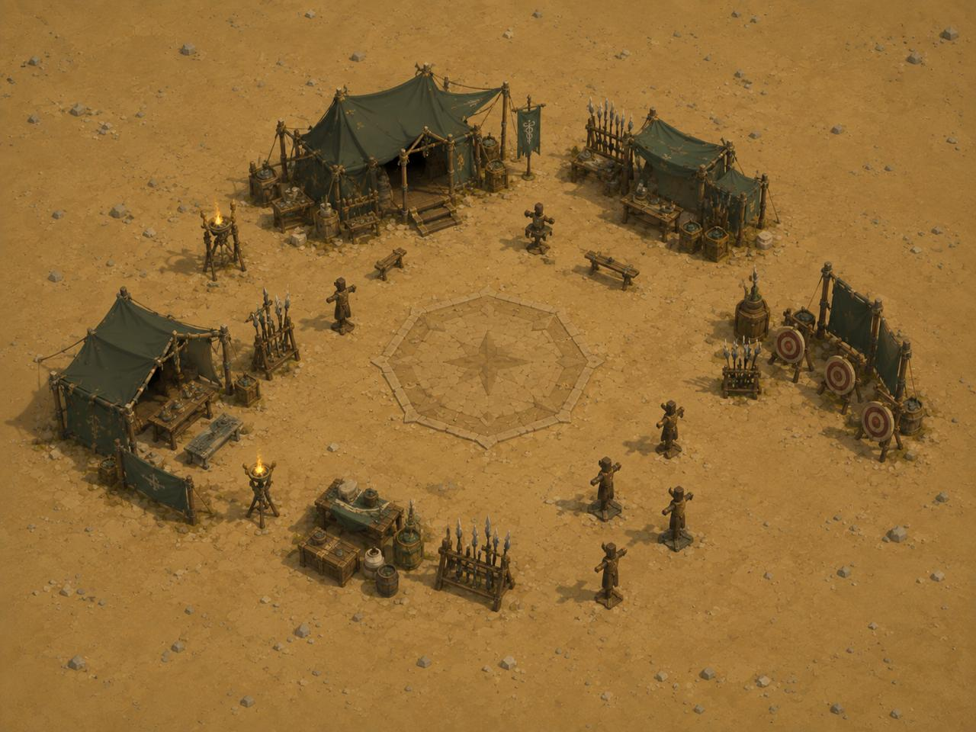

Reference 8 — Training Dummy (Close-Up Model)
A wooden post dummy in a T-cross shape: a thick rounded wooden head atop a vertical log body, with a horizontal log arm extending left and right. The body is wrapped with thick rope in a diagonal crosshatch pattern and draped with a teal/green cloth bearing a golden Eye of Horus-style ankh symbol — matching the Arena’s colour scheme. The base is a heavy reinforced wooden frame with gold-capped corner bolts, providing structural stability on the sand. The overall proportions are stocky and primitive — clearly a combat practice target, not a living figure. Higher tier dummies in the game should feel progressively more reinforced and elaborate than this base model (heavier materials, additional armour plates, runic markings). All dummies share the same basic silhouette regardless of tier — tier is communicated through the HP value and label, not a fundamentally different shape.
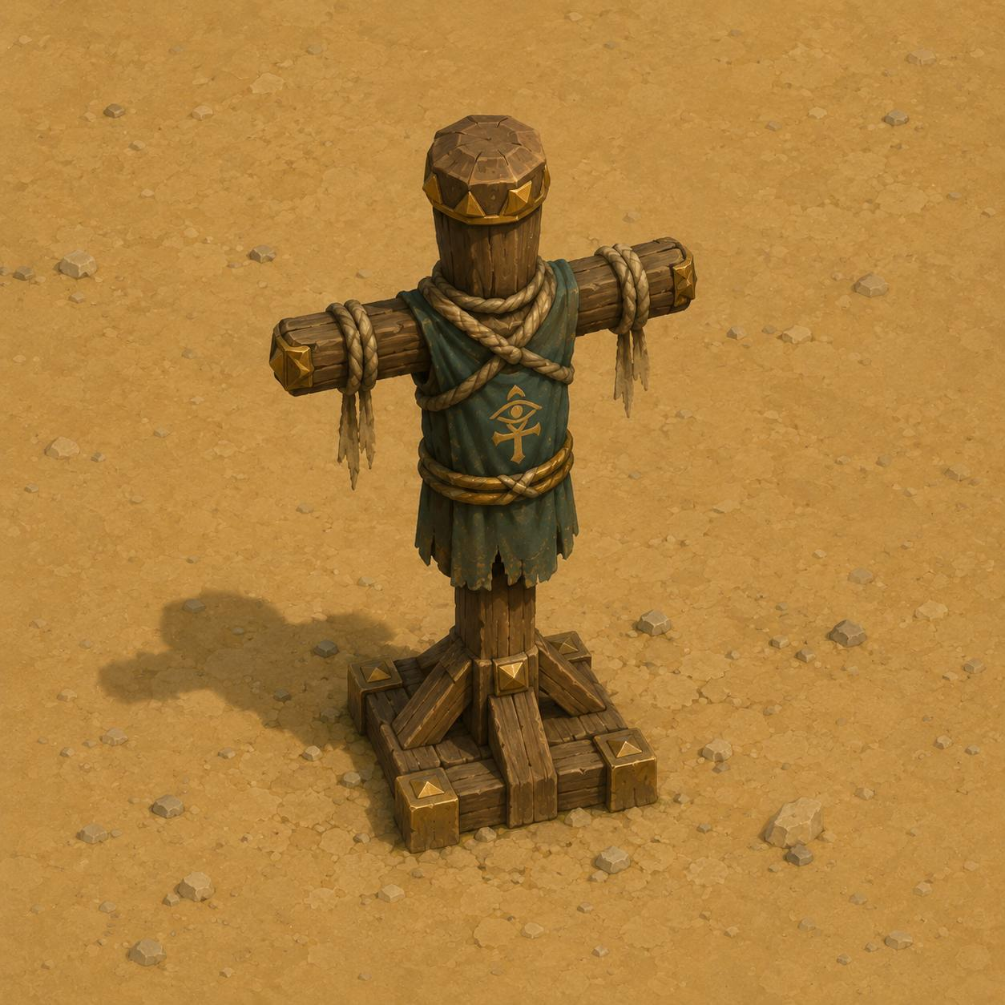

Reference 9 — Item Icon Set: Gold Coin Piles
An 8-stage icon set for the in-game gold currency, showing a single coin scaling up through increasingly large stacked piles, in a low-poly stylized gold-coin aesthetic with a soft highlight on each pile. Intended to replace the current placeholder gold icon — the displayed icon should scale visually with the quantity of gold held (single coin at low amounts, large pyramid pile at high amounts).
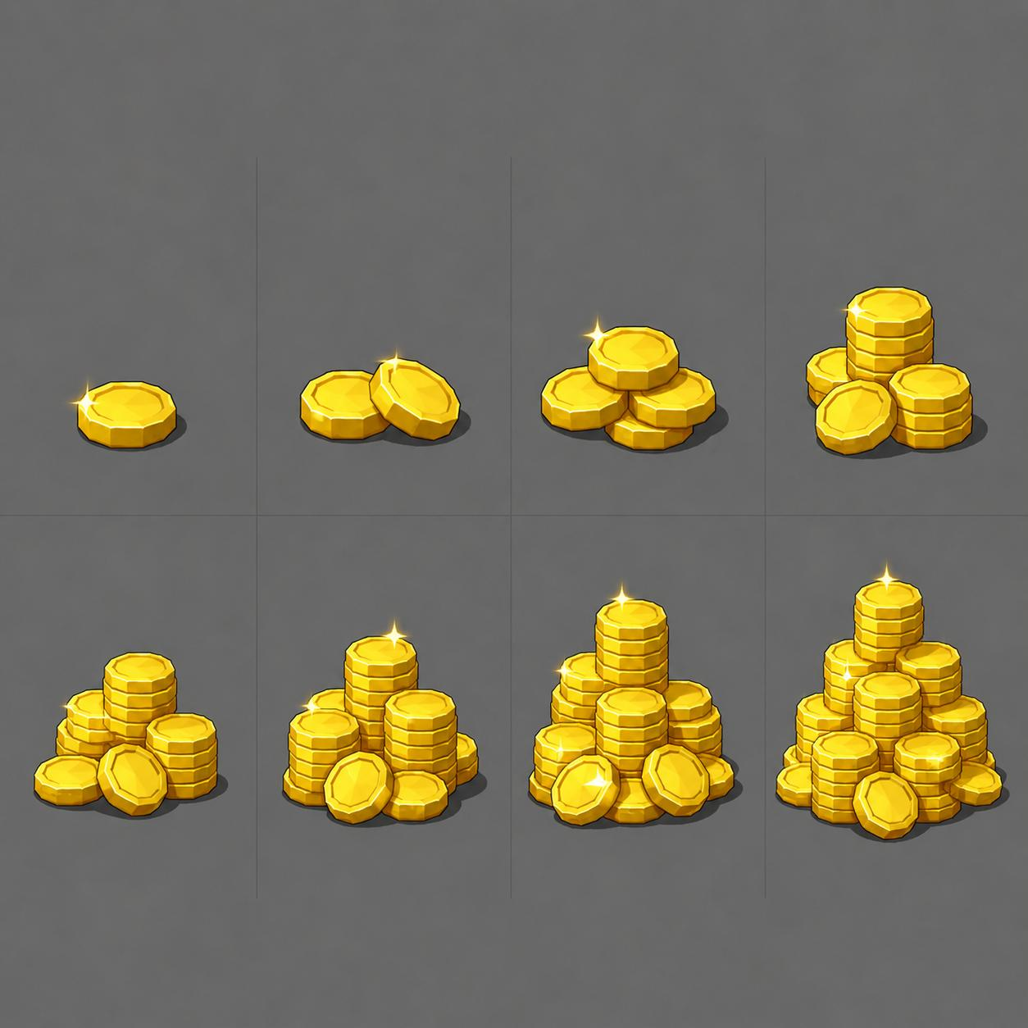

Reference 10 — Item Icon: Chicken (Food)
The cooked chicken food item rendered in a low-poly style, shown from front, side, and top views, with a reference card confirming the heal value of 20 HP — matching the existing food table. Replaces the current placeholder chicken icon.
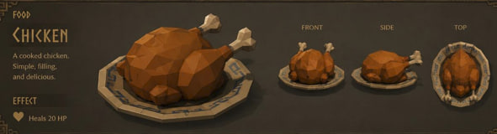

Reference 11 — Weapon Reference: Kopesh (formerly Scimitar)
Reference renders for the curved-blade weapon — renamed from “Scimitar” to “Kopesh” throughout the game (item names, configs, and UI labels). Shown in full-size and a smaller variant, with a red crystalline blade and gold/ruby hilt. This colorway is not tied to a specific gear tier — it serves as the universal placeholder appearance for the Kopesh across all tiers until tier-specific weapon art is produced.
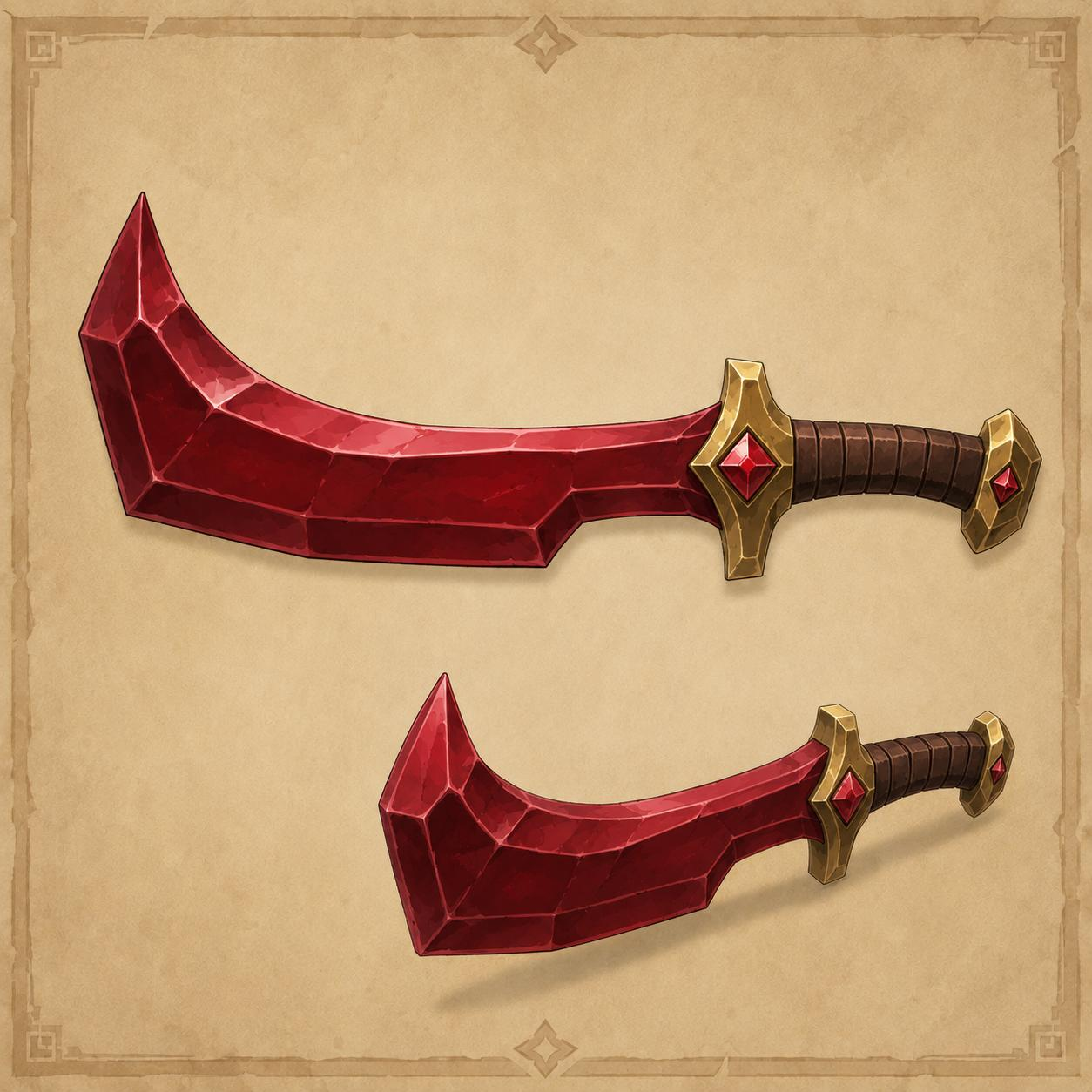

Reference 12 — Weapon Reference: Stiletto
Reference renders for the Stiletto weapon — a straight thin-blade dagger style, matching the same red crystalline blade and gold/ruby hilt styling as the Kopesh reference, with two size variants shown. As with the Kopesh, this colorway is a universal placeholder across all tiers until tier-specific art is produced.
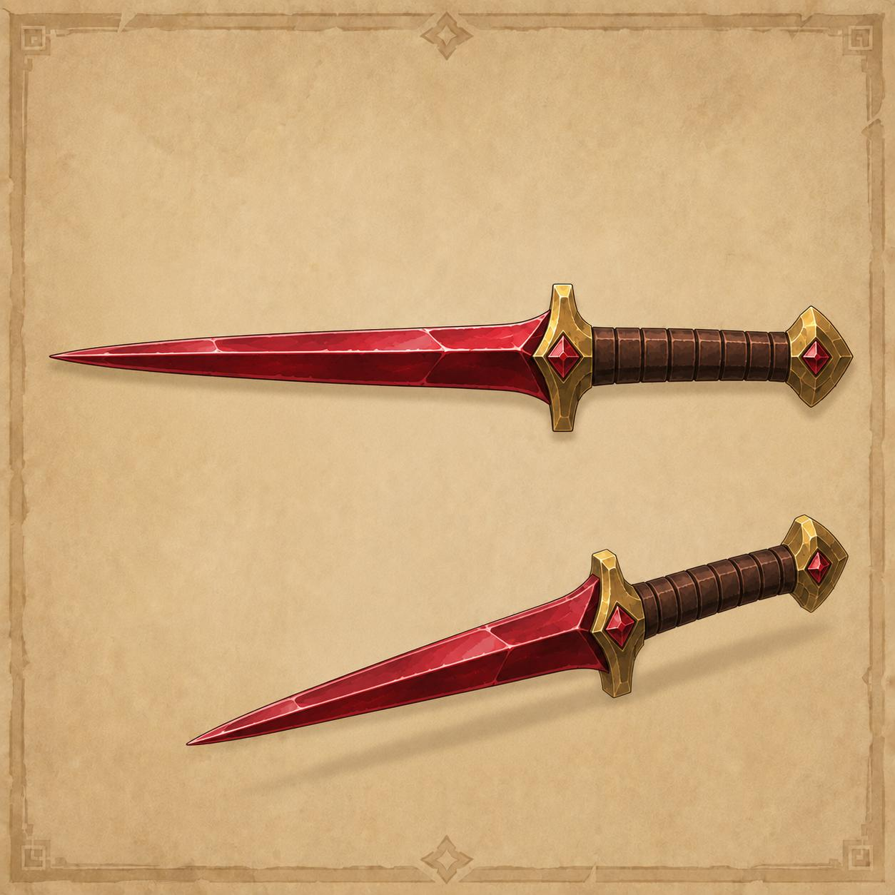

Reference 13 — Tier 1 Leather Armor (Character Turnaround)
Full character turnaround for the new Tier 1 armor set — Leather Armor — replacing Bronze as the entry-level set (Bronze and Iron shift up one tier; see Section 4 item tables for the renumbered tier assignments). Shows the character equipped with the full set from five angles (front, three-quarter front, side, back, three-quarter back), plus individual callouts for the chest jerkin, bracers & gloves, boots, helmet, and kite shield, with a six-color palette reference (browns, olive green, dark brown, gold accent). The active equip slots for this set are chestplate, platelegs, helmet, and shield, matching the existing equipment schema; boots and bracers are shown for visual completeness but are not yet a tracked equipment slot.
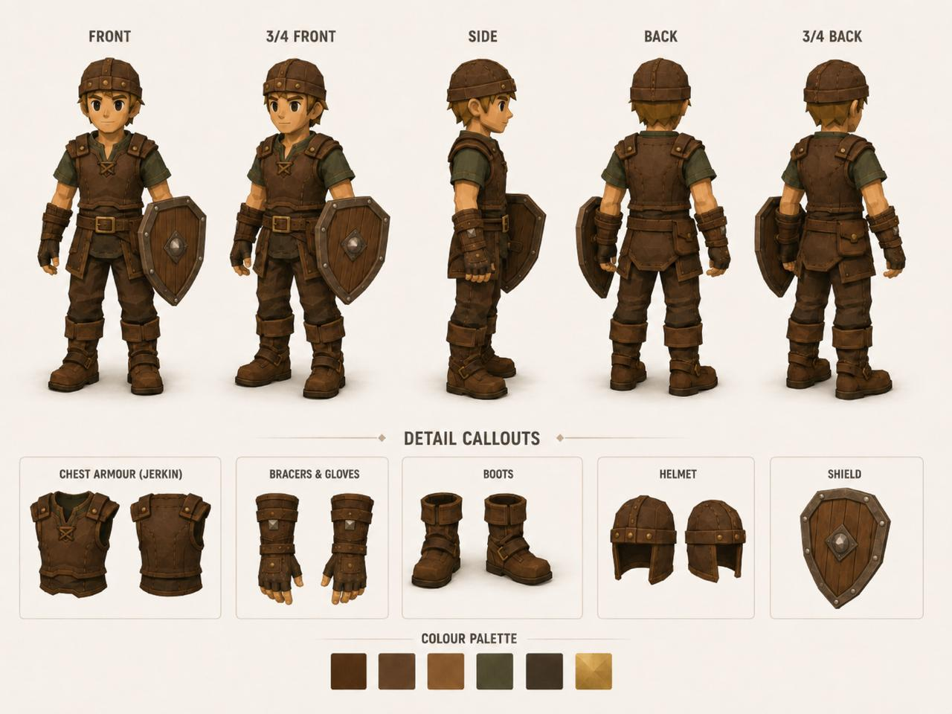

Reference 14 — Tier 1 Leather Armor (Individual Piece Detail)
Higher-detail individual renders of the Tier 1 Leather Armor pieces — chest jerkin with belt, gloves/bracers, boots, platelegs, helmet, and kite shield — in the same brown leather and bronze-rivet styling as Reference 13. Used as the asset source for in-inventory and in-equipment icons for the new Tier 1 set.
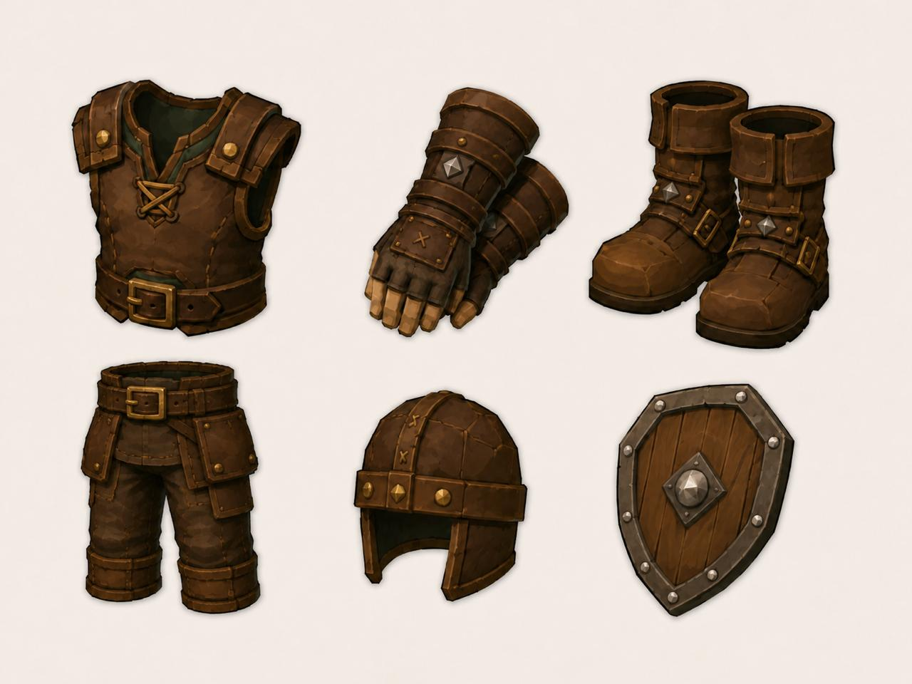

Reference 15 — Lobby NPC Character Models (Egyptian Desert Warriors)
A set of four character models — Shieldbearer/Khopesh Warrior, Spearmaiden, Dune Stalker (Dual Blades), and Sun Priestess — each shown with their associated weapons and accessories (curved sword and ankh-emblem shield; spear and banner; twin curved blades and neck wrap; staff and amulet). These replace the current placeholder NPC sprites for the Lobby's banker, merchant, cosmetic shop, and food shop NPCs. Specific character-to-role assignment to be finalized during implementation.
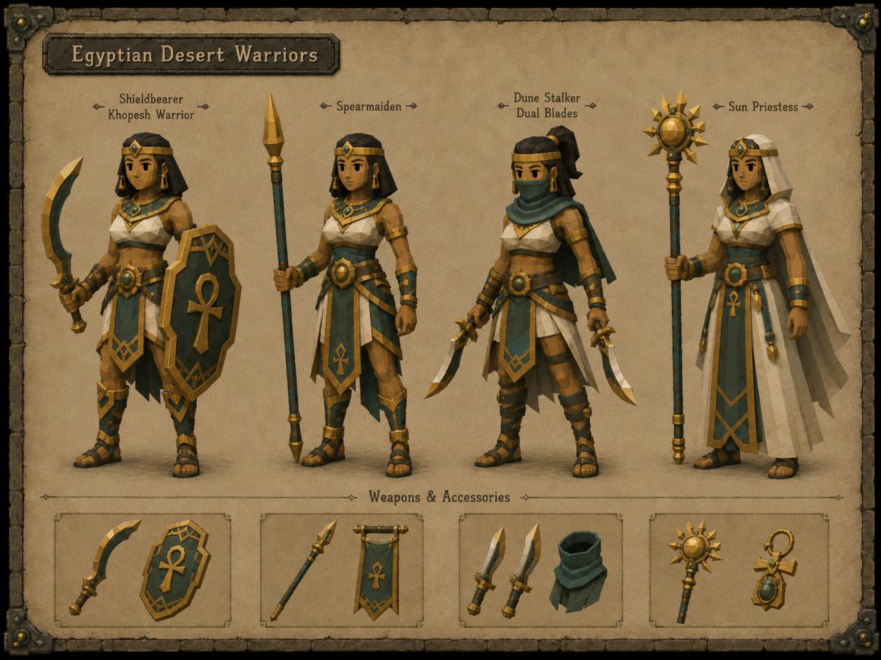

Reference 16 — Player Movement Sprite Sheet (Walk/Run, 8-Directional)
Full 8-directional (N, NE, E, SE, S, SW, W, NW) Walk and Run animation cycles for the player character, 6 frames per direction per cycle. This sprite set is the basis for replacing the current movement animation with smoother, fully directional motion (see Section 7.4).
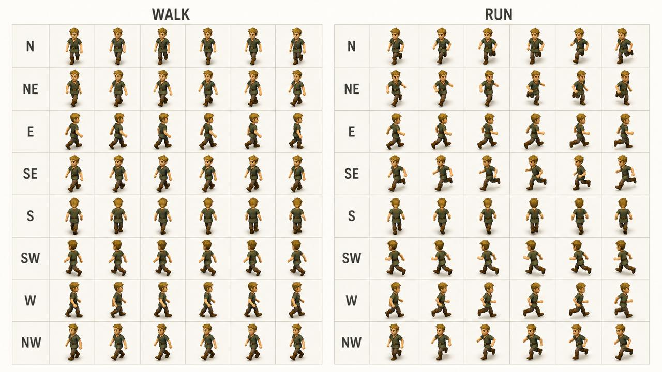

Reference 17 — Player Attack Sprite Sheet (Kopesh & Stiletto, 8-Directional)
Full 8-directional attack animation cycles, 6 frames per direction, split into two sets matching the two weapon types covered so far: Kopesh Attack and Stiletto Attack. These correspond to the existing combat style/weapon-type system and should drive the attacker's swing animation referenced in Section 7.1.
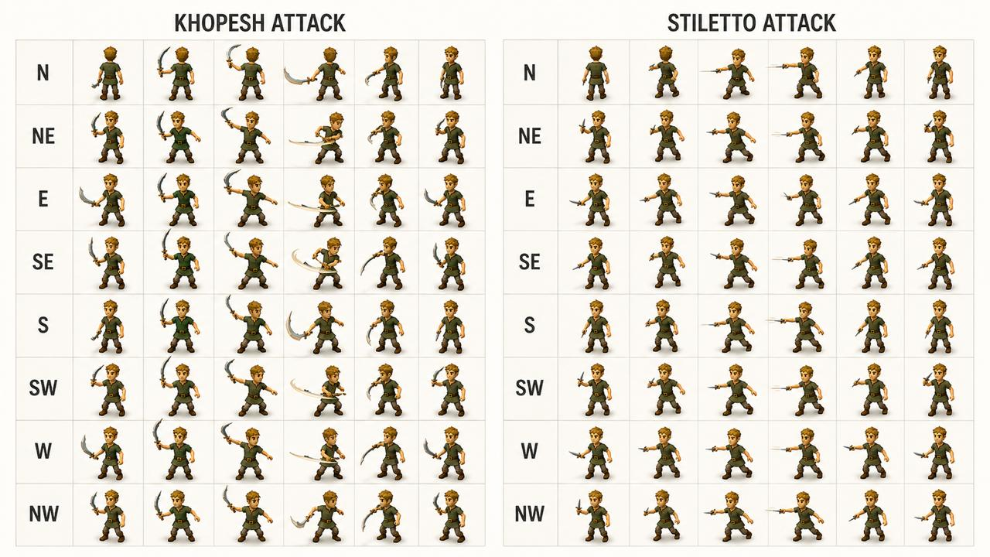

Reference 18 — Group Boss Sprite Sheet (Minotaur, Movement & AOE Telegraph)
Movement and idle frames for the Group Boss (Minotaur-style model matching Reference 5's Ancient Egypt Cow description), plus a charge-up sequence showing the purple energy telegraph building from a small spark into a full ground-burst. This telegraph sequence maps directly to the boss AOE warning-ring-to-AOE-fire mechanic — the warning frames should play during the telegraph window, and the full-burst frame should align with the AOE damage tick.
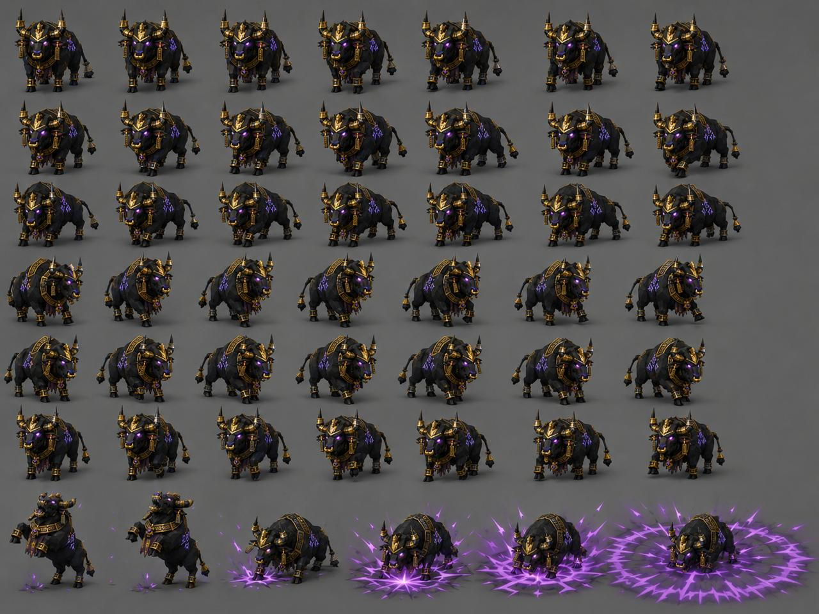

Reference 19 — Training Dummy Recoil Sprite Sheet (8-Directional)
8-directional hit-recoil animation frames for the Training Dummy (idle plus recoil variants per direction, 4 frames each), matching the dummy model described in Reference 8. Used to animate the dummy's reaction when struck during combat.
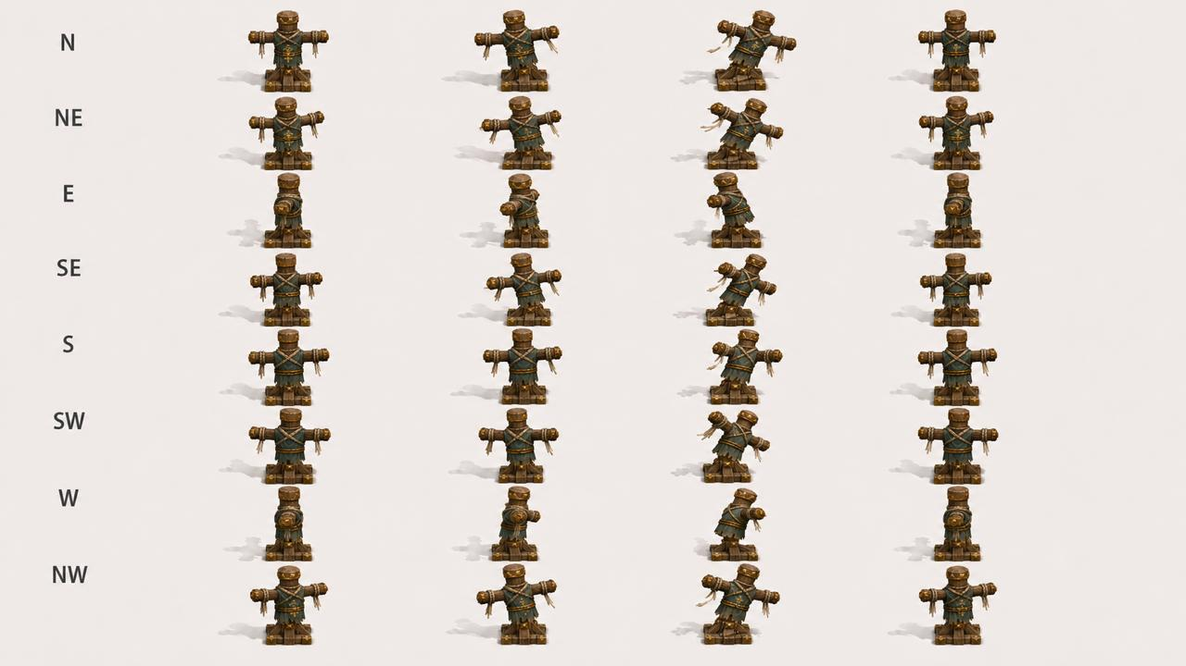

7.4 Movement, Animation & Camera Feel
The current build's camera and character movement read as flat and 2D. The following changes define the target feel, drawing on the new sprite reference assets (References 16–19).
- Camera rotation (left/right arrows): currently snaps in a full rotation per key press, which feels jarring. Replace with smooth, continuous incremental rotation while the key is held — matching the OSRS camera model, where the view rotates fluidly around the player rather than jumping between fixed angles.
- Camera pitch (up/down arrows): currently unbound. These should control the 3D view angle/tilt, smoothly adjusting the camera pitch between a minimum (near top-down) and maximum (more oblique) angle, again matching OSRS camera behavior.
- Character scale: the player sprite is currently roughly 5x larger than other world assets (e.g. training dummies), nearly covering them when adjacent. Rescale the player character to roughly 1.5–2 game tiles, consistent with the proportions shown in References 16 and 17.
- Movement and combat animation: replace the current movement/attack animation with the full 8-directional Walk, Run, Kopesh Attack, Stiletto Attack, and Dummy Recoil sprite sets (References 16, 17, and 19), with smooth tweened transitions between directions and movement states rather than instant frame swaps. The Group Boss (Reference 18) should similarly use its movement and AOE telegraph frames, with the telegraph building visibly into the AOE burst.
- Tile walkability/collision: standalone static objects (e.g. training dummies) should block movement on their occupying tile(s), while moveable entities (other players, creatures, the boss) should not block movement — implemented as a per-asset collision flag on the relevant tiles.

8. Technical Architecture (High-Level)
This section sketches the technical layers at a conceptual level. Full engineering spec to follow in a subsequent document.

Layer | Detail
Blockchain | Solana — fast finality, low transaction cost, strong wallet ecosystem
Smart Contract | Escrow contract in Rust/Anchor. Holds wager funds, commits seed hash, releases payout post-fight.
Randomness | Commit-reveal scheme: server commits a hashed seed before fight, reveals post-fight. Players can optionally contribute entropy. Chainlink VRF or Switchboard as an alternative for fully on-chain randomness if needed.
Fight Simulation | Server-side deterministic engine. Takes seed as input, outputs full fight log (every tick, every roll, every HP state).
Playback Engine | Browser-based client. Receives fight log, animates tick by tick. Built in React or a lightweight game engine (Phaser.js candidate).
Backend | Node.js API server. Manages lobby state, WebSocket connections for real-time lobby updates, fight log delivery.
Data Layer | Fight history, leaderboard data, player records stored in a standard database (Postgres). On-chain data is source of truth for financial settlement.

9. Open Questions for Next Phase
The following decisions need to be made before moving into full product specification:

9.1 Combat Parameters — RESOLVED
- V1 base player: max hit 5, accuracy 40%. Full stat and level system built into the algorithm from day one — V1 is every player at base state. Fight duration at base stats is substantially longer than the simulated 12/60% parameters, intentionally pushing players toward the training grounds to level up. See Section 3.4 for the full combat formula and Section 3.5 for the level and XP system.
- Miss mechanic retained — zero hits occur when accuracy roll fails. At V1 base (40% accuracy) approximately 60% of ticks deal zero damage, creating clear visual incentive to level up Attack. At max stats (80% accuracy) ~20% of ticks are zeros, maintaining visual rhythm without stalling fights.
- V1 fights intentionally longer than the 60-second optimised simulation — longer fights at base stats create the push to train. Fully leveled and geared fights approach the 60-second median. No fight duration cap. No draws. Fight ends on kill only.

9.2 Wagering Limits
- Minimum and maximum wager amounts per token?
- Should the protocol enforce a wager cap, or is it open-ended?
- How are very large wagers handled — same flow, or a high-stakes mode with additional confirmation steps?

9.3 Dispute Resolution
- What happens if a player's connection drops mid-fight? Since the outcome is already determined on-chain, this is resolvable — but the UX path needs defining.
- What if the server delivering the fight log goes down? Players should be able to re-request the fight log from an alternative endpoint.

9.4 Anti-Abuse
- Bot / wallet farm prevention: are there any guardrails, or is it open to all wallets?
- Wash trading / self-dealing: a player could theoretically challenge their own second wallet to farm volume stats. Does this matter, and how is it addressed?

9.5 Regulatory Posture
- V1 launches as a free-to-play game with no real-money wagering — no gambling license required. Development can proceed in private immediately. V2 (real-money wagering) requires a Curaçao eGaming license as a baseline, with a roadmap toward MGA or UKGC as the product matures. Legal entity incorporation and jurisdiction selection should occur during V1 development so licensing applications can be filed in parallel with V2 development. The US, UK, Australia, and FATF blacklist jurisdictions are geo-blocked from day one of V2.
- Should age verification or KYC be considered, or does the wallet-native model sidestep this?

10. Out of Scope (v1)
The following are explicitly deferred to post-launch phases to keep v1 scoped and shippable:

- Automated matchmaking / open challenge order book
- Mobile native app (browser-first at launch)
- Tournaments or bracket play
- Real-money wagering (V2 feature)
- Spectator mode for third parties
- Chat or social features beyond the lobby player list
- $ARENA governance mechanisms
- Multiple fight types or game modes

ARENA — Concept Specification
Ideation Phase · Not for Distribution

