**Wallet Connection**

Hello guys. Here’s a document on the full working of our tool - Wallet Connection. Let’s get started.

1]

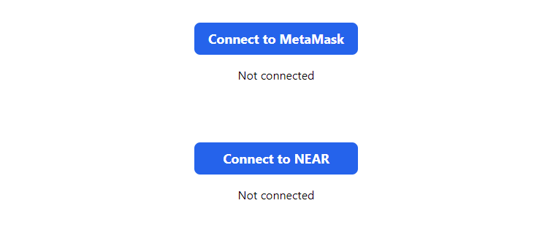This is our landing page.

The orders button is splitted into two sections - Cconnect to MetaMask and Connect to NEAR.

You can connect to MetaMask by clicking button1.

You can connect to Near Wallet by clicking button2.

2]

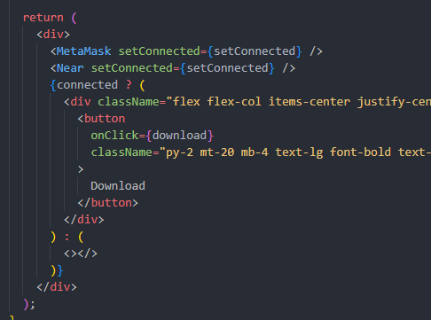

This is a index.js .

As you can see, if you connect your wallet (MetaMask, Near Wallet), the Download Button is appeared.

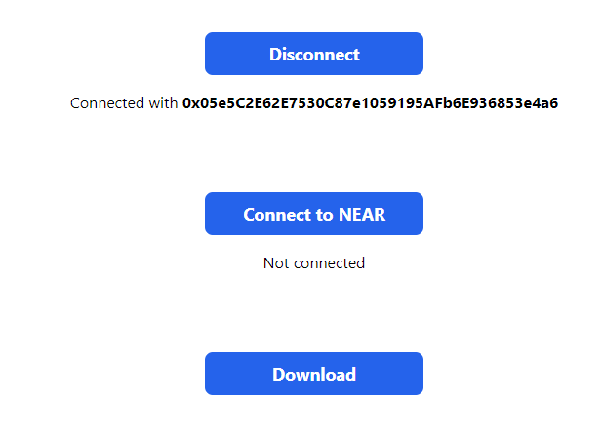

This is the page when you connected the MetaMask wallet.

Here users can download apk file from NFT Storage.

If you click the Disconnect Button, wallet will be disconnected and Download Button disappeared.

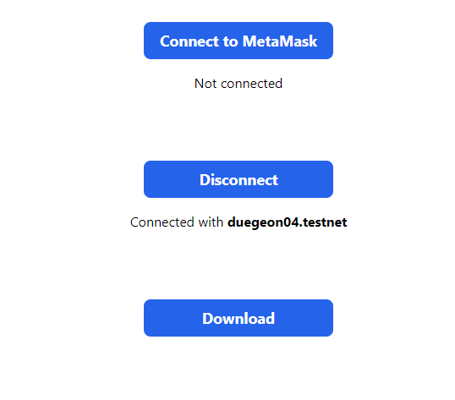

This is page when you connected the Near wallet.

The function is equal with when you connected the MetaMask Wallet.

3]

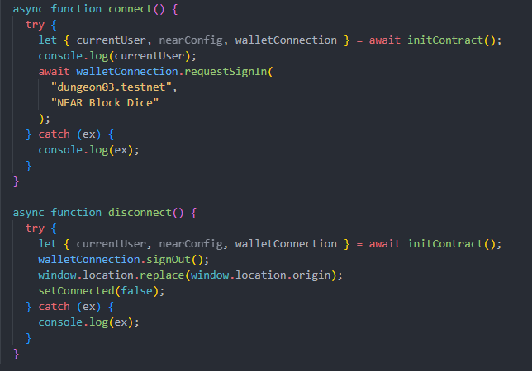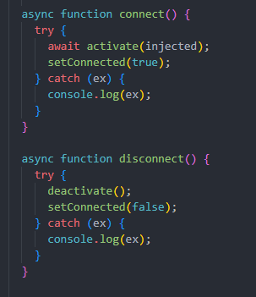

In near.js, there are 2 functions include connect and disconnect.

Near Wallet is a browser wallet, that’s way we need to redirect.

So I implement it in this code.

In metamask.js, there are 2 functions too.

The function is in the wallect folder of the components components.