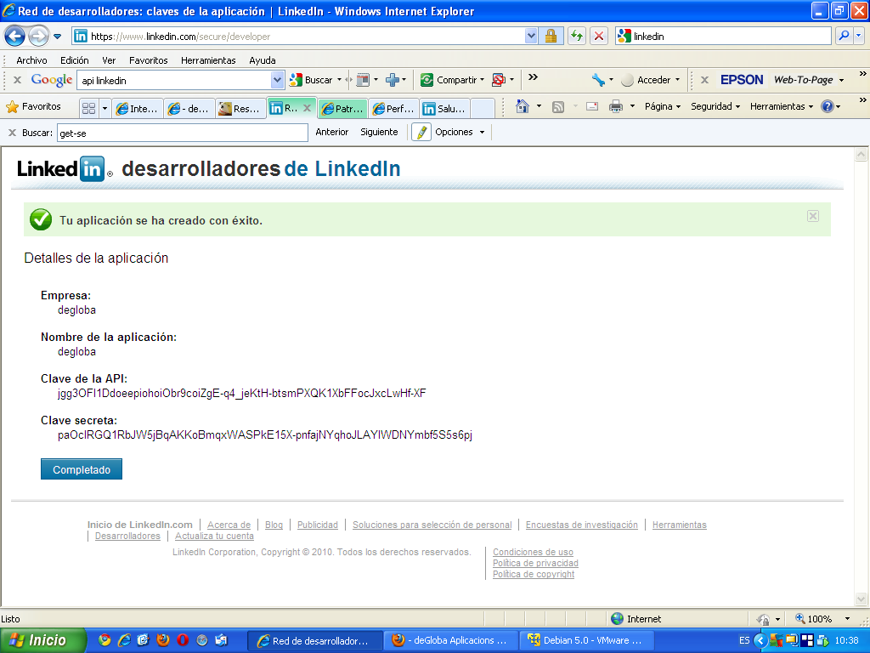

Linkedin API Integration In Java Very Simple Example
Get the zip file from google code and export to jar file then add that jar to your class path
then send a request to this servlet thats it
package com.cs.liveebiz.server.linkedinapi;
import java.io.IOException;
import java.util.EnumSet;
import javax.servlet.ServletException;
import javax.servlet.http.HttpServlet;
import javax.servlet.http.HttpServletRequest;
import javax.servlet.http.HttpServletResponse;
import javax.servlet.http.HttpSession;
import com.cs.liveebiz.server.common.ui.ImportLinkedInProfile;
import com.cs.liveebiz.server.common.util.UserContextHolder;
import com.google.code.linkedinapi.client.LinkedInApiClient;
import com.google.code.linkedinapi.client.LinkedInApiClientFactory;
import com.google.code.linkedinapi.client.enumeration.ProfileField;
import com.google.code.linkedinapi.client.oauth.LinkedInAccessToken;
import com.google.code.linkedinapi.client.oauth.LinkedInOAuthService;
import com.google.code.linkedinapi.client.oauth.LinkedInOAuthServiceFactory;
import com.google.code.linkedinapi.client.oauth.LinkedInRequestToken;
import com.google.code.linkedinapi.schema.Education;
import com.google.code.linkedinapi.schema.Person;
import com.google.code.linkedinapi.schema.Position;
@SuppressWarnings("serial")
public class LogonServlet extends HttpServlet {
private static final String AUTH_TOKEN_PARAMETER = "oauth_token";
private static final String AUTH_TOKEN_VERIFIER_PARAMETER = "oauth_verifier";
/**
* Consumer Key you can get this from linked in by adding your application at (https://www.linkedin.com/secure/developer)
*/
private static final String CONSUMER_KEY_OPTION = "consumerKey";
/**
* Consumer Secret you can get this from linked in by adding your application
*/
private static final String CONSUMER_SECRET_OPTION = "consumerSecret";
public void doGet(HttpServletRequest req, HttpServletResponse resp) throws ServletException, IOException {
try {
String oauthToken = req.getParameter(AUTH_TOKEN_PARAMETER);
String oauthVerifier = req.getParameter(AUTH_TOKEN_VERIFIER_PARAMETER);
final String consumerKeyValue = CONSUMER_KEY_OPTION;
final String consumerSecretValue = CONSUMER_SECRET_OPTION;
HttpSession session = req.getSession();
final LinkedInOAuthService oauthService = LinkedInOAuthServiceFactory.getInstance().createLinkedInOAuthService(consumerKeyValue, consumerSecretValue);
if (oauthToken == null && oauthVerifier == null ) {

// REQUEST TOKEN
LinkedInRequestToken requestToken = oauthService.getOAuthRequestToken("same servlet reqpath"); //calbackUrl
System.out.println("Fetching request token from LinkedIn..."
+ requestToken);
session.setAttribute("requestToken", requestToken);
String authUrl = requestToken.getAuthorizationUrl();
resp.sendRedirect(authUrl);
Access token path: /uas/oauth/accessToken

} else {
// REQUEST TOKEN
String sVerifier = req.getParameter("oauth_verifier");
LinkedInRequestToken requestToken = (LinkedInRequestToken) session.getAttribute("requestToken");
Authorize path: /uas/oauth/authorize

Request token path: /uas/oauth/requestToken

// ACCESTOKEN
LinkedInAccessToken accessToken = oauthService.getOAuthAccessToken(requestToken,sVerifier);
The site: https://api.linkedin.com. Some libraries will have you enter this root URL.

System.out.println("Access token: " + accessToken.getToken());
System.out.println("Token secret: " + accessToken.getTokenSecret());
final LinkedInApiClientFactory factory = LinkedInApiClientFactory.newInstance(consumerKeyValue, consumerSecretValue);
final LinkedInApiClient client = factory.createLinkedInApiClient(accessToken);

//OPERACIONS API
System.out.println("Fetching profile for current user.");
Person profile = client.getProfileForCurrentUser(EnumSet.of(ProfileField.ID));
Person profile2 = client.getProfileById(profile.getId());
printResult(profile2);
resp.sendRedirect("page to which you want to redirect after processing the result");
}
}
catch (Throwable ex) {
// TODO
//resp.setContentType("text/plain");
ex.printStackTrace();
}
}
/**
* Print the result of API call.
*/
private void printResult(Person profile) {
System.out.println("ImagePath" + profile.getPictureUrl());
System.out.println("Industry:" + profile.getIndustry());
ImportLinkedInProfile importProfile = new ImportLinkedInProfile();
//Here in this bean you can add your functionality
importProfile.processImportedResult(profile);
for (Position position:profile.getPositions().getPositionList()) {
System.out.println("position:" + position.getTitle());
System.out.println("comp:" + position.getCompany().getName());
if(position.getEndDate() != null)
System.out.println("EndDate:" + position.getEndDate().getMonth() + "" +position.getEndDate().getYear());
if(position.getStartDate() != null)
System.out.println("StartDate:" + position.getStartDate().getMonth() + "" +position.getStartDate().getYear());
System.out.println("Summary:" + position.getSummary());
}

for (Education education:profile.getEducations().getEducationList()) {
System.out.println("degree:" + education.getDegree());
System.out.println("school name:" + education.getSchoolName());
if(education.getEndDate() != null)
System.out.println("EndDate:" + education.getEndDate().getMonth() + "" +education.getEndDate().getYear());
if(education.getStartDate() != null)
System.out.println("StartDate:" + education.getStartDate().getMonth() + "" +education.getStartDate().getYear());
}
}
}

