Article

Monitoring SARS-COVID-2 Populations in Wastewater by Amplicon Sequencing and Using the Novel Program SAM Refiner

**Devon Gregory** 1 and Marc Johnson 2,*

1 Dept. of Molecular Microbiology and Immunology; University of Missouri, Columbia, MO 65201 , USA; gregoryde@missouri.edu

|  |
| --- |
| **Citation:** Gregory, D.; Johnson, M. Monitoring SARS-COVID-2 Populations in Wastewater by Amplicon Sequencing and Using the Novel Program SAM Refiner. *Viruses* **2021**, *13*, x. https://doi.org/10.3390/xxxxx  Academic Editor: Firstname Lastname  Received: date  Accepted: date  Published: date  **Publisher’s Note:** MDPI stays neutral with regard to jurisdictional claims in published maps and institutional affiliations.    **Copyright:** © 2021 by the authors. Submitted for possible open access publication under the terms and conditions of the Creative Commons Attribution (CC BY) license (https://creativecommons.org/licenses/by/4.0/). |

2 Dept. of Molecular Microbiology and Immunology; University of Missouri, Columbia, MO 65201 , USA; marcjohnson@missouri.edu

* Correspondence: marcjohnson@missouri.edu

**Abstract:** Sequencing SARS-COVID-2 from wastewater has become a useful tool in monitoring the spread of variants. We use a novel computation workflow with SARS-COIVD-2 amplicon sequencing in order to track wastewater populations of the virus. As part of this workflow, we developed a program for both variant reporting and removal of PCR generated chimeric sequences. With these methods, we are able to track viral population dynamics over time. We obverse the emergence of the variants of concern B.1.1.7 and P.1, and their displacement of the D614G B.1 variant.

**Keywords:** Coronavirus; Wastewater; Metagenomics, Moleculare Epidemiology

1. Introduction

SARS-CoV-2 became pandemic and caused a world wide health crisis in 2020 [1]. Full genome sequences of SARS-CoV-2 were rapidly made available within the first months of spread [2, 3]. Partial and whole genome sequencing of SARS-CoV-2 has been an important tool in monitoring transmission paths and the emergence of variants. Most sequencing of SARS-CoV-2 has been done on clinical samples. However, early in the SARS-CoV-2 pandemic, waste water began to be used to track community levels and spread of SARS-CoV-2 by RT-qPCR methods [4, 5]. Investigators have also used high throughput sequencing on waste water samples to obtain full or partial SARS-CoV-2 genomic sequences which were used for metagenomic and epidemiologic analysis [6, 7, 8, 9, 10, 11, 12, 13]. They find community clinical variants present in waste water samples, as well as variants not reported from community clinical samples. Variants not observed in clinical samples may represent new spread not yet picked up by clinical sampling or variants that are under-represented in clinical samples. Approaches using wastewater are particularly relevant with the emergence of variants that may vary from previous isolates in their transmission and/or disease.

The state of Missouri has been monitoring wastewater with RT-qPCR to track the prevalence and spread of SARS-CoV-2 (https://storymaps.arcgis.com/stories/f7f5492486114da6b5d6fdc07f81aacf). We sought to begin using the same samples for high throughput sequencing to track the presence and spread of known variants and as yet reported variants. We were specifically interested in the spike gene and used primers to target 3 regions for amplification, the N-terminal domain (NTD), receptor binding domain (RBD) and the region of the S1 and S2 subunit split (S1S2). We chose these regions due to the numerous variations matching evolving lineages found in them and their significance in immune evasion [14]. While there are a number of high throughput sequencing technologies and methods, the sequence output is relatively standard. The processing and analysis of that sequence data is not. There are numerous programs and pipelines that can be used to obtain information from sequences and remove errors generated from PCR, such as single nucleotide polymorphisms (SNPs) and chimeric sequences. While many of these are quality approaches, we were unable to find a simple program or workflow with existing programs that provided easily human readable output that detailed variants with the information we wanted and with sufficient removal of chimeric sequences. Specifically, we wished to include deletion and insertion events as well as SNPs and multiple nucleotide polymorphisms (MNP)s in our analysis and be able to view linked variances as single variants. We also wished to be able to view downstream amino acid changes and have better chimera removal than we saw with existing programs.

Here we detail the workflow (Fig1) we used to analyze high throughput sequencing data and the program we developed to provide a human readable, information dense output for viewing variants.

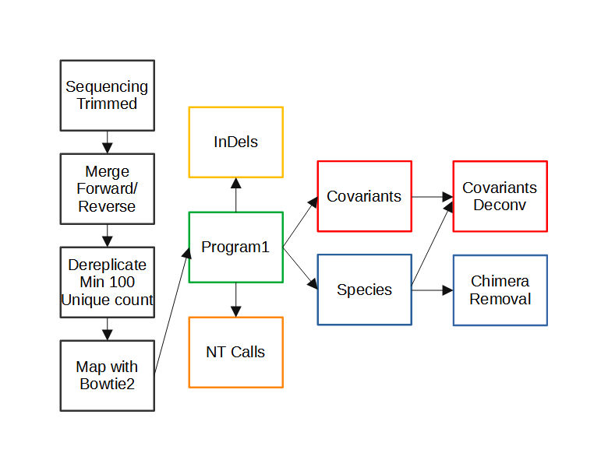**Figure 1. Workflow of Amplicon Sequencing Analysis.** Computational processing of sequencing results prior to the use of SAM Refiner is seen in the black boxes. Paired end reads generated from an Illumina MiSeq were trimmed of low quality calls at the end of the reads. Paired end reads were then merged into single contiguous reads. Reads were then derepliced to unique sequences with at least 100 counts while preserving the count information in the sequence IDs. Dereplicated sequences were then mapped to SARS-COVID-2’s Spike ORF using Bowtie2. SAM Refiner was then used to process the mapped reads to obtain information about the variants observed, initially outputing 4 TSV files to report unique sequences, nt calls, indels and covariants. The unique sequences and covariants were further processed to remove chimeric PCR artifacts to produce covariant deconvolution and chimera removed outputs.

2. Materials and Methods

*2.1 Wastewater Collection*

*2.2 RNA Extraction*

*2.3 Sequencing*

The primary RT-PCR (25ul) was performed on RNA extracted from wastewater samples with loci specific primers (0.5uM each) shown in Table 1 using the Superscript IV One-Step RT-PCR System (Thermo Fisher).    Primary RT-PCR amplification was performed as follows: 25oC(2:00)+ 50oC(20:00)+ 95oC(2:00) + [95oC(0:15)+55oC(0:30)+72oC(1:00)] x 25 cycles.    Secondary PCR (25ul) was performed using 5ul of the primary PCR as template with gene specific primers containing 5' adapter sequences (0.5uM each), dNTPs (100uM each) and Q5 DNA polymerase (NEB).    Secondary PCR amplification was performed as follows: 95oC(2:00) + [95oC(0:15) + 55oC(0:30) + 72oC(1:00)] x 20 cycles.    A tertiary PCR (50ul) was performed to add adapter sequences required for Illumina cluster generation with forward and reverse primers (0.2uM each), dNTPs (200uM each), and Phusion High-Fidelity DNA Polymerase (1U).    PCR amplification was performed as follows:

98oC(3:00)+[98oC(0:15)+50oC(0:30)+72oC(0:30)] x 7 cycles +72oC(7:00).    Amplified product (10ul) from each PCR reaction is combined and thoroughly mixed to make a single pool.    Pooled amplicons were purified by addition of Axygen AxyPrep MagPCR Clean-up beads in a 1.0 ratio to purify final amplicons.    The final amplicon library pool was evaluated using the Agilent Fragment Analyzer automated electrophoresis system, quantified using the Qubit HS dsDNA assay (Invitrogen), and diluted according to Illumina’s standard protocol.    The Illumina MiSeq instrument was used to generate paired-end 300 base pair length reads. Adapter sequences were trimmed from output sequences using cutadapt [15]. The raw and trimmed reads for the samples used in this report are available at <https://github.com/degregory/SR_manuscript/tree/master/Fenton_Data>.

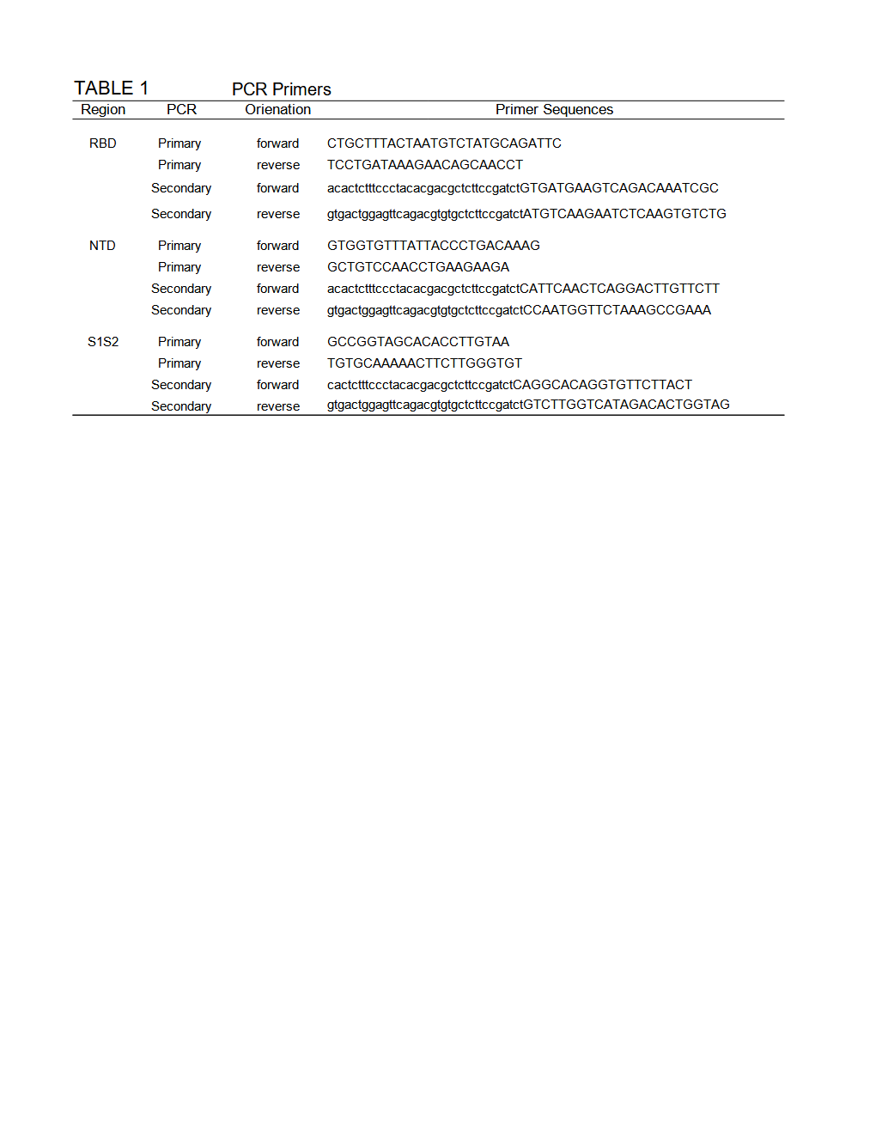**Table 1. PCR primers used to amplify Spike regions for MiSeq sequencing.** Upper case indicate SARS-COVID-2 sequence. Lower case indicates adapter sequence.

3. Results

3.1. *Computational Pre-processing*

Figure 1 illustrates the steps of our workflow. The first two steps of our process used the VSEARCH tool [16]. First, the trimmed paired reads were merged using vsearch –fastq_merge with default parameters. Then merged reads were dereplicated using vsearch --derep_fulllength with the arguments --minsize 100 and --sizeout. These arguments limit the output to unique sequences that occur at least 100 times and appends the sequence IDs with ‘size=#’, where # is the number of times that sequence occurred in the reads. The cutoff of 100 counts removes late stage PCR errors, leaving only sequences representing the original templates or errors that occurred in early cycles of the PCR. This removal makes further analysis simpler and faster. However, very low frequency original template sequences will also be removed by this cut off, so it could be skipped to preserve such rare sequences. The resulting unique sequences were mapped to SARS-COVID-2’s (NCBI Reference Sequence: NC_045512.2, https://www.ncbi.nlm.nih.gov/nuccore/NC_045512) spike ORF using Bowtie2 [17] with default parameters to generate standard SAM formatted files. Having SAM formatted files allows the use of the program we developed for amplicon sequencing results. All files associated with these steps for our analysis of the Fenton, MO sewershed in this manuscript can be accessed at https://github.com/degregory/SR_manuscript/tree/master/Fenton_Data.

3.2. SAM Refiner: SAM Processing

Our program, SAM Refiner, is currently a command line based python script and is available at https://github.com/degregory/SAM_Refiner along with updated documentation. In order to run SAM Refiner, a python compiler or interpreter is needed (https://docs.python.org/3/tutorial/interpreter.html). Though only tested in a Linux environment, it should function with other common OSes. Figure 2 shows the command line usage for SAM Refiner. SAM formatted files are the starting point for our program. These file are generated by many mapping programs, such as Bowtie2 [17] or BWA [18]. The default functions of SAM Refiner follow. Files with the extension .sam (case insenstive) in the working directory will be identified and processed. To process SAM files, SAM Refiner must be provided a FASTA formatted file for a reference sequence using the command line argument ‘–r reference.fasta’, where the FASTA file contains the same sequence ID and sequence used to map the sequencing reads in the SAM formatted file. If the IDs of the given reference and the reference of mapped sequences in the SAM file do not match, those sequences will be ignored. If the SAM formatted files were generated from dereplicated or collapsed sequences that still contain the unique read count, SAM Refiner can process the counts from certain formats. SAM Refiner will recognize the counts in sequence ids where the count is at the end of the id and denoted with a ‘=’ or ‘-’, i.e. ‘Seq1:1;counts=20’ will be recognized as a sequence with 20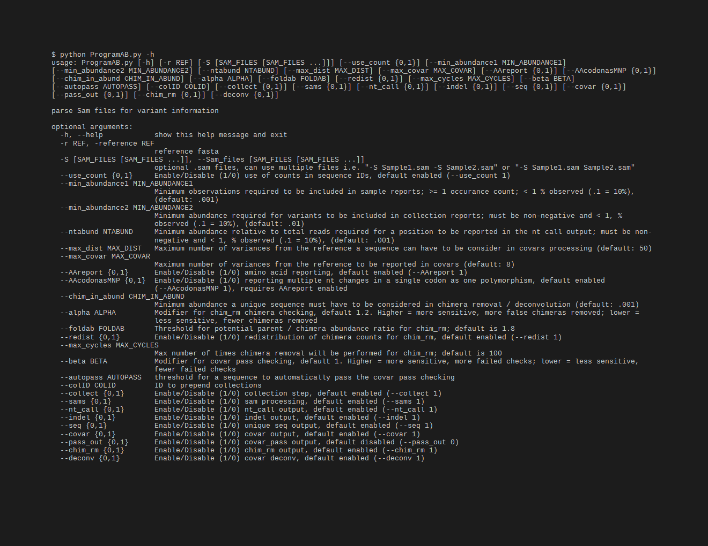 occurrences.

**Figure 2 Command Line Usage of SAM Refiner.** The standard help output from SAM Refiner is shown. Syntax for the command line usage is seen, followed by details about potential arguments to modify program parameters.

For each SAM file, SAM Refiner initially outputs 4 tab separated values (TSV) files that can be read by any standard spreadsheet software. For a SAM file with the name Sample.sam, the outputs are named Sample_unique_seqs.tsv, Sample_nt_calls.tsv, Sample_indels.tsv and Sample_covars.tsv. Example outputs of each are provided in Supplemental Files 1, 2, 3 and 4 respectively (https://github.com/degregory/SR_manuscript/tree/master/Supplementals). All reports are based on the FASTA reference relative to the SAM formatted file, so any errors made by the mapping or incongruence between the FASTA reference and the mapping reference will result in propagated errors. The reports also include the coded amino acids and their position in the coded peptide as if the reference is an in-frame coding sequence. If multiple nucleotides in a single codon differ from the reference, they will be reported together as a single polymorphism with the associated amino acid change. Within the files, all of the sample specific outputs start with name of the sample taken from the SAM file name followed in parenthesis by the count of reads mapped.

The Sample_unique_seqs.tsv file (Sup. 1) lists the unique sequence reads mapped in the SAM file using a variance notation to list the variations from the reference along with occurrence count and abundance. For example, using the previously mentioned SARS COVID 2 spike ORF as the reference sequence, a sequence read that matches the reference except for having a T at position 1501 instead of the reference A would be reported simply as ‘1501A(N501Y)’. The abundance reported uses a decimal notation, so .2 represents 20%. Unique sequences that have an abundance below .001 are not reported.

The Sample_nt_calls.tsv file (Sup. 2) has a line for each nt position covered at in at least .1% of the reads. Based on the reference sequence, each line first reports the nt position, the reference nt, the amino acid position and the reference amino acid residue. The line then reports the number of calls for each base and for deletions at that position, followed by the most abundant (primary) call and its counts and abundance. If that primary nt is different from the reference, the amino acids encoded by the primary nt sequence and the reference sequence with only the nt at the reported position changed. Further, if the second (secondary) and third (tertiary) most abundance nts are above .1% of the total read counts, those nts, their counts and abundances, and their associated amino acid changes are also reported.

The Sample_indels.tsv (Sup. 3) file lists each insertion or deletion found in the mapping along with its occurrence count and abundance. Reported insertions have the format of ‘position-insertNT(s)’, so an insertion between nt positions 54 and 55 of the sequence ‘GCA’ will be reported as ‘55-insertGCA’. Reported deletions have the format ‘start Position-end positionDel’, so a deletion of the nts at positions 61 through 64 would be reported as ‘61-64Del’. If there are no indels in the reads, no indel report will be generated.

Finally, the Sample_covars.tsv (Sup. 4) file lists all observed single variance and variance combinations relative to the reference sequence. The number and abundance of sequence reads containing each covariant are reported, regardless of whether any of those reads have other variations or not. As an example of this processing, the sequence ‘1212G(G404G) 1501T(N501Y) 1709A(A570D)’ with 100 counts would have the covariants of ‘1212G(G404G)’, ‘1501T(N501Y)’, ‘1709A(A570D)’, ‘1212G(G404G) 1501T(N501Y)’, ‘1212G(G404G) 1709A(A570D)’, ‘1501T(N501Y) 1709A(A570D)’ and ‘1212G(G404G) 1501T(N501Y) 1709A(A570D)’, and contribute 100 counts to each. Because unique sequences that fall below the .1% reporting cutoff can still contribute to covariants, there may be variances in the reported covariants that aren’t seen in the unique sequence output. Any sequence with more than 50 variances from the reference are ignored. While all sequences with 50 or fewer variances are analyzed, only combinations of 8 or less variances are reported.

Once the above outputs are generated from each SAM file found, SAM Refiner will collect information from each sample and report them in a single file for the covars and unique_seqs reports (Collected_Covariances.tsv and Collected_Unique_Seqs.tsv). These collections have a threshold of 1% occurrence for reporting.

Many options are available as command line arguments to change parameters of SAM Refiner’s SAM processing (Fig. 2). There are no strictly required command line arguments, though the -r argument is required for the SAM processing. Omitting the reference will cause SAM Refiner to skip the SAM processing and only perform the collections and chimera removal (see below), which require per-exisiting outputs. The other input option is the ‘--S’ argument to provide SAM Refiner with the SAM files to process instead of allowing it to search the working directory. The use of dereplicated/collapsed counts in the SAM files can be disabled with ‘--use_counts 0’. There are also options for the outputs. All outputs can be separately suppressed with the arguments ‘--seq 0’, ‘--nt_call 0’, ‘--indel 0’, ‘--covar 0’ and ‘--collect 0’. The collections file names can be prepended with a string specified by the argument ‘--colID’. To change the reporting threshold for the sample and collected outputs, arguments ‘--min_abundance1’ and ‘--min_abundance2’ are used respectively. For ‘--min_abundance1’, despite its name, the value can be used to either set a minimal abundance threshold or a minimal count threshold. Values of 1 or greater will set a count threshold, while those less than 1 will set an abundance threshold. Only an abundance threshold is available for ‘--min_abundance2’. All amino acid information in the reports can be suppressed with the argument ‘--AAreport 0’. This disabling is recommended if the reference doesn’t primarily provide an in frame coding sequence. Users can also have all nt changes processed independently, even if they are in the same codon with --AAcodonasMNP 0’. Using ‘--ntabund’ will change the required mapped coverage threshold for reporting a position in the nt_calls output. Finally, ‘--max_dist’ and ‘--max_covar’ allow changes to the covar processing and reporting. Sequences with more variations than the amount specifiec by ‘--max_dist’ are not included in the covar analysis. The maximum number of variances reported in a combination can be set with ‘--max_covar’. As an example, if ‘--max_covar 2’ were used for Sup. 4, then ‘1216-1216Del 1501T(N501Y) 1709A(A570D)’, ‘1212G(G404G) 1501T(N501Y) 1709A(A570D)’ and ‘1217-1217Del 1501T(N501Y) 1709A(A570D)’ would not be reported.

Using the SAM files generated from the sequencing data of the Fenton sewershed, we ran SAM Refiner with the SARS-COVID-2’s (NCBI Reference Sequence: NC_045512.2) spike ORF sequence as a reference, the same as was used with the Bowtie2 mapping. The resulting outputs can be accessed at https://github.com/degregory/SR_manuscript/tree/master/Fenton_Data. These outputs allow us to see the variants present at different dates in this sewer shed. However, as can be seen in Sup. 1, many of the sequences reported appear to be chimeric sequences arising from template jumping. While, these outputs can still be used for further analysis, removing chimeric sequences makes such analysis easier. SAM Refiner also has methods to remove such chimeric sequences.

3.3 SAM Refiner: Chimera Removal

PCR amplification can introduce sequence errors, obscuring the original template sequences. Of most concern are the introduction of false SNPs and chimeric reads. Most PCR introduced SNPs can be removed from analysis by the use of an abundance threshold such as is the default for SAM Refiner, or as was used in our pre-processing dereplication step. There are also numerous programs that can be used to attempt to remove such errors. Chimeric sequences are generally more difficult to remove. Many programs exist for this task, however we were unable to find any that provided satisfying results for our amplicon sequencing. We developed two algorithms for SAM Refiner in order to remove chimeric errors arising from PCR template jumping from the SAM processing outputs. They are redundant in their function, but use different methods, allowing for increased confidence in results by crosschecking between the two methods.

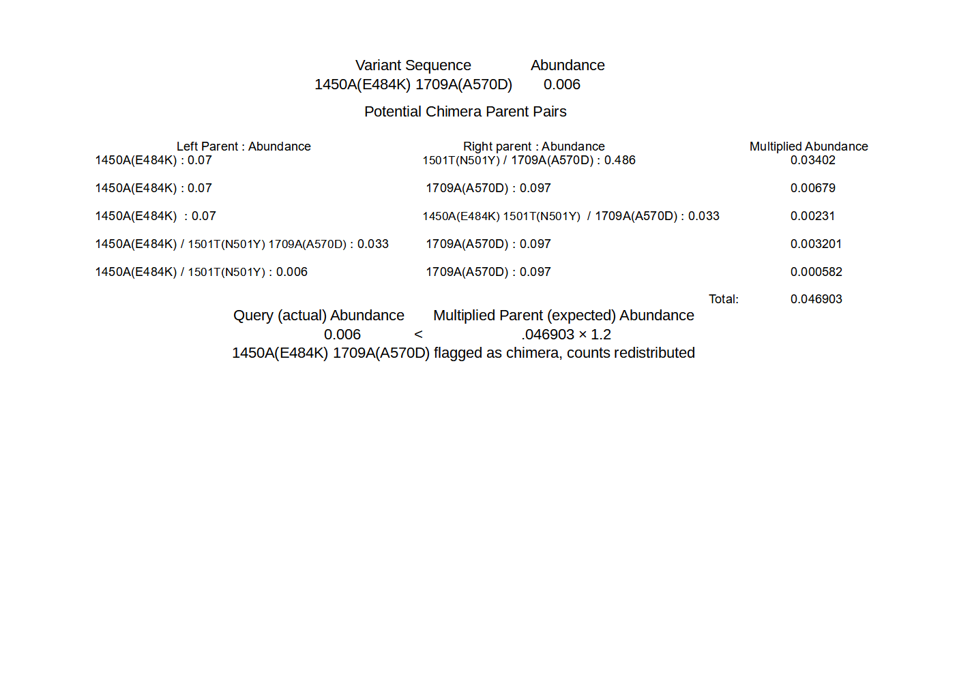**Figure 3. First method of detection and removal of chimeras, Chimera Removed.** Using the sequences shown in Sup. 5, the query of the least abundant sequence is shown. Potential parents whose recombination could result in the query sequence are found. The abundances of each potential pair are multiplied. The sum of the multiplied pairs’ abundances (expected) is then compared to the abundance of the query sequence (actual) to determine if the query sequence is a chimera. If the actual abundance is greater or equal to 1.2 times the expected abundance, the sequence is considered non-chimeric.

The algorithms to remove chimeric sequences rely on the unique sequence and covariant files generated by from the SAM processing. The first algorithm, chimera removed (chim rm), goes through the individual unique sequences, starting with the lowest abundance, and determines if that sequence is a chimera. Figure 3 shows a simplified example of how the determination is made on an example unique sequence output (Sup. 5). The more detailed and exact method is as follows. The sequence being considered as a potential chimera is broken up into all possible dimeric halves. Each pair is then compared to all the other sequences to detect potential parents. A sequence is flagged as a potential parent if its abundance is greater than or equal to the abundance of the potential chimera multiplied by 1.8 (foldab) and there is at least one other sequence that would be a matched parent to the complimentary dimeric half. When a pair of dimeric halves have potential parents, the abundances of parent pairs are multiplied. The products from each potential parent pairings are summed as an expected abundance value and compared to the observed abundance of the potential chimera. If the potential chimeras abundance is less than that of the expected value multiplied by 1.2 (alpha), that sequence is flagged as a chimera and removed. The counts attributed to that flagged chimeric sequence are then redistributed to the parents sequences based on the relative expected contribution to recombination. Once this process has been done for all the sequences, it is repeated until no more sequences are flagged as chimeric or 100 chimera removal cycles have completed. The results of this algorithm that have a recalculated abundance of .001 or greater are output in a new file (Sup. 6 Example_a1.2f1.8rd1_chim_rm.tsv). The added string represent values of the parameters used for the processing (see below for more information on the parameters).

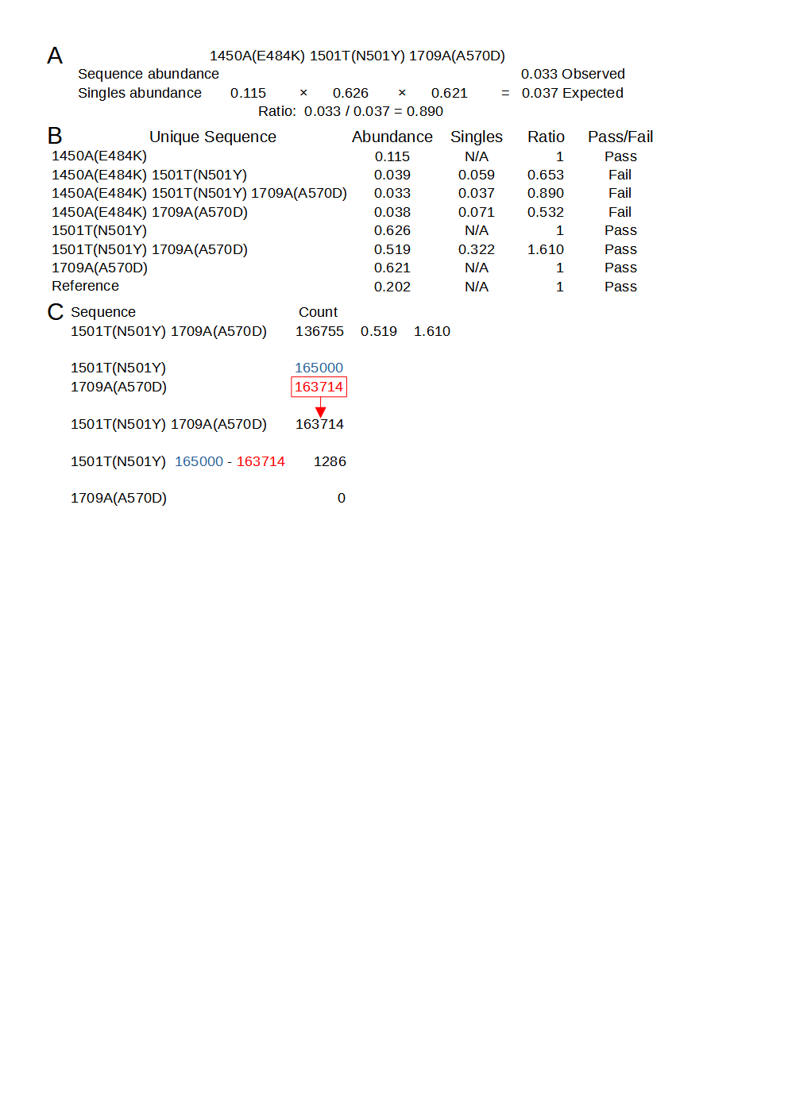**Figure 4. SAM Refiner’s second chimera removal method, Covariant Deconvolution.** A. Calculations of the singles / expected abundance for one of the unique sequences and of the abundance ratio. B. Calculations for determining if a unique sequence passes the initial check. Sequences pass when they have an Abundance/Singles ratio of 1 or greater. C. Passed sequences are processed in order of greatest ratio to least. Counts of the sequence are set to the counts of the least abundant single variant, and that count is removed from all other sequences that share a single variant.

The second algorithm, covariant deconvolution (covar deconv), is a two-step process. Figure 4 shows these processes using example outputs in Sup. 5 and 7. The first step determines if a sequence is likely to be a true or chimeric sequence by obtaining the ratio of a given unique sequence’s covariant observed abundance relative to an expected abundance assuming random recombination of its individual polymorphisms. The expected abundance is obtained by multiplying the abundances of each individual variance that is present in that covariant sequence. For instance, in a sample where ‘1501T(N501Y)’ has an abundance of 0.32 and ‘1709A(A570D)’ has an abundance of 0.35, the expected abundance of the covariant ‘1501T(N501Y) 1709A(A570D)’ would be 0.112 [0.32 × 0.35]. If the ratio of the observed abundance to the expected abundance is equal to or greater than 1 (beta), that covariant passes the check and is sent to the second step. Any sequence that has an abundance of .3 or greater is automatically passed. If such a sequence has an observed/expected ratio less than 1, it will be assigned a ratio of 1. The second step processes the passed sequences in order of greatest ratio to least. If multiple sequences have the same ratio, they are processed in order of greatest to least distance from the reference. Sequences are assigned a new occurrence count based on their constituent individual variances. For the sequence being processed, the count for the least abundant individual variance is assigned to the sequence and constituent variances making up the sequence have their count reduced by the amount of the least variance. This reduction means the individual variance that had the least counts is assigned 0 counts, so any sequence not yet processed in which that variance is present is functionally removed. This process is repeated until all sequences have been reassessed or removed. The final results with an abundance of .001 or greater are reported in a new file (Sup. 8 Example_covar_deconv.tsv).

As before, the results from individual samples are collected and reported for entries above 1% occurrence. A number of command line arguments will also influence the chimera removal algorithms. Both chimera removal algorithms run by default, but either or both can be disabled (--chim_rm 0 and –covar_deconv 0). The collections are again disabled with ‘--collect 0’. An additional outputs of the covariants that passed the first step of the second algorithm can be generated with ‘--pass_out 1’(Sup. 9). The outputs are constrained as before by a minimum abundance with command line arguments ‘--min_abundance1’ and ‘--min_abundance2’. Collection file names are also prepended with ‘--colID’. The only input parameter that can be changed by command line argument is the abundance of sequences or covariants that will be considered in the algorithms. By default, only entries from the inputs that have a .001 abundance or greater are processed. This threshold can be changed with ‘--chim_in_abund’. Four parameters can be altered for the first algorithm. The abundance ratio that is used as a threshold for selecting potential parents of potential chimera can be set with ‘--foldab’. Larger values will reduce the likelihood of chimeras being found, but alos make it less likely a sequence will be falsely categories as a chimera. The multiplier for the parental summed abundance for determining if a sequence is a chimera can be set with ‘--alpha’. Larger values will increase the likelihood of chimeras being found, but also increase the likelihood of non-chimeras from being mistaken for chimeras. Redistribution of a chimera’s counts to parent sequences can be disabled with ‘--redist 0’. The maximum number of chimera removal cycles can be change by ‘--max_cycles’, ei ‘--max_cycles 2’ will only allow two iterations of the chimera removal. The second algorithm has two parameter that can be changed. The ratio threshold at which a covariant will be passed to the second step can be altered with ‘--ratio’. The abundance at which a covariant will automatically be passed can be changed with ‘--autopass’.

The chimera removal methods of SAM Refiner were also used on the Fenton sewershed sequencing data. Due to the relatively high amount of chimeric sequences in our samples, we used the command line arguments ‘--foldab=0.6 –alpha=2,2’. The outputs generated for the Fenton sewershed from 2-2-21 to 4-13-21 can be accessed at https://github.com/degregory/SR_manuscript/tree/master/Fenton_Data. The two different chimera removal methods showed good concordance, validating each as being a viable method. Duplicate preparation and sequencing of the same wastewater sample also generally provided similar results, though less consistently. These differences were more pronounced with low abundant sequences, such as is seen with the two 3-30 RBD samples where one detects T478K and the other does not (Fig. 5). These differences illustrate the stochastic nature of RT-PCR amplification.

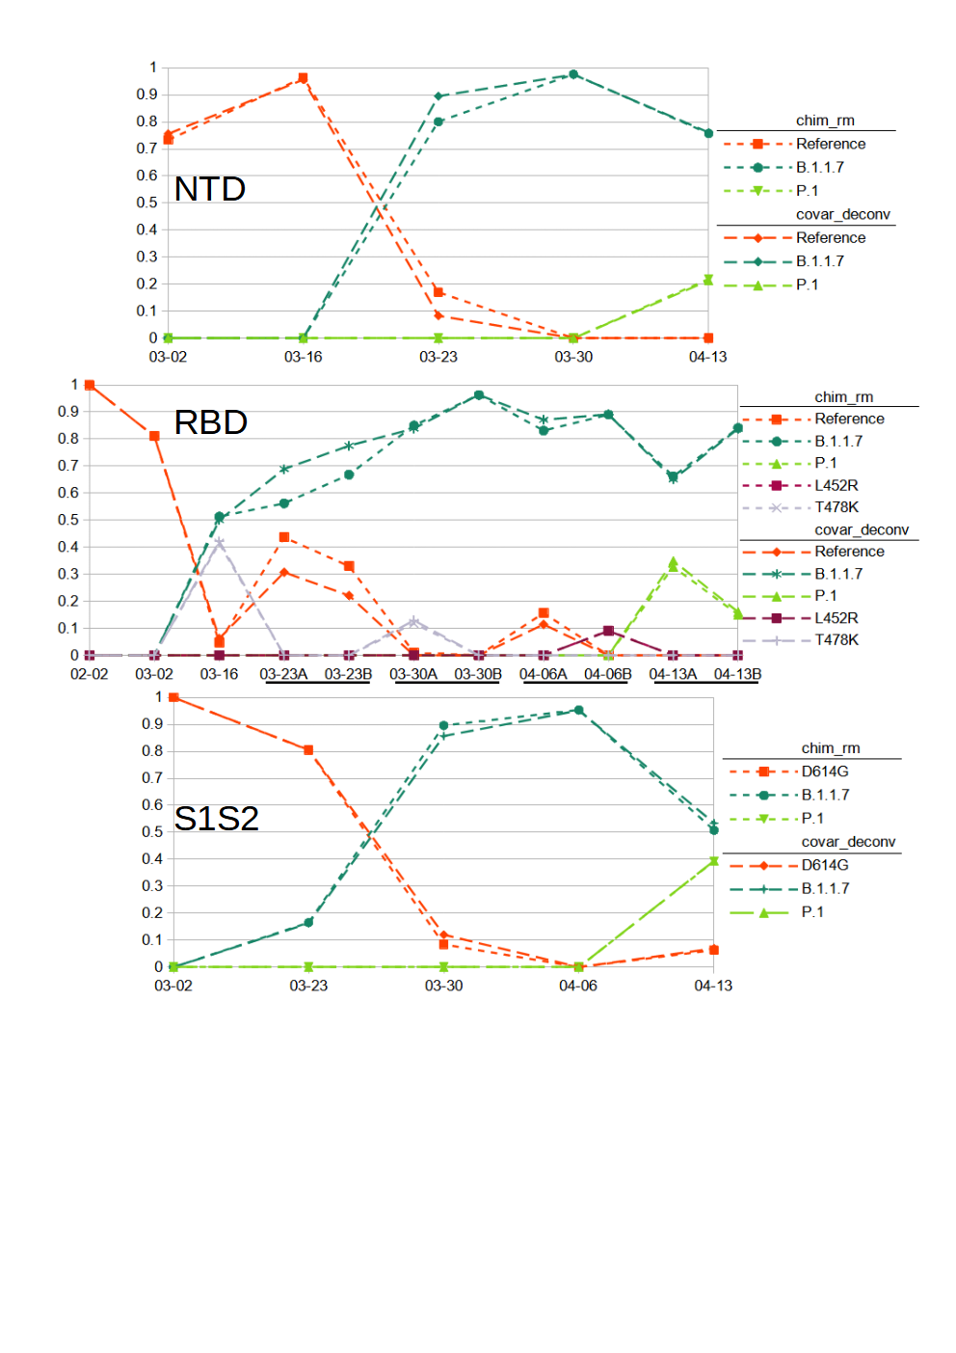**Figure 5 Relative Abundance of Reference and Variant SARS-COVID-2 Sequences Observed in Fenton, MO sewewshed from February to March.** Results from sequencing of Spike amplicons of the NTD, RBD and S1S2 junction regions are shown. Lines of short dashes connect values obtained by the chimera removed method, lines of long dahses connect values obtained by the covariant deconvolution method. All amplicons show a population shift from Reference with D614G to B.1.1.7 sequences with the appearance of P.1 sequence at the last time point. Additionally, known common polymorphisms T478K and L452R were observed from the RBD amplicons. RT-PCR for the RBD amplican was performed in duplicate for some samples. Results from sequencing of Spike amplicons of the NTD, RBD and S1S2 junction regions are shown. Lines of short dashes connect values obtained by the chimera removed method, lines of long dahses connect values obtained by the covariant deconvolution method. All amplicons show a population shift from Reference with D614G to B.1.1.7 sequences with the appearance of P.1 sequence at the last time point. Additionally, known common polymorphisms T478K and L452R were observed from the RBD amplicons. RT-PCR for the RBD amplican was performed in duplicate for some samples.

We used the chimera removed and covariant deconvolution outputs to assign sequences to known variants or the reference (Sup. 10, 11 & 12) based on variances present. Variances that only appeared in one sequencing run and did not appear frequently in GSIAD (https://www.gisaid.org/) were considered likely PCR error and not taken into account for sequence assignment. Based on the assignments, we were able to observe the changes to virus populations in the sewershed over time (Fig. 5). We classified the sequences found from the NTD amplicon as matching reference sequence, lineage B.1.1.7 or lineage P.1. Sequences from the RBD amplicon matched reference sequence, lineages B.1.1.7 or P.1, or had the single variations of T478K or L452R. T478K or L452R are associated with several common lineages. However, the other variances associated with those lineages were not detected. While these SNPs could be the result of PCR error, it is also possible the associated lineages exist in the sewershed and simply were not detected due stochastic effects or those SNPs arose in the reference background. Sequences from the S1S2 amplicon matched lineage B.1.1.7, lineage P.1 or only had the now ubiquitous D614G variation. The 03-23 S1S2 sample had a sequence containing A688V, which is associated with the P.1 lineage. However, other variances associated with P.1 were not detected at in that sample. Instead N679K was associated with A688V. As that is the only sample where those covariant sequences were observed and the variances are not frequently reported in GISAID (outside of P.1 for A688V), we assigned it to the reference category. Looking at all samples over time and the three amplicon regions in concert, we can conclude that the SARS-COVID-2 population of this sewershed changed from almost exclusively having only the D614G variation to mainly the B.1.1.7 lineage, with the introduction of P.1 early in April. This general method is now being used to track SARS-COVID-2 variants in many Missouri sewersheds (https://storymaps.arcgis.com/stories/f7f5492486114da6b5d6fdc07f81aacf).

3.4. SAM Refiner: Limitations and Future Development

While the outputs of SAM Refiner can be very informative, the program has some limitations, some of which may be overcome in future development. Currently the greatest limitation is the need for users to be familiar with command line usage. We hope to develop a graphical user interface version of these programs to overcome this user hurdle in the future. We also intend to develop SAM Refiner to be available from widely used functional collections, such as BioConda (https://bioconda.github.io/) and Galaxy (https://usegalaxy.org/).

Though SAM Refiner can be used on sequencing not based on amplicons, its usefulness will be more limited, as the relative abundance of sequences and covariants will be calculated based on total reads and not positional coverage. Future development may include modes for whole genome sequencing or multiple amplicons, even the ability to use multiple sequences for a reference.

The accuracies of the chimera removal algorithms will vary greatly depending on the parameters used and the sample they are being run on. Due to the stochastic nature of chimera generation and amplification during PCR and the possible complexity of the original template sequences, samples will sometimes be refractory to chimera removal algorithms. This problem is faced by all programs designed for this purpose. The ability to modify parameters in the algorithms and having two algorithms with different approaches to the chimera removal improves the accuracy the user can achieve with this software. Some samples will however always fail to be processed accurately by one or both methods.

**Supplementary Materials:** The following are available online at https://github.com/degregory/SR_manuscript/tree/master/Supplementals, Sup. 1 Example of SAM Refiner’s Output for Reporting Unique Sequences, Sup. 2 Example of SAM Refiner’s Output for Reporting Positional NT Calls, Sup. 3 Example of SAM Refiner’s Output for Reporting Insertions and Deletions, Sup. 4 Example of SAM Refiner’s Output for Reporting Covariance, Sup. 5 Sample Unique Sequences Output With Chimeric Sequences, Sup. 6 Sample Output of Sequences of SAM Refiner’s Chimeras Removed, Sup. 7 Sample Covariance Output With Chimeric Sequences, Sup. 8 Sample Passed Sequences Output from the First Part of SAM Refiner’s Covariant Deconvolution Method, Sup. 9 Sample Output of Sequences by SAM Refiner’s Covariant Deconvolution Method, Sup. 10 Assignment of NTD Covariant Sequences to Variants and Lineages, Sup. 11 Assignment of RBD Covariant Sequences to Variants and Lineages, Sup. 12 Assignment of S1S2 Covariant Sequences to Variants and Lineages

**Author Contributions:** Conceptualization, MJ.; methodology, MJ; software, DG; validation, DG and MJ.; formal analysis, DG and MJ; investigation, DG and MJ; resources, MJ; data curation, DG and MJ; writing—original draft preparation, DG; writing—review and editing, DG and MJ; visualization, DG; supervision, MJ; project administration, MJ; funding acquisition, MJ All authors have read and agreed to the published version of the manuscript

**Funding:** Please add: “This research received no external funding” or “This research was funded by NAME OF FUNDER, grant number XXX” and “The APC was funded by XXX”. Check carefully that the details given are accurate and use the standard spelling of funding agency names at https://search.crossref.org/funding. Any errors may affect your future funding.

**Institutional Review Board Statement:** In this section, please add the Institutional Review Board Statement and approval number for studies involving humans or animals. Please note that the Editorial Office might ask you for further information. Please add “The study was conducted according to the guidelines of the Declaration of Helsinki, and approved by the Institutional Review Board (or Ethics Committee) of NAME OF INSTITUTE (protocol code XXX and date of approval).” OR “Ethical review and approval were waived for this study, due to REASON (please provide a detailed justification).” OR “Not applicable.” for studies not involving humans or animals. You might also choose to exclude this statement if the study did not involve humans or animals.

**Data Availability Statement:** Raw and processed data can be accessed at https://github.com/degregory/SR_manuscript

**Acknowledgments:** We would like to acknowledge Christopher Bottoms for assistance in software development, ….

**Conflicts of Interest:** The authors declare no conflict of interest. The funders had no role in the design of the study; in the collection, analyses, or interpretation of data; in the writing of the manuscript, or in the decision to publish the results.

References

1. Ghebreyesus, Tedros Adhanom. (2020) Speech. https://www.who.int/director-general/speeches/detail/who-director-general-s-opening-remarks-at-the-media-briefing-on-covid-19---11-march-2020
2. Zhu N., Zhang D., Wang W., Li X., Yang B., et al. (2020). A novel coronavirus from patients with pneumonia in China, 2019. N. Engl. J. Med. 382 727–733
3. Wu F., Zhao S., Yu B., Chen Y. M., Wang W., et al. (2020). A new coronavirus associated with human respiratory disease in China. Nature 579 265–269
4. Ahmed W, Angel N, Edson J, Bibby K, Bivins A, et al. (2020 ) First confirmed detection of SARS-CoV-2 in untreated wastewater in Australia: A proof of concept for the wastewater surveillance of COVID-19 in the community. Sci Total Environ. 2020 Aug 1;728:138764
5. Medema G., Heijnen L., Elsinga G., Italiaander R., and Brouwer A. (2020) Presence of SARS-Coronavirus-2 RNA in Sewage and Correlation with Reported COVID-19 Prevalence in the Early Stage of the Epidemic in The Netherlands. Environmental Science & Technology Letters 2020 7 (7), 511-516
6. Nemudryi A, Nemudraia A, Wiegand T, Surya K, Buyukyoruk M, et al. (2020 )Temporal Detection and Phylogenetic Assessment of SARS-CoV-2 in Municipal Wastewater. Cell Rep Med. 2020 Sep 22;1(6):100098
7. Martin J, Klapsa D, Wilton T, Zambon M, Bentley E et al. (2020) Tracking SARS-CoV-2 in Sewage: Evidence of Changes in Virus Variant Predominance during COVID-19 Pandemic. Viruses. 2020 Oct 9;12(10):1144.
8. Ul-Rahman A, Shabbir MAB, Aziz MW, Yaqub S, Mehmood A, et al. (2020) A comparative phylogenomic analysis of SARS-CoV-2 strains reported from non-human mammalian species and environmental samples. Mol Biol Rep. 2020 Nov;47(11):9207-9217.
9. Crits-Christoph A, Kantor RS, Olm MR, Whitney ON, Al-Shayeb B, et al. (2021) Genome Sequencing of Sewage Detects Regionally Prevalent SARS-CoV-2 Variants. mBio. 2021 Jan 19;12(1):e02703-20.
10. Izquierdo-Lara R, Elsinga G, Heijnen L, Munnink BBO, Schapendonk CME, et al. (2021) Monitoring SARS-CoV-2 Circulation and Diversity through Community Wastewater Sequencing, the Netherlands and Belgium. Emerg Infect Dis. 2021 May;27(5):1405-1415
11. La Rosa G, Mancini P, Bonanno Ferraro G, Veneri C, et al. (2021) Rapid screening for SARS-CoV-2 variants of concern in clinical and environmental samples using nested RT-PCR assays targeting key mutations of the spike protein. Water Res. 2021 Jun 1;197:117104.
12. Smyth D, Trujillo M, Cheung K, Gao A, Hoxie I, et al. (2021) Detection of Mutations Associated with Variants of Concern Via High Throughput Sequencing of SARS-CoV-2 Isolated from NYC Wastewater. medRxiv [Preprint]. 2021
13. Fontenele RS, Kraberger S, Hadfield J, Driver EM, Bowes D et al. (2021) High-throughput sequencing of SARS-CoV-2 in wastewater provides insights into circulating variants. medRxiv [Preprint]. 2021 Jan 25:2021.01.22.21250320.
14. Martin, Marcel. (2011) Cutadapt removes adapter sequences from high-throughput sequencing reads. EMBnet.journal, [S.l.], v. 17, n. 1, p. pp. 10-12, may 2011.
15. Rognes T, Flouri T, Nichols B, Quince C, Mahé F. (2016) VSEARCH: a versatile open source tool for metagenomics. PeerJ 4:e2584.
16. Langmead B, Salzberg SL. Fast gapped-read alignment with Bowtie 2. Nature Methods. 2012 Mar 4;9(4):357-9.
17. Li H. and Durbin R. (2009) Fast and accurate short read alignment with Burrows-Wheeler Transform. Bioinformatics, 25:1754-60.