ConfigBox

Overview
ConfigBox.scad contains code to generate a wide variety of boxes / containers / enclosures by passing a collection of features to the model generator.
Each feature includes the kind of item, plus one or more of the following values:
- side (side of the box it’s on)
- type (RAISED,ENGRAVED,THROUGH: sticking out from the box, etched into it, cut through the side)
- external (whether the item is on the inside or outside of the box)
- shape (standard shapes, e.g. ELLIPSE, RECTANGLE)
- location (x,y,z relative to the specified side)
- size (l,w,h relative to the specified side)
- dia (diameter)
In addition, there are a number of specialized values specific to certain kinds of features.
Each feature is a collection of values that specify its parameters. However, convenience functions are provided to generate these collections, providing default values for each parameter and ensuring each collection has the correct number of values.

Minimal Configuration
The absolute minimum code required to make a box consists of the include statement for ConfigBox.scad, a list of specs with a default box, and a call to makeBox():
include <ConfigBox.scad>
specs=[
Box()
];
makeBox(specs);

This will result in a 100×75×50mm box with a lid line at 25mm, a wall thickness of 2mm, a pop hinge and a friction latch. The model, when rendered is laid out for printing, with top and bottom arranged back-to-back:
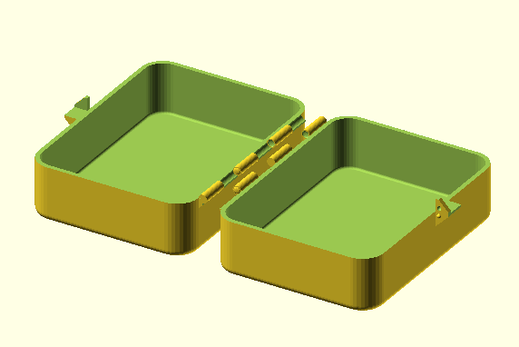
This default configuration is the starting point for all boxes. Variations of this configuration are generated by overriding the default values of the box itself, and adding one or more features.

Coordinates
The general rule for the boxes is that the XY origin is in the bottom left corner of the side.
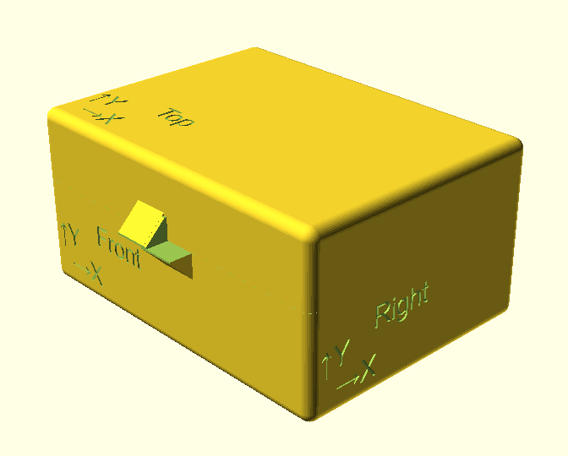
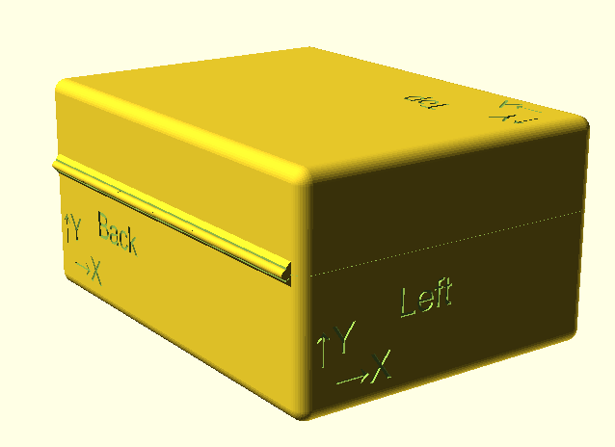
The one exception to this is the bottom. Its coordinates are set to match the top. This tends to help in designing project enclosures, where elements on the top and bottom need to meet up.
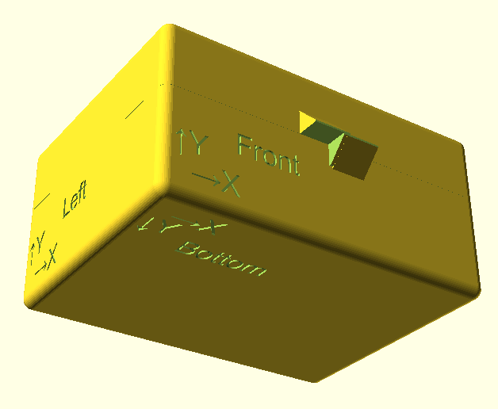
The coordinates on the interior walls reflect their opposite faces, making the X axis right-to-left for the inside of the box.
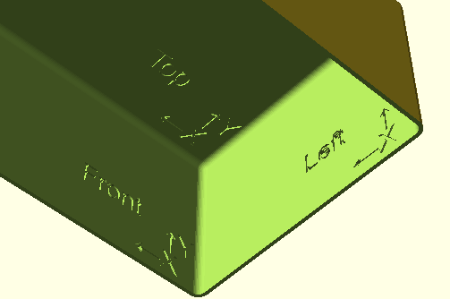

Box()
The Box() function creates the overall container. Fully expanded, the function looks like this:
Box(w=100,d=75,h=50,wall=2,lidz=25,wdradius=10,hradius=3,interfaceType=HINGE,latchType=FRICTION,overlap=0)

The parameters for Box() are as follows:
- w: width (left to right)
- d: depth (front to back)
- h: height (top to bottom)
- wall: thickness of all sides
- lidz: the elevation of the top/bottom break, relative to the bottom
- wdradius: the radius of the corners of the box, as viewed from above
- hradius: the radius of the corners of the box, as viewed from the side
- interfaceType: the manner in which the top and bottom are joined
- latchType: the type of latch used
- overlap: the amount of overlap, if any, between top and bottom (usually left as default)

interfaceType
- HINGE: A pop hinge that snaps together without additional hardware
- PINHINGE: A hinge with holes for a 1.75mm pin (i.e. a piece of filament)
- FLEX: A flexible hinge specifically for flex materials such as TPU
- SNAP: Top and bottom snap together via an overlapping interface
- SLIDE: Top and bottom slide together via an overlapping interface
- NONE: No specific connection between top and bottom

latchType
- FRICTION: A catch with a bump and indentation on the top, with an identical one on the bottom
- FLAP: A flap with an indentation on the top, with a matching bump on the bottom
- NONE: No latch
Note: If the interfaceType is SLIDE, a latch (assuming one is specified) will be added to both the front and back of the box.

Features

Circle()
The Circle() function creates a circle (RAISED, ENGRAVED or THROUGH) on the inside or outside of a specific wall of the box.

Parameters
- side: (default TOP) TOP, BOTTOM, LEFT, RIGHT, FRONT, BACK
- type: (default ENGRAVED) RAISED, ENGRAVED, THROUGH
- external: (default true) On the outside or inside of the box
- x: (default 25) The horizontal coordinate relative to the specified side
- y: (default 40) The vertical coordinate relative to the specified side
- z: (default 0) The offset from the surface of the side
- dia: (default 10) The diameter of the circle
- h: (default 0) The height of the circle (typically only used in the case of a raised shape)

Square()
The Square() function creates a square (RAISED, ENGRAVED or THROUGH) on the inside or outside of a specific wall of the box.

Parameters
- side: (default TOP) TOP, BOTTOM, LEFT, RIGHT, FRONT, BACK
- type: (default ENGRAVED) RAISED, ENGRAVED, THROUGH
- external: (default true) On the outside or inside of the box
- x: (default 25) The horizontal coordinate relative to the specified side
- y: (default 10) The vertical coordinate relative to the specified side
- z: (default 0) The offset from the surface of the side
- w: (default 10) The width of the square
- h: (default 0) The height of the square (typically only used in the case of a raised shape)
- r: (default 0) The corner radius

Hexagon()
The Hexagon() function creates a hexagon (RAISED, ENGRAVED or THROUGH) on the inside or outside of a specific wall of the box.

Parameters
- side: (default TOP) TOP, BOTTOM, LEFT, RIGHT, FRONT, BACK
- type: (default ENGRAVED) RAISED, ENGRAVED, THROUGH
- external: (default true) On the outside or inside of the box
- x: (default 25) The horizontal coordinate relative to the specified side
- y: (default 60) The vertical coordinate relative to the specified side
- z: (default 0) The offset from the surface of the side
- w: (default 10) The width of the hexagon
- h: (default 0) The height of the hexagon (typically only used in the case of a raised shape)
- r: (default 0) The corner radius

Oval()
The Oval() function creates a oval (RAISED, ENGRAVED or THROUGH) on the inside or outside of a specific wall of the box.

Parameters
- side: (default TOP) TOP, BOTTOM, LEFT, RIGHT, FRONT, BACK
- type: (default ENGRAVED) RAISED, ENGRAVED, THROUGH
- external: (default true) On the outside or inside of the box
- x: (default 25) The horizontal coordinate relative to the specified side
- y: (default 50) The vertical coordinate relative to the specified side
- z: (default 0) The offset from the surface of the side
- angle: (default 0) The angle of rotation
- l: (default 10) The length of the oval
- w: (default 5) The width of the oval
- h: (default 0) The height of the oval (typically only used in the case of a raised shape)

Polygon()
The Polygon() function creates a convex shape based on a set of points. The order of the points is unimportant. The function just wraps a line around the points, rounding the corners according to the r parameter.

Parameters
- side: (default TOP) TOP, BOTTOM, LEFT, RIGHT, FRONT, BACK
- type: (default ENGRAVED) RAISED, ENGRAVED, THROUGH
- external: (default true) On the outside or inside of the box
- x: (default 75) The horizontal coordinate relative to the specified side
- y: (default 35) The vertical coordinate relative to the specified side
- z: (default 0) The offset from the surface of the side
- h: (default 0) The height of the hexagon (typically only used in the case of a raised shape)
- r: (default 0.5) The corner radius
- points: (default [[-7.7,3.3],[7.7,3.3],[-7.7,0],[7.7,0],[-5.3,-3.3],[5.3,-3.3]]) The coordinates of the polygon’s corners

Shape()
The Shape() function creates a shape (RAISED, ENGRAVED or THROUGH) on the inside or outside of a specific wall of the box.

Parameters
- side: (default TOP) TOP, BOTTOM, LEFT, RIGHT, FRONT, BACK
- type: (default ENGRAVED) RAISED, ENGRAVED, THROUGH
- external: (default true) On the outside or inside of the box
- x: (default 25) The horizontal coordinate relative to the specified side
- y: (default 25) The vertical coordinate relative to the specified side
- z: (default 0) The offset from the surface of the side
- angle: (default 0) The angle of rotation
- l: (default 10) The length of the shape
- w: (default 10) The width of the shape
- h: (default 0) The height of the shape (typically only used in the case of a raised shape)
- r: (default 3) The corner radius
- shape: (default RECTANGLE) ELLIPSE, RECTANGLE, OVAL

Hole()
The Hole() function creates a circular hole in a side. This is just a specific case of Circle() that puts defaults to a through-hole on the exterior of a side.

Parameters
- side: (default TOP) TOP, BOTTOM, LEFT, RIGHT, FRONT, BACK
- x: (default 10) The horizontal coordinate relative to the specified side
- y: (default 60) The vertical coordinate relative to the specified side
- dia: (default 6) The diameter of the hole

Grid()
The Grid() function creates an elliptical or rectangular grid.

Parameters
- side: (default TOP) TOP, BOTTOM, LEFT, RIGHT, FRONT, BACK
- type: (default ENGRAVED) RAISED, ENGRAVED, THROUGH
- external: (default true) On the outside or inside of the box
- x: (default 50) The horizontal coordinate relative to the specified side
- y: (default 50) The vertical coordinate relative to the specified side
- z: (default 0) The offset from the surface of the side
- angle: (default 0) The angle of rotation
- l: (default 22) The length of the grid
- w: (default 22) The width of the grid
- h: (default 0) The height of the grid (typically only used in the case of a raised shape)
- r: (default 0) The corner radius
- shape: (default RECTANGLE) ELLIPSE, RECTANGLE
- spl: (default 3) Grid spacing along the length (radially for ellipse)
- spw: (default 3) Grid spacing across the width (spoke angle for ellipse)
- thickness: (default 1) The thickness of the grid lines
- invert: (default false) Inverts the grid (negative image)

Svg()
The Svg() function creates an arbitrary shape based on an SVG file (RAISED, ENGRAVED or THROUGH) on the inside or outside of a specific wall of the box. Typically used for decoration or complex cutouts. The SVG image (page size) should be scaled to 200×200mm in order to be sized correctly on the box.

Parameters
- side: (default TOP) TOP, BOTTOM, LEFT, RIGHT, FRONT, BACK
- type: (default ENGRAVED) RAISED, ENGRAVED, THROUGH
- external: (default true) On the outside or inside of the box
- x: (default 75) The horizontal coordinate relative to the specified side
- y: (default 50) The vertical coordinate relative to the specified side
- z: (default 0) The offset from the surface of the side
- angle: (default 0) The angle of rotation
- l: (default 20) The length of the graphic
- w: (default 20) The width of the graphic
- h: (default 0) The height of the graphic (typically only used in the case of a raised shape)
- filename: (default "fleur.svg") The SVG file

Text()
The Text() function creates text on the inside or outside of a specific wall of the box.

Parameters
- side: (default TOP) TOP, BOTTOM, LEFT, RIGHT, FRONT, BACK
- type: (default ENGRAVED) RAISED, ENGRAVED, THROUGH
- external: (default true) On the outside or inside of the box
- x: (default 50) The horizontal coordinate relative to the specified side
- y: (default 10) The vertical coordinate relative to the specified side
- z: (default 0) The offset from the surface of the side
- angle: (default 0) The angle of rotation
- h: (default 0) The height of the text (typically only used in the case of raised text)
- text: (default "Text") The text to be displayed
- size: (default 6) The text size
- typeface: (default "Verdana:style=Regular") The typeface

CircularText()
The CircularText() function creates an arc of text on the inside or outside of a specific wall of the box.

Parameters
- side: (default TOP) TOP, BOTTOM, LEFT, RIGHT, FRONT, BACK
- type: (default ENGRAVED) RAISED, ENGRAVED, THROUGH
- external: (default true) On the outside or inside of the box
- x: (default 50) The horizontal coordinate relative to the specified side
- y: (default 25) The vertical coordinate relative to the specified side
- z: (default 0) The offset from the surface of the side
- angle: (default 90) The angle of rotation
- h: (default 0) The height of the text (typically only used in the case of raised text)
- text: (default "Circular Text") The text to be displayed
- size: (default 3) The text size
- typeface: (default "Verdana:style=Regular") The typeface
- r: (default 10) Radius of the arc
- arc: (default 180) Number of degrees in the arc

Knockout()
The Knockout() function creates a knockout cut in specific wall of the box.

Parameters
- side: (default TOP) TOP, BOTTOM, LEFT, RIGHT, FRONT, BACK
- x: (default 75) The horizontal coordinate relative to the specified side
- y: (default 20) The vertical coordinate relative to the specified side
- angle: (default 0) The angle of rotation
- l: (default 20) The length of the knockout
- w: (default 10) The length of the knockout
- r: (default 6) The corner radius
- shape: (default RECTANGLE) ELLIPSE, RECTANGLE

Standoff()
The Standoff() function creates a cylindrical post with a bore hole, typically for mounting PCBs. Standoffs are always inside the box.

Parameters
- side: (default BOTTOM) TOP, BOTTOM, LEFT, RIGHT, FRONT, BACK
- x: (default 50) The horizontal coordinate relative to the specified side
- y: (default 50) The vertical coordinate relative to the specified side
- dia: (default 6) The diameter
- h: (default 20) The height
- boreDia: (default 2.9) The bore diameter
- boreDepth: (default 12) The bore depth

Post()
The Post() function creates a cylindrical post. Posts are always inside the box.

Parameters
- side: (default BOTTOM) TOP, BOTTOM, LEFT, RIGHT, FRONT, BACK
- x: (default 50) The horizontal coordinate relative to the specified side
- y: (default 25) The vertical coordinate relative to the specified side
- dia: (default 6) The diameter
- h: (default 20) The height

Torus()
The Torus() function creates a torus.

Parameters
- side: (default LEFT) TOP, BOTTOM, LEFT, RIGHT, FRONT, BACK
- x: (default 37.5) The horizontal coordinate relative to the specified side
- y: (default 25) The vertical coordinate relative to the specified side
- z: (default 0) The offset from the surface of the side
- outerDia: (default 6) The outer diameter of the torus
- innerDia: (default 3) The inner diameter of the torus

Counterbore()
The Counterbore() function creates a circular bore hole.

Parameters
- side: (default TOP) TOP, BOTTOM, LEFT, RIGHT, FRONT, BACK
- x: (default 10) The horizontal coordinate relative to the specified side
- y: (default 20) The vertical coordinate relative to the specified side
- z: (default 0) The offset from the surface of the side
- dia: (default 6) The diameter of the bore
- h: (default 2) the depth of the bore

Hexbore()
The Hexbore() function creates a hexagonal bore hole (e.g. for hex nuts).

Parameters
- side: (default TOP) TOP, BOTTOM, LEFT, RIGHT, FRONT, BACK
- x: (default 10) The horizontal coordinate relative to the specified side
- y: (default 30) The vertical coordinate relative to the specified side
- z: (default 0) The offset from the surface of the side
- w: (default 6) The width of the bore
- h: (default 2) the depth of the bore

Squarebore()
The Squarebore() function creates a square bore hole.

Parameters
- side: (default TOP) TOP, BOTTOM, LEFT, RIGHT, FRONT, BACK
- x: (default 10) The horizontal coordinate relative to the specified side
- y: (default 40) The vertical coordinate relative to the specified side
- z: (default 0) The offset from the surface of the side
- w: (default 6) The width of the bore
- h: (default 2) the depth of the bore

Countersink()
The Countersink() function creates a 90º countersink.

Parameters
- side: (default TOP) TOP, BOTTOM, LEFT, RIGHT, FRONT, BACK
- x: (default 10) The horizontal coordinate relative to the specified side
- y: (default 50) The vertical coordinate relative to the specified side
- z: (default 0) The offset from the surface of the side
- outerDia: (default 6) Outer diameter
- innerDia: (default 3) Inner diameter

Order of Operations
When rendering a box, the code adds and subtracts features in the following order:
- Create the basic box
- Add any raised objects (circle, square, text, svg, post, etc) on the sides (i.e. anything other than top or bottom)
- Split top and bottom (implies raised objects on the cut line will be split)
- Add hinges and latches
- Subtract any cuts required for top/bottom interface (slide and snap lid)
- Add any structures required for top/bottom interface (slide and snap lid)
- Add raised items on top and bottom (implies these are not split at the cut line)
- Subtract any through-holes, engravings and voids (e.g. circle, square, text, bores, countersinks)

