**Project 1**

Analysis of Top Rated IMDB Movies vs The top 500 Most Profitable Hollywood Movies

Taken from Kaggle August 14, 2023

Sources: <https://www.kaggle.com/datasets/joebeachcapital/top-500-hollywood-movies-of-all-time>

<https://www.kaggle.com/datasets/harshitshankhdhar/imdb-dataset-of-top-1000-movies-and-tv-shows>

Stakeholders: movie producers, aspiring filmmakers

What genres are most popular?

How can user ratings be maximized?

What can I expect from my low budget? Or a high budget?

PART 1: EDA

1. Analyze ‘IMDBTop1000’ table

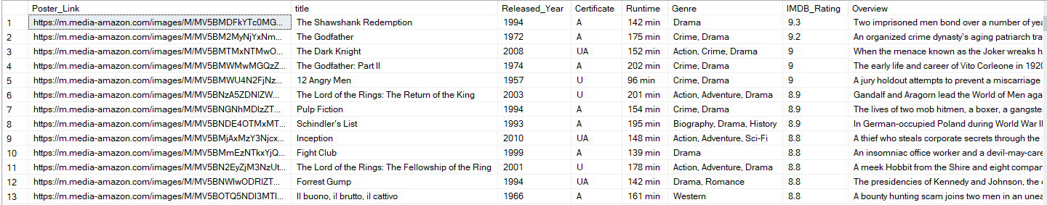

1. Count the number of movies for each genre and count how many unique genres are there. Some movies have multiple genres so string_split was used

SELECT TRIM(value) AS genre_value, COUNT(*) AS movie_count

FROM (

SELECT LTRIM(RTRIM(value)) AS value

FROM IMDBTop1000

CROSS APPLY STRING_SPLIT(genre, ',')

) AS genres

GROUP BY TRIM(value)

ORDER BY movie_count DESC;

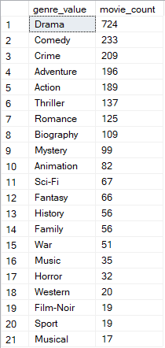

There are 21 unique genres in this table and the most occurring genre is Drama with 724.

1. Get the minimum, maximum and average rating of all the movies in the table (IMDB_Rating)

SELECT MIN(IMDB_Rating) AS min_rating, MAX(IMDB_Rating) AS max_rating, AVG(IMDB_Rating) AS average_rating

FROM IMDBTop1000;



Min, max, and average released_year (rounded)

SELECT MIN(Released_Year) AS min_year,

MAX(Released_Year) AS max_year,

ROUND(AVG(Released_Year), 0) AS avg_year

FROM IMDBTop1000;



Min, max, and average runtime in minutes with trimming of number and conversions because Runtime is in nvarchar

SELECT MIN(CONVERT(INT, LEFT(runtime, CHARINDEX(' ', runtime) - 1))) AS min_runtime,

MAX(CONVERT(INT, LEFT(runtime, CHARINDEX(' ', runtime) - 1))) AS max_runtime,

AVG(CONVERT(FLOAT, LEFT(runtime, CHARINDEX(' ', runtime) - 1))) AS avg_runtime

FROM IMDBTop1000;



Min, max, and average meta_score (metascore is reviews from Metacritic by reviewers compared to IMDB’s reviews by users)

SELECT

MIN(Meta_score) AS Min_Meta_score,

MAX(Meta_score) AS Max_Meta_score,

AVG(CAST(Meta_score AS FLOAT)) AS Avg_Meta_score

FROM IMDBTop1000;



1. Count how many times each director appeared on this list

SELECT Director, COUNT(*) AS DirectorCount

FROM IMDBTop1000

GROUP BY Director

ORDER BY DirectorCount DESC;

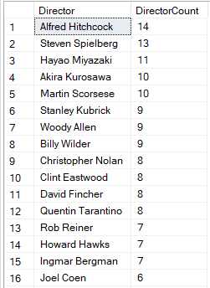

1. Count how many times each star appeared on this table from all 4 columns 'star1', 'star2', 'star3', 'star4'

SELECT Star1, COUNT(*) AS StarCount

FROM (

SELECT Star1 FROM IMDBTop1000

UNION ALL

SELECT Star2 FROM IMDBTop1000

UNION ALL

SELECT Star3 FROM IMDBTop1000

UNION ALL

SELECT Star4 FROM IMDBTop1000

) AS AllStars

GROUP BY Star1

ORDER BY StarCount DESC;

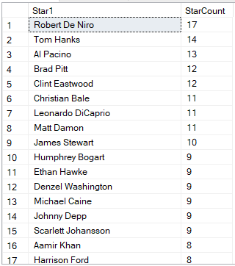

**PART 2: Insights**

1. Which genres have the highest IMDB rating? And how many movies are in each genre?

SELECT

TRIM(value) AS genre_value,

COUNT(*) AS movie_count,

AVG(IMDB_Rating) AS average_rating

FROM (

SELECT LTRIM(RTRIM(value)) AS value, IMDB_Rating

FROM IMDBTop1000

CROSS APPLY STRING_SPLIT(genre, ',')

) AS genres

GROUP BY TRIM(value)

ORDER BY average_rating DESC;

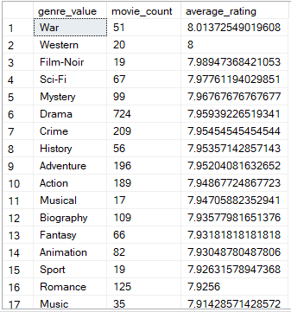

1. Min, Max, and Average number of votes

SELECT

MIN(No_of_Votes) AS MinVotes,

MAX(No_of_Votes) AS MaxVotes,

AVG(No_of_Votes) AS AvgVotes

FROM IMDBTop1000;



--Vote number range and average rating split into 2

SELECT

CASE

WHEN No_of_Votes >= 25088 AND No_of_Votes < 273693 THEN '25088-273693'

WHEN No_of_Votes >= 273693 AND No_of_Votes <= 2343110 THEN '273693-2343110'

ELSE 'Other'

END AS VoteRange,

AVG(IMDB_Rating) AS AverageRating

FROM IMDBTop1000

GROUP BY

CASE

WHEN No_of_Votes >= 25088 AND No_of_Votes < 273693 THEN '25088-273693'

WHEN No_of_Votes >= 273693 AND No_of_Votes <= 2343110 THEN '273693-2343110'

ELSE 'Other'

END;

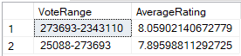

--Vote number range and average rating split into 10

SELECT

CASE

WHEN No_of_Votes >= 25088 AND No_of_Votes < 256890 THEN '25088-256890'

WHEN No_of_Votes >= 256890 AND No_of_Votes < 488692 THEN '256890-488692'

WHEN No_of_Votes >= 488692 AND No_of_Votes < 720495 THEN '488692-720495'

WHEN No_of_Votes >= 720495 AND No_of_Votes < 952296 THEN '720495-952296'

WHEN No_of_Votes >= 952296 AND No_of_Votes < 1180099 THEN '952296-1180099'

WHEN No_of_Votes >= 1180099 AND No_of_Votes < 1407901 THEN '1180099-1407901'

WHEN No_of_Votes >= 1407901 AND No_of_Votes < 1635703 THEN '1407901-1635703'

WHEN No_of_Votes >= 1635703 AND No_of_Votes < 1863506 THEN '1635703-1863506'

WHEN No_of_Votes >= 1863506 AND No_of_Votes < 2091308 THEN '1863506-2091308'

WHEN No_of_Votes >= 2091308 AND No_of_Votes <= 2343110 THEN '2091308-2343110'

ELSE 'Other'

END AS VoteRange,

AVG(IMDB_Rating) AS AverageRating

FROM IMDBTop1000

GROUP BY

CASE

WHEN No_of_Votes >= 25088 AND No_of_Votes < 256890 THEN '25088-256890'

WHEN No_of_Votes >= 256890 AND No_of_Votes < 488692 THEN '256890-488692'

WHEN No_of_Votes >= 488692 AND No_of_Votes < 720495 THEN '488692-720495'

WHEN No_of_Votes >= 720495 AND No_of_Votes < 952296 THEN '720495-952296'

WHEN No_of_Votes >= 952296 AND No_of_Votes < 1180099 THEN '952296-1180099'

WHEN No_of_Votes >= 1180099 AND No_of_Votes < 1407901 THEN '1180099-1407901'

WHEN No_of_Votes >= 1407901 AND No_of_Votes < 1635703 THEN '1407901-1635703'

WHEN No_of_Votes >= 1635703 AND No_of_Votes < 1863506 THEN '1635703-1863506'

WHEN No_of_Votes >= 1863506 AND No_of_Votes < 2091308 THEN '1863506-2091308'

WHEN No_of_Votes >= 2091308 AND No_of_Votes <= 2343110 THEN '2091308-2343110'

ELSE 'Other'

END

ORDER BY VoteRange;

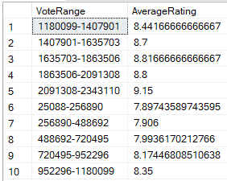

1. Min, max, and average runtime in minutes with trimming of number and conversions because Runtime is in nvarchar

SELECT MIN(CONVERT(INT, LEFT(runtime, CHARINDEX(' ', runtime) - 1))) AS min_runtime,

MAX(CONVERT(INT, LEFT(runtime, CHARINDEX(' ', runtime) - 1))) AS max_runtime,

AVG(CONVERT(FLOAT, LEFT(runtime, CHARINDEX(' ', runtime) - 1))) AS avg_runtime

FROM IMDBTop1000;



--runtime ranges and the average rating of each split into 3

SELECT

CASE

WHEN runtime_int >= 45 AND runtime_int <= 137 THEN '45-137'

WHEN runtime_int > 137 AND runtime_int <= 229 THEN '138-229'

WHEN runtime_int > 229 AND runtime_int <= 321 THEN '230-321'

ELSE 'Other'

END AS RuntimeRange,

AVG(IMDB_Rating) AS AverageRating

FROM (

SELECT

CAST(SUBSTRING(Runtime, 1, PATINDEX('%[^0-9]%', Runtime) - 1) AS INT) AS runtime_int,

IMDB_Rating

FROM IMDBTop1000

) AS RuntimeData

GROUP BY

CASE

WHEN runtime_int >= 45 AND runtime_int <= 137 THEN '45-137'

WHEN runtime_int > 137 AND runtime_int <= 229 THEN '138-229'

WHEN runtime_int > 229 AND runtime_int <= 321 THEN '230-321'

ELSE 'Other'

END

ORDER BY AverageRating;

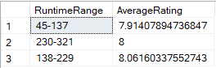

1. Top rated movie in each genre with its corresponding Metascore

WITH TopRatedMovies AS (

SELECT

genre_value,

MAX(title) AS top_rated_movie,

MAX(IMDB_Rating) AS max_rating

FROM (

SELECT TRIM(value) AS genre_value,

title,

IMDB_Rating,

ROW_NUMBER() OVER (PARTITION BY TRIM(value) ORDER BY IMDB_Rating DESC) AS rn

FROM IMDBTop1000

CROSS APPLY STRING_SPLIT(genre, ',')

) AS genre_movies

WHERE rn = 1

GROUP BY genre_value

),

TopRatedMoviesWithMetaScore AS (

SELECT

TRM.genre_value AS genre,

TRM.top_rated_movie,

TRM.max_rating AS max_rating,

IMDB.Meta_score AS meta_score

FROM TopRatedMovies AS TRM

LEFT JOIN IMDBTop1000 AS IMDB ON TRM.top_rated_movie = IMDB.title

)

SELECT

genre,

top_rated_movie,

max_rating,

meta_score

FROM TopRatedMoviesWithMetaScore

ORDER BY max_rating DESC;

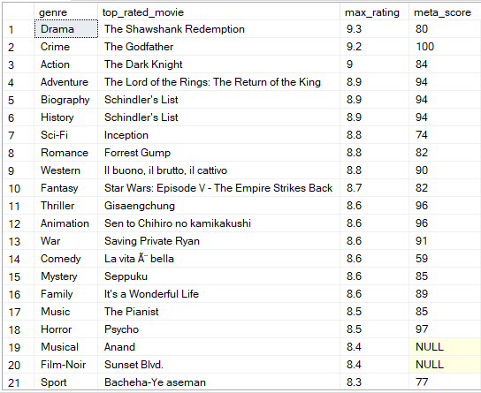

A movie like Schindler’s List for instance appeared on this list twice

--Top meta score for each genre with its corresponding IMDB_rating

WITH TopMetaScoreMovies AS (

SELECT

genre_value,

MAX(title) AS top_meta_score_movie,

MAX(Meta_score) AS max_meta_score

FROM (

SELECT TRIM(value) AS genre_value,

title,

Meta_score,

ROW_NUMBER() OVER (PARTITION BY TRIM(value) ORDER BY Meta_score DESC) AS rn

FROM IMDBTop1000

CROSS APPLY STRING_SPLIT(genre, ',')

) AS genre_movies

WHERE rn = 1

GROUP BY genre_value

),

TopMetaScoreMoviesWithIMDBRating AS (

SELECT

TMM.genre_value AS genre,

TMM.top_meta_score_movie,

TMM.max_meta_score AS max_meta_score,

IMDB.IMDB_Rating AS IMDB_Rating

FROM TopMetaScoreMovies AS TMM

LEFT JOIN IMDBTop1000 AS IMDB ON TMM.top_meta_score_movie = IMDB.title

)

SELECT

genre,

top_meta_score_movie,

max_meta_score,

IMDB_Rating

FROM TopMetaScoreMoviesWithIMDBRating

ORDER BY max_meta_score DESC;

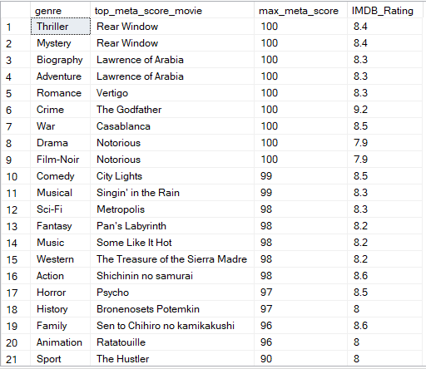

1. Top Rated and top Meta Score for each genre side by side

WITH TopRatedMovies AS (

SELECT

genre_value,

MAX(title) AS top_rated_movie,

MAX(IMDB_Rating) AS max_rating

FROM (

SELECT TRIM(value) AS genre_value,

title,

IMDB_Rating,

ROW_NUMBER() OVER (PARTITION BY TRIM(value) ORDER BY IMDB_Rating DESC) AS rn

FROM IMDBTop1000

CROSS APPLY STRING_SPLIT(genre, ',')

) AS genre_movies

WHERE rn = 1

GROUP BY genre_value

),

TopMetaScoreMovies AS (

SELECT

genre_value,

MAX(title) AS top_meta_score_movie,

MAX(Meta_score) AS max_meta_score

FROM (

SELECT TRIM(value) AS genre_value,

title,

Meta_score,

ROW_NUMBER() OVER (PARTITION BY TRIM(value) ORDER BY Meta_score DESC) AS rn

FROM IMDBTop1000

CROSS APPLY STRING_SPLIT(genre, ',')

) AS genre_movies

WHERE rn = 1

GROUP BY genre_value

)

SELECT

TRM.genre_value AS genre,

TRM.top_rated_movie,

TRM.max_rating,

TMM.top_meta_score_movie,

TMM.max_meta_score

FROM TopRatedMovies AS TRM

INNER JOIN TopMetaScoreMovies AS TMM ON TRM.genre_value = TMM.genre_value

ORDER BY TRM.genre_value;

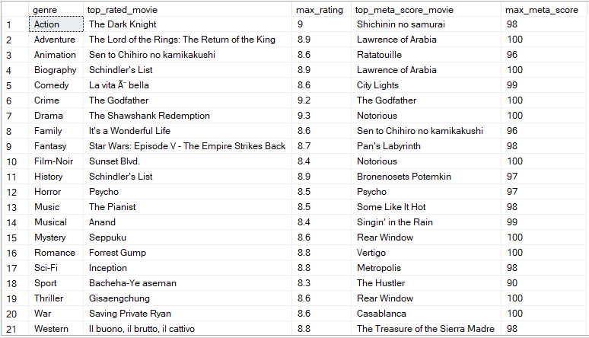

**PART 3: THE TOP OF THE TOP** - analysis of the highly rated movies in IMDB, their budget, genre, rating, stars, number of votes, runtime, etc.

1. Rename all columns in the MostProfitable500 table to Pascal Case (table from: <https://www.kaggle.com/datasets/joebeachcapital/top-500-hollywood-movies-of-all-time>)

EXEC sp_rename 'MostProfitable500.[worldwide gross (m)]', 'WorldwideGrossM', 'COLUMN';

EXEC sp_rename 'MostProfitable500.[% budget recovered]', 'BudgetRecoveredPercent', 'COLUMN';

EXEC sp_rename 'MostProfitable500.[X times budget recovered]', 'XTimesBudgetRecovered', 'COLUMN';

EXEC sp_rename 'MostProfitable500.[budget (millions)]', 'BudgetMillions', 'COLUMN';

EXEC sp_rename 'MostProfitable500.[domestic gross (m)]', 'DomesticGrossM', 'COLUMN';

EXEC sp_rename 'MostProfitable500.[domestic %]', 'DomesticPercent', 'COLUMN';

EXEC sp_rename 'MostProfitable500.[international gross (m)]', 'InternationalGrossM', 'COLUMN';

EXEC sp_rename 'MostProfitable500.[% of gross from international]', 'PercentGrossFromInternational', 'COLUMN';

EXEC sp_rename 'MostProfitable500.[worldwide gross]', 'WorldwideGross', 'COLUMN';

EXEC sp_rename 'MostProfitable500.[year]', 'Year', 'COLUMN';

EXEC sp_rename 'MostProfitable500.[decade]', 'Decade', 'COLUMN';

EXEC sp_rename 'MostProfitable500.[source]', 'Source', 'COLUMN';

EXEC sp_rename 'MostProfitable500.[budget source]', 'BudgetSource', 'COLUMN';

EXEC sp_rename 'MostProfitable500.[force label]', 'ForceLabel', 'COLUMN';

EXEC sp_rename 'MostProfitable500.[horror]', 'Horror', 'COLUMN';

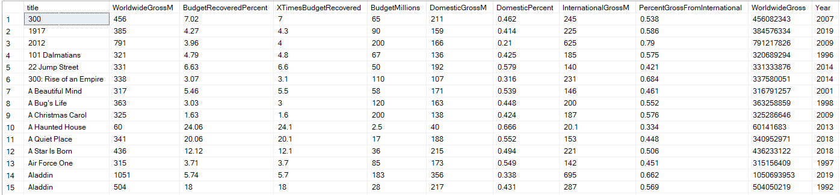

1. Relate the 2 tables ‘IMDBTop1000’ and ‘MostProfitable500’ by joining the 2 on the title column with their similarities (e.g. the movie 300 exists on both tables) and excluding non quantifiable analytical data such as ‘overview’ and ‘poster_link’. Ordered by IMDB_rating first then by Meta_score

SELECT t1.title,

t1.Released_Year,

t1.Certificate,

t1.Runtime,

t1.Genre,

t1.IMDB_Rating,

t1.Meta_score,

t1.Director,

t1.Star1,

t1.Star2,

t1.Star3,

t1.Star4,

t1.No_of_Votes,

t2.WorldwideGrossM,

t2.BudgetRecoveredPercent,

t2.XTimesBudgetRecovered,

t2.BudgetMillions,

t2.DomesticGrossM,

t2.DomesticPercent,

t2.InternationalGrossM,

t2.PercentGrossFromInternational,

t2.WorldwideGross,

t2.Year,

t2.Decade,

t2.Source,

t2.Horror

FROM IMDBTop1000 AS t1

INNER JOIN MostProfitable500 AS t2 ON t1.title = t2.title

ORDER BY IMDB_Rating DESC

SELECT t1.title,

t1.Released_Year,

t1.Certificate,

t1.Runtime,

t1.Genre,

t1.IMDB_Rating,

t1.Meta_score,

t1.Director,

t1.Star1,

t1.Star2,

t1.Star3,

t1.Star4,

t1.No_of_Votes,

t2.WorldwideGrossM,

t2.BudgetRecoveredPercent,

t2.XTimesBudgetRecovered,

t2.BudgetMillions,

t2.DomesticGrossM,

t2.DomesticPercent,

t2.InternationalGrossM,

t2.PercentGrossFromInternational,

t2.WorldwideGross,

t2.Year,

t2.Decade,

t2.Source,

t2.Horror

FROM IMDBTop1000 AS t1

INNER JOIN MostProfitable500 AS t2 ON t1.title = t2.title

ORDER BY IMDB_Rating DESC

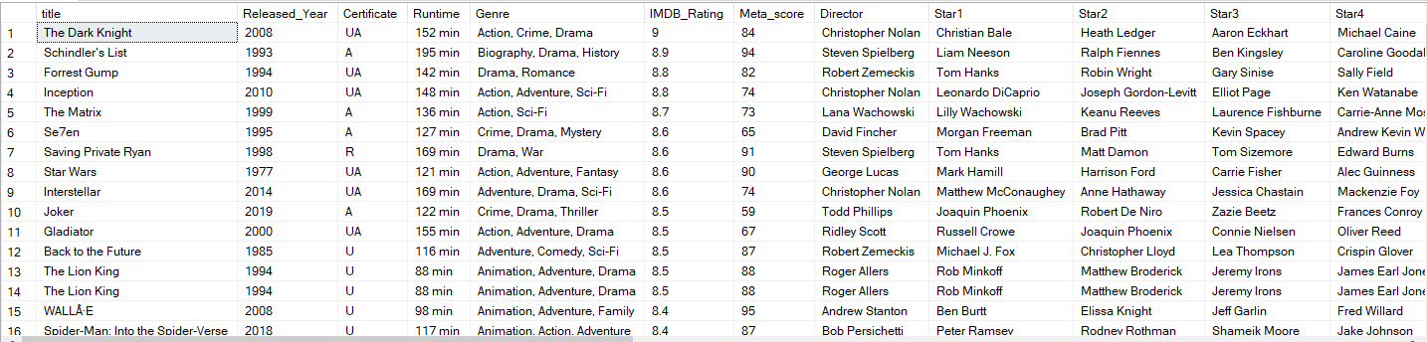

1. Top 20 movies in terms of Worldwide Gross. Times budget recovered and Budget(millions) ranks are also displayed

WITH Top20 AS (

SELECT *,

RANK() OVER (ORDER BY worldwidegross DESC) AS worldwidegross_rank,

RANK() OVER (ORDER BY xtimesbudgetrecovered DESC) AS xtimesbudgetrecovered_rank,

RANK() OVER (ORDER BY budgetmillions DESC) AS budgetmillions_rank

FROM MostProfitable500

)

SELECT

title, WorldwideGross, XTimesBudgetRecovered, BudgetMillions, worldwidegross_rank, xtimesbudgetrecovered_rank, budgetmillions_rank

FROM Top20

WHERE worldwidegross_rank <= 20

ORDER BY worldwidegross_rank;

