Technical solution description

t-systems

Ravil galeyev

015

**Table of contents**

|  |  |
| --- | --- |
| Introduction  Subject area  Functionality  Technical requirements  System architecture  Entities  Database Model  RESTful service  Testing  Document control | 2  2  3  4  5  6  8  9  9  10 |

**Introduction**

The task is to write an application that simulates the work of the information system of a company engaged in the carriage of goods. Below is a more detailed subject area and technical requirements.

**Subject area**

The following types of entities:

* Truck
  + Reg. number (2 letters +5 digits)
  + Size driver shift
  + Capacity
  + Condition (defective, faulty)
* Driver
  + First name
  + Last name
  + Personal number
  + Hours of operation this month
  + Status (rest, work, driving)
  + Current truck
* Order
  + Unique number
  + Completed (yes / no)
  + List of baggage
  + Truck appointed to carry out the order
  + The list of drivers who carry out the order
* Baggage
  + Unique number
  + Name
  + Weight (kg)
  + Status (prepared, shipped, delivered)
* Map
  + Cities
  + Distances

**The application must provide the following functionality:**

* For the employees of the company (through UI-interface):
  + View the list, add, edit and delete trucks, drivers;
  + View the list and adding new orders
  + View the status of orders and freight;
  + Displays a list of trucks that are suitable for delivery of the order if:
    - Truck is in good condition;
    - Truck is suitable for capacity;
    - Truck does not perform at the moment no orders;
  + Selection and appointment of the drivers on the basis of the size of the change and used trucks:
    - Time limit per month (176 hours) for each of the drivers in the change
    - Now the driver does not perform other orders;
* For drivers (via UI-interface):
  + Obtain data on their appointments, providing your personal number:
  + Personal number of the driver
  + Personal numbers to drivers
  + Truck number
  + Order number
  + List of baggage
* For drivers (via ws / rs-interface), the actual recorded time:
  + Driver atonement replaced:
    - Personal number of the driver;
    - Status (the main driver, and leisure);
  + Driver has changed status:
    - Personal number of the driver;
    - Status (the main driver, and leisure);
  + Driver finished the shift;
    - Personal number of the driver;
  + Status of the order has changed:
    - Number of baggage;
    - Status (shipped, delivered).

**Technical requirements**

As a result, required a multi-user application with the client for the company's employees, the remote server (network connection) and open (on the server) WS/RS systems, interfaces to third-party driver systems. All data stored on the server side.

Each client may download some data, after each change, the data must be synchronized with the server. The client must have a graphical user interface (console interface is allowed but not recommended). For WS / RS additional client interface is required. It should be possible to call services via REST interface. The application must handle the hardware and software errors.

**Technologies to be used:**

1. part:

* IDE - Intellij IDEA
* Tomcat 8.0.x
* Servlet/JSP
* DB – MySQL 5.6
* Maven 3.*
* JPA 2.0 (Hibernate)

1. part (including previous):

* AS – Glassfish 4.0
* JAX-WS/RS (Jersey)
* JSF 2.x
* Spring Framework

**System architecture**

**Entities**

This Application consists of seven entities with the corresponding mapping to tables in the database.

Baggage

Baggage entity represents all required information about each baggage and maps it to the corresponding table in the database.

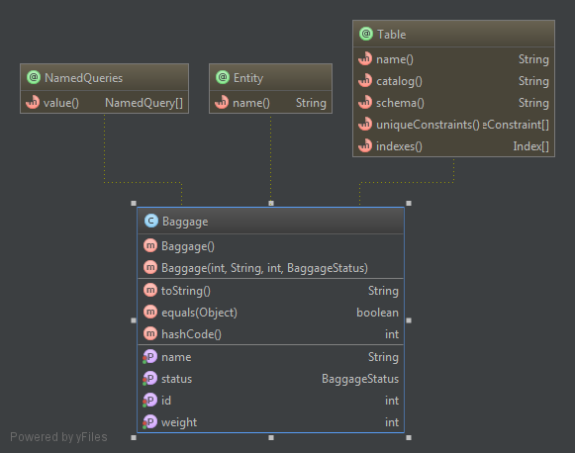

City

City entity represents all required information about each baggage and maps it to the corresponding table in the database.

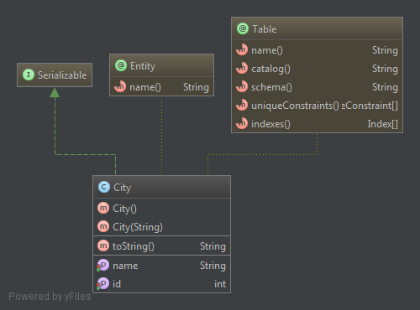

Driver

Driver entity represents all required information about each baggage and maps it to the corresponding table in the database.

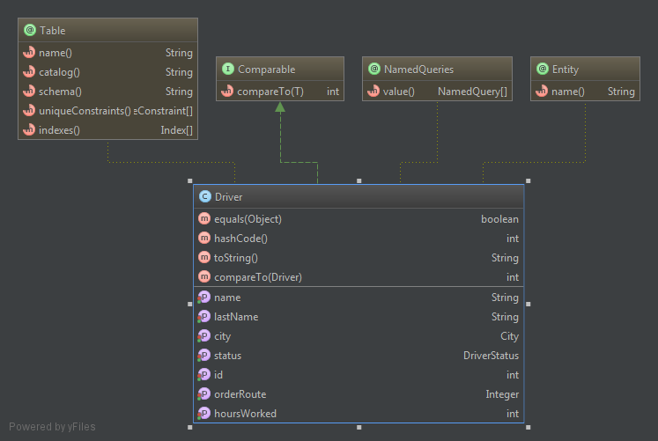

Map

Map entity represents all required information about each baggage and maps it to the corresponding table in the database.

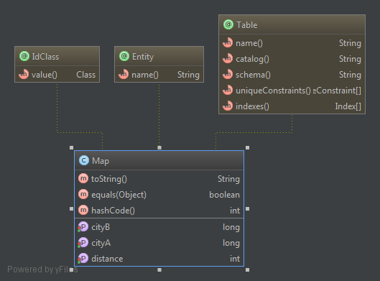

OrderRoute

OrderRoute entity represents all required information about each baggage and maps it to the corresponding table in the database. Each order Route entity consist from one part of order. For example for order with one baggage will consist two entitis: first for city of loading and second for unloading city. Each entity will consist the order of visits and mark of accomplish.

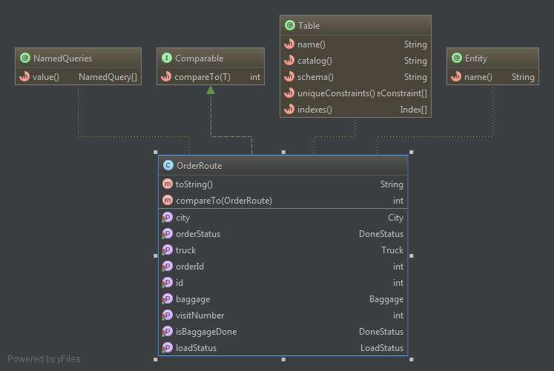

Truck

Truck entity represents all required information about each baggage and maps it to the corresponding table in the database.

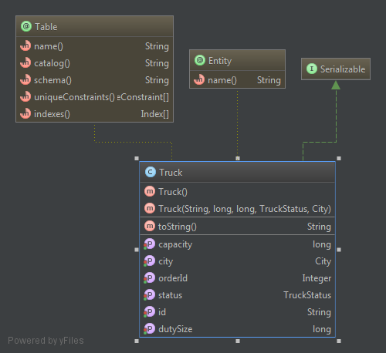

User

User entity represents all required information about each baggage and maps it to the corresponding table in the database.

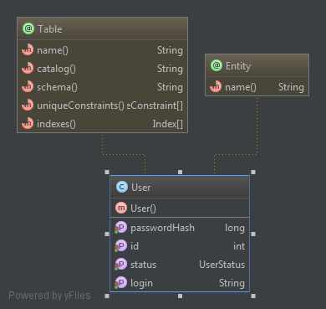

**Database Model**

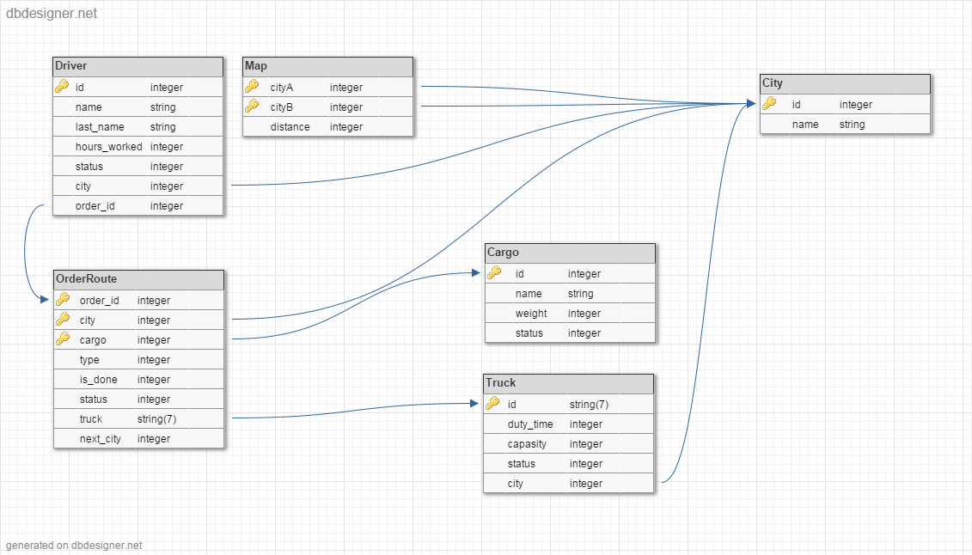

**RESTful service**

API access is available at the following URL:

localhost:8080/webservice/rest/driver/view

returns json driver information. Two parameters are required:

login - driver login, password - driver password

For statuses changing uses following URLs

For driver

localhost:8080/webservice/rest/driver/status

id - driver id (login), status - driver status

For baggage

localhost:8080/webservice/rest/baggage/status

id - baggage id, status - baggage status

**Testing**

Test classes diagram.

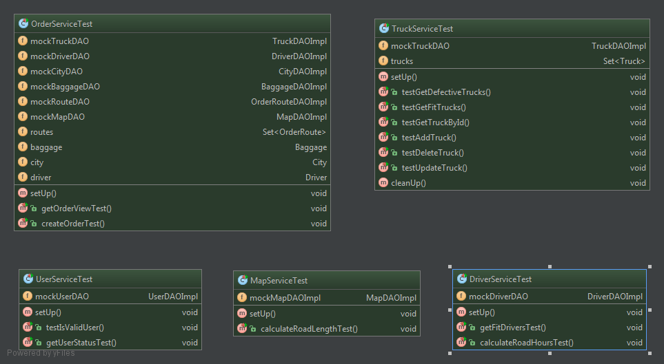

**Document control**

Title: Technical Solution Description

Issue: 1 Draft 2

Date: 19 Aug 2015

Author: Ravil Galeyev

Filename: TSD.doc