Part 1: Verification Warm-Up
- Can the value of the variable i become strictly greater than 200?:
No. It can be verified through the following query:
E<> i > 200
- Is it true that no matter what happens (always) is the value of i smaller than or equal to 100?
Yes. It can be verified through the following query:
A[] i <= 100
- Is it true that no matter what happens (always) is the value of i strictly smaller than 100?
No. It can be verified through the following query:
A[] i < 100
- Is there a run of the system in which i never exceeds 42?
Yes. It can be verified through the following query:
E[] i <= 42
- Is it true that no matter what happens (always) is the value of i greater than or equal to 0?
No. It can be verified through the following query:
A[] i >= 0
Part 2: Scheduling
- The "Job" template for the extended model, including a short description of what you did and why.
The Job template models a non-preemptive task that can execute on either CPU. Each job has processor-dependent execution times and dependency constraints. Dependencies are enforced using a global bitmask. A job may request a CPU only after all its predecessor jobs have completed. After execution, the job signals completion and updates the global state. The first parameter of a job is the ID, which marks the bit in the global bitmask, the second and third parameters are the execution time for the two CPUs, and the fourth parameter indicates the dependencies by marking the corresponding bit(s) in the global bitmask.
The “Job” template is shown below:
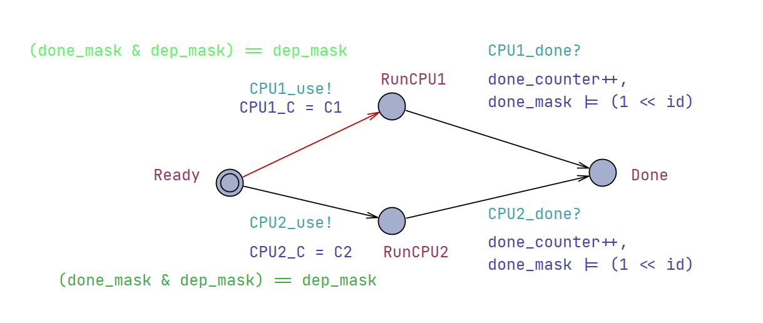
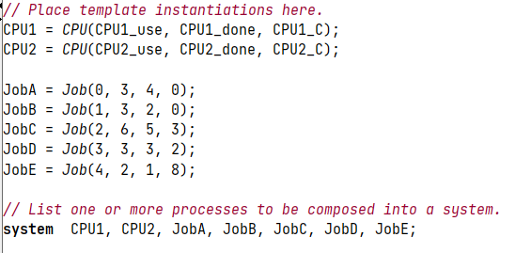
- All queries you used, i.e., for generating the trace as well as for proving optimality of the result. Please include a short description as well.
E<> done_counter == 5
Finds a schedule in which all jobs have completed.

E<> (done_counter == 5 && y <= 8)
Checks that there exists a schedule completing all jobs within the optimal 8 time units.
A[] (done_counter == 5 imply y >= 8)
Proves that no schedule can complete all jobs in less than 8 time units.
- Minimal execution time for the following problem instance:
14 time units.
Part 3：A Deadlock
- The two timed automata for Consumer and Buffer:
Consumer:
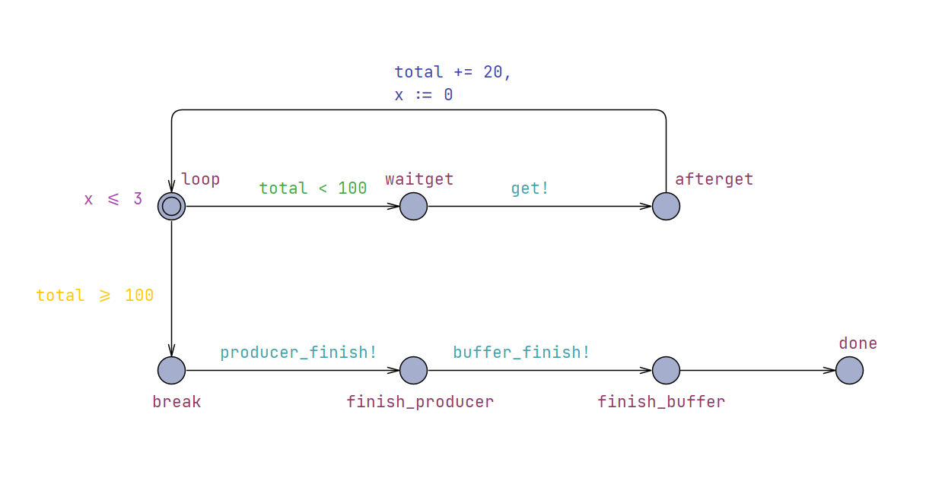
Buffer:
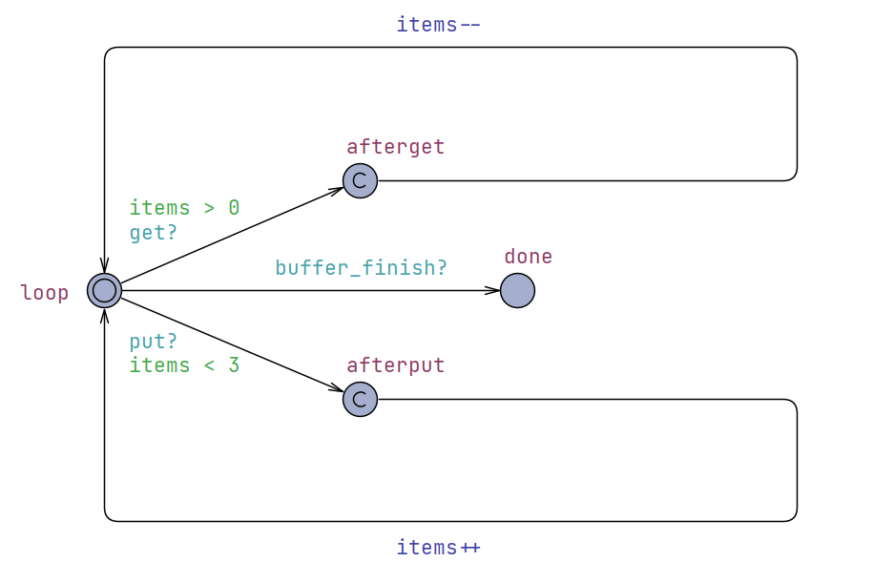

- The extended query to exclude the "artificial" deadlock state:
A[] (deadlock imply (Producer.done && Buffer.done && Consumer.done))
The query ensures that deadlock can only occur in the intended termination state where all automata have finished.
- An explanation to the second deadlock:
Even after changing the termination order in which the Producer is terminated before the Buffer, a deadlock can still occur. In this deadlock, the Producer is blocked waiting to synchronize on put, while the Buffer is full and the Consumer has already left the consumption loop. Since the Producer can only accept the termination signal in its main loop, it cannot be terminated while waiting to put, causing the system to deadlock.
It is shown in the figure below:
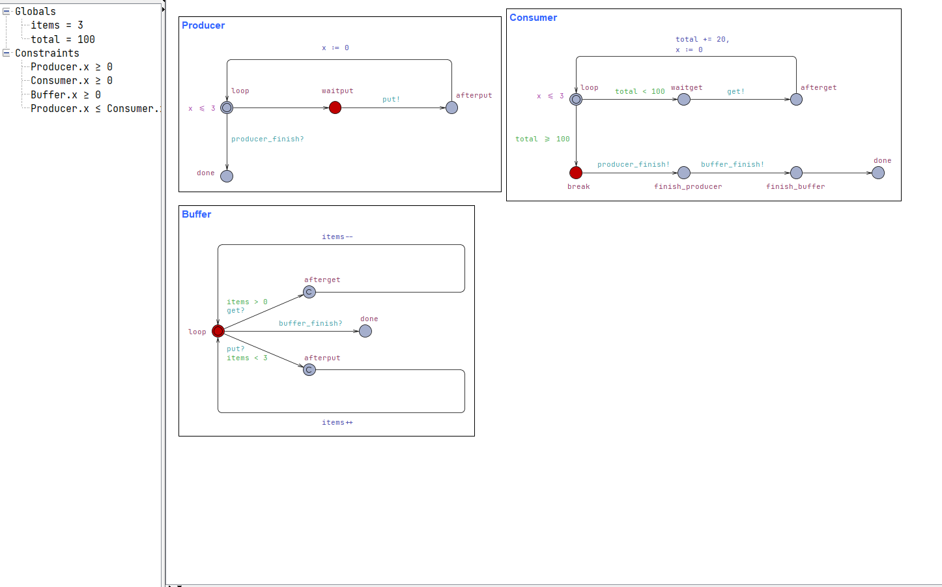
- Your suggested fix to that problem:
The Producer was modified to allow reception of the producer_finish signal also while waiting to put. After this modification, the verification query is satisfied, and the system is free from deadlocks except for the allowed terminal state.
