DataCycle Domotic
Smart-Apartment IoT Data Platform
Installation Guide
Step-by-step instructions to deploy DataCycle on a fresh Windows VM,
from web wizard to running pipeline.
Audience | End user / IT installer (no Python required)
Estimated time | 45-60 minutes
Document version | 1.0
Document date | April 2026

Before you start
DataCycle is a self-contained data platform that runs entirely on a single Windows VM. The installer is a single Python file — fill out a form on the project's web wizard, download a .py, run it, done.

Prerequisites
These need to be installed on the target machine before you run the installer:
Tool | Why | Where
Python 3.11 or newer | Pipeline + installer | https://www.python.org/downloads/
Git | Repo cloning during install | https://git-scm.com/downloads
PostgreSQL 14 or newer | Silver + Gold storage | https://www.postgresql.org/download/windows/
Power BI Desktop | Dashboards (Windows-only) | https://www.microsoft.com/en-us/download/details.aspx?id=58494
KNIME Analytics Platform 5.x | ML predictions | https://www.knime.com/downloads
The installer auto-detects all five and warns if anything is missing — but won't proceed until at least Python and Git are installed.

What you'll need to type into the wizard
- Postgres ADMIN credentials (typically the postgres user) — used only at install time, never written to disk
- App user name + password (defaults to domotic) — created during install, used by all pipeline scripts
- App database name (e.g. domotic_prod) — created during install
- Postgres host + port (typically localhost:5432)
- MySQL connection details (provided by school: user / password / host / database)
- sFTP credentials for the weather forecasts (provided by school)
- SMB share UNC path (e.g. \\\\server\\share), credentials, and a free drive letter (Z:)
- Bronze storage root (default: storage\bronze relative to install folder)
Privacy note
Form values never touch any backend. The wizard runs entirely in your browser; on submit, JavaScript renders the installer template locally and triggers a download. The Postgres admin password is baked into the .py file you download — if you re-share that file, the admin password travels with it.

Step 1 — Generate the installer
- Open the project's install wizard URL in your browser (e.g. https://datacycledomotic.vercel.app/install)
- Fill in every field. Tip: tooltips on each field explain valid formats
- Click "Generate installer" — your browser downloads data-cycle-installer.py
- Move the file to a stable location, e.g. C:\DEV\users\Install\
If you've installed before, the wizard offers a "Restore from previous installer" upload. Drop your old .py file in to pre-fill the form.

Step 2 — Run the installer
Open PowerShell, cd to the folder containing data-cycle-installer.py, and run:
cd C:\DEV\users\Install
python data-cycle-installer.py
By default the installer creates a sub-folder data-cycle-domotic/ next to the .py. Pass a path to override:
python data-cycle-installer.py D:\Projects\DataCycle

What it does (10 steps)
# | Step | Time
1 | Prerequisites — verify Python, Git, Power BI, KNIME presence | 5 s
2 | Clone repo (or git pull if the dir already exists) | 30-60 s
3 | Write .env with all your wizard inputs | <1 s
4 | Create Python venv + install requirements.txt | 2-3 min
5 | Mount SMB drive + validate Postgres / MySQL / sFTP credentials | 5-10 s
6 | Create Postgres app user, app database, silver/gold schemas | 10-30 s
7 | Bootstrap silver — MySQL dim import + (opt) full SMB backfill + weather | 25-35 min
8 | Run initial gold ETL | 30-60 s
9 | Verify row counts + auto-config Power BI / KNIME with your DB credentials | 30-60 s
10 | Optional autostart watcher in Windows Startup folder | <1 s
Idempotent
Re-running the installer is always safe. It skips clone if already cloned, skips dependency install if venv intact, skips DB creation if already created, and the bronze→silver step uses watermarks to skip already-processed files. So if anything fails halfway, just re-run.

Step 3 — Verify everything works

3.1 The auto-launched admin dashboard
At the end of the install, you're prompted: "Launch the admin dashboard now? [Y/n]". Hit Y. The Streamlit dashboard opens in your browser at http://localhost:8501.
Healthy state:
- 🟢 Database — connection green
- 🟢 Watcher process — Running
- Six freshness tiles all green (Sensors environment, energy, presence; Weather; Predictions motion + consumption)
- Every gold table has > 0 rows
If anything is yellow / red, the dashboard's "Quick actions" buttons let you trigger the matching ETL step (e.g. "Run gold ETL (sensors)").

3.2 Power BI
Open the dashboard:
start <install-dir>\bi\power_bi\DataCycleDomotic.pbix
- Click Refresh (Home tab) — pulls latest data from your local Postgres
- Press F11 to enter fullscreen presentation mode
- To preview tenant-only views: Modeling tab → View as → Other user → Jimmy or Jeremie

3.3 KNIME predictions (optional, takes 5-15 minutes)
If you accepted the install's offer to run KNIME predictions, they'll already be in gold.fact_prediction_motion and gold.fact_prediction_consumption. Otherwise:
cd <install-dir>
.venv\Scripts\python.exe scripts\run_knime_predictions.py
Or click "Run KNIME predictions" in the admin pane.

Appendix · Screenshots
Captured during the reference install on the project VM. Use these as a visual cross-reference while running the installer on a new machine.
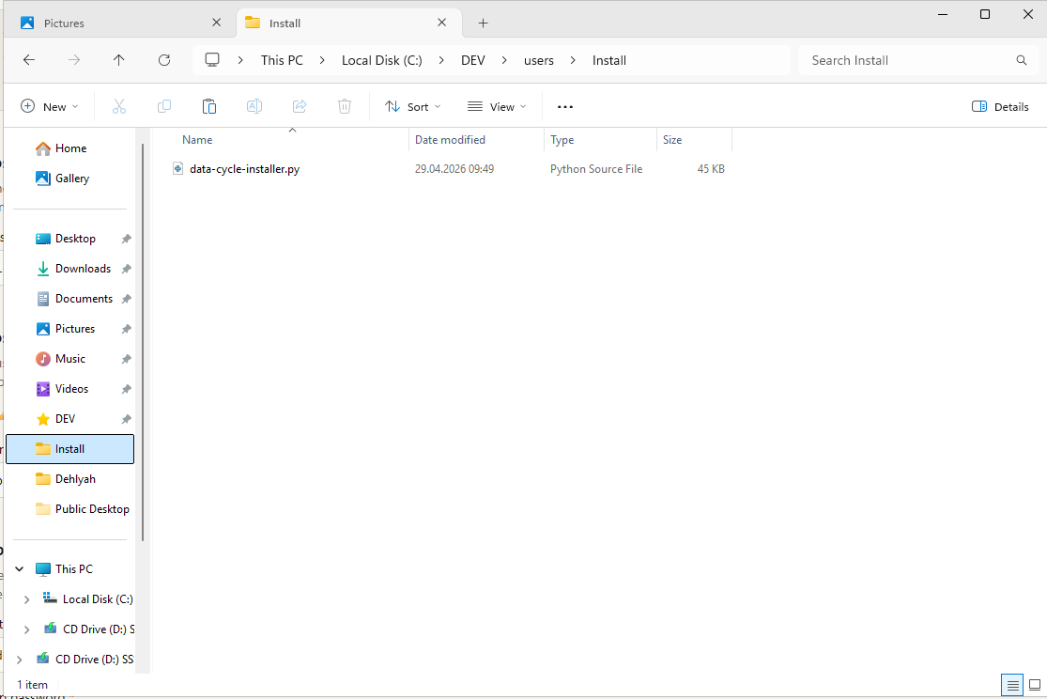
Figure 1 — 1040C2B7-74DE-47…
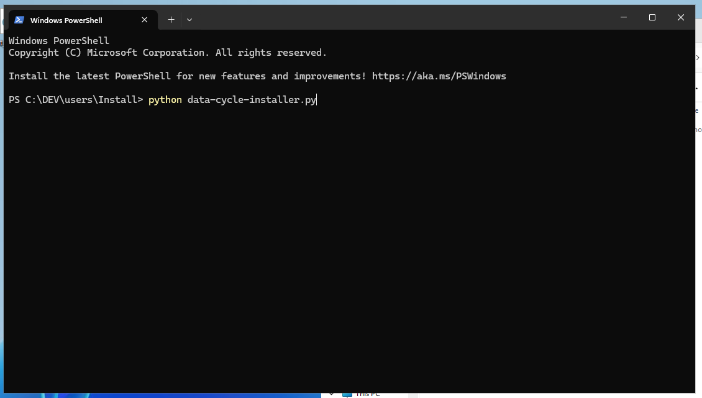
Figure 2 — 3AE380FD-DD9F-46…
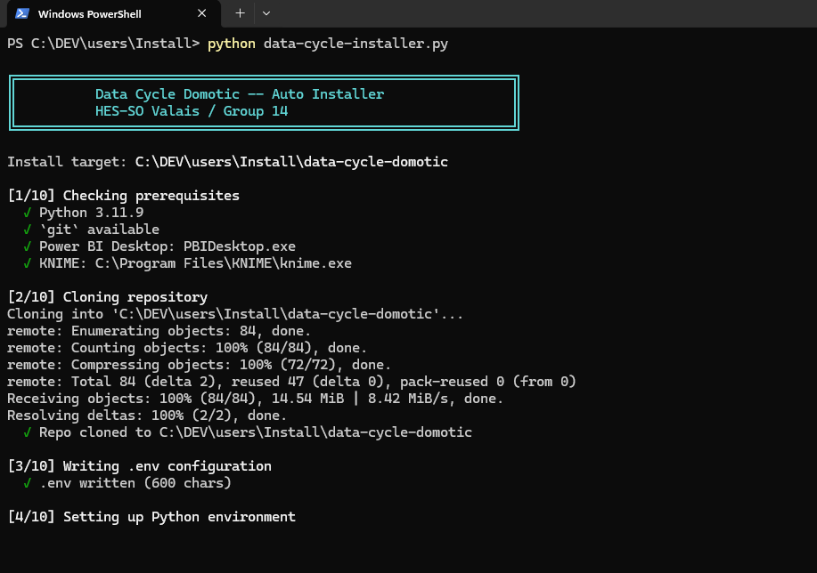
Figure 3 — 4C6FF717-9045-44…
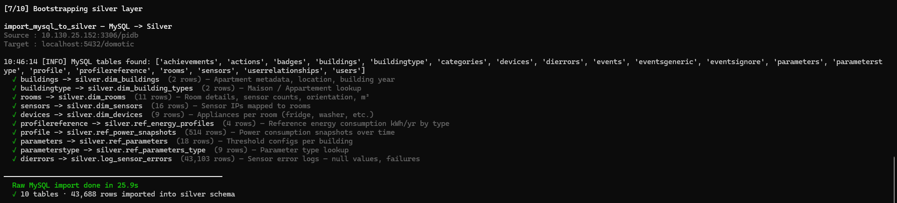
Figure 4 — 558580E8-FE8B-44…
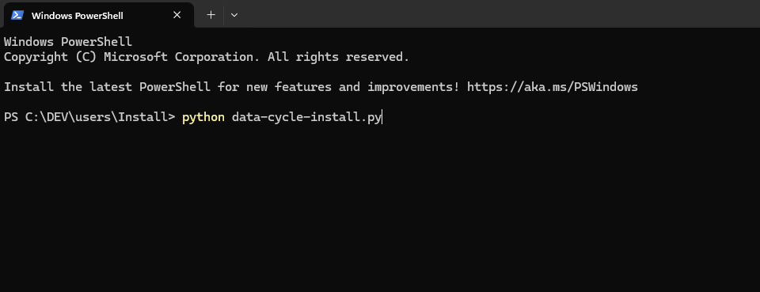
Figure 5 — 68DF600B-0BDD-4C…
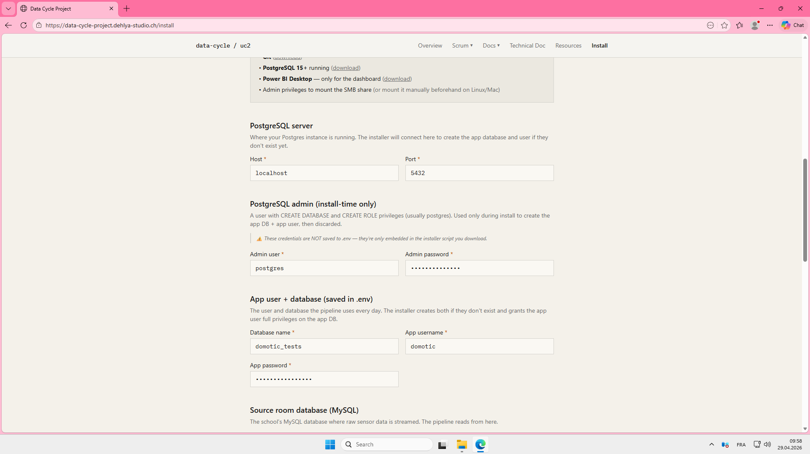
Figure 6 — 8EE0142D-8DA3-4C…
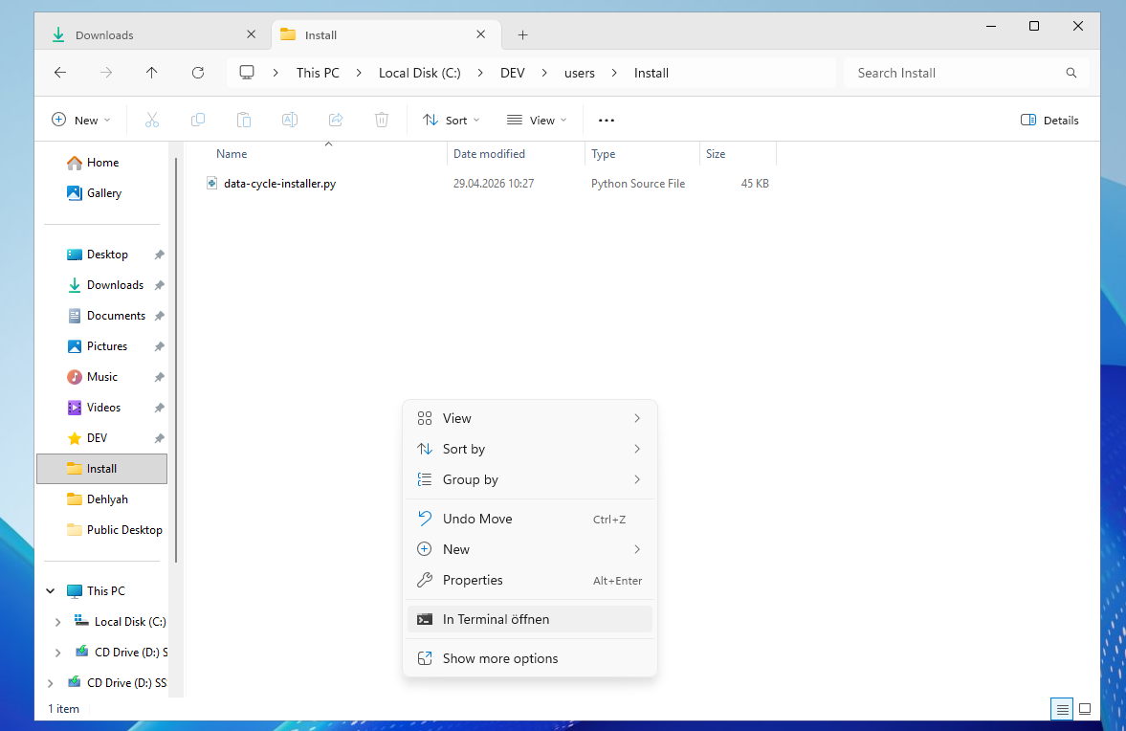
Figure 7 — E4DE7D7D-4219-43…
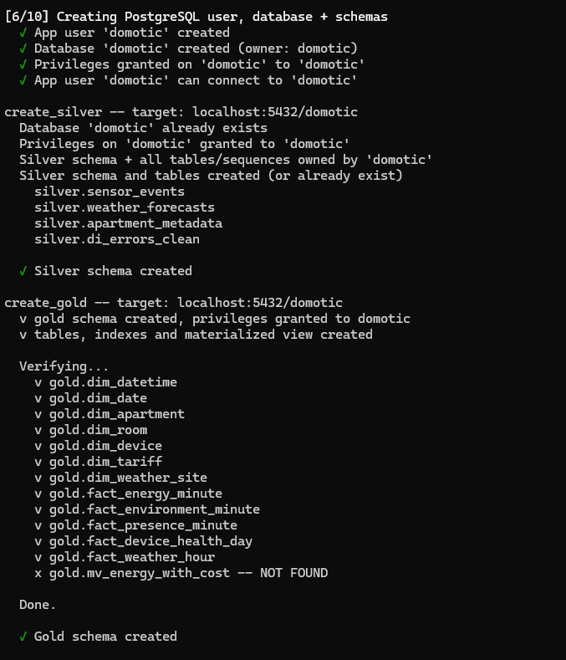
Figure 8 — E64411AE-A03E-41…
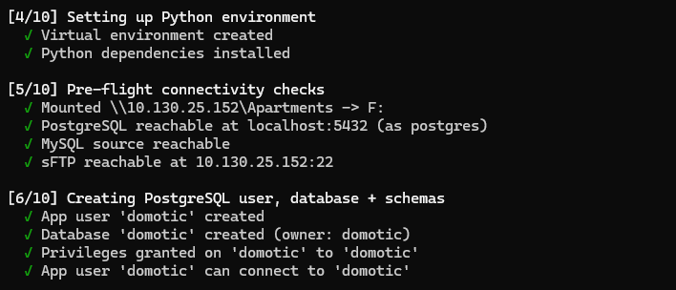
Figure 9 — FFD037F6-BF8C-4D…

Common install issues
Symptom | Fix
psycopg2.OperationalError: password authentication failed for user 'postgres' | Wrong admin password in the wizard form. Re-run wizard, fix it, re-run installer.
Cannot connect to MySQL | School VPN required — connect to VPN first.
SMB path not found: Z:\ | Mount failed — installer prints the net use command it tried; run it manually with the correct credentials, then re-run installer.
Silver step says "0 new files" but bronze has data | Old bug — pull latest, re-run. The watermark scanner now does a full scan each time.
KNIME predictions fail with "Attempt to overwrite the password" | Old .knwf shipped before the Variable-to-Credentials swap. Pull latest, re-run configure_bi_knime.py then deploy_knime.py.
Admin dashboard fails with "DB_URL not set" | .env empty or missing. Re-run installer (idempotent — won't redo finished work).
Java exit code=4 on KNIME | KNIME GUI is open with the same workspace. Close it (Stop-Process -Name knime -Force) and retry.

Uninstall / clean reset
To completely remove DataCycle from a machine:
# Stop running pipelines
Get-Process knime,java,javaw,python,pythonw -EA SilentlyContinue | Stop-Process -Force

# Remove the watcher autostart shortcut
Remove-Item "$env:APPDATA\Microsoft\Windows\Start Menu\Programs\Startup\DataCycle Watcher.lnk" -EA SilentlyContinue

# Drop DBs + user (use admin password)
$env:PGPASSWORD = '<admin pwd>'
psql -U postgres -h localhost -c "DROP DATABASE IF EXISTS <your_db_name>;"
psql -U postgres -h localhost -c "DROP USER IF EXISTS domotic;"
Remove-Item Env:\PGPASSWORD

# Remove the install dir + KNIME workspace
Remove-Item C:\path\to\data-cycle-domotic -Recurse -Force
Remove-Item $HOME\knime-workspace -Recurse -Force

— end of installation guide —

