Data cycle - User guide
Group 14 – Apartments Domotic
Germanier Sacha, Von Roten Johann, Herbelin Dehlya
[Date]

Table of contents

Introduction 2
Navigation & Filter 2
Compare page 3
Overview page 4
Environment page 5
Energy page 6
Presence page 7
Device health page 8
Conclusion 9
FAQ 9

Introduction
Welcome to this dashboard guide. This guide is here to help you get the most out of the report. It’s designed to make the data easy to read and show you how to find exactly what you’re looking for in just a few clicks.

You will learn how to:
- Customize your view: You don’t have to look at everything at once. We’ll show you how to use the filters (the slicers at the top of each page) to zoom in on a specific date or in a particular room.
- Understanding the numbers: We break down what each chart and KPI means so you can spot trends immediately.

Navigation & Filters
At the top of each page, you can click on the menu. This will switch between different thematic pages of the report:
- Overview: A high-level summary of all key metrics.
- Environment: Details regarding temperature, humidity, or air quality.
- Energy: Insights into power consumption and efficiency.
- Presence: Tracking occupancy and movement patterns.
- Device Health: Monitoring the status and connectivity of your hardware.
Go to another page menu
- Tip — press F11 in Power BI Desktop for a fullscreen presentation view that hides every toolbar.
- Apartment-level access — each tenant only sees their own apartment thanks to Row-Level Security. To preview a tenant view (admin only): Modeling → View as → Other user → Jimmy or Jeremie.
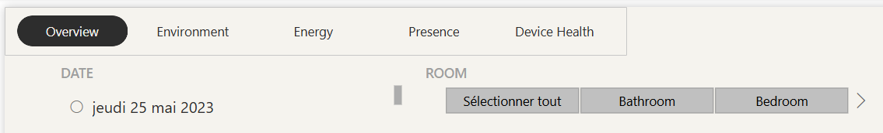
Filter to show only the data for this date
Filter to show only data for one or many rooms

Compare page

In this page, you can see the two apartments’ metrics to compare their data.
On the metric column you can see what is measured. On the source column you can see the origin of the metric. The next column is the apartment. The actual values are recorded for each specific apartment. You can show one or both apartments by selecting the apartment slicer (Jimmy / Jeremie / both) and the date range. The last column displays only if you select both apartments and show the difference between the two.
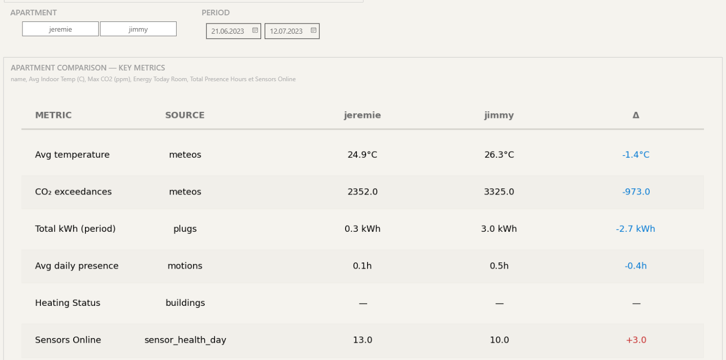

Overview page
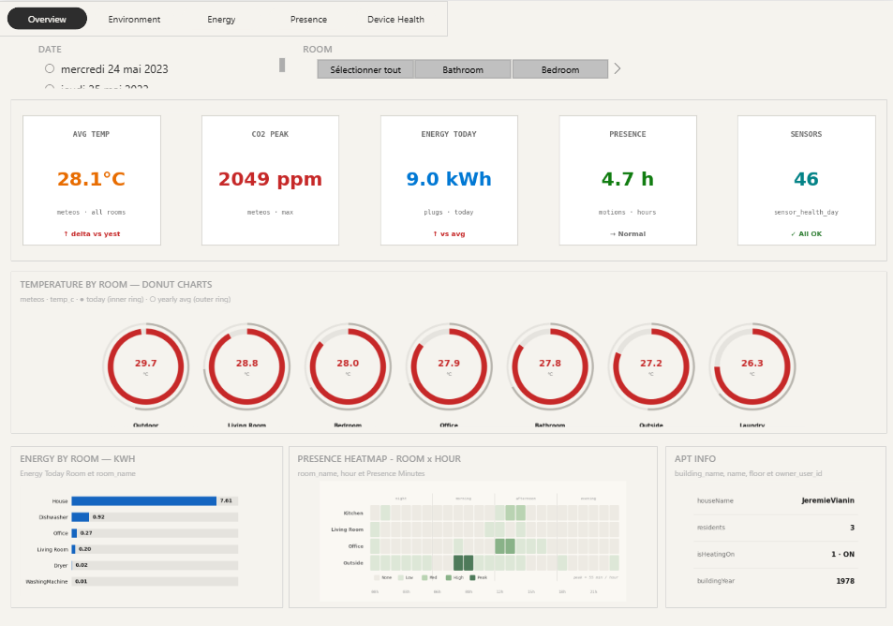
The overview page shows a quick overview of different pages. At the top you can see Key performance indicators. Each card uses color-coded metrics and trend indicators to help you instantly determine if performance is optimal or requires intervention.


This section shows the temperature in each room. You can show by adjusting the room filter.


Some graphs displayed in other pages are displayed here to quickly track energy, presence by just looking at the overview page. At the right most you can see information about the apartment.

Environment page
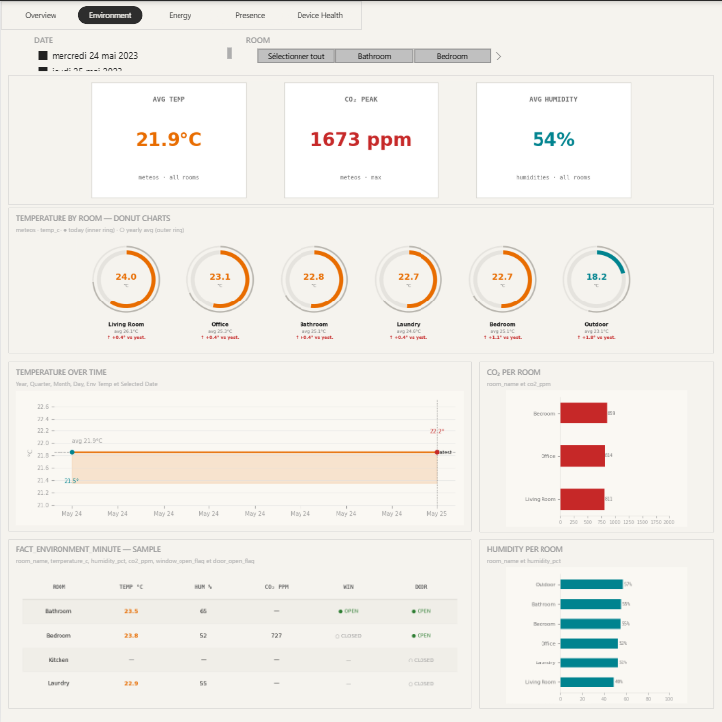
The environment page shows the temperature, CO₂ and humidity of the different rooms in the apartment.


This section of the page shows the temperature of each room.
Average in the year and yesterday comparison are displayed below


Selecting multiple dates on the filter will show the temperature over time. Next to this timeline you can see CO₂ levels by room.

This table shows a sample of all the data recorded for a multiple room. Next to this table you can see the humidity by room in ascending order.


Energy page
Total kWh, current power, monthly kWh and top consumption are at the top of this page to track the consumption of the apartment.
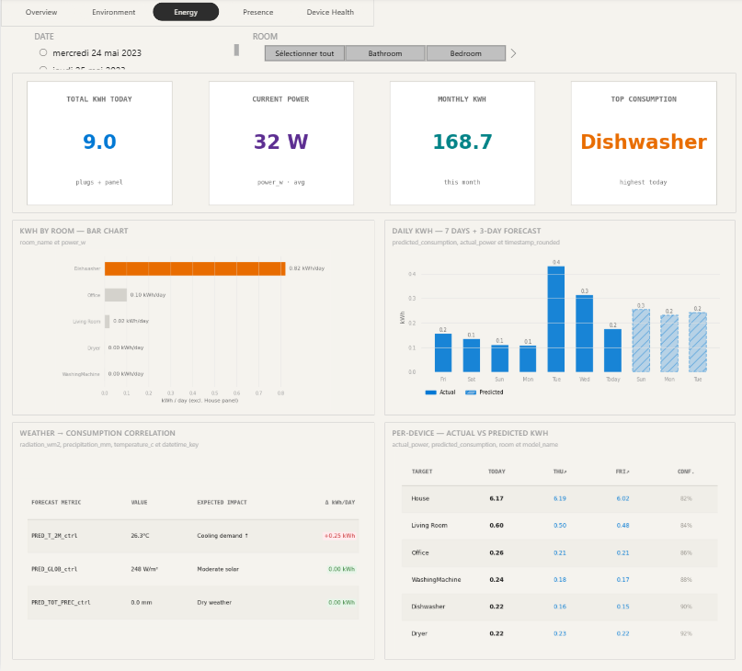

kWh by room chart helps you to see what consumes the most. Next to the chart you have an overview over the last 7 days, and a prediction of consumption based on the past data.


To better understand your consumption, this page shows a table to find correlation. On the right there is a much-detailed view of the prediction and the actual kWh.


Presence page
This page aims to provide an overview of the occupancy of different rooms in the apartment. It allows for the analysis of movement patterns, the identification of the most frequented areas, and the forecasting of future occupancy.
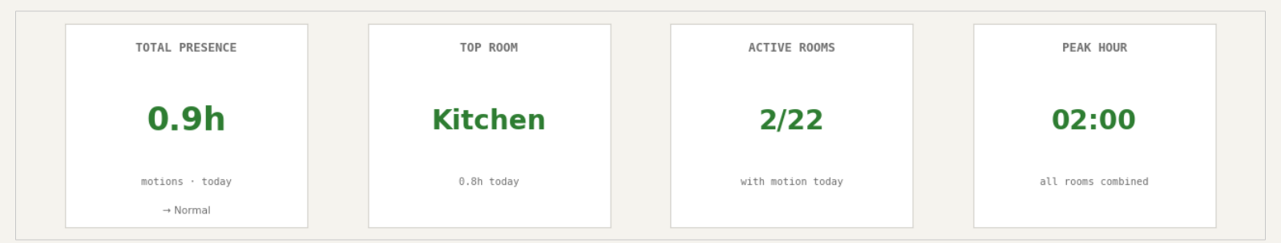

These two graphs show the most used room in hours and at what time in the day.
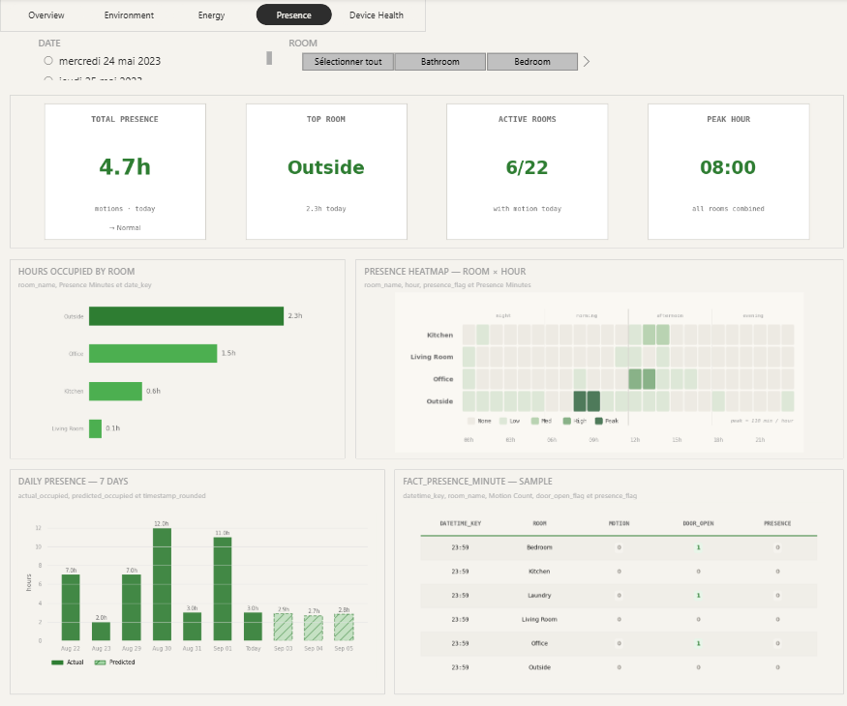

The last section of the page shows the daily presence for seven days and on the table, it shows in much more detail motion or door open and presence in a room at a specific hour.

Predicted presence for next 3 days

Device health page
This page aims to provide a detailed view of the device in the apartment. In the first section of the page, it shows the KPIs of all the devices to check if all is up and running.
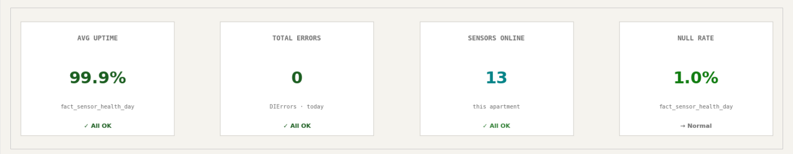

This table shows a sample of the device uptime and error to check whether all devices are online or any are offline.
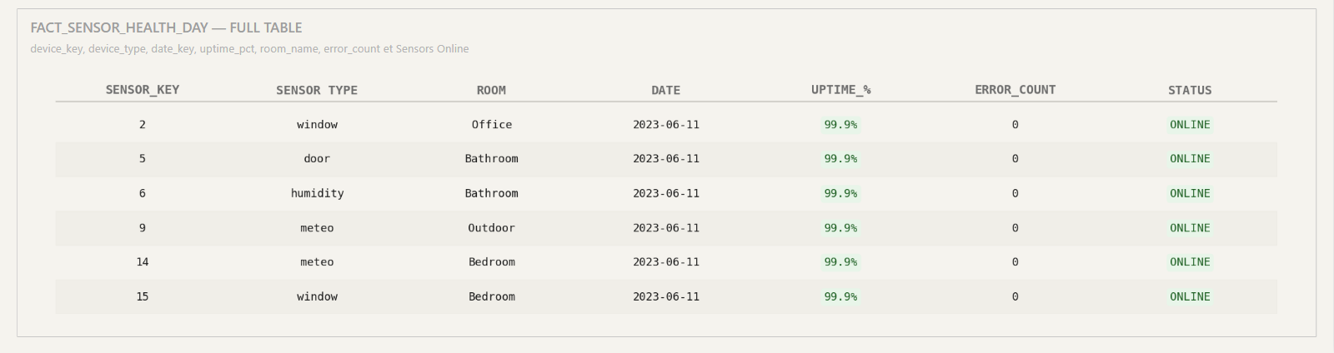

Reminder — Power BI Desktop displays a snapshot of the data taken at refresh time. To pull the latest values, click Home → Refresh (or press Ctrl+R) before reading the dashboards.

Conclusion
Throughout this guide, you have learned the meaning of the data displayed and how to use the different filters to use this report to reach its full potential.

FAQ
- Why are some fields displaying “--” or “No data”?
There is no data for this date or period, try to select another date or room.

- Can I isolate a single value in a graph?
You can select one element in the filter, and it will show only the data for this one.

- Is the filter synchronized across pages?
Yes — selections in the slicers apply across every page of the report.

- How often is the data updated?
The pipeline keeps the database fresh in the background — sensor readings every minute, gold facts every 15 minutes, and ML predictions daily at 06:30. Power BI Desktop loads a snapshot of this data when you open the file: click Home → Refresh (or press Ctrl+R) to pull the latest values.

