**Windows**

Big reduction in file size.

Fast Web View optimization is turned on.

Compressed un-compressed streams using flate.

Original:

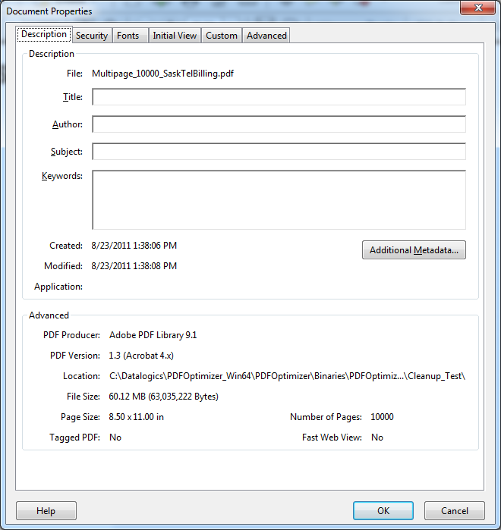

PDFOptimizer Output:

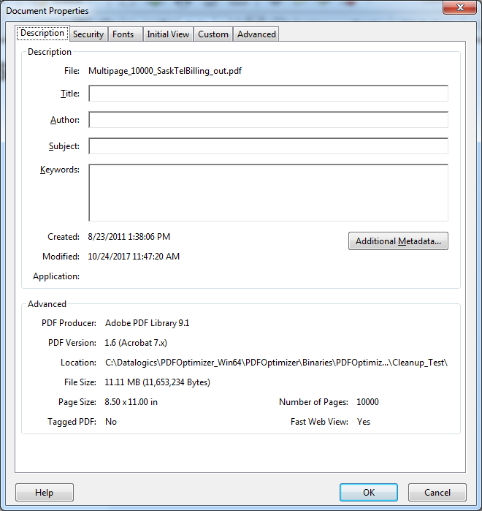

**Linux**

Compress-entire-file option is ignored

