**Windows & Linux: configom**

Small change in file size

9 fonts are listed as embedded (Courier, Frutiger-Black, Frutiger-BlackItalic, Frutiger-Light, Frutiger-Roman, Helvetica-Black, Sabon-Italic, Sabon-Roman, Symbol) in the configom.pdf. The configom_out.pdf shows 3 of these fonts are subset (Courier, Symbol, and Helvetica-Black, but Helvetica-Black also remains as an embedded font. Are the Frutiger and Sabon fonts not able to be subset?

Configom.pdf:

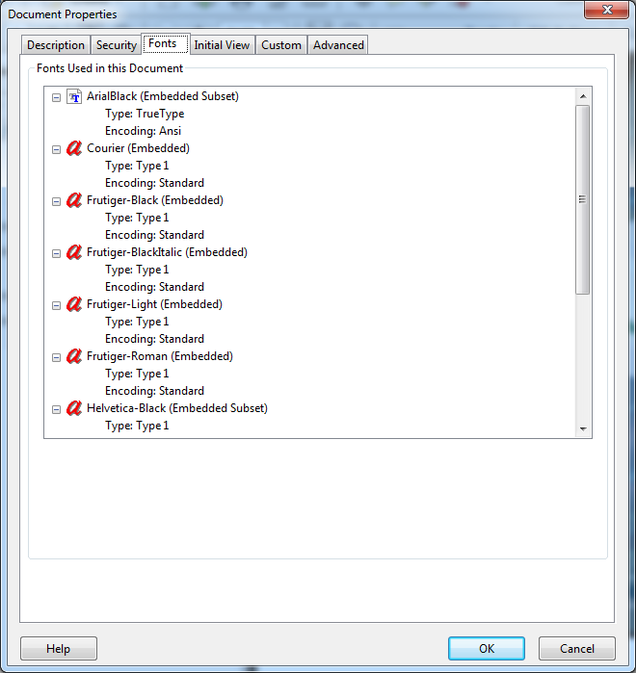

Configom_out.pdf:

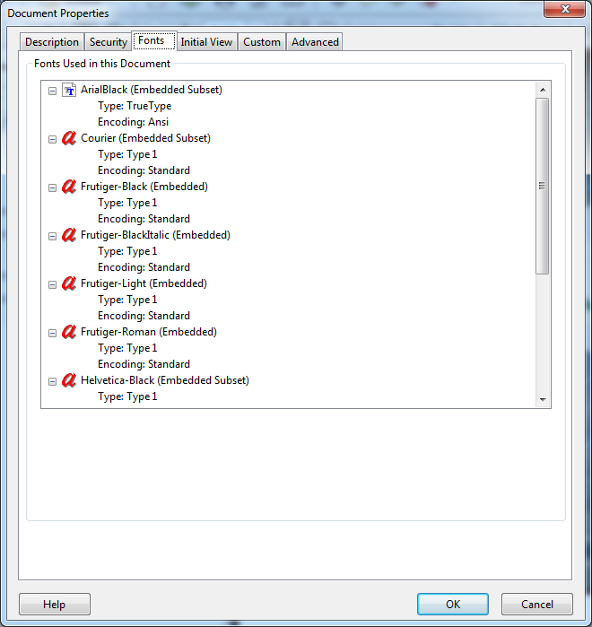

**Windows and Linux: Parabolic**

Not quite sure about what’s happening with this one. There are a lot of TrueType fonts embedded in the parabolic.pdf, but they are not subset in the parabolic_out.pdf

Parabolic.pdf:

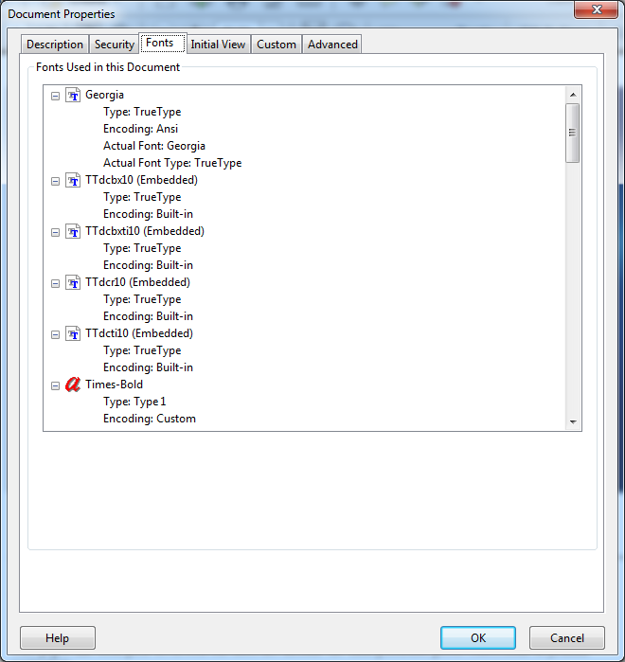

Parabolic_out.pdf:

